**Wireless Tower Lights**

Senior Capstone Design 2017-2018

Paul

Kevin

Andrew

Adrian

This is the rough draft of our documentation.

Table of contents:

Meeting minutes …………………………………………………………………………. X

Diagrams ………………………………………………………………………………….X2

Meeting minutes:

9/08/2017 Meeting Notes – with Rinker

Meeting started at 3:31, all members present, Adrian on Zoom meeting

Q&A with Rinker:

General schedule: Rinker’s in CDA start of the week, always in Moscow on Friday, in between depends on events.

Current system in the tower: 3 high powered LEDs (in series) in each room facing the proper direction, controlled over CAT cable from the basement. LEDs prefer constant current over constant voltage, using constant current power source. Each color takes 270 mili-amps. Constant current circuit used here.

Future objectives: Convert system to be wireless. Nodes will need to sleep for a couple days before the show begins, using low power, and should then be remotely wake-able. Power and LED configurations are up to us.

Current goofy lights: broadcast from laptop to Arduino like board, transmits out to the glasses. Wireless protocol related to Zigby. Not wifi, but 802.15.4 (ad-hoc sensor network). Devices can sleep, wakeup, reconnect to network, etc. Zigby handles errors when reconnecting, etc. We avoid using Zigby as we’re broadcasting in real time, and do not want the error handling. Broadcasts on 2.4ghz, regular wifi frequency. 9v lith-ion batteries are being used in the glasses. LEDs in the glasses are in series. Uses a resistor to deliver the correct voltage. Uses the chip from an Arduino, straight up programmed from the Arduino IDE. Atmega328p. Broadcasts to all glasses i.e. DMX. Uses 16 different channels for groups of lights.

802.15.4 only goes at 250kbps. Might want to reduce each channel to 2 bytes instead of 3?

DMX protocol: Used in theater lights, wired protocol, goes through each light sequentially.

Current code is all available for use.

Mouser.com parts. Superbrightleds.com

Meeting adjourned at 4:39

Diagrams:

What we have:

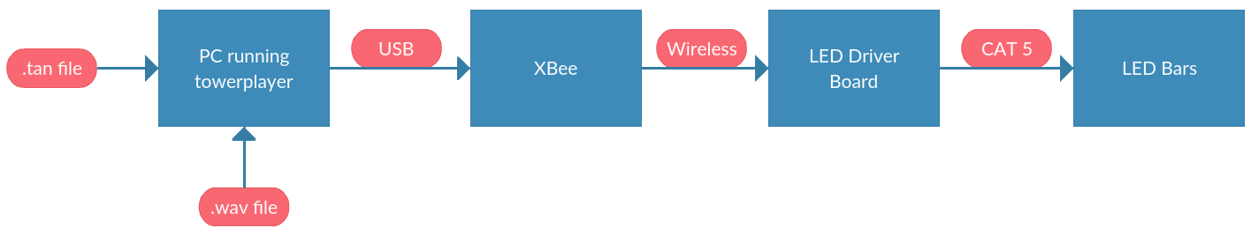

What we want:

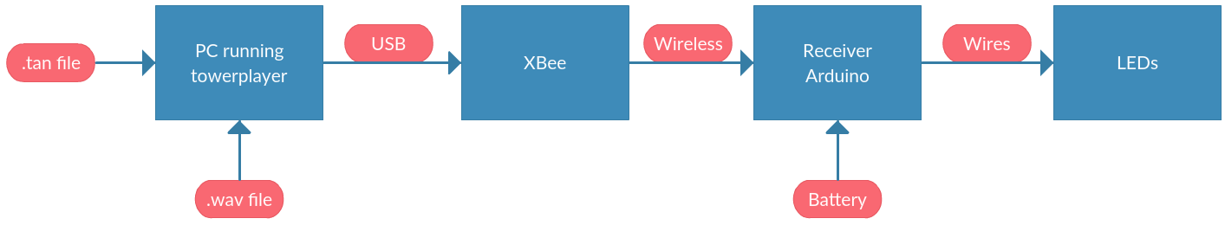

End of rough draft.