Wireless Requirements
Frequency Requirements:
The wireless protocol needs to have an effective range of potentially up to 100 meters. Additionally, the frequency must be one that will work even in crowded venues, with lots of different cellphones, and Wi-Fi signals present.
Speed Requirements:
The wireless protocol needs to have the ability to send enough data fast enough to keep up with the Tower Lights show. Depending on the total number of light-bars, this number can change. The speed requirement will also depend on how many possible colors we implement and how many frames per second we will display.
Packet Requirements:
The information packets sent over the wireless protocol must contain all the information needed to set the individual light bars to the appropriate color. There can be only one packet that will be sent to all the light bars, and each light bar will be encoded with which part of the packet to read.
Current Ideas:
The 802.15.4 protocol (Zigbee) is 2.4Ghz, but will not interfere with Wi-Fi. This protocol can operate at a speed of 250kbps, which is much lower than Wi-Fi, but may be adequate for this project. Shown below is a diagram of how 802.15.4 differs from Wi-Fi.
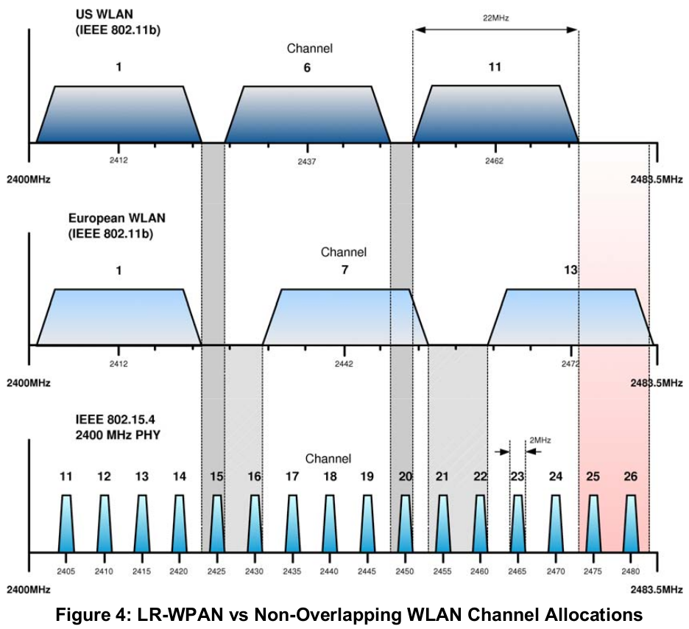

(Jennic 2008)

