Is there a Gender Pay Gap in UK?

Results
Using the UK Government's 2025-26 gender pay gap reporting data, this analysis examines differences in mean hourly pay between men and women across reporting employers. The sample contains 11,187 employer reports, with an average gender pay gap of 11.50%. This indicates that, on average across employers, women's mean hourly pay was 11.50% lower than men's. Figure 1 illustrates the distribution of employer-level gender pay gaps.

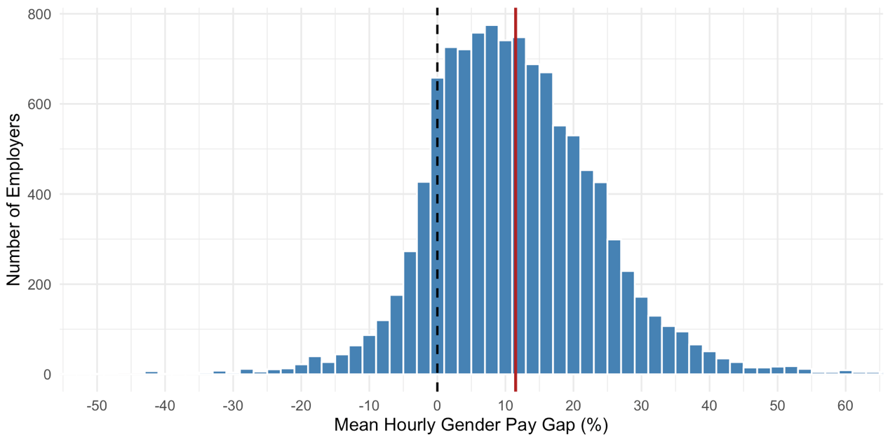
Figure 1. Distribution of the mean hourly gender pay gap across UK reporting employers, 2025-26.
Note: Positive values indicate higher average hourly pay for men. The dashed line indicates zero, and the solid red line indicates the sample mean. The x-axis is restricted to -50% to 60% for readability.

A two-sided one-sample t-test showed that the mean employer-level gender pay gap was significantly different from zero, t (11,186) = 76.06, p < .001. The result indicates a positive average gender pay gap across reporting employers, with men earning more per hour than women on average within employers.

