Weather and daily bike rentals
Yuqi Jiang 5802046

The analysis examined daily bike rentals in the UCI Bike Sharing Dataset for Capital Bikeshare from 1 January 2011 to 31 December 2012. All 731 days had complete observations for total rentals, temperature and wind speed. Total rentals included casual and registered users. Normalised weather measures were converted to degrees Celsius and miles per hour before analysis.

1. Descriptive statistics and associations
Daily rentals varied considerably, ranging from 22 to 8,714, with a mean of 4,504.35 and a standard deviation of 1,937.21. Temperatures also varied considerably across days, ranging from -5.22°C to 32.50°C, with a mean of 15.28°C. Mean wind speed was 12.76 mph (SD = 5.19 mph). Table 1 summarises the three variables and their pairwise correlations. The histograms in Appendix A show that wind speed had a right-skewed distribution, with relatively few days at high wind speeds.
Table 1 Descriptive statistics and Pearson correlations
Panel A Descriptive statistics
Variable | N | Mean | SD | Min | Max
Daily rentals | 731 | 4,504.35 | 1,937.21 | 22.00 | 8,714.00
Temperature (°C) | 731 | 15.28 | 8.60 | -5.22 | 32.50
Wind speed (mph) | 731 | 12.76 | 5.19 | 1.50 | 34.00
Panel B Pearson correlations
Variable | Daily rentals | Temperature (°C) | Wind speed (mph)
Daily rentals | —
Temperature (°C) | 0.63 | —
Wind speed (mph) | -0.23 | -0.16 | —
As shown in Panel B of Table 1, daily bike rentals were positively correlated with temperature (r = .63) and negatively correlated with wind speed (r = -.23). The correlation between temperature and wind speed was weakly negative at -0.16. Figure 1C shows the same pattern. The points are widely scattered, and the fitted line slopes only slightly downward.

When two predictors are highly correlated, different combinations of their coefficients can produce nearly the same fitted values. The likelihood then changes little across those combinations, forming a ridge that makes each coefficient harder to estimate precisely. Here, the weak correlation between temperature and wind speed makes it easier to estimate their separate associations with daily bike rentals in the joint model.
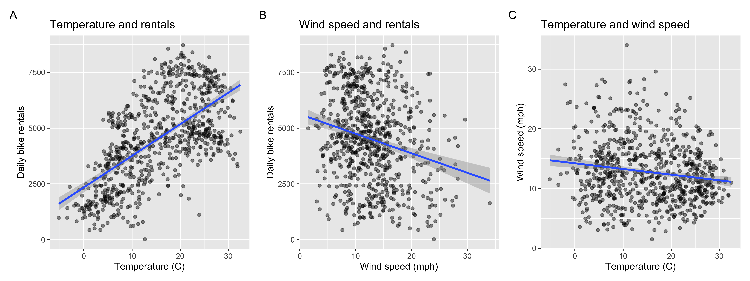
Figure 1. Pairwise relationships between temperature, wind speed and daily rentals. Note. Blue lines show separate linear fits; shaded bands are 95% confidence intervals for the fitted means.

2. Regression Analysis
Table 2 reports the three ordinary least squares models. In the wind-only model, each additional 1 mph was associated with 87.51 fewer daily rentals (95% CI for the slope [-113.88, -61.13]), t (729) = -6.51, p < .001. The interval is compatible with approximately 61 to 114 fewer rentals per mph and lies entirely below zero. However, wind speed alone explained only 5.5% of rental variation. In the temperature-only model, each additional 1°C was associated with 141.29 more daily rentals (95% CI [128.54, 154.04]), t (729) = 21.76, p < .001. The interval supports a positive association of approximately 129 to 154 additional rentals per degree. Temperature alone explained 39.4% of the variation.

In the joint model, holding wind speed constant, each additional 1°C was associated with 136.35 more rentals (95% CI [123.63, 149.07]), t (728) = 21.05, p < .001. Holding temperature constant, each additional 1 mph was associated with 51.82 fewer rentals (95% CI for the slope [-72.89, -30.75]), t(728) = -4.83, p < .001.

Together, the predictors explained 41.3% of rental variation, approximately 1.9 percentage points more than temperature alone. If only one weather variable were available, temperature would be preferred for this linear prediction task because its single-predictor model explained substantially more variation than the wind-only model.
Table 2 Unstandardised regression estimates for daily bike rentals
Variable | Wind only | Temperature only | Both
Intercept | 5621.15*** | 2344.98*** | 3081.86***
 | [5257.83, 5984.47] | [2121.44, 2568.52] | [2710.03, 3453.69]
p value | <0.001 | <0.001 | <0.001
Temperature (°C) | — | 141.29*** | 136.35***
 |  | [128.54, 154.04] | [123.63, 149.07]
p value |  | <0.001 | <0.001
Wind speed (mph) | -87.51*** | — | -51.82***
 | [−113.88, −61.13] |  | [−72.89, −30.75]
p value | <0.001 |  | <0.001
N | 731 | 731 | 731
R² | 0.055 | 0.394 | 0.413
Adjusted R² | 0.054 | 0.393 | 0.411
Each coefficient is followed by its 95% confidence interval. * p < .05; ** p < .01; *** p < .001.

3. The Reason of Wind Coefficient Changes
After adjusting for temperature, the estimated wind speed coefficient became less negative, changing from -87.51 to -51.82 daily rentals per mph (Table 2). With a correlation of -0.16 between wind speed and temperature, windier days tended to be slightly colder. Colder days also tended to have fewer rentals. The wind-only model therefore picks up some of the lower rental counts associated with the colder temperatures on windier days. When comparing days at the same temperature, a 1 mph increase in wind speed is associated with a smaller drop in daily rentals.

Figure 2 illustrates this pattern. In Panel B, the orange and green lines represent the two lowest temperature quartiles. Their different intercepts show that, at the same wind speed, the model predicts fewer rentals for the colder group. The grouped model fits a common wind slope across all four quartiles, and that slope is less negative than the overall slope in Panel A. Because temperature still varies within each quartile, Panel B illustrates adjustment using broad temperature groups.
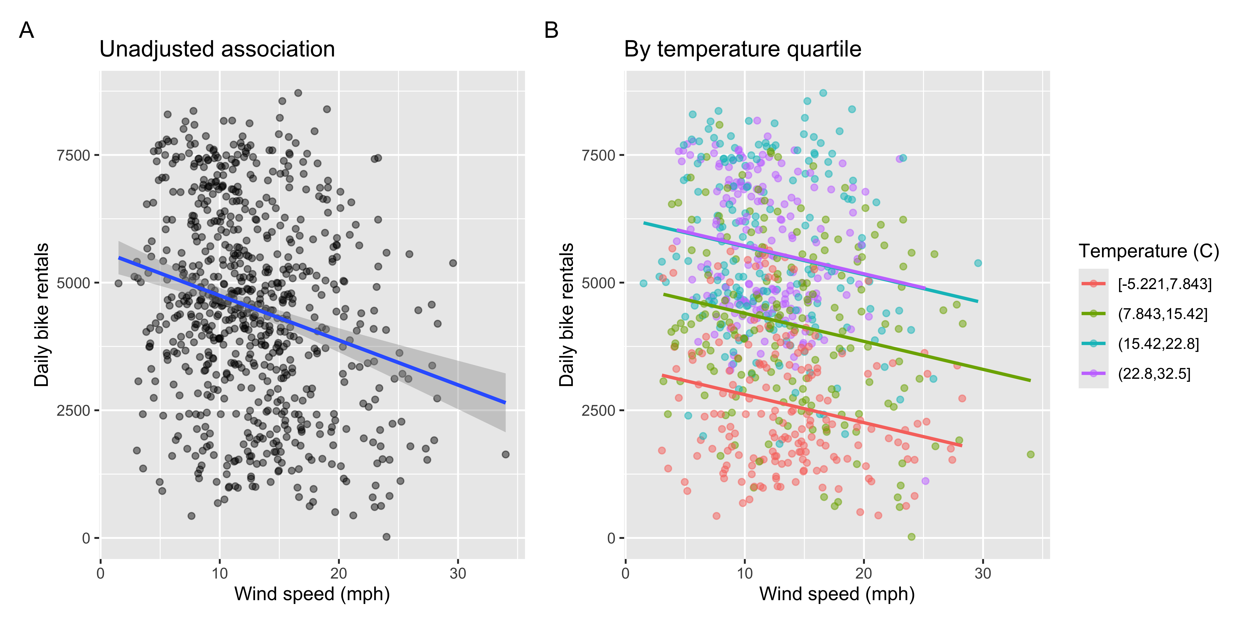
Figure 2. Wind speed and daily rentals before and after temperature grouping. Panel A shows the unadjusted fit. Panel B groups days into temperature quartiles.

4. Monthly variation in the temperature association
Figure 3 shows separate fitted lines for each month, pooling observations from the same month in 2011 and 2012. Figure 4 reports the corresponding slopes and their 95% confidence intervals. The estimated slopes were positive from January to May and in October and December, with confidence intervals entirely above zero. In March, for example, a 1°C higher temperature was associated with about 291 more daily rentals (95% CI [226, 357], p < .001). The slopes were negative in June and July, with both confidence intervals entirely below zero. In July, a 1°C higher temperature was associated with about 158 fewer daily rentals (95% CI [-287, -29.9], p = .017). The estimated slope was positive in August and negative in September and November. The 95% confidence intervals included zero in all three months, so none of these slopes was statistically significant at the 5% level.
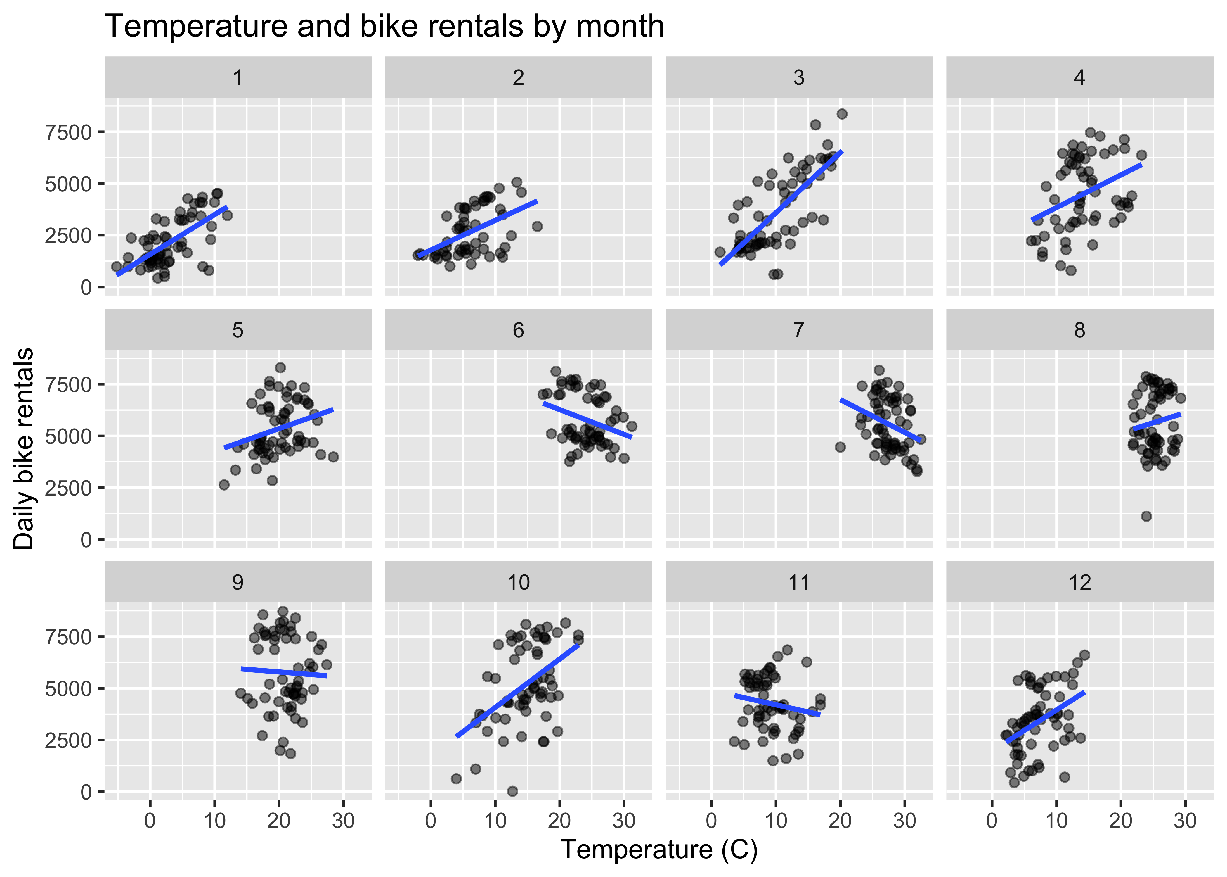
Figure 3. Temperature and daily bike rentals by month.
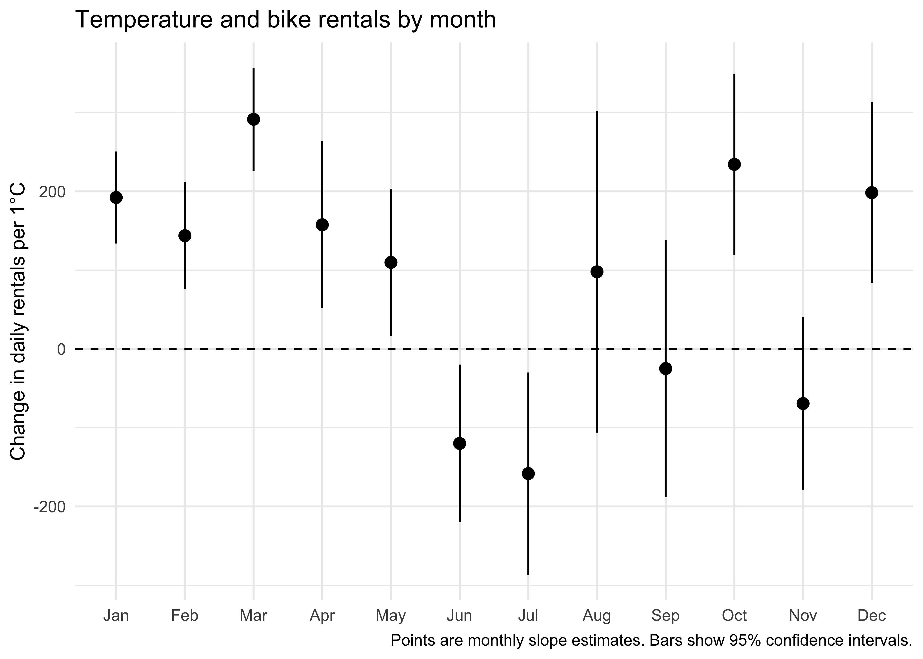
Figure 4. Figure 4. Estimated temperature slopes for daily bike rentals by month
Note. Points show the estimated difference in daily rentals associated with a 1°C higher temperature. Vertical bars show 95% confidence intervals, and the dashed line marks zero.

In winter and spring, warmer days may make cycling more comfortable and encourage more people to rent a bike for their journeys. On colder days, some of those travellers may choose to drive or take public transport to avoid the cold. In June and July, the negative slopes may reflect a different response to warmer weather. On particularly hot days, cycling may feel less comfortable, so some people may choose an air-conditioned car or bus to stay cool. These travel choices could help explain why warmer days were associated with more rentals in many cooler months but with fewer rentals in June and July.

Each monthly estimate was based on roughly 60 days, and temperatures varied over a narrower range within some months. Both factors can make the monthly slopes less precise. Additional years of data would help assess whether these patterns recur.

Across the full sample, warmer days were associated with more rentals, but this pattern did not hold in every month. In June and July, warmer days were associated with fewer rentals.

Appendix A Univariate distributions
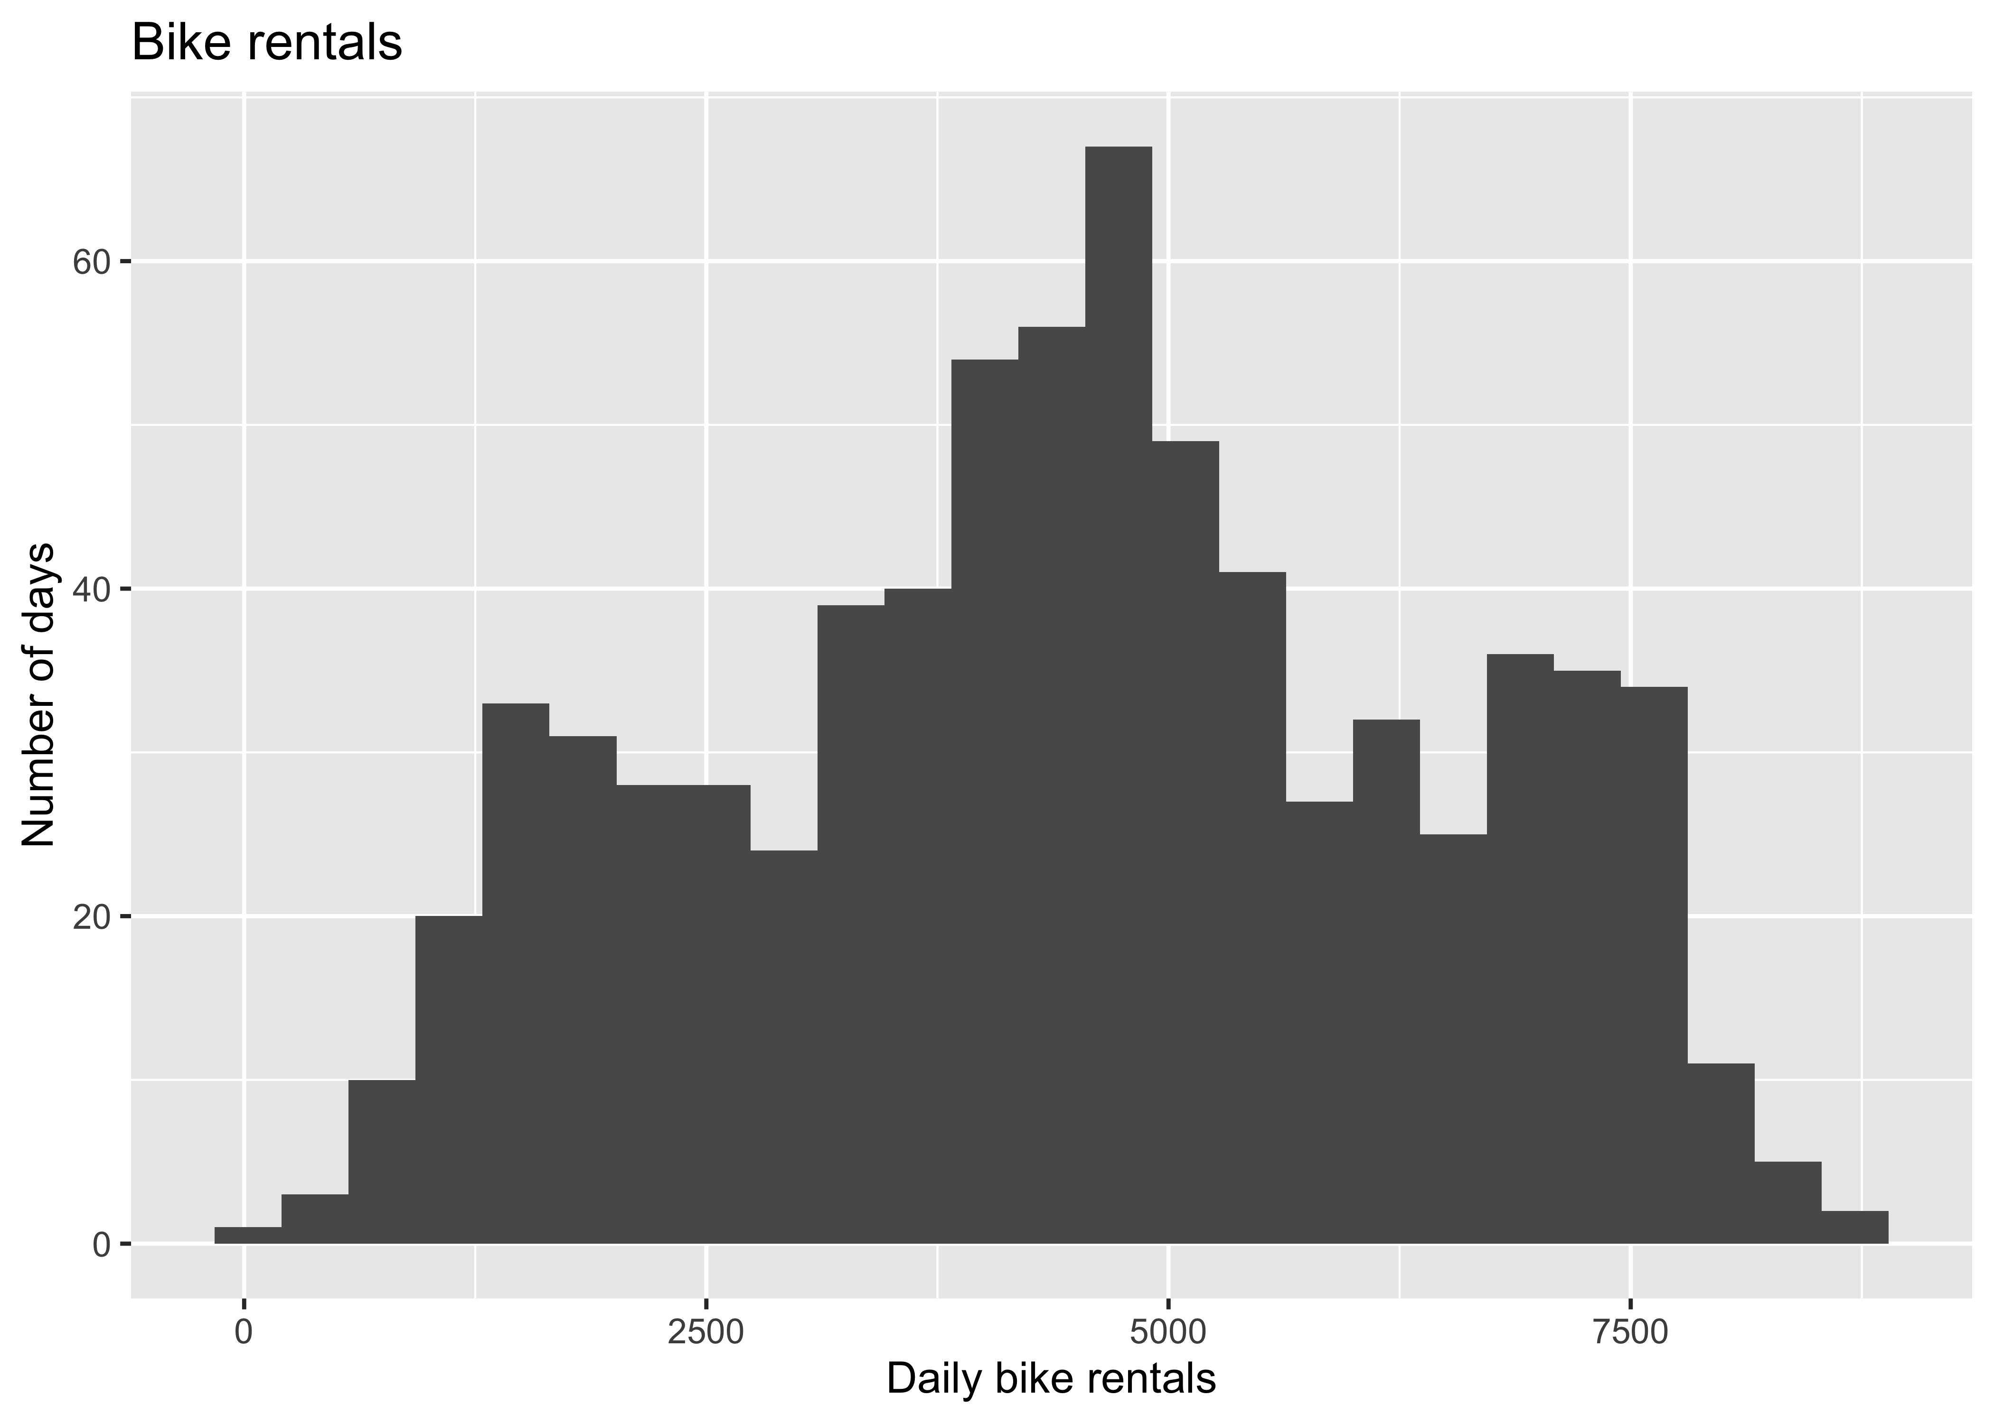
Figure A1. Distribution of total daily bike rentals.
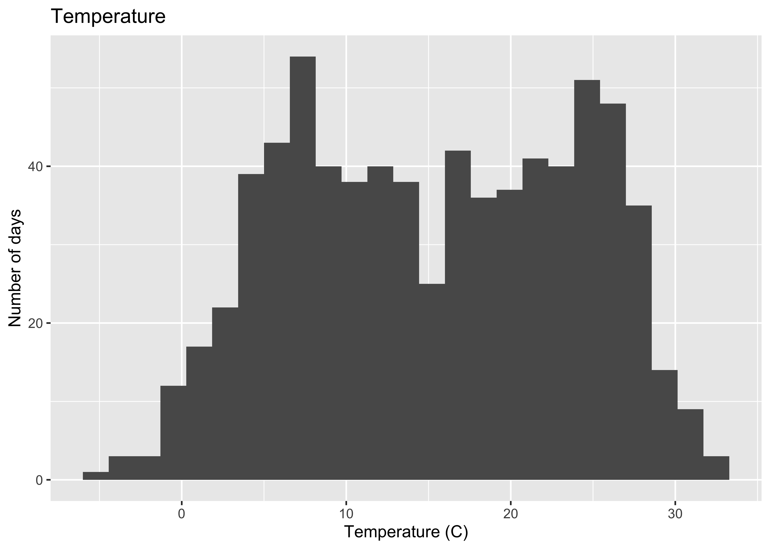
Figure A2. Distribution of daily temperature in degrees Celsius.
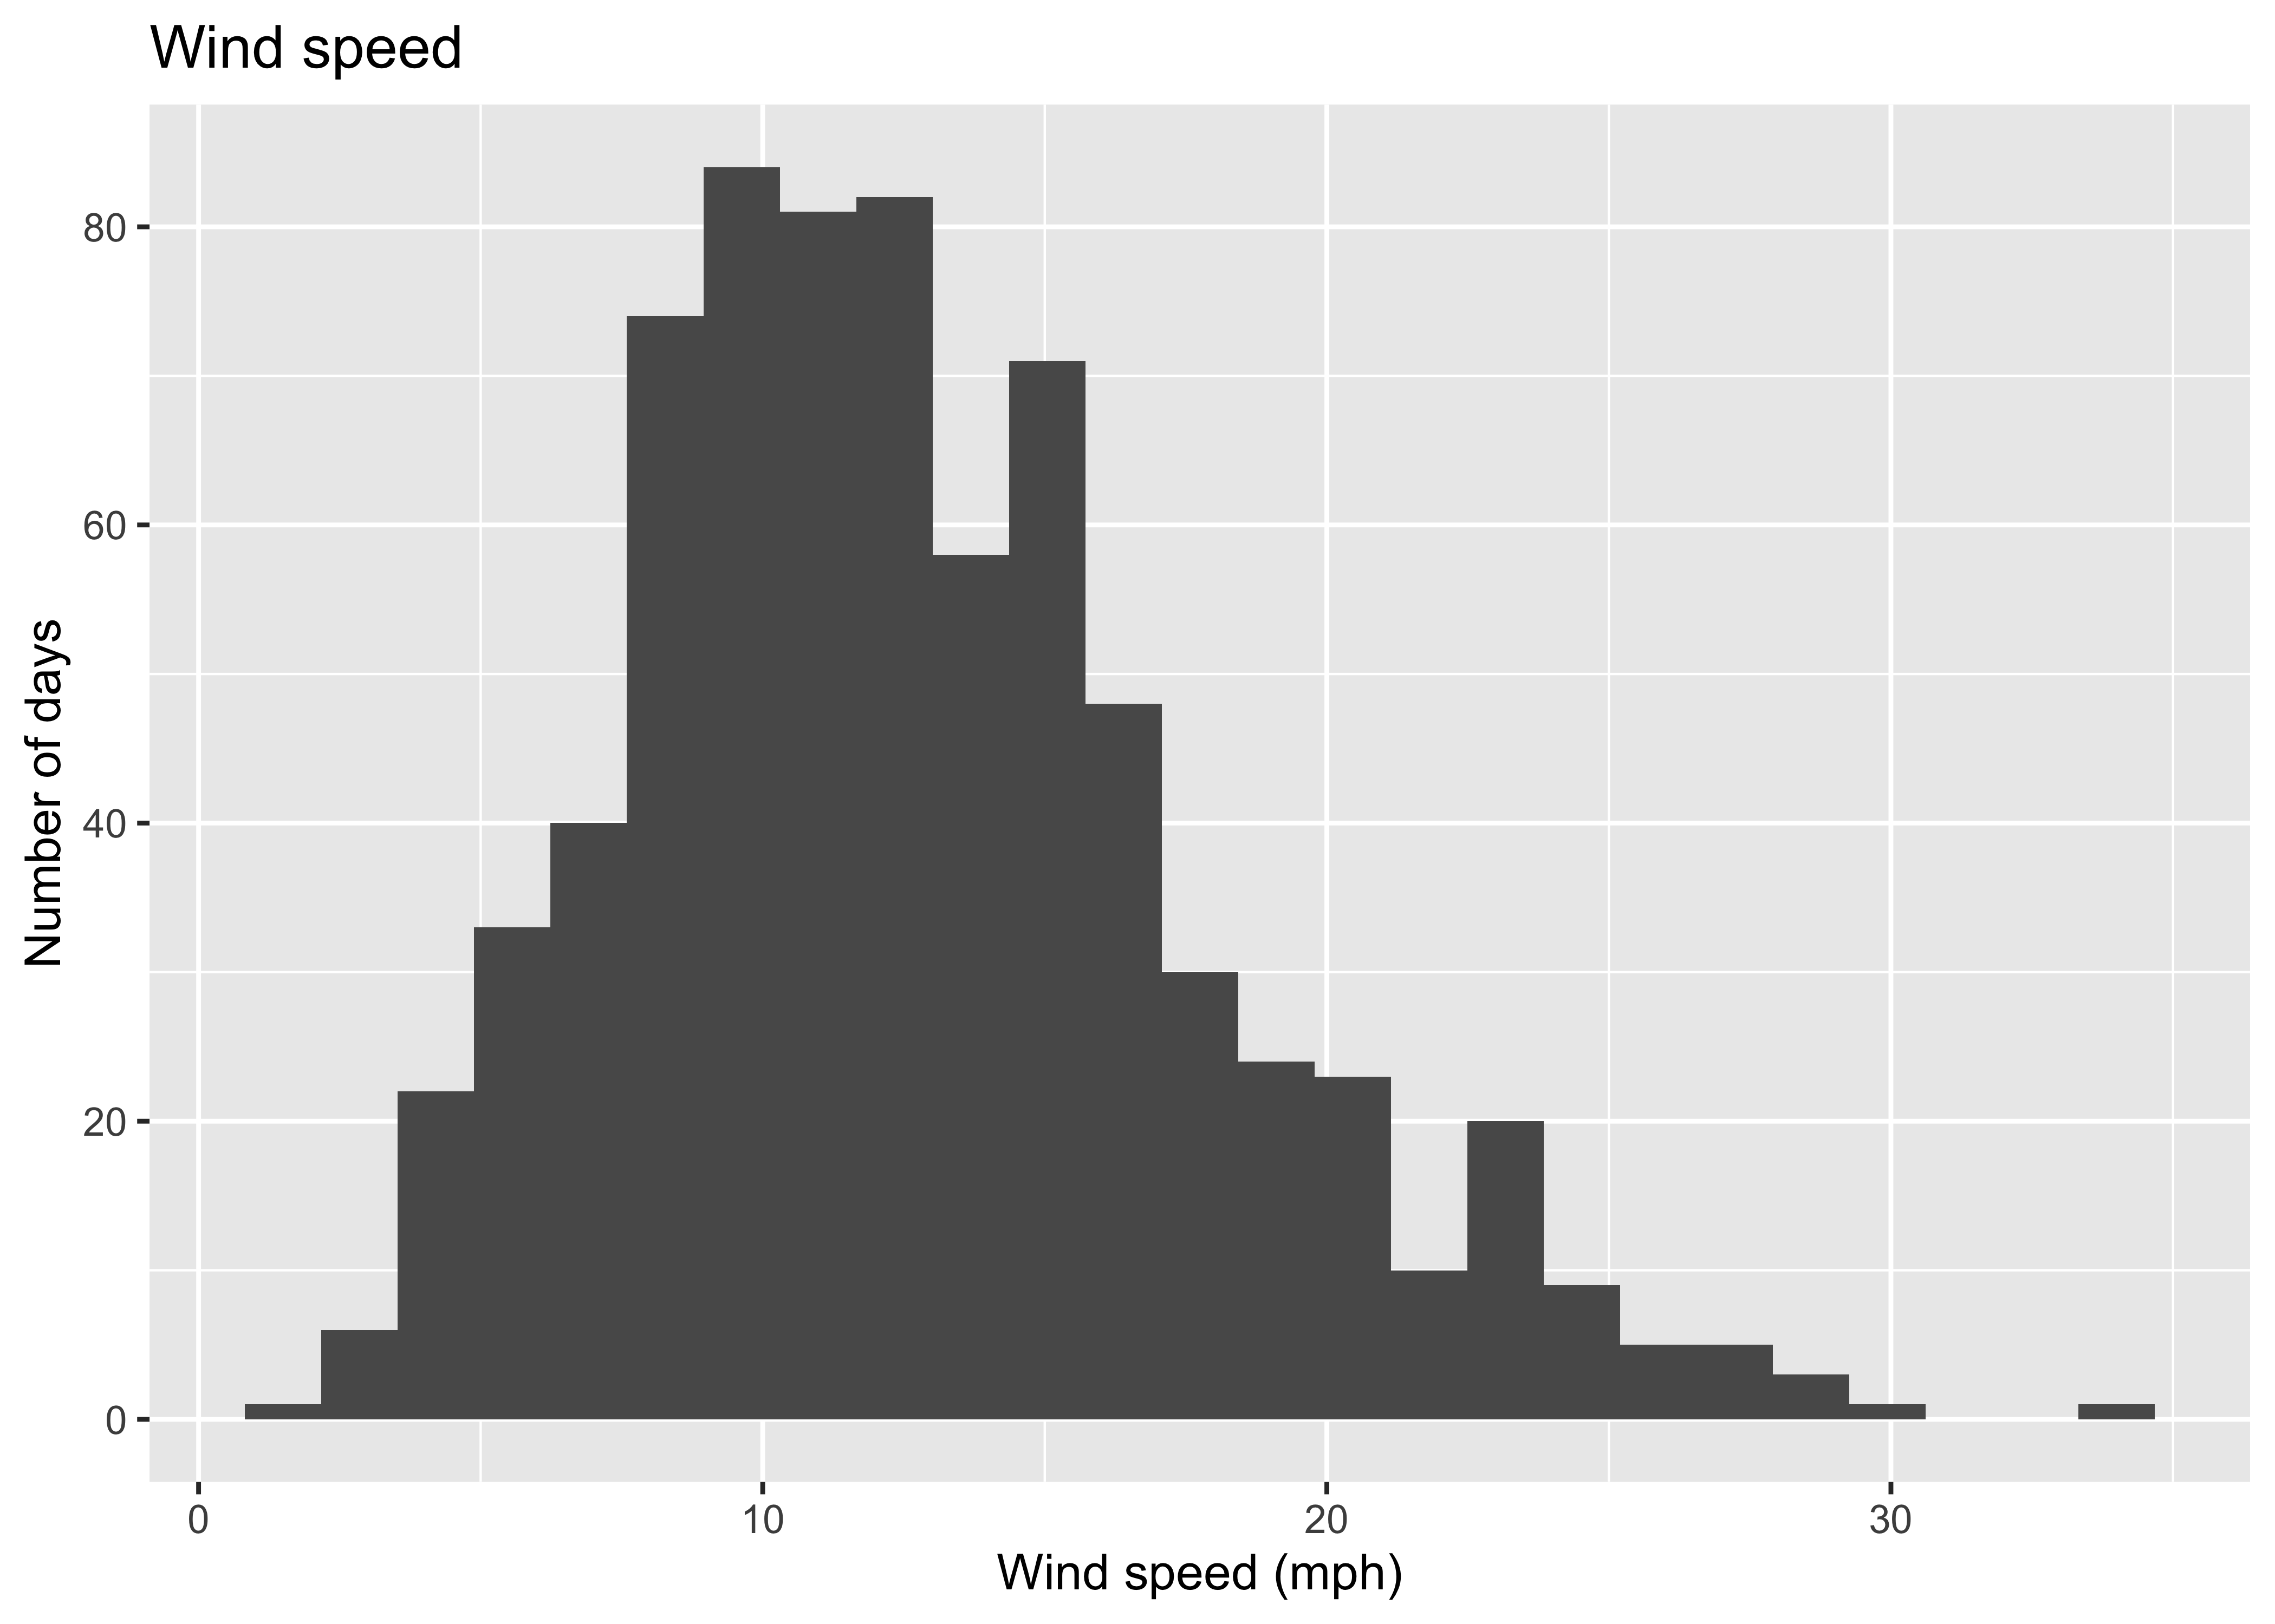
Figure A3. Distribution of daily wind speed in mph.

