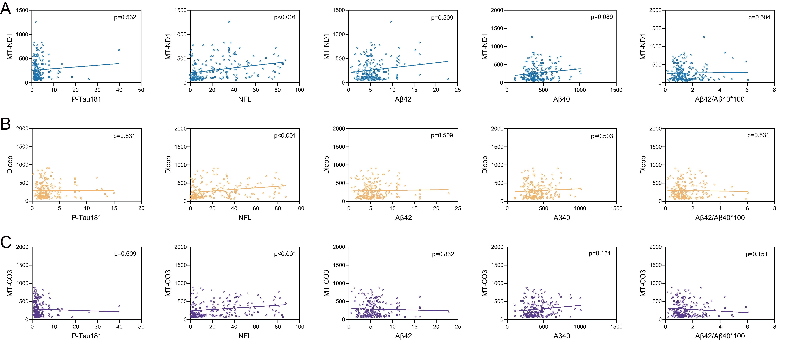
Figure 3. Spearman correlation analysis examining the relationship between the expression of plasma extracellular vesicle (EV)-derived mitochondrial DNA (A:ND1, B:D-LOOP, and C:COX3) and plasma biomarkers related to brain aging, including amyloid-beta 40 (Aβ40; pg/ml), ratio of Aβ42 to Aβ40, amyloid-beta 42 (Aβ42; pg/ml), neurofilament light chain (NfL; pg/ml), and phosphorylated Tau181 (p-Tau181; pg/ml). The p-values shown have undergone Benjamini-Hochberg multiple testing correction.

Table1. Distribution of extracellular vesicle-derived mitochondrial genes and plasma brain aging biomarker levels in three age groups.
Characteristics | Young  (20–40 years)  (n = 61) | Middle-aged  (41–65 years)  (n = 67) | Older adults (>65 years)  (n = 72) | actual P-value | F(df between groups, df within groups)
MT-ND1(Copies/mL) | 174.5 ± 148.9 | 268.7 ± 210.8 | 345.7 ± 218.1 | 0.000008 | F (2, 197) = 12.487044
MT-CO3 (Copies/mL) | 227.9 ± 215.4 | 267.5 ± 191.7 | 351.3 ± 200.5 | 0.001775 | F (2, 197) = 6.542025
D-loop (Copies/mL) | 206.4 ± 177.3 | 299.3 ± 215.1 | 360.2 ± 203.3 | 0.000086 | F (2, 197) = 9.817429
NfL (pg/ml) | 4.7 ± 3.6 | 13.9 ± 10.0 | 50.4 ± 18.3 | 5.6321E-55 | F (2, 197) = 251.598967
Aβ42 (pg/ml) | 5.1 ± 3.0 | 5.3 ± 1.7 | 7.1 ± 4.0 | 0.004 | F (2, 197) = 8.892010
pTau181 (pg/ml) | 2.8 ± 3.7 | 3.7 ± 5.5 | 3.1 ± 2.0 | 0.029 | F (2, 197) = 0.894974
Aβ40 (pg/ml) | 370.5 ± 134.4 | 394.8 ± 143.2 | 486.1 ± 173.4 | 0.000032 | F (2, 197) = 10.911238
(Aβ42/Aβ40)*100 | 1.5 ± 0.9 | 1.5 ± 0.7 | 1.6 ± 1.2 | 0.545 | F (2, 197) = 0.608799

Supplementary Table 1. Baseline traits of participants in three age groups.
Characteristics | Young  (20–40 years)  (n = 61) | Middle-aged  (41–65 years)  (n = 67) | Elderly  (> 65 years)  (n = 72) | actual P value | F(df between groups, df within groups)
Age (year) | 30.8 ± 6.2 | 54.3 ± 7.1 | 77.3 ± 6.6 | 1.9576E-95 | F (2, 197) = 802.949993
AST (U/L) | 26.9 ± 37.0 | 28.1 ± 17.9 | 23.3 ± 9.3 | 0.459 | F (2, 197) = 1.9576E-95
ALT (U/L) | 29.2 ± 34.3 | 30.9 ± 24.4 | 20.9 ± 14.1 | 0.008 | F (2, 197) = 3.143398
GGT (U/L) | 35.0 ± 43.9 | 30.1 ± 19.0 | 29.7 ± 19.2 | 0.516 | F (2, 197) = 0.664374
ALP (U/L) | 70.4 ± 20.7 | 73.0 ± 20.7 | 79.3 ± 26.5 | 0.07 | F (2, 197) = 2.699393
GLDH (U/L) | 7.8 ± 25.9 | 5.1 ± 4.4 | 5.4 ± 7.1 | 0.553 | F (2, 197) = 0.594004
CREA (µmol/L) | 71.1 ± 70.1 | 63.5 ± 14.9 | 67.3 ± 18.4 | 0.581 | F(2, 197) = 0.544807
eGFR(ml/min) | 120.8 ± 13.2 | 106.9 ± 15.0 | 84.6 ± 16.6 | 2.4523E-30 | F (2, 197) = 98.311149
Platelets (× 10⁹/L) | 256.3 ± 53.3 | 230.4 ± 55.8 | 237.7 ± 81.0 | 0.074 | F (2, 197) = 2.638683
HGB (g/L) | 133.3 ± 18.9 | 138.5 ± 15.1 | 123.7 ± 16.4 | 0.000002 | F (2, 197) = 13.936092
RBC (× 10¹²/L) | 4.6 ± 0.5 | 4.6 ± 0.5 | 4.1 ± 0.5 | 1.2145E-8 | F (2, 197) = 20.021610
WBC (× 10⁹/L) | 6.5 ± 2.3 | 6.0 ± 1.5 | 6.3 ± 1.8 | 0.41 | F (2, 197) = 0.896281
LYMPH% (%) | 33.4 ± 8.9 | 31.7 ± 7.6 | 28.3 ± 9.5 | 0.004 | F (2, 197) = 5.816410
LYMPH (× 10⁹/L) | 2.1 ± 0.6 | 1.9 ± 0.5 | 1.7 ± 0.6 | 0.000450 | F (2, 197) = 8.016866
NEUT% (%) | 57.9 ± 9.8 | 59.0 ± 8.2 | 61.7 ± 10.6 | 0.06 | F (2, 197) = 2.852730
NEUT (× 10⁹/L) | 3.9 ± 2.1 | 3.6 ± 1.3 | 4.0 ± 1.7 | 0.423 | F (2, 197) = 0.863609
N/L ratio | 2.0 ± 1.3 | 2.1 ± 1.1 | 2.8 ± 2.3 | 0.008 | F (2, 197) = 4.929706
P/L ratio | 131.0 ± 40.0 | 131.9 ± 48.7 | 160.1 ± 98.2 | 0.02 | F (2, 197) = 3.976326
HDL-C (mmol/L) | 1.4 ± 0.4 | 1.2 ± 0.3 | 1.3 ± 0.3 | 0.008 | F (2, 197) = 5.015242
LDL-C (mmol/L) | 2.7 ± 0.7 | 3.1 ± 0.8 | 2.8 ± 0.9 | 0.025 | F (2, 197) = 3.759085
CHOL (mmol/L) | 4.4 ± 1.0 | 4.7 ± 1.1 | 4.5 ± 1.2 | 0.174 | F (2, 197) = 1.766157
TG (mmol/L) | 1.2 ± 0.7 | 1.5 ± 0.7 | 1.3 ± 0.7 | 0.083320 | F (2, 197) = 2.516682
APOB (g/L) | 0.8 ± 0.3 | 1.0 ± 0.3 | 0.9 ± 0.3 | 0.084 | F (2, 197) = 2.505766
APOA1 (g/L) | 1.2 ± 0.3 | 1.1 ± 0.2 | 1.2 ± 0.2 | 0.098 | F (2, 197) = 2.354256
ALB (g/L) | 45.2 ± 6.4 | 42.7 ± 6.4 | 40.5 ± 7.3 | 0.000495 | F (2, 197) = 7.912325
URIC (µmol/L) | 330.5 ± 97.4 | 327.7 ± 90.0 | 314.9 ± 89.7 | 0.576 | F (2, 197) = 0.553408
UREA (mmol/L) | 4.8 ± 1.3 | 5.9 ± 1.5 | 5.9 ± 1.8 | 0.000063 | F (2, 197) = 10.168783
HCY (µmol/L) | 13.9 ± 8.0 | 14.1 ± 7.0 | 16.3 ± 7.8 | 0.122419 | F (2, 197) = 2.122854
GLU (mmol/L) | 5.1 ± 1.0 | 5.7 ± 1.6 | 5.8 ± 1.6 | 0.014 | F (2, 197) = 4.345704
SBP (mm Hg) | 123.1 ± 15.8 | 130.7 ± 17.0 | 141.0 ± 21.1 | 3.0986E-7 | F (2, 197) = 16.187399
DBP (mm Hg) | 82.6 ± 10.6 | 84.7 ± 12.4 | 80.8 ± 11.0 | 0.133 | F (2, 197) = 2.040053
Male: n (%) | 27 (44.3%) | 42 (62.7%) | 35 (48.6%) | 0.088 | /
Current smoker n (%) | 13 (21.3%) | 23 (34.3%) | 19 (26.4%) | 0.249 | /
Current alcohol drinker: n (%) | 19 (31.1%) | 23 (34.3%) | 18 (25.0%) | 0.474 | /
Diabetes mellitus: n (%) | 2 (3.3%) | 18 (26.9%) | 18 (25.0%) | < 0.001 | /
Hypertension: n (%) | 8 (13.1%) | 25 (37.3%) | 47 (65.3%) | < 0.001 | /
Coronary heart disease: n (%) | 13 (21.3%) | 35 (52.2%) | 39 (54.2%) | < 0.001 | /

Supplementary Table 2. Multivariable regression analysis examining the relationship between the levels of extracellular vesicle-derived mitochondrial genes and plasma biomarkers of brain aging.
Biomarker | Model | MT-ND1 |  | MT-CO3 |  | D-loop
 |  | β (95%CI) | P-value | β (95%CI) | P-value | β (95%CI) | P-value
Aβ42 (pg/ml) | Non-adjusted | 0.002390 (0.000277, 0.004503) | 0.329508 | -0.000604(-0.002743,0.001535) | 0.761358 | 0.000370(-0.001763,0.002503) | 0.896757
Aβ42 (pg/ml) | Model I | 0.000906 (-0.001260, 0.003071) | 0.742594 | -0.001970(-0.004068, 0.000128) | 0.439238 | -0.001265(-0.003407,0.000877) | 0.742594
Aβ42 (pg/ml) | Model II | 0.000793 (-0.001362, 0.002949) | 0.742594 | -0.002073(-0.001362, 0.002949) | 0.742594 | -0.001276(-0.003404,0.000852) | 0.742594
Aβ42 (pg/ml) | Model III | 0.000301(-0.001946,0.002547) | 0.896757 | -0.002008(-0.004185,0.000168) | 0.439238 | -0.001260(-0.003483,0.000963) | 0.742594
pTau181 (pg/ml) | Non-adjusted | 0.002503 (-0.001376, 0.003965) | 0.742594 | -0.000720 (-0.003397, 0.001957) | 0.761358 | -0.000830 (-0.003497, 0.001837) | 0.761358
pTau181 (pg/ml) | Model I | 0.001083 (-0.001761, 0.003927) | 0.742594 | -0.001052 (-0.003827, 0.001723) | 0.742594 | -0.001280 (-0.004097, 0.001536) | 0.742594
pTau181 (pg/ml) | Model II | 0.001155 (-0.001695, 0.004005) | 0.742594 | -0.000996 (-0.003777, 0.001785) | 0.742594 | -0.001273(-0.004092,0.001545) | 0.742594
pTau181 (pg/ml) | Model III | 0.001249(-0.001696,0.004195) | 0.742594 | -0.001346(-0.004224,0.001532) | 0.742594 | -0.001396(-0.004318,0.001526) | 0.742594
Aβ40 (pg/ml) | Non-adjusted | 0.119757 (0.013443, 0.226071) | 0.329508 | 0.105841 (-0.000828, 0.212511) | 0.439238 | 0.050350 (-0.056735, 0.157435) | 0.742594
Aβ40 (pg/ml) | Model I | 0.040502(-0.067882, 0.148887) | 0.742594 | 0.043859(-0.061853,0.149571) | 0.742594 | -0.032458 (-0.139902, 0.074985) | 0.761358
Aβ40 (pg/ml) | Model II | 0.030317(-0.075431, 0.136066) | 0.761358 | 0.035114(-0.067990,0.138218) | 0.753897 | -0.033465 (-0.138063, 0.071133) | 0.761358
Aβ40 (pg/ml) | Model III | 0.010804(-0.096743,0.118352) | 0.911821 | 0.054152(-0.050689,0.158993) | 0.742594 | -0.029022(-0.135707,0.077663) | 0.761358
NfL (pg/ml) | Non-adjusted | 0.033650 (0.018464, 0.048836) | 0.0012 | 0.025201 (0.009687, 0.040715) | 0.03168 | 0.027631 (0.012256, 0.043006) | 0.01476
NfL (pg/ml) | Model I | 0.000216 (-0.008096, 0.008528) | 0.959172 | -0.000773(-0.008882, 0.007336) | 0.911821 | -0.004525(-0.012736,0.003686) | 0.742594
NfL (pg/ml) | Model II | -0.000227 (-0.008498, 0.008044) | 0.959172 | -0.001156 (-0.009221, 0.006909) | 0.911821 | -0.004569(-0.012726,0.003589) | 0.742594
NfL (pg/ml) | Model III | -0.002955(-0.010439,0.004530) | 0.742594 | 0.000824 (-0.006504,0.008152) | 0.911821 | -0.002649(-0.010081,0.004783) | 0.742594
Aβ42/Aβ40*100 | Non-adjusted | 9.7315E-7 (-0.000006, 0.000007) | 0.896757 | -0.000005(-0.000011,0.000002) | 0.742594 | -0.000001(-0.000007,0.000005) | 0.896757
Aβ42/Aβ40*100 | Model I | -3.6306E-7(-0.000007, 0.000007) | 0.950849 | -0.000006(-0.000013,6.4282E-7) | 0.439238 | -0.000002(-0.000009,0.000004) | 0.742594
Aβ42/Aβ40*100 | Model II | -3.5664E-7(-0.000007, 0.000007) | 0.950849 | -0.000006(-0.000013,6.5998E-7) | 0.439238 | -0.000002(-0.000009,0.000004) | 0.742594
Aβ42/Aβ40*100 | Model III | -0.000001(-0.000009,0.000006) | 0.896757 | -0.000006(-0.000013,7.7882E-7) | 0.439238 | -0.000003(-0.000010,0.000005) | 0.742594
Note: AGE is adjusted in Model I. The list of variables adjusted in Model II includes Model I and eGFR, Model III includes Model II and ALT, eGFR, HGB, RBC, LYMPH, LYMPH%, N/L ratio, P/L ratio, HDL-C , LDL-C , TG , ALB, UREA, HCY, GLU, SBP, DBP, diabetes mellitus, coronary heart disease. The p-values shown have undergone Benjamini–Hochberg multiple testing correction.

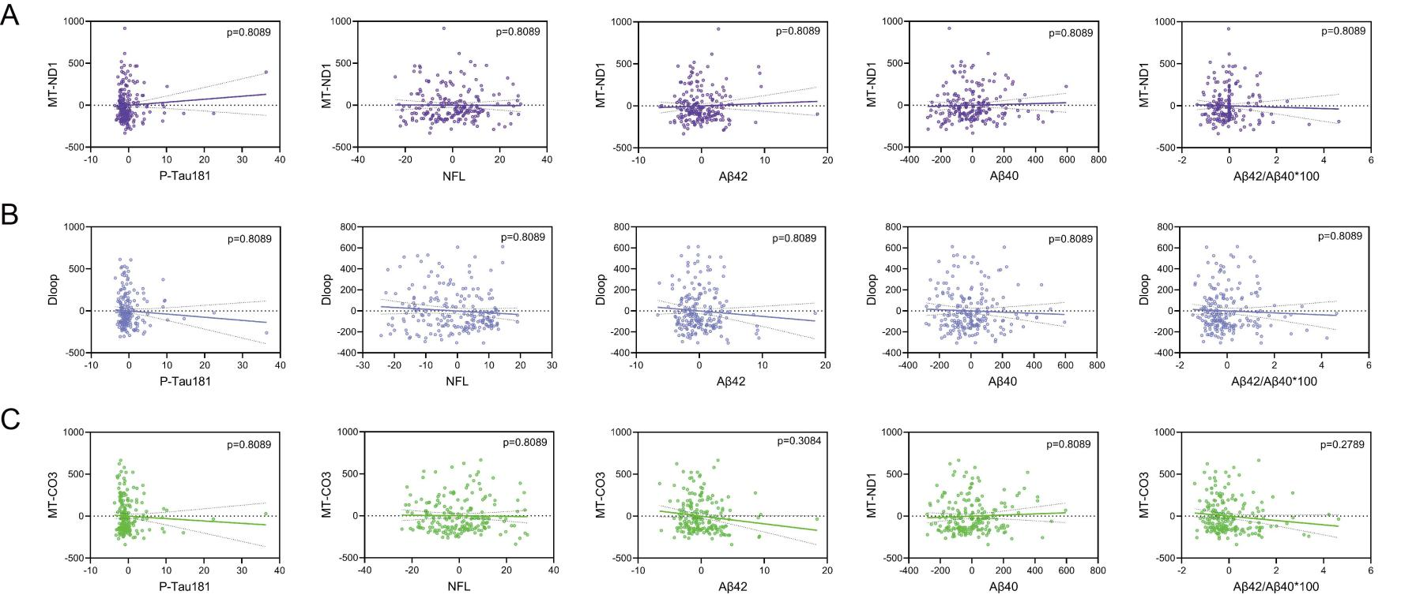
Supplementary Figure 9. Residual partial correlation plots (Spearman) illustrating the relationships of three EV-mtDNA targets (A: MT-ND1, B: Dloop, C: MT-CO3) with five brain-aging biomarkers, after removing the effects of age, eGFR, and sex. Each panel displays the partial correlation coefficients (and data spread) for one mtDNA gene against all biomarkers: amyloid-beta 40 (Aβ40), Aβ42/Aβ40 ratio, amyloid-beta 42 (Aβ42), neurofilament light chain (NfL), and phosphorylated Tau181 (p-Tau181). The p-values shown have undergone Benjamini–Hochberg multiple testing correction.

