**House Price Team**

**Code of Conduct:**

· Arrive on time to meetings punctually.

· Complete individually assigned tasks efficiently and effectively.

· Work in such a manner that one’s actions are not disrespectful of others in the group.

· Complete work honestly and diligently.

· Each member should contribute equally and positively to the group.

· Respond to emails or phone calls as promptly as possible.

· Attend each meeting unless there is a legitimate excuse to not come, for which at least the group leader must be informed as soon as possible.

· Each member should take care of his/her share of the work and complete it to the best of his/her ability.

· Each member should try to do the best they can instead of trying to fulfill minimum requirements.

If the members respect each other then the team would feel a sense of accomplishment, unity, and share of responsibility. Overall, if each member of the team accepts these rules then everything will run efficiently and we all will do well on the assignments. For example, if group members listen to other group member's ideas, then the group would have more ideas to work with to come up with the best solutions.

Tasks are assigned to members, and they must be completed by a certain time. Meetings are comfortable in that no one feels their ideas or opinions are being disrespected or ignored. We work to get the assignment done while upholding the University Honor Code. We want to reduce stress, miscommunication, and create a productive team environment.

Learning how to work in groups is a very important skill because it will certainly be required in nearly any business related field. Thus, we hope that if we abide by the guidelines we have established then we can have a successful term and combine our talents and ideas to produce high-quality solutions.

**Members of *[House Price Team]***

I hereby have read the team contract and agree to abide by its terms. If I fail to do so then I understand the group has the right to inform the instructor of my behavior which may result in my permanent removal from the team.

[signature of each group member] 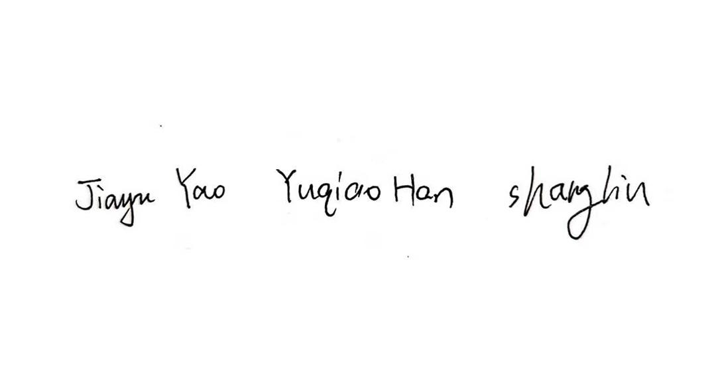

Agreement Reference: people.terry.uga.edu/rwatson/general/sample%20team%20agreement.docx