Personal Portfolio Website Plan

# Your Name: Clarissa Elise Meirthew

# Ideas for your website

Determine how you will use your personal portfolio website to showcase your skills.

Idea 1: I will use this website as a multimedia tool to showcase my career in the entertainment industry.

Idea 2: Possibly a background headshot photo of myself (if it’s not too cluttery)

Idea 3: I want to be able to navigate throughout the entire page from whatever page within the site a viewer is on. A detailed nav will be at the top of every page

Idea 4:

Idea 5:

# Website Plan

|  |  |  |
| --- | --- | --- |
| Topic | Questions | Answers |
| Purpose of Website | What is the purpose and goal of the website? | To bring awareness to my talents all in one place |
| Target Audience | Describe the target audience (age, gender, demographics) | 18-65, all genders |
| Graphics | What graphics will you use on the website? | Photos, hyperlinks |
| Color | What colors will you use within the site to enhance the purpose and brand? | White and variations of gray. The photos are the focus so the background can be very basic |
| Accessibility | How will the website accommodate people with disabilities? | There will be audio reading |
| Project Timeline | Identify the project timeline | Reasonably 6 months after learning. Rushed, 3 months after learning. I still have to learn so much more because I’m not familiar with any webpage design. Then applying it will also take time because I’m a perfectionist and it has to be right. |

# Wireframe

Sketch the wireframe for your home page below.

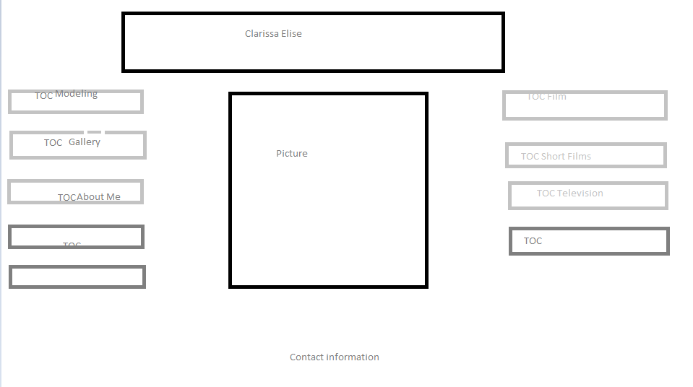

# Site map

Create a site map for the website below.

