SELECT \* FROM Shoes WHERE name='Nike-1'

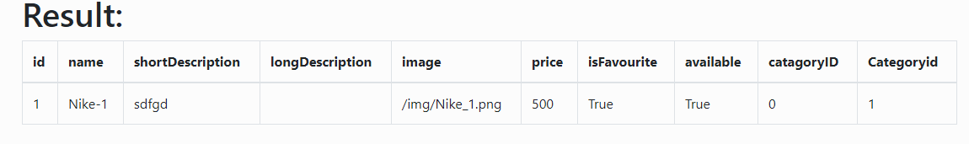

SELECT \* FROM Shoes WHERE name='Nike'



SELECT \* FROM Shoes

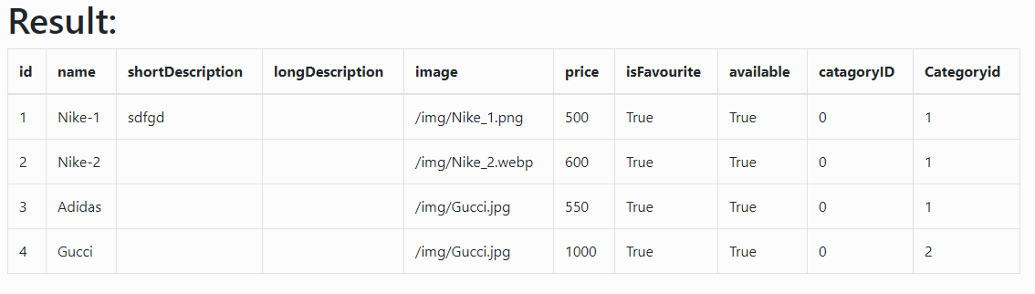

SELECT name, id FROM Shoes WHERE name!=’’

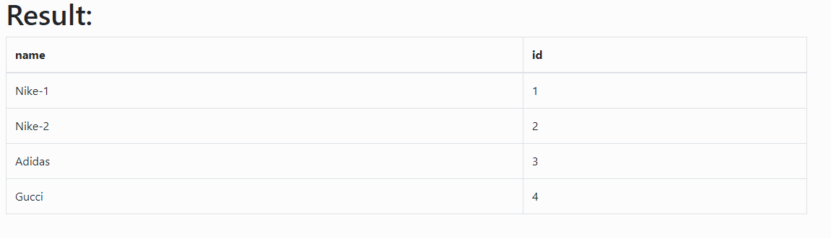

SELECT name, id FROM Shoes WHERE name!=""

