חלופה מערכות הגנת סייבר במקצוע "תכנון ותכנות מערכות" - הערכה לעבודת גמר 5) יחידות לימוד( – תשפ"ה

346327026 | מספר ת.ז. | Yury Moiseev | שם התלמיד
TuneTrace |  |  | נושא העבודה

Revision History

Ed. Id | Date | File Reference | Reason for Change
1 | 06/01/2025 | - | Started working on the document
2 | 20/01/2025 | - | Fixed minor issues, added new sections
3 | 25/01/2025 |  | Added new sections to the document, fixed minor discrepancies
4 | 04/02/2025 |  | Completed the document up to the “test” section

Introduction
- The document is intended to provide all the necessary information about top level design of the project
- The name of the project is “TuneTrace”
- The slogan of the project is: “Trace the tune that echoes in your mind”

System Overview
- The project’s main purpose is to help find songs with a specific melody. The melody is entered via singing/humming/playing it on a musical instrument to the device’s microphone. Then, the melody is analyzed by a few layers of ai and compared to the songs that are currently present in the database. Then the list of songs with the same or very similar melodies are displayed in a list, allowing to find the one the client was looking for, as well as compare songs with similar melodies. As for additional features, the project also provides non-administrator users with a request system, which is created for further modifications of the melody database. Administrator users have direct access to modifying the database, by approving or denying requests to add certain songs, or by adding songs themselves.

Related software or hardware
Operating systems

End-user characteristics
….

General Constraints
- For proper execution of all the features python version 3.6+ is required
- Some features include audio recording and therefore require access to microphone
Potential Platform Conflicts:
  - PyAudio: Likely the most problematic module, requiring platform-specific libraries (e.g., portaudio on Linux) or manual builds on macOS/Windows.
  - Cryptography and argon2: Require development tools/libraries (e.g., OpenSSL, build-essential) on some platforms.
  - os: Minor differences in functionality depending on the operating system.

System Architecture - Functionality

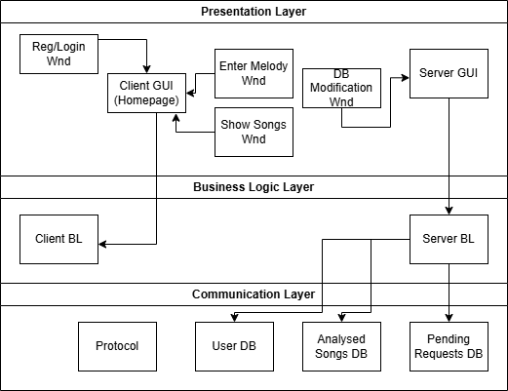

Subsystem Architecture
- Login/Register Use Case:
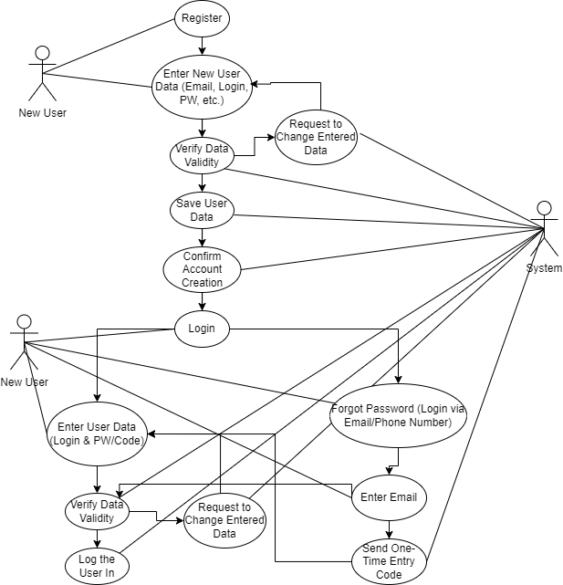

- Main Workflow Use Case
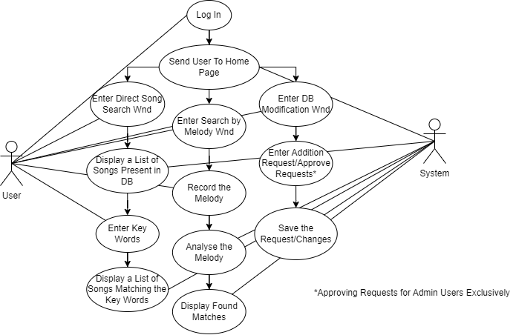

Sequence diagrams
- Login/Register Sequence Diagram
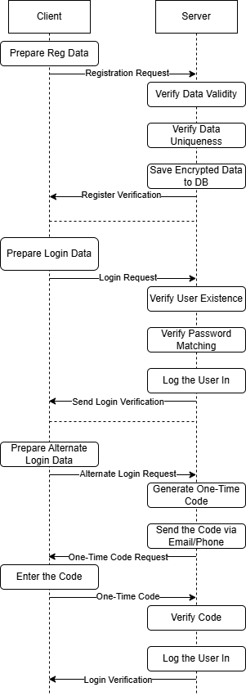
- Main Workflow Sequence Diagram
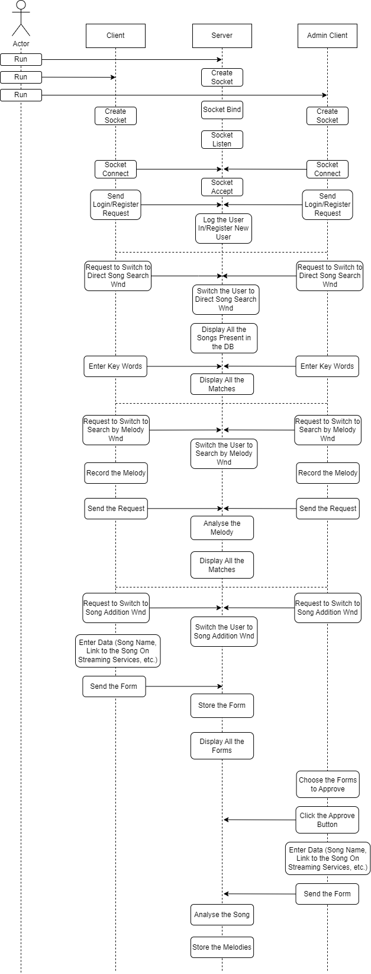
…

DB tables
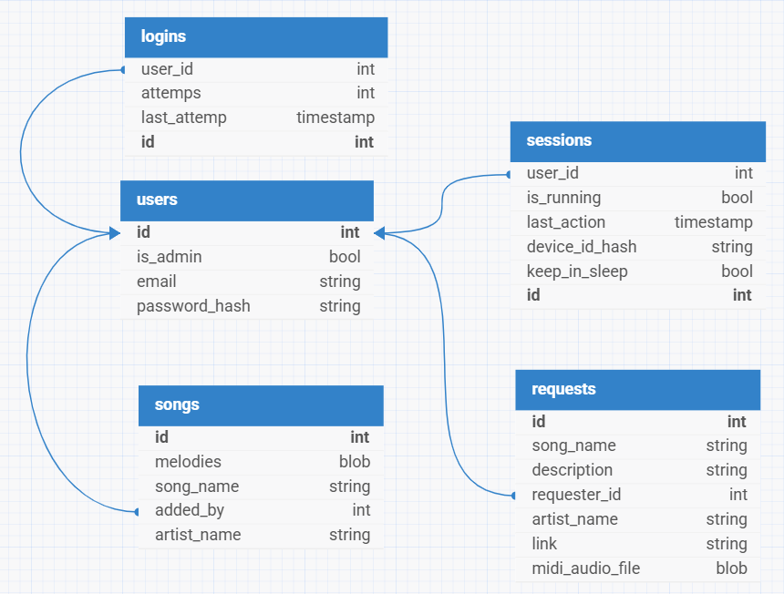
- Users – self-explanatory
- Logins – keeps track of the amount of times password for the certain account was entered incorrectly. After a certain number of attempts, the account locks away from accessing for a peroid of time to prevent possible password brute-forcing
- Sessions – the table to make the manipulation with client’s data easier and less messy, as well as to provide additional security and convinience features, such as logging into the account from a remembered device without having to enter the login and password
- Request – the table where the requests are kept, which may eventually become searchable songs
- Songs – self-explanatory for the most part; the “melodies” row stores melodies as midi files to provide maximum storage efficiency since midi files take up as little memory as possible

Protocol
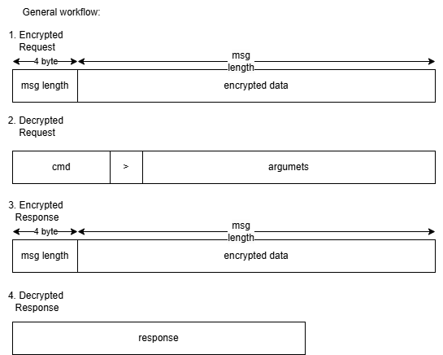

Encryption
- Password hashing – to protect users’ personal data password hasher “Argon2” is used
- All the communication between server and client is protected via RSA encryption
- Device id hashing – the hashes of MAC adresses of the devices that have a session running for them are done using hmac and hashlib (with high entropy of the id there is little to no need in using purposefully slow hashing algorithms like Argon)

Classes
GUI class that implements a custom widget for files drag-and-drop functionality as well as local directory browsing:
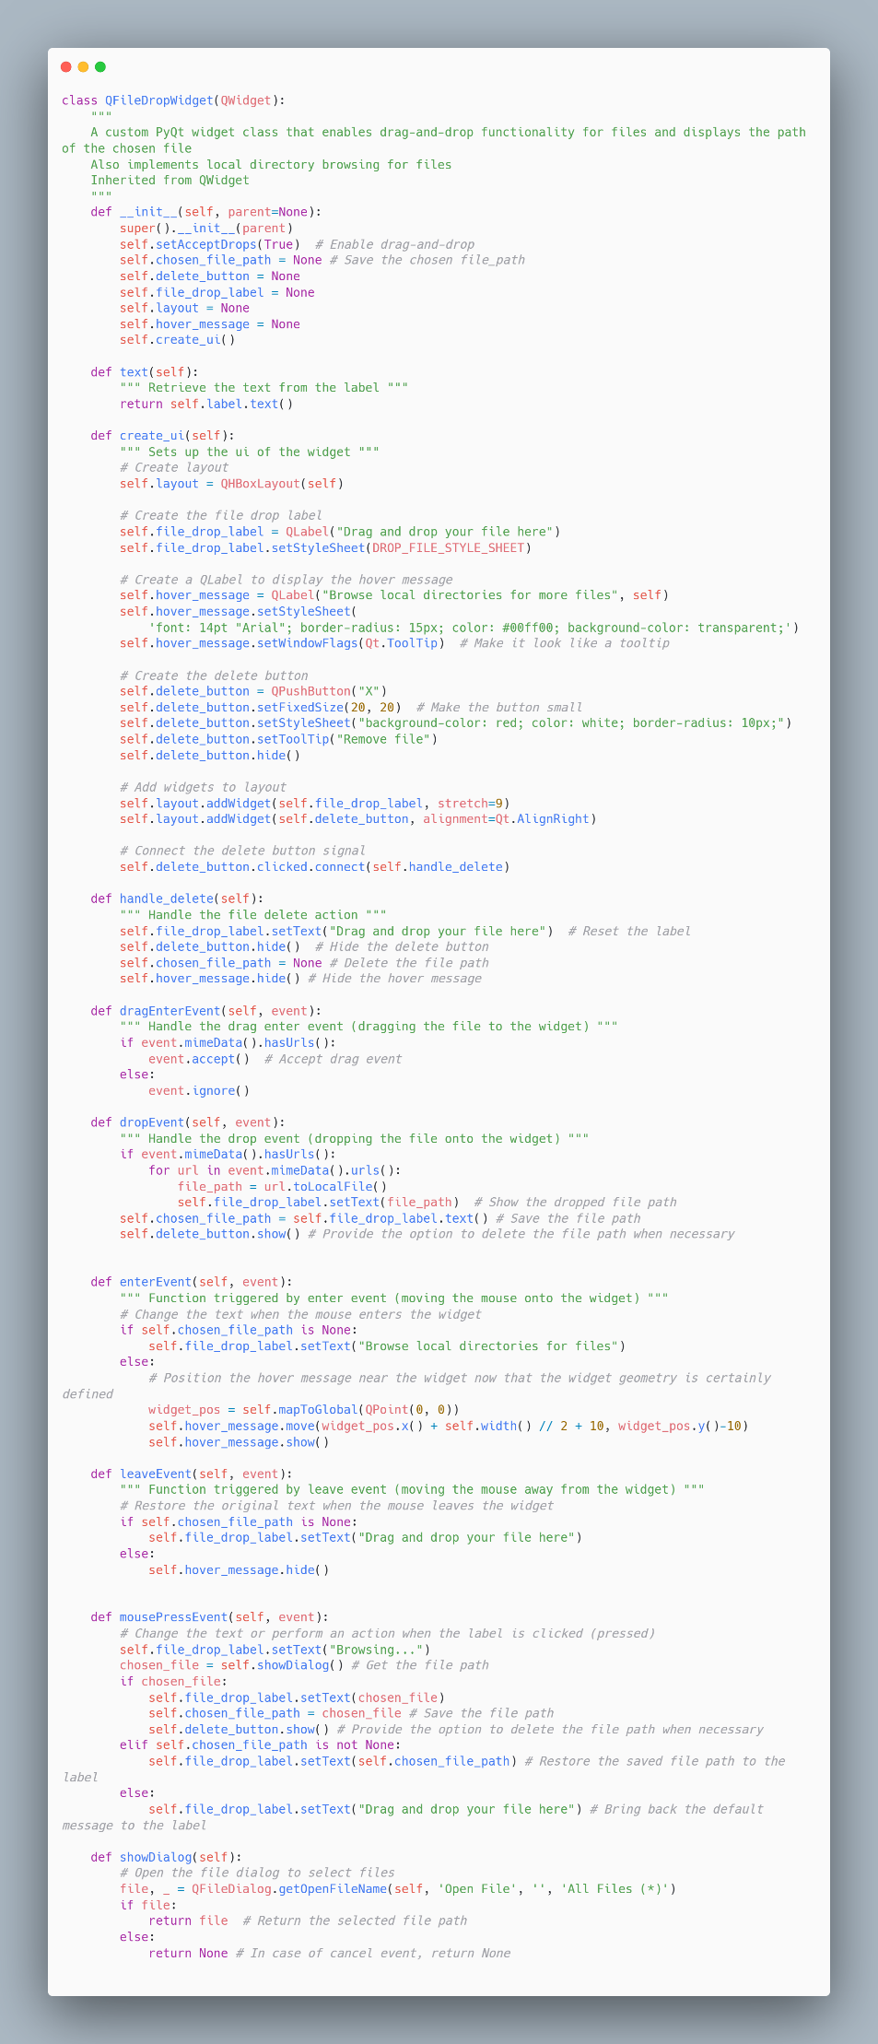
Use case of the widget in the window class:
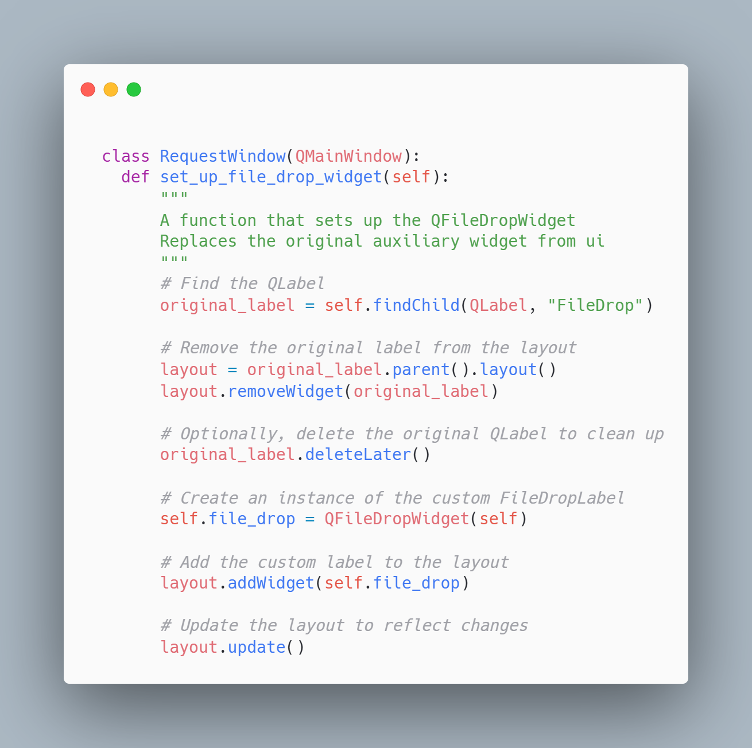

System Architecture - Presentation Layer
…

Forms workflow

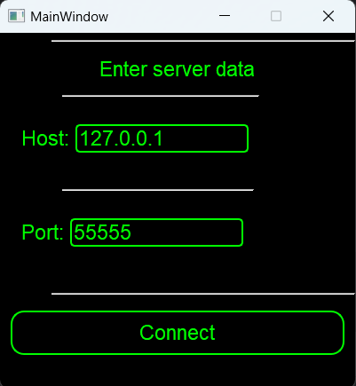
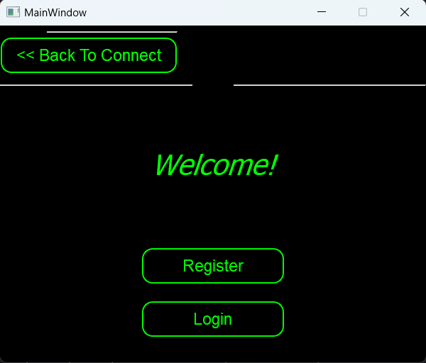
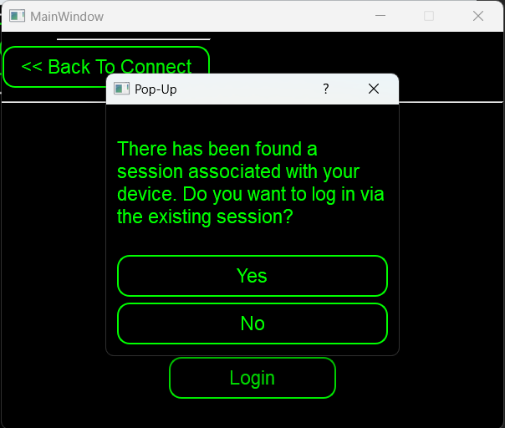
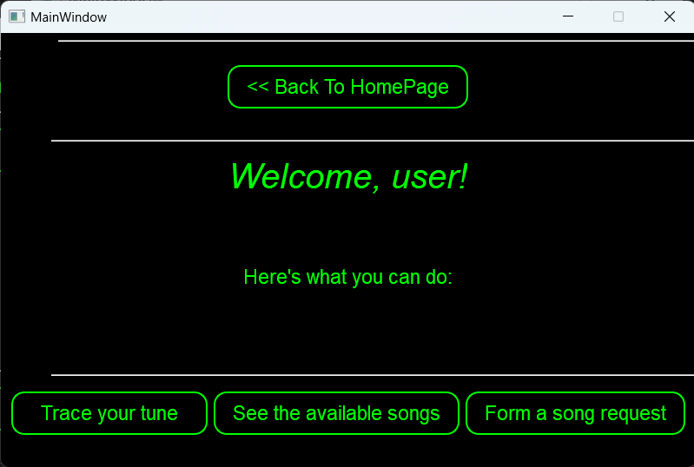
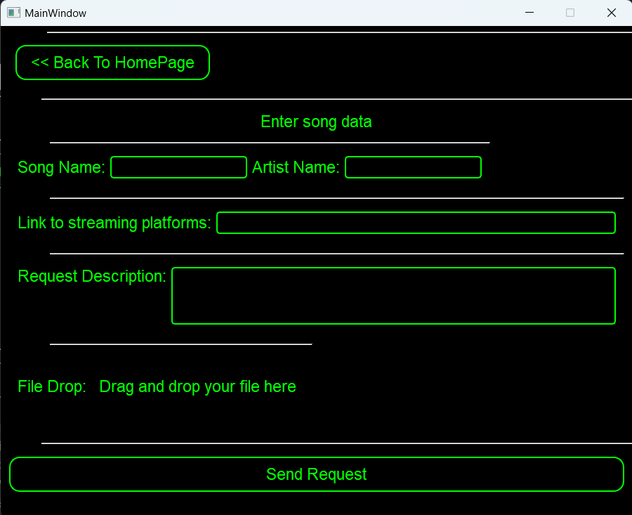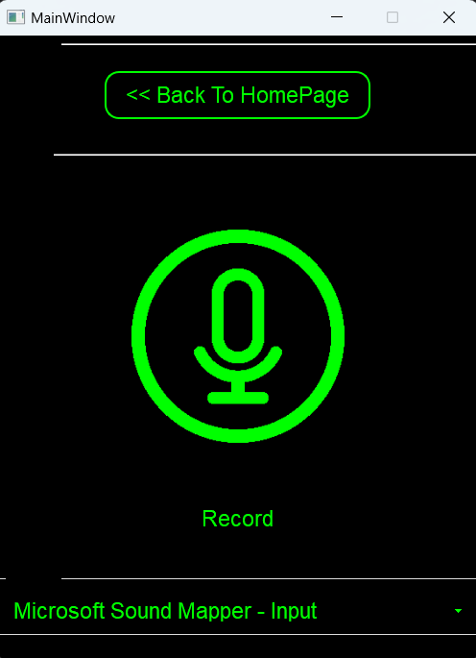

Source Code
ServerBL side:
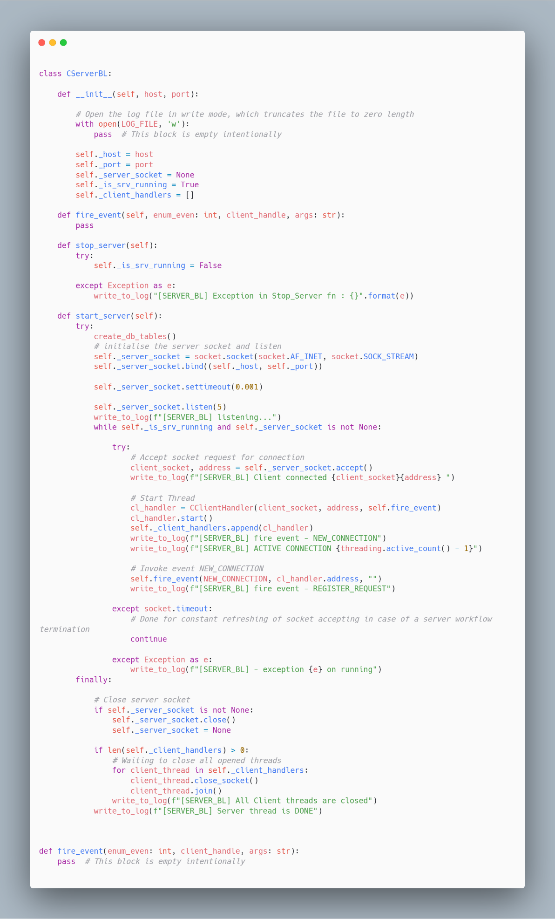
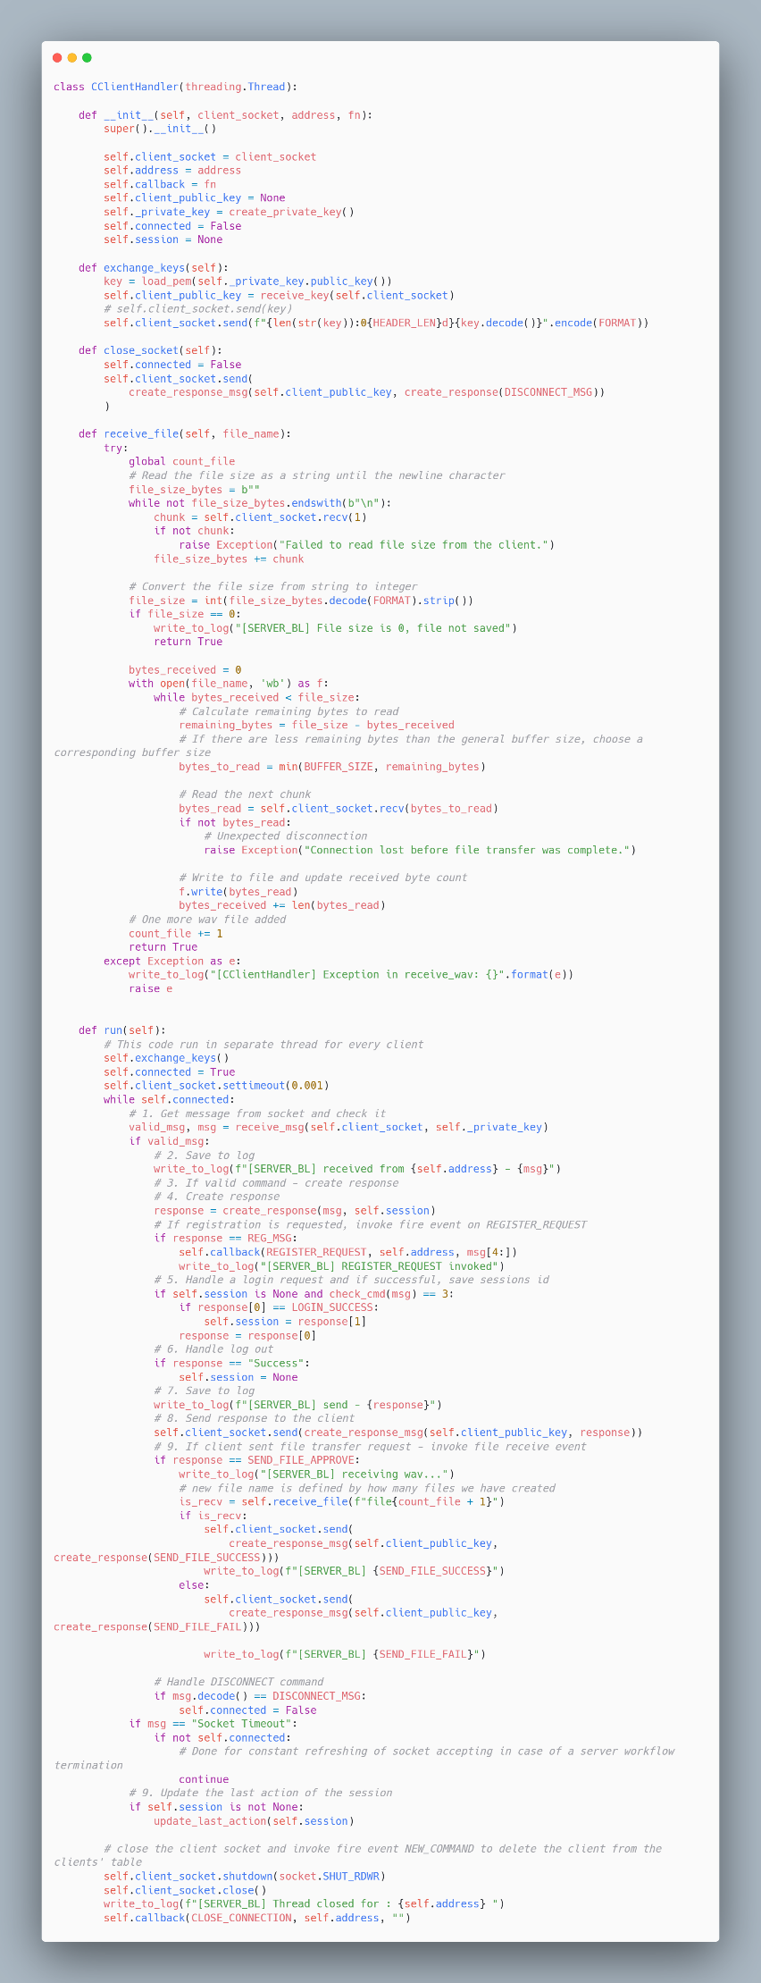
Client’s side:
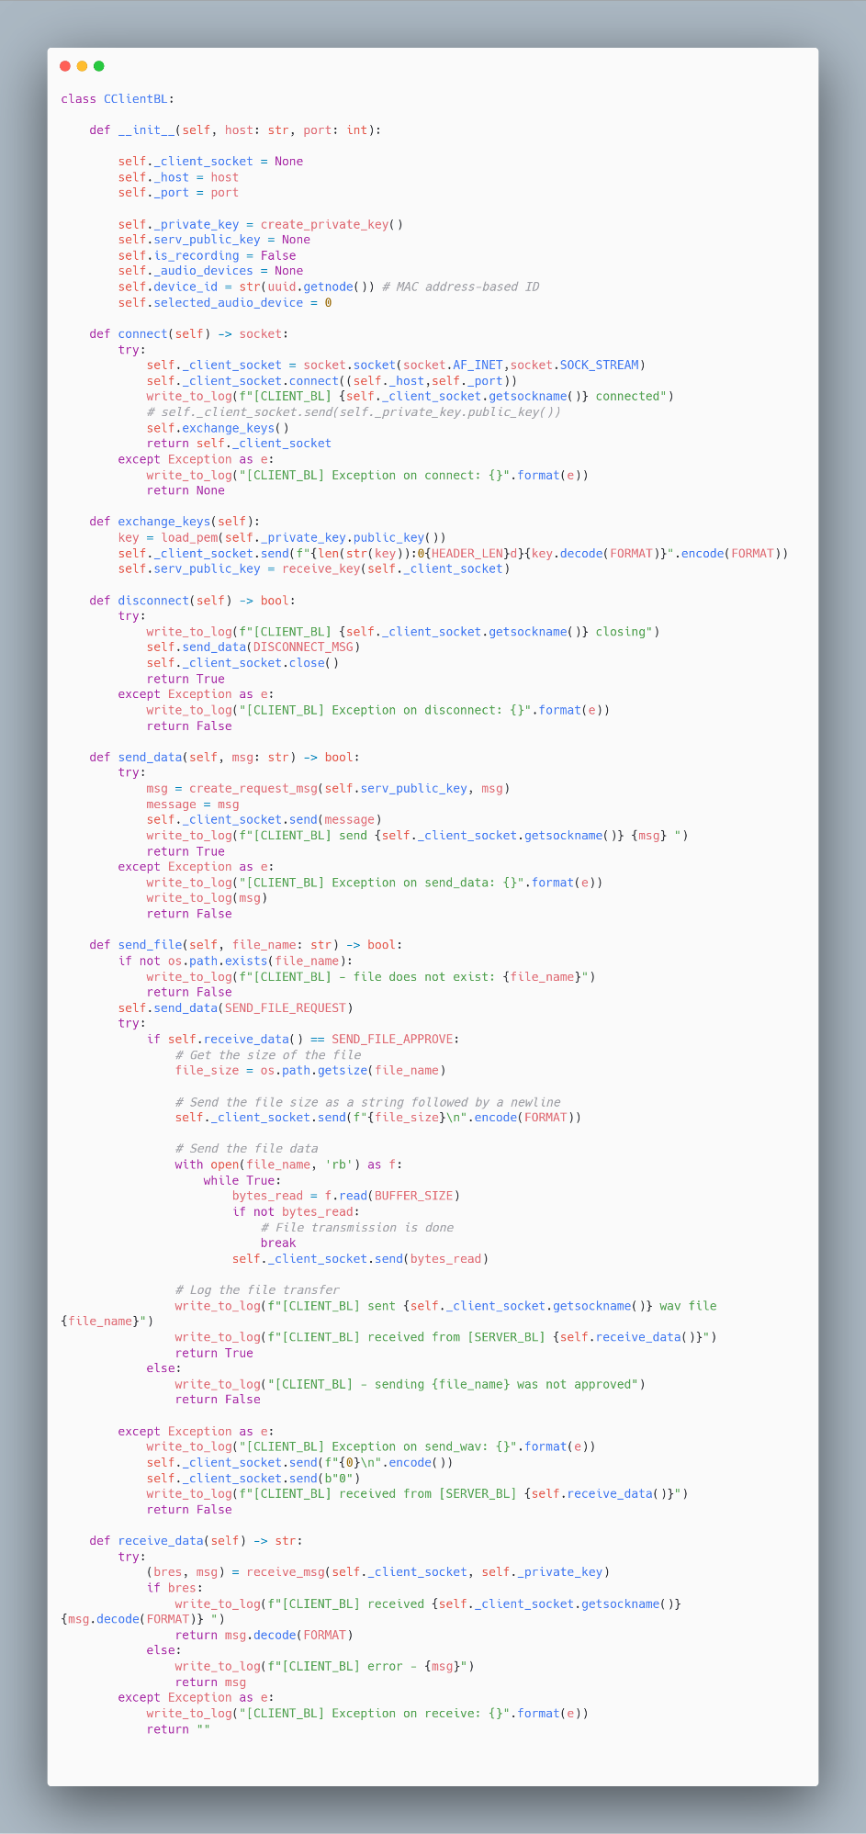

1.8 SW Test plan
…

Test scenarios
…

Test Results
…

Bibliography

AI Usage
- In the workflow, to extract the pitch of the melody, the library crepe is used. The library is based on an ai model, trained specifically for pitch detection
- Language models, such as ChatGPT and DeepSeek were used in order to provide general information on different existing solutions for specified tasks. For example, to compare note sequences, aka melodies, FastDTW algorithm was advised to be implemented in the workflow.
- The language models mentioned were used for a brief introduction into the new topic, such as GUI creation using PyQt and Qt Designer, by creating basic functions or breaking down the already existing examples found online

