חלופה מערכות הגנת סייבר במקצוע "תכנון ותכנות מערכות" - הערכה לעבודת גמר 5) יחידות לימוד( – תשפ"ה

346327026 | מספר ת.ז. | Yury Moiseev | שם התלמיד
TuneTrace |  |  | נושא העבודה

Revision History

Ed. Id | Date | File Reference | Reason for Change
1 | 06/01/2025 | - | Started working on the document
2 | 20/01/2025 | - | Fixed minor issues, added new sections
3 | 25/01/2025 |  | Added new sections to the document, fixed minor discrepancies
4 | 04/02/2025 |  | Completed the document up to the “test” section

Introduction
- The document is intended to provide all the necessary information about top level design of the project
- The name of the project is “TuneTrace”
- The slogan of the project is: “Trace the tune that echoes in your mind”

System Overview
The project’s main purpose is to help find songs with a specific melody. The melody is entered via singing/humming/playing it on a musical instrument to the device’s microphone. Then, the melody is analyzed by a few layers of ai and compared to the songs that are currently present in the database. Then the list of songs with the most similar melodies are displayed in a list, allowing to find the one the client was looking for, as well as compare songs with similar melodies. As for additional features, the project also provides non-administrator users with a request system, which is created for further modifications of the melody database. Administrator users have direct access to modifying the database, by approving or denying requests to add certain songs, or by adding songs themselves.

Related software or hardware
The client’s side is lightweight and does not have high hardware requirements. The app is cross-platform and should run on any OS.

End-user characteristics
The UI is user friendly and doesn’t require any qualifications. However, the closer the melody is to the original, the more efficient the execution is, thus higher singing/playing precision is advised.

General Constraints
- For proper execution of all the features python version 3.6+ is required
- Some features include audio recording and therefore require access to microphone

System Architecture - Functionality

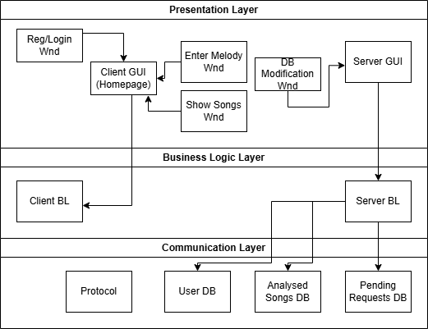

Subsystem Architecture
- Login/Register Use Case:
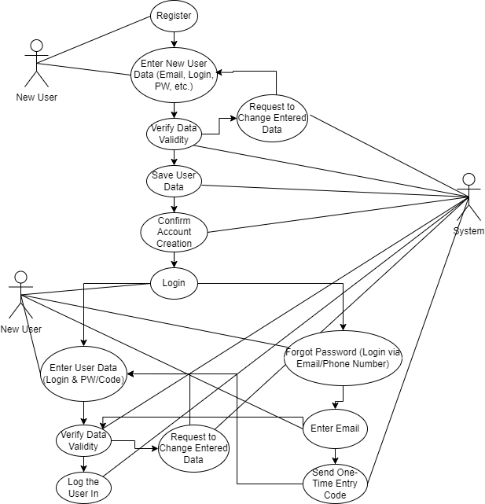

- Main Workflow Use Case
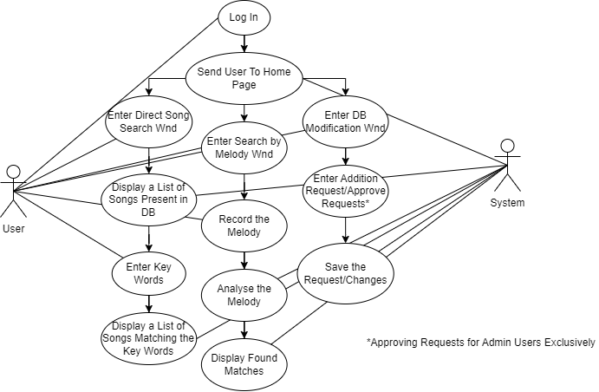

Sequence diagrams
- Login/Register Sequence Diagram
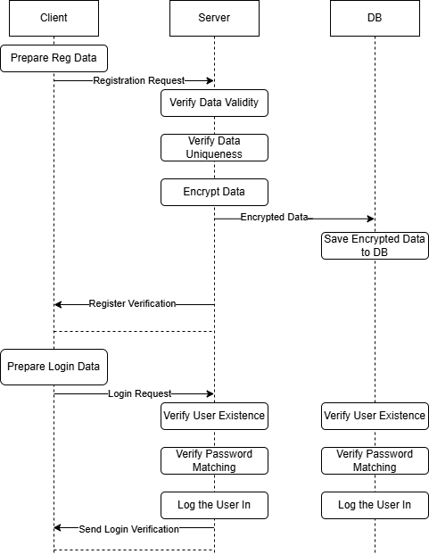
- Main Workflow Sequence Diagram
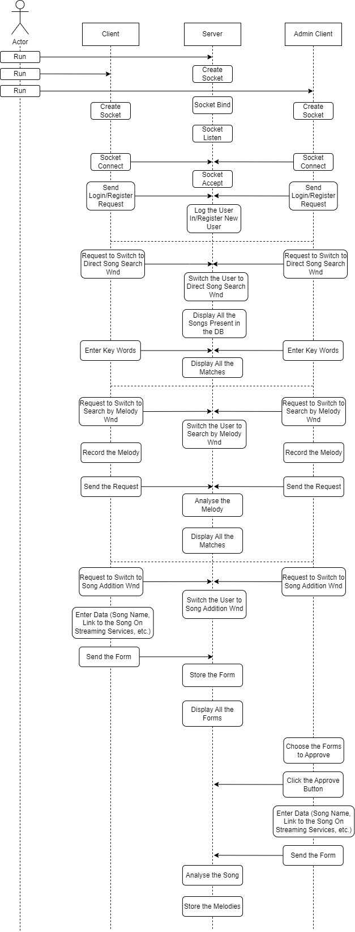
…

DB tables
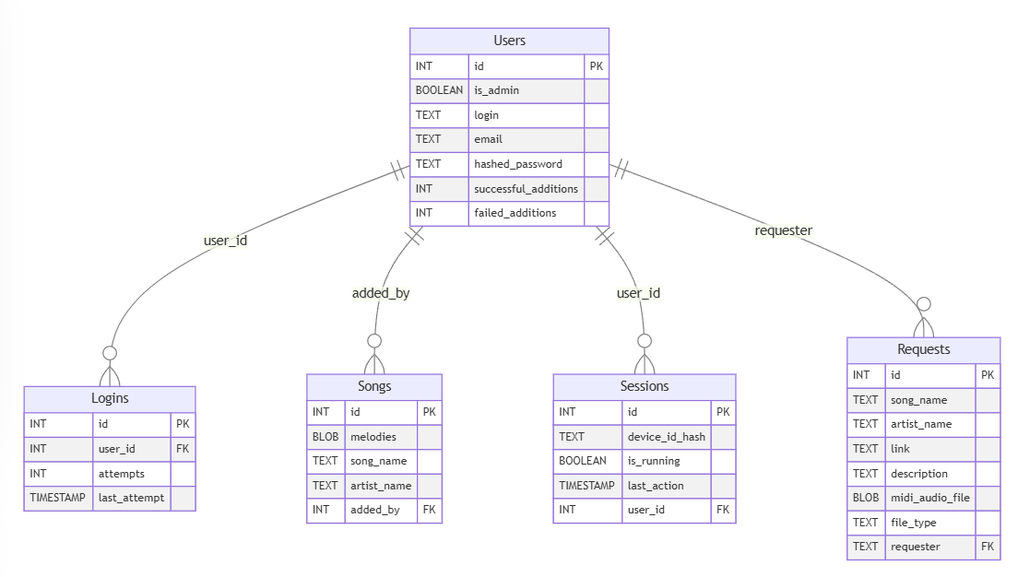
- Users – self-explanatory
- Logins – keeps track of the amount of times password for the certain account was entered incorrectly. After a certain number of attempts, the account locks away from accessing for a peroid of time to prevent possible password brute-forcing
- Sessions – the table to make the manipulation with client’s data easier and less messy, as well as to provide additional security and convinience features, such as logging into the account from a remembered device without having to enter the login and password
- Request – the table where the requests are kept, which may eventually become searchable songs
- Songs – self-explanatory for the most part; the “melodies” row stores melodies as midi files to provide maximum storage efficiency since midi files take up as little memory as possible

Protocol
Packet protocol (details in the schemes below):
- The information (message, session token, arguments, etc.) that the client or the server sends is packed into a packet via the packet protocol.
- The packet is dumped into a string. The string is encrypted via RSA or secret Fernet key (depending on the length and type of a message)
- After the encrypted string is received, the first 4 bytes of it are extracted as a type (sender, msg type, encryption, dump type), and is decryoted using the RSA or secret Fernet key
- Since symmetric key rotations are encrypted via RSA, they need to have a shorted dump string. Therefore, there is a separate protocol for dumping key rotation messages (both request and key itself). The dumped strings only include packet id and message (request or key)
Packet protocol scheme:
- Dumping and encrypting
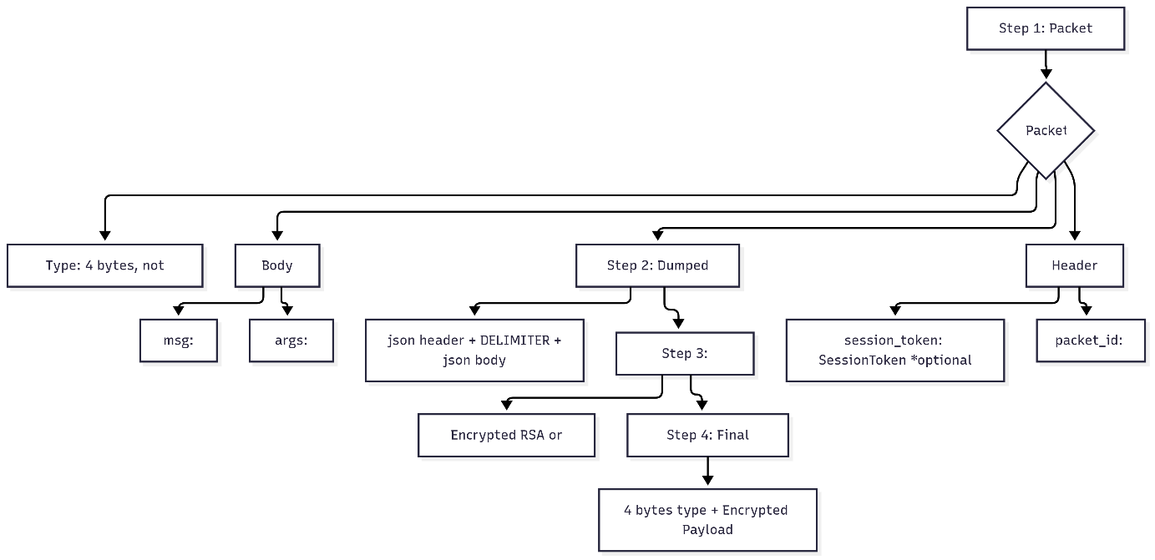
- Loading and decrypting a packet from a string
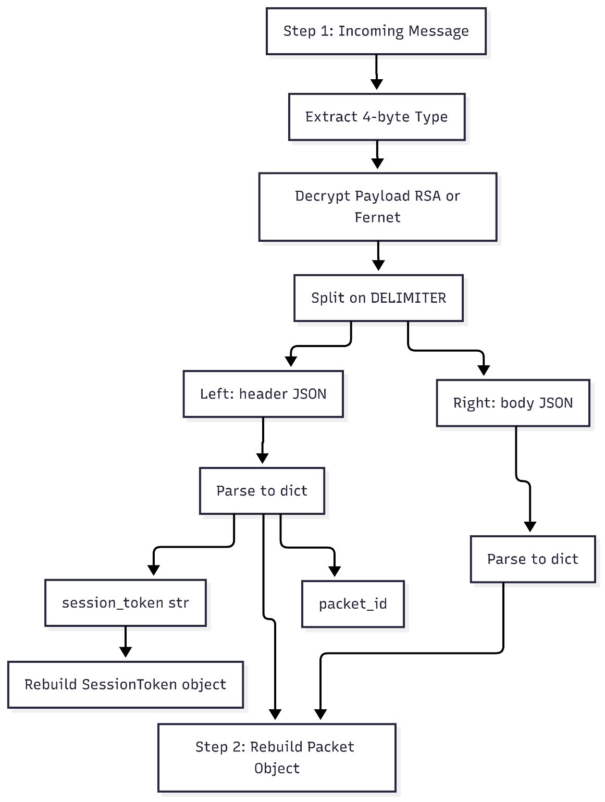

Encryption
- Password hashing – to protect users’ personal data password hasher “Argon2” is used
- Device id hashing – the hashes of MAC adresses of the devices that have a session running for them are done using hmac and hashlib (with high entropy of the id there is little to no need in using purposefully slow hashing algorithms like Argon)
- As mentioned in the previos step, dumped packet strings are encrypted via Fernet or RSA
- Most of the messages, as well as files, are encrypted via Fernet key, to eliminate the errors caused by big message sizes/file transfers.
- Each time a countdown goes to 0 (every 100 mesages), the client sends a request to rotate the Fernet key, the server responds with a key. Fernet key rotation is encrypted via RSA to increase robustness.

Classes
Overall Architecture:
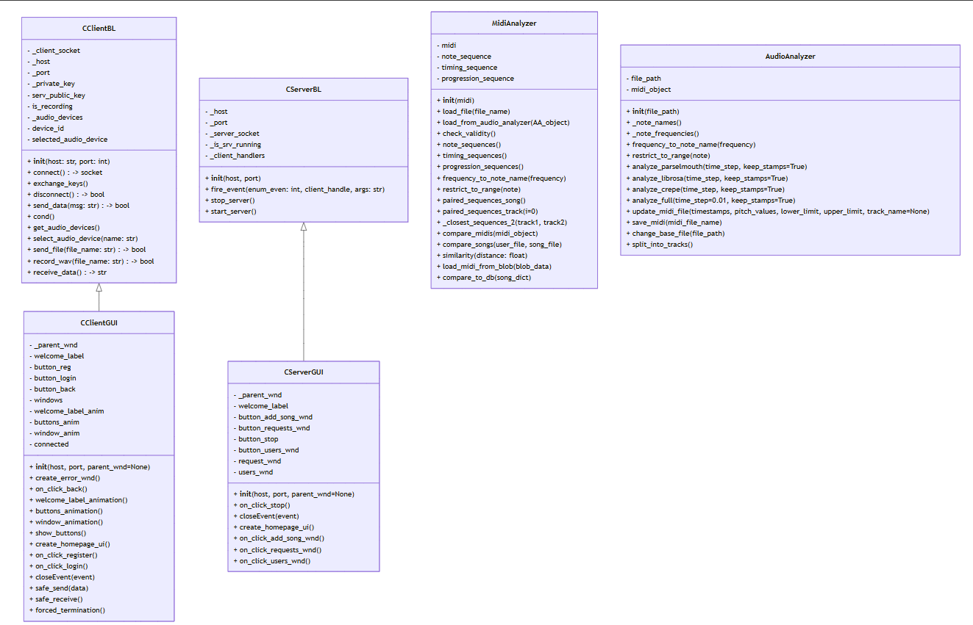
GUI class that implements a custom widget for files drag-and-drop functionality as well as local directory browsing:
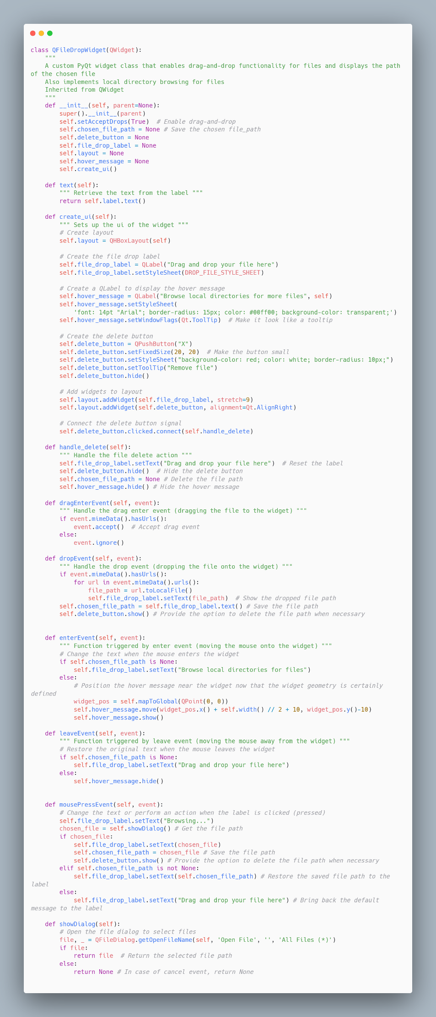
Use case of the widget in the window class:
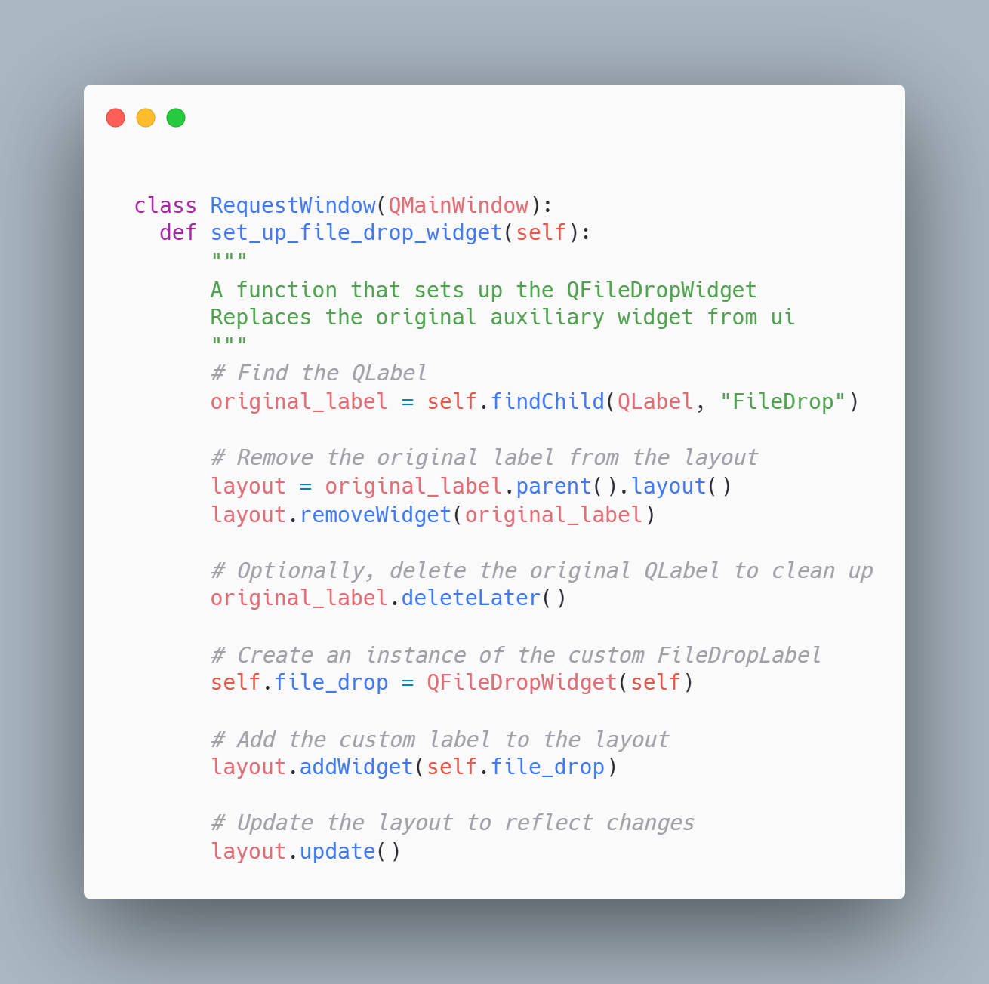

System Architecture - Presentation Layer
The following form diagram represents a schematic version of GUI. May have slight variations from the actual application

Forms workflow
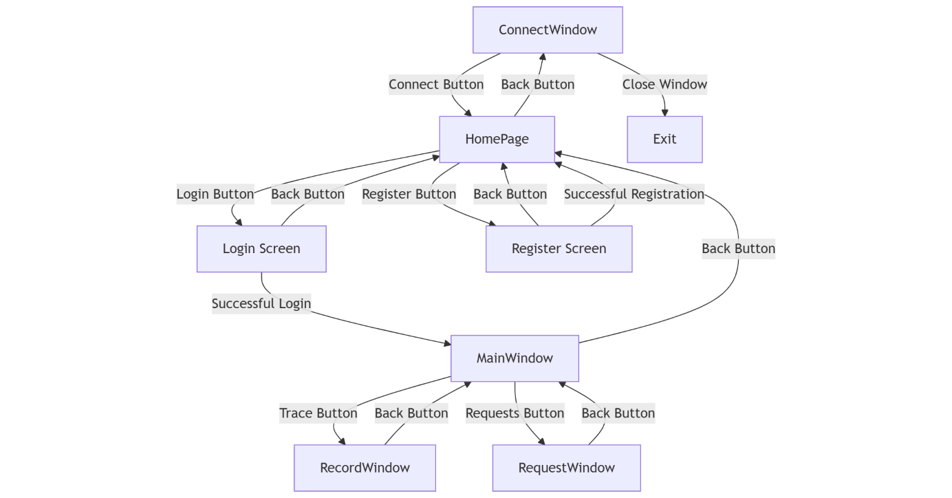

Source Code
ServerBL side:

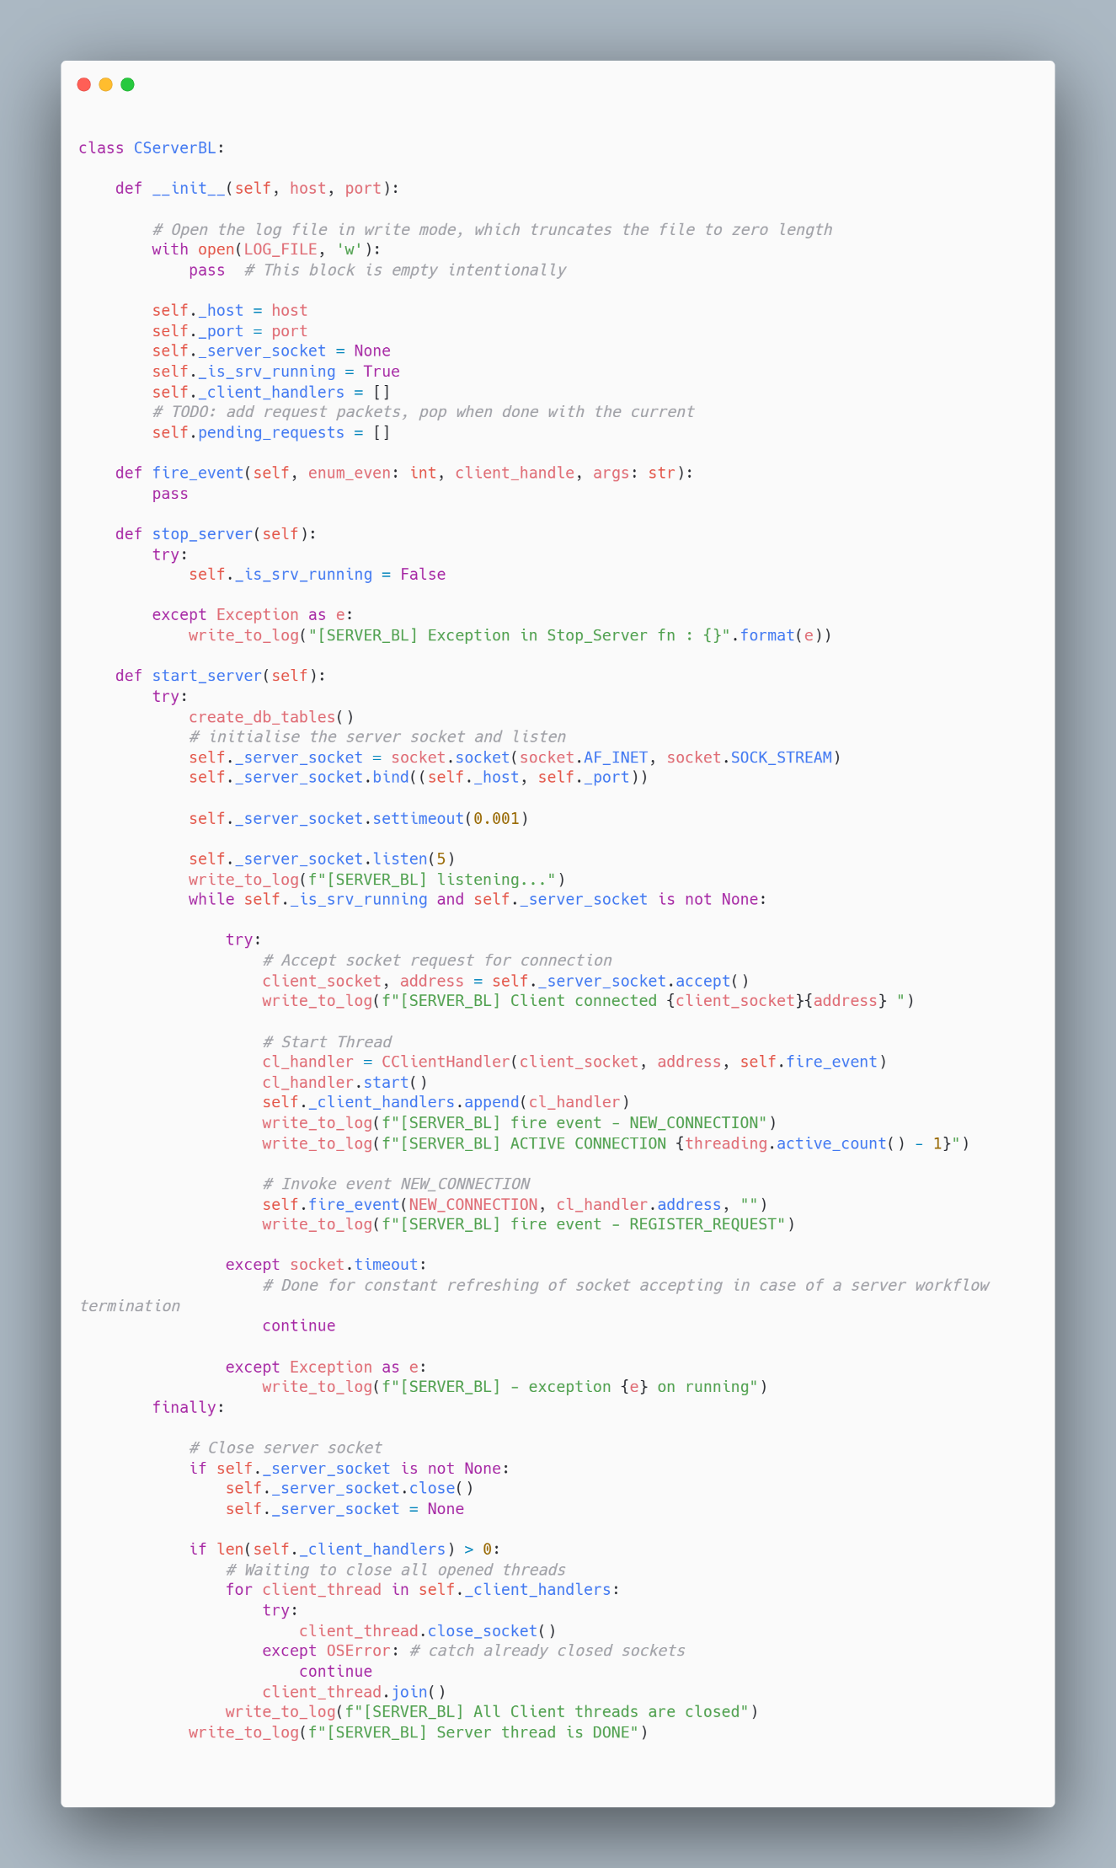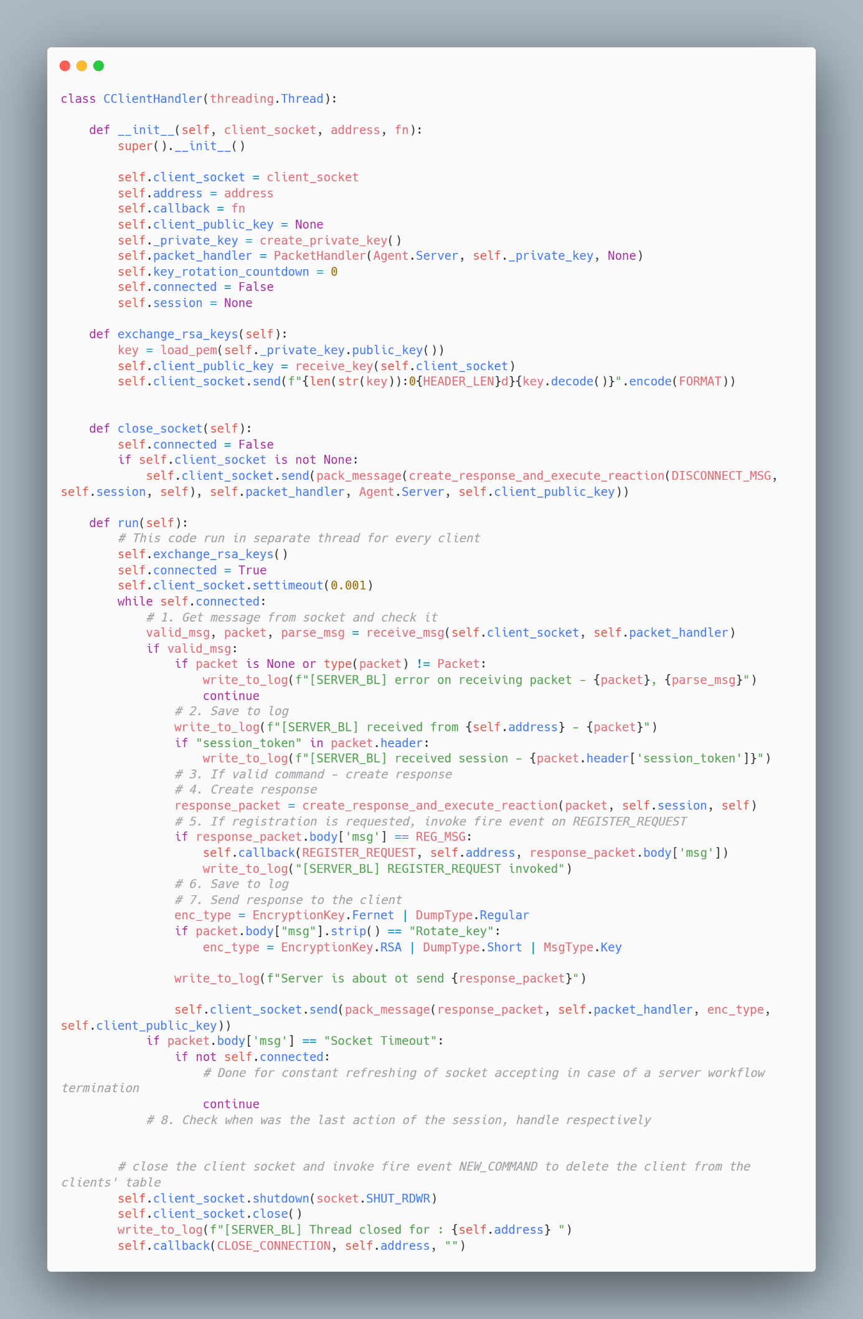
Client’s side:
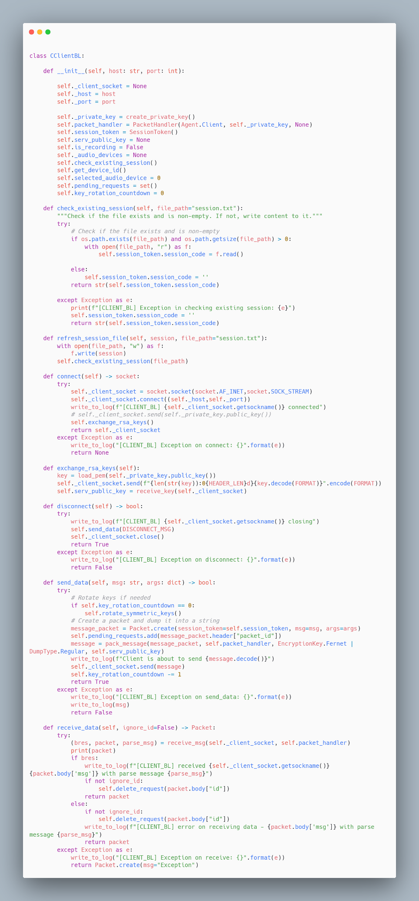

1.8 SW Test plan
This section describes the software testing strategy for the TuneTrace application. Testing will include both standard operational flows and edge cases, with a focus on performance, reliability, and user experience.

Test scenarios
# | Test Case Name | Description | Expected Result
1 | Server Connection Initialization | The app starts and connects to server backend. | Connection is established within 3 seconds; user is not blocked.
2 | Server Unreachable Handling | The app starts but server is offline or doesn’t accept the connection within the given time limits | "Server Unreachable" message is displayed, with Retry option.
3 | User Login with Correct Credentials | User inputs valid username and password. | User is authenticated and enters main menu.
4 | User Login with Incorrect Credentials | User inputs invalid login details. | Authentication fails with "Invalid credentials" message.
6 | Audio Recording Start | User clicks "Start Recording" button. | Recording starts immediately.
7 | Audio Recording Aborted | User starts and stops recording prematurely. | The audio recording process is aborted, the file is not saved
8 | Upload Audio to Analysis Service | User records melody and submits it. | Upload succeeds, user sees "Analyzing your melody..." screen.
9 | Authenticate via Session Code | Client’s app side reads the session code from file after launching and sends the session token along with the login request | The Client sees a pop-up window of whether they want to log in via the session. The log in is successful if they proceed, redirection to entering credentials is done if they refuse
10 | Analyze Melody Successfully | Server analyzes uploaded audio. | List of best matches shown in ranked order.
11 | Add New Song to Database (Admin) | Server admin validates a new song to be added to the database. | Song is processed and appears in future search results.
12 | Double Check Requests Requiring Session Token | The Client sends a valid request and an invalid session token alongside with it | Server checks the session token, refuses to process the request, sends the corresponding error message
13 | Logout Manually | User manually presses "Logout" button. | Session ends cleanly, user returned to login page.
14 | Data Privacy Handling | Check if communication between client and server are encrypted. | All data transmission uses RSA/Fernet encryption.
15 | Automatic Symmetric Key Rotation | After a certain number of messages (100), Client’s side of the app automatically sends a request to the server to rotate the Fernet key | The key rotation request is handeled before the first request after the countdown is gone to 0

Test Results
# | Test Case Name | Result | Notes
1 | Server Connection Initialization | Passed | Connected within 2.5 seconds.
2 | Server Unreachable Handling | Passed | Correct error handling and retry option displayed.
3 | User Login with Correct Credentials | Passed | Login successful, user directed to main menu.
4 | User Login with Incorrect Credentials | Passed | Authentication fails, 'Invalid credentials' message shown.
6 | Audio Recording Start | Passed | Recording started immediately without lag.
7 | Audio Recording Aborted | Passed | Recording aborted correctly, no file saved.
8 | Upload Audio to Analysis Service | Passed | Audio uploaded successfully, analysis screen shown.
9 | Authenticate via Session Code | Passed | Session login popup appears, correct behavior on proceed/refuse.
10 | Analyze Melody Successfully | Passed | Top matches shown as expected, ranked list displayed.
11 | Add New Song to Database (Admin) | Passed | Song added successfully to the search database.
12 | Double Check Requests Requiring Session Token | Passed | Invalid session token correctly rejected, error message sent.
13 | Logout Manually | Passed | Session closed cleanly, redirected to login screen.
14 | Data Privacy Handling | Passed | Confirmed RSA/Fernet encryption for all transmissions.
15 | Automatic Symmetric Key Rotation | Passed | Key rotated correctly after 100 messages without disrupting communication.

Bibliography
Crepe library documentation - https://pypi.org/project/crepe/
Audio track separation library - https://www.samgalope.dev/2024/07/27/how-to-use-python-and-demucs-to-separate-audio-files/
Working with midi files in python - https://www.twilio.com/en-us/blog/working-with-midi-data-in-python-using-mido
A bit of research of how it is better to store midi files - https://stackoverflow.com/questions/37086225/best-way-to-store-files
Demucs github - https://github.com/facebookresearch/demucs
An overview of general session implementation - https://medium.com/lightrail/getting-token-authentication-right-in-a-stateless-single-page-application-57d0c6474e3
Using DTW for melody comparison – MelodyComparison.pdf

AI Usage
- In the workflow, to extract the pitch of the melody, the libraries CREPE and torchcrepe are used. The libraries are based on ai models, trained specifically for pitch detection. Additionally, to split the processed song into stems (individual instruments) for further pitch extraction, the model Demucs is utilized.
- Language models, such as ChatGPT and DeepSeek were used in order to provide general information on different existing solutions for specified tasks. For example, to compare note sequences, aka melodies, Sliding DTW algorithm was advised to be implemented in the workflow.
- The language models mentioned were used for a brief introduction into the new topic, such as GUI creation using PyQt and Qt Designer, by creating basic functions or breaking down the already existing examples found online

