חלופה מערכות הגנת סייבר במקצוע "תכנון ותכנות מערכות" - הערכה לעבודת גמר 5) יחידות לימוד( – תשפ"ה

346327026 | מספר ת.ז. | Yury Moiseev | שם התלמיד
TuneTrace |  |  | נושא העבודה

Revision History

Ed. Id | Date | File Reference | Reason for Change
1 | 06/01/2025 | - | Started working on the document
2 | 20/01/2025 | - | Fixed minor issues, added new sections
3 | 25/01/2025 |  | Completed the document, fixed minor discrepancies

Introduction
- The document is intended to provide all the necessary information about top level design of the project
- The name of the project is “TuneTrace”
- The slogan of the project is: “Trace the tune that echoes in your mind”

System Overview
- The project’s main purpose is to help find songs with a specific melody. The melody is entered via singing/humming/playing it on a musical instrument to the device’s microphone. Then, the melody is analyzed by a few layers of ai and compared to the songs that are currently present in the database. Then the list of songs with the same or very similar melodies are displayed in a list, allowing to find the one the client was looking for, as well as compare songs with similar melodies. As for additional features, the project also provides non-administrator users with a request system, which is created for further modifications of the melody database. Administrator users have direct access to modifying the database, by approving or denying requests to add certain songs, or by adding songs themselves.

Related software or hardware
Operating systems

End-user characteristics
….

General Constraints
- For proper execution of all the features python version 3.6+ is required
- Some features include audio recording and therefore require access to microphone
Potential Platform Conflicts:
  - PyAudio: Likely the most problematic module, requiring platform-specific libraries (e.g., portaudio on Linux) or manual builds on macOS/Windows.
  - Cryptography and argon2: Require development tools/libraries (e.g., OpenSSL, build-essential) on some platforms.
  - os: Minor differences in functionality depending on the operating system.

System Architecture - Functionality

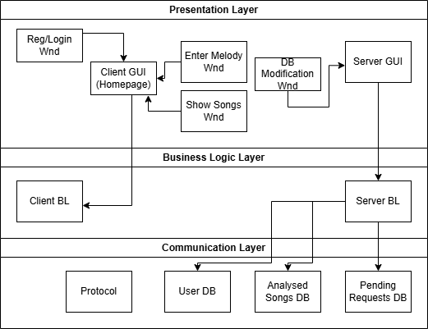

Subsystem Architecture
- Login/Register Use Case:
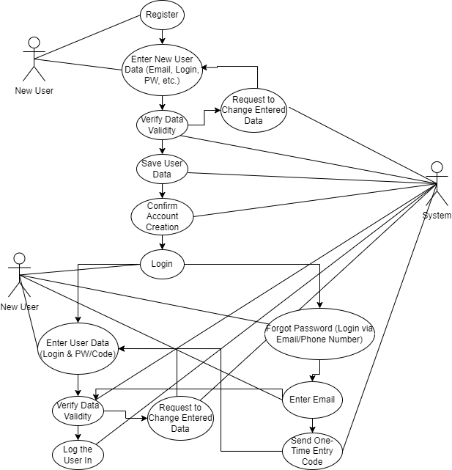

- Main Workflow Use Case
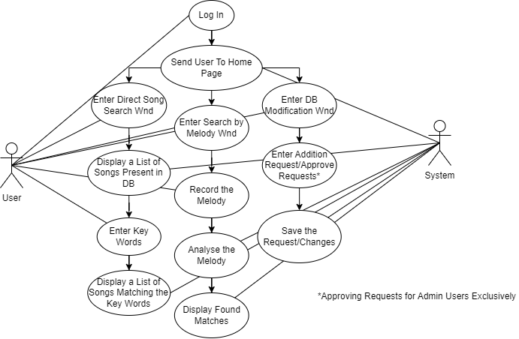

Sequence diagrams
- Login/Register Sequence Diagram
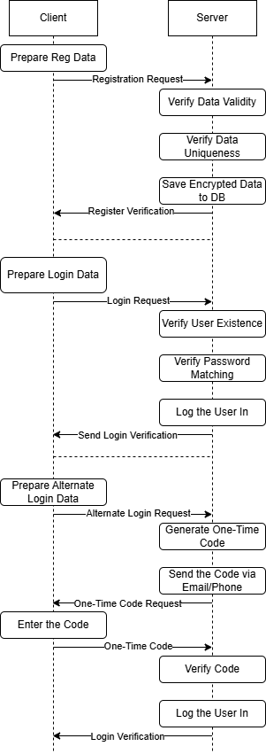
- Main Workflow Sequence Diagram
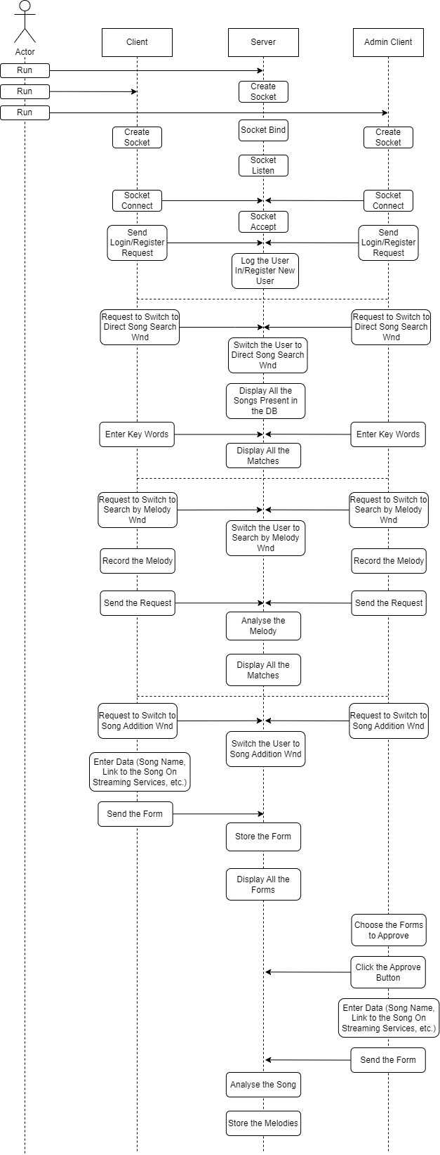
…

DB tables
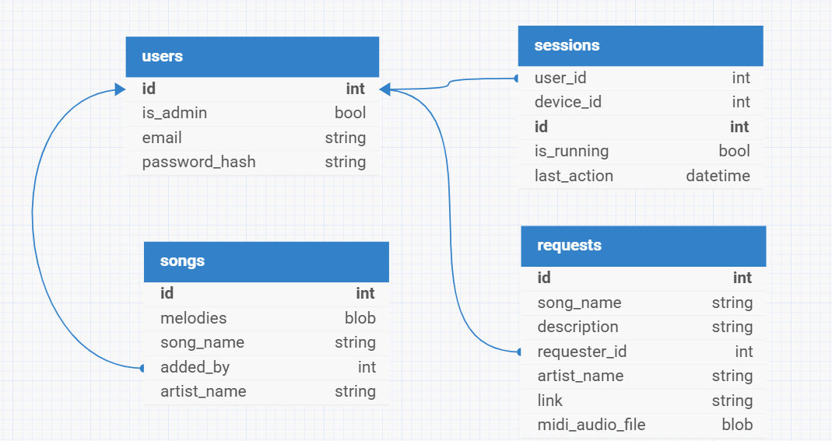
- Users – self-explanatory
- Sessions – the table to make the manipulation with clients data easier and less messy, as well as to prevent some of possible cyber attacks
- Request – the table where the requests are kept, which may eventually become searchable songs
- Songs – self-explanatory for the most part; the “melodies” row stores melodies as midi files to provide maximum storage efficiency aka midi files take up as little memory as possible

Protocol
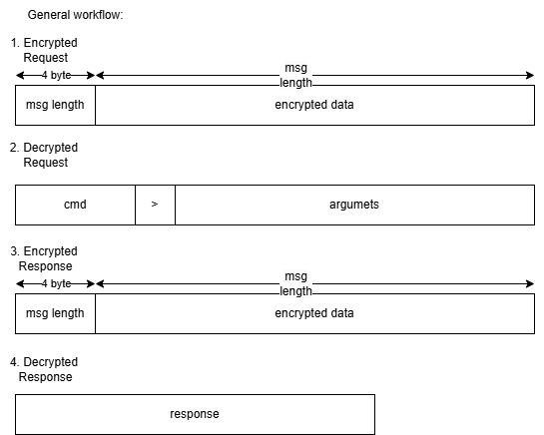

Encryption
- Password hashing – to protect users’ personal data password hasher “Argon2” is used
- All the communication between server and client is protected via RSA encryption

Classes
GUI class that implements a custom widget for files drag-and-drop functionality as well as local directory browsing:
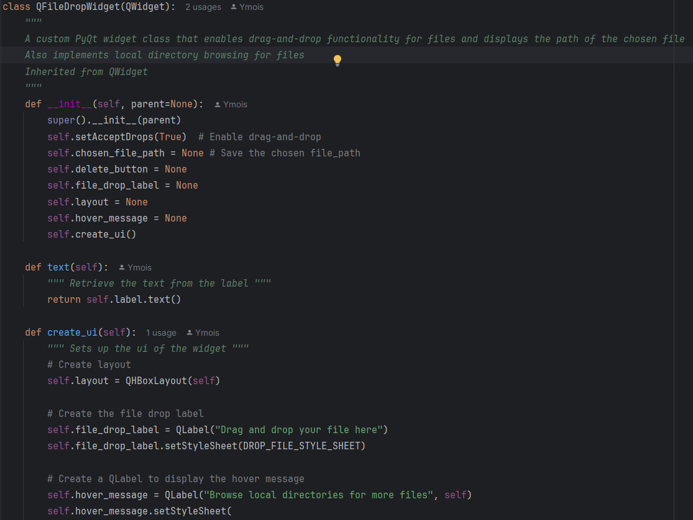
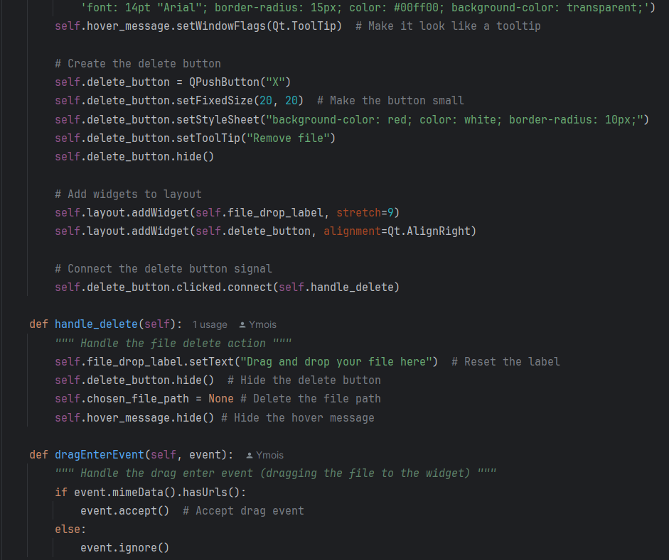
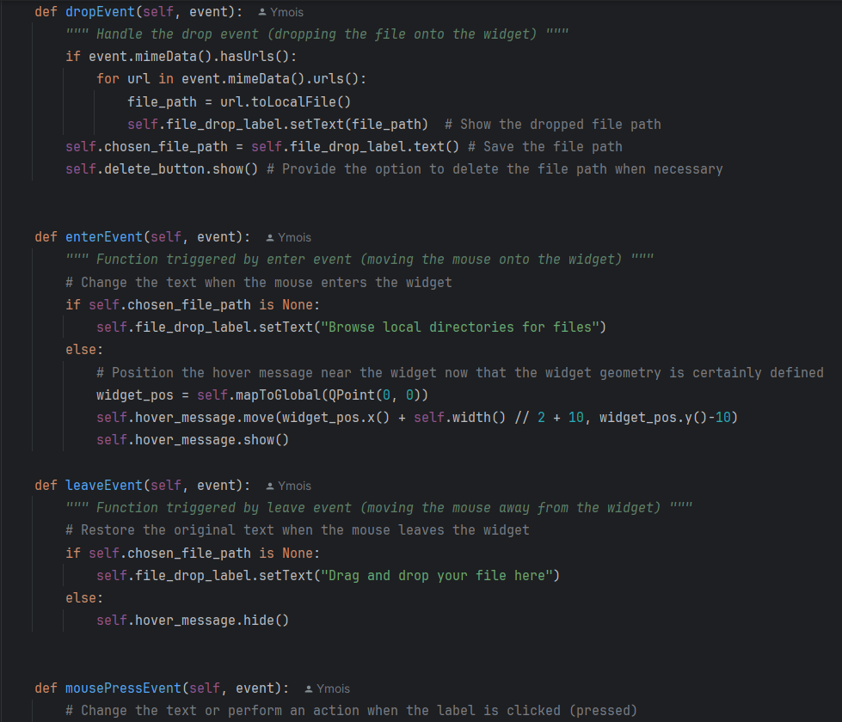
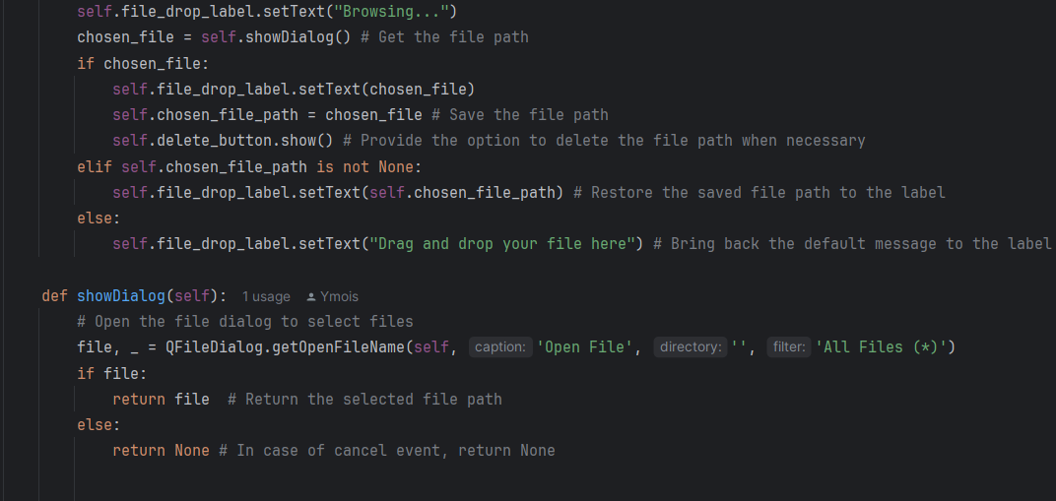
Use case of the widget in the window class:
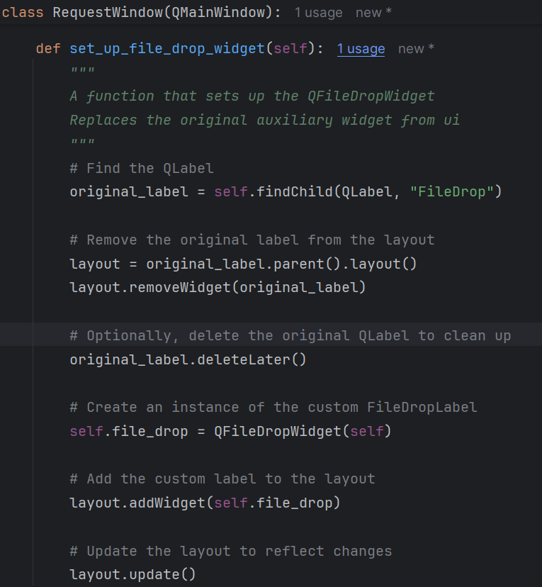

System Architecture - Presentation Layer
…

Forms workflow
…
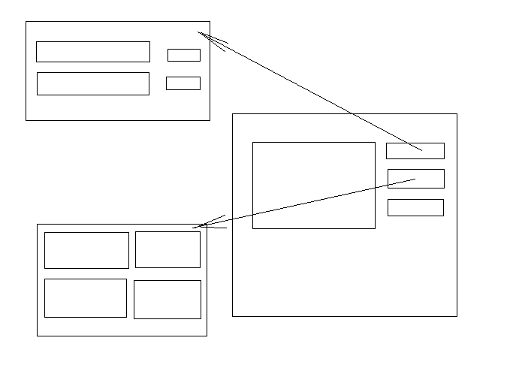…

Source Code
…

1.8 SW Test plan
…

Test scenarios
…

Test Results
…

Bibliography

