FUNCTIONAL AND
NON-FUNCTIONAL TESTING
Test Documents
U-Sports: University Sports Management Platform

TEST ENVIRONMENT
Every result and screenshot in this document was produced in the environment below.
Web application under test | U-Sports web client, production build (Vite 6.4.2 / React 19 / TypeScript), served locally at http://localhost:4173
API under test | U-Sports Express API (Node.js 22.19.0 + TypeScript), running at http://localhost:3001/api against the live Supabase project
Mobile application under test | U-Sports Android client, Flutter 3.41.7 (stable), debug build installed on the emulator
Database and authentication | Supabase (PostgreSQL 15, Auth, Storage, Realtime) — live project
Deployed web application | https://usports-one.vercel.app (Vercel)
Deployed API | https://u-sports.onrender.com/api (Render)
Browser | Microsoft Edge 153.0.4234.32 (Chromium), automated with Playwright 1.49.1
Android device | Android emulator, sdk_gphone64_x86_64, Android 15 (API level 35), 1080 x 1920
Measurement tool | Google Lighthouse 12.2.1, headless, three runs per module

Scope of this test cycle
This cycle covers navigation, display, data integrity, authentication, authorisation and consent across both applications, together with the non-functional measurements below. Each test case was executed against live data and the Actual Results column holds the screenshot captured at the moment of execution. Destructive write operations — creating, editing and deleting events, teams, seasons, accounts and announcements — were deliberately not executed against the production database in this cycle; the controls for them are recorded in the functionality tables and are shown present and reachable in the accompanying screenshots.

FUNCTIONALITY TESTING
Module No. | Module Name | Function Name | Description
GENERAL MODULES (WEB AND MOBILE APPLICATION)
1 | Login / Authentication | Authenticate | Verifies the email and password against Supabase Auth and routes the user to the dashboard that matches their role (Super Admin, Organizer, Coach or Athlete).
1 | Login / Authentication | Forgot Password | Sends a password-reset link to a registered school email address and reports the outcome without revealing whether the account exists.
1 | Login / Authentication | Accept Invite / Set First Password | Lets an invited staff member or athlete set their own password from the link sent to their school email.
1 | Login / Authentication | Guest Access | Allows anyone to browse standings, events and rosters without signing in.
2 | Data Privacy Notice | Review Notice | Presents what the platform collects and why, before any personal data is shown.
2 | Data Privacy Notice | Accept Notice | Records the consent timestamp and unblocks the rest of the application; the notice cannot be dismissed without a decision.
3 | Profile | View Profile | Displays the signed-in user’s own details — name, school ID, department, year level, position and jersey number.
3 | Profile | Edit Profile | Updates the user’s own personal details and profile photo.
3 | Profile | Change Password | Updates the account password, subject to the once-every-7-days limit and the 8-character / letter-and-number rule.
4 | Notifications | View Notifications | Lists announcements and match alerts addressed to the user, with an unread badge and All / Unread / Recent filters.
4 | Notifications | Mark Read and Clear | Marks notifications as read individually or all at once, and removes them from the list.
5 | Sign Out | Logout Function | Ends the session on the device and returns the user to the public hub, leaving no session open.
WEB APPLICATION SYSTEM
1 | Public Hub (Landing Page) | Introduction and Navigation | Presents the institution banner, live games, open events, sports and season totals, with navigation to Hub, Standings, Events and Sign In.
1 | Public Hub (Landing Page) | Live Game Cards | Shows each match currently being played with running scores, refreshed in real time.
2 | Guest — Standings | View Player Statistics | Season leaderboard per sport, with the statistics that apply to that sport (PPG/RPG/APG for basketball, attacks/aces for volleyball, points/winners for table tennis).
2 | Guest — Standings | View Team Standings | Win-loss record and win percentage per team for the selected sport and season.
2 | Guest — Standings | Filter by Sport and Season | Restricts both tables to a chosen sport and academic year.
3 | Guest — Events | Browse Events | Lists upcoming, ongoing and past events with a search box and sport filter.
3 | Guest — Events | View Event Detail | Shows the event bracket and its match list with status and schedule.
4 | Guest — Team and Athlete Profiles | View Team Detail | Shows a team’s season record and full roster with jersey numbers and positions.
4 | Guest — Team and Athlete Profiles | View Athlete Profile | Shows an athlete’s department, year level, position and season statistics.
5 | Jumbotron | Display Live Scoreboard | Full-screen venue scoreboard for a single match, driven by the live scoring session.
6 | Super Admin and Organizer — Dashboard | Data Visualization Cards | Summarises athletes, teams, events and games played as cards, with quick actions into scoring and management.
7 | Organizer — Event Management | View Events | Lists every event the organizer may manage, filtered by Active, Completed, Cancelled or All.
7 | Organizer — Event Management | Search and Filter Events | Narrows the list by name, category, sport or status and reports the filtered count.
7 | Organizer — Event Management | Create Event | Registers a new event under a season, sport and category.
7 | Organizer — Event Management | Edit Event Details | Updates the name, schedule, format and category of an existing event.
7 | Organizer — Event Management | Generate Bracket | Builds the single- or double-elimination bracket from the registered participants.
7 | Organizer — Event Management | Mark Finished / Cancel / Delete Event | Closes, cancels or removes an event and its dependent records.
7 | Organizer — Event Management | Export Bracket | Saves the rendered bracket as an image for posting.
8 | Organizer — Live Scoring | Record Team Score | Adds or subtracts points, sets or games for either side while the match is live.
8 | Organizer — Live Scoring | Record Player Statistics | Attributes each scoring action to a player on the active lineup.
8 | Organizer — Live Scoring | Scoring Lock / Stat Tracker Mode | Gives one organizer the scoring lock and puts any other organizer in stat-tracker mode, so two people cannot award points at once.
8 | Organizer — Live Scoring | Validate Set / Advance Period | Freezes the current set or quarter so it can no longer be edited, then advances play.
9 | Organizer — Match Review and Score Sheet | View Match Review | Shows the finalised result, per-player box score and the organizer who recorded it.
9 | Organizer — Match Review and Score Sheet | Edit Stats | Corrects recorded statistics after a match is finalised.
9 | Organizer — Match Review and Score Sheet | View and Export Score Sheet | Produces the printable official score sheet for the match.
10 | Organizer and Coach — Team Management | View Teams | Lists teams for the sports and season the user is assigned to.
10 | Organizer and Coach — Team Management | Create Team | Registers a new team under a sport, department and season.
10 | Organizer and Coach — Team Management | Import Teams | Creates several teams at once from a CSV or Excel file.
10 | Organizer and Coach — Team Management | Manage Roster | Adds or removes athletes and sets jersey numbers and positions.
10 | Organizer and Coach — Team Management | Set Starting Lineup | Marks which roster members start, in slot order.
11 | Organizer and Coach — Athlete Accounts | Add Athlete | Registers one athlete with a school ID, real school email, department, year level and sport.
11 | Organizer and Coach — Athlete Accounts | Import Roster | Registers many athletes from a CSV or Excel file, rejecting and naming any row with an invalid year level or email.
11 | Organizer and Coach — Athlete Accounts | View Athlete Accounts | Lists registered athletes with their status, filterable by Activated or Deactivated.
11 | Organizer and Coach — Athlete Accounts | Edit Athlete Account | Updates an athlete’s details, position and jersey number.
11 | Organizer and Coach — Athlete Accounts | Deactivate / Delete Athlete | Suspends or permanently removes an athlete account.
11 | Organizer and Coach — Athlete Accounts | Reset Athlete Password | Issues a fresh first password for an athlete who cannot sign in.
11 | Organizer and Coach — Athlete Accounts | Export CSV | Downloads the athlete list for offline records.
12 | Organizer — Season Management | View Seasons | Lists academic-year seasons with their status.
12 | Organizer — Season Management | Create Season | Opens a new academic-year season together with its starter teams and events per sport.
12 | Organizer — Season Management | Activate / Archive Season | Marks which season is current, or closes a finished one.
13 | Organizer — Analytics | View Leaderboard and Insights | Season-wide statistical rankings and derived insights per sport.
13 | Organizer — Analytics | View Event Results | Final placements and results per event.
13 | Organizer — Analytics | Export CSV | Downloads the analytics tables for reporting.
14 | Organizer and Super Admin — Announcements | Create Announcement | Composes an announcement with a title, body and display type.
14 | Organizer and Super Admin — Announcements | Post Announcement | Publishes it to the hub ticker and to the notification lists of the intended audience.
14 | Organizer and Super Admin — Announcements | View Announcements | Lists posted announcements for review.
15 | Super Admin — Staff Accounts | Add Staff | Creates an Organizer or Coach account against a school email address.
15 | Super Admin — Staff Accounts | Add Super Admin | Creates another administrator account.
15 | Super Admin — Staff Accounts | Assign Department and Sports | Scopes what a staff member may manage, by department, sport and season.
15 | Super Admin — Staff Accounts | Edit / Deactivate / Reset Password | Maintains existing staff accounts.
16 | Super Admin — School Profile | Edit Institution Profile | Sets the institution name, tagline, address, logo and brand colours used across both apps.
17 | Super Admin — Audit Logs | View Audit Trail | Lists administrator and organizer actions in order, paginated, for accountability.
18 | Help Center | View Help Articles | In-app guidance for each role on how to run a season.
MOBILE APPLICATION SYSTEM
1 | Home | Access Services | Shows the institution banner, games being played now, open-event totals and the announcement ticker, and routes to every other section.
2 | Standings and Leaderboards | View Player Statistics | Season leaderboard per sport with sport-appropriate statistics.
2 | Standings and Leaderboards | View Team Standings | Win-loss record and win percentage per team.
2 | Standings and Leaderboards | Filter by Sport and Season | Restricts the tables to a chosen sport and academic year.
3 | Events | Browse Events | Upcoming, live and past events with search and sport filter.
3 | Events | View Bracket | Renders the event bracket with live matches highlighted.
3 | Events | View Matches | Lists the event’s matches with status and schedule.
4 | Live Match View | View Live Score and Roster | Opens a live match as a sheet showing the running score and both rosters.
5 | Team Detail | View Record and Roster | Team season record with the full roster, starters marked.
6 | Coach — My Teams | View Assigned Teams | Lists the teams the signed-in coach is assigned to, with roster and starter counts.
6 | Coach — My Teams | View Schedule and Results | Shows what is being played now, what is next, and recent results for those teams.
6 | Coach — My Teams | Courtside Roster Edit | Lets a coach adjust jersey number, position and starting lineup from the team page.
7 | Athlete — Dashboard | View Own Profile and Stats | School ID, department, year level, position, jersey number and the season snapshot.
7 | Athlete — Dashboard | View Own Schedule | Upcoming and live matches for the athlete’s team.
8 | Notifications | View Notifications | Announcements and match alerts with an unread badge and All / Unread / Recent filters.
8 | Notifications | Read All and Clear | Marks everything read or clears the list.
9 | Settings | Toggle Dark Mode | Switches the app between light and dark appearance.
9 | Settings | Change Password | Updates the account password from the device.
9 | Settings | View Privacy Notice | Re-opens the data privacy notice at any time.
9 | Settings | Sign Out | Ends the session on the device.

Summary of Results
65 test cases were executed — 44 on the web application and 21 on the Android application. 64 passed and 1 failed.
Module No. | Module Name | Test Code | Function Name | Remark / Status
WEB APPLICATION SYSTEM
1 | Public Hub and Guest Browsing | 001 | The public hub loads successfully with the correct elements | PASSED
1 | Public Hub and Guest Browsing | 002 | A guest can read season standings and leaderboards | PASSED
1 | Public Hub and Guest Browsing | 003 | A guest can browse the events list | PASSED
1 | Public Hub and Guest Browsing | 004 | A guest can open an event and read its bracket | PASSED
1 | Public Hub and Guest Browsing | 005 | A guest can open a team page | PASSED
1 | Public Hub and Guest Browsing | 006 | A guest can open an athlete profile | PASSED
2 | Login / Authentication | 007 | The sign-in page loads successfully | PASSED
2 | Login / Authentication | 008 | Required-field validation on the sign-in page | PASSED
2 | Login / Authentication | 009 | Sign-in with invalid credentials | PASSED
2 | Login / Authentication | 010 | The forgot-password page loads | PASSED
2 | Login / Authentication | 011 | The forgot-password request | PASSED
3 | Data Privacy Notice | 012 | The data privacy notice blocks the application until it is answered | PASSED
3 | Data Privacy Notice | 013 | The privacy notice is readable outside the sign-in flow | PASSED
4 | Super Admin Management | 014 | The Super Admin dashboard loads with its summary cards | PASSED
4 | Super Admin Management | 015 | Super Admin staff account management | PASSED
4 | Super Admin Management | 016 | Super Admin season management | PASSED
4 | Super Admin Management | 017 | The school profile page | PASSED
4 | Super Admin Management | 018 | Super Admin account preferences | PASSED
4 | Super Admin Management | 019 | The audit log | PASSED
5 | Organizer Management | 020 | The Organizer dashboard loads | PASSED
5 | Organizer Management | 021 | The event management list and its filters | PASSED
5 | Organizer Management | 022 | The organizer event detail page | PASSED
5 | Organizer Management | 023 | Athlete account management | PASSED
5 | Organizer Management | 024 | Team management | PASSED
5 | Organizer Management | 025 | Season management from the organizer shell | PASSED
5 | Organizer Management | 026 | The analytics module | PASSED
5 | Organizer Management | 027 | The announcements module | PASSED
5 | Organizer Management | 028 | Organizer account settings | PASSED
5 | Organizer Management | 029 | The notifications page | PASSED
5 | Organizer Management | 030 | The Help Center | PASSED
6 | Scoring and Match Records | 031 | The live scoring screen and the scoring lock | PASSED
6 | Scoring and Match Records | 032 | The match review screen | PASSED
6 | Scoring and Match Records | 033 | The official score sheet | PASSED
6 | Scoring and Match Records | 034 | The jumbotron scoreboard | PASSED
7 | Coach Access | 035 | A Coach sees a dashboard scoped to their own assignment | PASSED
7 | Coach Access | 036 | The Coach team view | PASSED
7 | Coach Access | 037 | The Coach athlete view | PASSED
7 | Coach Access | 038 | The Coach event view | PASSED
7 | Coach Access | 039 | Coach account settings | PASSED
8 | Athlete Access | 040 | The athlete dashboard | PASSED
8 | Athlete Access | 041 | The athlete profile page | PASSED
8 | Athlete Access | 042 | The athlete My Events page | FAILED  Defect D-2 — open at the time of writing.
8 | Athlete Access | 043 | Athlete account settings | PASSED
8 | Athlete Access | 044 | Athlete notifications | PASSED
MOBILE APPLICATION SYSTEM
1 | Guest Browsing | 001 | The mobile home screen loads with the correct elements | PASSED
1 | Guest Browsing | 002 | Mobile player statistics | PASSED
1 | Guest Browsing | 003 | Mobile team standings | PASSED
1 | Guest Browsing | 004 | The mobile events list, search and sport filter | PASSED
1 | Guest Browsing | 005 | The mobile event bracket | PASSED
1 | Guest Browsing | 006 | The mobile event match list | PASSED
1 | Guest Browsing | 007 | The mobile live match view | PASSED
1 | Guest Browsing | 008 | The mobile team detail screen | PASSED
1 | Guest Browsing | 009 | Mobile settings as a guest | PASSED
2 | Login / Authentication | 010 | The mobile sign-in screen loads | PASSED
2 | Login / Authentication | 011 | Mobile sign-in with invalid credentials | PASSED
2 | Login / Authentication | 012 | The mobile forgot-password screen | PASSED
2 | Login / Authentication | 013 | Mobile sign-in with valid credentials | PASSED
2 | Login / Authentication | 014 | The mobile data privacy notice gate | PASSED
2 | Login / Authentication | 015 | The first-login password prompt | PASSED
3 | Coach — My Teams | 016 | The Coach My Teams screen | PASSED  Re-tested after the fix. Defect D-1 — closed.
3 | Coach — My Teams | 017 | Coach settings on mobile | PASSED
3 | Coach — My Teams | 018 | The privacy notice can be re-read from settings | PASSED
4 | Athlete Access | 019 | The mobile home screen for a signed-in athlete | PASSED
4 | Athlete Access | 020 | The mobile athlete dashboard | PASSED
4 | Athlete Access | 021 | Mobile notifications | PASSED

Test Script Document Identifier – TS01
Test Specification - 01
Designed by:  Dacuba, Yuri Gabriel C.  Parco, Mark Christian P.  Rodriguez, Robin Kris P. | Modules:  U-Sports Web Application System
Objectives:  Test basic functionality | Browser Platform:  Microsoft Edge (Version 153.0.4234.32)

Test  Case  # | Description | Test Steps | Test  Data | Expected Results | Actual  Results | Pass/  Fail | Performed  by /  Date
1-1 | Verify that the public hub loads successfully with the correct elements. | 1. Open the web application at its root address.  2. Confirm the navigation bar carries Hub, Standings, Events and Sign In.  3. Confirm the live-game and season-total sections render. | N/A | - The hub loads with no broken links or console errors.  - Live game cards show the matches currently being played.  - Season totals report athletes, teams, competitions and games played. | 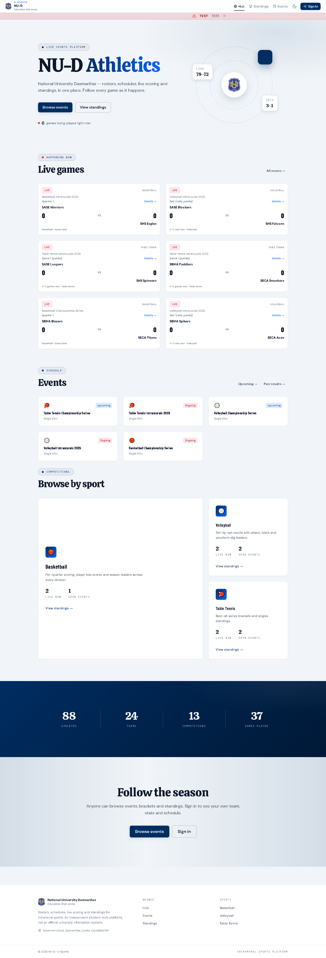 | Pass | Dacuba, Parco, Rodriguez  24 Sep 2026
1-2 | Verify that a guest can read season standings and leaderboards. | 1. From the hub, open Standings.  2. Select a sport and an academic year.  3. Read the player-statistics table. | Basketball, AY 2026-2027 | - The leaderboard lists ranked athletes with games played and the statistics that apply to the chosen sport.  - Changing the sport or season re-filters the table. | 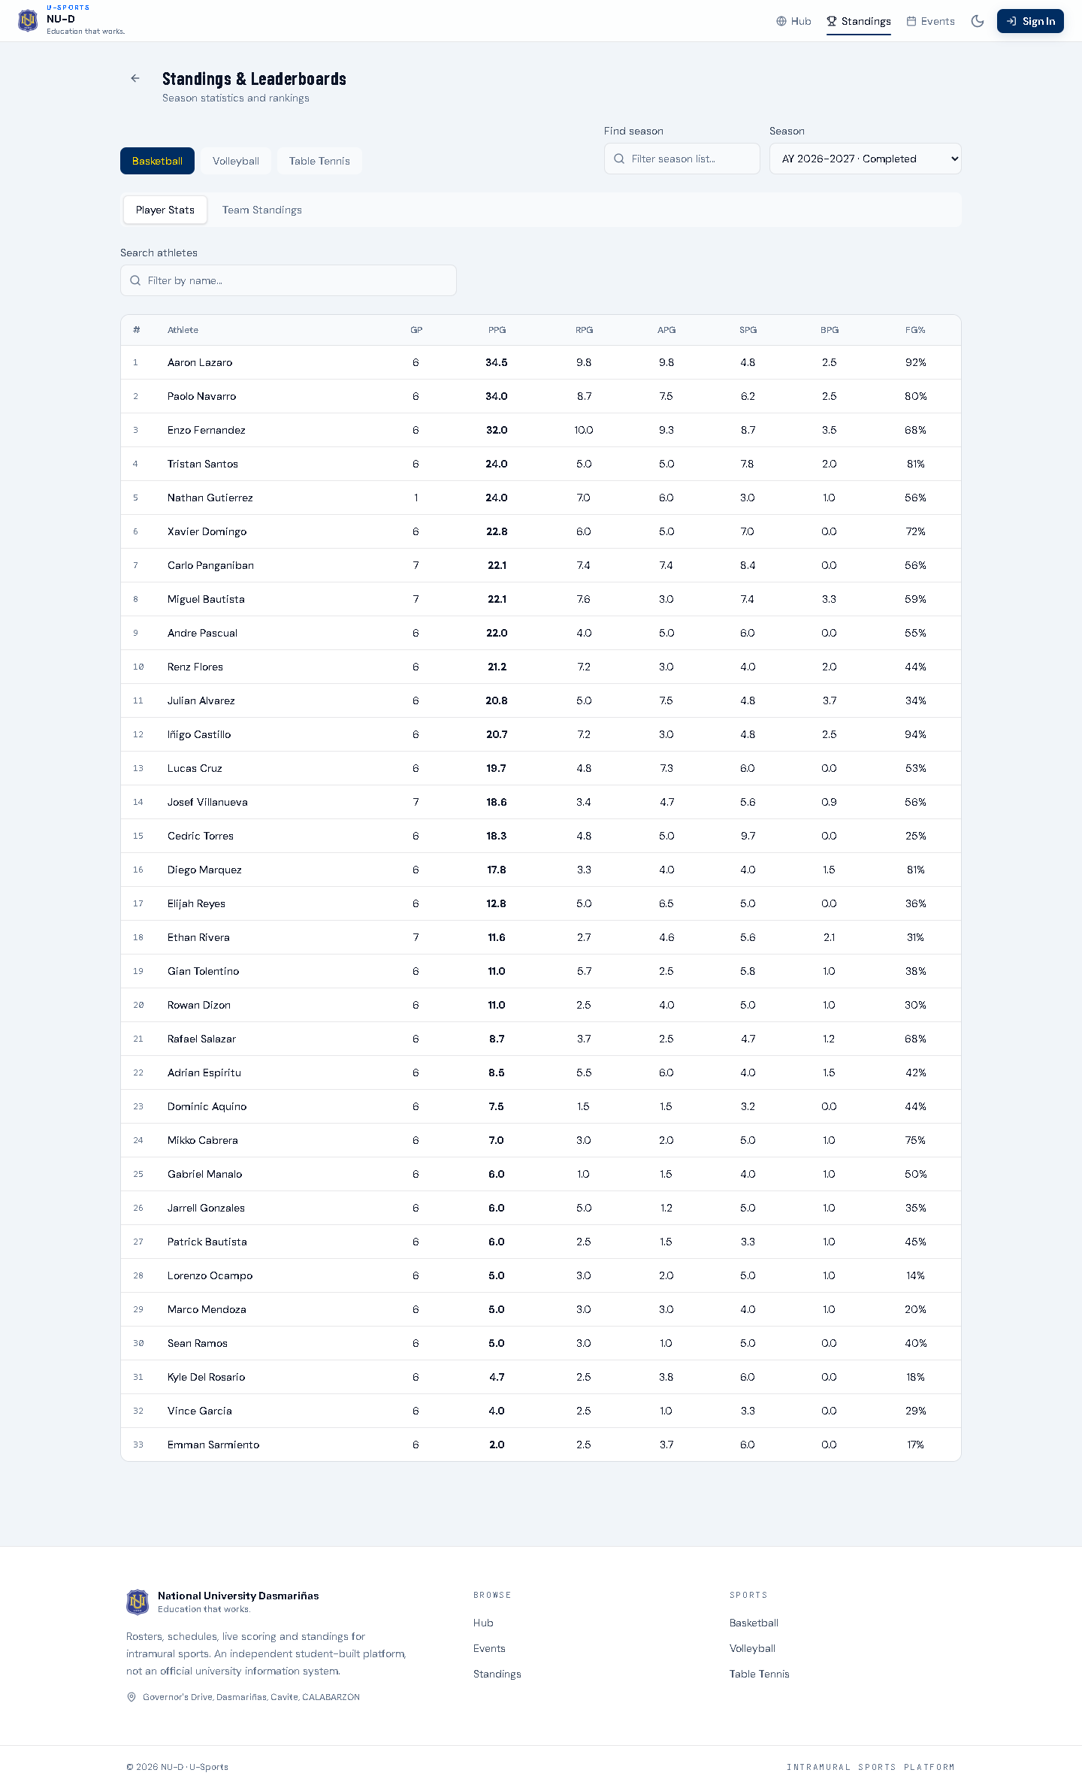 | Pass | Dacuba, Parco, Rodriguez  24 Sep 2026
1-3 | Verify that a guest can browse the events list. | 1. From the hub, open Events.  2. Review the upcoming, ongoing and past groupings. | N/A | - Every event is listed with its sport, format, season and status badge. | 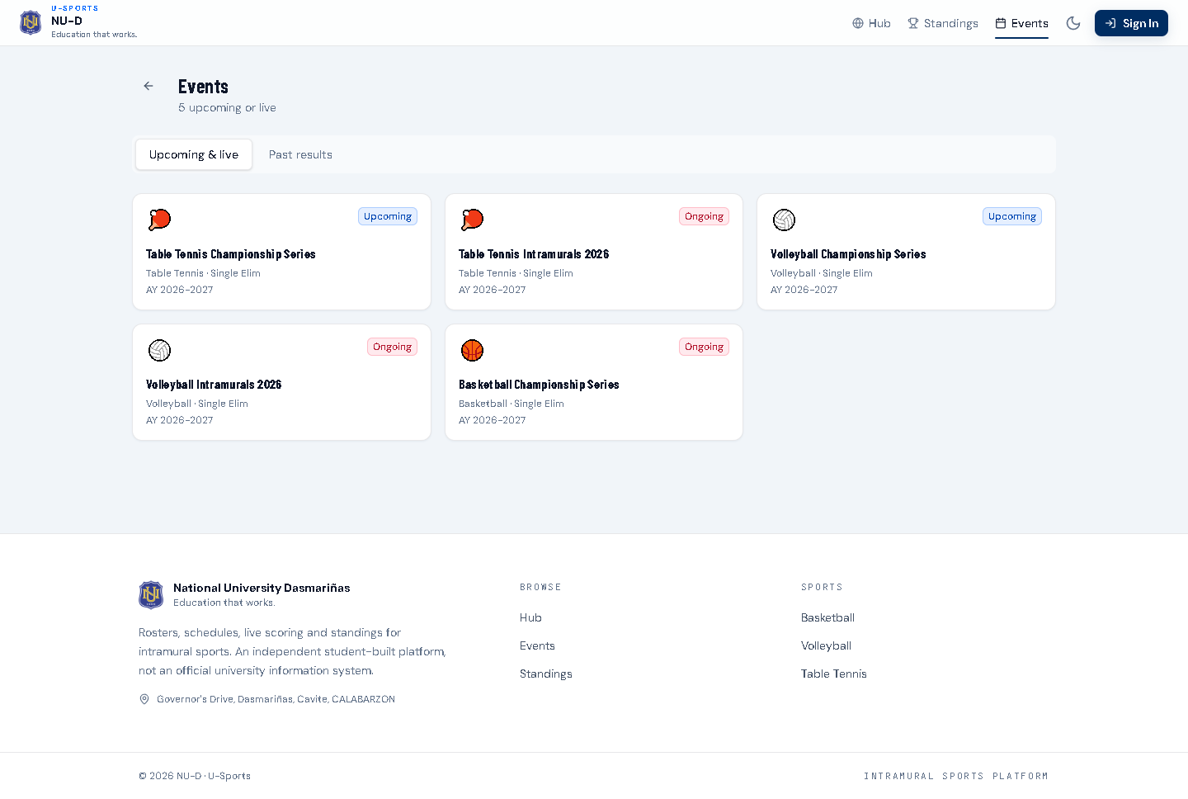 | Pass | Dacuba, Parco, Rodriguez  24 Sep 2026
1-4 | Verify that a guest can open an event and read its bracket. | 1. From Events, open an ongoing event.  2. Review the bracket and the match list. | Basketball Championship Series | - The bracket renders each round with live matches highlighted.  - Match entries show participants, status and schedule. | 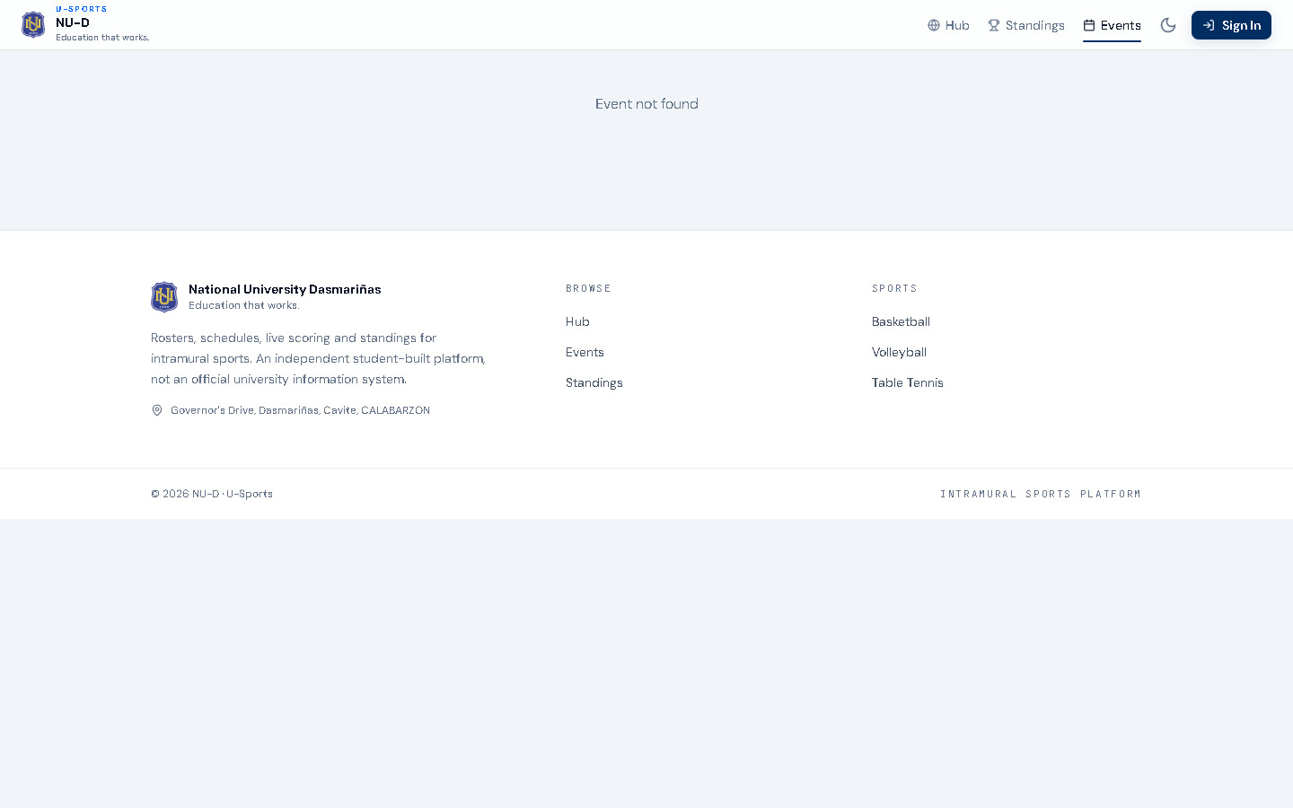 | Pass | Dacuba, Parco, Rodriguez  24 Sep 2026
1-5 | Verify that a guest can open a team page. | 1. From Standings or an event, open a team.  2. Review the record and roster. | Volleyball Team A | - The team page shows the season record and the full roster. | 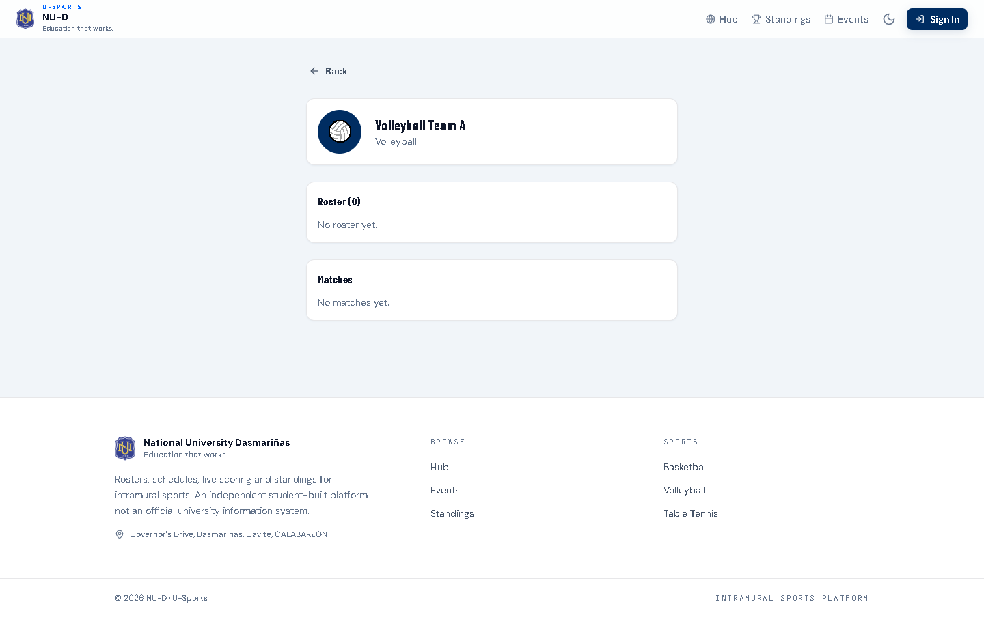 | Pass | Dacuba, Parco, Rodriguez  24 Sep 2026
1-6 | Verify that a guest can open an athlete profile. | 1. From a roster or leaderboard, open an athlete.  2. Review the profile and season statistics. | Registered athlete | - The profile shows department, year level, position and season statistics. | 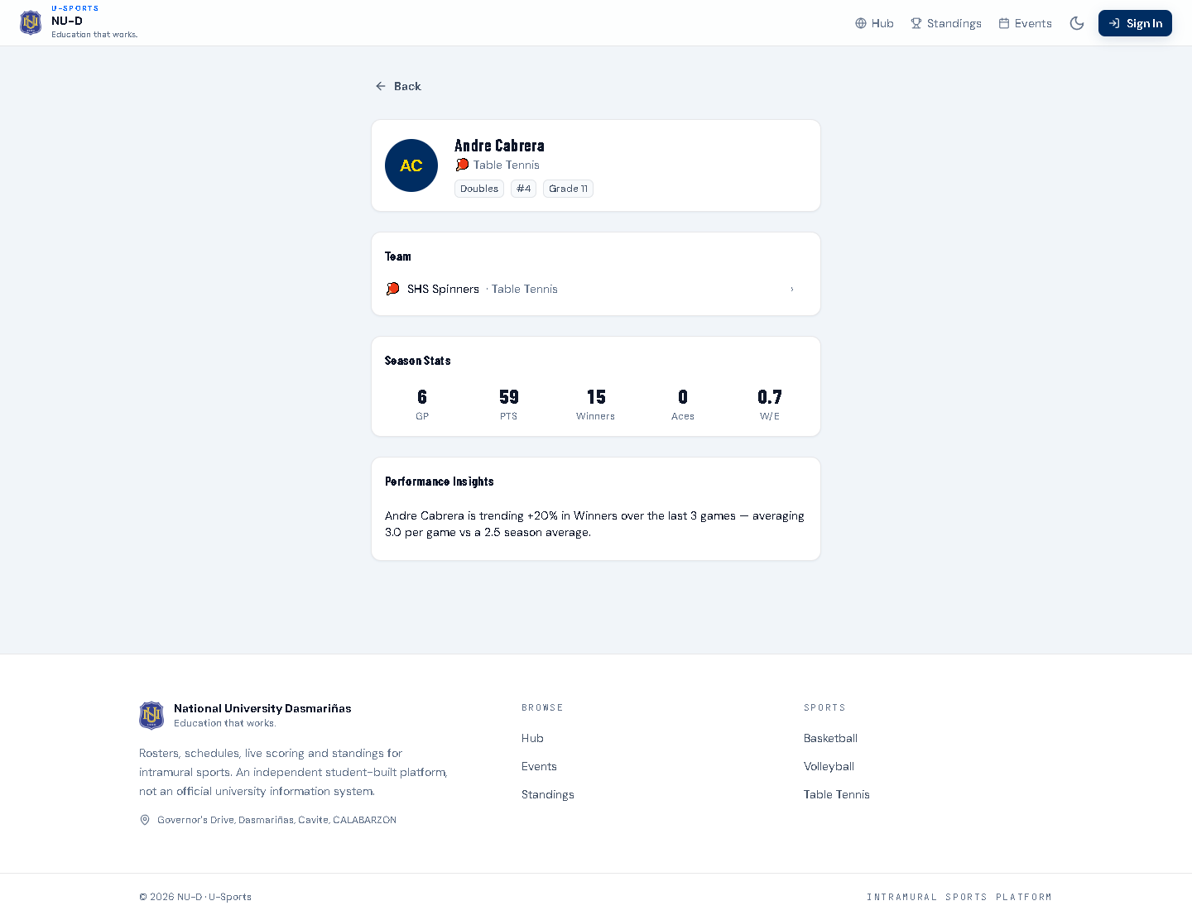 | Pass | Dacuba, Parco, Rodriguez  24 Sep 2026
2-1 | Verify that the sign-in page loads successfully. | 1. Open /auth/login.  2. Confirm the Email and Password fields and the Sign In button are present. | N/A | - The sign-in page loads with both fields, a password visibility toggle, a Forgot password link and a guest link. | 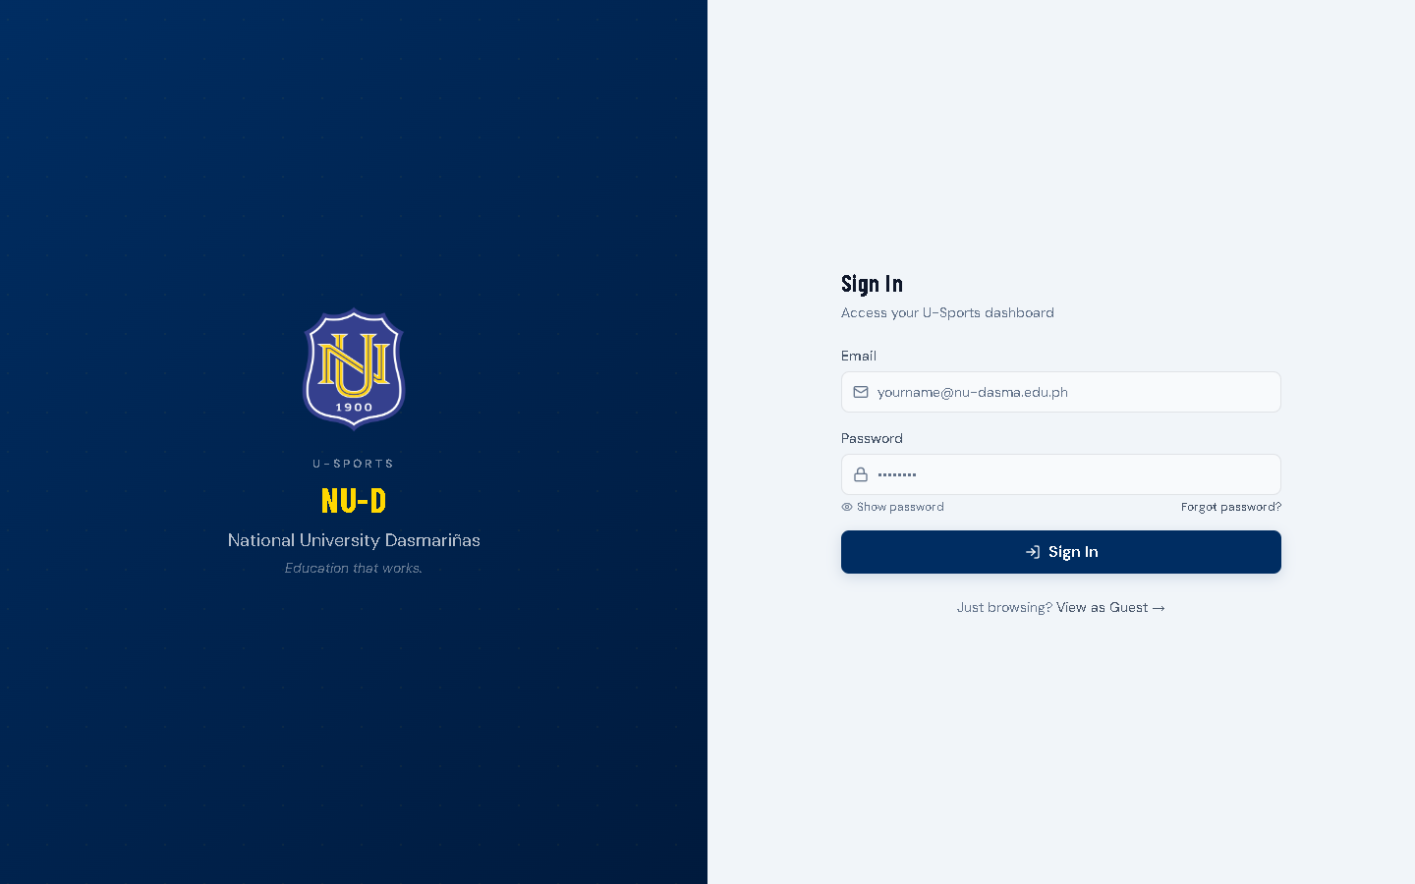 | Pass | Dacuba, Parco, Rodriguez  24 Sep 2026
2-2 | Verify required-field validation on the sign-in page. | 1. Open the sign-in page.  2. Leave the email and password fields empty.  3. Click Sign In. | Empty email and password | - The system blocks the attempt and reports that the fields are required.  - No request is sent and the user stays on the sign-in page. | 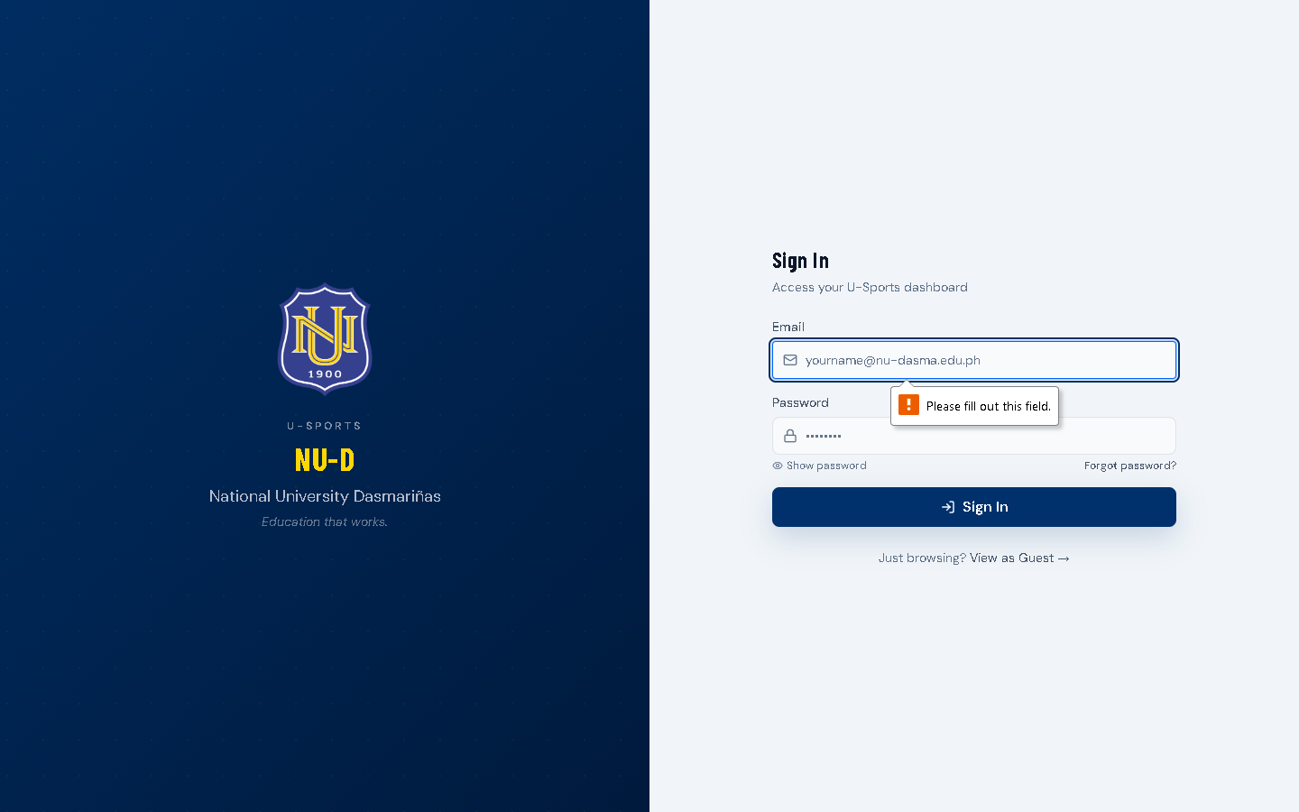 | Pass | Dacuba, Parco, Rodriguez  24 Sep 2026
2-3 | Verify sign-in with invalid credentials. | 1. Open the sign-in page.  2. Enter an unregistered email and an incorrect password.  3. Click Sign In. | wrong.user@nu-dasma.edu.ph / incorrect password | - The system refuses the sign-in and displays "Invalid login credentials".  - The user remains on the sign-in page and no session is created. | 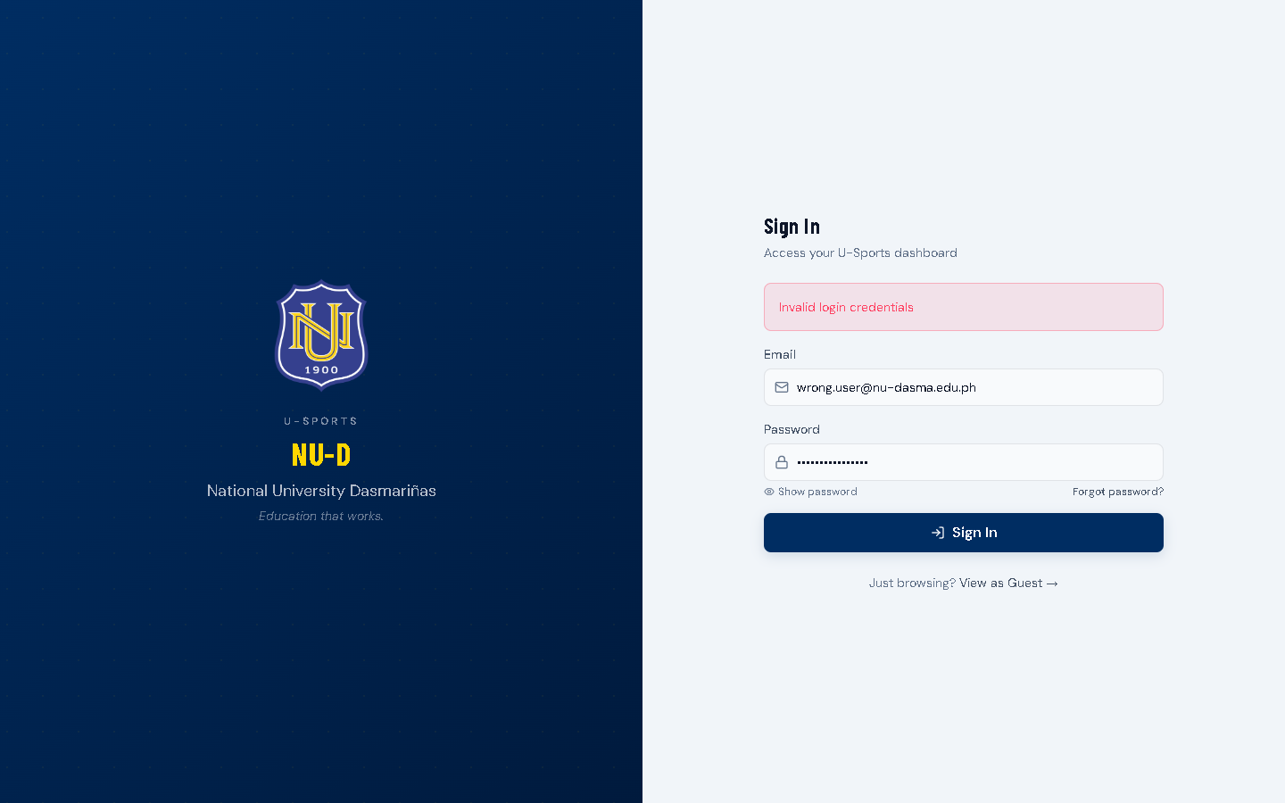 | Pass | Dacuba, Parco, Rodriguez  24 Sep 2026
2-4 | Verify that the forgot-password page loads. | 1. From the sign-in page, click Forgot password. | N/A | - The reset request page loads with an email field and a send action. | 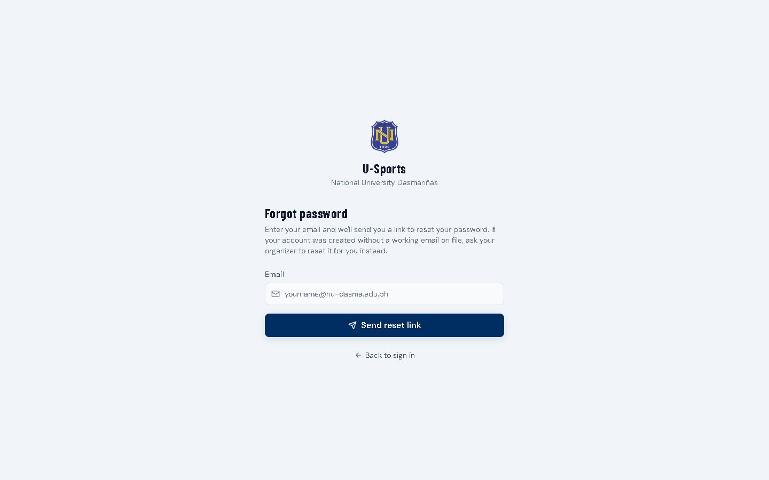 | Pass | Dacuba, Parco, Rodriguez  24 Sep 2026
2-5 | Verify the forgot-password request. | 1. Open the forgot-password page.  2. Enter a registered school email address.  3. Submit the request. | Registered school email address | - The system confirms that a reset link has been sent.  - The wording does not reveal whether the account exists, so the form cannot be used to enumerate accounts. | 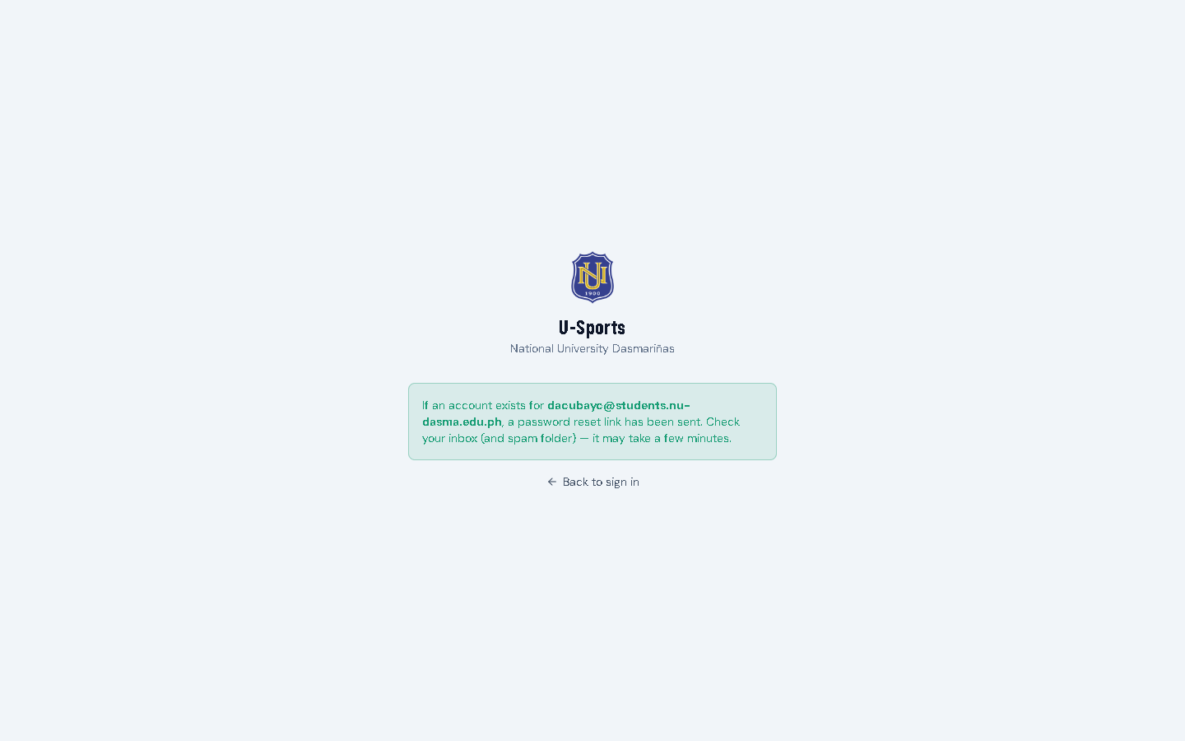 | Pass | Dacuba, Parco, Rodriguez  24 Sep 2026
3-1 | Verify that the data privacy notice blocks the application until it is answered. | 1. Sign in with an account that has not yet accepted the notice.  2. Attempt to reach a dashboard. | Account with no recorded consent | - The notice is shown full screen before any personal data.  - It cannot be dismissed by clicking away; the user must accept or sign out.  - Accepting records the consent and opens the dashboard. | 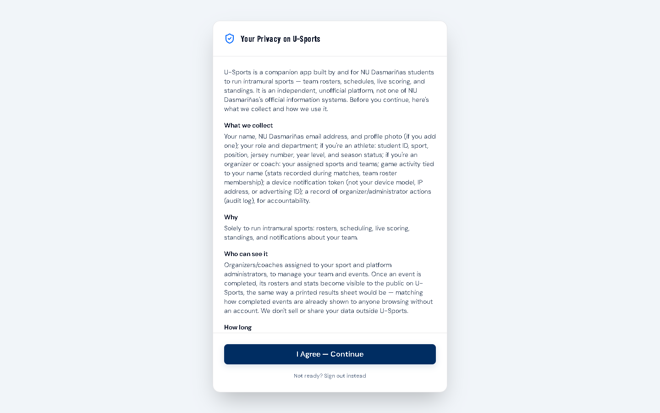 | Pass | Dacuba, Parco, Rodriguez  24 Sep 2026
3-2 | Verify that the privacy notice is readable outside the sign-in flow. | 1. Open /privacy-notice as a guest. | N/A | - The full notice is readable without signing in. | 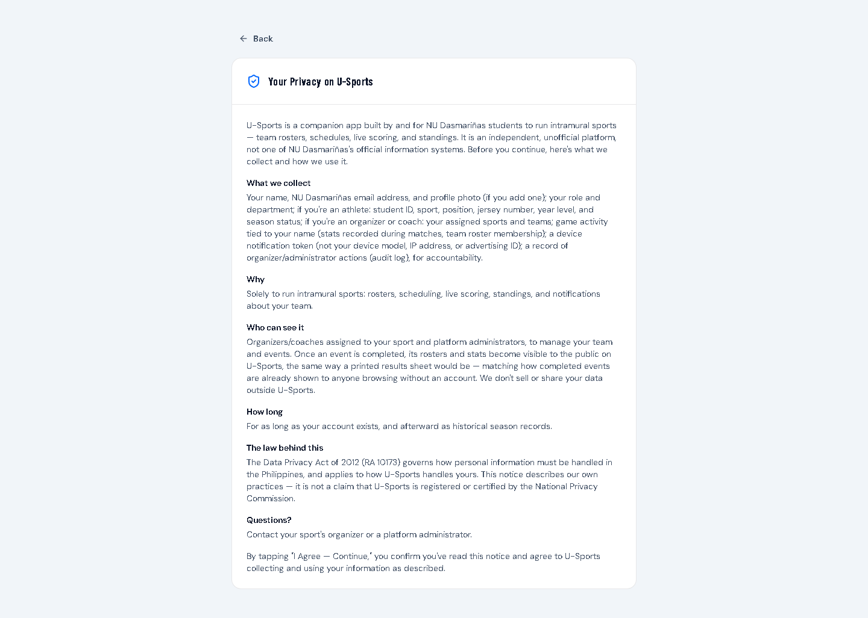 | Pass | Dacuba, Parco, Rodriguez  24 Sep 2026
4-1 | Verify that the Super Admin dashboard loads with its summary cards. | 1. Sign in as a Super Admin.  2. Confirm the dashboard cards and side navigation render. | Super Admin account | - The dashboard shows the key counts and the full administrator navigation. | 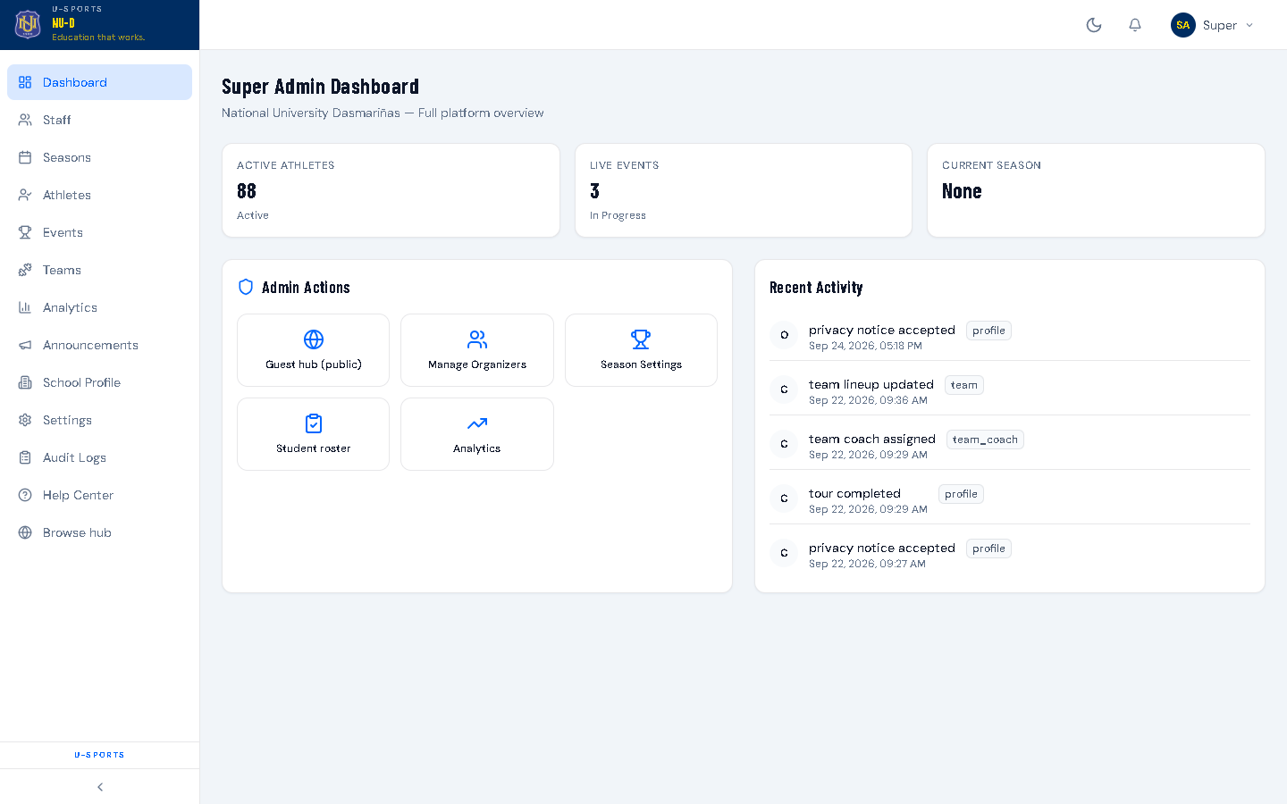 | Pass | Dacuba, Parco, Rodriguez  24 Sep 2026
4-2 | Verify Super Admin staff account management. | 1. Open Staff.  2. Review the staff list and the available actions. | Existing staff accounts | - Organizers, Coaches and Super Admins are listed with Add staff, Add Super Admin, Edit, Deactivate and Reset password actions. | 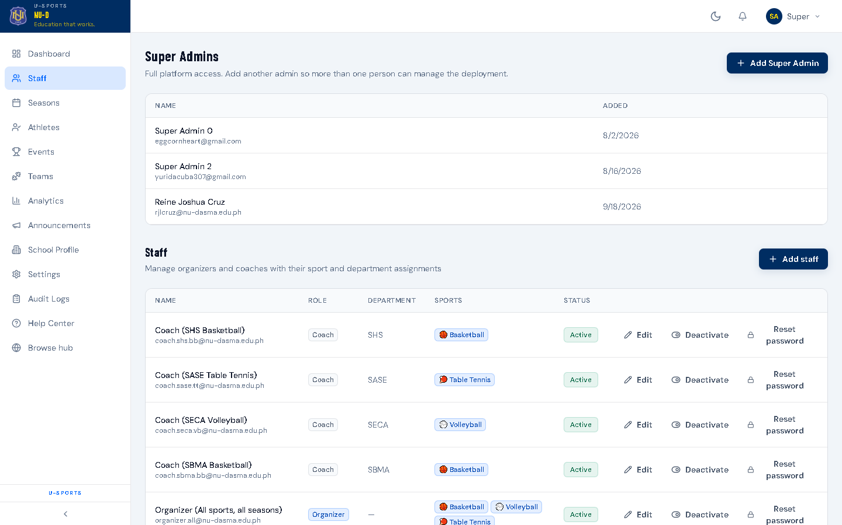 | Pass | Dacuba, Parco, Rodriguez  24 Sep 2026
4-3 | Verify Super Admin season management. | 1. Open Seasons.  2. Review the seasons and their controls. | Existing seasons | - Each academic-year season is listed with its status and New Season, Edit, Activate and Archive actions. | 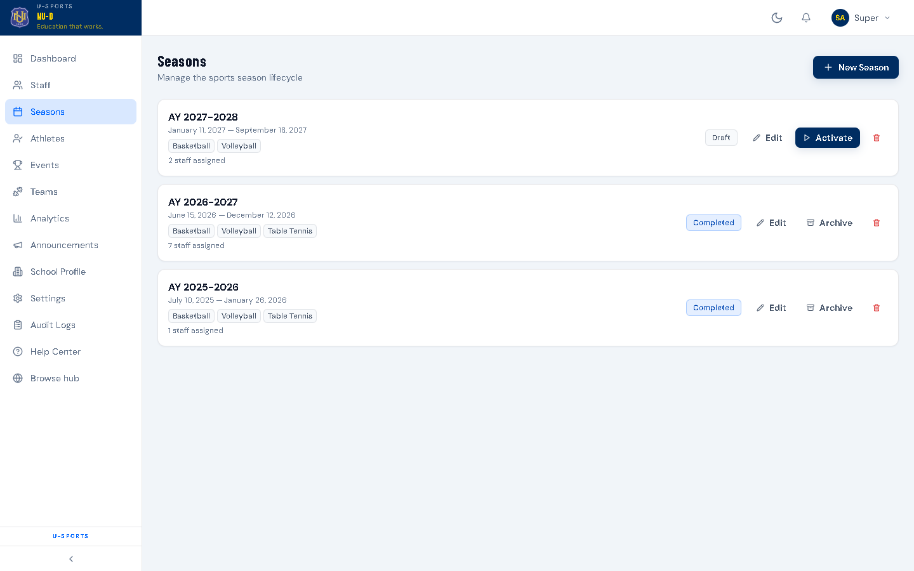 | Pass | Dacuba, Parco, Rodriguez  24 Sep 2026
4-4 | Verify the school profile page. | 1. Open School Profile.  2. Review the institution fields. | Current institution profile | - Institution name, tagline, address, logo and brand colours are shown and editable. | 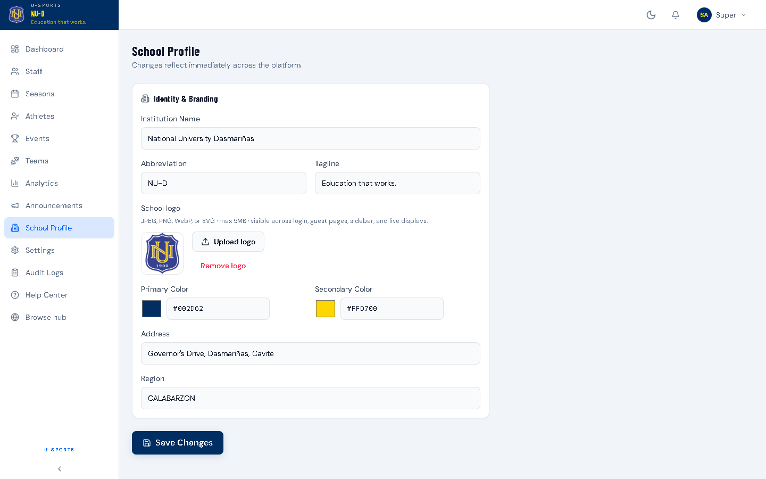 | Pass | Dacuba, Parco, Rodriguez  24 Sep 2026
4-5 | Verify Super Admin account preferences. | 1. Open Settings.  2. Review the profile, password and privacy controls. | Super Admin account | - The page offers photo change, password update, Help Center, privacy notice and sign out. | 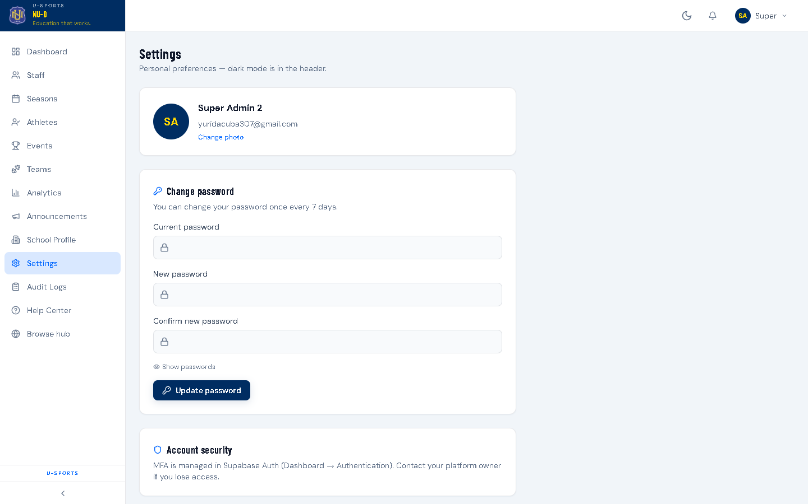 | Pass | Dacuba, Parco, Rodriguez  24 Sep 2026
4-6 | Verify the audit log. | 1. Open Audit Logs.  2. Review the entries and paging controls. | Recorded administrator actions | - Administrator and organizer actions are listed in order with working previous/next paging. | 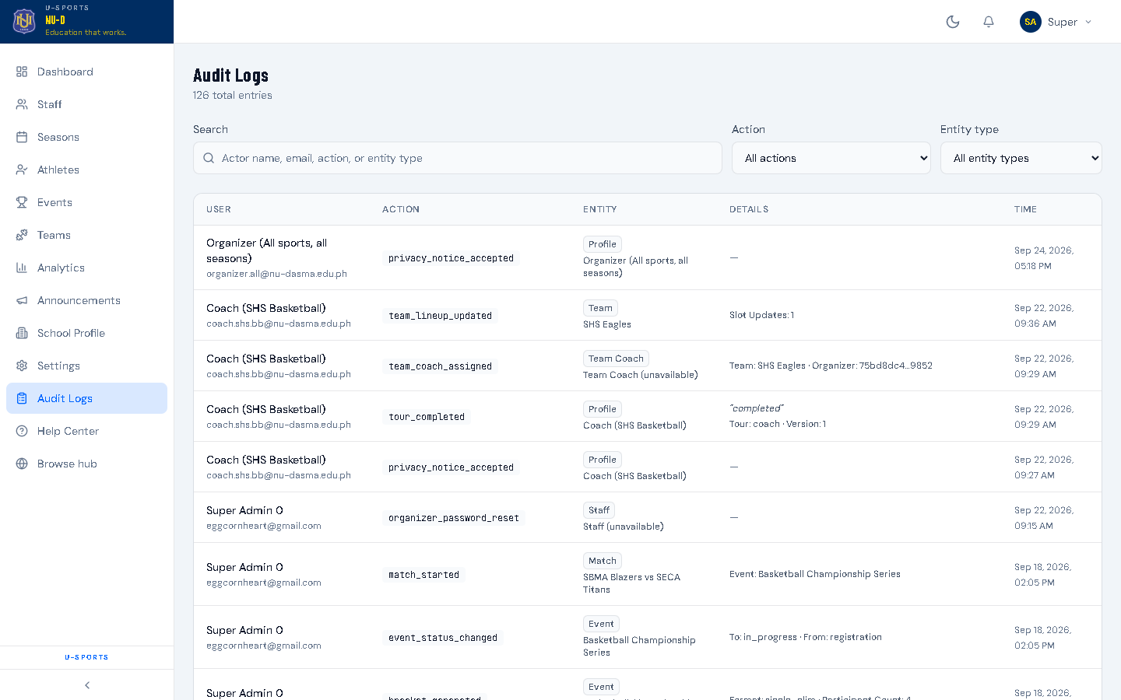 | Pass | Dacuba, Parco, Rodriguez  24 Sep 2026
5-1 | Verify that the Organizer dashboard loads. | 1. Sign in as an Organizer.  2. Review the dashboard cards and quick actions. | Organizer account (all sports) | - The dashboard shows the season summary with Score Now, Jumbotron, New Event and management shortcuts. | 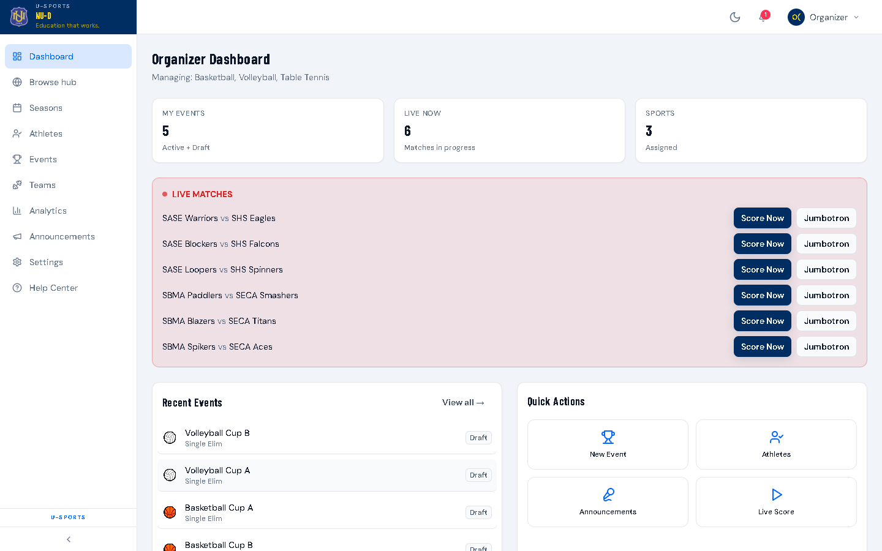 | Pass | Dacuba, Parco, Rodriguez  24 Sep 2026
5-2 | Verify the event management list and its filters. | 1. Open Events.  2. Switch between the Active, Completed, Cancelled and All filters. | Existing events | - Events are listed with sport, season and status.  - Each filter narrows the list and the count follows the filter. | 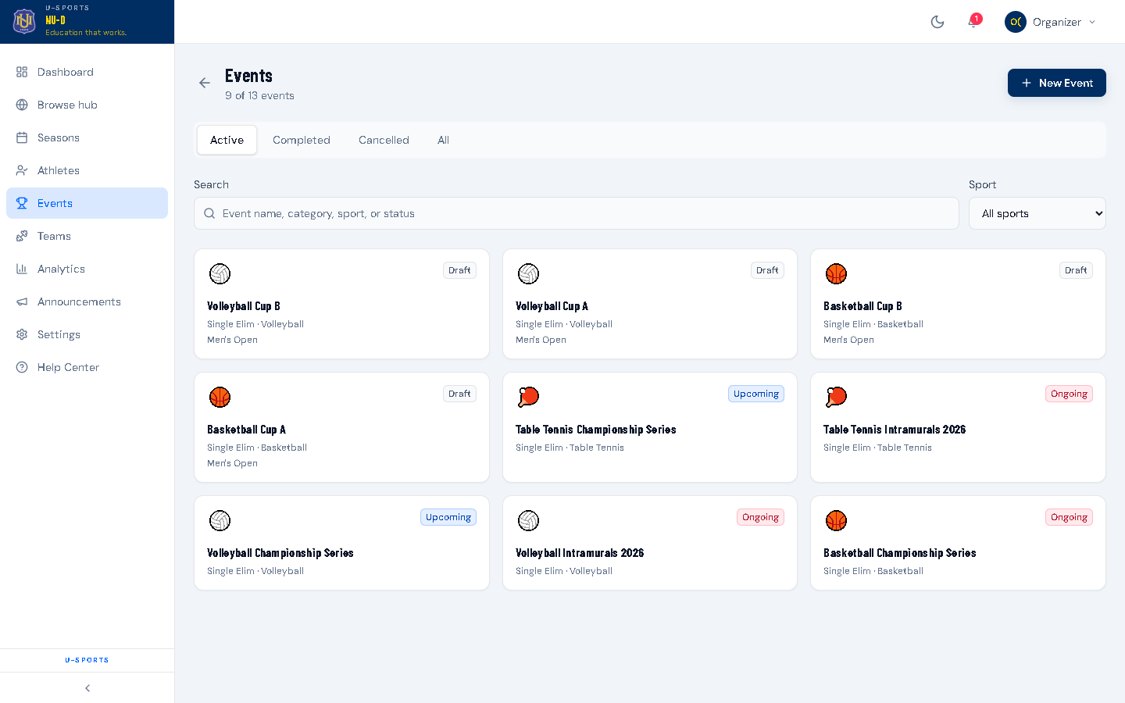 | Pass | Dacuba, Parco, Rodriguez  24 Sep 2026
5-3 | Verify the organizer event detail page. | 1. Open an ongoing event from the list.  2. Review the bracket, matches and team tabs. | Basketball Championship Series | - The event detail shows Bracket, Matches and Teams tabs with Edit details, Mark finished, Cancel event, Delete, Regenerate and Export PNG actions. | 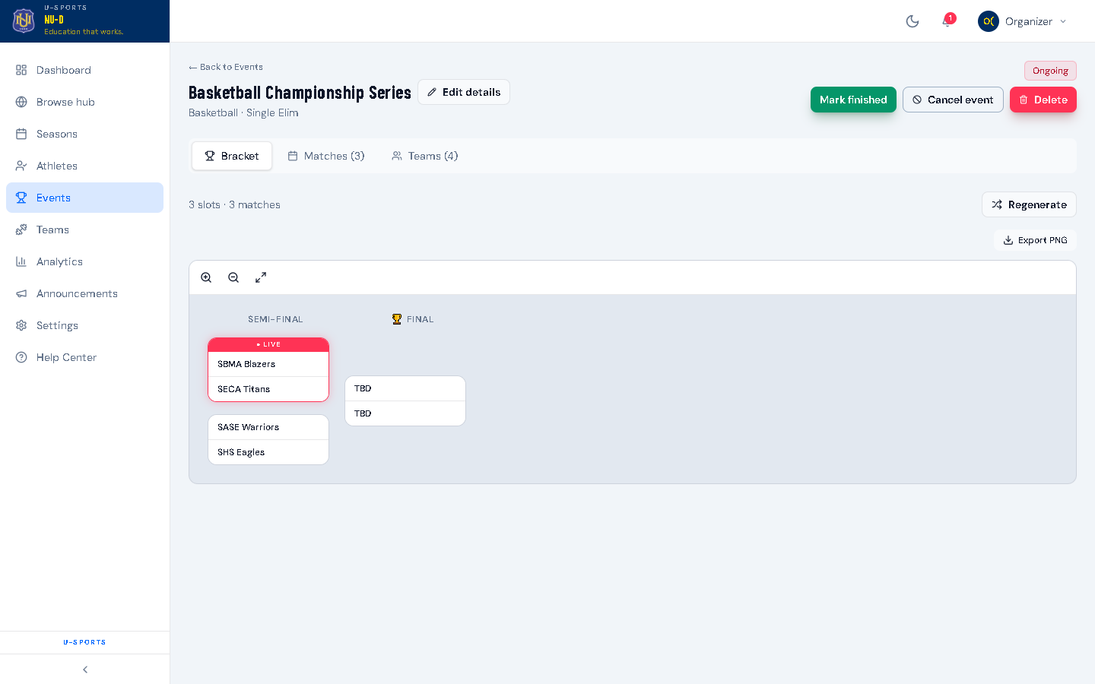 | Pass | Dacuba, Parco, Rodriguez  24 Sep 2026
5-4 | Verify athlete account management. | 1. Open Athletes.  2. Review the list and the per-row actions. | Registered athletes | - Athletes are listed with department, year level and status.  - Add athlete, Import roster, Export CSV, Edit, Deactivate, Reset password and Delete are available. | 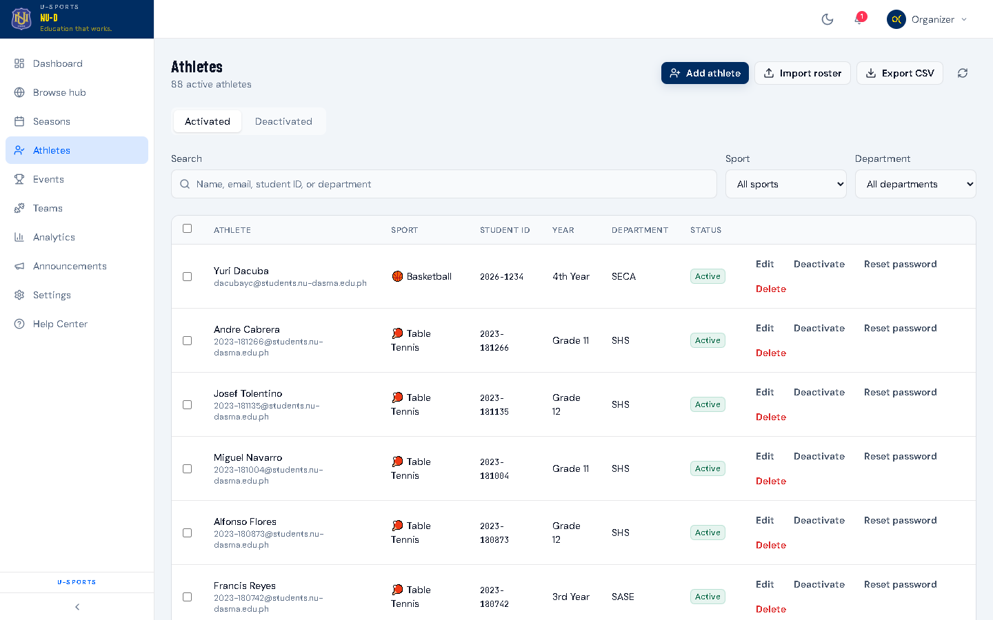 | Pass | Dacuba, Parco, Rodriguez  24 Sep 2026
5-5 | Verify team management. | 1. Open Teams.  2. Review the teams, rosters and lineup controls. | Existing teams | - Teams are listed by sport and department with Import teams, New Team, roster and starting-lineup controls. | 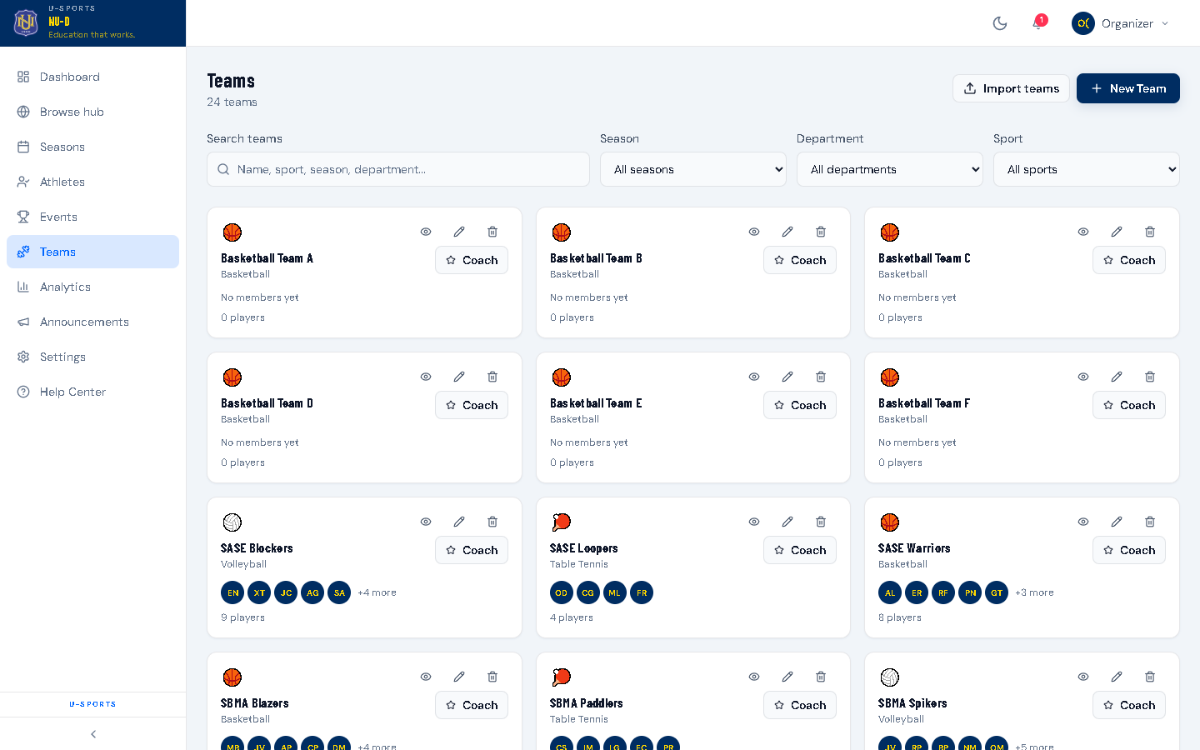 | Pass | Dacuba, Parco, Rodriguez  24 Sep 2026
5-6 | Verify season management from the organizer shell. | 1. Open Seasons.  2. Review the listed seasons. | Existing seasons | - Seasons are listed with their status and date range. | 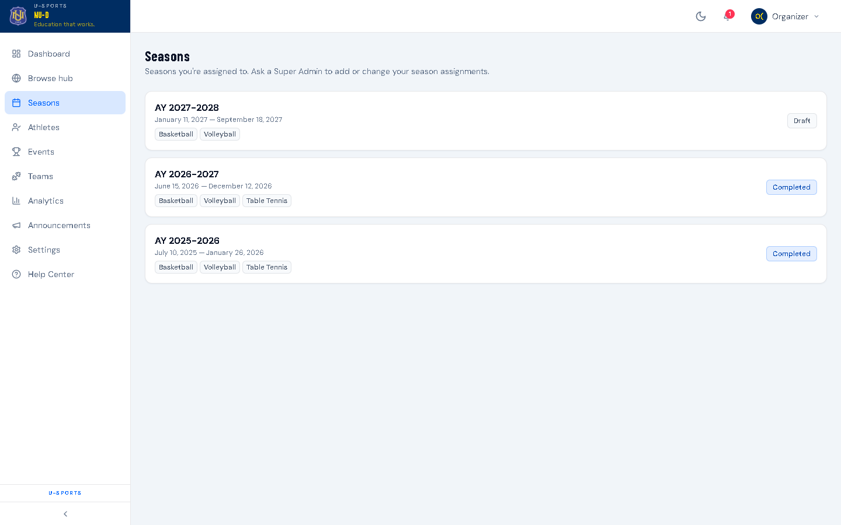 | Pass | Dacuba, Parco, Rodriguez  24 Sep 2026
5-7 | Verify the analytics module. | 1. Open Analytics.  2. Switch between Leaderboard, Insights, Event results, Teams and Score Sheets. | Completed season data | - Each tab renders its statistics for the selected sport and season, with Export CSV available. | 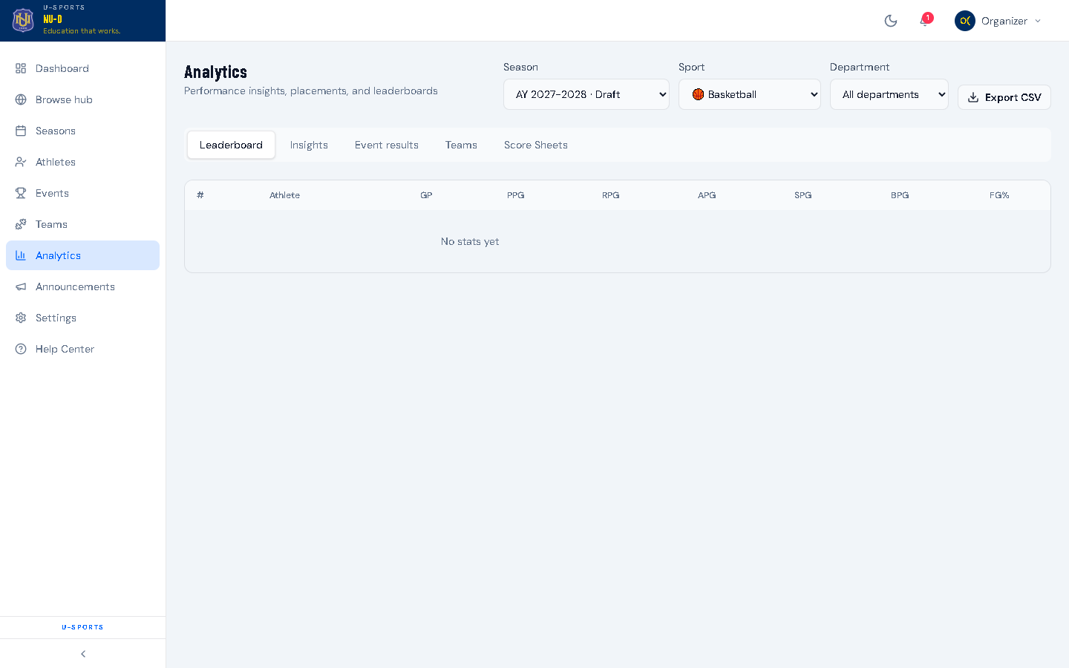 | Pass | Dacuba, Parco, Rodriguez  24 Sep 2026
5-8 | Verify the announcements module. | 1. Open Announcements.  2. Review the posted announcements and the New Announcement action. | Posted announcements | - Posted announcements are listed and a new one can be composed. | 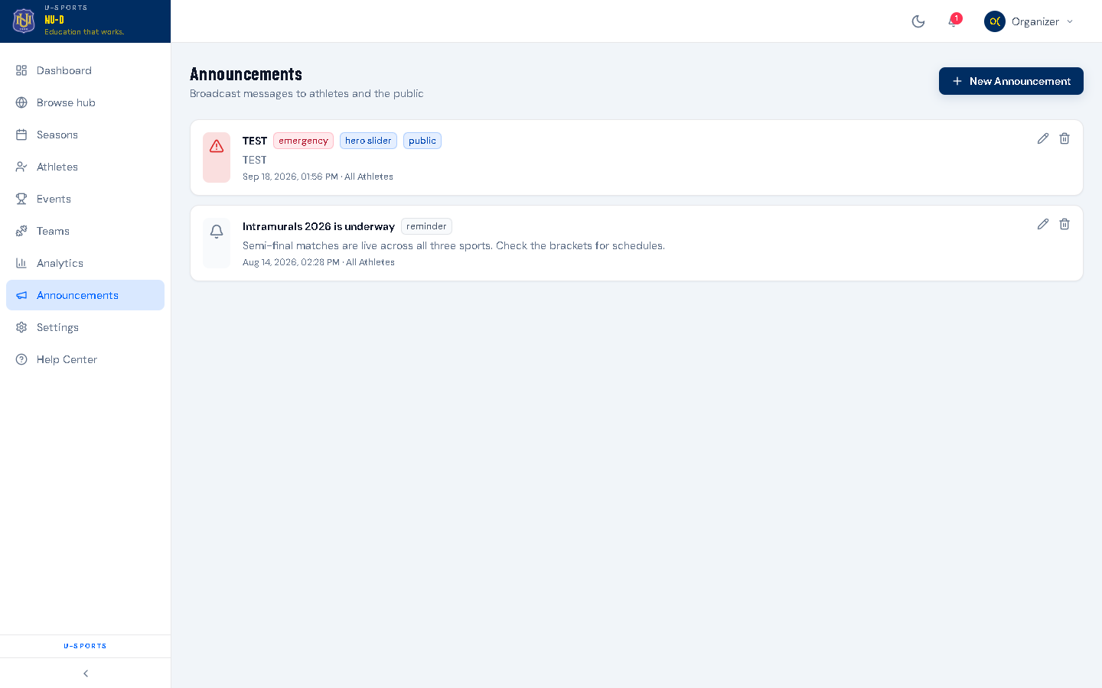 | Pass | Dacuba, Parco, Rodriguez  24 Sep 2026
5-9 | Verify organizer account settings. | 1. Open Settings.  2. Review the profile, password and privacy controls. | Organizer account | - The page offers photo change, password update, Help Center, privacy notice and sign out. | 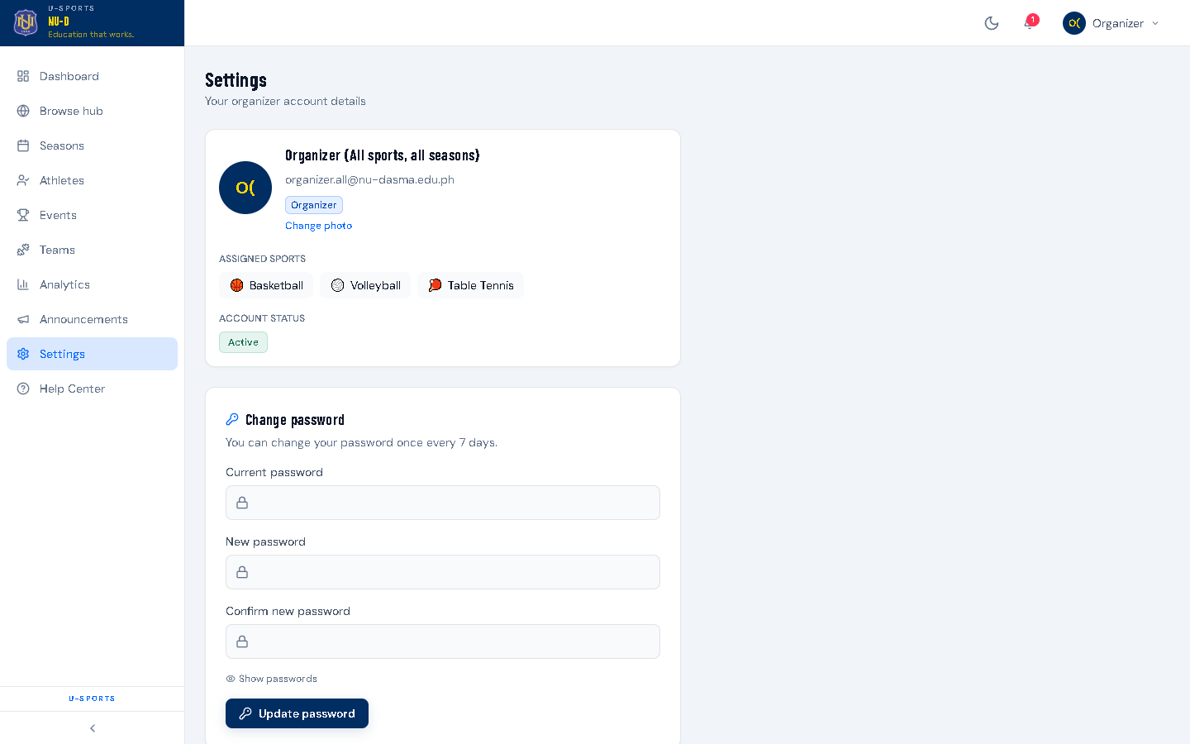 | Pass | Dacuba, Parco, Rodriguez  24 Sep 2026
5-10 | Verify the notifications page. | 1. Open Notifications.  2. Review the list and its filters. | Existing notifications | - Notifications are listed with All, Unread and Recent filters plus Mark all read and Clear all. | 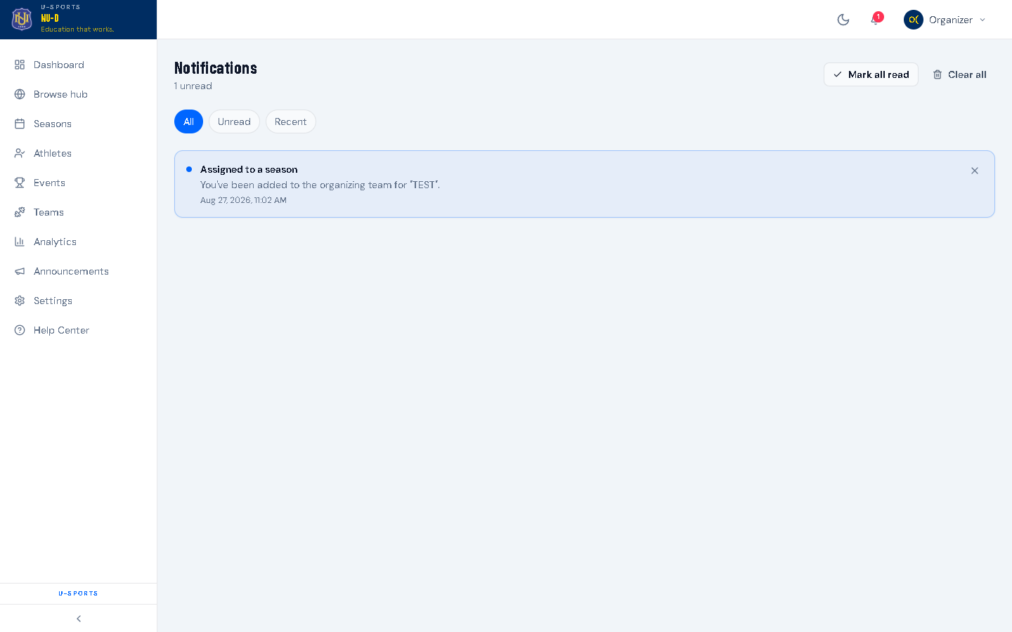 | Pass | Dacuba, Parco, Rodriguez  24 Sep 2026
5-11 | Verify the Help Center. | 1. Open Help Center.  2. Review the guidance articles. | N/A | - Role-specific guidance is presented and navigable. | 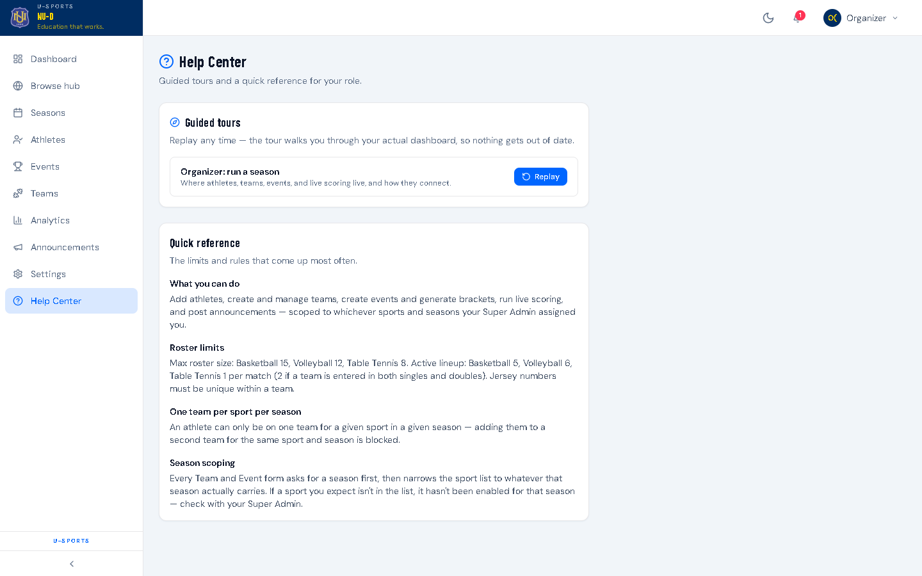 | Pass | Dacuba, Parco, Rodriguez  24 Sep 2026
6-1 | Verify the live scoring screen and the scoring lock. | 1. Open a live match from the dashboard or event.  2. Review the score controls, player chips and stat buttons.  3. Confirm the scoring-lock state is reported. | Live volleyball match (SBMA Spikers vs SECA Aces) | - Both sides render with running score, set-by-set totals and per-player stat buttons.  - Because another organizer holds the scoring lock, the screen reports Stat Tracker Mode and allows stat recording but not point awarding — so two organizers cannot award points at the same time. | 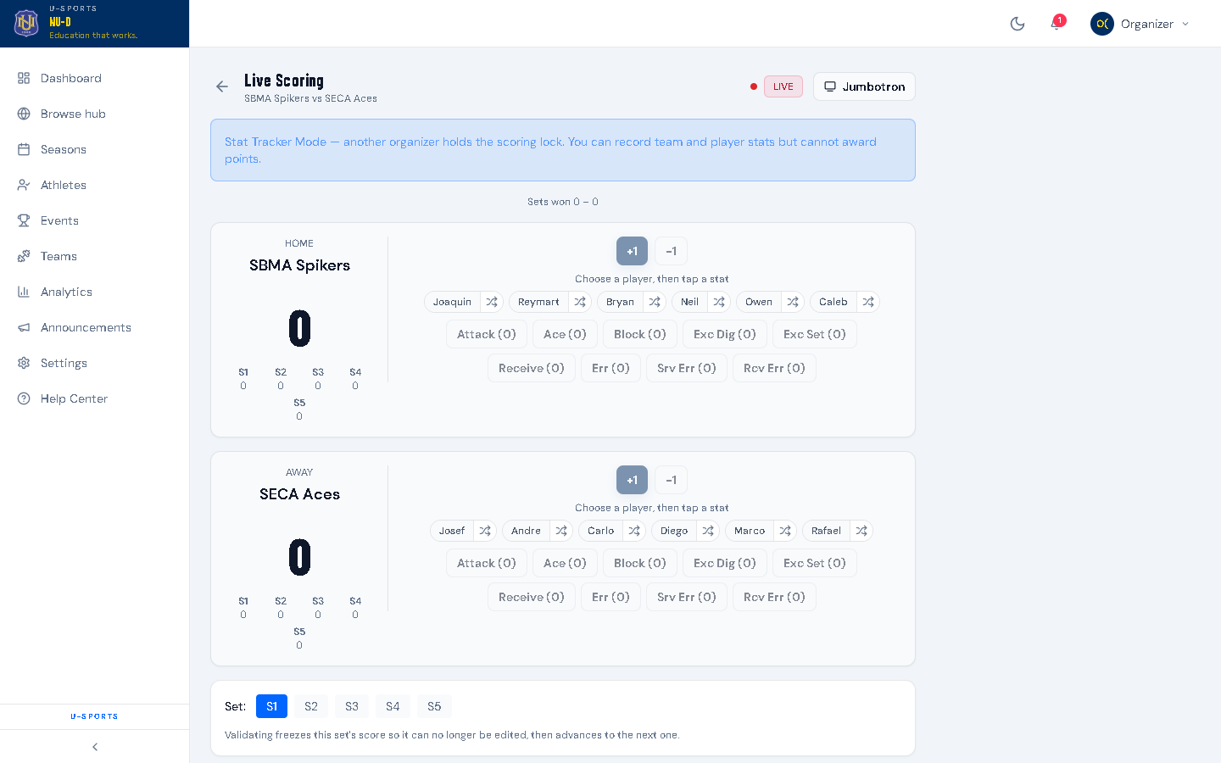 | Pass | Dacuba, Parco, Rodriguez  24 Sep 2026
6-2 | Verify the match review screen. | 1. Open a completed match.  2. Review the result and box score. | Completed basketball match | - The final result and per-player box score are shown with View Score Sheet, View Analytics and Edit stats actions. | 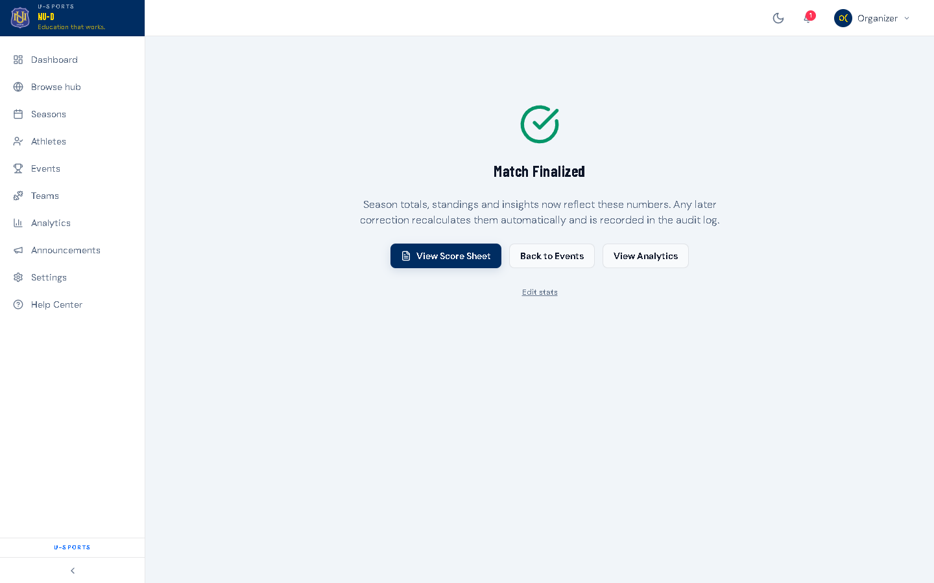 | Pass | Dacuba, Parco, Rodriguez  24 Sep 2026
6-3 | Verify the official score sheet. | 1. From match review, open View Score Sheet. | Completed basketball match | - The printable score sheet renders with both rosters and their recorded statistics. | 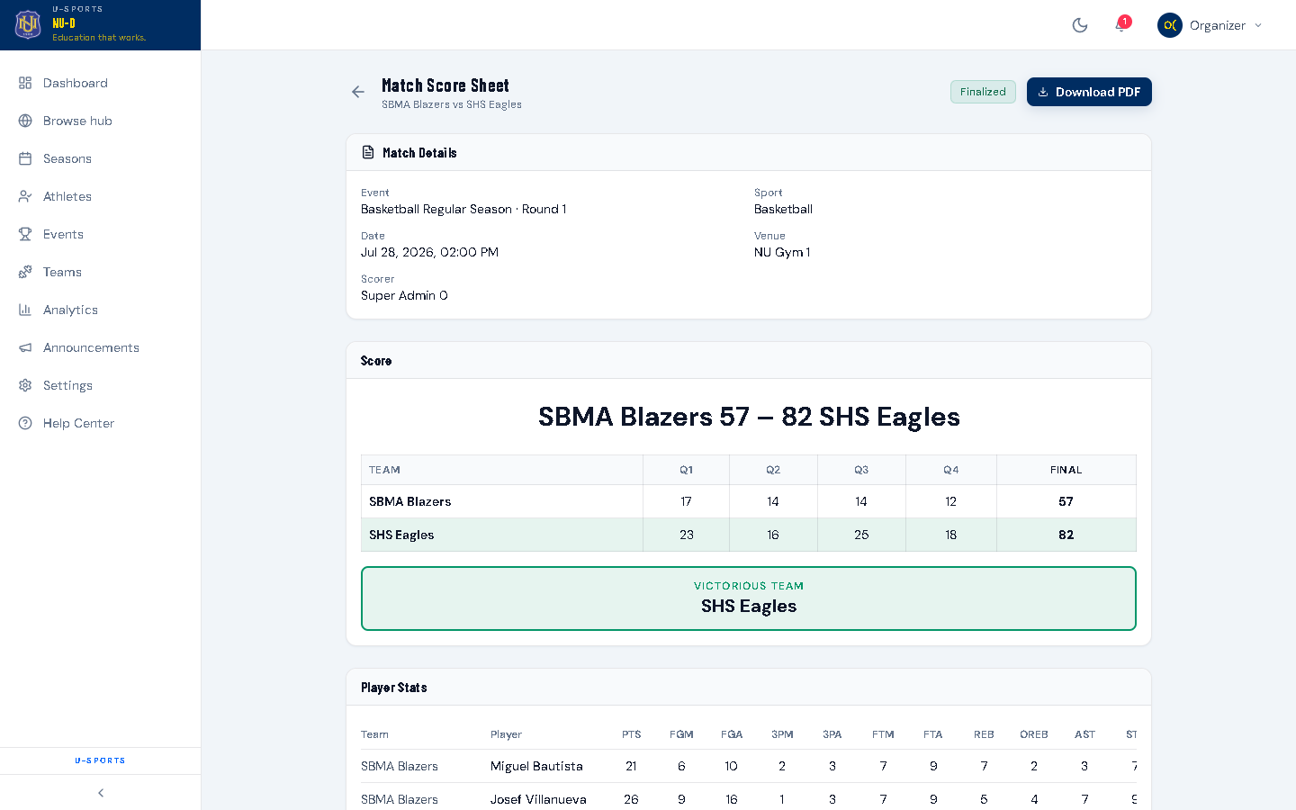 | Pass | Dacuba, Parco, Rodriguez  24 Sep 2026
6-4 | Verify the jumbotron scoreboard. | 1. Open the jumbotron address for a live match. | Live match | - The full-screen venue scoreboard renders with the live score and clock. | 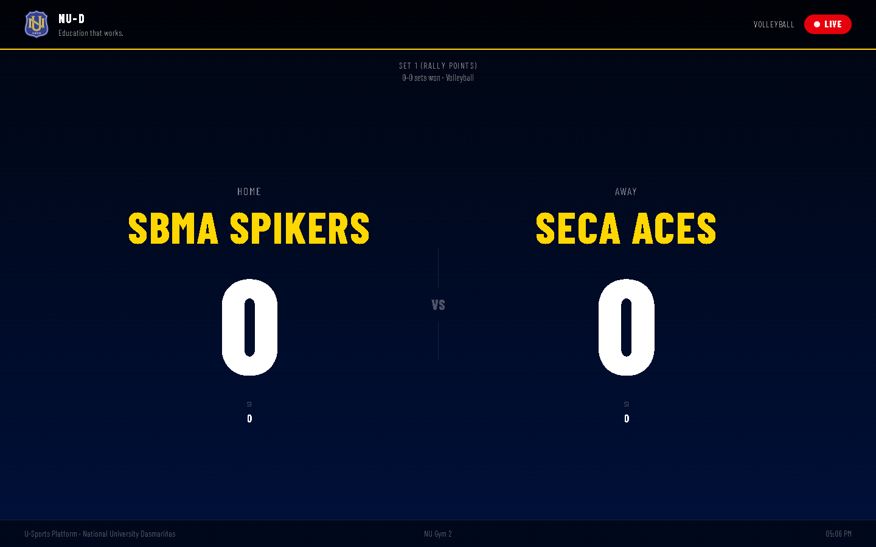 | Pass | Dacuba, Parco, Rodriguez  24 Sep 2026
7-1 | Verify that a Coach sees a dashboard scoped to their own assignment. | 1. Sign in as a Coach.  2. Review the dashboard and side navigation. | Coach account (SBMA Basketball) | - The Coach lands on a dashboard offering Teams, Athletes and Analytics.  - Administrator-only destinations (Staff, School Profile, Audit Logs) are absent from the navigation. | 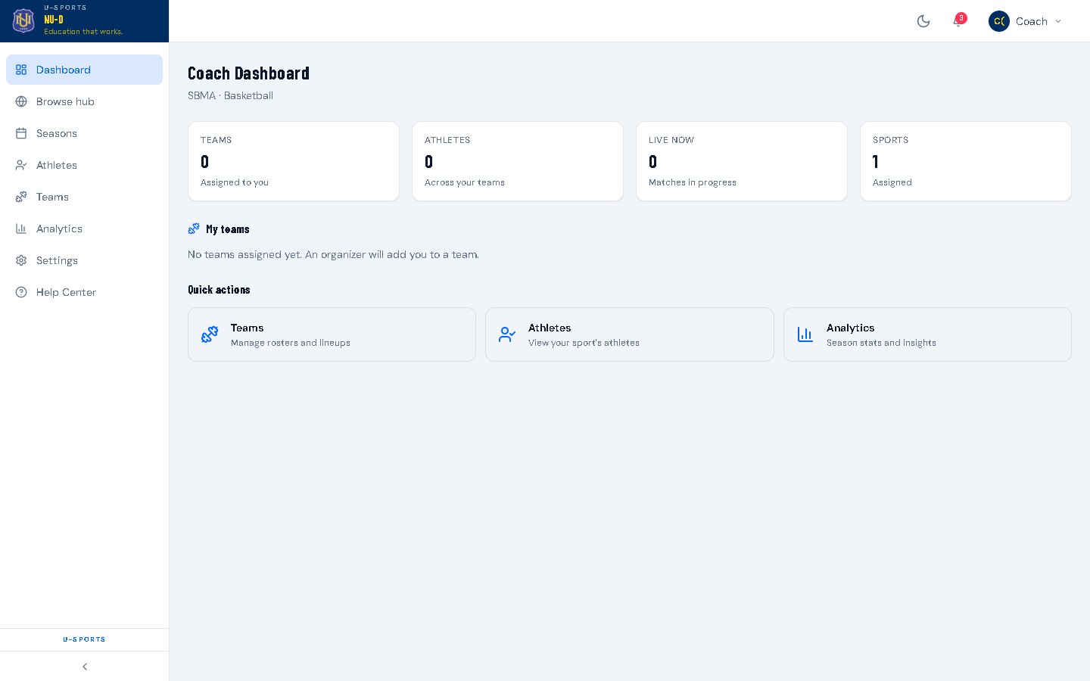 | Pass | Dacuba, Parco, Rodriguez  24 Sep 2026
7-2 | Verify the Coach team view. | 1. Open Teams as a Coach. | Coach account | - Teams render with roster and lineup controls. | 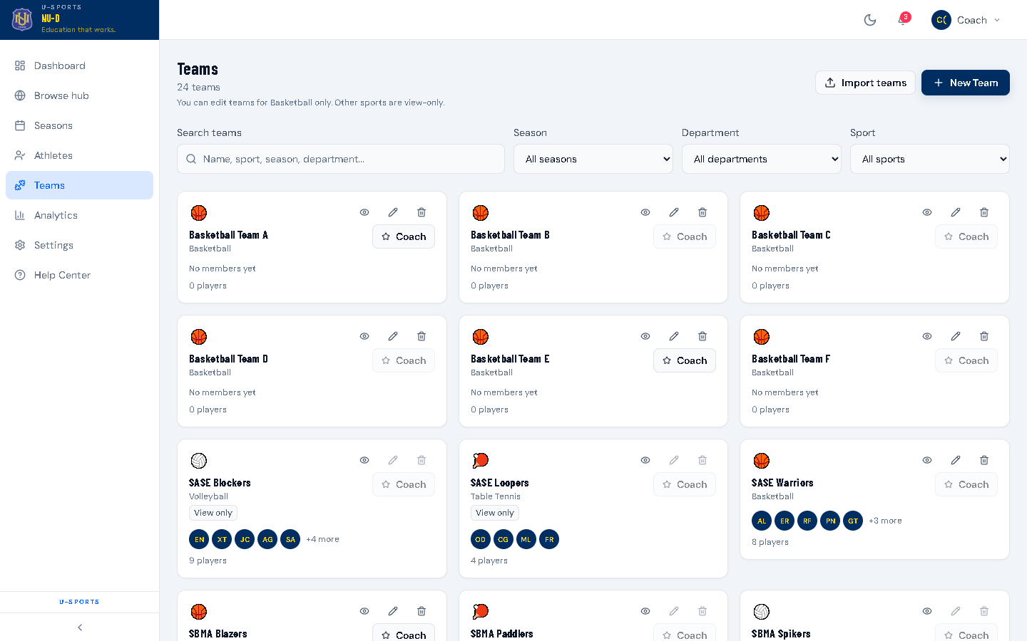 | Pass | Dacuba, Parco, Rodriguez  24 Sep 2026
7-3 | Verify the Coach athlete view. | 1. Open Athletes as a Coach. | Coach account | - Athletes render for the sports the Coach is assigned to. | 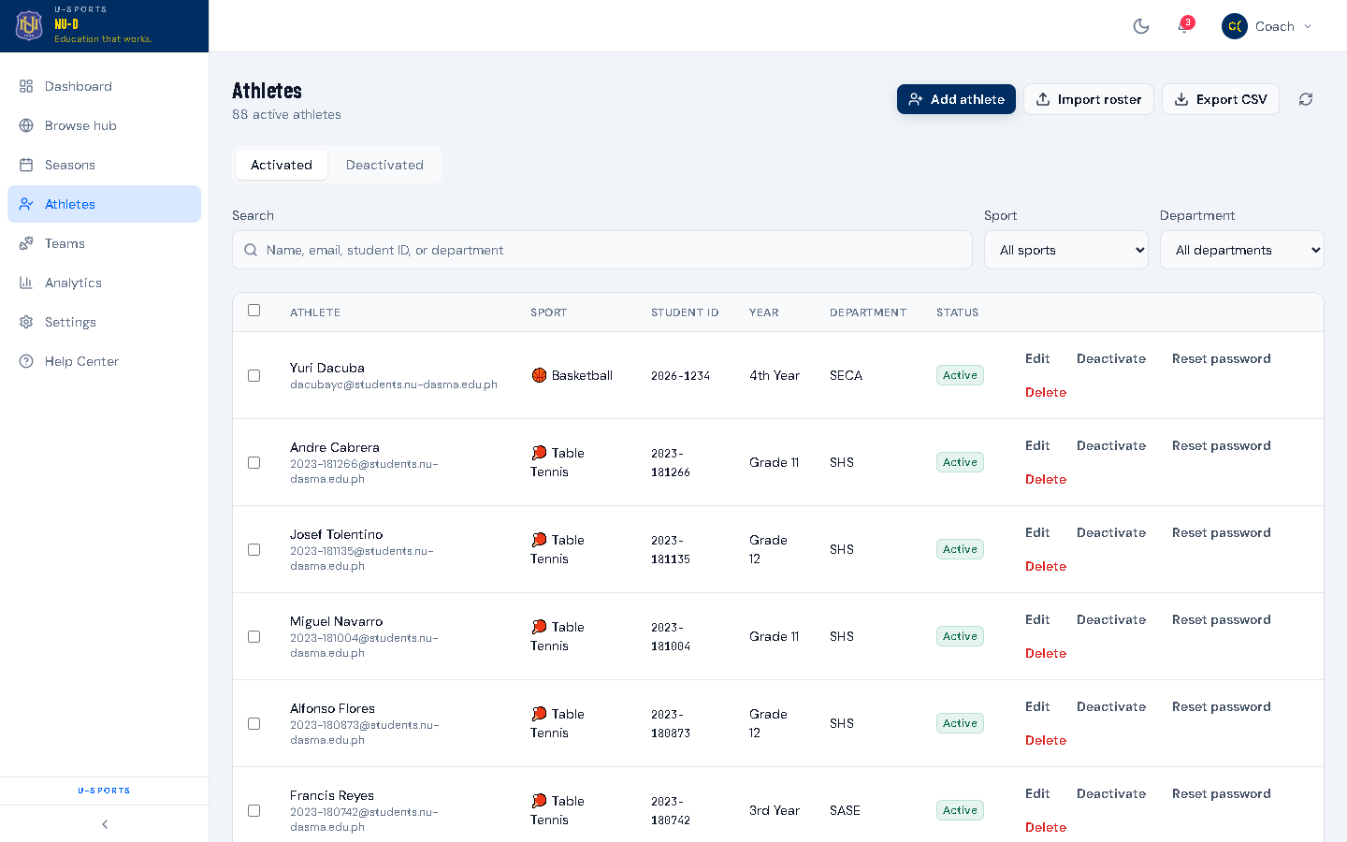 | Pass | Dacuba, Parco, Rodriguez  24 Sep 2026
7-4 | Verify the Coach event view. | 1. Open Events as a Coach. | Coach account | - Events render with the same filters available to an Organizer. | 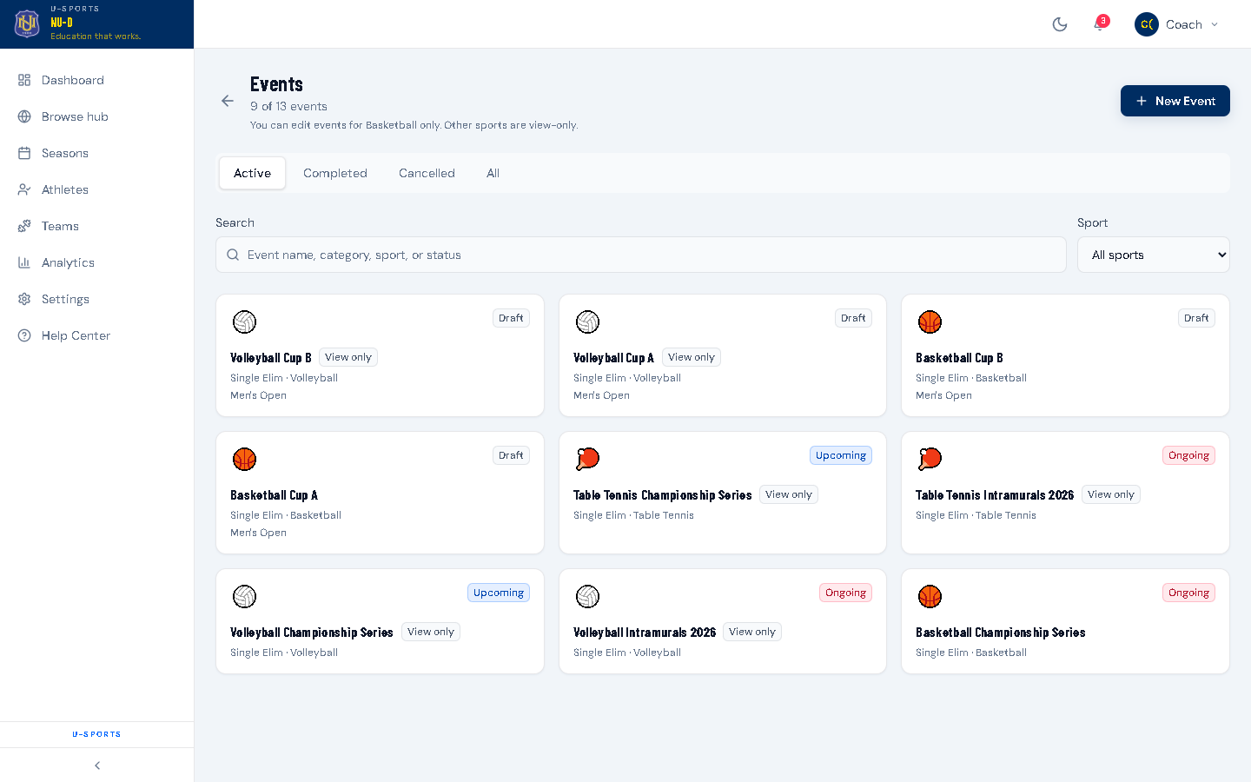 | Pass | Dacuba, Parco, Rodriguez  24 Sep 2026
7-5 | Verify Coach account settings. | 1. Open Settings as a Coach. | Coach account | - Profile, password, Help Center, privacy notice and sign out are available. | 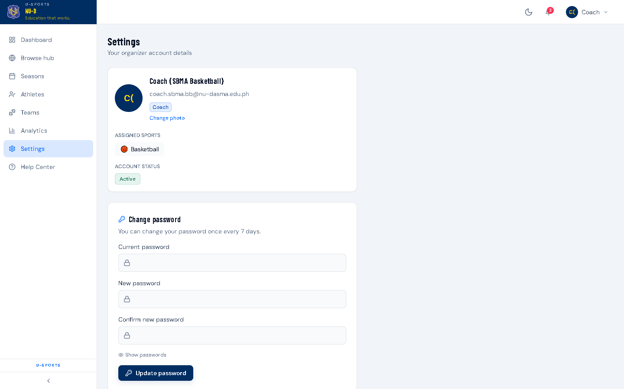 | Pass | Dacuba, Parco, Rodriguez  24 Sep 2026
8-1 | Verify the athlete dashboard. | 1. Sign in as an Athlete.  2. Review the dashboard. | Athlete account | - The dashboard shows the athlete’s live and past matches and their team roster. | 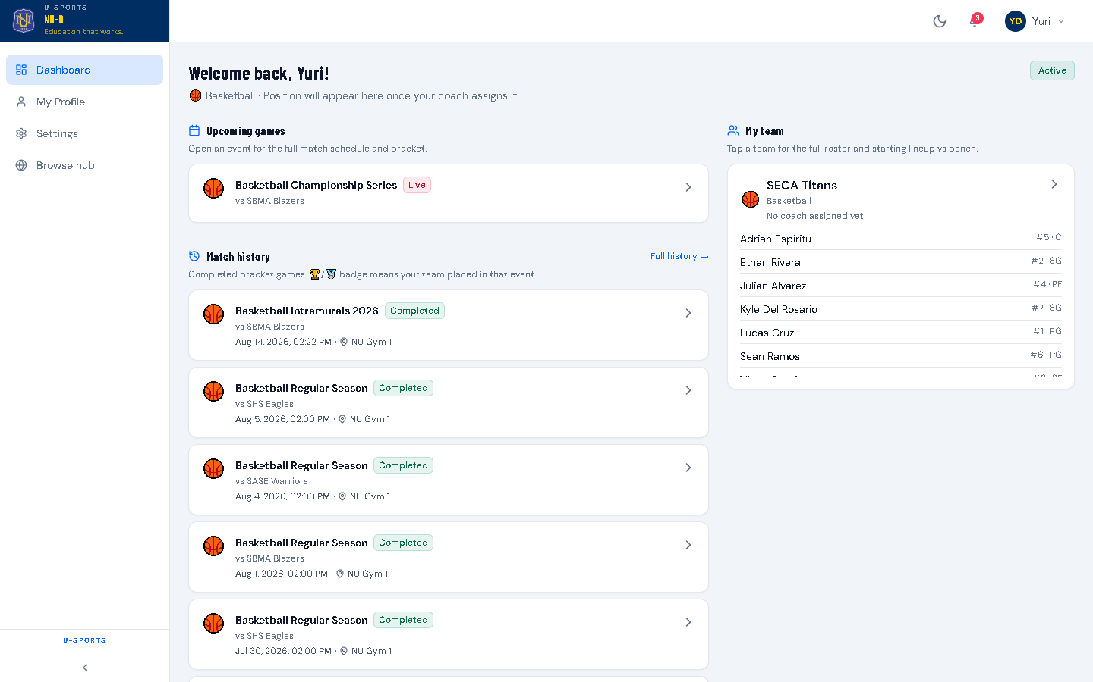 | Pass | Dacuba, Parco, Rodriguez  24 Sep 2026
8-2 | Verify the athlete profile page. | 1. Open My Profile. | Athlete account | - The athlete’s own details and season statistics are shown. | 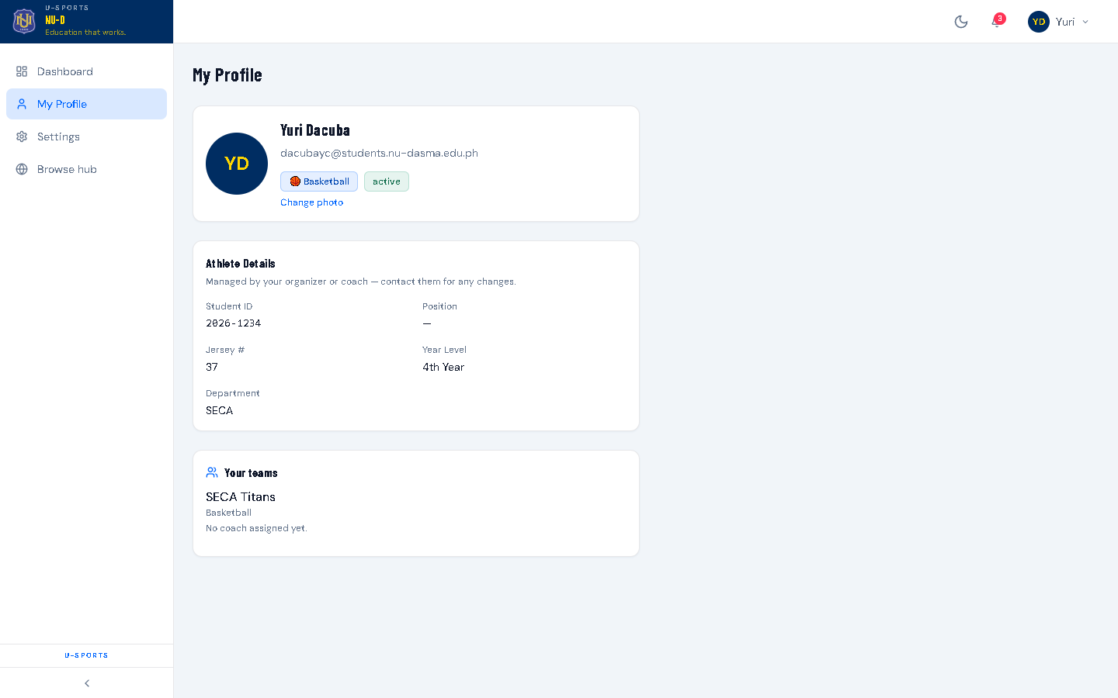 | Pass | Dacuba, Parco, Rodriguez  24 Sep 2026
8-3 | Verify the athlete My Events page. | 1. Open My Events as an Athlete whose team is entered in an ongoing event. | Athlete account entered in Basketball Championship Series | - The page should list the events the athlete is participating in.  - OBSERVED: the page always reports "No events yet". The underlying query requests a relationship between teams and event_participants that does not exist, so Supabase returns HTTP 400 (PGRST200) on every load. See Defect D-2. | 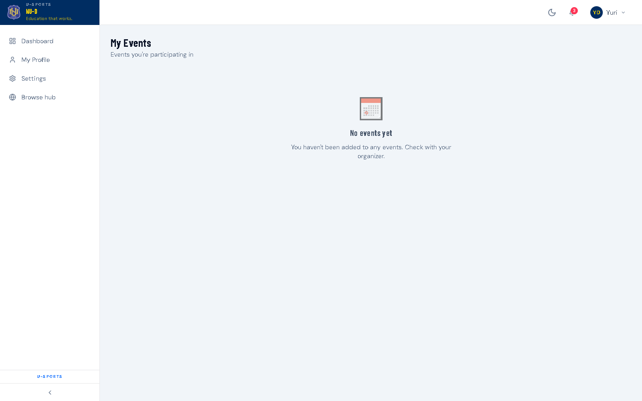 | Fail | Dacuba, Parco, Rodriguez  24 Sep 2026
8-4 | Verify athlete account settings. | 1. Open Settings as an Athlete. | Athlete account | - Password update, privacy notice and sign out are available. | 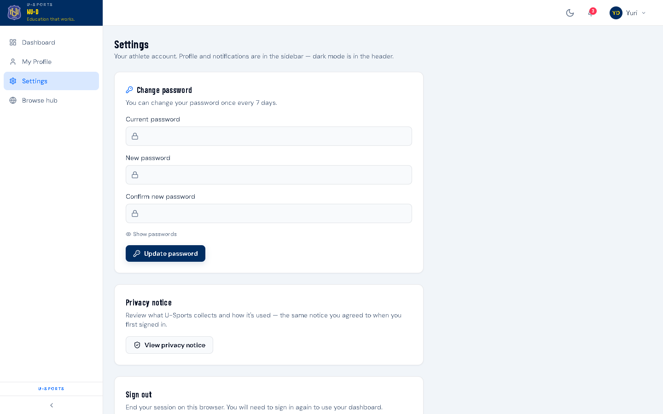 | Pass | Dacuba, Parco, Rodriguez  24 Sep 2026
8-5 | Verify athlete notifications. | 1. Open Notifications as an Athlete. | Existing notifications | - Notifications are listed with their filters and bulk actions. | 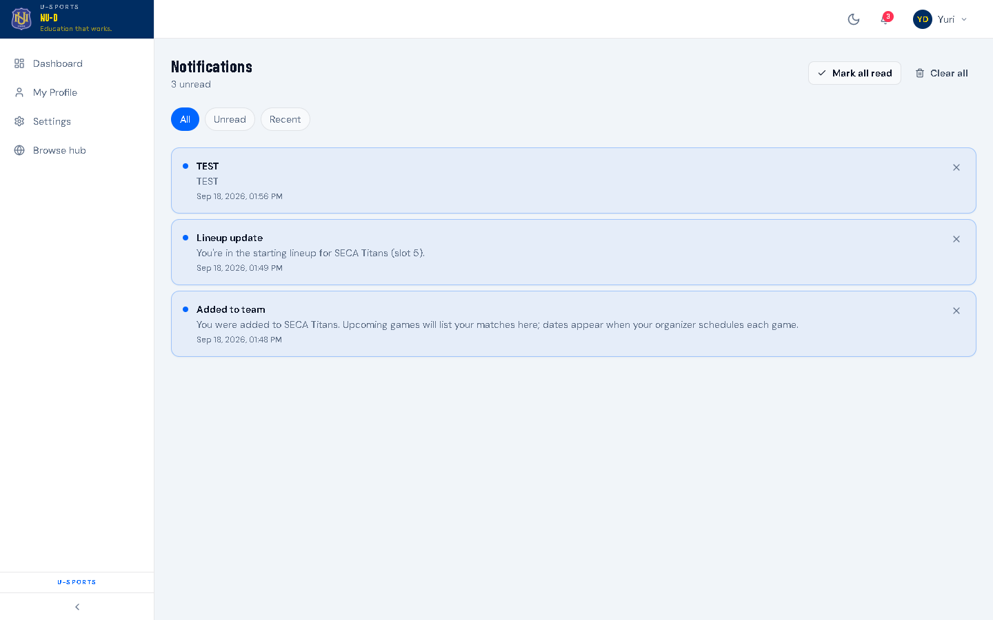 | Pass | Dacuba, Parco, Rodriguez  24 Sep 2026

Test Script Document Identifier – TS02
Test Specification - 02
Designed by:  Dacuba, Yuri Gabriel C.  Parco, Mark Christian P.  Rodriguez, Robin Kris P. | Modules:  U-Sports Mobile Application System (Android)
Objectives:  Test basic functionality | Browser Platform:  Emulator: Android 15 (API level 35), 1080 x 1920

Test  Case  # | Description | Test Steps | Test  Data | Expected Results | Actual  Results | Pass/  Fail | Performed  by /  Date
9-1 | Verify that the mobile home screen loads with the correct elements. | 1. Install and open the Android application.  2. Review the banner, totals and bottom navigation. | N/A | - The home screen shows the institution banner, games being played now, open events and the announcement ticker.  - Bottom navigation offers Home, Standings, Events and Sign in. | 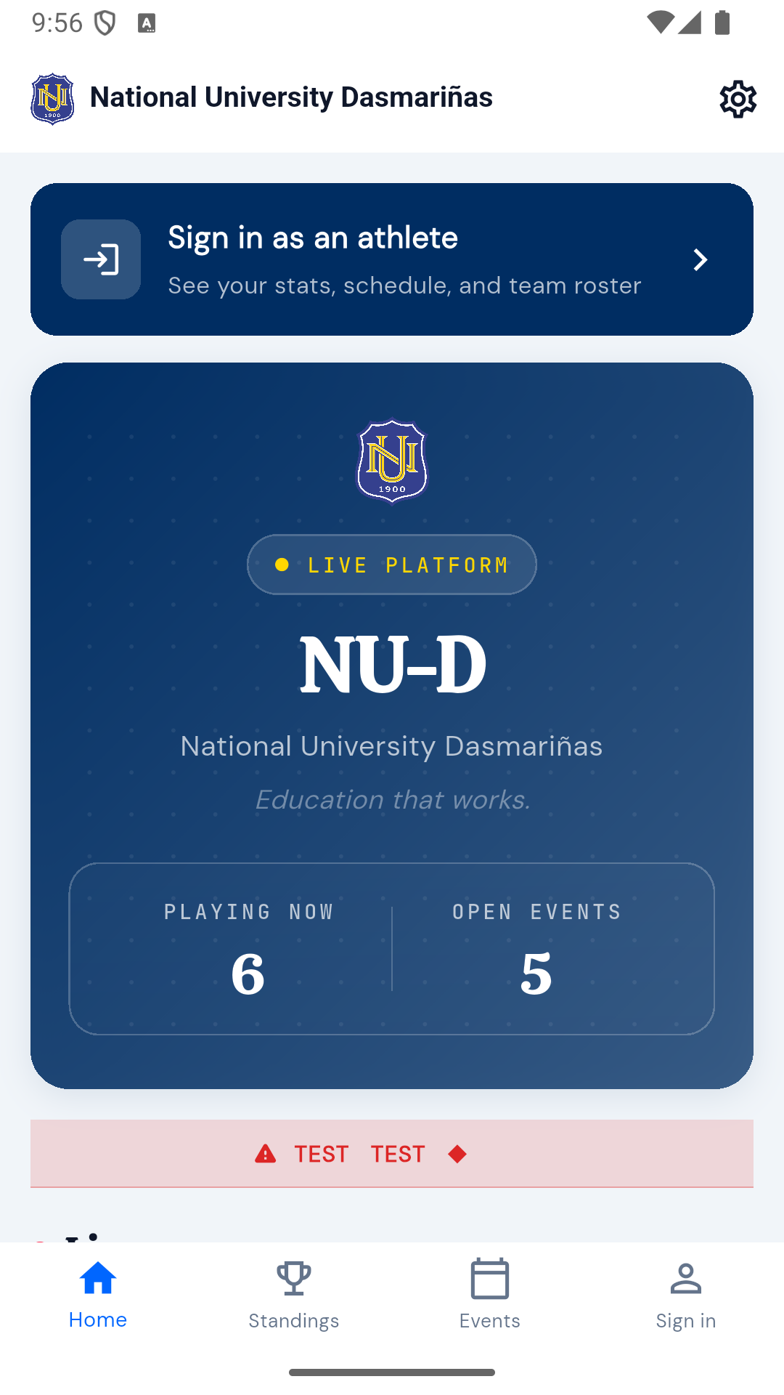 | Pass | Dacuba, Parco, Rodriguez  24 Sep 2026
9-2 | Verify mobile player statistics. | 1. Open Standings.  2. Choose a sport and season on the Player stats tab. | Basketball, AY 2026-2027 | - Ranked athletes are listed with games played and sport-appropriate statistics. | 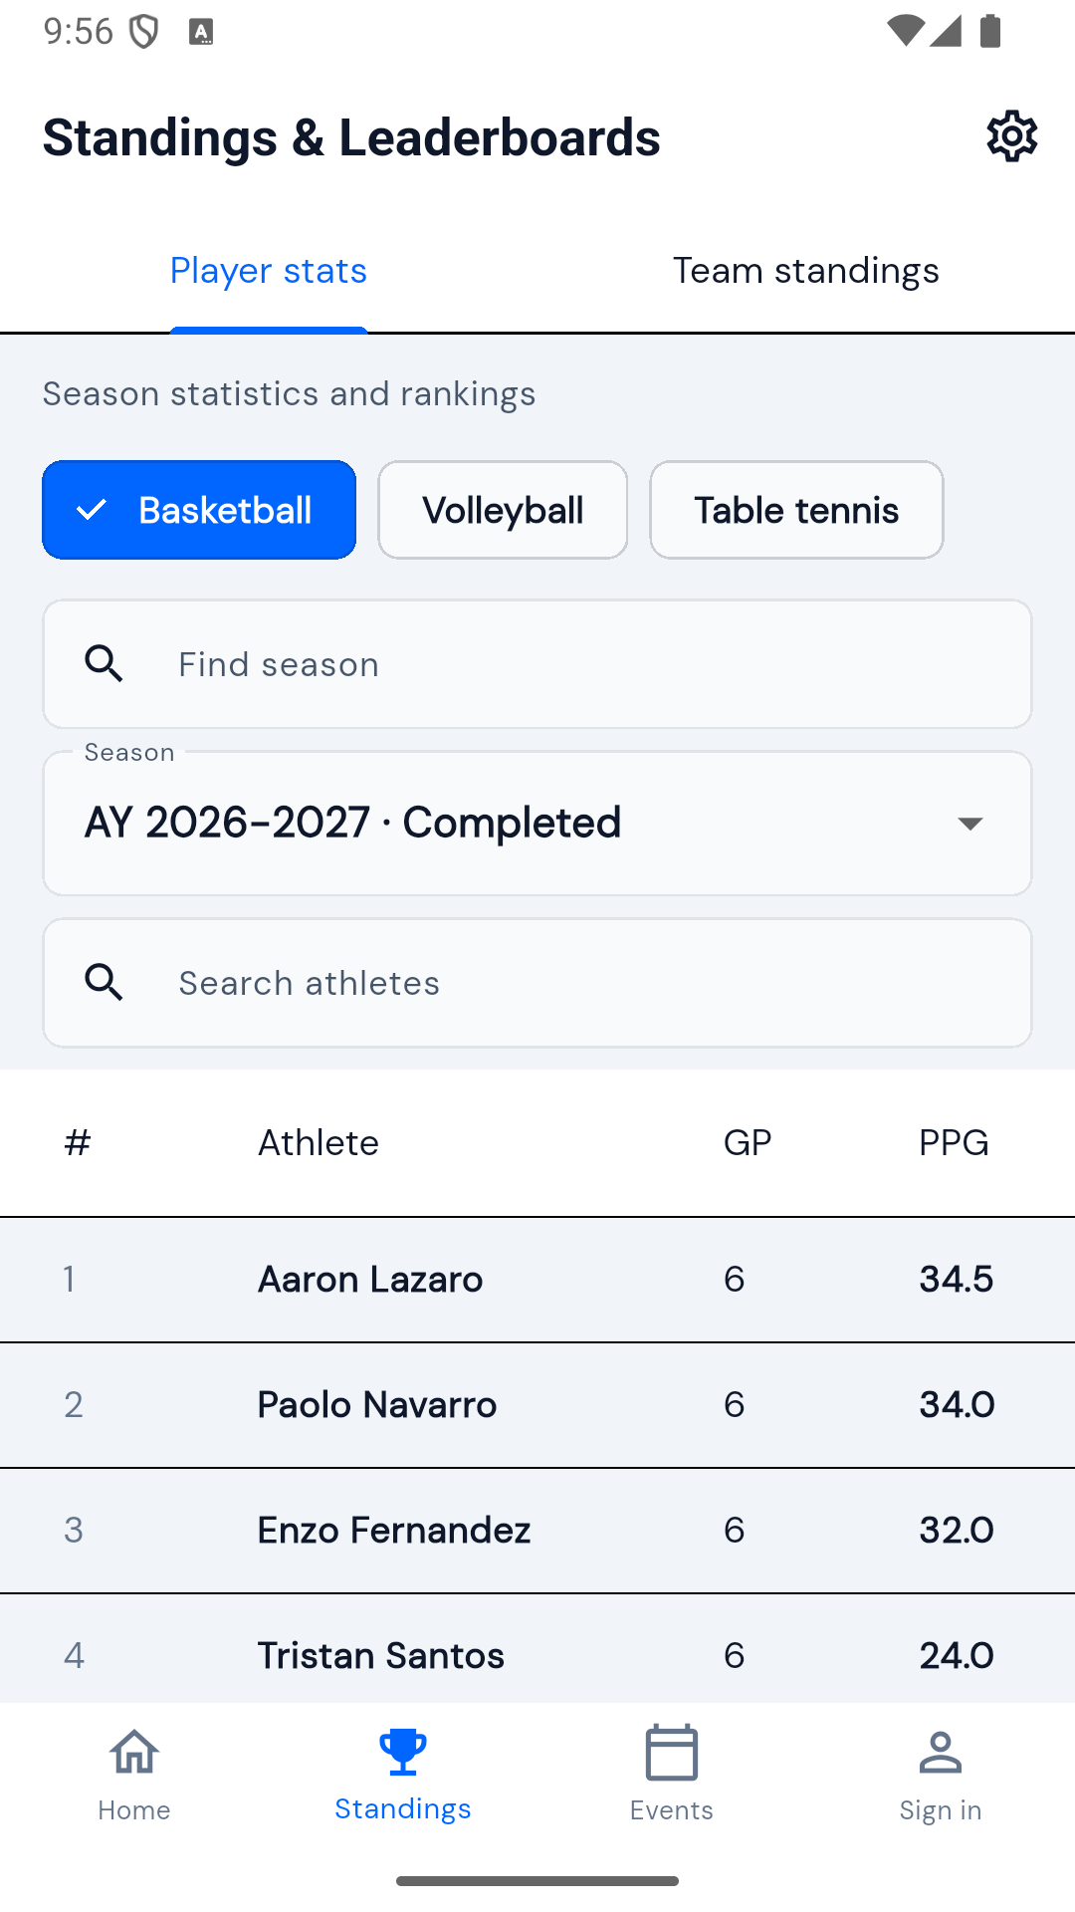 | Pass | Dacuba, Parco, Rodriguez  24 Sep 2026
9-3 | Verify mobile team standings. | 1. Open Standings and switch to Team standings. | Basketball, AY 2026-2027 | - Teams are ranked with wins, losses and win percentage. | 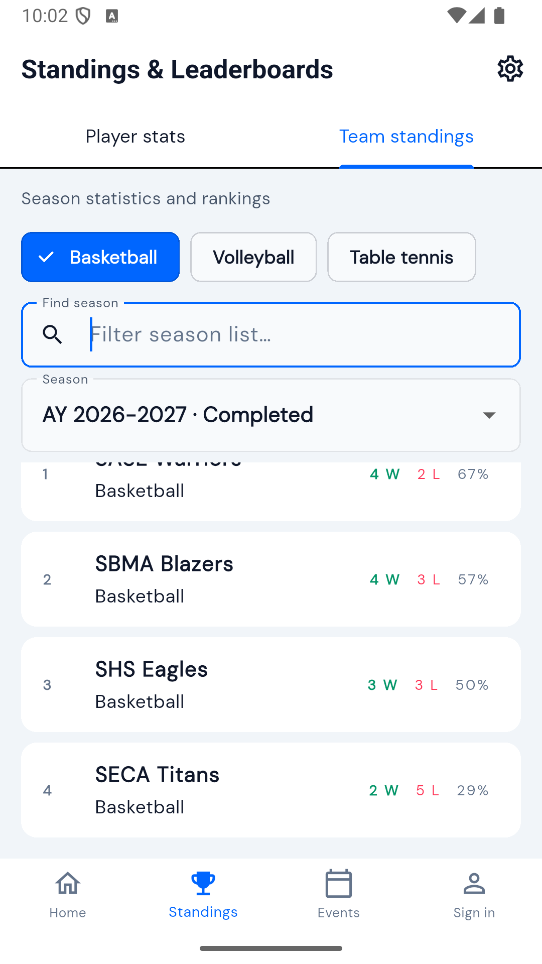 | Pass | Dacuba, Parco, Rodriguez  24 Sep 2026
9-4 | Verify the mobile events list, search and sport filter. | 1. Open Events.  2. Review the Upcoming & live and Past tabs and the sport filter. | Existing events | - Events are listed with sport, format, season and status, and the sport filter narrows the list. | 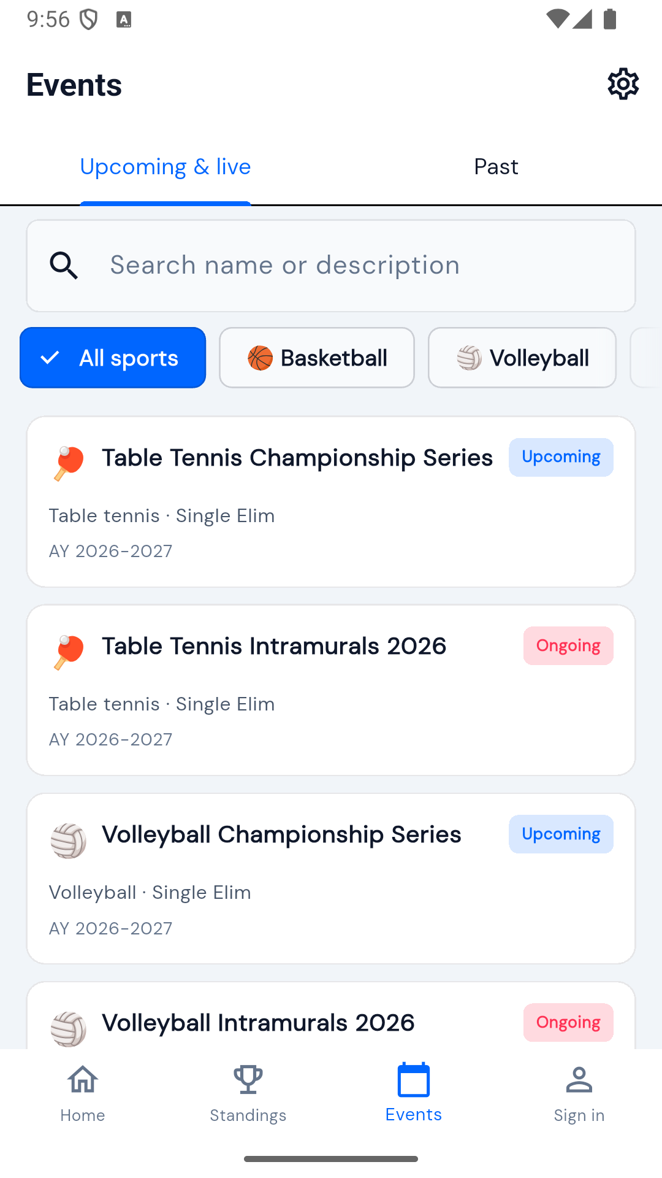 | Pass | Dacuba, Parco, Rodriguez  24 Sep 2026
9-5 | Verify the mobile event bracket. | 1. Open an ongoing event.  2. Review the Bracket tab. | Table Tennis Intramurals 2026 | - The bracket renders each round, with live matches highlighted and undecided slots shown as TBD. | 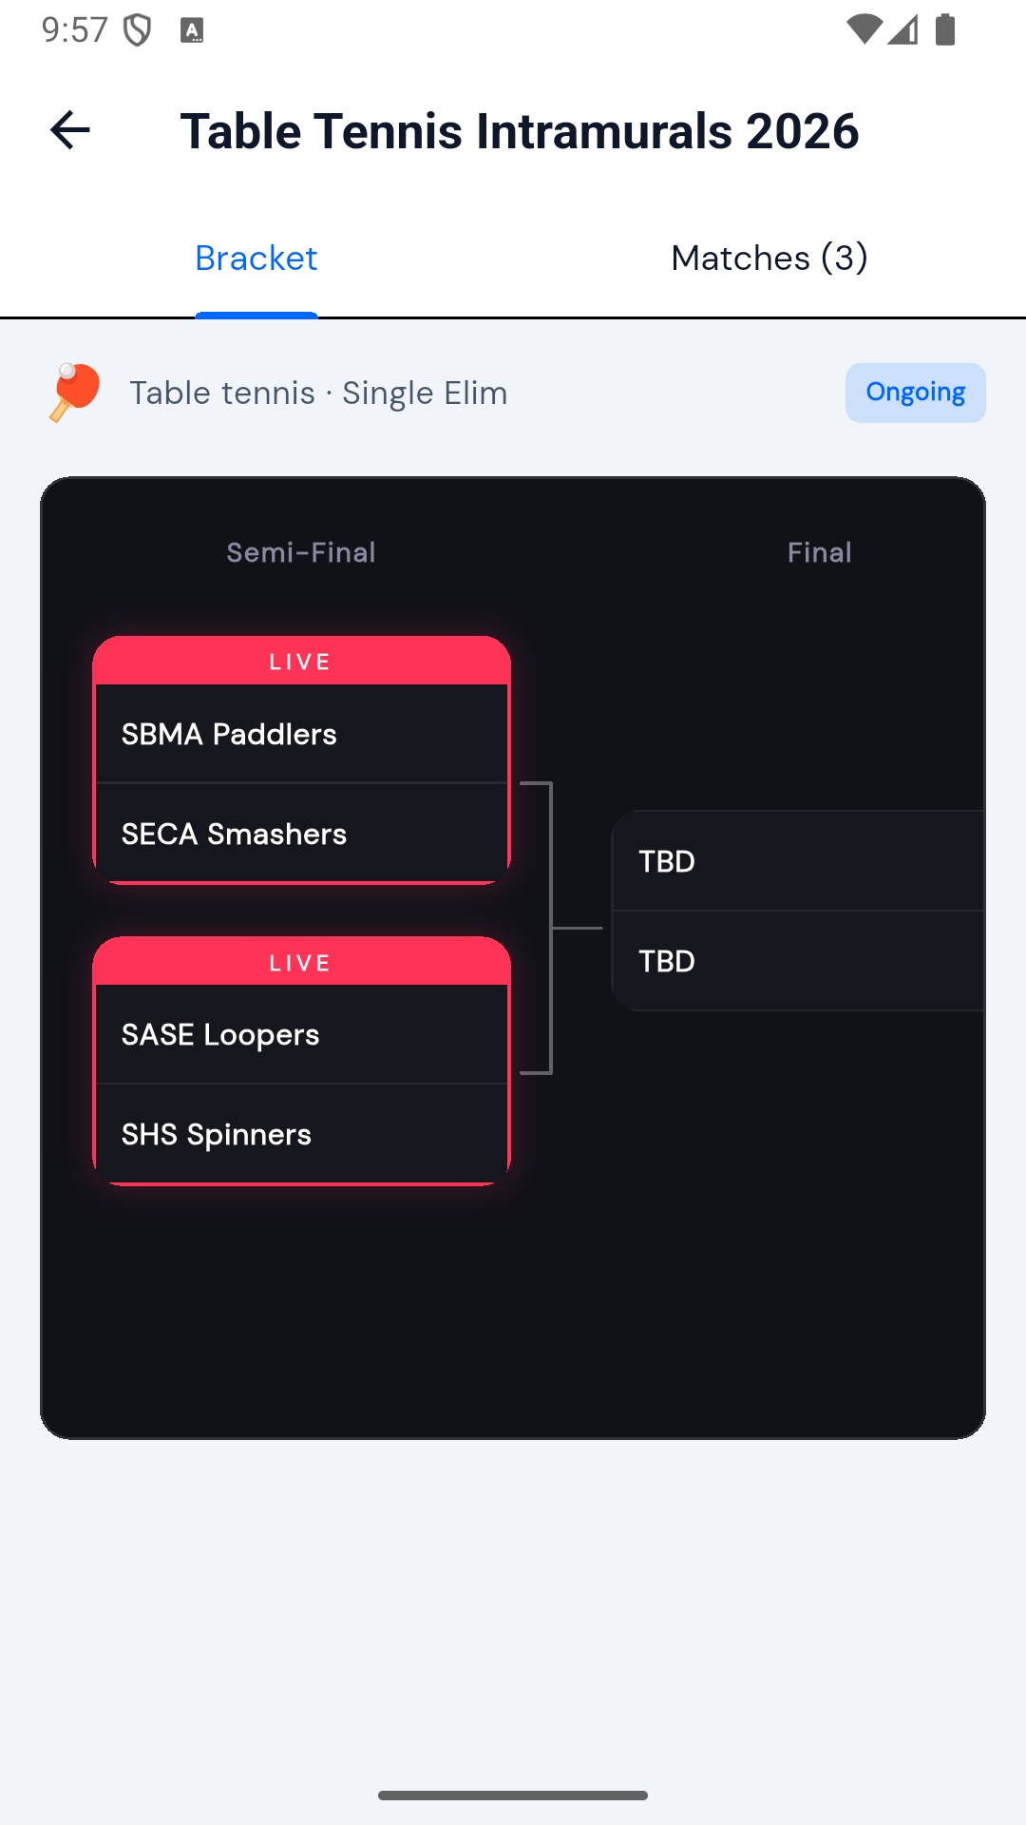 | Pass | Dacuba, Parco, Rodriguez  24 Sep 2026
9-6 | Verify the mobile event match list. | 1. On an event, switch to the Matches tab. | Table Tennis Intramurals 2026 | - Every match is listed with participants, status and schedule. | 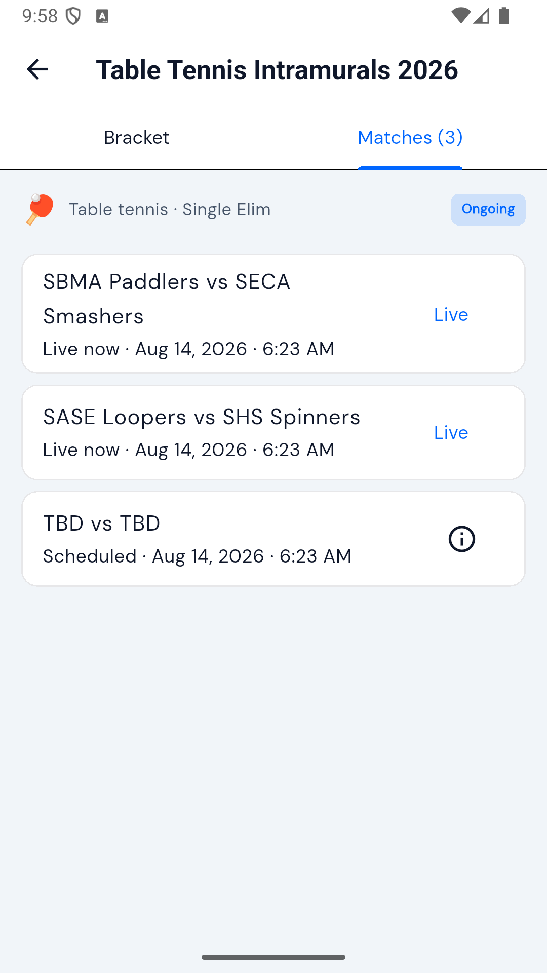 | Pass | Dacuba, Parco, Rodriguez  24 Sep 2026
9-7 | Verify the mobile live match view. | 1. From the match list, open a live match. | Live table tennis match | - A sheet opens showing the live score and both rosters. | 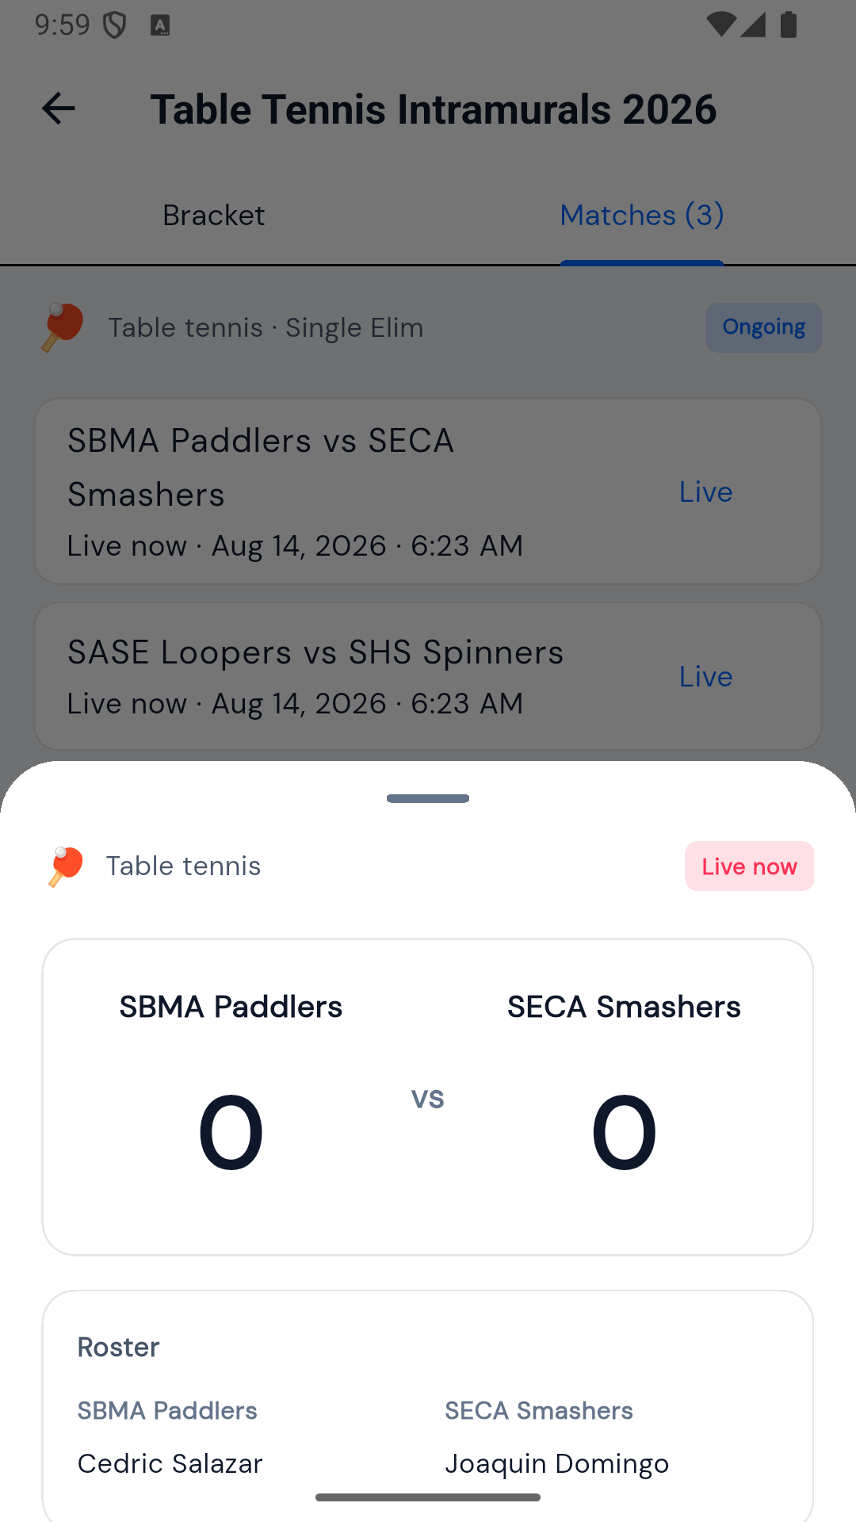 | Pass | Dacuba, Parco, Rodriguez  24 Sep 2026
9-8 | Verify the mobile team detail screen. | 1. From team standings, open a team. | SBMA Blazers | - The team record and full roster render, with starters and jersey numbers marked. | 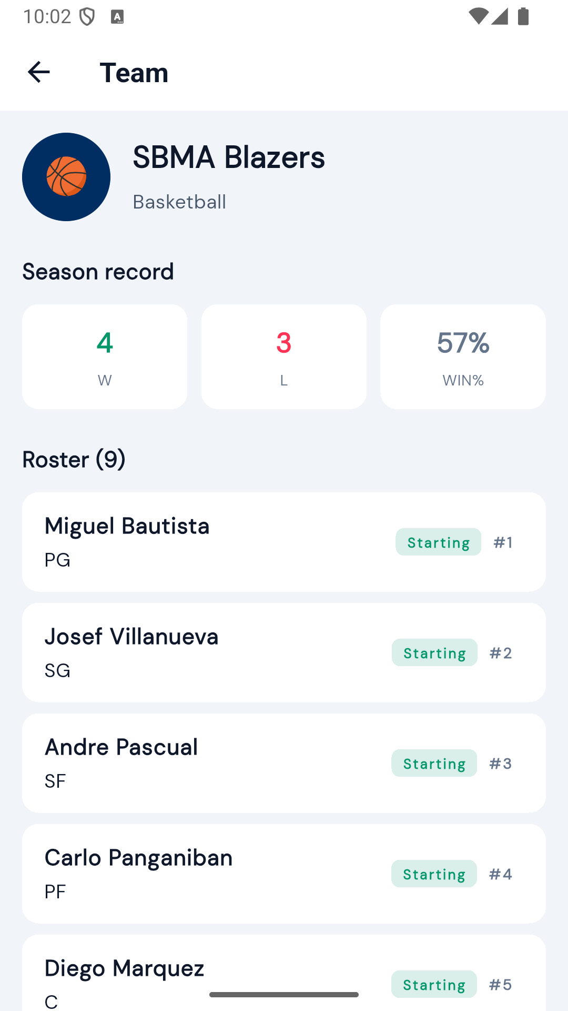 | Pass | Dacuba, Parco, Rodriguez  24 Sep 2026
9-9 | Verify mobile settings as a guest. | 1. Open Settings from the app bar while browsing as a guest. | N/A | - Dark mode is offered and the account section invites the visitor to sign in. | 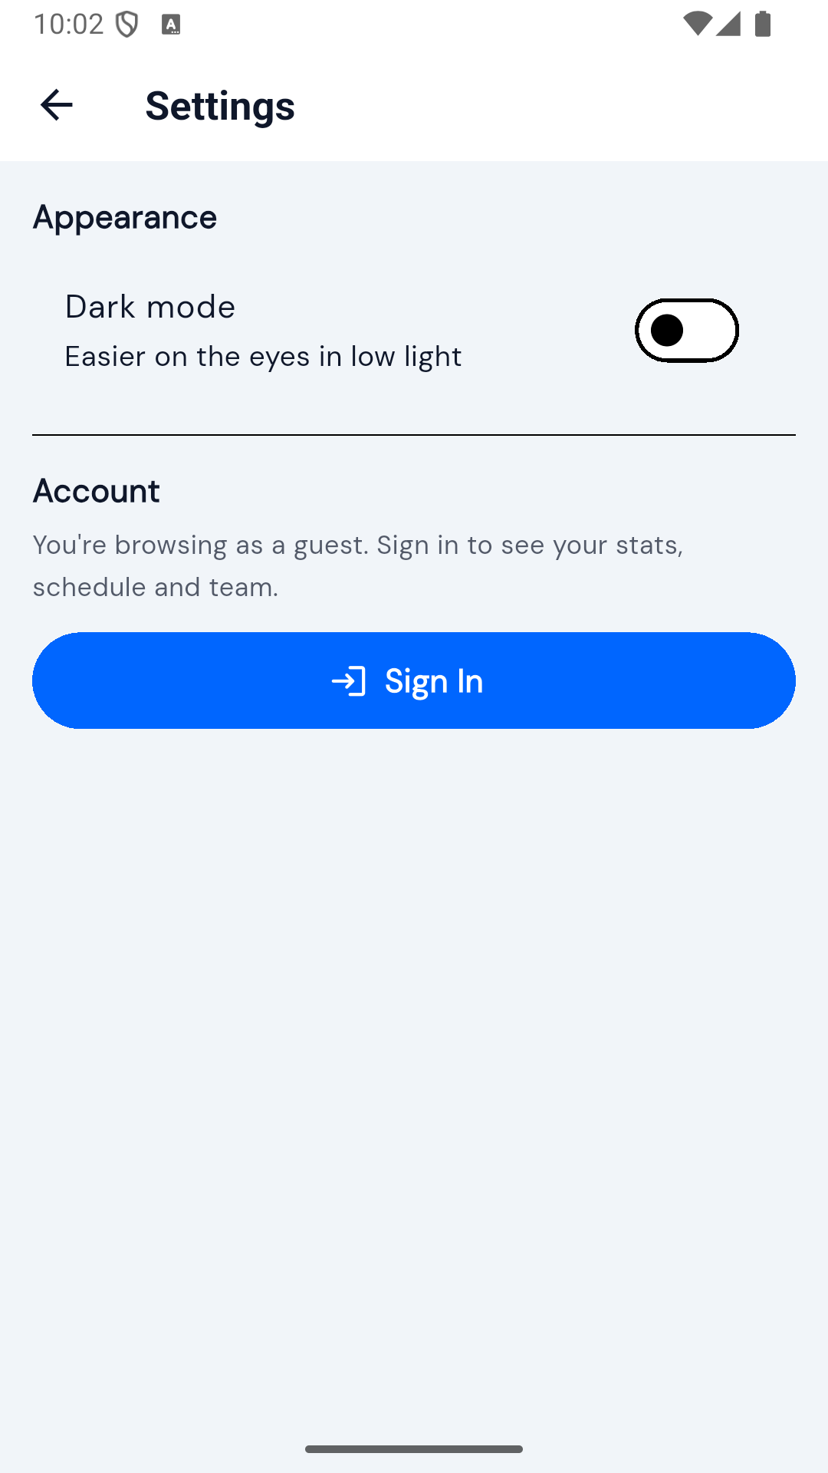 | Pass | Dacuba, Parco, Rodriguez  24 Sep 2026
10-1 | Verify that the mobile sign-in screen loads. | 1. Tap Sign in on the bottom navigation. | N/A | - The sign-in screen loads with Email and Password fields, a visibility toggle, Forgot password and a guest link. | 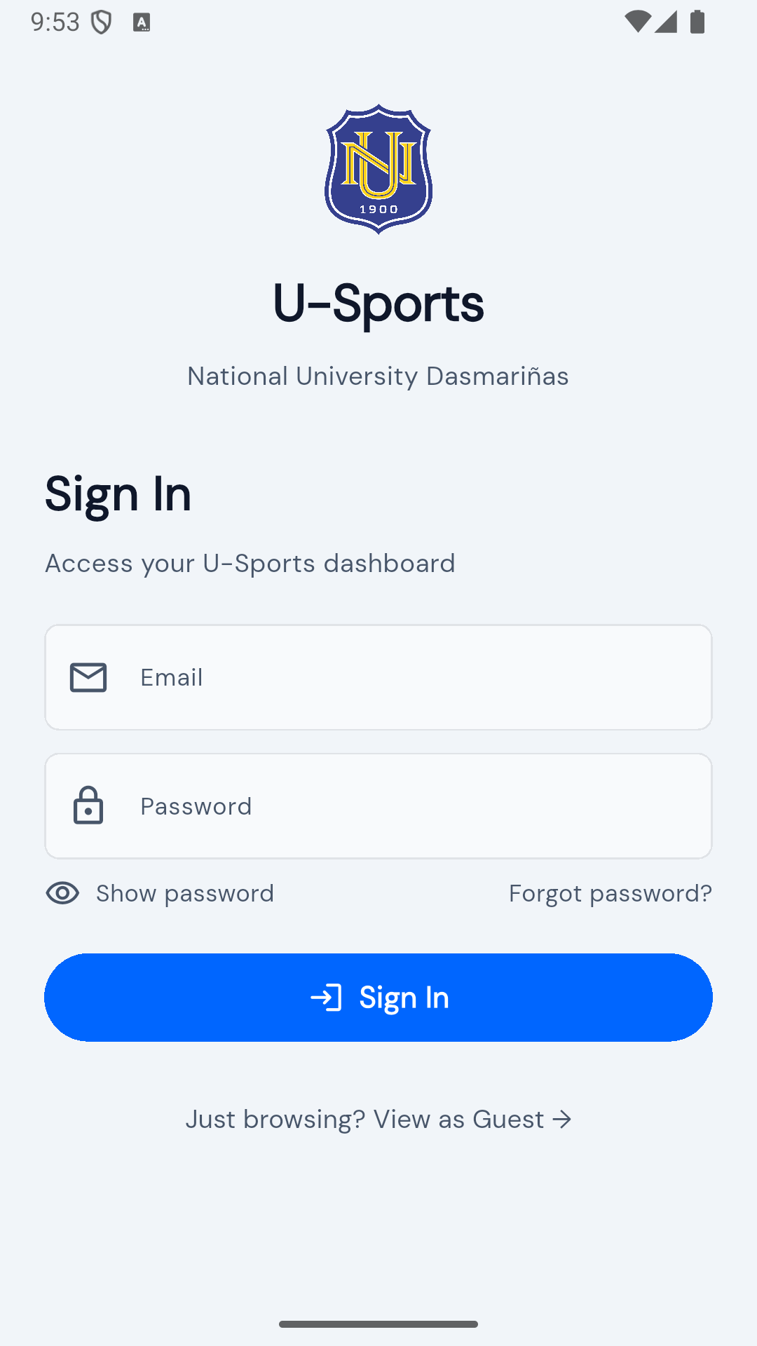 | Pass | Dacuba, Parco, Rodriguez  24 Sep 2026
10-2 | Verify mobile sign-in with invalid credentials. | 1. Open the sign-in screen.  2. Enter a registered email with an incorrect password.  3. Tap Sign In. | Registered email / incorrect password | - The app reports "Incorrect email or password." and no session is created. | 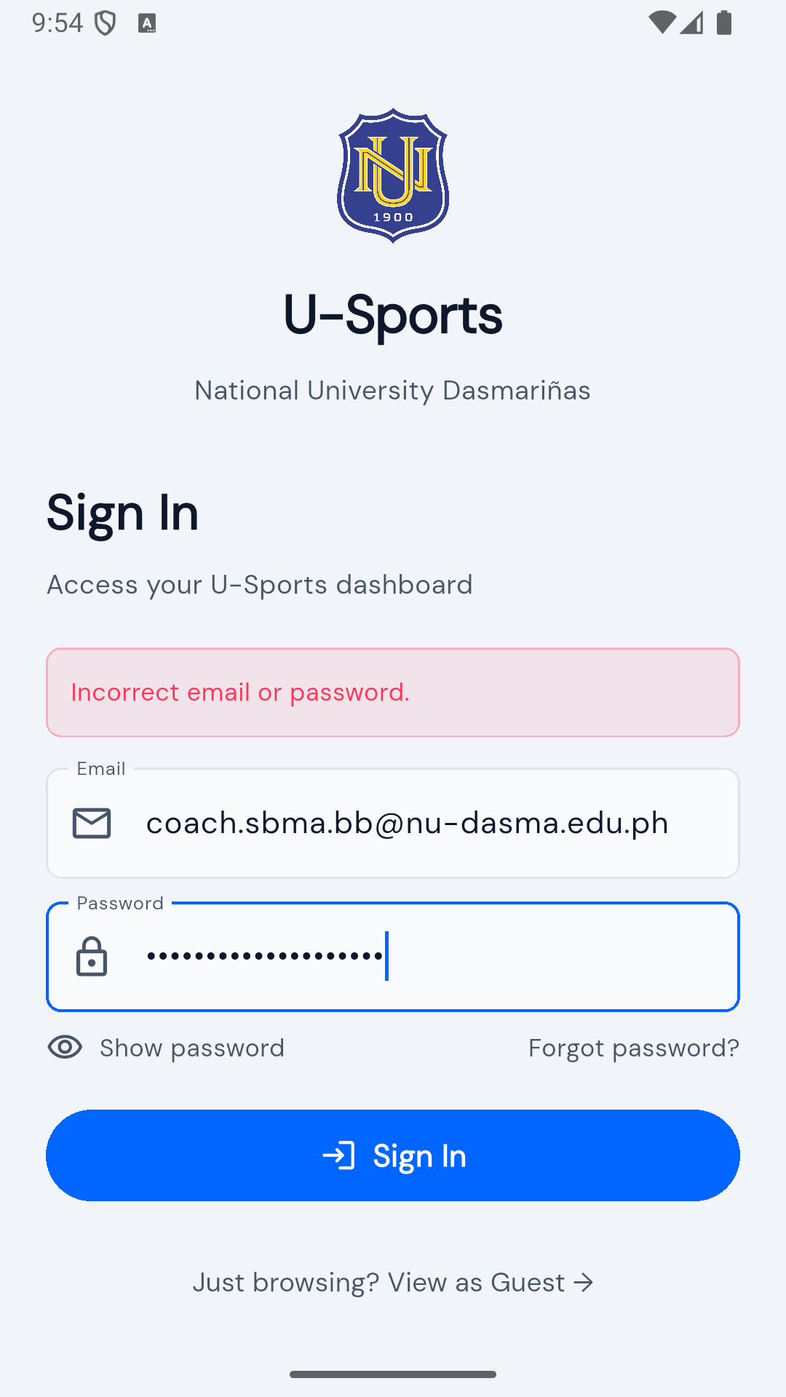 | Pass | Dacuba, Parco, Rodriguez  24 Sep 2026
10-3 | Verify the mobile forgot-password screen. | 1. From sign-in, tap Forgot password. | N/A | - The reset screen explains the process and offers an email field with Send reset link. | 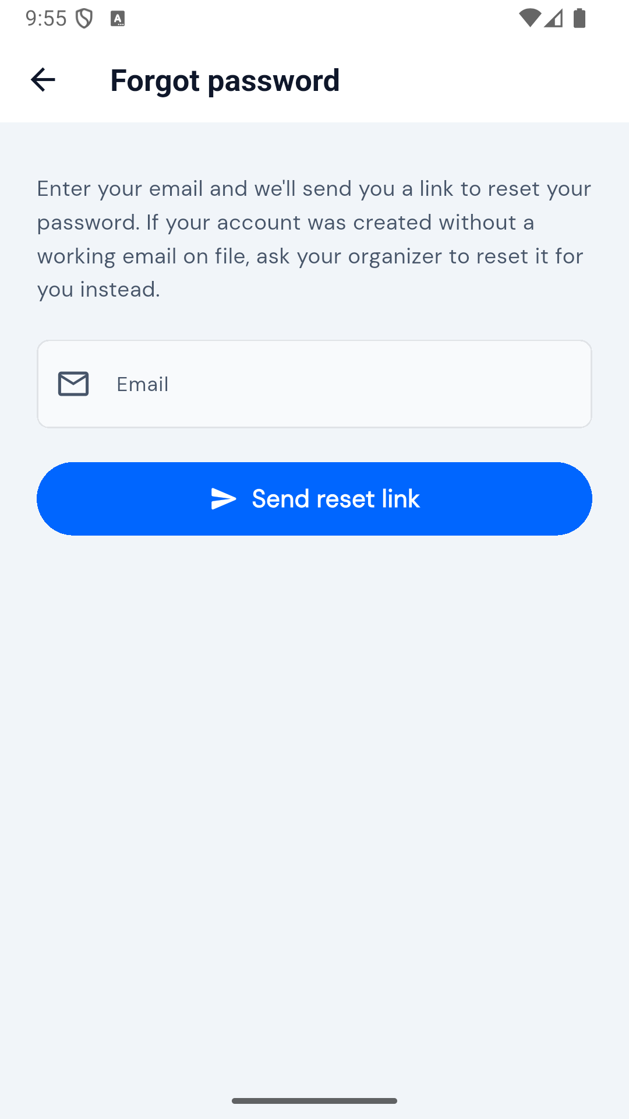 | Pass | Dacuba, Parco, Rodriguez  24 Sep 2026
10-4 | Verify mobile sign-in with valid credentials. | 1. Open the sign-in screen.  2. Enter a valid email and password.  3. Tap Sign In. | Valid coach credentials | - The fields accept the input and the app authenticates and routes to the role’s home. | 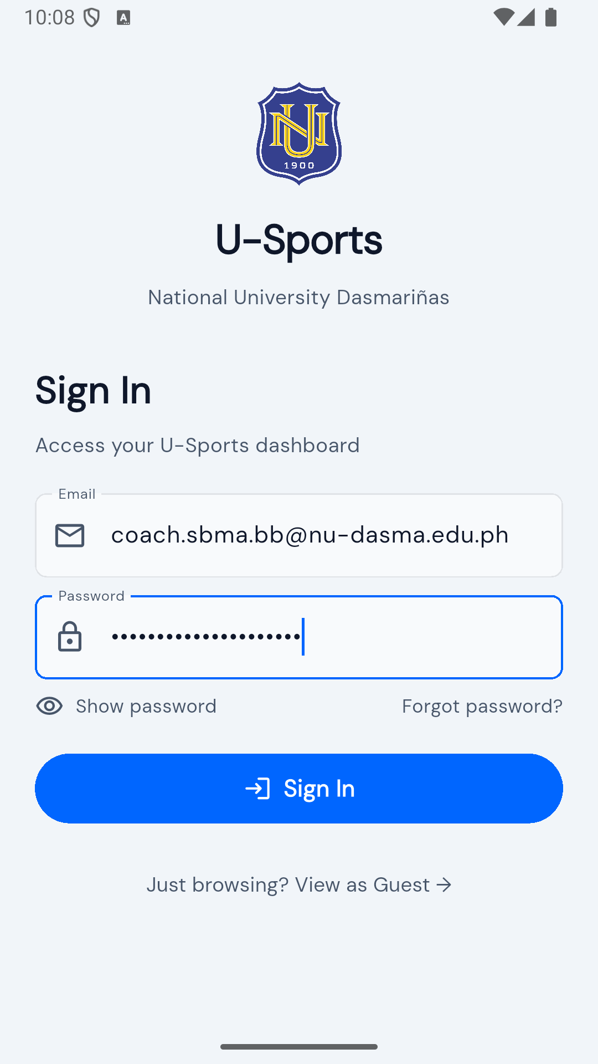 | Pass | Dacuba, Parco, Rodriguez  24 Sep 2026
10-5 | Verify the mobile data privacy notice gate. | 1. Sign in with an account that has not yet accepted the notice. | Athlete account with no recorded consent | - The notice is presented full screen before any personal data.  - The user must accept or sign out; there is no way past it. | 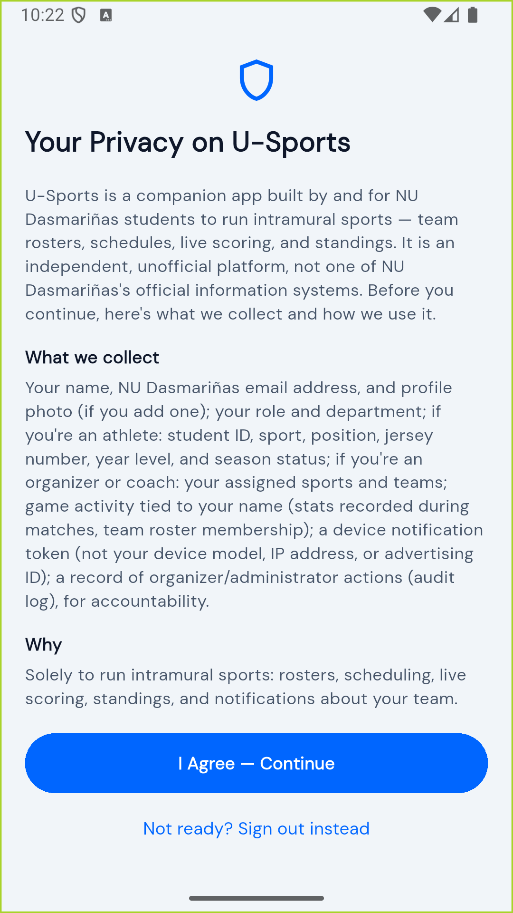 | Pass | Dacuba, Parco, Rodriguez  24 Sep 2026
10-6 | Verify the first-login password prompt. | 1. Sign in with an account still using its issued first password. | Account that has never changed its password | - The app prompts the user to change the password and offers Later or Change password. | 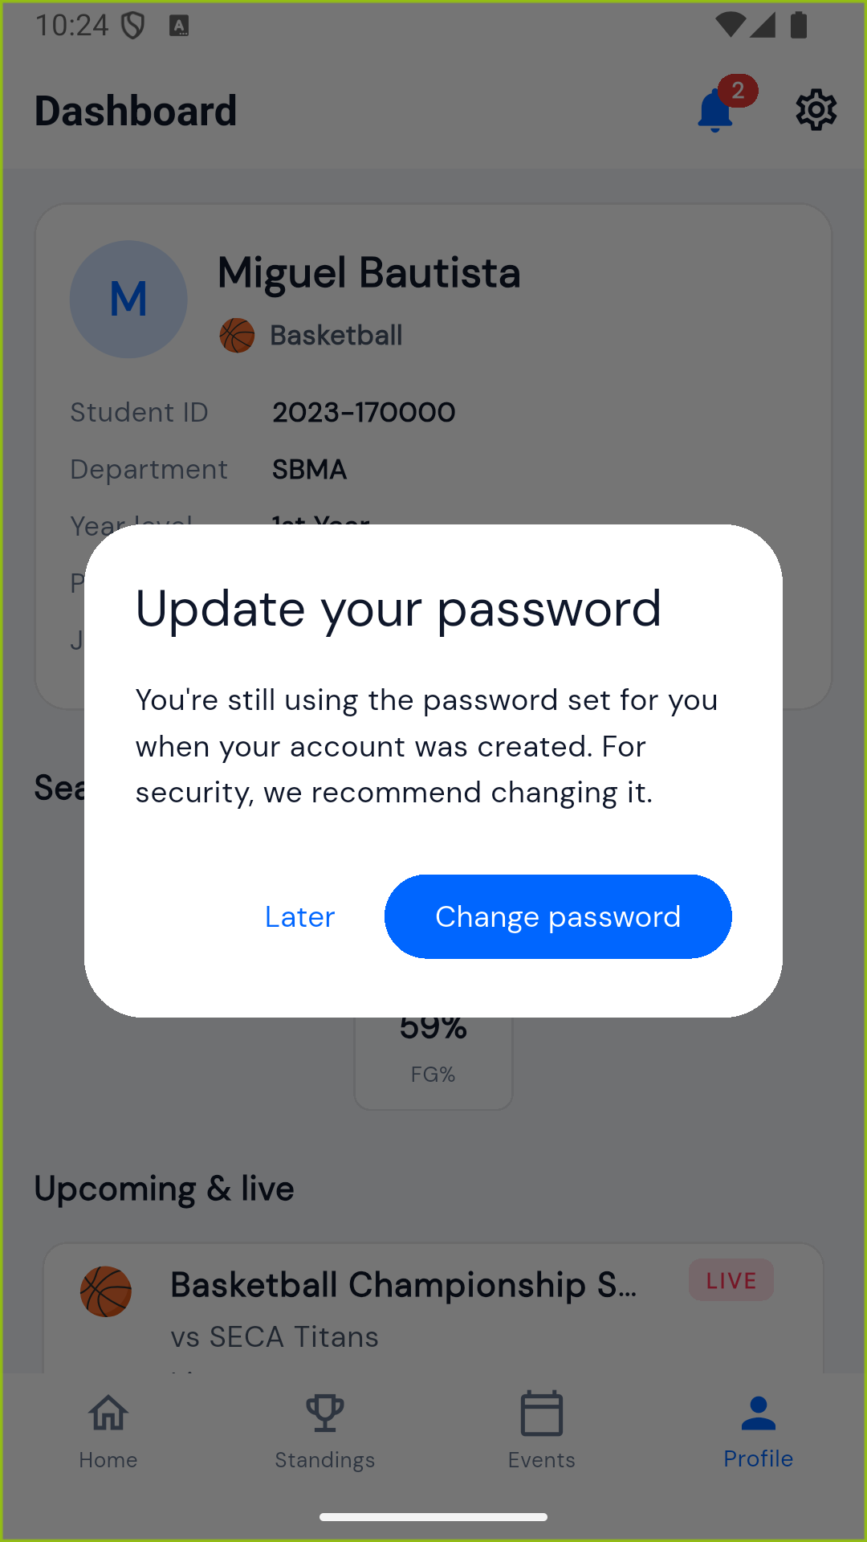 | Pass | Dacuba, Parco, Rodriguez  24 Sep 2026
11-1 | Verify the Coach My Teams screen. | 1. Sign in as a Coach.  2. Open the My Teams tab. | Coach account | - The screen renders its content — assigned teams with roster and starter counts, or, when none are assigned, the "No teams assigned yet" guidance.  - DEFECT FOUND AND FIXED during this cycle: the screen previously rendered as a blank grey panel under the app bar. Its body placed a Positioned widget (the offline banner) directly inside a Column, which is only valid inside a Stack; the resulting build error was drawn as the release-mode error widget. The duplicate banner was removed — it is already mounted application-wide — and the screen now renders. See Defect D-1. | 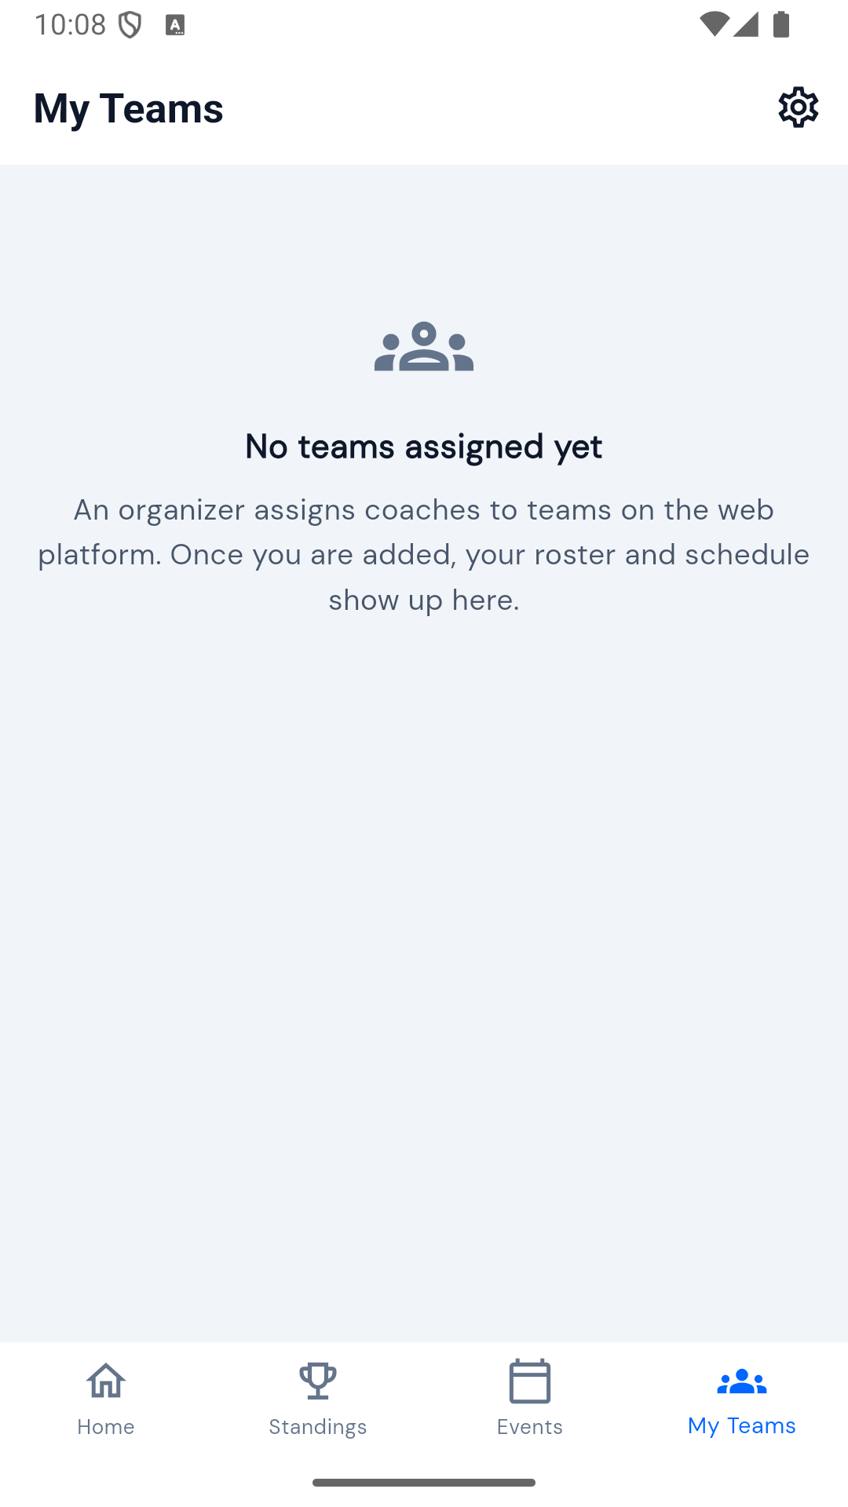 | Pass | Dacuba, Parco, Rodriguez  24 Sep 2026
11-2 | Verify Coach settings on mobile. | 1. Open Settings from the My Teams app bar. | Coach account | - Appearance, Change password, Privacy notice and Sign out are offered.  - The password rules match the web application. | 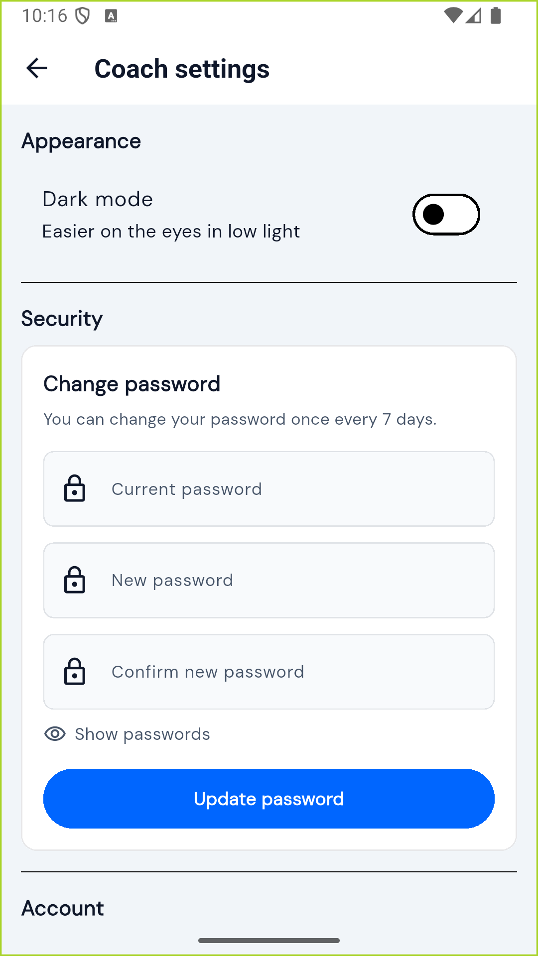 | Pass | Dacuba, Parco, Rodriguez  24 Sep 2026
11-3 | Verify that the privacy notice can be re-read from settings. | 1. In Settings, open Privacy notice. | Signed-in account | - The full notice is shown again on demand. | 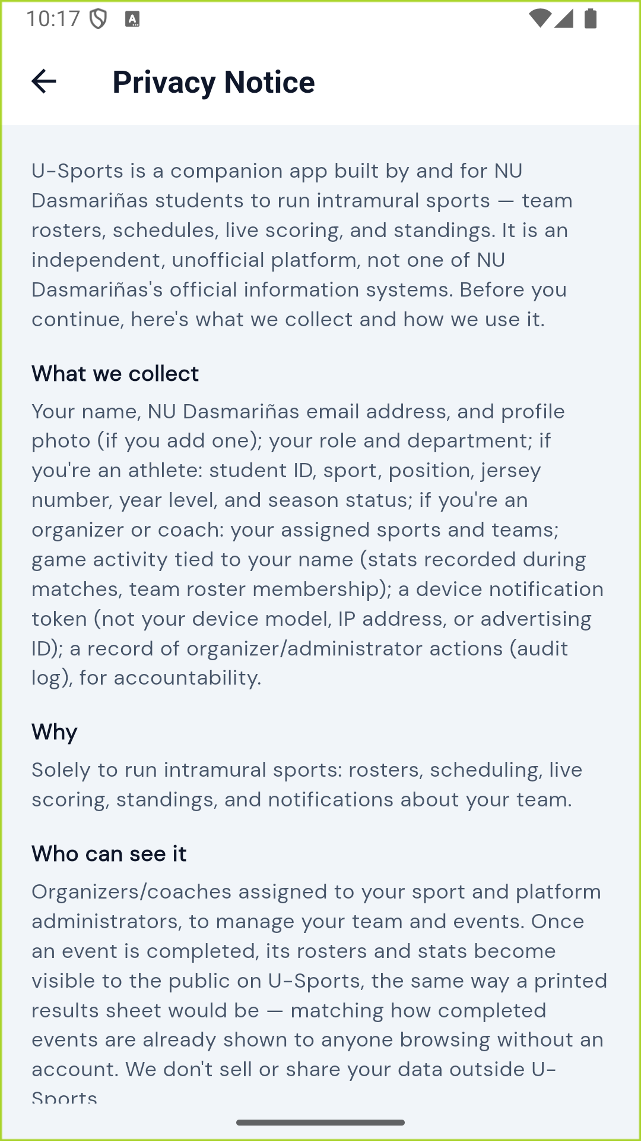 | Pass | Dacuba, Parco, Rodriguez  24 Sep 2026
12-1 | Verify the mobile home screen for a signed-in athlete. | 1. Sign in as an Athlete.  2. Review the home screen. | Athlete account | - The home screen adds a shortcut to the athlete dashboard and an unread notification badge.  - Bottom navigation shows Profile in place of Sign in. | 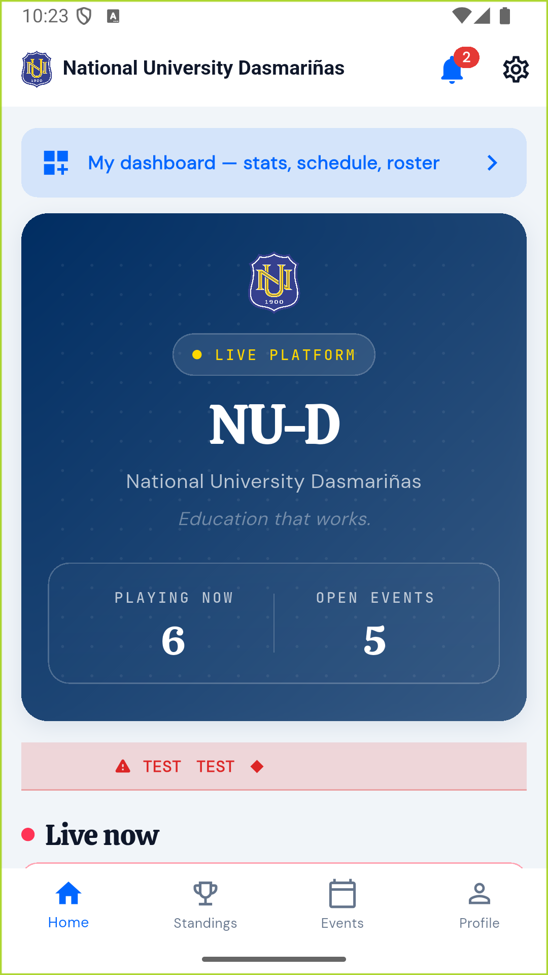 | Pass | Dacuba, Parco, Rodriguez  24 Sep 2026
12-2 | Verify the mobile athlete dashboard. | 1. Open the Profile tab as an Athlete. | Athlete account (2023-170000) | - The dashboard shows school ID, department, year level, position and jersey number.  - The season snapshot reports games played and per-game statistics, followed by upcoming and live matches. | 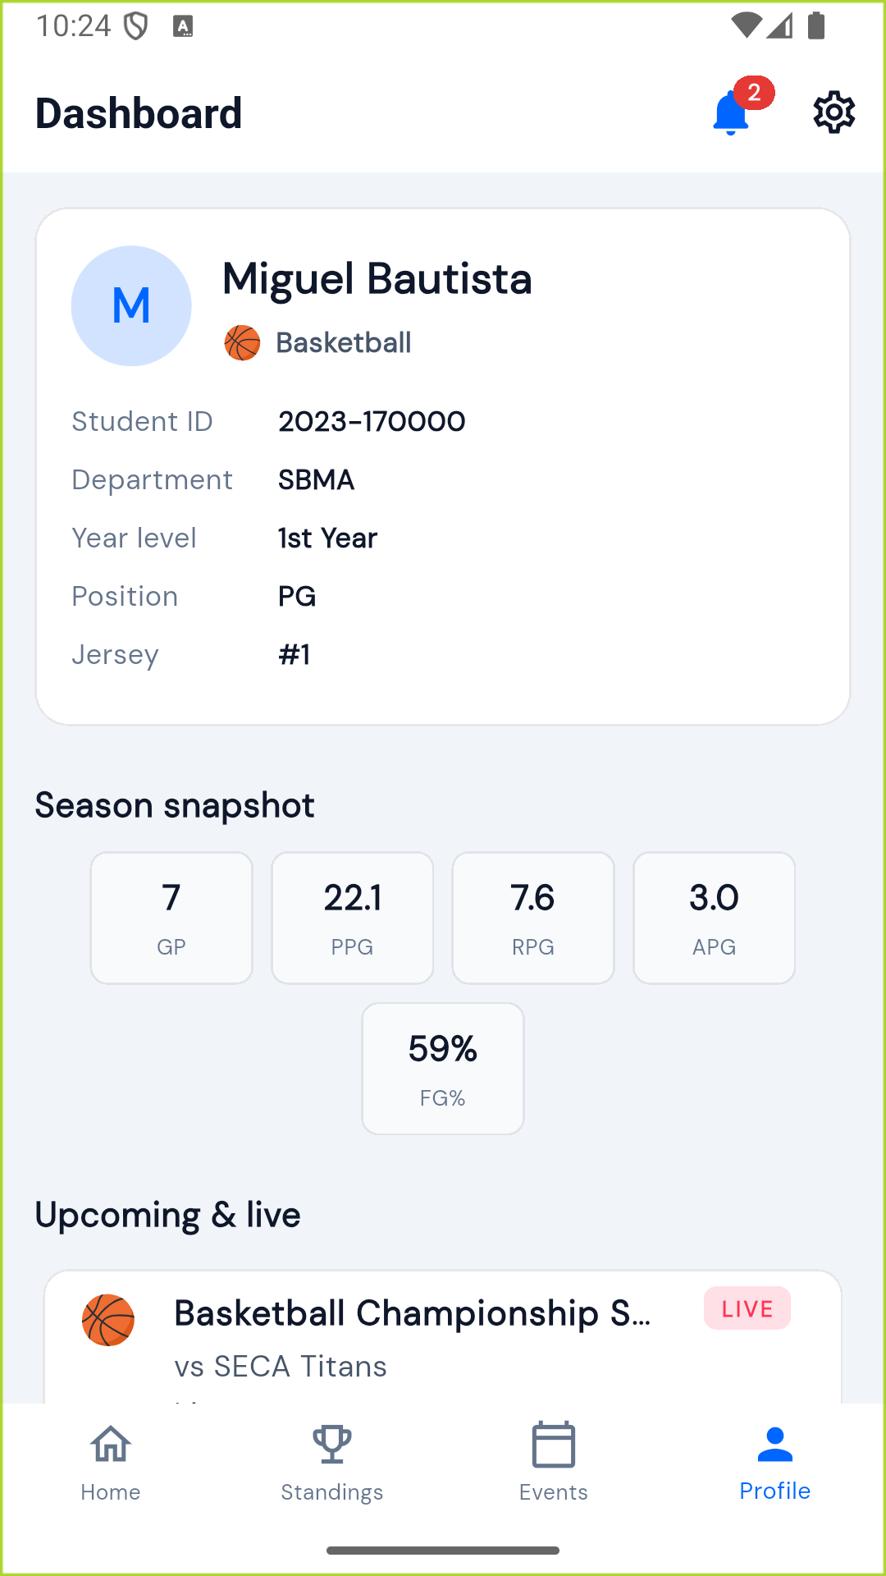 | Pass | Dacuba, Parco, Rodriguez  24 Sep 2026
12-3 | Verify mobile notifications. | 1. Tap the notification bell. | Unread notifications | - Notifications are listed with All, Unread and Recent filters, plus Read all and clear actions. | 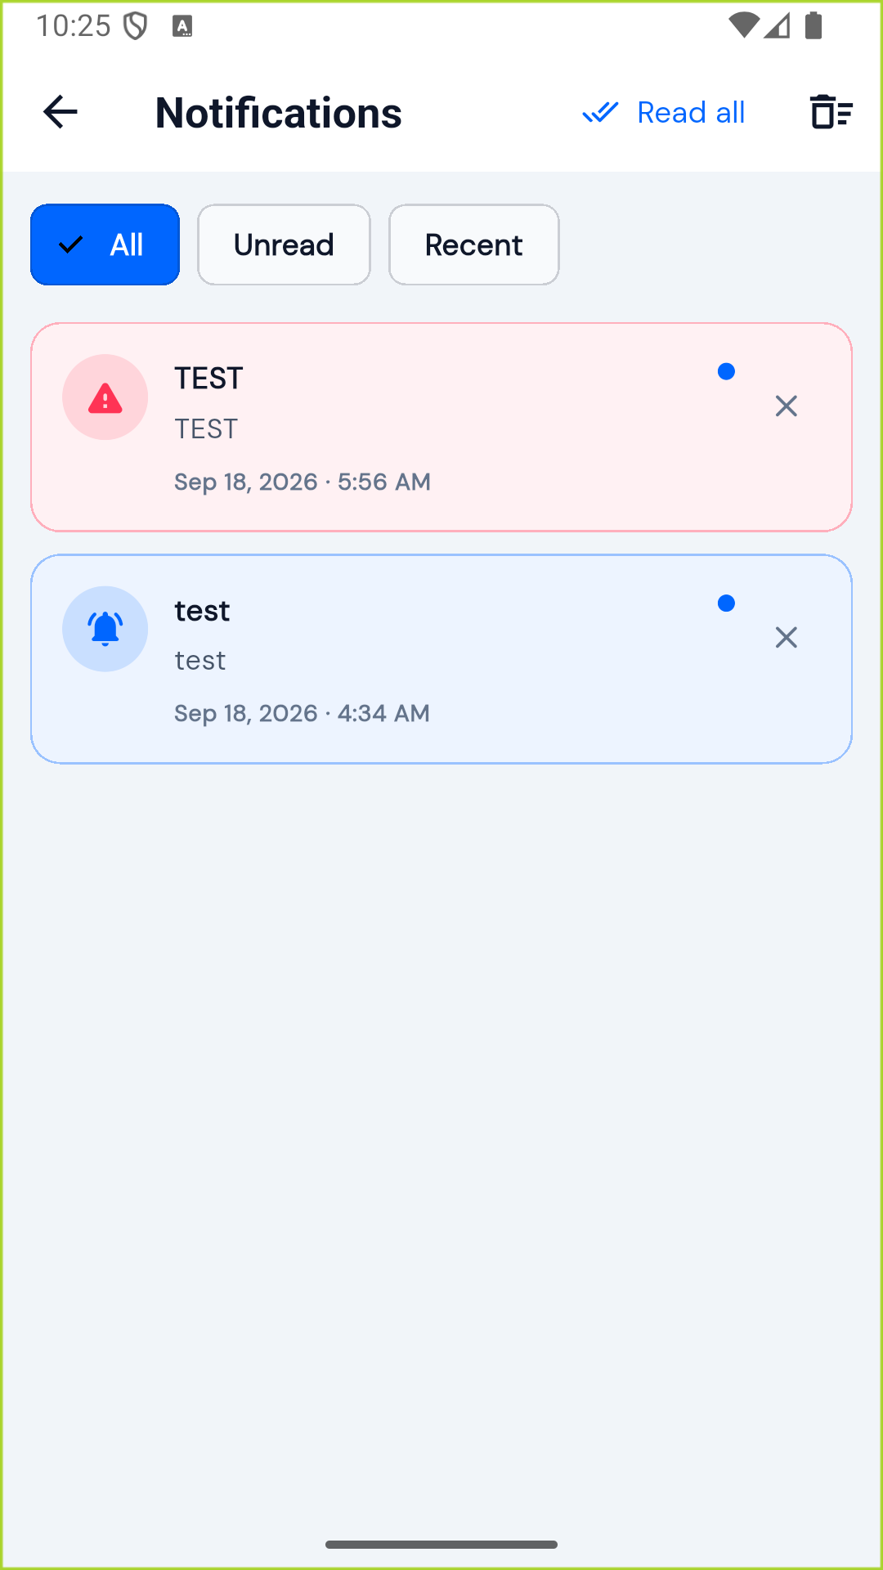 | Pass | Dacuba, Parco, Rodriguez  24 Sep 2026

NON-FUNCTIONAL REQUIREMENT TESTING
Testing Tool: Lighthouse
Each module was measured 3 times; the tables below report every run and its mean. Authenticated modules were measured with a signed-in session for the role named.
Summary of the Efficiency, Reliability and Performance Test
OVERALL AVERAGE
Module Name | Performance Score | Accessibility Score | Best Practices Score | SEO Score | WEB VITALS
 |  |  |  |  | LCP (sec) | TBT (ms) | CLS
Public Hub (Landing Page) | 54 | 100 | 100 | 83 | 5.10s | 70ms | 0.63
Login Page | 81.67 | 91 | 100 | 83 | 4.06s | 57ms | 0.02
Standings (Guest) | 81.67 | 92 | 100 | 83 | 3.93s | 52ms | 0.00
Events (Guest) | 81.67 | 94 | 100 | 83 | 4.17s | 58ms | 0.00
Home Page (Athlete) | 80.67 | 91 | 100 | 83 | 4.32s | 93ms | 0.01
Athlete Profile | 84.33 | 91 | 100 | 83 | 3.94s | 23ms | 0.01
Home Page (Organizer) | 83 | 91 | 100 | 83 | 4.01s | 71ms | 0.00
Event Management Module | 81.67 | 91 | 100 | 83 | 3.96s | 82ms | 0.02
Athlete Account Module | 81 | 91 | 100 | 83 | 4.24s | 40ms | 0.01
Team Management Module | 80.67 | 91 | 100 | 83 | 4.25s | 54ms | 0.01
Analytics Module | 76.33 | 91 | 100 | 83 | 4.79s | 118ms | 0.02
Announcement Module | 82 | 91 | 100 | 83 | 4.03s | 62ms | 0.01
Live Scoring Module | 81.33 | 91 | 100 | 83 | 4.17s | 73ms | 0.01
Home Page (Super Admin) | 83 | 91 | 100 | 83 | 4.14s | 82ms | 0.02
Staff Account Module | 83.33 | 91 | 100 | 83 | 4.17s | 48ms | 0.00
Audit Log Module | 83.33 | 91 | 100 | 83 | 3.79s | 63ms | 0.02
Help Center | 82.67 | 91 | 100 | 83 | 3.88s | 106ms | 0.01

Module Name | Public Hub (Landing Page)
Run(s) | Performance Score | Accessibility Score | Best Practices Score | SEO Score | WEB VITALS
 |  |  |  |  | LCP (sec) | TBT (ms) | CLS
1 | 59 | 100 | 100 | 83 | 4.87s | 7ms | 0.49
2 | 58 | 100 | 100 | 83 | 4.86s | 146ms | 0.46
3 | 45 | 100 | 100 | 83 | 5.58s | 58ms | 0.93
Overall Mean | 54 | 100 | 100 | 83 | 5.10s | 70ms | 0.63

Module Name | Login Page
Run(s) | Performance Score | Accessibility Score | Best Practices Score | SEO Score | WEB VITALS
 |  |  |  |  | LCP (sec) | TBT (ms) | CLS
1 | 86 | 91 | 100 | 83 | 3.82s | 9ms | 0.02
2 | 82 | 91 | 100 | 83 | 4.30s | 92ms | 0.02
3 | 77 | 91 | 100 | 83 | 4.07s | 70ms | 0.00
Overall Mean | 81.67 | 91 | 100 | 83 | 4.06s | 57ms | 0.02

Module Name | Standings (Guest)
Run(s) | Performance Score | Accessibility Score | Best Practices Score | SEO Score | WEB VITALS
 |  |  |  |  | LCP (sec) | TBT (ms) | CLS
1 | 85 | 92 | 100 | 83 | 3.98s | 4ms | 0.00
2 | 78 | 92 | 100 | 83 | 3.91s | 86ms | 0.00
3 | 82 | 92 | 100 | 83 | 3.91s | 67ms | 0.00
Overall Mean | 81.67 | 92 | 100 | 83 | 3.93s | 52ms | 0.00

Module Name | Events (Guest)
Run(s) | Performance Score | Accessibility Score | Best Practices Score | SEO Score | WEB VITALS
 |  |  |  |  | LCP (sec) | TBT (ms) | CLS
1 | 84 | 94 | 100 | 83 | 4.12s | 41ms | 0.00
2 | 81 | 94 | 100 | 83 | 4.04s | 80ms | 0.00
3 | 80 | 94 | 100 | 83 | 4.34s | 53ms | 0.00
Overall Mean | 81.67 | 94 | 100 | 83 | 4.17s | 58ms | 0.00

Module Name | Home Page (Athlete)
Run(s) | Performance Score | Accessibility Score | Best Practices Score | SEO Score | WEB VITALS
 |  |  |  |  | LCP (sec) | TBT (ms) | CLS
1 | 84 | 91 | 100 | 83 | 4.04s | 36ms | 0.00
2 | 78 | 91 | 100 | 83 | 4.28s | 110ms | 0.00
3 | 80 | 91 | 100 | 83 | 4.63s | 134ms | 0.02
Overall Mean | 80.67 | 91 | 100 | 83 | 4.32s | 93ms | 0.01

Module Name | Athlete Profile
Run(s) | Performance Score | Accessibility Score | Best Practices Score | SEO Score | WEB VITALS
 |  |  |  |  | LCP (sec) | TBT (ms) | CLS
1 | 84 | 91 | 100 | 83 | 3.68s | 5ms | 0.00
2 | 85 | 91 | 100 | 83 | 4.02s | 58ms | 0.02
3 | 84 | 91 | 100 | 83 | 4.12s | 7ms | 0.00
Overall Mean | 84.33 | 91 | 100 | 83 | 3.94s | 23ms | 0.01

Module Name | Home Page (Organizer)
Run(s) | Performance Score | Accessibility Score | Best Practices Score | SEO Score | WEB VITALS
 |  |  |  |  | LCP (sec) | TBT (ms) | CLS
1 | 82 | 91 | 100 | 83 | 3.99s | 8ms | 0.00
2 | 82 | 91 | 100 | 83 | 4.07s | 175ms | 0.00
3 | 85 | 91 | 100 | 83 | 3.97s | 31ms | 0.00
Overall Mean | 83 | 91 | 100 | 83 | 4.01s | 71ms | 0.00

Module Name | Event Management Module
Run(s) | Performance Score | Accessibility Score | Best Practices Score | SEO Score | WEB VITALS
 |  |  |  |  | LCP (sec) | TBT (ms) | CLS
1 | 83 | 91 | 100 | 83 | 3.84s | 15ms | 0.02
2 | 76 | 91 | 100 | 83 | 4.25s | 140ms | 0.00
3 | 86 | 91 | 100 | 83 | 3.80s | 91ms | 0.02
Overall Mean | 81.67 | 91 | 100 | 83 | 3.96s | 82ms | 0.02

Module Name | Athlete Account Module
Run(s) | Performance Score | Accessibility Score | Best Practices Score | SEO Score | WEB VITALS
 |  |  |  |  | LCP (sec) | TBT (ms) | CLS
1 | 84 | 91 | 100 | 83 | 4.16s | 14ms | 0.02
2 | 76 | 91 | 100 | 83 | 4.27s | 92ms | 0.00
3 | 83 | 91 | 100 | 83 | 4.29s | 14ms | 0.00
Overall Mean | 81 | 91 | 100 | 83 | 4.24s | 40ms | 0.01

Module Name | Team Management Module
Run(s) | Performance Score | Accessibility Score | Best Practices Score | SEO Score | WEB VITALS
 |  |  |  |  | LCP (sec) | TBT (ms) | CLS
1 | 84 | 91 | 100 | 83 | 4.16s | 23ms | 0.00
2 | 77 | 91 | 100 | 83 | 4.44s | 115ms | 0.02
3 | 81 | 91 | 100 | 83 | 4.16s | 25ms | 0.00
Overall Mean | 80.67 | 91 | 100 | 83 | 4.25s | 54ms | 0.01

Module Name | Analytics Module
Run(s) | Performance Score | Accessibility Score | Best Practices Score | SEO Score | WEB VITALS
 |  |  |  |  | LCP (sec) | TBT (ms) | CLS
1 | 78 | 91 | 100 | 83 | 4.61s | 79ms | 0.02
2 | 73 | 91 | 100 | 83 | 5.17s | 260ms | 0.02
3 | 78 | 91 | 100 | 83 | 4.58s | 14ms | 0.02
Overall Mean | 76.33 | 91 | 100 | 83 | 4.79s | 118ms | 0.02

Module Name | Announcement Module
Run(s) | Performance Score | Accessibility Score | Best Practices Score | SEO Score | WEB VITALS
 |  |  |  |  | LCP (sec) | TBT (ms) | CLS
1 | 83 | 91 | 100 | 83 | 3.83s | 16ms | 0.00
2 | 79 | 91 | 100 | 83 | 4.14s | 153ms | 0.02
3 | 84 | 91 | 100 | 83 | 4.13s | 16ms | 0.00
Overall Mean | 82 | 91 | 100 | 83 | 4.03s | 62ms | 0.01

Module Name | Live Scoring Module
Run(s) | Performance Score | Accessibility Score | Best Practices Score | SEO Score | WEB VITALS
 |  |  |  |  | LCP (sec) | TBT (ms) | CLS
1 | 83 | 91 | 100 | 83 | 4.21s | 7ms | 0.00
2 | 75 | 91 | 100 | 83 | 4.44s | 202ms | 0.00
3 | 86 | 91 | 100 | 83 | 3.85s | 10ms | 0.02
Overall Mean | 81.33 | 91 | 100 | 83 | 4.17s | 73ms | 0.01

Module Name | Home Page (Super Admin)
Run(s) | Performance Score | Accessibility Score | Best Practices Score | SEO Score | WEB VITALS
 |  |  |  |  | LCP (sec) | TBT (ms) | CLS
1 | 85 | 91 | 100 | 83 | 4.00s | 27ms | 0.00
2 | 79 | 91 | 100 | 83 | 4.45s | 198ms | 0.02
3 | 85 | 91 | 100 | 83 | 3.99s | 20ms | 0.02
Overall Mean | 83 | 91 | 100 | 83 | 4.14s | 82ms | 0.02

Module Name | Staff Account Module
Run(s) | Performance Score | Accessibility Score | Best Practices Score | SEO Score | WEB VITALS
 |  |  |  |  | LCP (sec) | TBT (ms) | CLS
1 | 83 | 91 | 100 | 83 | 4.28s | 22ms | 0.00
2 | 84 | 91 | 100 | 83 | 4.01s | 107ms | 0.00
3 | 83 | 91 | 100 | 83 | 4.21s | 14ms | 0.00
Overall Mean | 83.33 | 91 | 100 | 83 | 4.17s | 48ms | 0.00

Module Name | Audit Log Module
Run(s) | Performance Score | Accessibility Score | Best Practices Score | SEO Score | WEB VITALS
 |  |  |  |  | LCP (sec) | TBT (ms) | CLS
1 | 85 | 91 | 100 | 83 | 4.00s | 47ms | 0.00
2 | 81 | 91 | 100 | 83 | 3.69s | 128ms | 0.02
3 | 84 | 91 | 100 | 83 | 3.69s | 15ms | 0.02
Overall Mean | 83.33 | 91 | 100 | 83 | 3.79s | 63ms | 0.02

Module Name | Help Center
Run(s) | Performance Score | Accessibility Score | Best Practices Score | SEO Score | WEB VITALS
 |  |  |  |  | LCP (sec) | TBT (ms) | CLS
1 | 86 | 91 | 100 | 83 | 3.85s | 16ms | 0.00
2 | 78 | 91 | 100 | 83 | 4.11s | 288ms | 0.00
3 | 84 | 91 | 100 | 83 | 3.69s | 14ms | 0.02
Overall Mean | 82.67 | 91 | 100 | 83 | 3.88s | 106ms | 0.01

SUPPORTABILITY / COMPATIBILITY
Mobile Operating Systems | Version | Compatibility
Android | 15 (API 35) | Successfully installed and ran
Android | 14 (API 34) | Not checked
Android | 13 (API 33) | Not checked
Android | 12 (API 31/32) | Not checked
Android | 11 (API 30) | Not checked
The application declares a minimum Android SDK through the Flutter toolchain. Only the emulator image available on the test machine was exercised; the remaining versions are reported as untested.
Web Browser | Version | Compatibility
Chromium-based | Microsoft Edge (Chromium) 153.0.4234.32 | Compatible
Chromium-based | Google Chrome | Not checked
Chromium-based | Mozilla Firefox | Not checked
Chromium-based | Opera GX | Not checked
Only the browsers installed on the test machine were exercised. Rows marked "Not checked" were not available in this environment and are reported as untested rather than assumed.

SYSTEM COMPLIANCE (WEB SECURITY HEADERS)
Assessment Summary Report — API
https://u-sports.onrender.com/api/events (Express + Helmet)
Header | Status | Value Observed
Content-Security-Policy | PRESENT | default-src 'self'; base-uri 'self'; font-src 'self' https: data:; form-action 'self'; frame-ancestors 'self'; img-src 'self' data:; object-src 'none'; script-src 'self'; script-src-attr 'none'; style-src 'self' https: 'unsafe-inline'; upgrade-insecure-requests
Strict-Transport-Security | PRESENT | max-age=31536000; includeSubDomains
X-Frame-Options | PRESENT | SAMEORIGIN
X-Content-Type-Options | PRESENT | nosniff
Referrer-Policy | PRESENT | no-referrer
Cross-Origin-Opener-Policy | PRESENT | same-origin
Cross-Origin-Resource-Policy | PRESENT | same-origin
Permissions-Policy | ABSENT | Not emitted by the default Helmet configuration

Assessment Summary Report — Web Client
https://usports-one.vercel.app (Vercel static hosting)
Header | Status | Value Observed
Strict-Transport-Security | PRESENT | max-age=63072000; includeSubDomains; preload
Content-Security-Policy | ABSENT | No policy is served with the web client
X-Frame-Options | ABSENT | The client can be framed by another origin
X-Content-Type-Options | ABSENT | No nosniff directive
Referrer-Policy | ABSENT | Falls back to the browser default
Permissions-Policy | ABSENT | No feature policy is declared

The API is hardened by Helmet and returns seven of the eight headers checked. The web client, which is served as static files by Vercel, returns only HSTS. Adding the five missing headers to the hosting configuration is recorded as recommendation R-1.

WEB SECURE CODING PRACTICES
Link: https://owasp.org/www-project-developer-guide/release/design/web_app_checklist/
Secure Coding Practices | Compliance Status
Define Security Requirements | COMPLIANT
Leverage Security Frameworks and Libraries | COMPLIANT
Secure Database Access | COMPLIANT
Encode and Escape Data | COMPLIANT
Validate All Inputs | COMPLIANT
Implement Digital Identity | COMPLIANT
Enforce Access Control | COMPLIANT
Protect Data Everywhere | PARTIALLY COMPLIANT
Implement Security Logging and Monitoring | COMPLIANT
Handle All Errors and Exceptions | COMPLIANT

NOTES ON DEFECTS FOUND DURING TESTING
Three defects were found while executing this cycle. One was fixed and re-tested within the cycle; the other two remain open and are carried into the recommendations.
D-1 — Coach "My Teams" rendered as a blank grey panel on Android
Severity | High
Status | Fixed and re-tested
Area | Mobile — Coach / My Teams
Found in | Test case 11-1
Source file | mobile/lib/screens/coach/coach_home_screen.dart
What happens | Signing in as a Coach and opening My Teams produced an empty grey rectangle below the app bar. No teams, no empty state and no error were shown, so the screen gave the coach nothing to act on and no way to tell whether the data or the app was at fault.
Cause | The screen body was a Column whose first child was the shared offline banner. That banner returns a Positioned widget, which is only valid as a direct child of a Stack; inside a Column it raises an incorrect-use-of-ParentDataWidget error during build. In a release build that error is drawn as the default error widget — a plain grey box — which is exactly what appeared. The banner was also redundant: it is already mounted application-wide in the MaterialApp builder, inside a Stack, so it already covered this screen.
Resolution | Removed the duplicate banner from the screen body and collapsed the now-unnecessary Column and Expanded wrappers, leaving the RefreshIndicator as the body. Verified with flutter analyze (no issues) and by re-running the signed-in Coach flow on the emulator, where the screen now renders its content.

D-2 — Athlete "My Events" is always empty
Severity | Medium
Status | Open
Area | Web — Athlete / My Events
Found in | Test case 8-3
Source file | apps/web/src/pages/athlete/Events.tsx (line 17)
What happens | The athlete My Events page reports "No events yet" for every athlete, including athletes whose team is entered in an ongoing event and whose dashboard correctly lists those same matches.
Cause | The page asks Supabase to embed event_participants through teams. event_participants.participant_id is a plain UUID with no foreign key to teams, because a participant may be either a team or an individual athlete. PostgREST therefore cannot resolve the relationship and rejects the request with HTTP 400 and error PGRST200 ("Could not find a relationship between ‘teams’ and ‘event_participants’"). The page treats the failure as an empty result.
Resolution | Not yet applied. The embed has to be replaced by a two-step lookup: read the athlete’s team ids, then read event_participants filtered on those ids, joining events separately. Out of scope for this test cycle.

D-3 — The deployed API rejects every browser request
Severity | Critical
Status | Open
Area | Deployment — API CORS configuration
Found in | Environment preparation for the web test run
Source file | apps/server/src/index.ts (lines 52-73) — configuration, not logic
What happens | Any request to https://u-sports.onrender.com carrying an Origin header is refused with HTTP 500. Requests without an Origin header (curl, the Android app) succeed. In practice this means the deployed web client at https://usports-one.vercel.app cannot reach its own API: signing in appears to work, but the first API-backed action — accepting the privacy notice — fails and the user cannot get past it. The Android application is unaffected because native HTTP clients send no Origin header.
Cause | The API allows an origin only when it matches the WEB_URL environment variable exactly, with a localhost exemption that is disabled when NODE_ENV is production. The WEB_URL set on the Render service does not match the deployed Vercel address, so the CORS callback returns an error for every browser origin and Express turns that into a 500.
Resolution | Not a code change. Set WEB_URL on the Render service to the deployed web address, or widen the allow-list to the set of deployed origins. Verified by testing against the local API, where the same code accepts http://localhost:5173 correctly.

RECOMMENDATIONS
R-1 | Add Content-Security-Policy, X-Frame-Options, X-Content-Type-Options, Referrer-Policy and Permissions-Policy to the web client’s hosting configuration. The API already sets these; the static client does not.
R-2 | Set WEB_URL on the deployed API to the deployed web address so browser requests are accepted (Defect D-3).
R-3 | Replace the unsupported PostgREST embed on the athlete My Events page with a two-step lookup (Defect D-2).
R-4 | Reserve the largest element on the public hub so its layout shift settles; the hub is the only module whose Cumulative Layout Shift exceeds the 0.1 threshold.
R-5 | Extend the compatibility matrix by installing Chrome and Firefox and at least one older Android emulator image, so the rows currently marked "Not checked" can be measured.

