# Week 1

## Computer Vision

### Amazon Rekognition

Amazon Rekognition is a fully managed, deep-learning-based, image-recognition service. The service can detect things, or labels, in an image. Amazon Rekognition has API operations that work with images to detect faces, detect labels, and more. You can also use APIs that store face metadata in collections, where you can query the collection through a face ID of a face image. You can even train the Amazon Rekognition API with *CreateDataset* and *DetectCustomLabel* API operations.

It allows to save a collection of images that can be used as a face dataset with its ID.

We can train custom models on our data.

## Data Extraction and Analysis

### Amazon Textract

It is a fully managed machine machine learning service that analyses documents and automatically extracts text and structure. Amazon Textract includes an API that you can use to extract information from documents, expenses (such as receipts), and government identity documents.

Some API examples: AnalyzeDocument, AnalyzeExpense, AnalyzeID, DetectDocumentText.

The *AnalyzeDocument* has three features: Tables, Forms and Queries. It returns a data structure in json with many blocks.

The *AnalyzeID* is used to extract information from identity-document fields.

### Amazon Comprehend

It is a natural-language processing service that uses machine learning to uncover valuable insights and connections in text. ou can use the natural-language processing API operations of Amazon Comprehend to detect a dominant language, named entities, key phrases, personally identifiable information (PII), and sentiment.

**Detecting the language** we have the APIs: *detect-dominant-language* (real-time), *batch-detect-dominant-language* (realtime batch), *start-dominant-language-detection-job* (asynchronous).

**Detecting named entities** we have the API: *detect-entities* (realtime), batch-detect-entities (realtime), start-entities-detection-job (async).

**Detecting key phrases** with APIs: *detect-key-phrases*, *batch-detect-key-phrases*, *start-key-phrases-detection-job*.

**Detecting Personal Identity Information** (PII) **entities** with APIs: *detect-pii-entities*, *describe-pii-entities-detection-job*, *start-pii-entities-detection-job*, *contains-pii-entities*.

**Detecting sentiment** with APIs: *detect-sentiment*, *batch-detect-sentiment*, *start-sentiment-detection-job*.

**Custom classification** with API *create-document-classifier*, the aforementioned are trained by amazon and with custom we can generate personalized models. **Custom models** usually works with *create-entity-recognizer* and *create-document-classifier* APIs to personalize it.

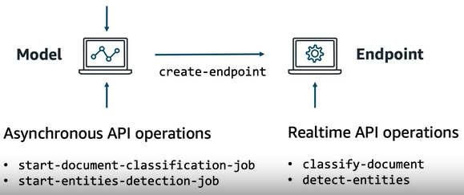

# Week 2

## Speech Recognition: Language Translation

### Amazon Transcribe

It is a fully managed service that automatically converts speech to text.

### Amazon Translate

It is a neural machine translation service for translating text between different languages. APIs operations: *TranslateText* (real-time) , *StartTextTranslationJob* (async batch) e *DescribeTextTranslateJob* (async batch).

## Virtual Agents

### Amazon Lex

It is a fully managed artificial intelligence service that supports conversions through voice and text chat interfaces.

## Amazon SageMaker

It is a fully managed service for preparing, building, training, and deploying high-quality machine learning models.

* Notebook instances

An Amazon SageMaker notebook instance is a machine learning instance, where you can compile and share code, documentation, and visualization models. With notebook instances in Amazon SageMaker, we can do the following:

* + Launch managed instances for jupyter notebooks;
  + Prepare and process data;
  + Write code to train models;
  + Deploy and validate models.

When we want to train a model in SageMaker, you can choose from a selection of algorithms. We can use built-in algorithms, supply a Docker image with our own algorithm, or purchase an algorithm in the AWS Marketplace.

A training job takes channels of data from an Amazon Simple Storage Service (Amazon S3) location that you supply. When a training job completes, you have a model. Alternatively, you can also purchase trained models from the AWS Marketplace.

After you train a model, you can perform inferences with your trained model. If you need real-time inferences, SageMaker can host inference endpoints. If you don’t need inferences in real time, you can use a model with batch transformations to get inferences from your datasets.