Building and evaluation of a PBPK model for Metformin in healthy adults
Abstract
Version | 1.0-OSP12.0
based on Model Snapshot and Evaluation Plan | https://github.com/Open-Systems-Pharmacology/Metformin-Model/releases/tag/v1.0
OSP Version | 12.0
Qualification Framework Version | 3.3
This evaluation report and the corresponding PK-Sim project file are filed at:
https://github.com/Open-Systems-Pharmacology/OSP-PBPK-Model-Library/

Table of Contents

Introduction
The presented model building and evaluation report evaluates the performance of a PBPK model for metformin in healthy adults.
The herein presented model represents an update of the metformin model published by Hanke et al. (Hanke 2020).
Metformin is widely used as first-line treatment of type 2 diabetes. It is a highly hydrophilic compound, positively charged at physiological pH and depends on active transport for its absorption, distribution and excretion. The absorption of metformin is saturable and reported to be restricted to the upper intestine (Vidon 1988). The excretion of metformin is mainly mediated via the sequential action of OCT2 and MATE in the kidney, with a moderate contribution of renal glomerular filtration (approximately 20 %). Metformin is recommended by the FDA as OCT2/MATE victim drug for the use in clinical DDI studies and drug labeling (FDA 2017).
The herein presented PBPK model of metformin PBPK model has been developed and evaluated by comparing simulations to observed data of both intravenously and orally administered metformin covering a dosing range from 0.001 to 2550 mg.
The presented model includes the following features:
- transport by PMAT,
- transport by OCT1,
- transport by OCT2,
- transport by MATE,
- renal clearance by glomerular filtration,
- oral absorption with dissolution rate assigned to a Weibull function.

Methods

Modeling strategy
The general concept of building a PBPK model has previously been described by Kuepfer et al. (Kuepfer 2016). Relevant information on anthropometric (height, weight) and physiological parameters (e.g., blood flows, organ volumes, binding protein concentrations, hematocrit, cardiac output) in adults was gathered from the literature and has been previously published (Willmann 2007). The information was incorporated into PK-Sim® and was used as default values for the simulations in adults.
Transporters and metabolizing enzymes relevant to the pharmacokinetics of the modeled drugs were implemented in agreement with current literature, utilizing the PK-Sim® expression database (PK-Sim Ontogeny Database Version 7.3) or otherwise referenced for the specific process.
A model was built based on clinical data from studies with intravenous and oral administration of metformin. The studies reported individual or mean plasma concentrations of metformin, and some of the studies reported fraction excreted to urine. For the studies reporting intravenous administration, metformin was administered in doses of 0.001 to 1000 mg. For the studies reporting oral administration, metformin was administered in doses of 0.001–2550 mg.
Virtual mean individuals were generated for each study according to the published demographic information, with corresponding age, weight, height, sex, ethnicity, hematocrit and GFR, if available. If no information was provided, a default virtual individual was applied (30 years of age, male, European, mean weight, height, hematocrit and GFR characteristics from the PK-Sim® population database).
The clinical datasets for metformin PBPK modeling were divided into a model building dataset for model building and a test dataset for model evaluation and verification. Both datasets are presented in Section 2.2.
A specific set of parameters (Section 2.3.4.) were optimized to describe the disposition of metformin using the Parameter Identification module provided in PK-Sim®. To limit the parameters to be optimized during model building, the minimal number of processes necessary to mechanistically describe the pharmacokinetics and drug-drug interactions (DDIs) of the modeled drugs were implemented into the models. The saturable absorption is implemented via PMAT and OCT1 in the small intestine. As late absorption of orally administered metformin is neither consistent with the reported plasma concentration time-profiles nor with the incomplete absorption of metformin, the relative expression of PMAT and OCT1 in the large intestinal mucosa was set to zero. For an improved capture of terminal half-life and to minimize drug accumulation over time in tissues the permeability calculation methods and selected specific permeability coefficients were optimized (i.e., liver, kidney, mucosa, and brain). No information regarding active transport processes at the basolateral side of the intestinal mucosa could be obtained. Therefore, the passive permeability from the intracellular to the interstitial space of the small intestinal mucosa was optimized. Metformin is primarily absorbed from the small intestine (Marathe 2000). In the updated model, to minimize absorption in the large intestine without causing accumulation of the drug inside of the intracellular space of the mucosa, the solubility in the distal Colon and rectum was set to 0 mg/l. While solubility is not the underlying cause of limited absorption in vivo, this adjustment was used as a practical modeling workaround. Finally, in the latest version of the model, meal events were introduced for the fed state simulations.
Details about input data (physicochemical, in vitro and clinical) can be found in Section 2.2.
Details about the structural model and its parameters can be found in Section 2.3.

Data used

In vitro and physicochemical data
A literature search was performed to collect available information on physicochemical properties of metformin. The obtained information from literature is summarized in the table below, and was used for model building. Final model parameters are stated in Section 3.1.
Parameter | Unit | Value | Source | Description
MW | g/mol | 129.16 | Wishart 2006 | Molecular weight
pK_{a} (base) |  | 2.80 | Desai 2014 | Base dissociation constant
pK_{b} (base) |  | 11.50 | Desai 2014 | Base dissociation constant
Solubility (pH 6.8) | g/L | 350.90 | Desai 2014 | Solubility
logP |  | -1.43 | Graham 2011 | Partition coefficient between octanol and water
fu | % | 100 | Tucker 1981, Pentikäinen 1979, Sirtori 1978 | Fraction unbound
PMAT Hill |  | 3 | Zhou 2007 | PMAT Hill coefficient, Literature value = 2.64
K_{m} OCT1 | µmol/L | 1180.00 | Chen 2009 | OCT1 Michaelis-Menten constant
K_{m} OCT2 | µmol/L | 810.00 | Chen 2009 | OCT2 Michaelis-Menten constant
K_{m} MATE1 | µmol/L | 283.00 | Yin 2016 | MATE1 Michaelis-Menten constant
Tablet fasted Weibull shape | - | 1.36 | Block 2008 | Dissolution profile shape
Tablet fasted Weibull time | min | 7.90 | Block 2008 | Dissolution time (50% dissolved)

Clinical data
A literature search was performed to collect available clinical data on metformin in adults.
The following publications were used for model building (training dataset) and model verification (test dataset):
Dose [mg] | Dosing | PK data | Dataset | Reference
0.00145 | iv, bolus, sd | plasma, blood and tissue (kidney,liver, intestines and muscle) | training | Gormsen 2016
250 | iv (15 min), sd | plasma, excretion into urine | training | Tucker 1981
500 | iv (5 min), sd | plasma, excretion into urine | test | Pentikäinen 1979
1000 | iv (bolus), sd | plasma, excretion into urine | training | Sirtori 1978
0.0008556 | po, -, fasted, sd | plasma and tissue (kidney, liver, and muscle) | training | Gormsen 2016
10 | po, sol, fasted, sd | plasma, excretion into urine | training | Stopfer 2018
250 | po, tab, fed, qd | plasma, excretion into urine | test | Somogyi 1987
500 | po, -, fasted, sd | plasma, excretion into urine | test | Wang 2008
500 | po, sol, fasted, sd | plasma, excretion into urine, and tissue (kidney) | training | Boehringer 2018
500 | po, tablet, fed, sd | plasma | test | Caillé 1993
500 | po, tablet, fed, sd | plasma, excretion into urine | test | Gusler 2001
500 | po, tablet, fasted, sd | plasma | test | Najib 2002
500 | po, tablet, fasted, sd | plasma, excretion into urine | test | Pentikäinen 1979
500 | po, tablet, fasted, sd | plasma, excretion into urine | test | Sambol 1996b
500 | po, tablet, fasted, sd | plasma, excretion into urine | training | Stopfer 2016
500 | po, tablet, fed, sd | plasma, excretion into urine | test | Tucker 1981
500 | po, tablet, fed, bid | plasma, excretion into urine | test | DiCicco 2014
500 ^{(a)} | po, tablet, fasted, bid | plasma | test | Jang 2016
500 ^{(a)} | po, tablet, fasted, bid | plasma | test | Kim 2014
500 | po, tablet, fasted, bid | plasma | test | Manitpisitkul 2014
500 ^{(a)} | po, tablet, fasted, bid | plasma | test | Oh 2016
750 ^{(b)} | po, tablet, fasted, bid | plasma | test | Cho 2011
750 ^{(b)} | po, tablet, fasted, bid | plasma | test | Cho 2014
750 ^{(b)} | po, tablet, fasted, bid | plasma | test | Ding 2014
850 | po, sol, fasted, sd | plasma, excretion into urine | training | Sambol 1996b
850 _{(c)} | po, tablet, fasted, bid | plasma | test | Chen 2009
850 | po, tablet, fasted, sd | plasma | test | Morrissey 2016
850 | po, tablet, fed, sd | blood, plasma | test | Robert 2003
850 | po, tablet, fasted, sd | blood, plasma, excretion into urine | test | Sambol 1995
850 | po, tablet, fasted, sd | plasma, excretion into urine | test | Sambol 1996a
850 | po, tablet, fed, sd | plasma, excretion into urine | training | Sambol 1996b
850 | po, tablet, fed, sd | plasma, excretion into urine | training | Sambol 1996b
850^{(c)} | po, tablet, fasted, bid | plasma, excretion into urine | test | Hibma 2016
850 | po, tablet, fasted, tid | plasma | test | Sambol 1996a
1000 | po, tablet, fasted, sd | plasma, excretion into urine | test | Johansson 2014
1000 | po, tablet, fasted, qd | plasma | test | Gan 2016
1500 | po, tablet, fed, qd | plasma | test | Tucker 1981
1700 | po, tablet, fasted, sd | plasma, excretion into urine | training | Sambol 1996a
2550 | po, tablet, fasted, sd | plasma, excretion into urine | training | Sambol 1996a
^{(a)} first dose 750 mg, second dose 500 mg
^{(b)} first dose 1000 mg, second dose 750 mg
^{(c)} first dose 1000 mg, second dose 850 mg

Model parameters and assumptions

Absorption
The parameter value for Specific intestinal permeability was optimized based on clinical oral data, see Section 2.3.4. The saturable absorption is implemented via PMAT and OCT1 in the small intestine. As late absorption of orally administered metformin is neither consistent with the reported plasma concentration time-profiles nor with the incomplete absorption of metformin, the relative expression of PMAT and OCT1 in the large intestinal mucosa was set to zero. Additionally, no information regarding active transport processes at the basolateral side of the intestinal mucosa could be obtained, therefore, the passive basolateral permeability (P (intracellular -> interstitial) was optimized see Section 2.3.4.
The measured solubility of metformin hydrochloride in a phosphate buffer at pH 6.8 was used in the model (see Section 2.2.1).
The dissolution of tablets was implemented via empirical Weibull dissolution.

Distribution
Metformin is not bound to plasma proteins (fu = 100 %) (see Section 2.2.1) (Sirtori 1978, Pentikäinen 1979 and Tucker 1981). A value of 100% was used in this PBPK model for Fraction unbound (plasma, reference value). The major binding partner was set to albumin (see Section 2.2.1).
An important parameter influencing the resulting volume of distribution is lipophilicity. The reported experimental logP of -1.43 was used in this model (see Section 2.2.1).
After testing the available organ-plasma partition coefficient and cell permeability calculation methods built in PK-Sim®, observed clinical data was best described by choosing the partition coefficient calculation by PK-SIM Standard and cellular permeability calculation by PK-SIM Standard.
The permeability coefficients for liver, kidney and brain (i.e., ((P (intracellular -> interstitial) liver periportal, (P (intracellular -> interstitial) liver pericentral and ((P (intracellular -> interstitial) kidney) were optimized to avoid accumulation of drug in tissue and to capture observed PK profiles Section 2.3.4.

Metabolism and Elimination
Following its absorption, metformin is not bound to plasma proteins, not metabolized, and not secreted to bile. Metformin is excreted unchanged with the urine by passive glomerular filtration and active renal secretion through the sequential action of organic cation transporter 2 (OCT2) and multidrug and toxin extrusion protein 1 (MATE1). The transport proteins involved in metformin PK were implemented in the model as described below:
- PMAT
The PMAT expression profiles are based on high-sensitive real-time RT-PCR (Nishimura 2005). Metabolic enzyme activity was described as saturable process following Hill kinetics, where the PMAT Hill was taken from literature and Kmand kcat where optimized based on clinical data (see Section 2.3.4).
- OCT1
The OCT1 expression profiles are based on Microarray expression data (Kolesnikov 2015). Transporter activity was described as saturable process following Michaelis-Menten kinetics, where the Km was taken from literature and kcat was optimized based on clinical data (see Section 2.3.4).
- OCT2
The OCT2 expression profiles are based on Expressed Sequece Tags (EST) (NCBI 2019). Transporter activity was described as saturable process following Michaelis-Menten kinetics, where the Km was taken from literature and kcat was optimized based on clinical data (see Section 2.3.4).
- MATE1
The MATE1 expression profiles assumed 100% expression in the Kidney (Otsuka 2005 and Masuda 2006). Transporter activity was described as saturable process following Michaelis-Menten kinetics, where the Km was taken from literature and kcat was optimized based on clinical data (see Section 2.3.4).
Additionally, passive renal clearance by glomerular filtration was implemented and the GFR fraction was set to 1. In addition, fraction of bile that was continuously released was set to 1 (EHC continuous fraction)

Automated Parameter Identification
This is the result of the final parameter identification.
Model Parameter | Optimized Value | Unit
kcat (PMAT) | 76.47 | 1/min
Km (PMAT) | 367.57 | µmol/l/min
kcat (OCT1) | 641.19 | 1/min
kcat (OCT2) | 17479.74 | 1/min
kcat (MATE1) | 165.69 | 1/min
P(intracellular-interstitial) Kidney | 4.02E-06 | cm/min
P(intracellular-interstitial) Liver | 4.83E-05 | cm/min
P(intracellular-interstitial) Brain | 0.02 | cm/min
Specific intestinal permeability | 8.49E-07 | cm/min
P(intracellular-interstitial) mucosa (Basolateral intestinal permeability) | 2.25E-05 | cm/min
Tablet dissolution fed Weibull Shape | 0.08 | -
Tablet dissolution fed Weibull Time | 7.90 | min

Results and Discussion
The next sections show:
- the final model input parameters for the building blocks: Section 3.1.
- the overall goodness of fit: Section 3.2.
- simulated vs. observed concentration-time profiles for the clinical studies used for model building and for model verification: Section 3.3.

Metformin final input parameters
The compound parameter values of the final PBPK model are illustrated below.

Compound: Metformin

Parameters
Name | Value | Value Origin | Alternative | Default
Solubility at reference pH | 350.9 mg/ml |  | Measurement | True
Reference pH | 6.8 |  | Measurement | True
Lipophilicity | -1.43 Log Units |  | Measurement | True
Fraction unbound (plasma, reference value) | 100 % |  | Measurement | True
Specific intestinal permeability (transcellular) | 8.4891040357E-07 cm/min | Parameter Identification-Parameter Identification-Value updated from ‘17_final’ on 2019-04-09 09:52 | Fit | True
Is small molecule | Yes
Molecular weight | 129.1636 g/mol
Plasma protein binding partner | Albumin

Calculation methods
Name | Value
Partition coefficients | PK-Sim Standard
Cellular permeabilities | PK-Sim Standard

Processes

Systemic Process: Glomerular Filtration-GFR
Species: Human

Parameters
Name | Value | Value Origin
GFR fraction | 1

Transport Protein: OCT1-Paper
Molecule: OCT1

Parameters
Name | Value | Value Origin
Transporter concentration | 1 µmol/l
Vmax | 641.185138023 µmol/l/min | Parameter Identification-Parameter Identification
Km | 1180 µmol/l

Transport Protein: OCT2-Paper
Molecule: OCT2

Parameters
Name | Value | Value Origin
Transporter concentration | 1 µmol/l
Vmax | 17479.74 µmol/l/min | Parameter Identification-Parameter Identification
Km | 810 µmol/l

Transport Protein: MATE1-Paper
Molecule: MATE1

Parameters
Name | Value | Value Origin
Transporter concentration | 1 µmol/l
Vmax | 165.69 µmol/l/min | Parameter Identification-Parameter Identification
Km | 283 µmol/l | Parameter Identification-Parameter Identification

Transport Protein: PMAT-Paper
Molecule: PMAT

Parameters
Name | Value | Value Origin
Transporter concentration | 1 µmol/l
Vmax | 76.4673688119 µmol/l/min | Parameter Identification-Parameter Identification-Value updated from ‘17_final’ on 2019-04-09 09:51
Km | 367.5702930377 µmol/l | Parameter Identification-Parameter Identification-Value updated from ‘17_final’ on 2019-04-09 09:52
Hill coefficient | 3

Metformin Diagnostics Plots
Below you find the goodness-of-fit visual diagnostic plots for the PBPK model performance of all data used presented in Section 2.2.2.
The first plot shows observed versus simulated plasma concentration, the second weighted residuals versus time.

Table 3-1: GMFE for Goodness of fit plot for concentration in plasma.
Group | GMFE
Metformin iv (model building) | 1.89
Metformin iv (model verification) | 2.23
Metformin oral administration (model building) | 1.57
Metformin oral administration (model verification) | 1.65
All | 1.67

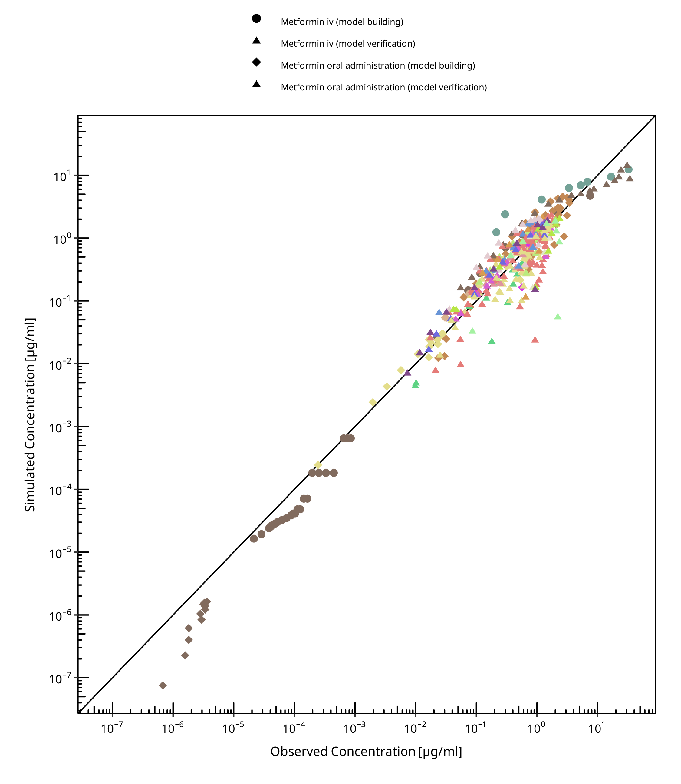
Figure 3-1: Goodness of fit plot for concentration in plasma.

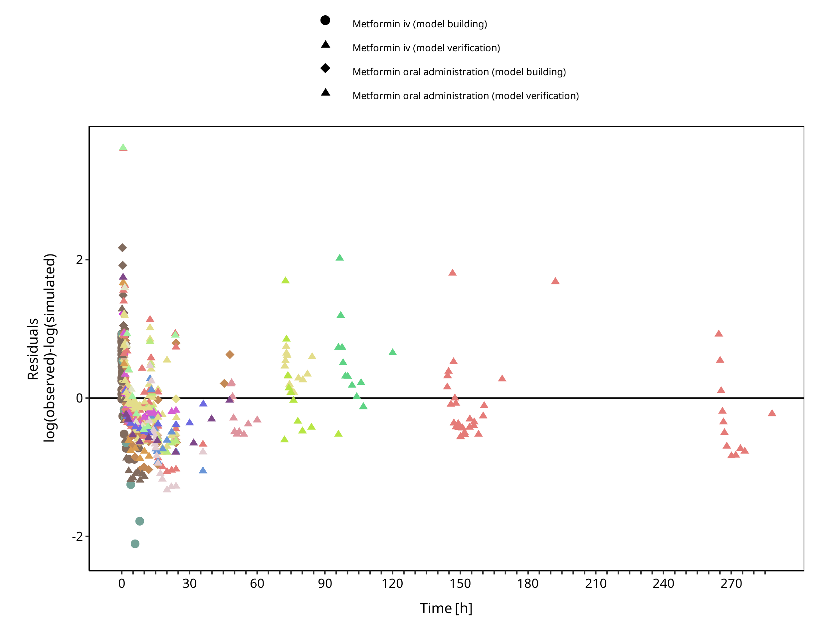
Figure 3-2: Goodness of fit plot for concentration in plasma.

Concentration-Time Profiles
Simulated versus observed concentration-time profiles of all data listed in Section 2.2.2 are presented below.

Model Building

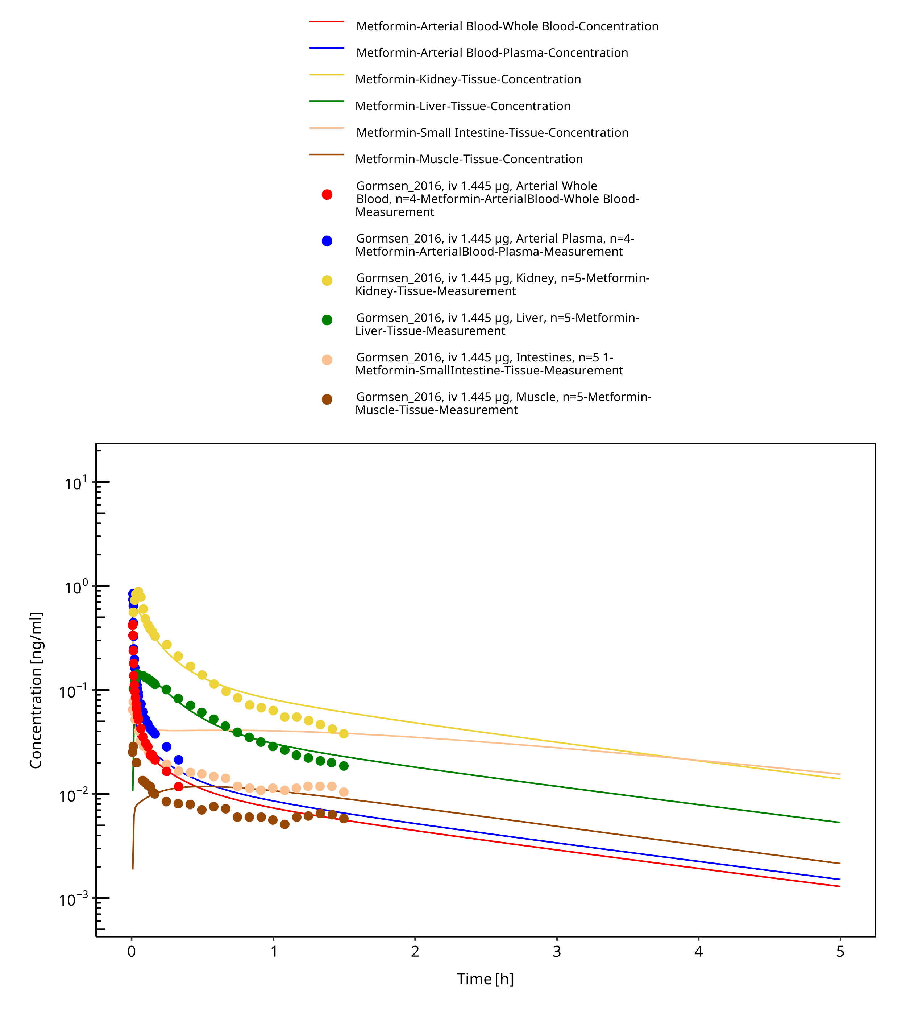
Figure 3-3: Metformin - iv, 0.0014 mg_Gormsen 2016

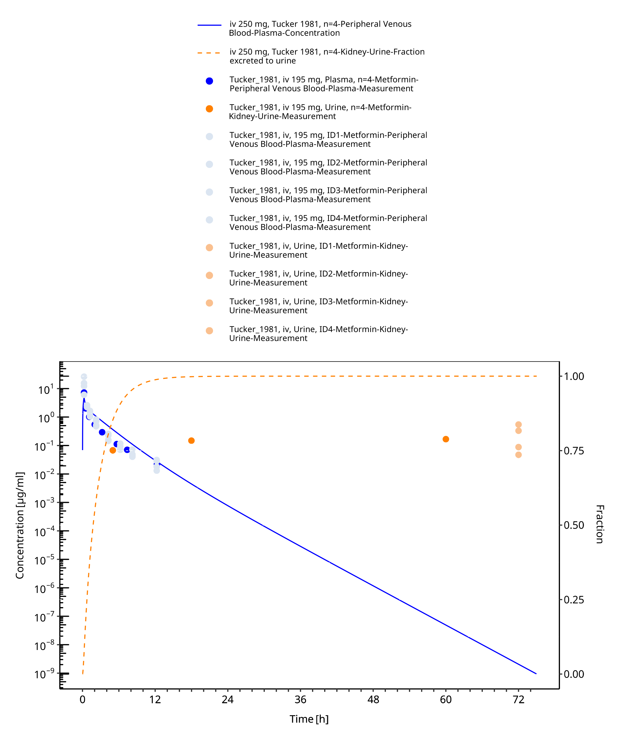
Figure 3-4: Metformin - iv, 250 mg_Tucker 1981

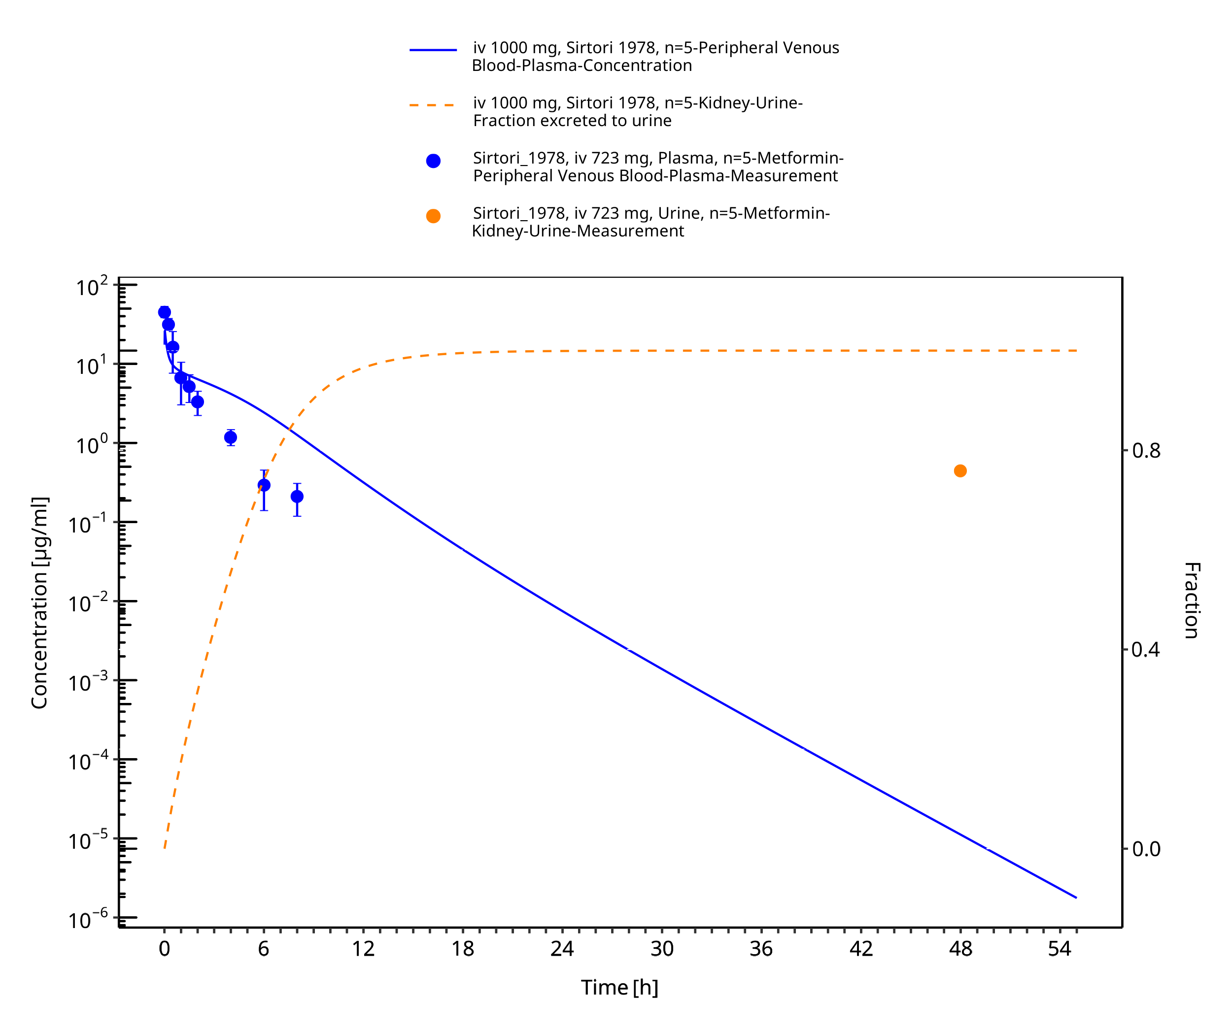
Figure 3-5: Metformin - iv, 1000 mg_Sirtori 1978

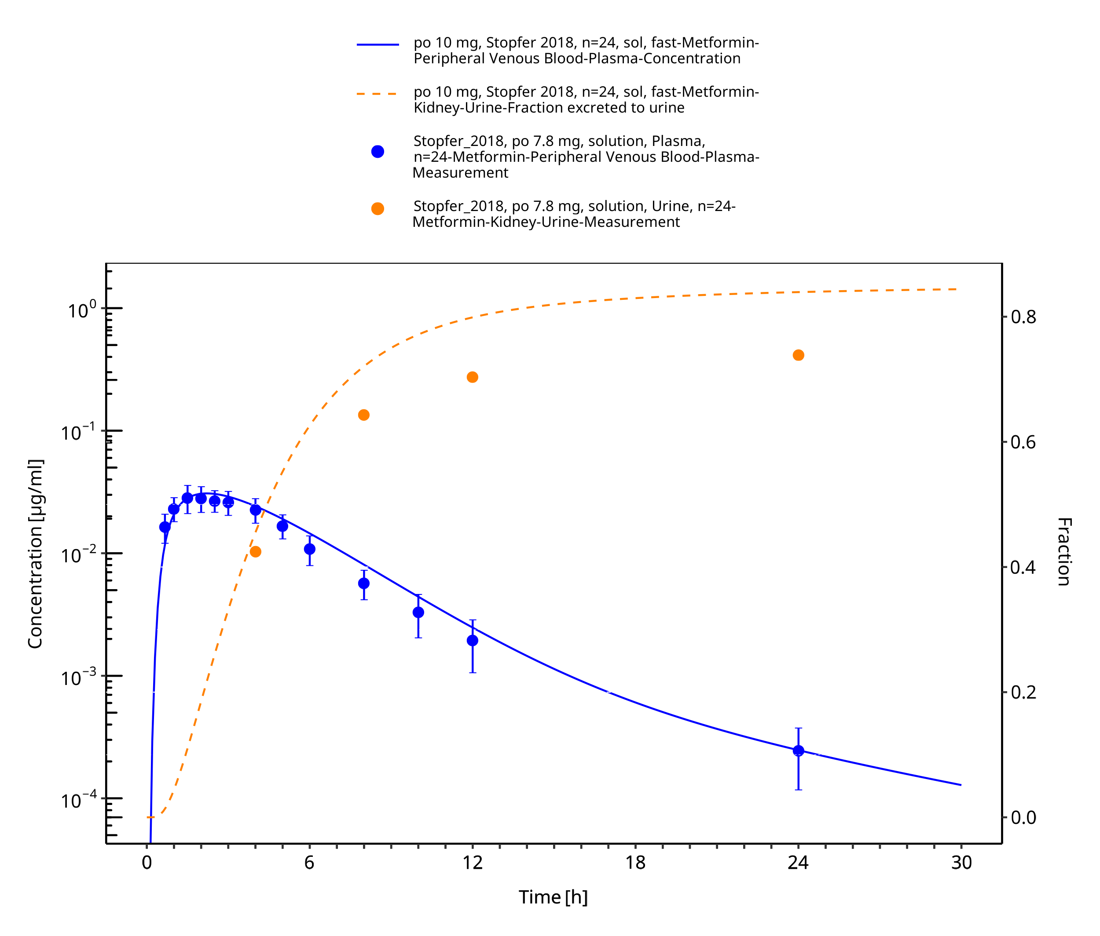
Figure 3-6: Metformin - po (sol) 10 mg_Stopfer 2018

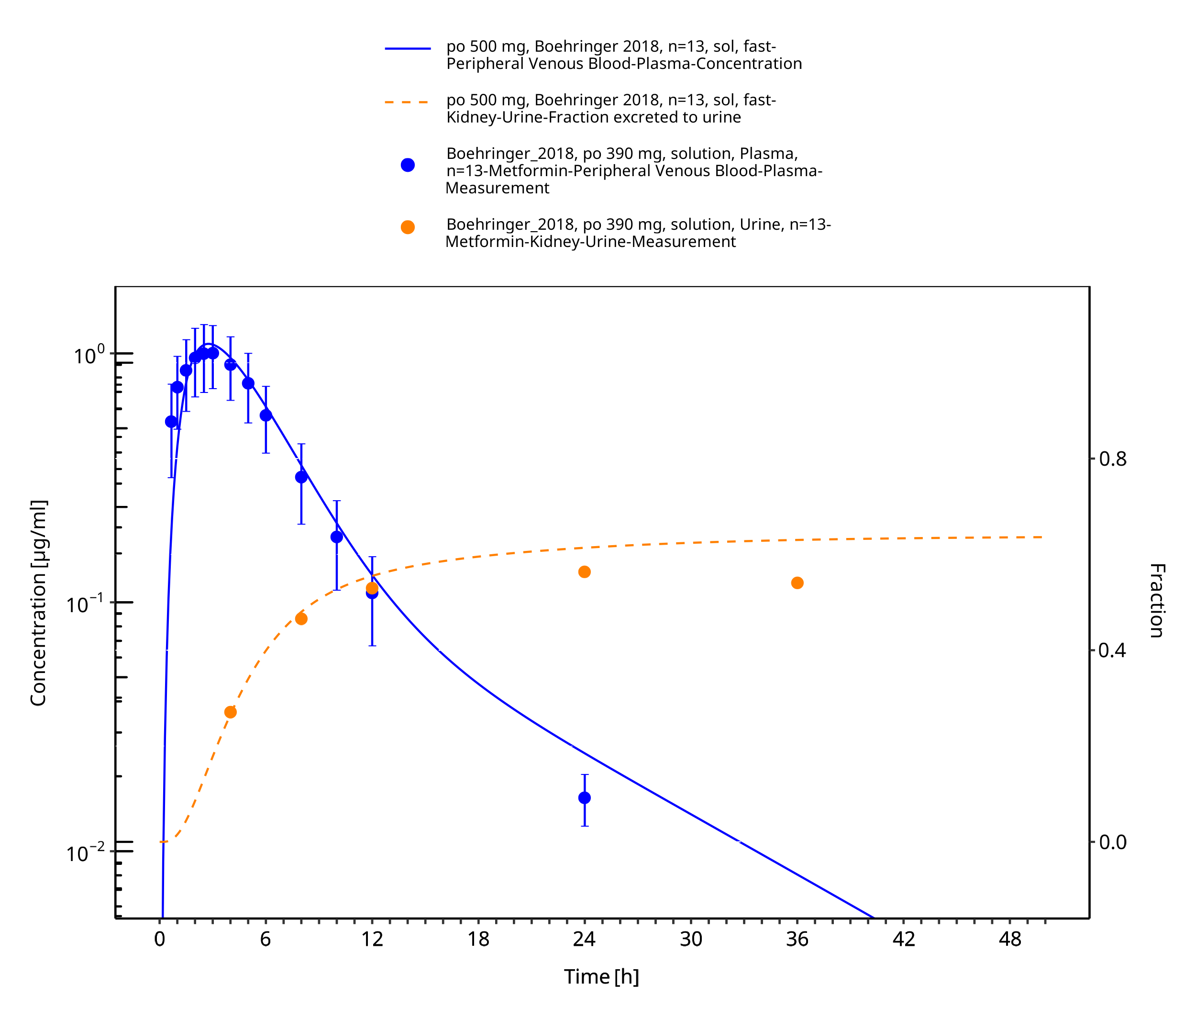
Figure 3-7: Metformin - po (sol) 500 mg_Boehringer 2018

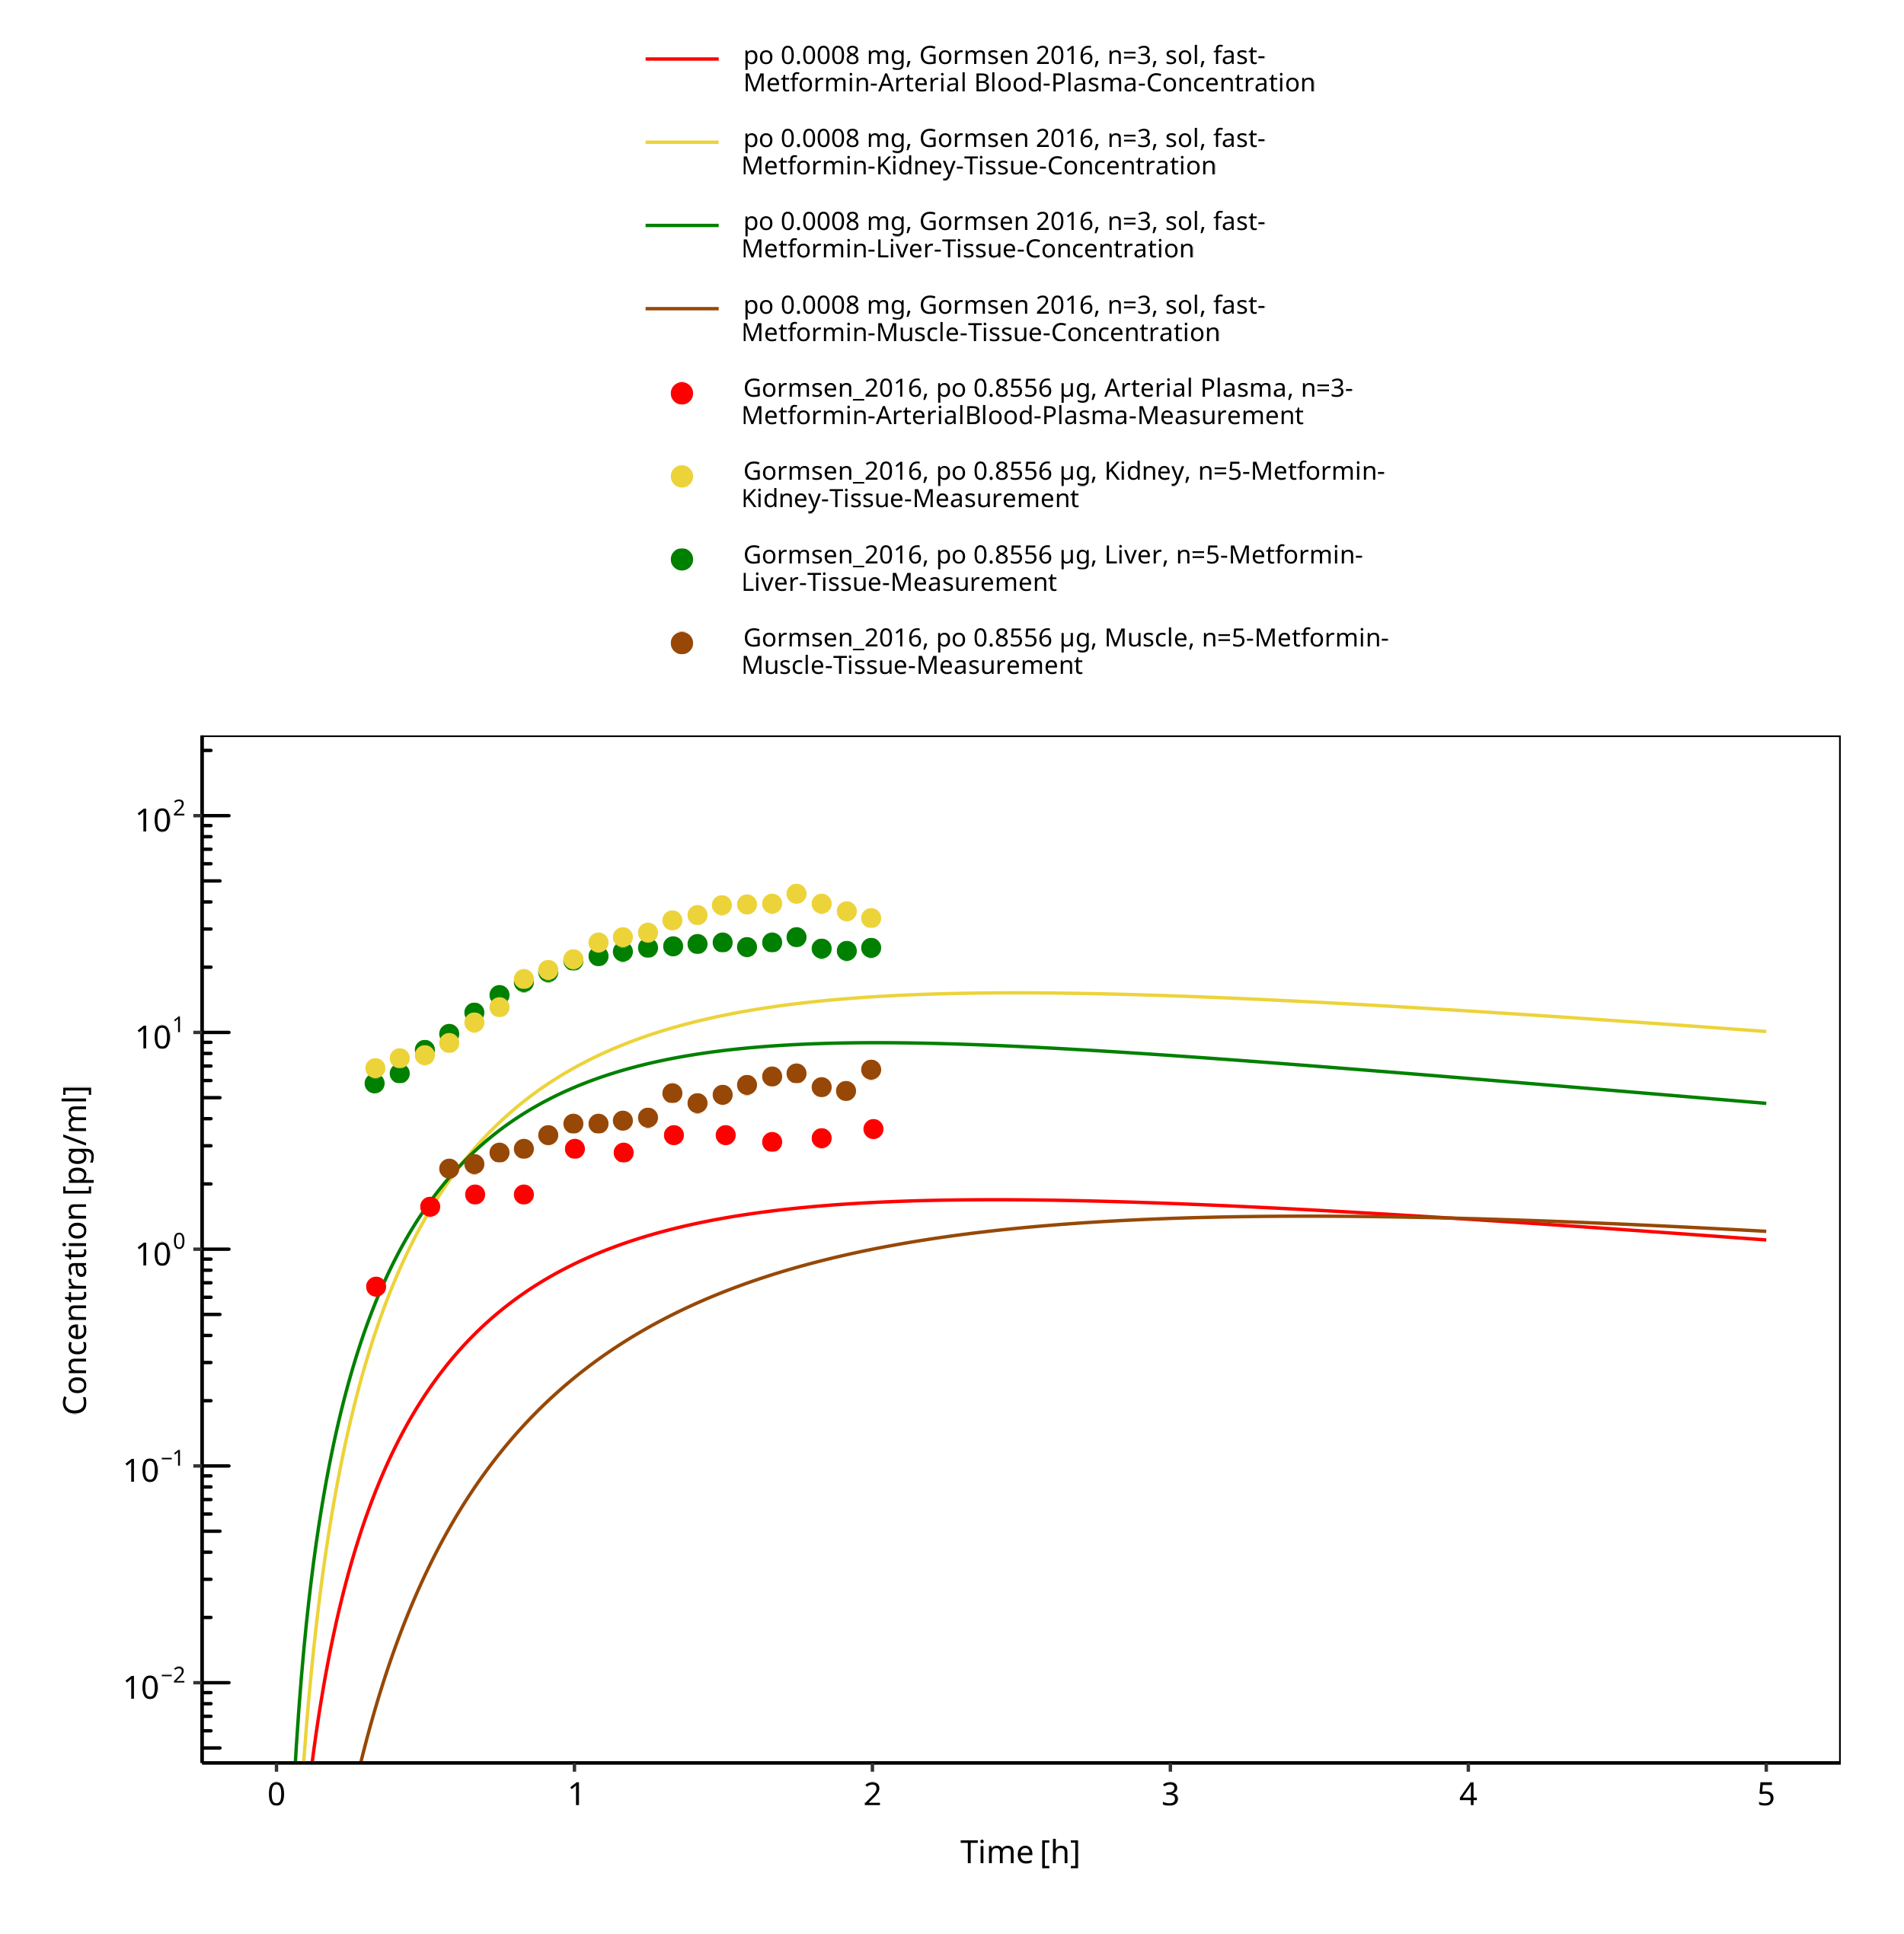
Figure 3-8: Metformin - po (sol) 0.0008 mg, Gormsen 2016

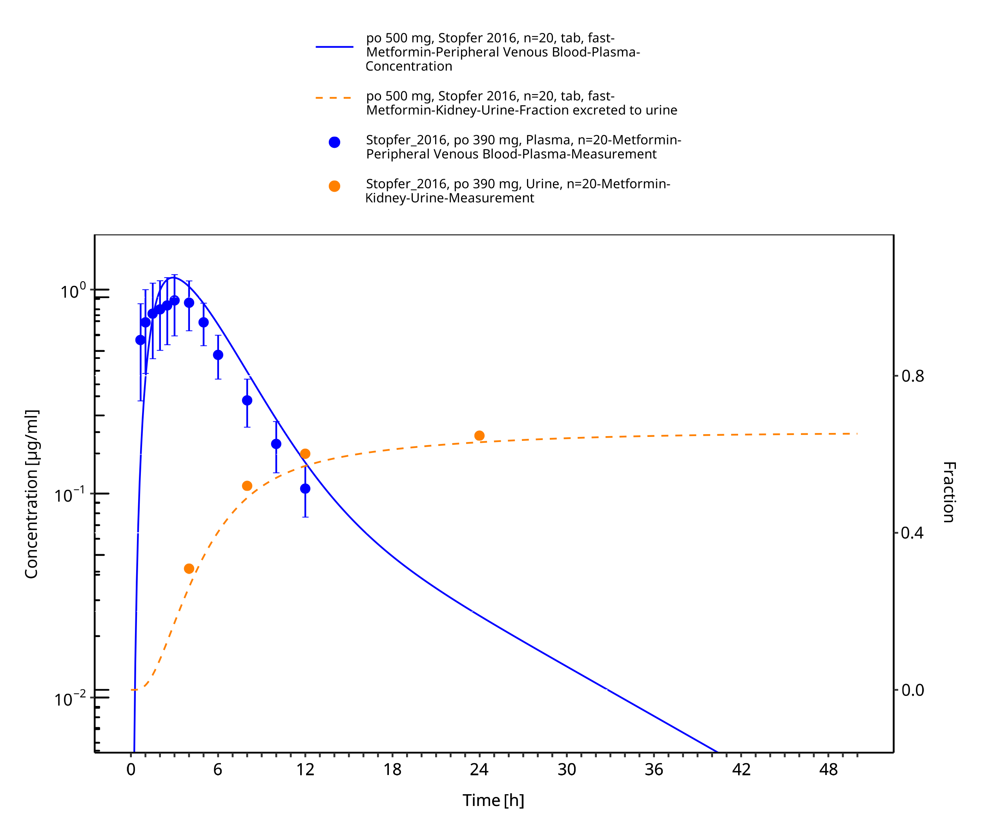
Figure 3-9: Metformin - po (tab) 500 mg_Stopfer 2016

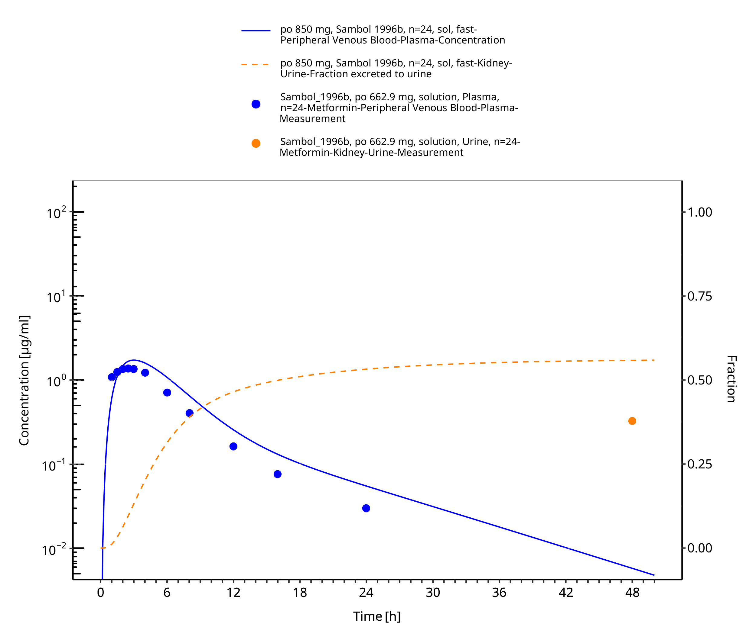
Figure 3-10: Metformin - po (sol) 850 mg_Sambol 1996b

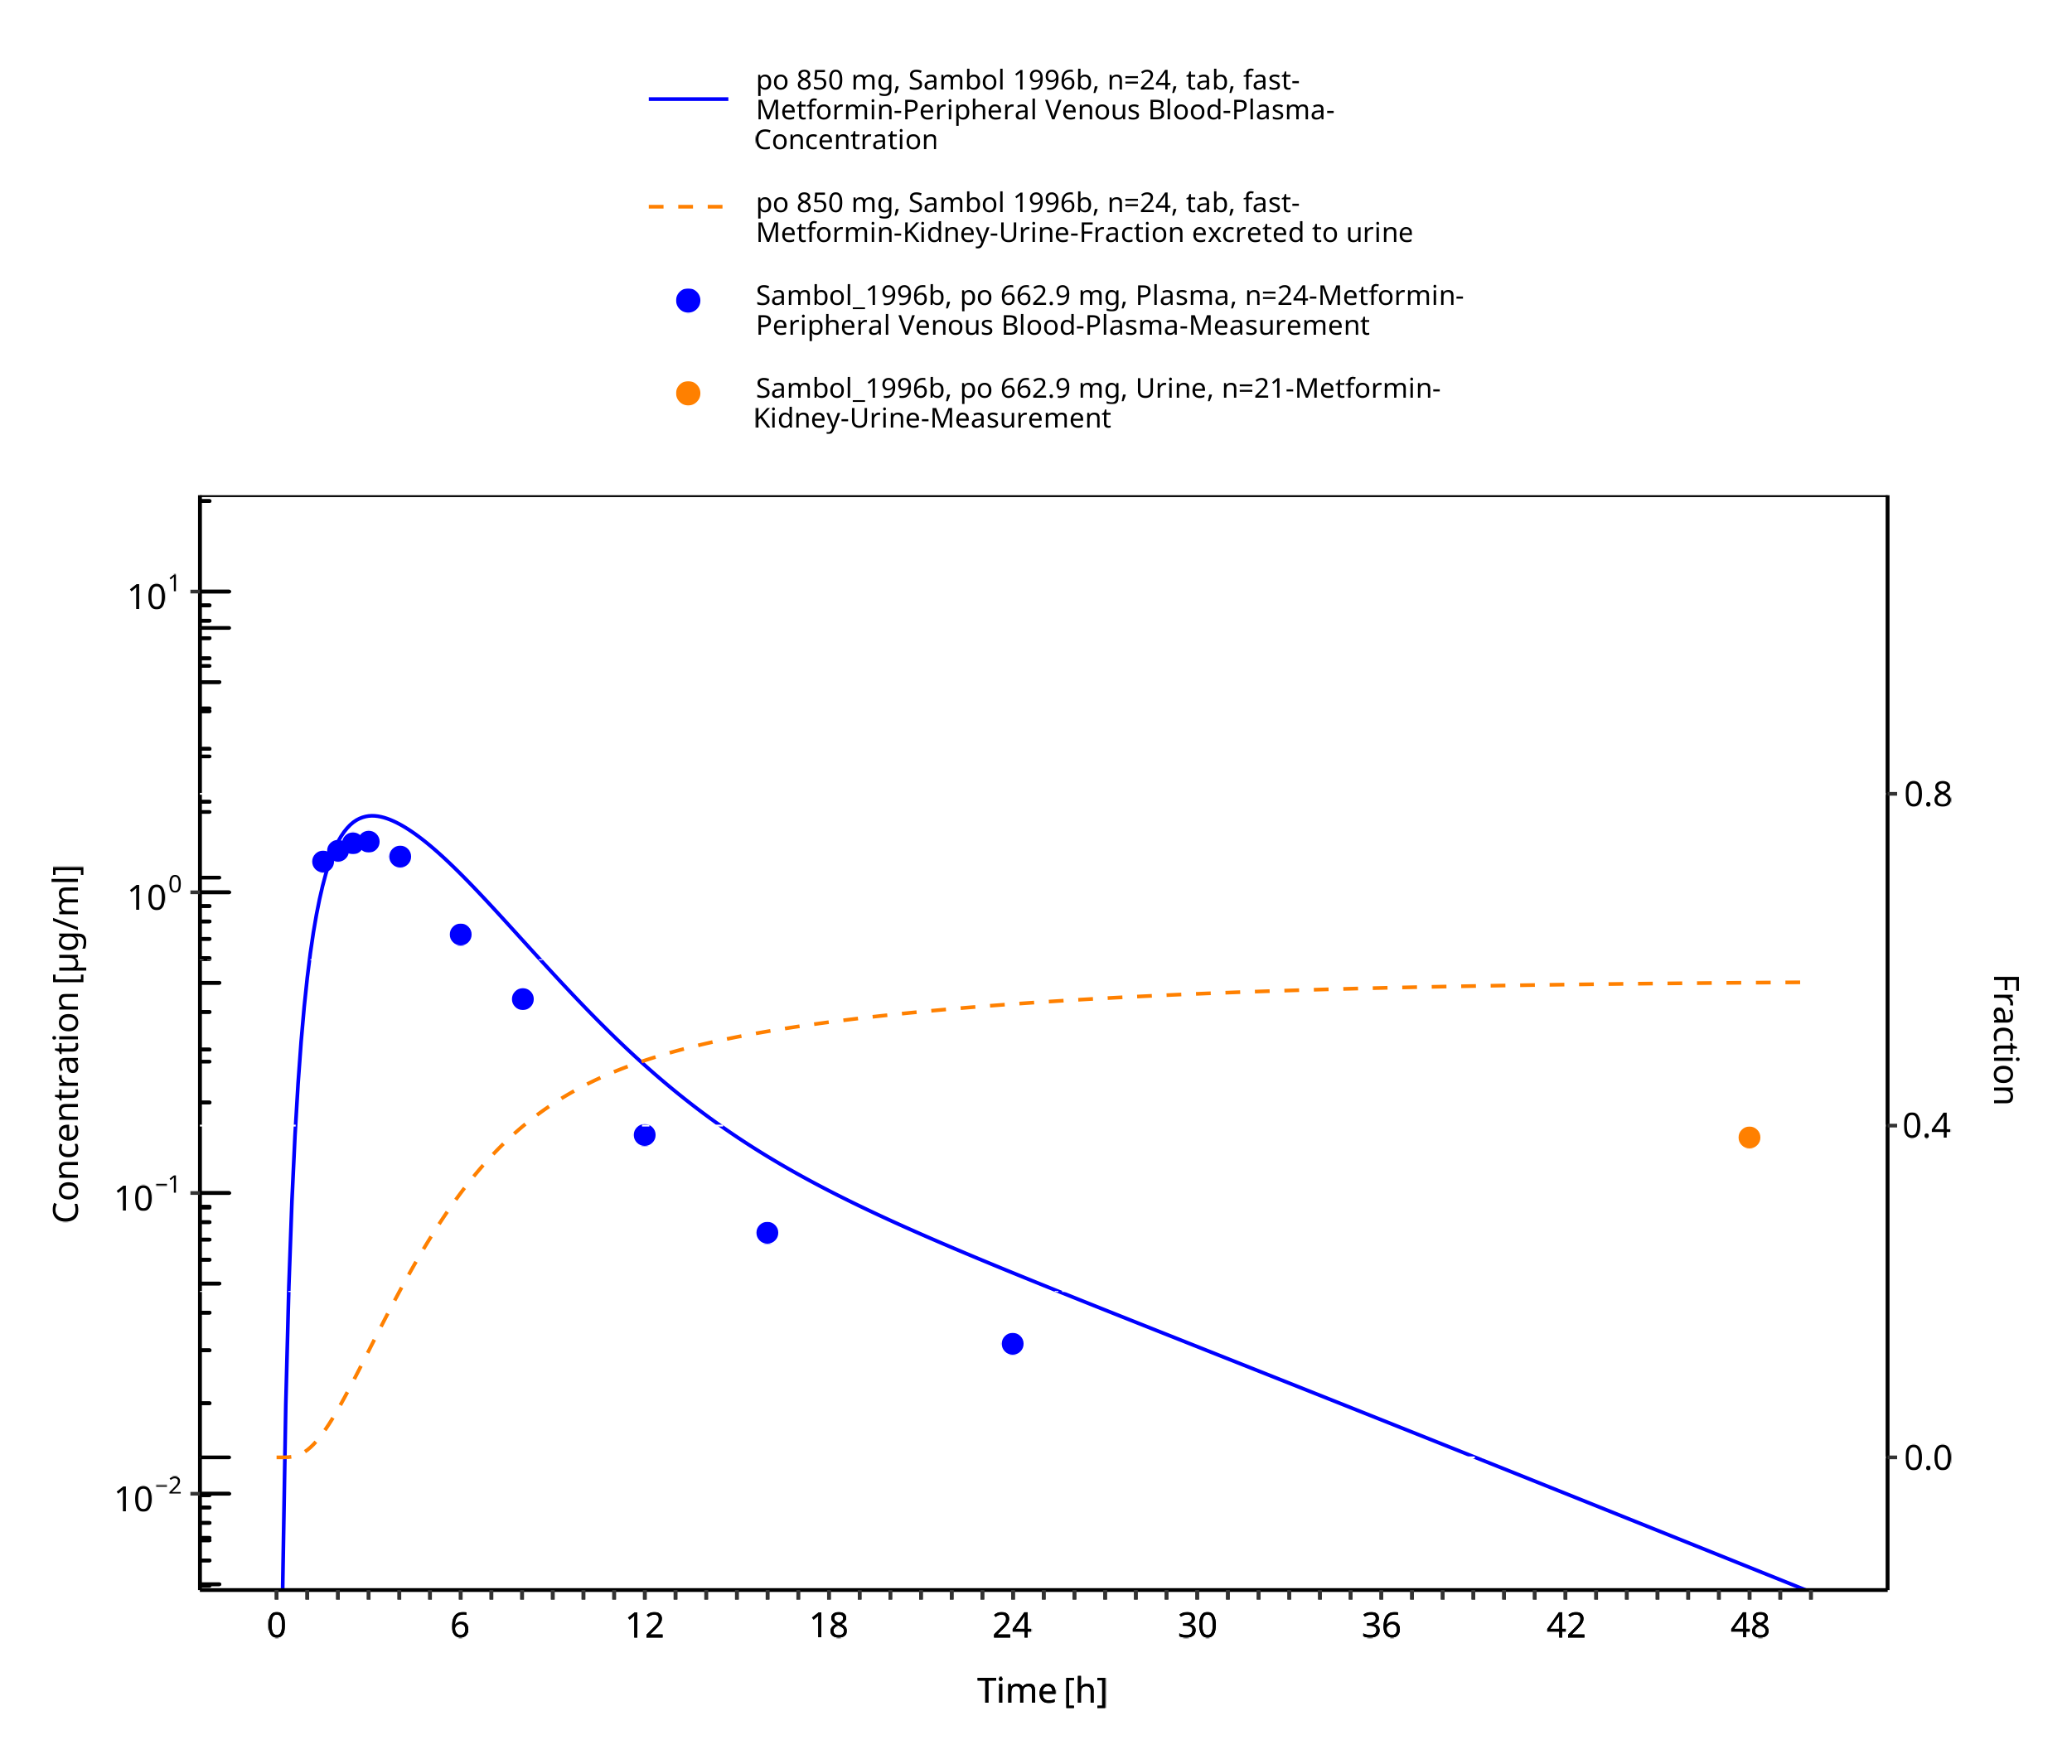
Figure 3-11: Metformin - po (tab) 850 mg_Sambol 1996b

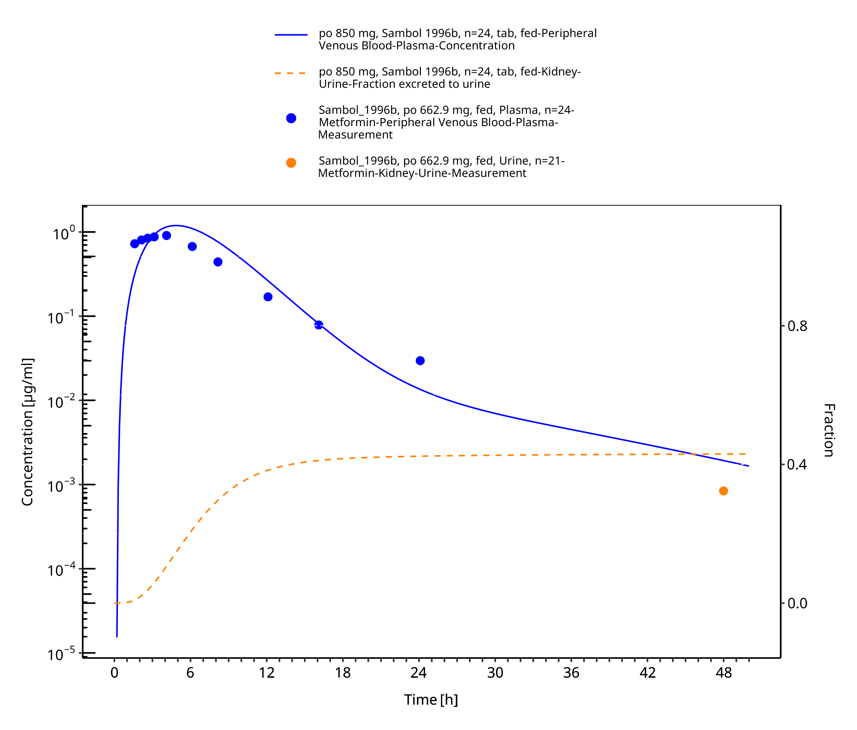
Figure 3-12: Metformin - po (tab) 850 mg_Sambol 1996a

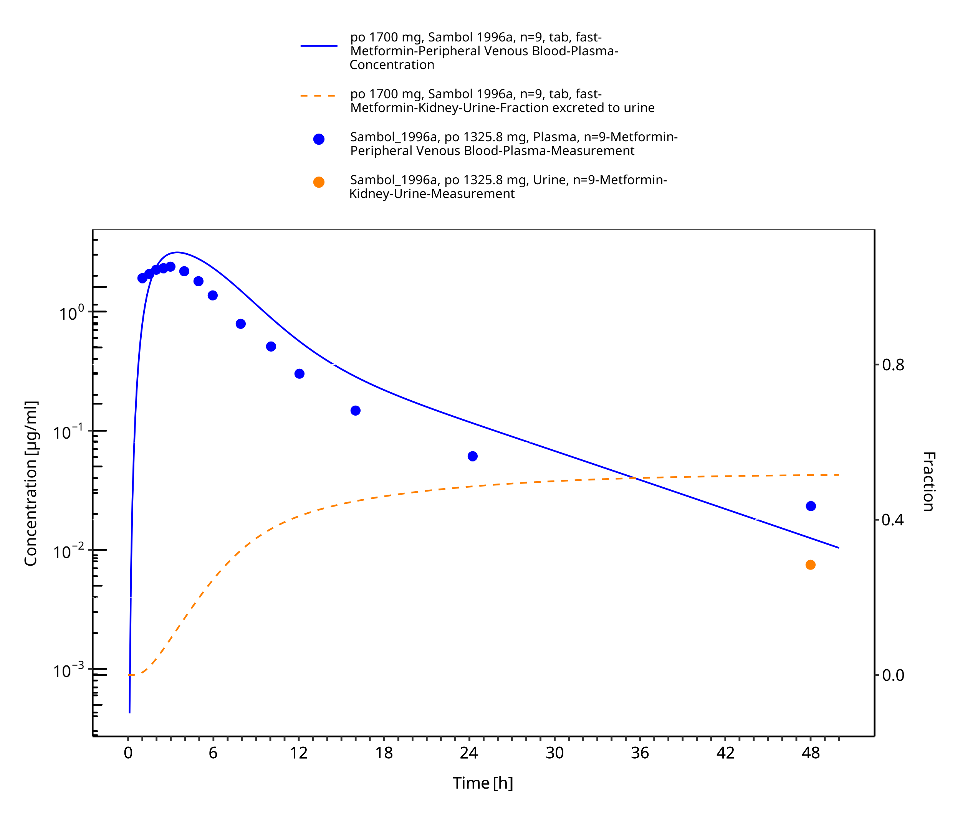
Figure 3-13: Metformin - po (tab) 0.1700 mg_Sambol 1996a

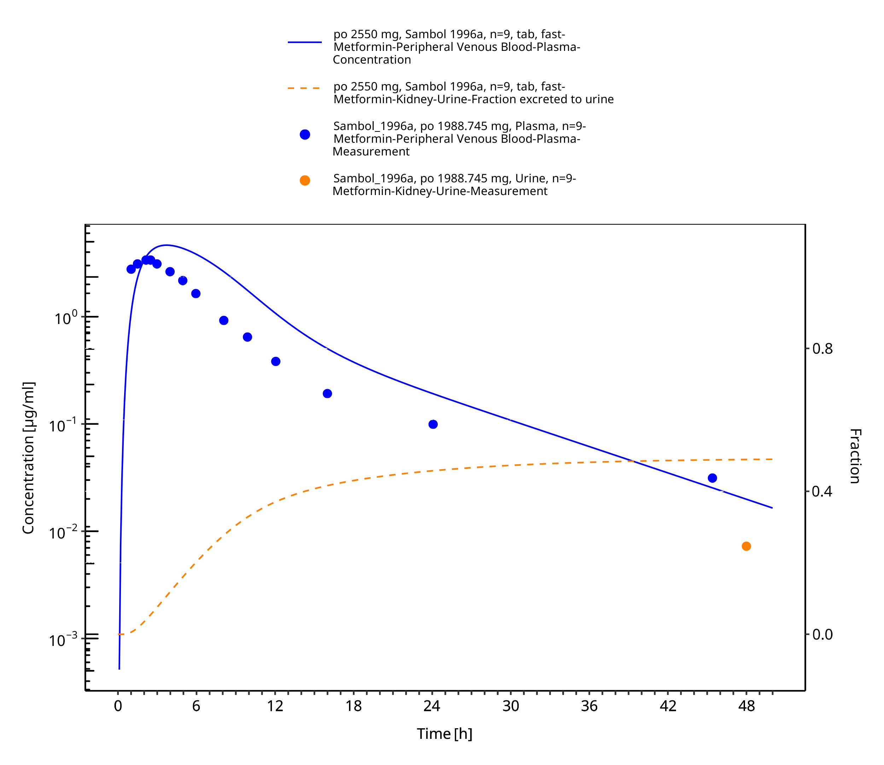
Figure 3-14: Metformin - po (tab) 2550 mg_Sambol 1996a

Model Verification

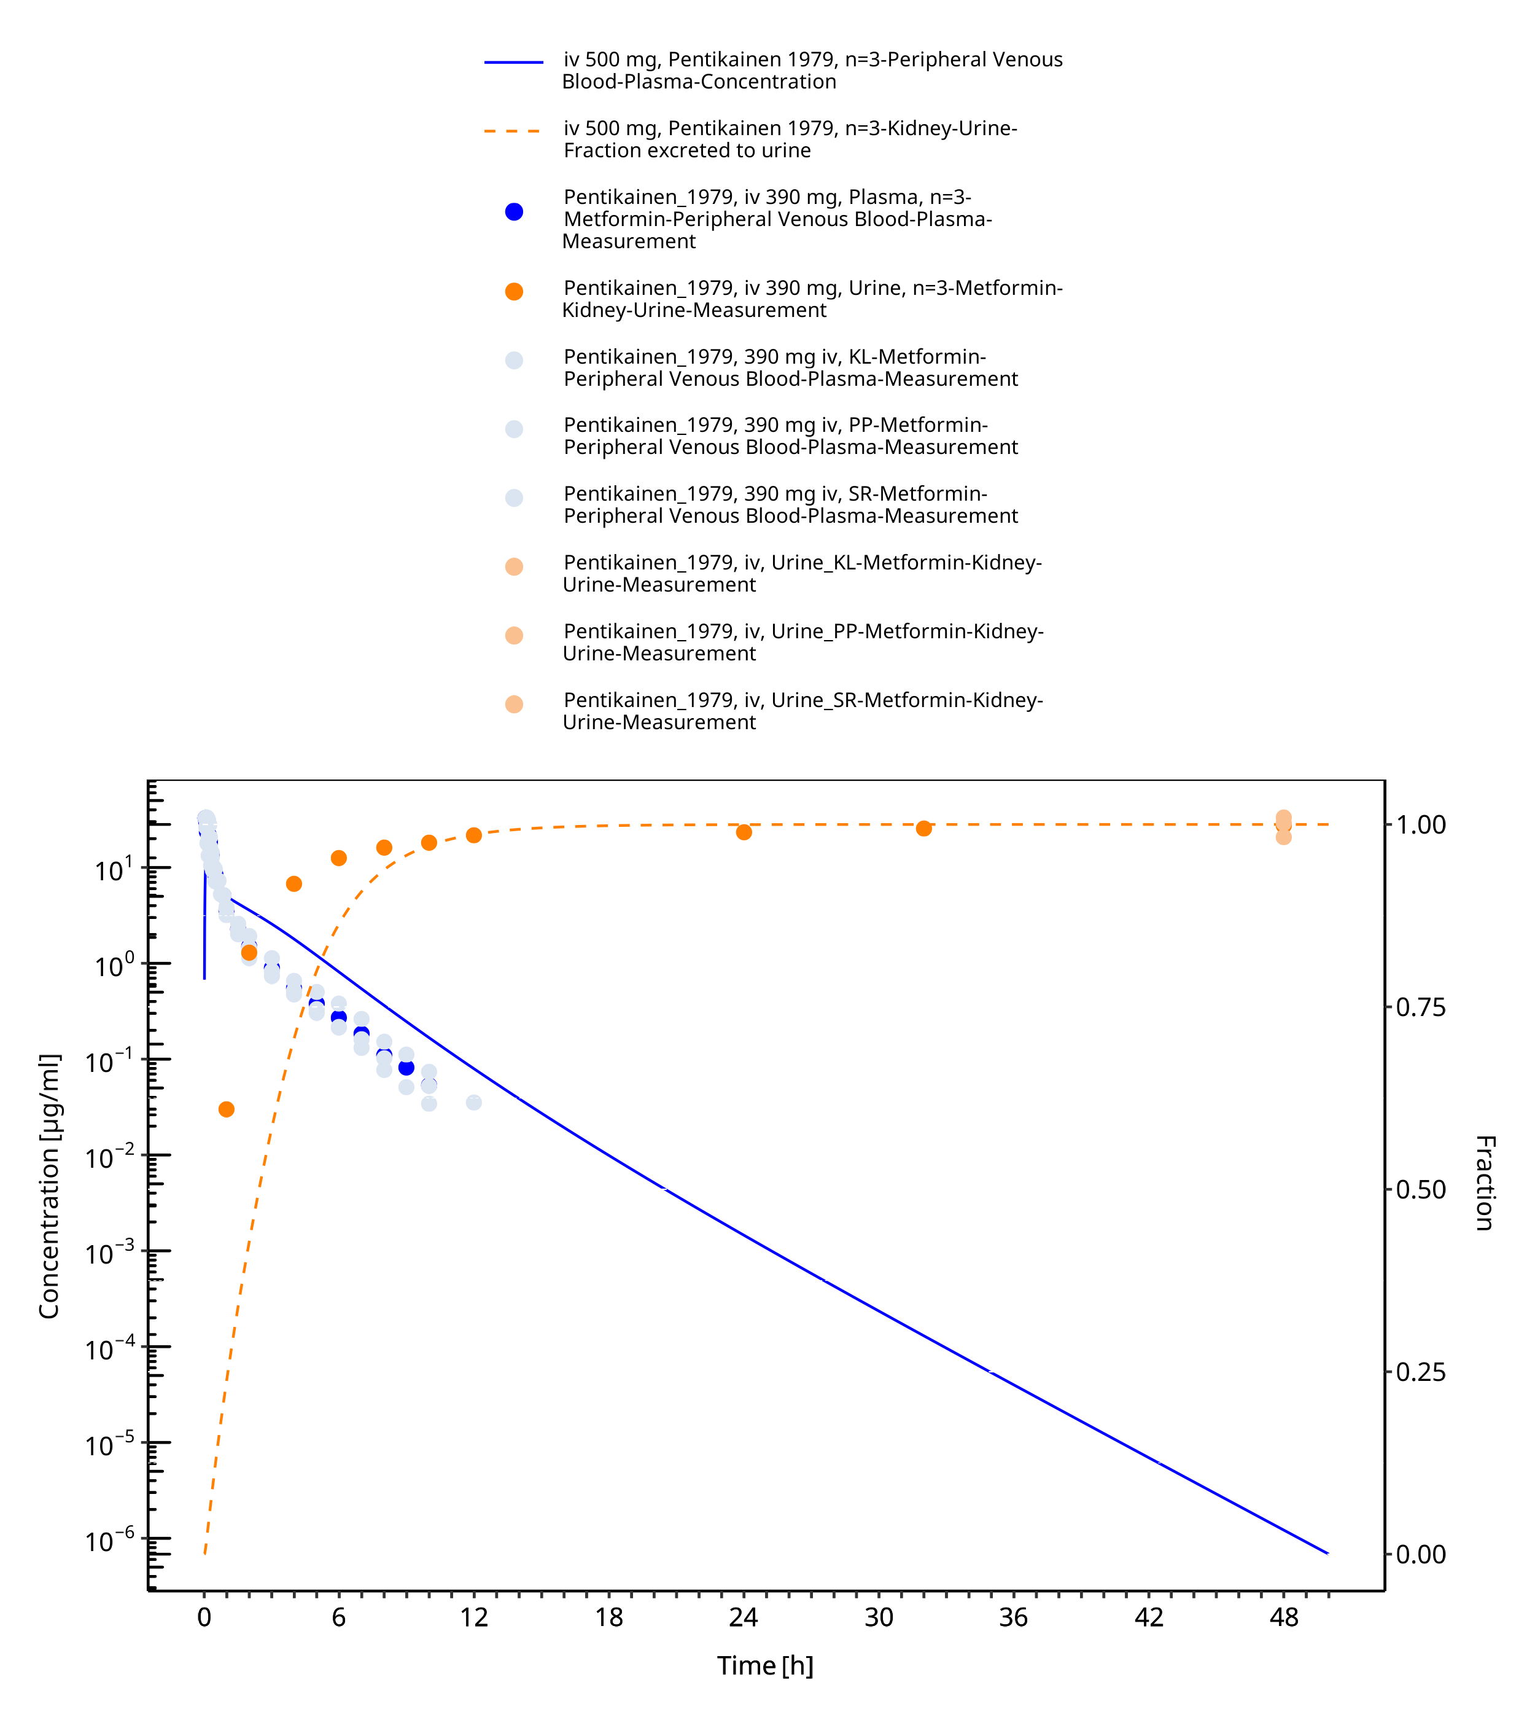
Figure 3-15: Metformin - iv 500 mg_Pentikainen 1979

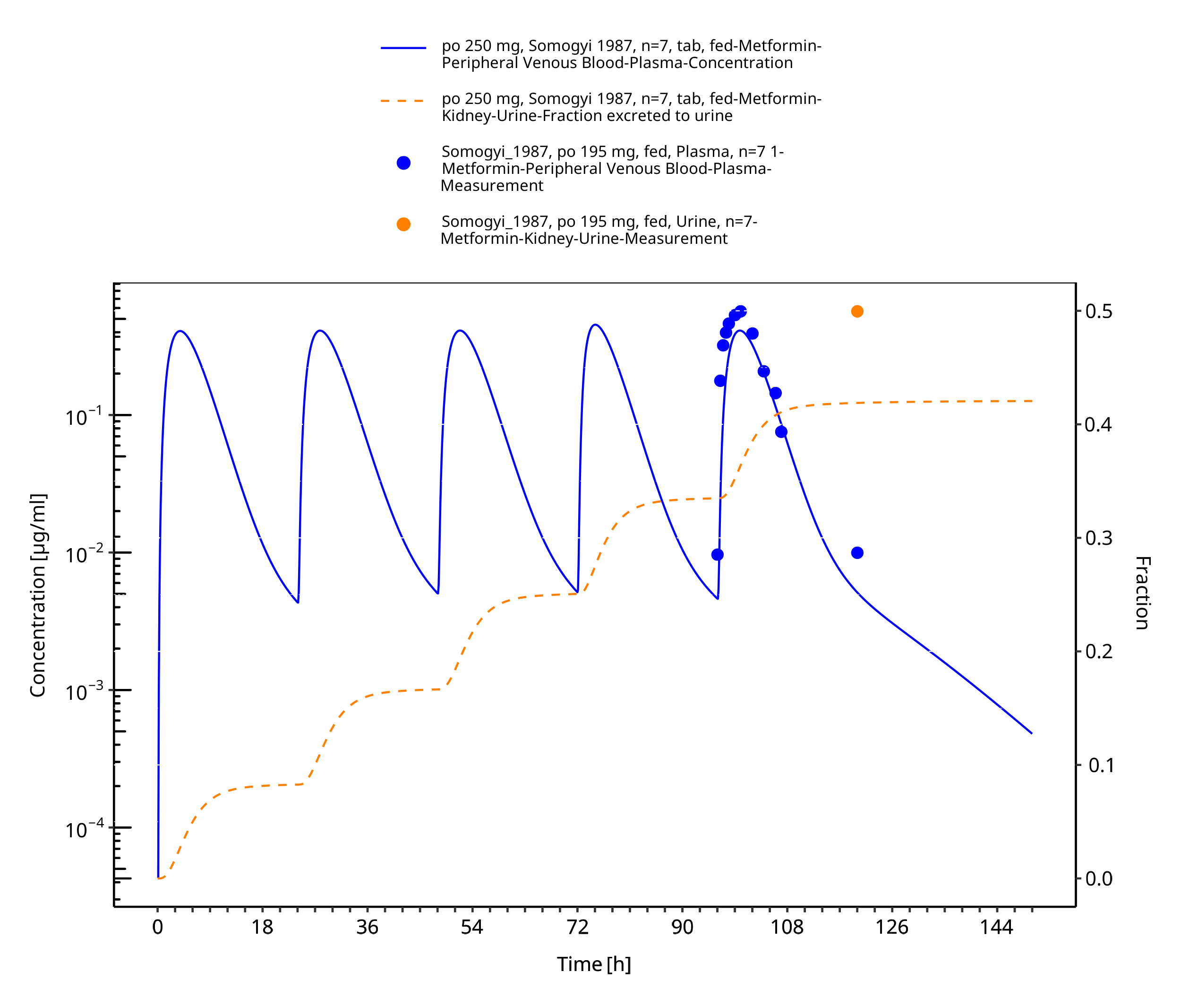
Figure 3-16: Metformin - po (tab) 250 mg_Somogyi 1987

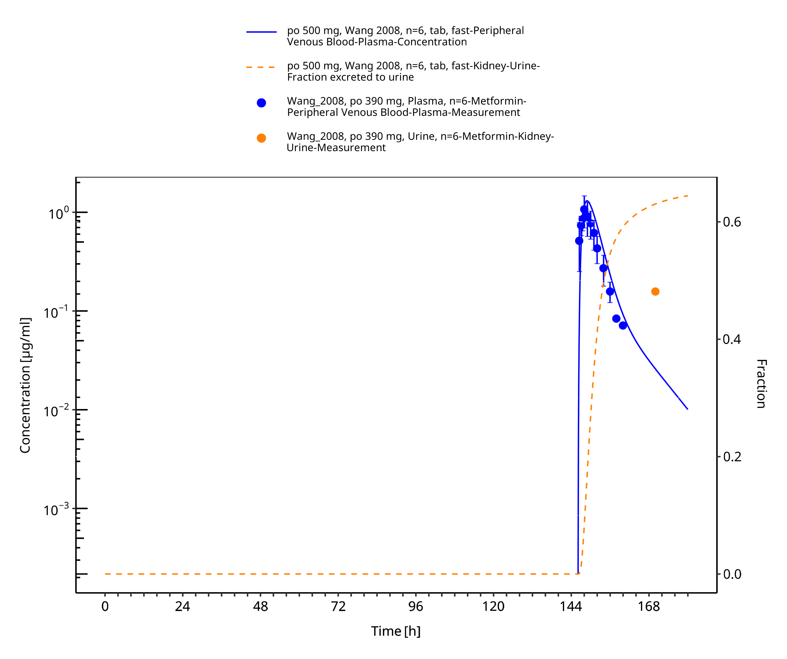
Figure 3-17: Metformin - po (tablet) 500 mg_Wang 2008

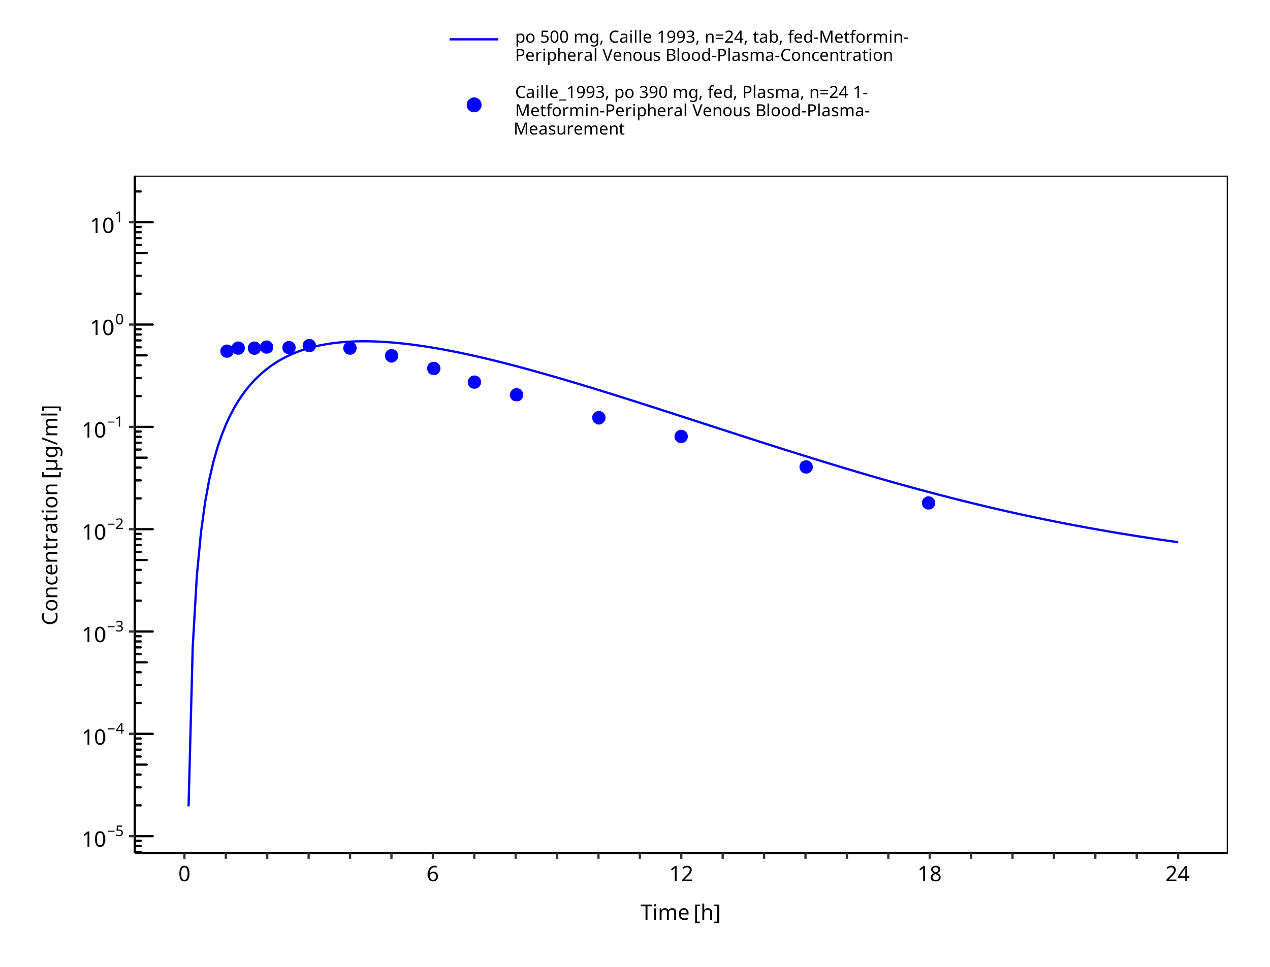
Figure 3-18: Metformin - po (tab) 500 mg_Caille 1993

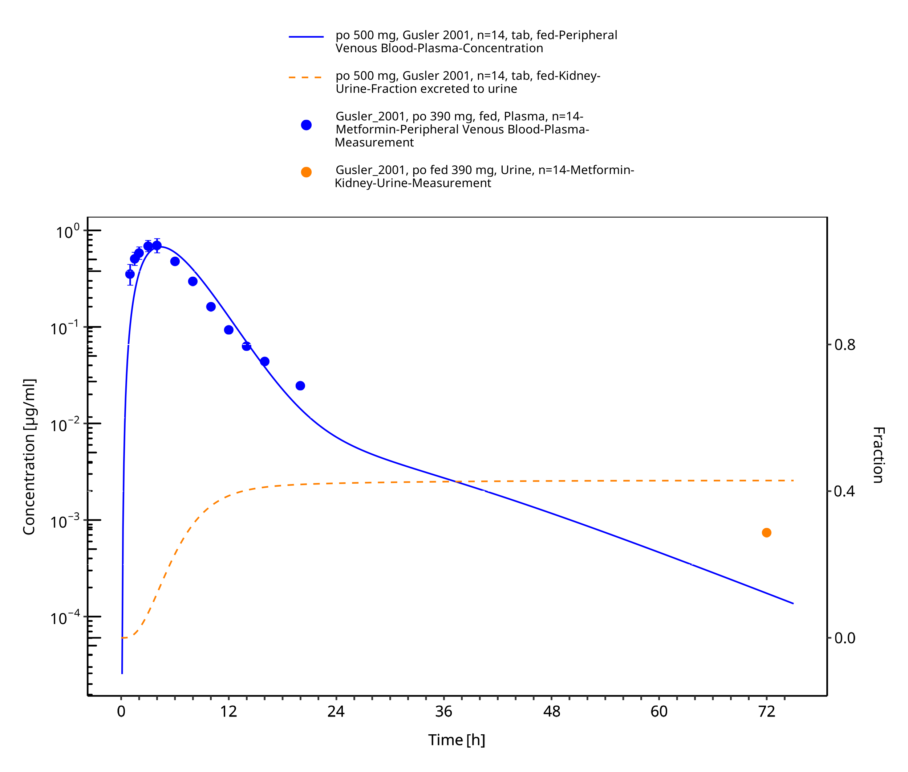
Figure 3-19: Metformin - po (tab) 500 mg_Gusler 2001

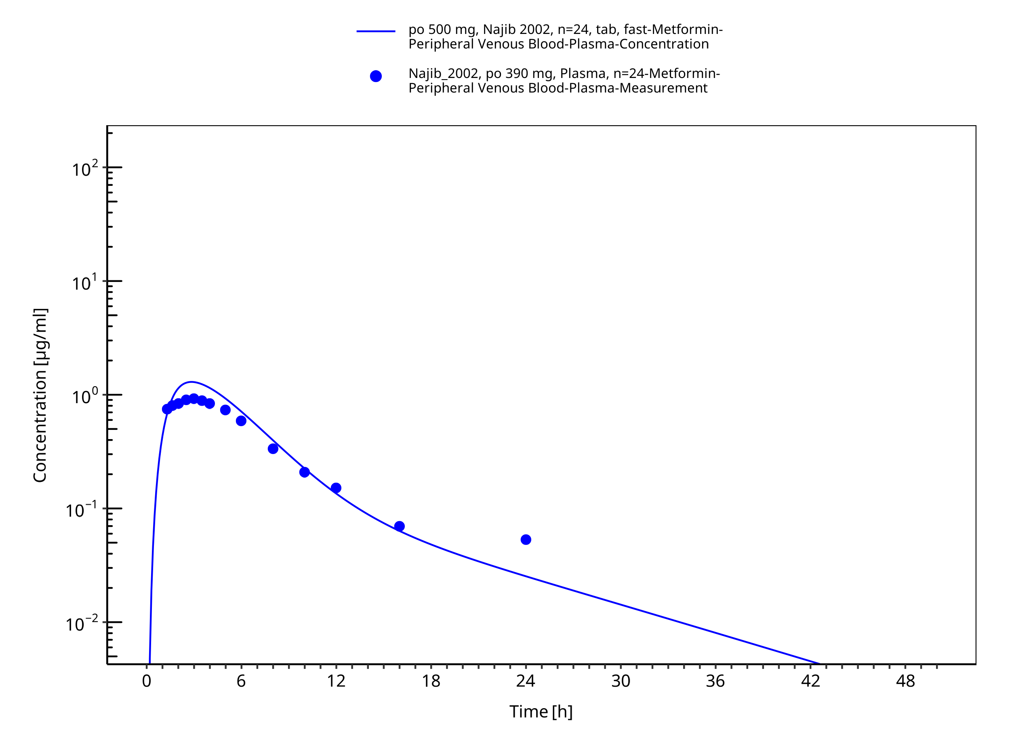
Figure 3-20: Metformin - po (tab) 500 mg_Najib 2002

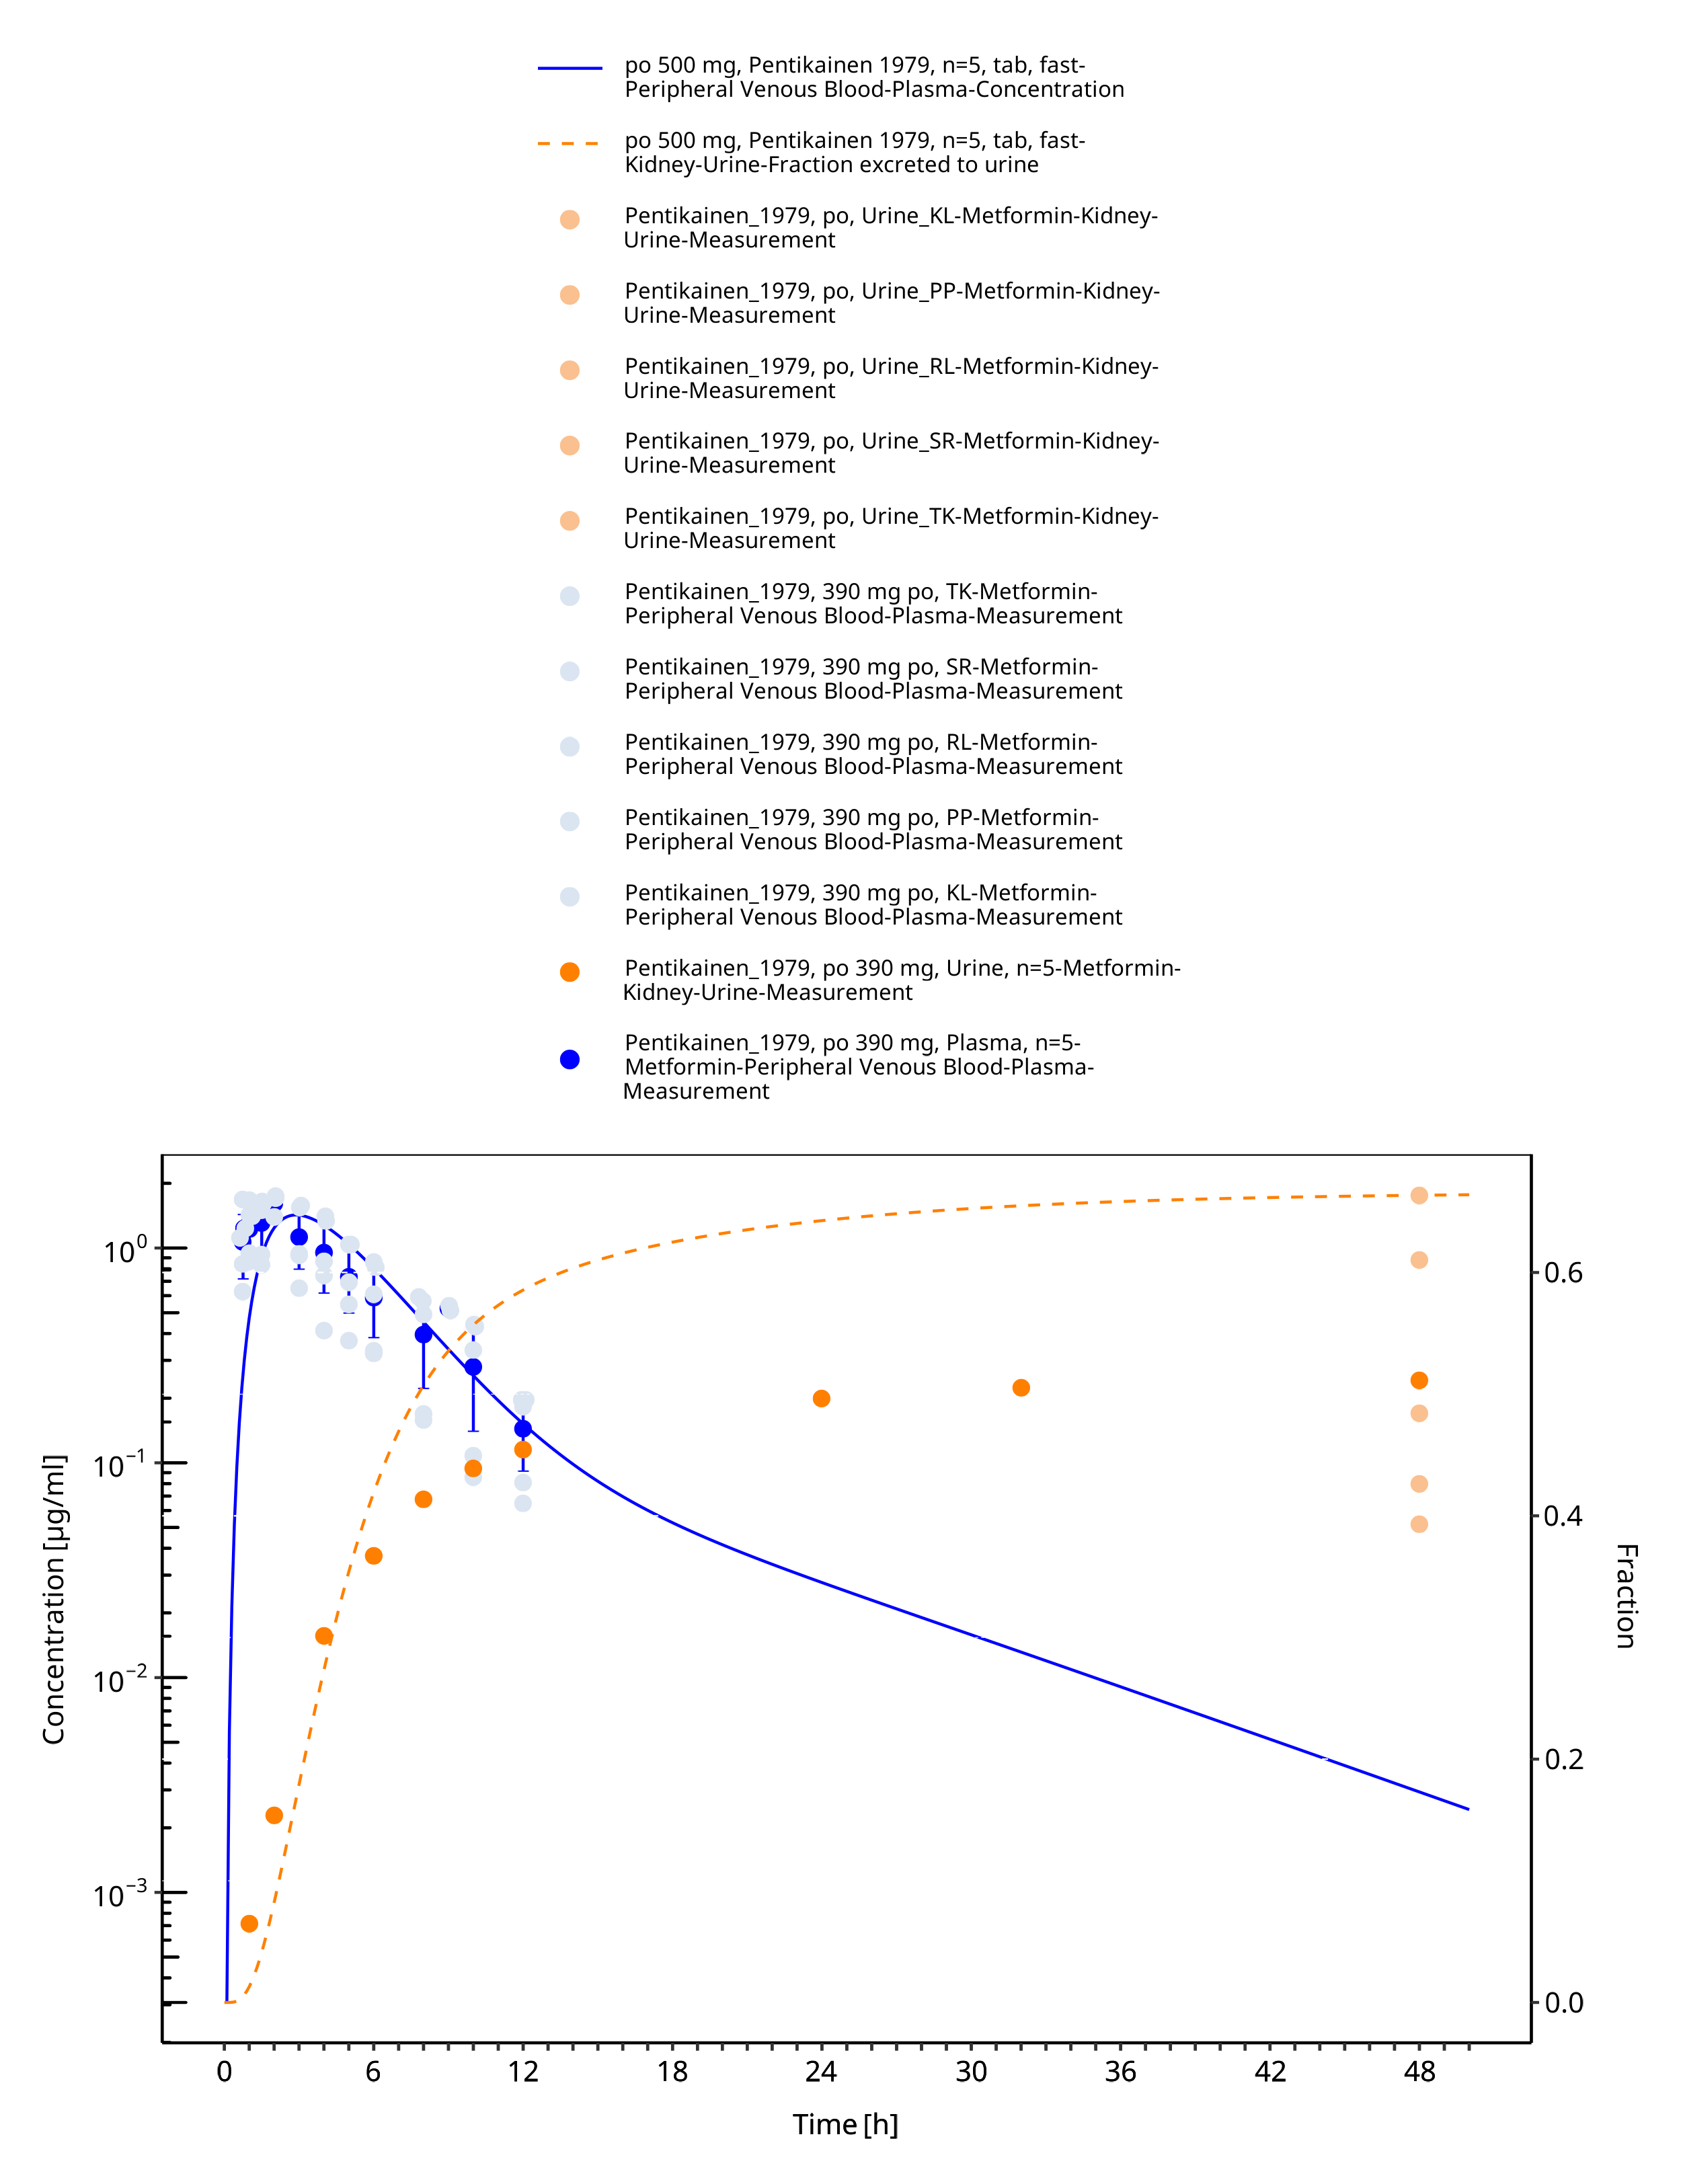
Figure 3-21: Metformin - po (tab) 500 mg_Pentikainen 1979

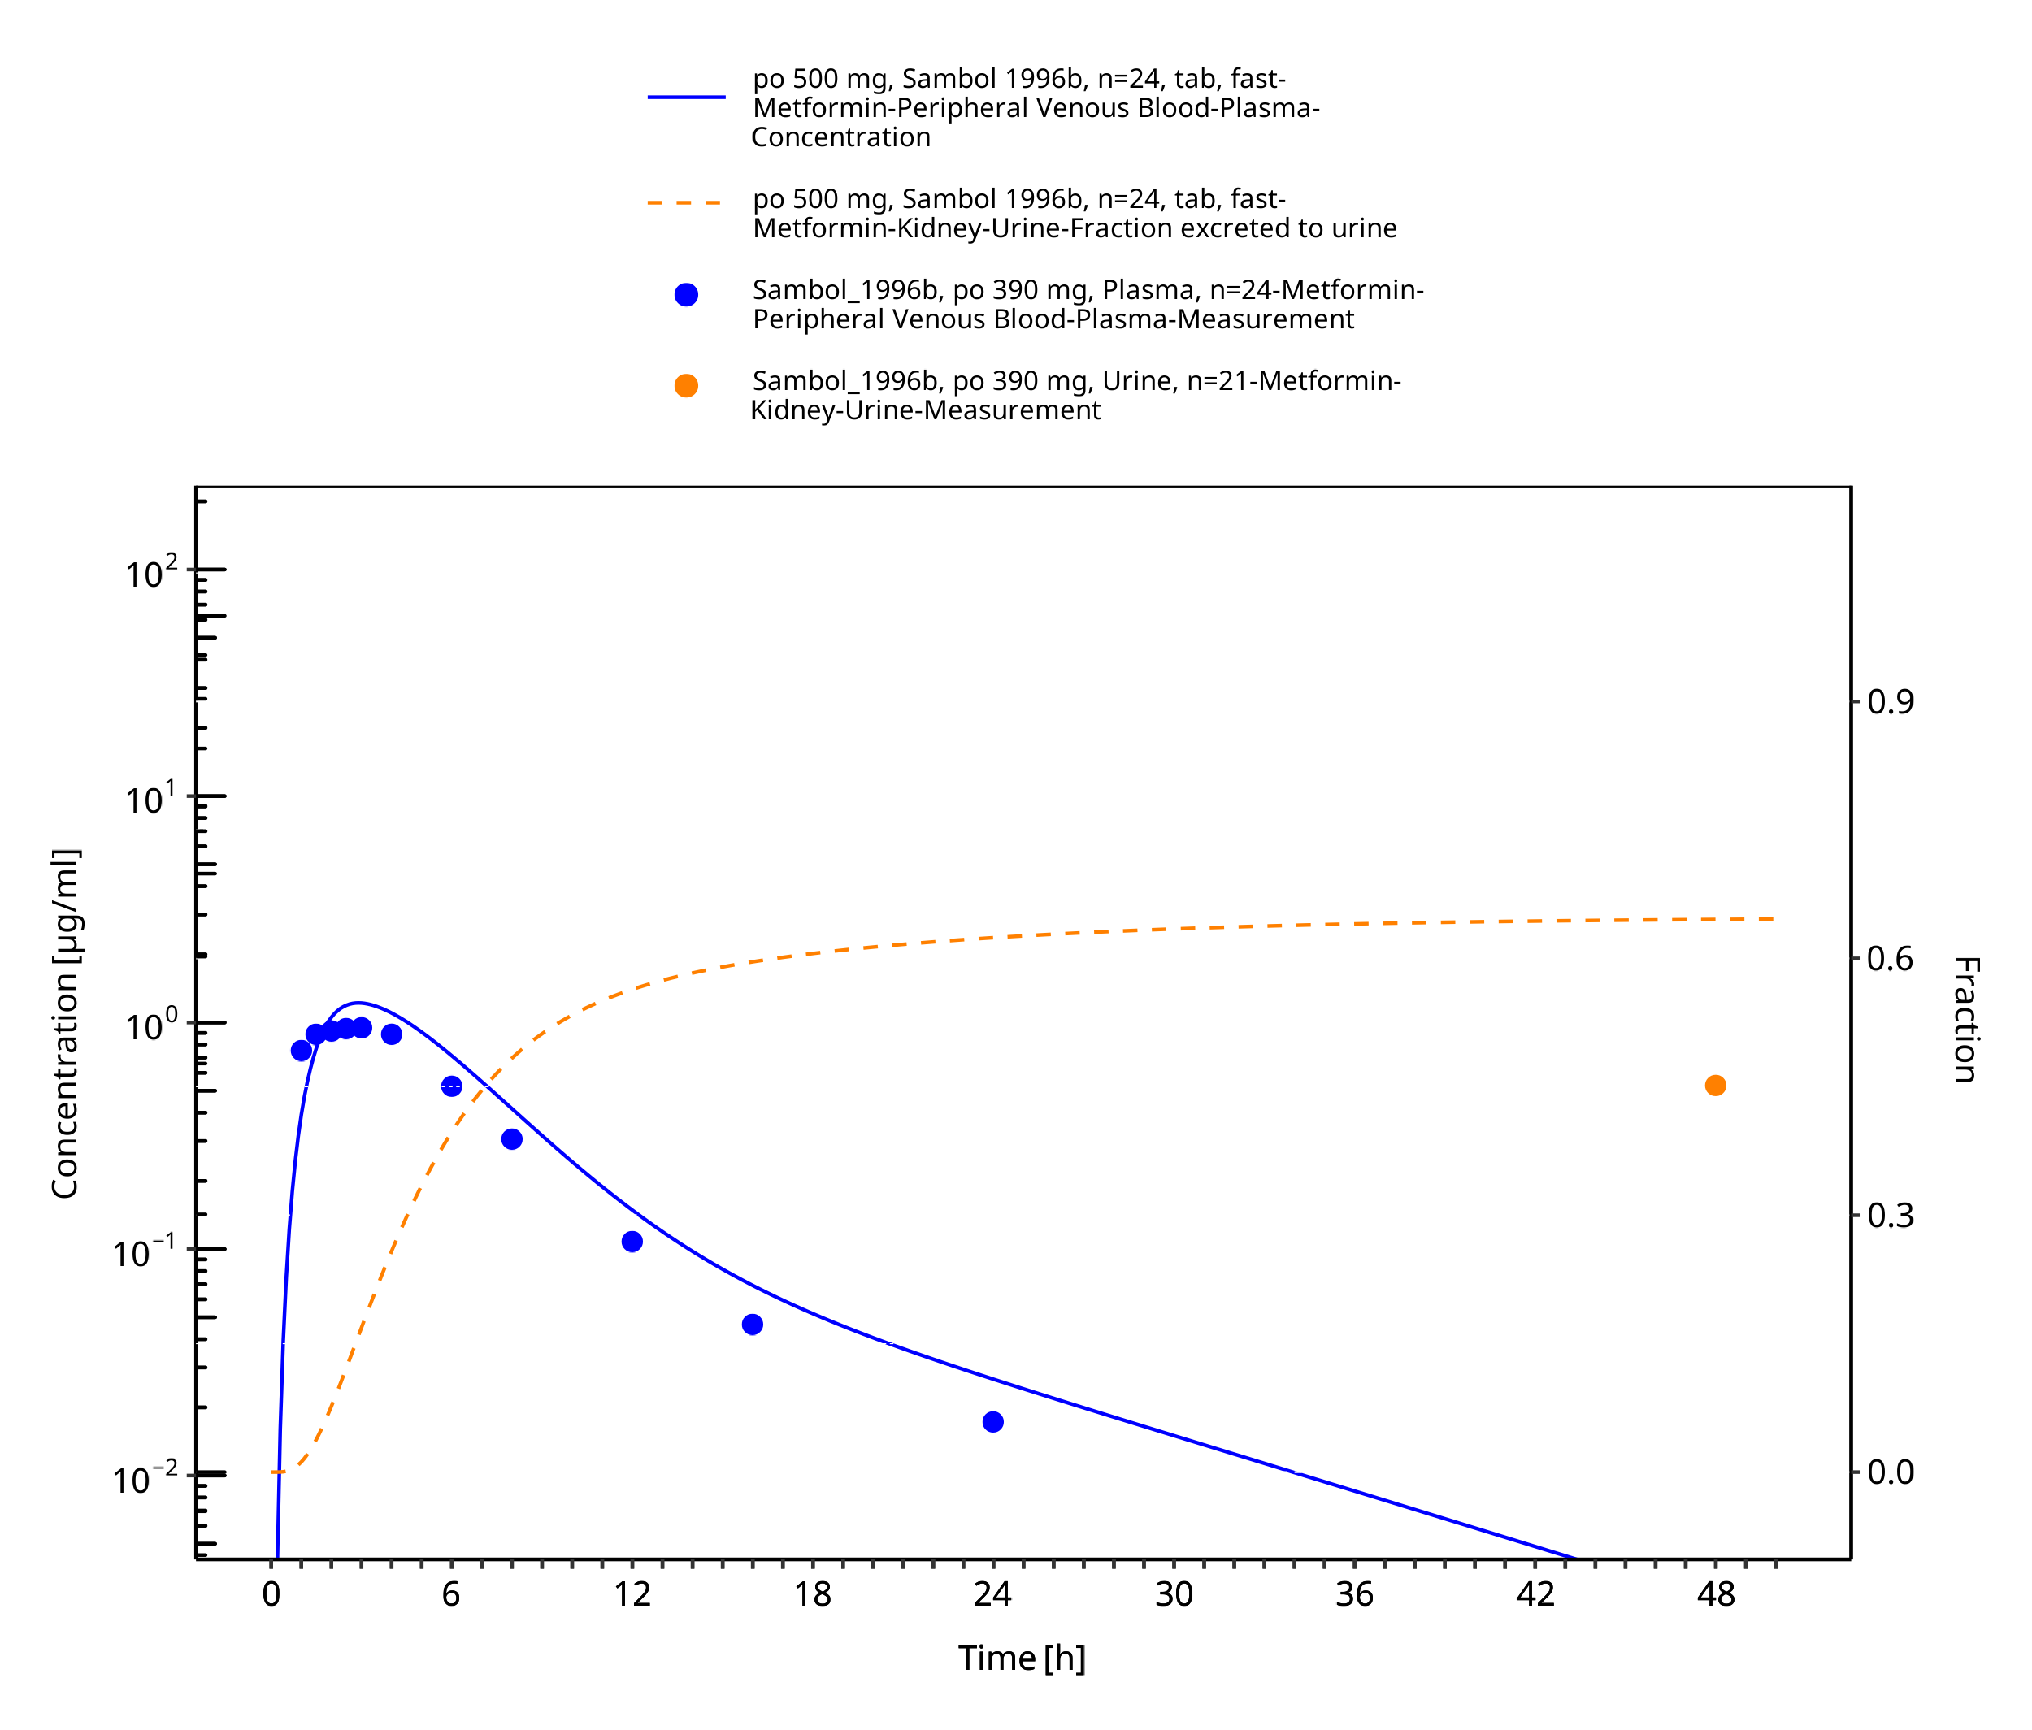
Figure 3-22: Metformin - po (tab) 500 mg_Sambol 1996b

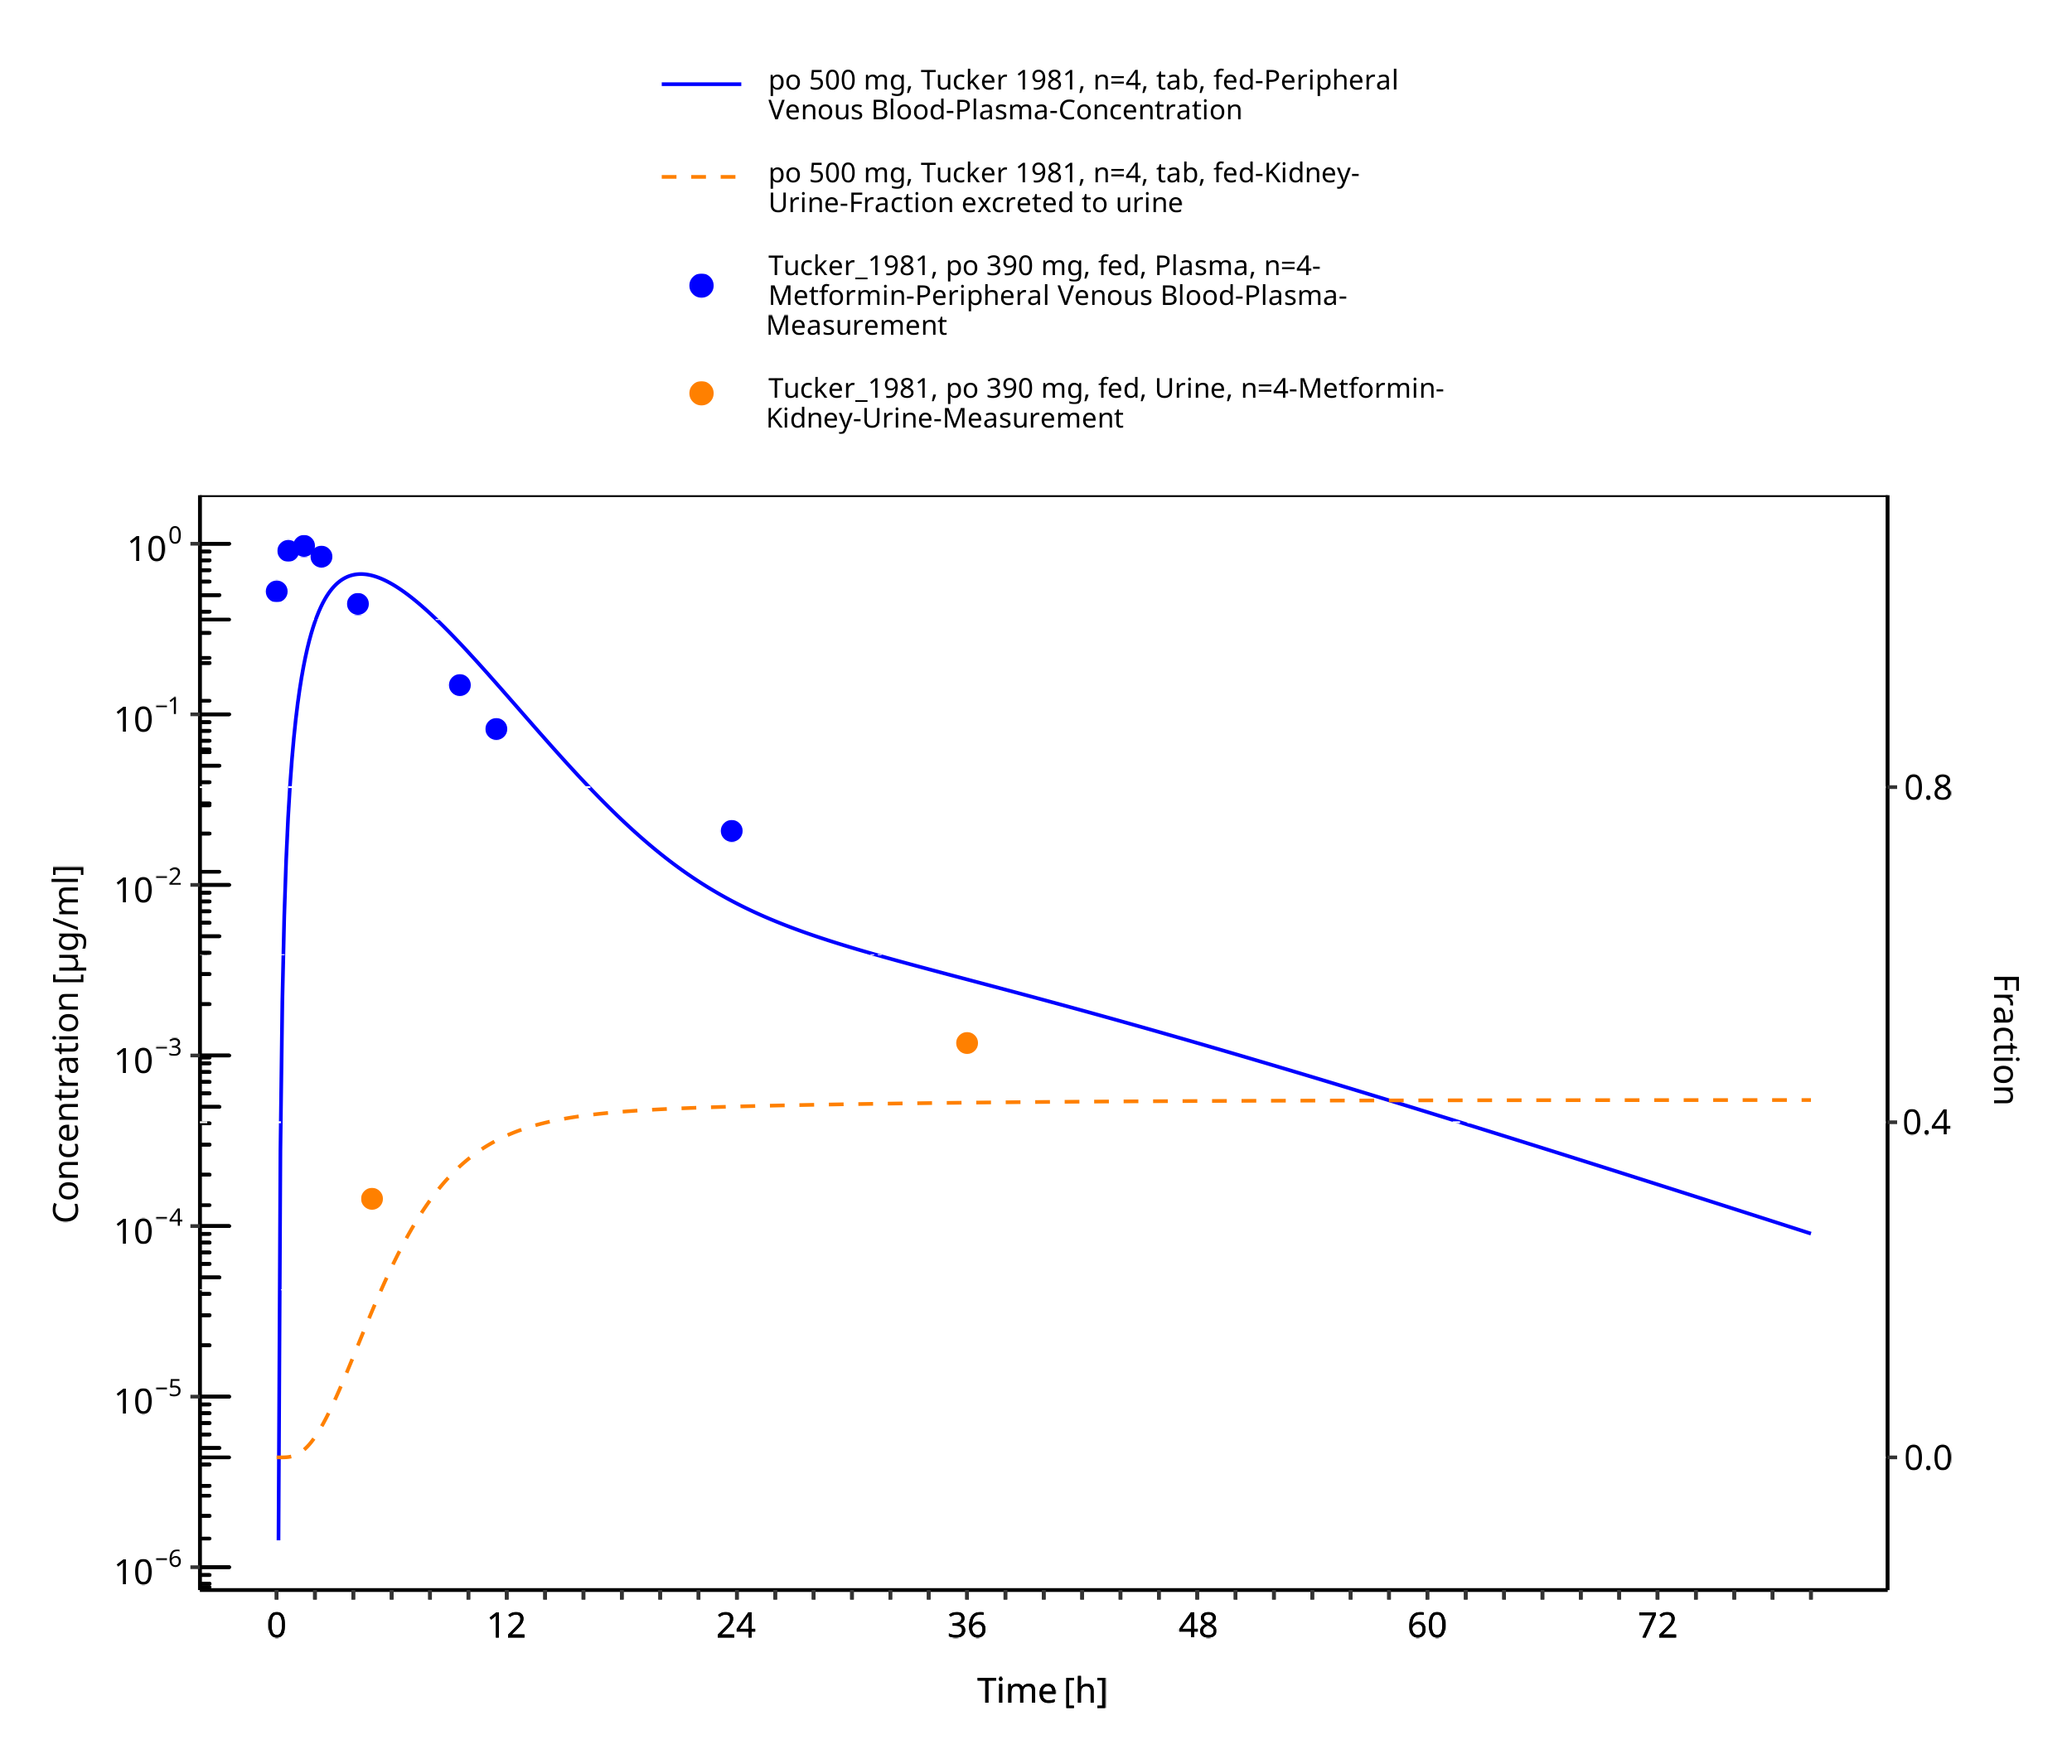
Figure 3-23: Metformin - po (tab) 500 mg_Tucker 1981

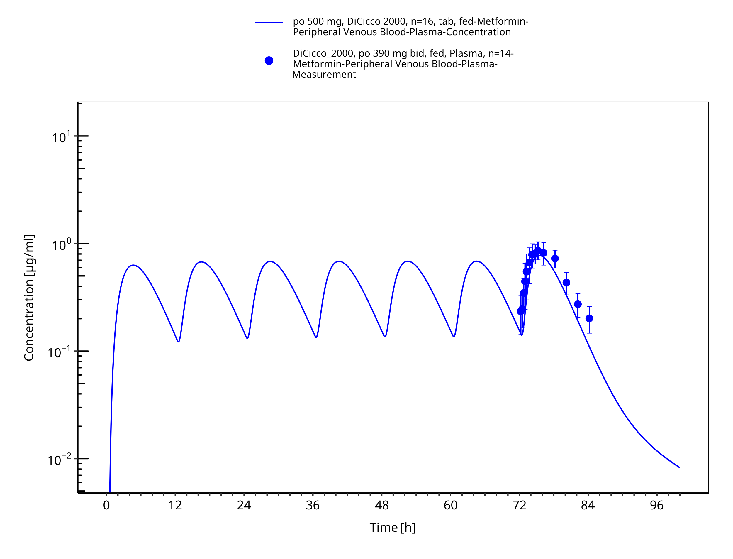
Figure 3-24: Metformin - po (tab) 500 mg_DiCicco 2000

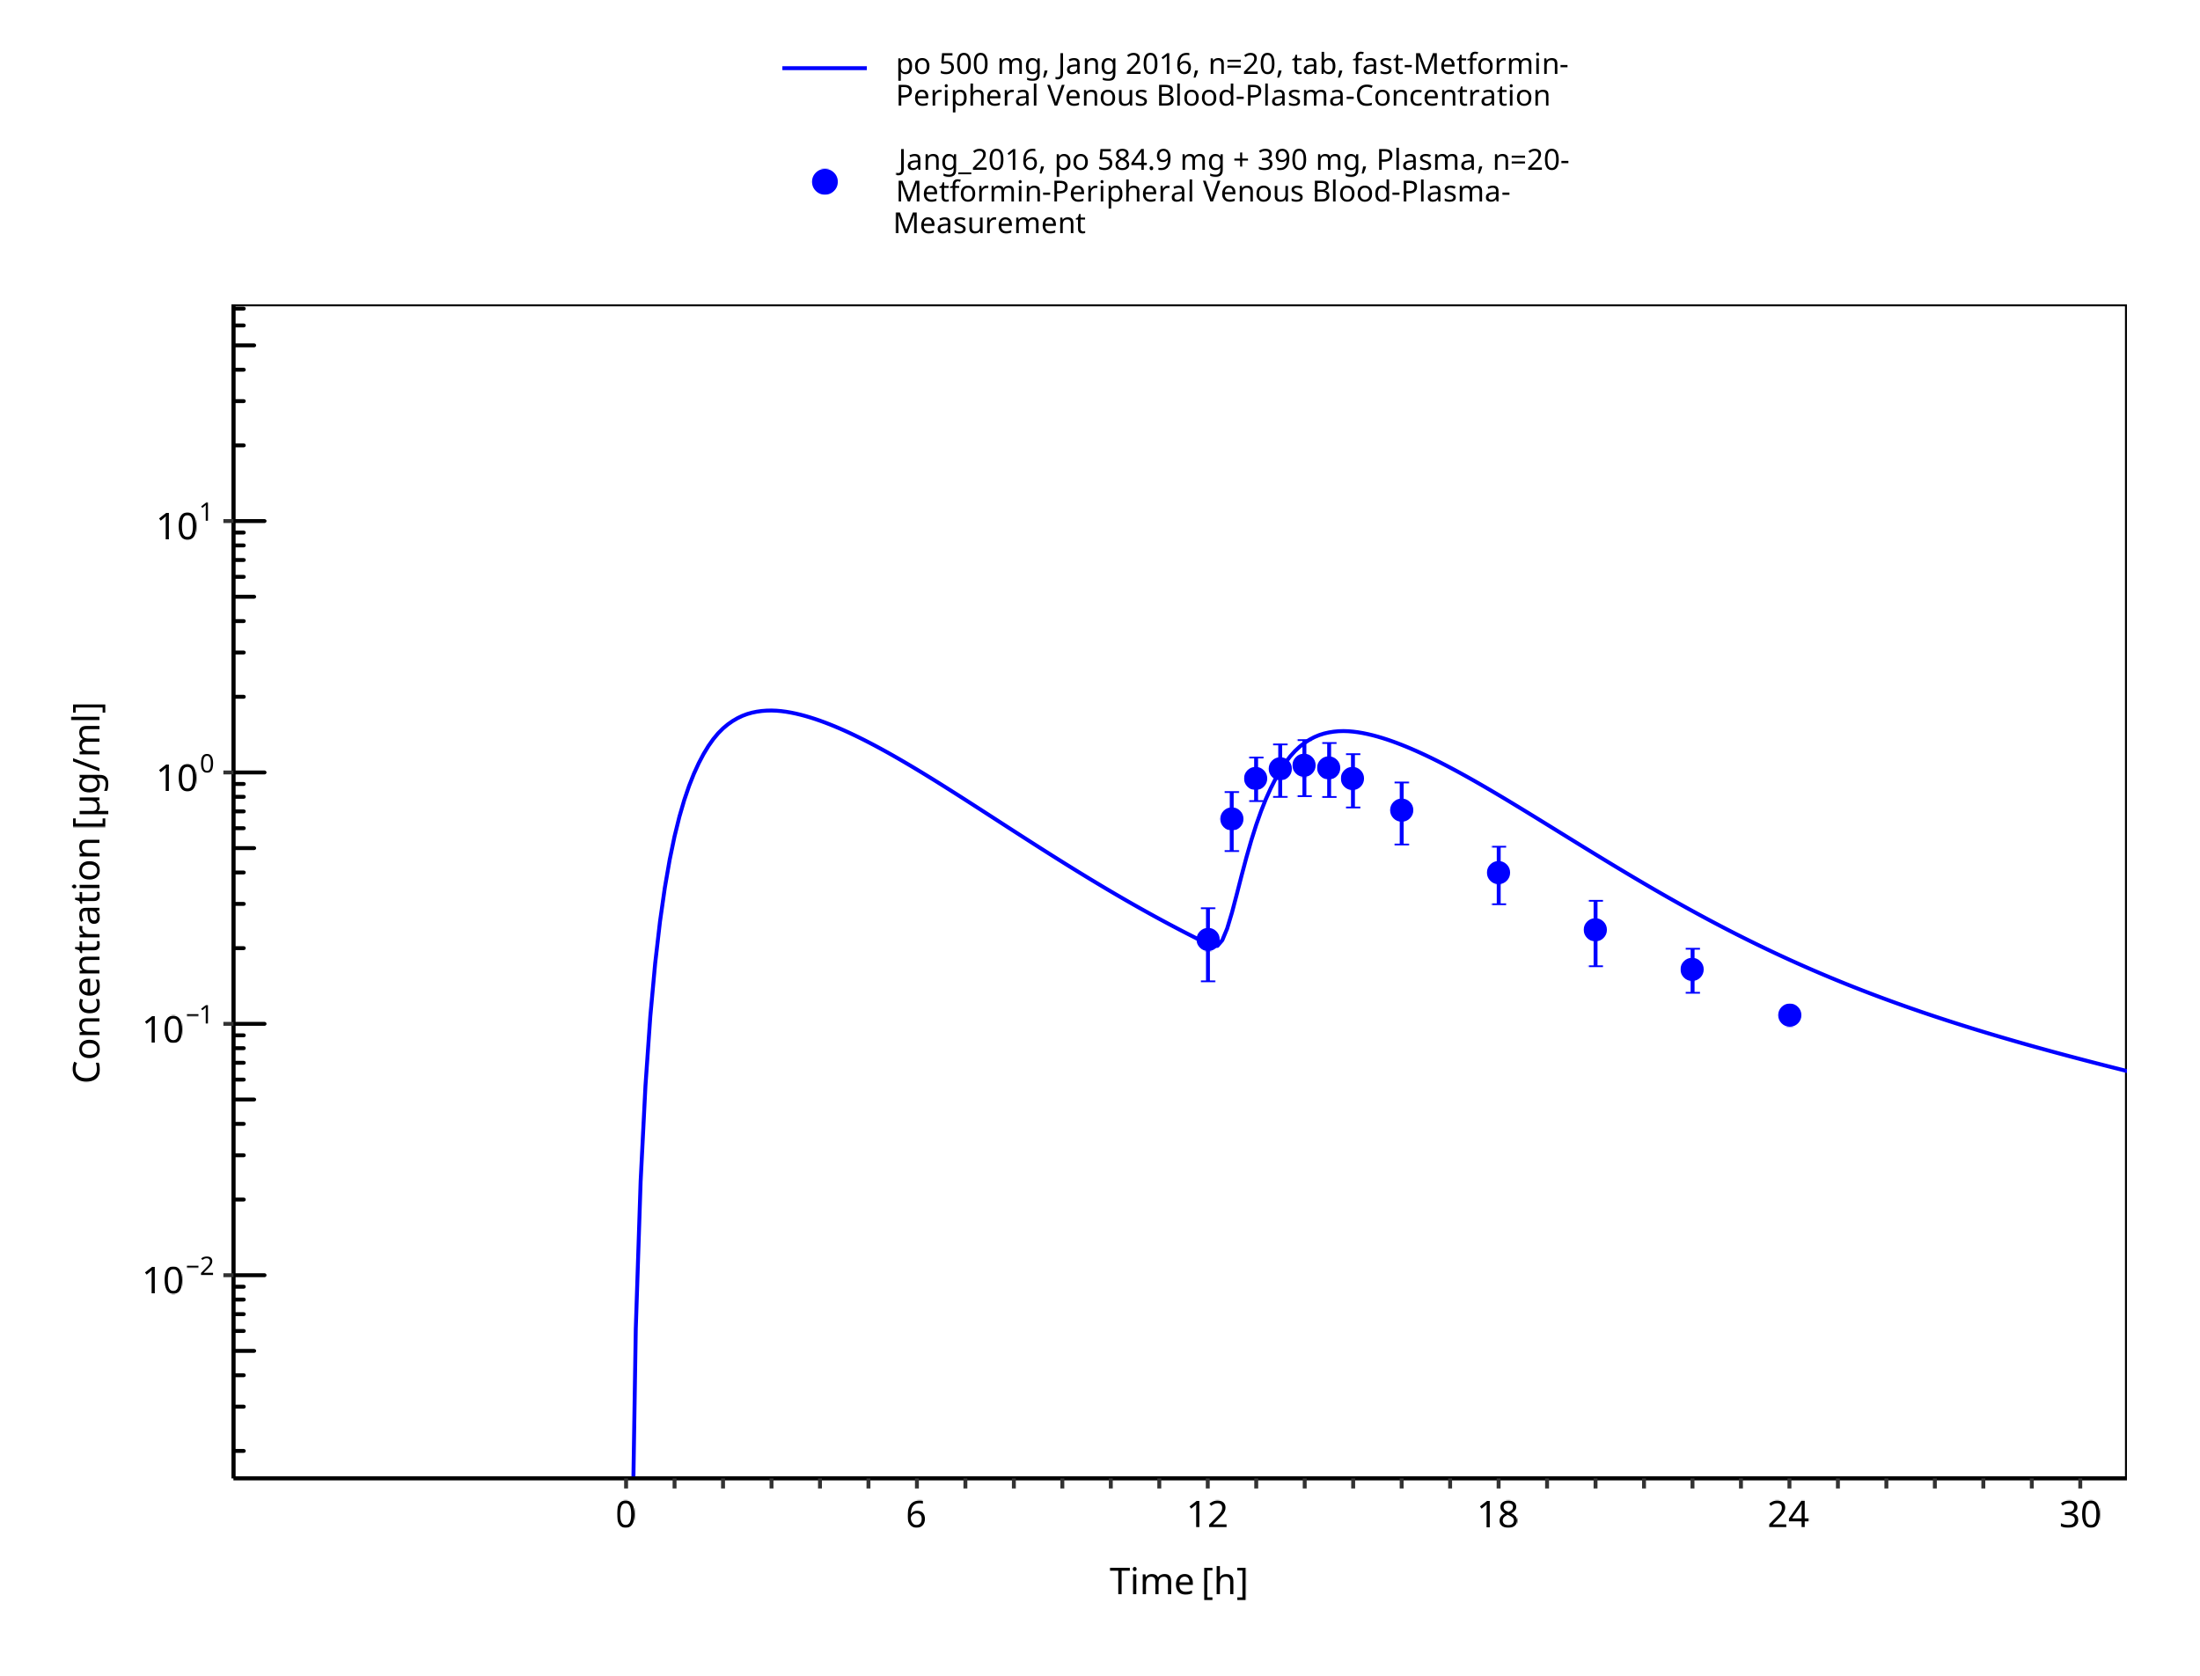
Figure 3-25: Metformin - po (tab) 500 mg_Jang 2016

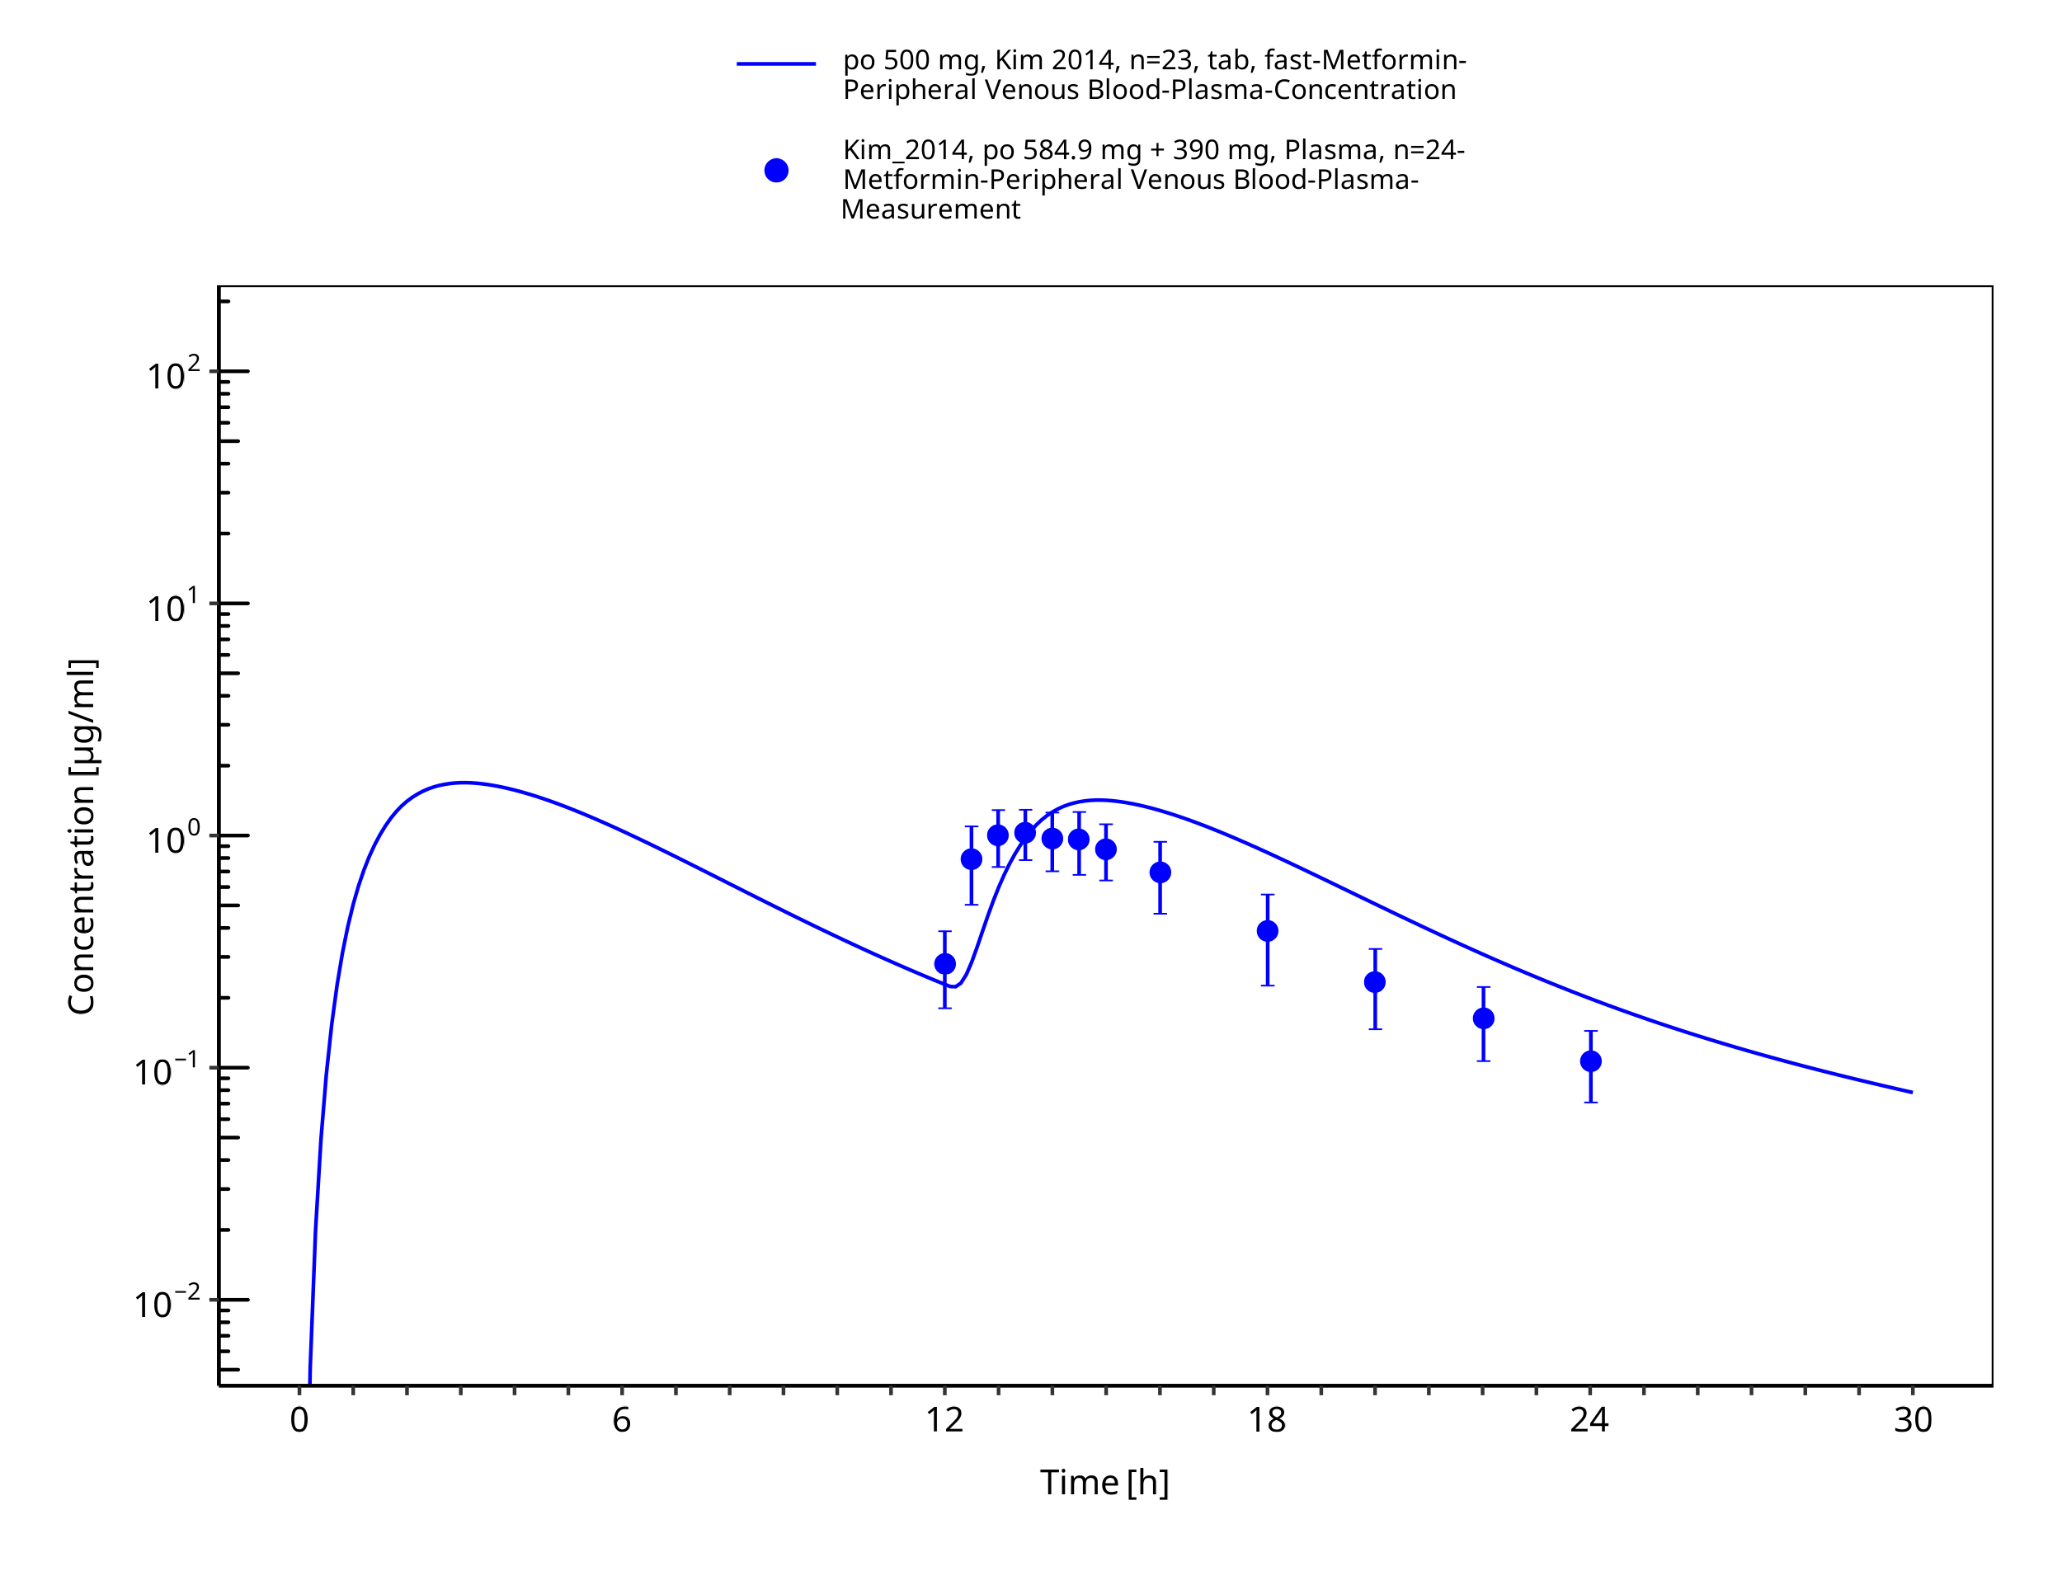
Figure 3-26: Metformin - po (tab) 500 mg_Kim 2014

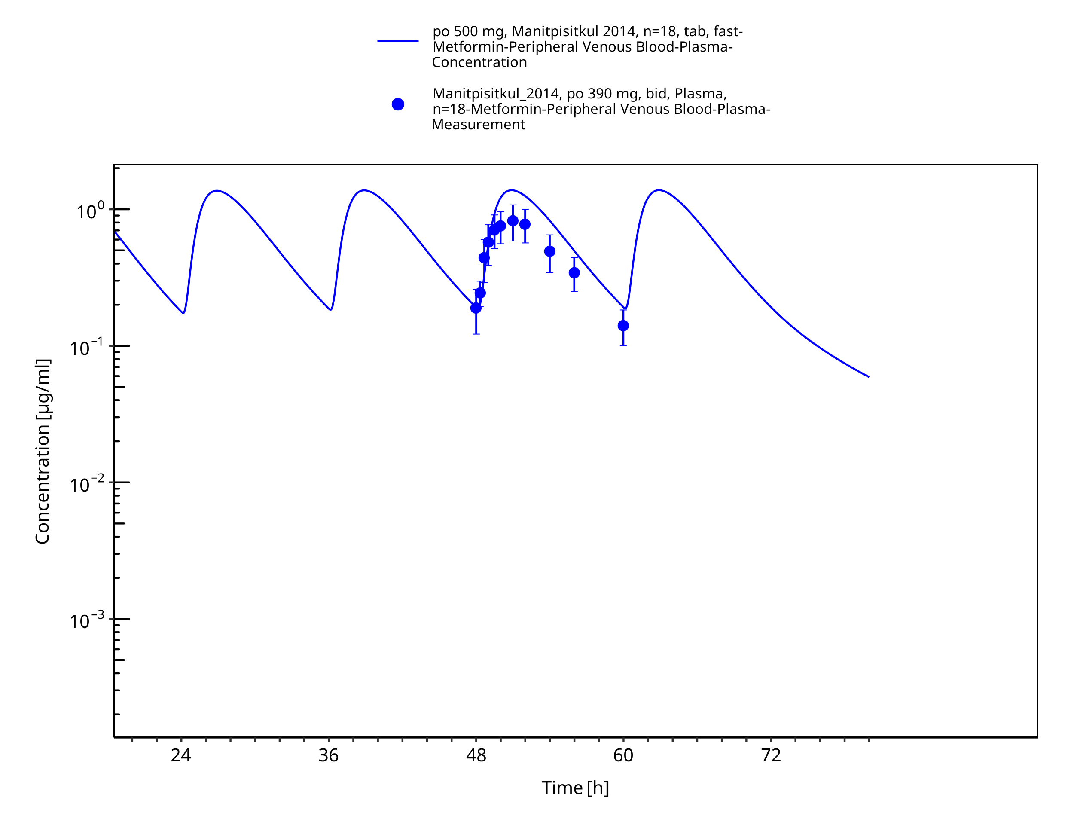
Figure 3-27: Metformin - po (tab) 500 mg_Manitpisitkul 2014

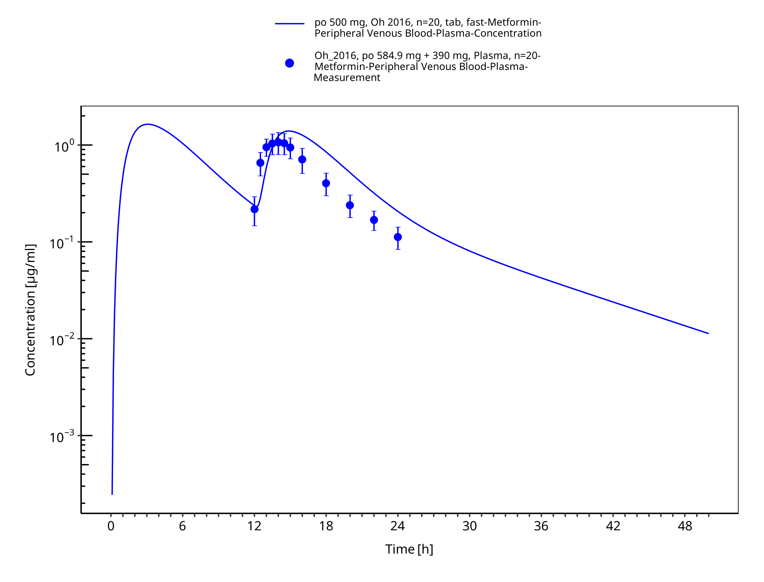
Figure 3-28: Metformin - po (tab) 500 mg_Oh 2016

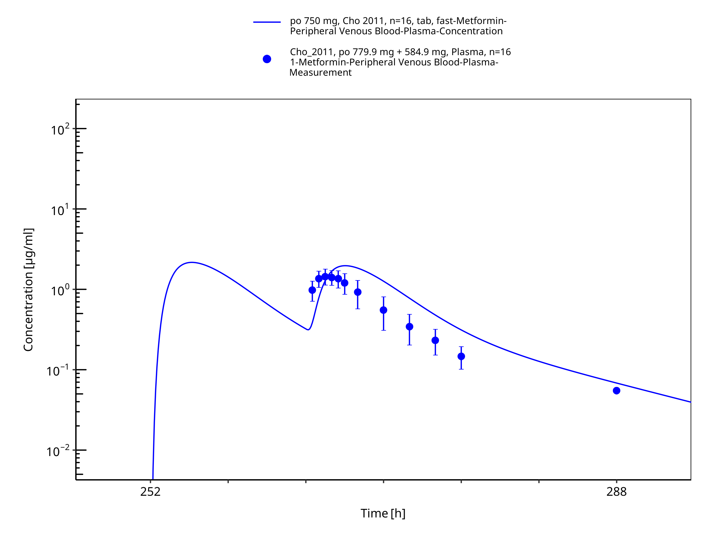
Figure 3-29: Metformin - po (tab) 750 mg_Cho 2011

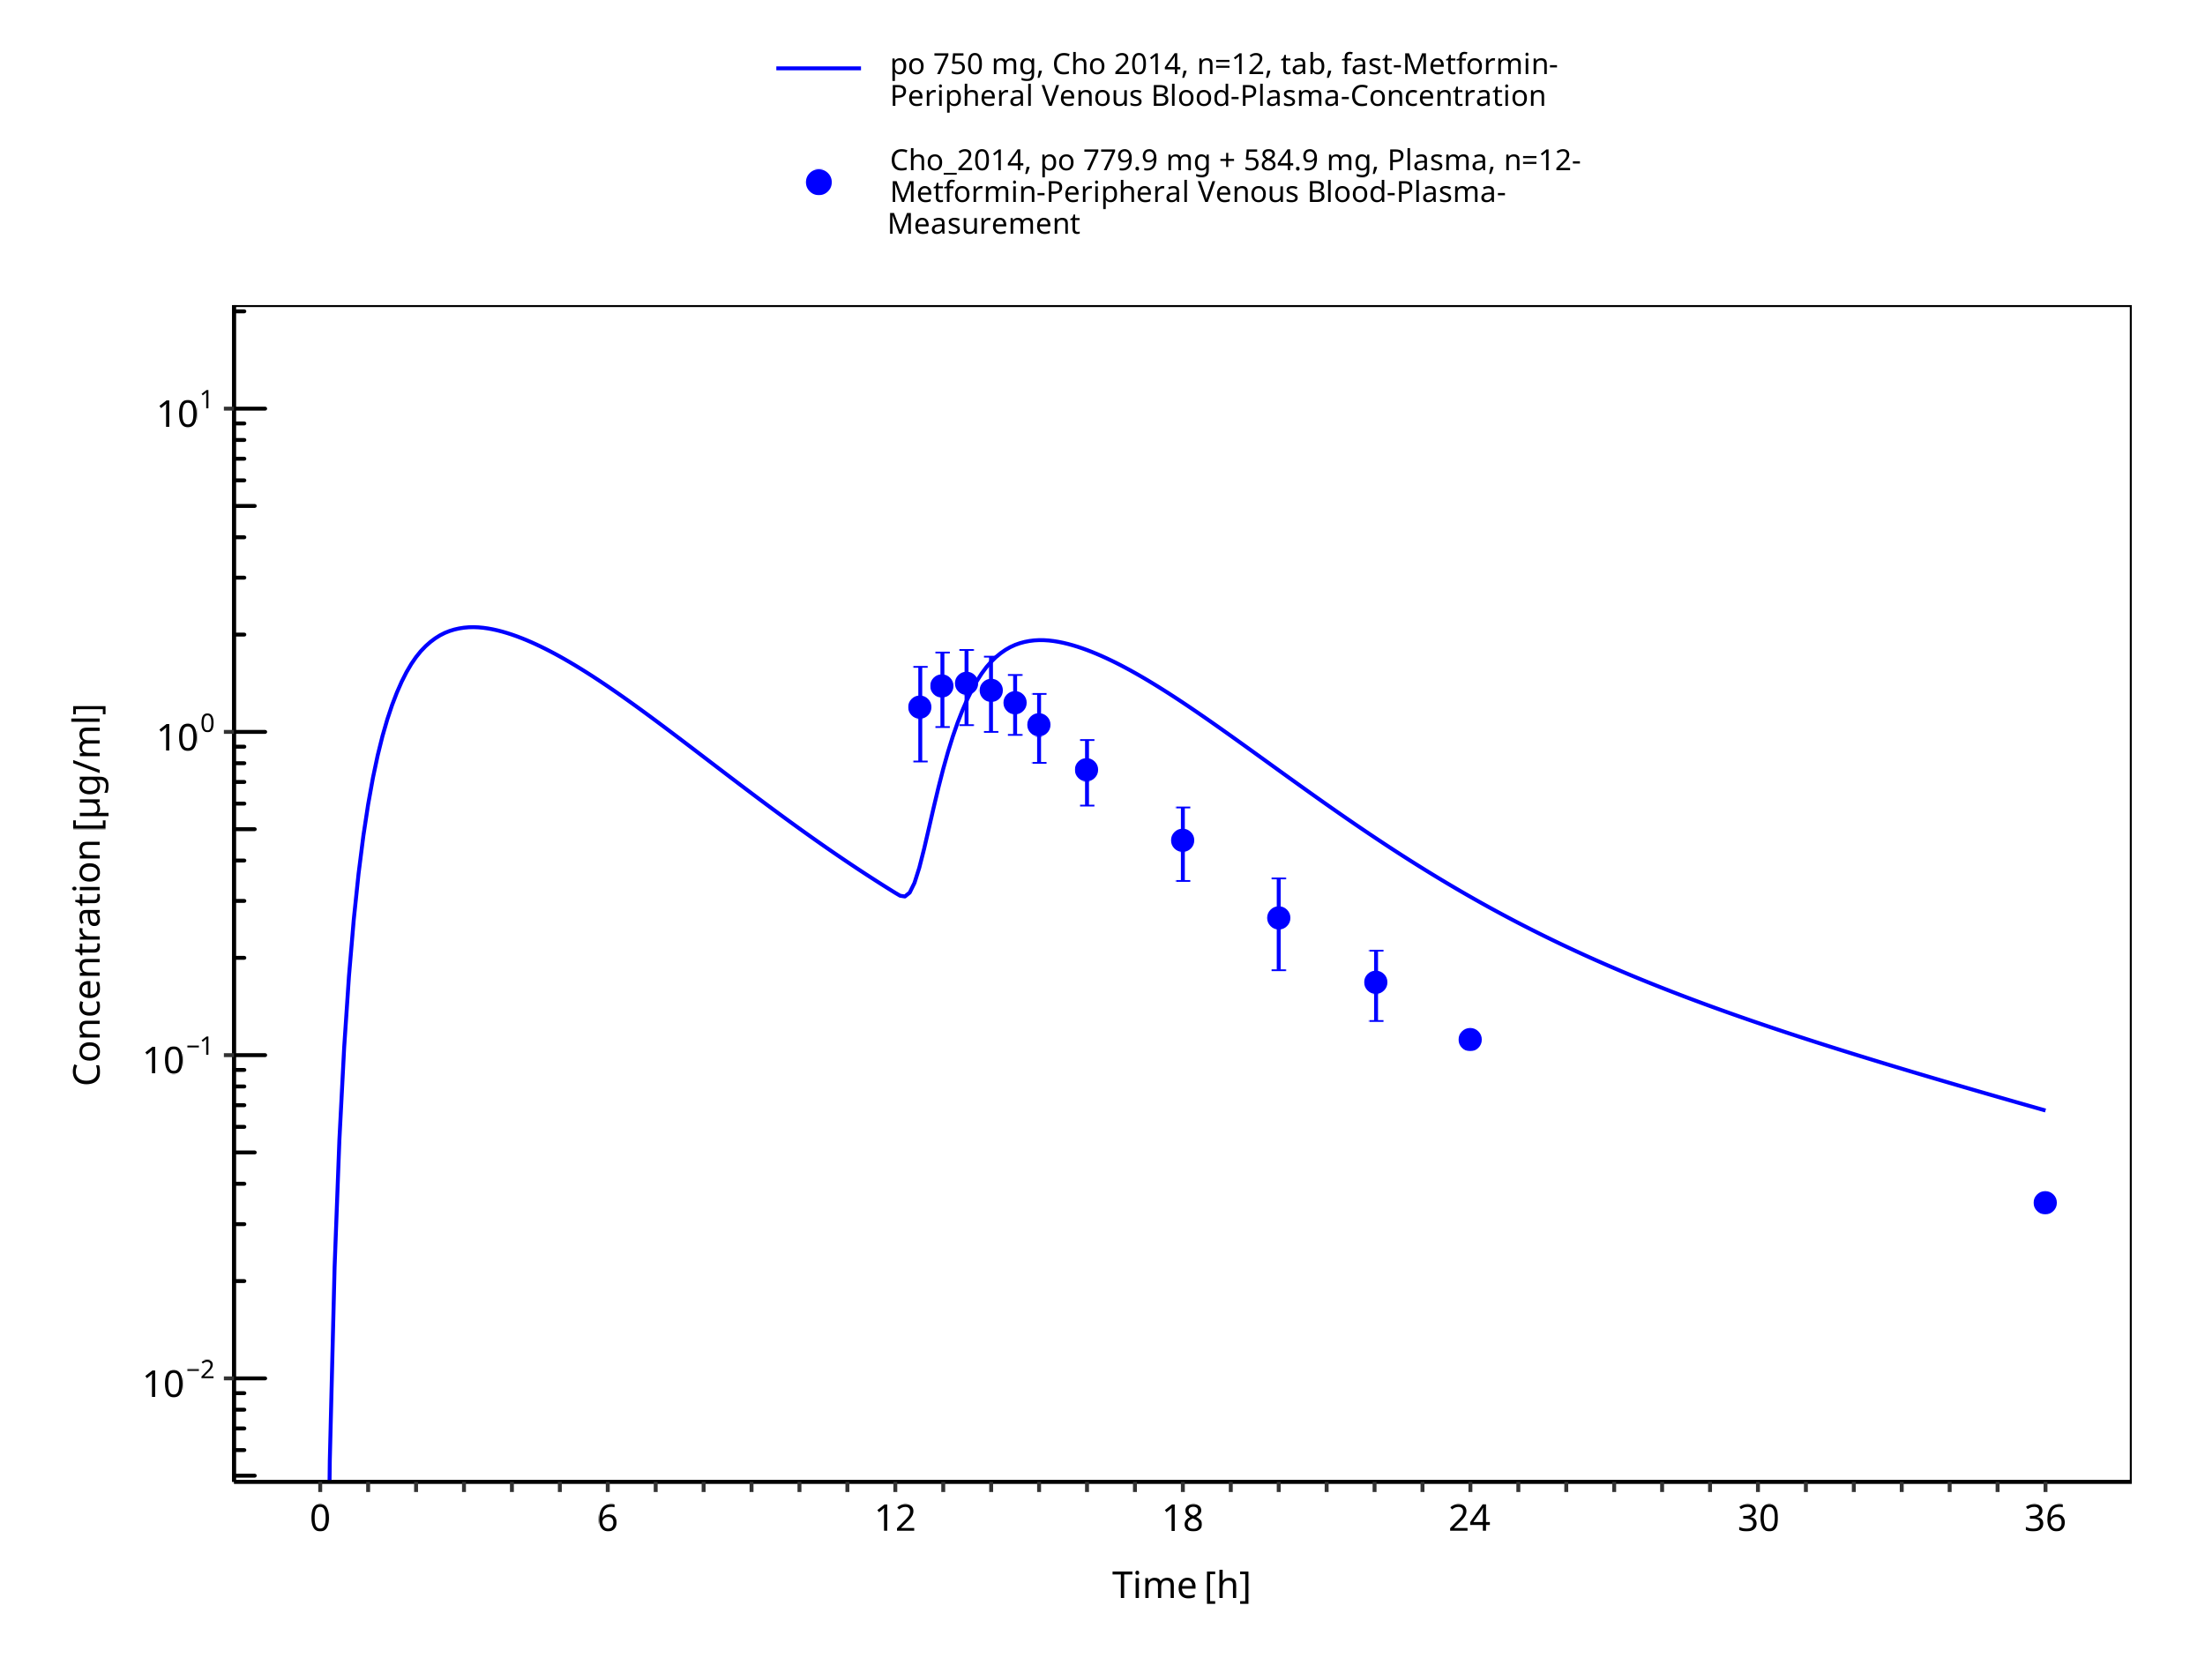
Figure 3-30: Metformin - po (tab) 750 mg_Cho 2014

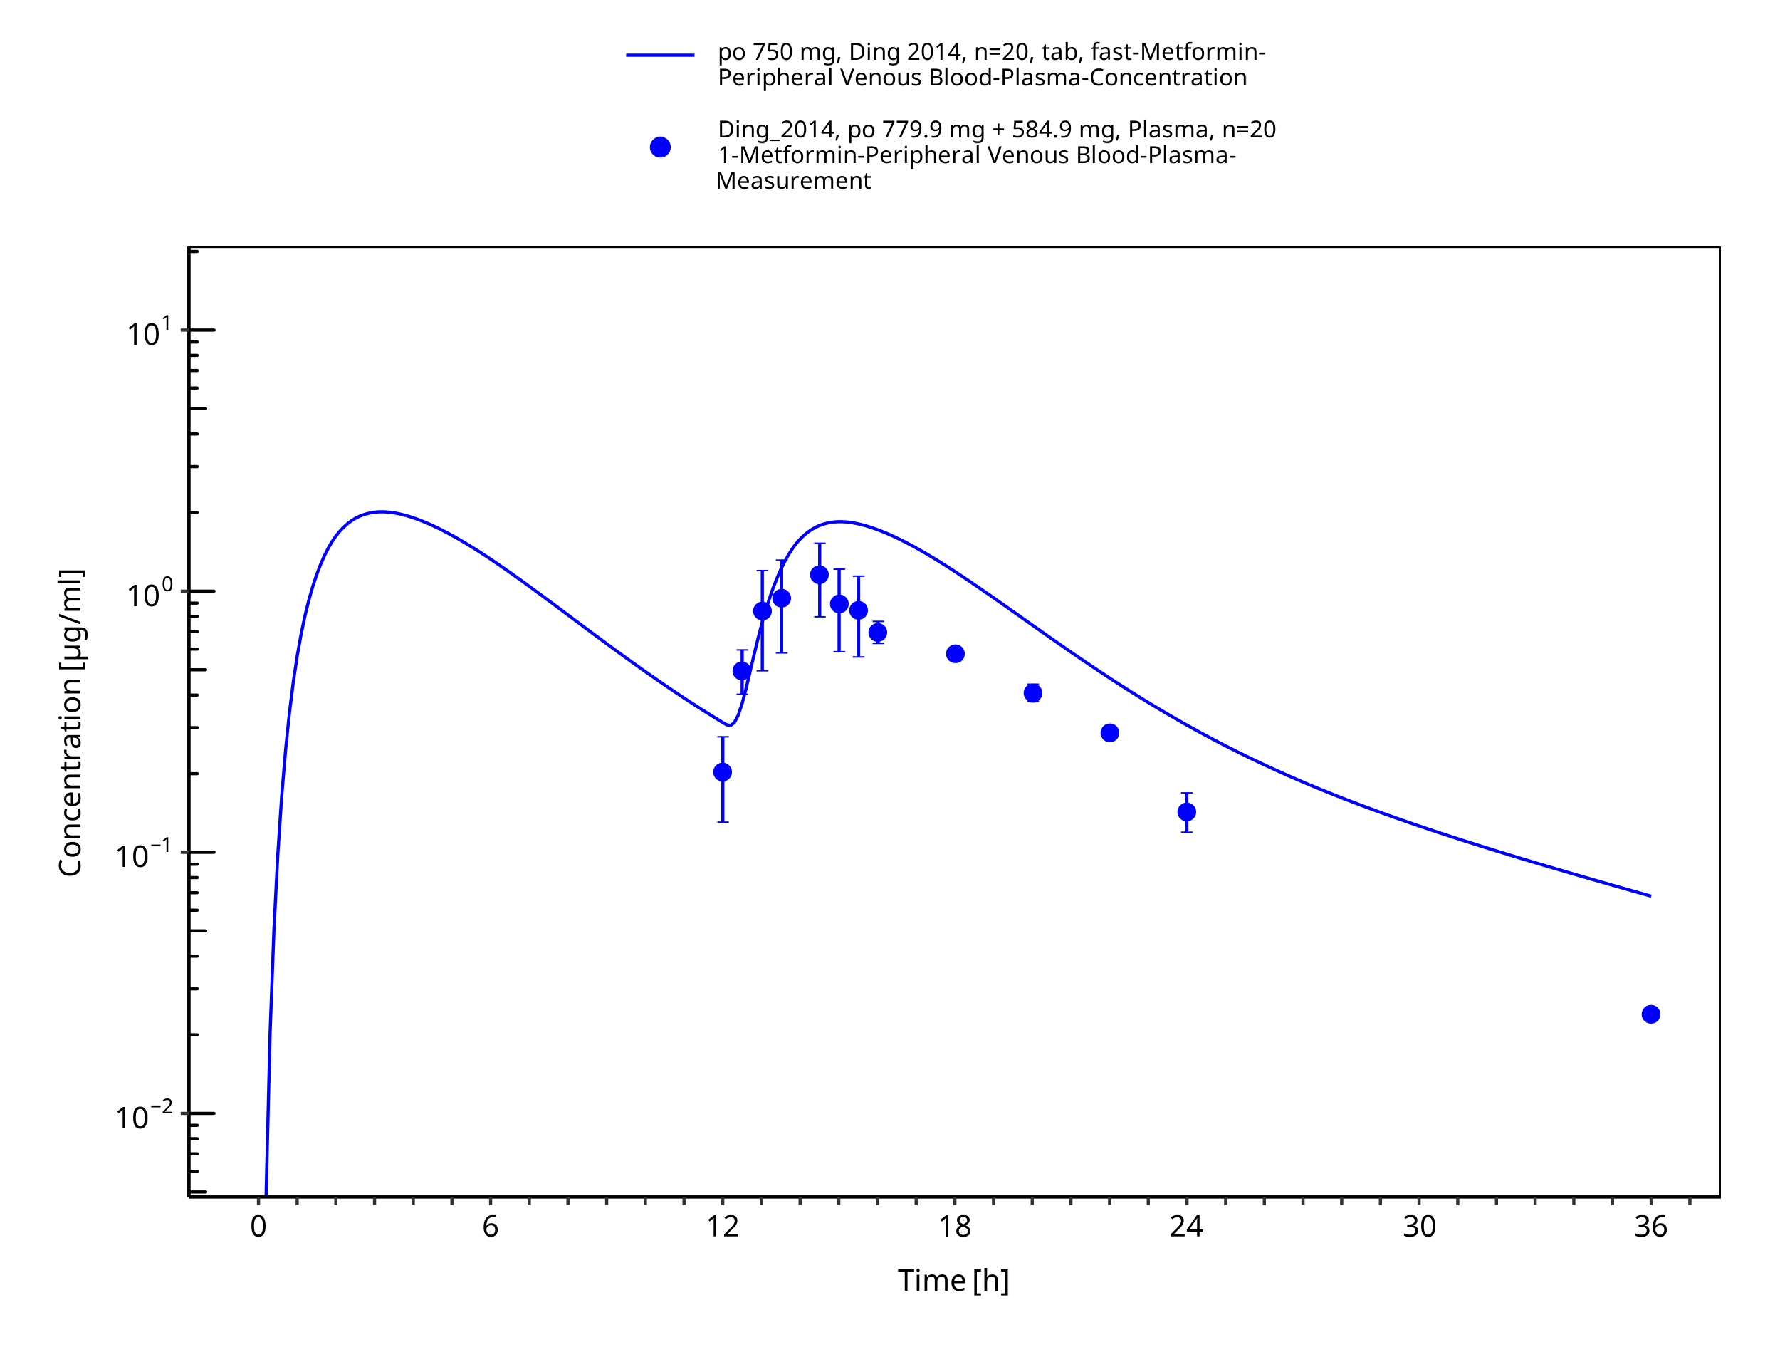
Figure 3-31: Metformin - po (tab) 750 mg tid_Ding 2014

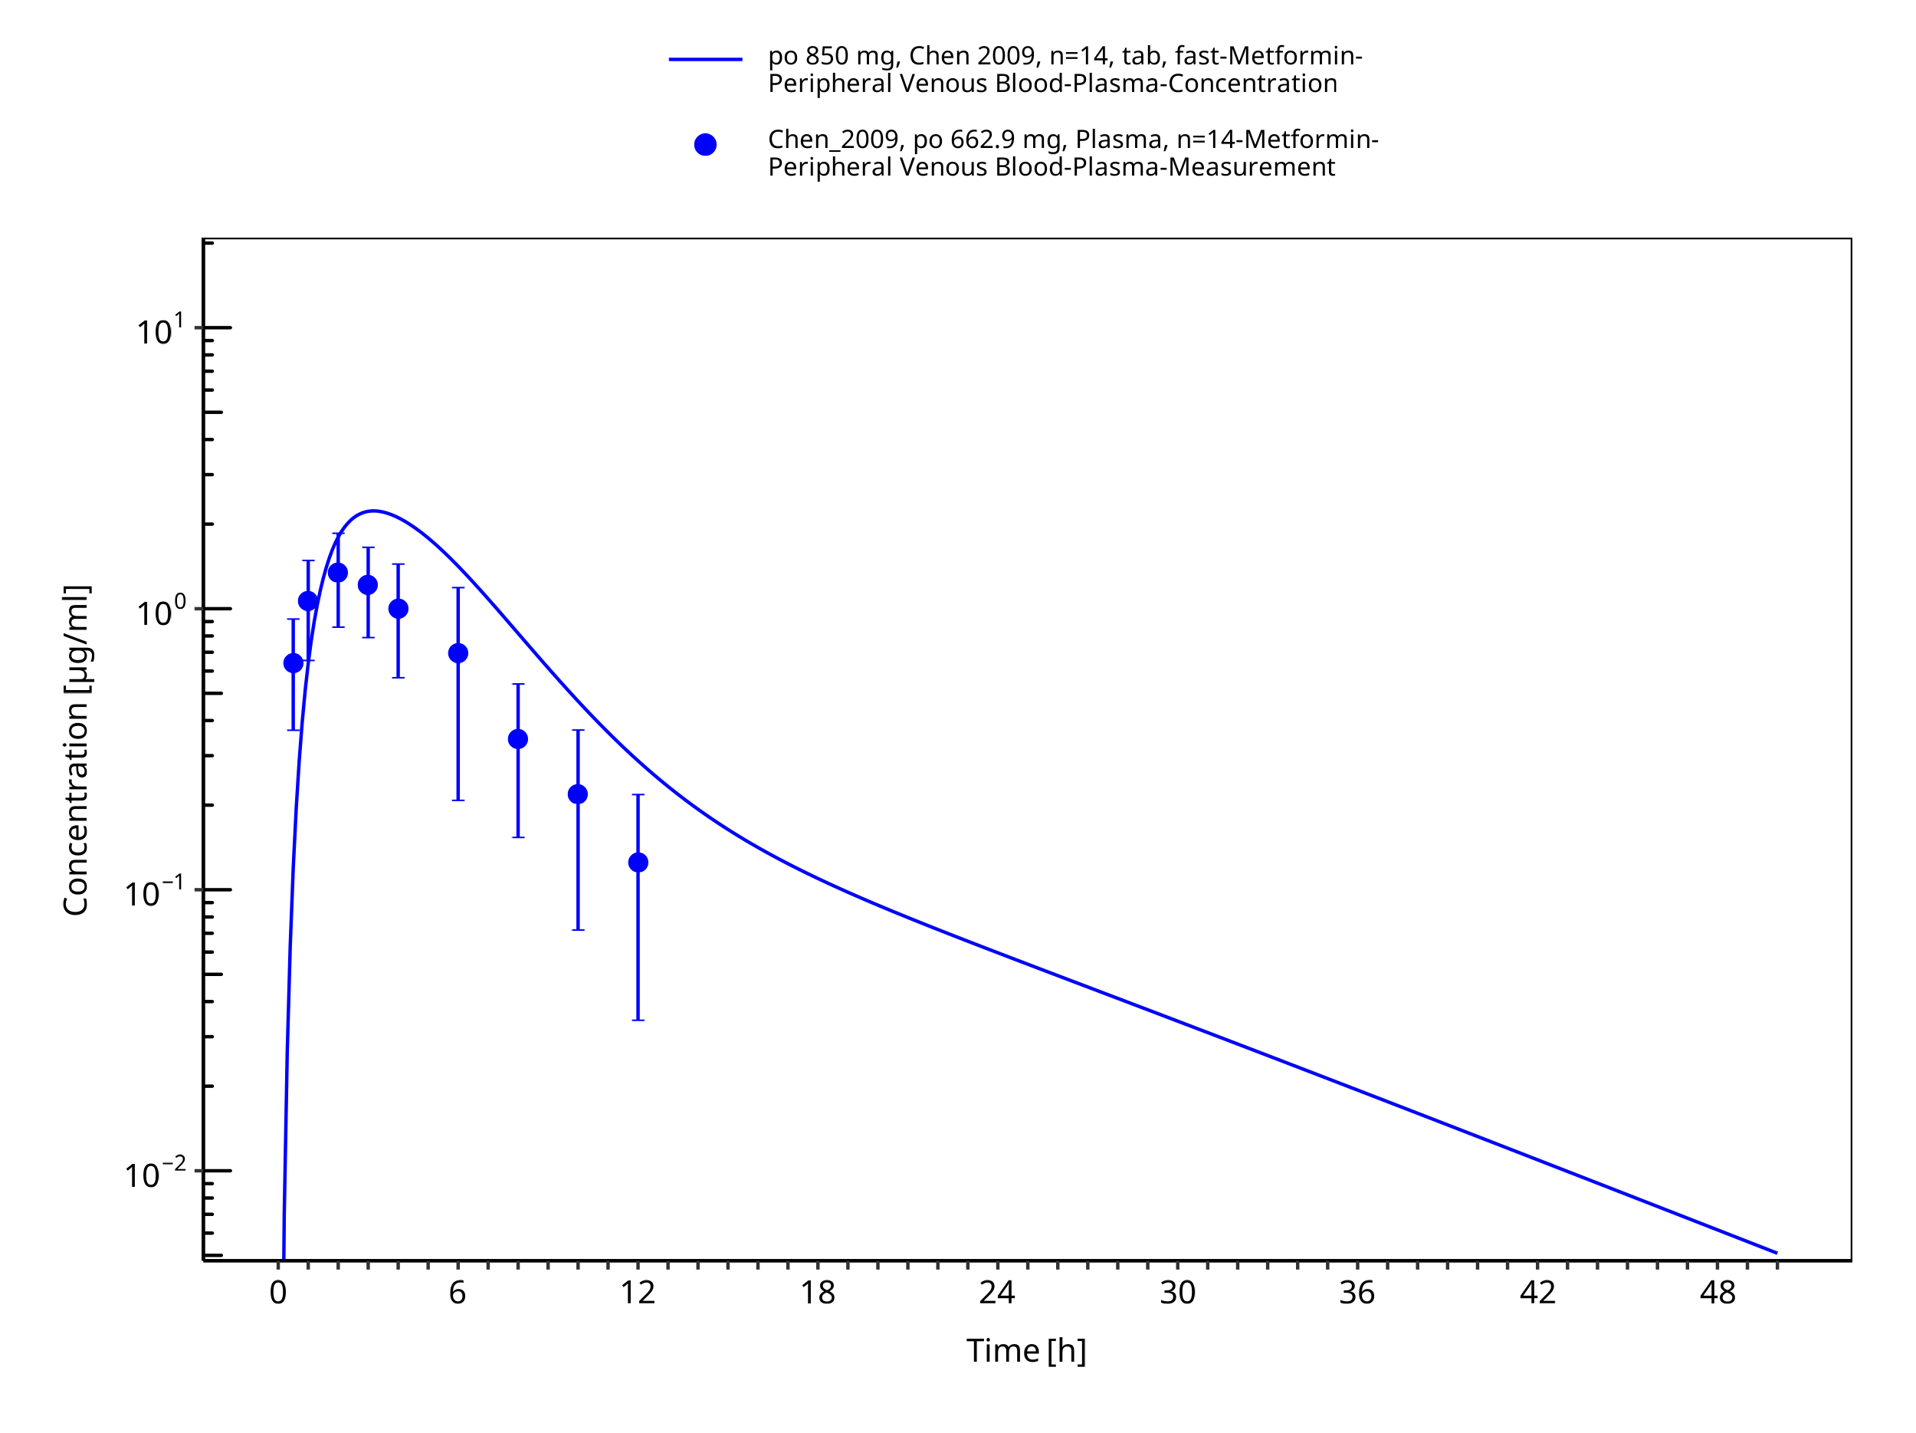
Figure 3-32: Metformin - po (tab) 850 mg_Chen 2009

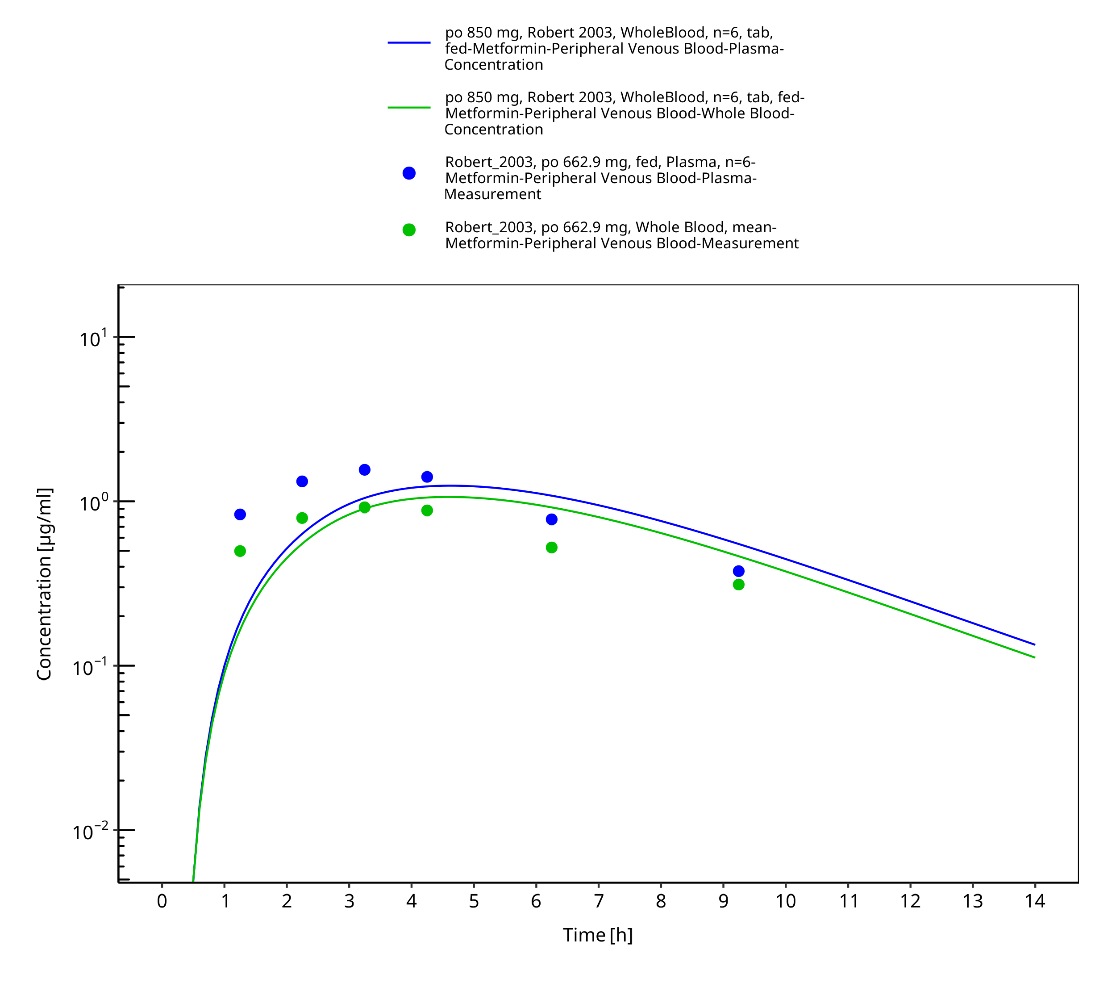
Figure 3-33: Metformin - po (tab) 850 mg_Robert 2003

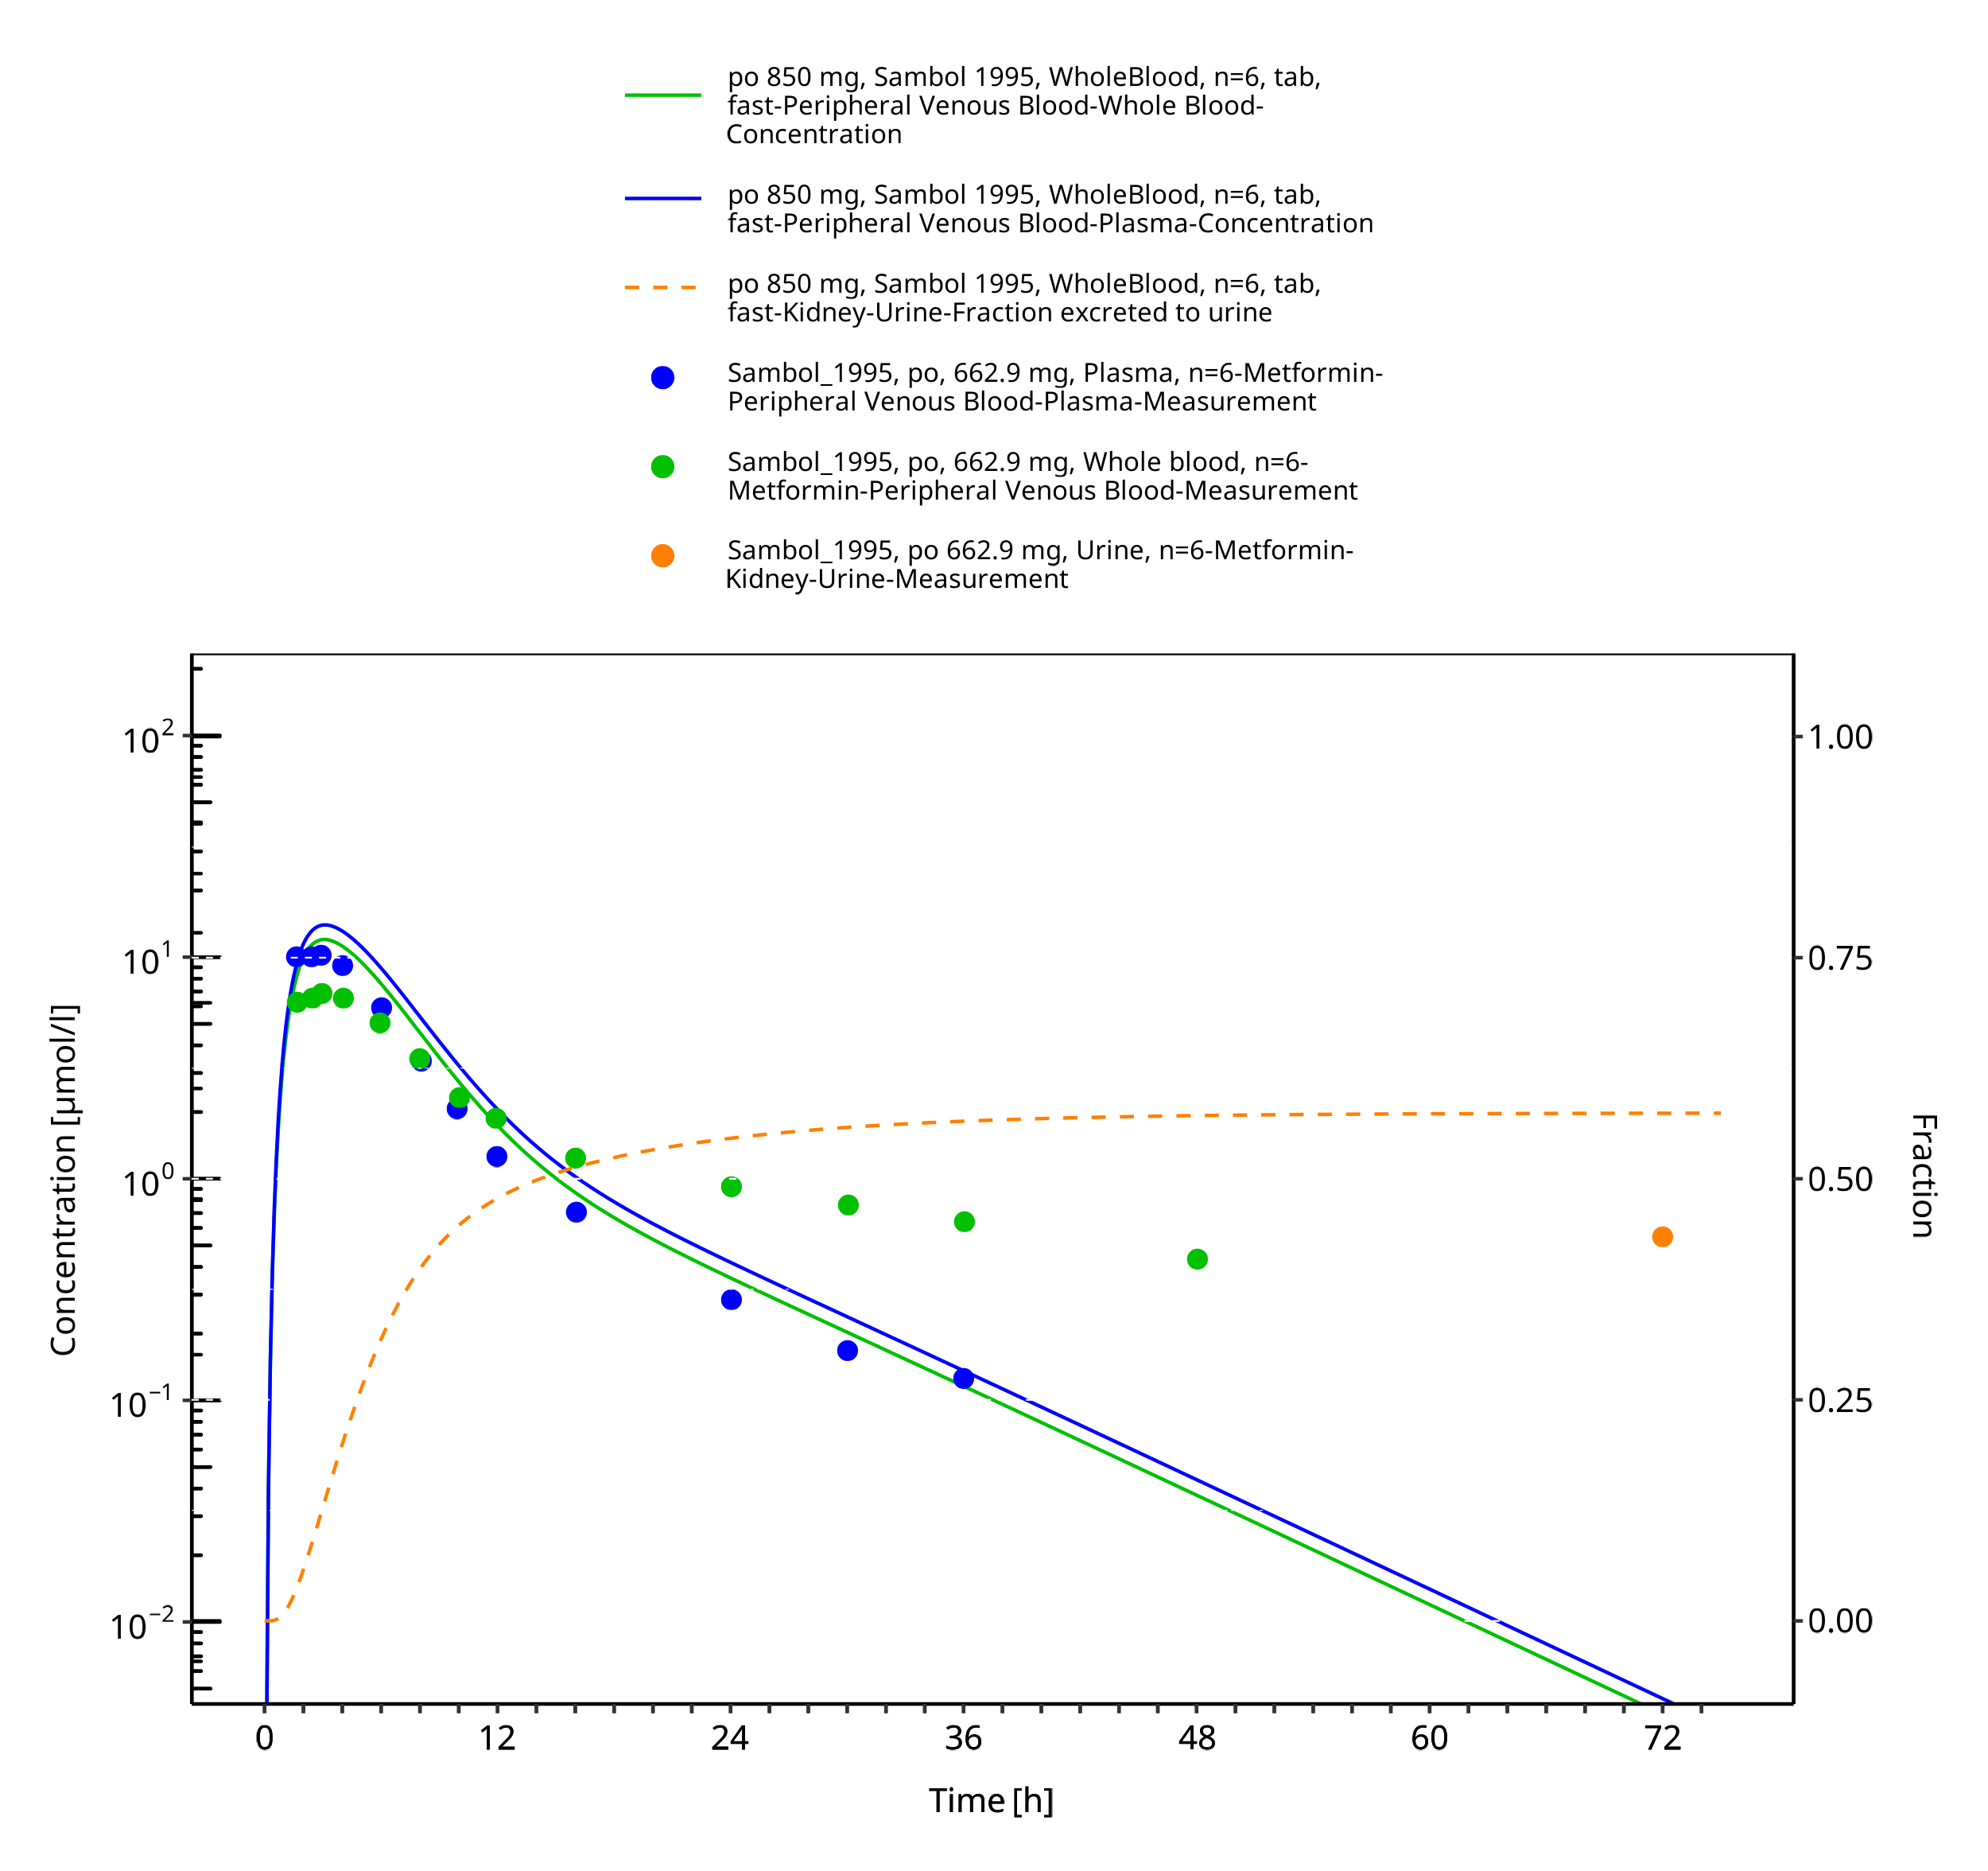
Figure 3-34: Metformin - po (tab) 850 mg_Sambol 1995

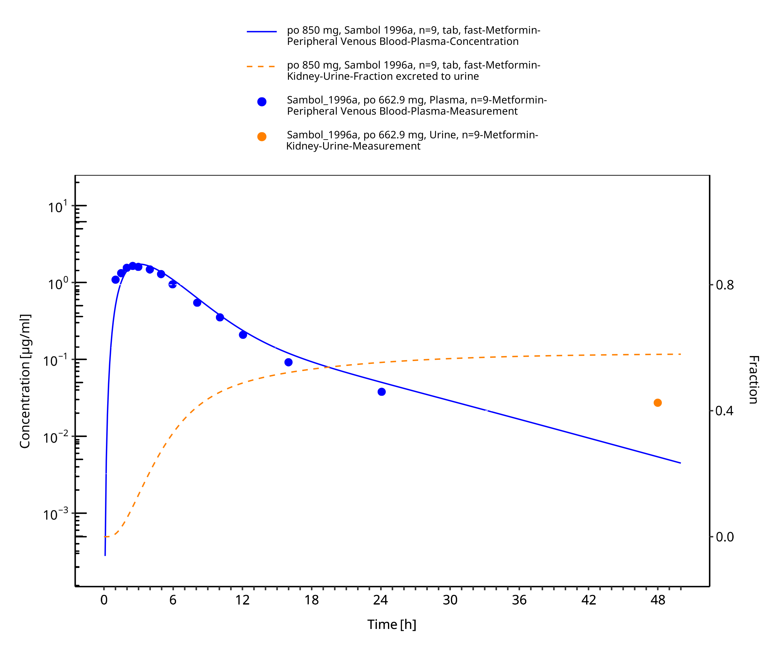
Figure 3-35: Metformin - po (tab) 850 mg_Sambol 1996a

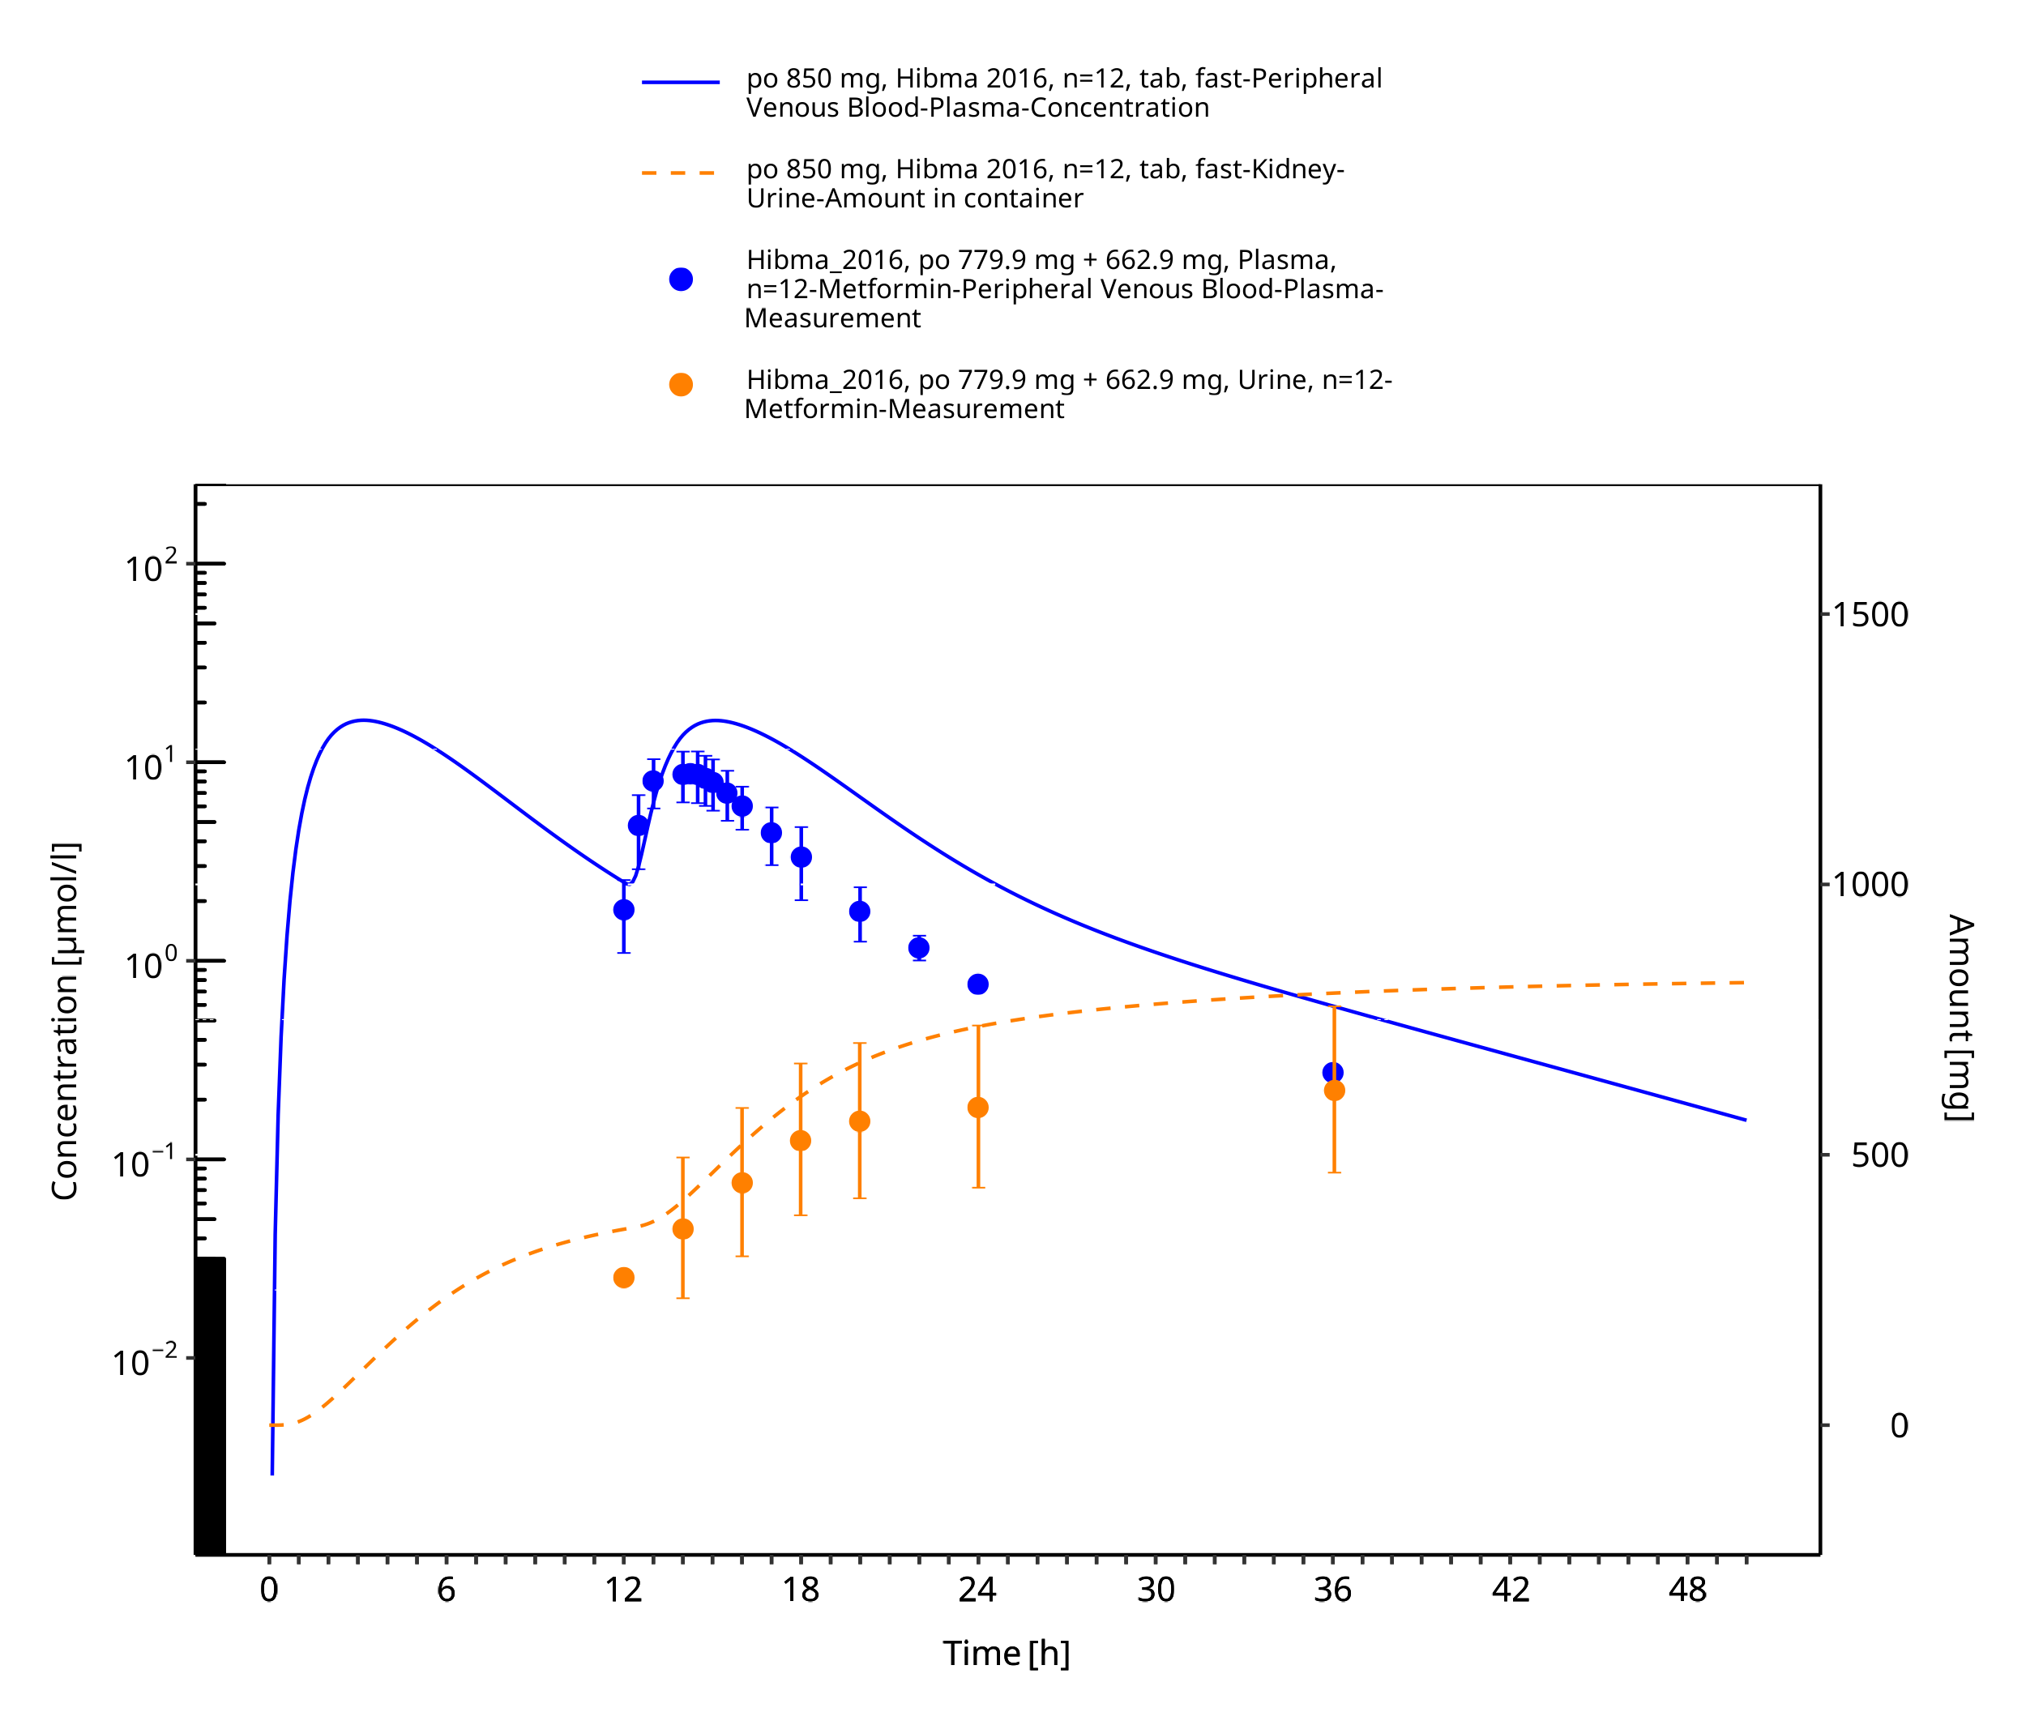
Figure 3-36: Metformin - po (tab) 850 mg_Hibma 2016

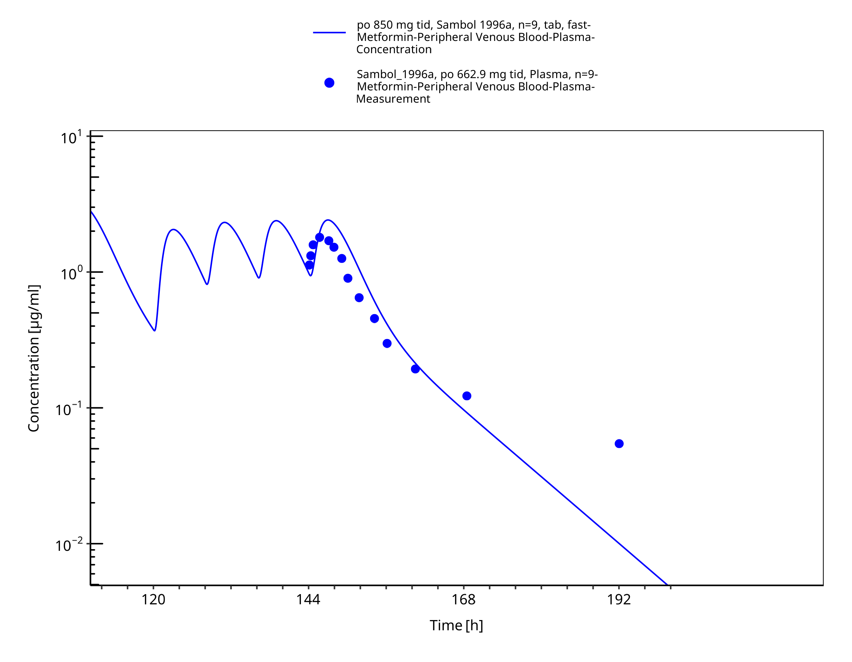
Figure 3-37: Metformin - po (tab) 850 mg tid_Sambol 1996a

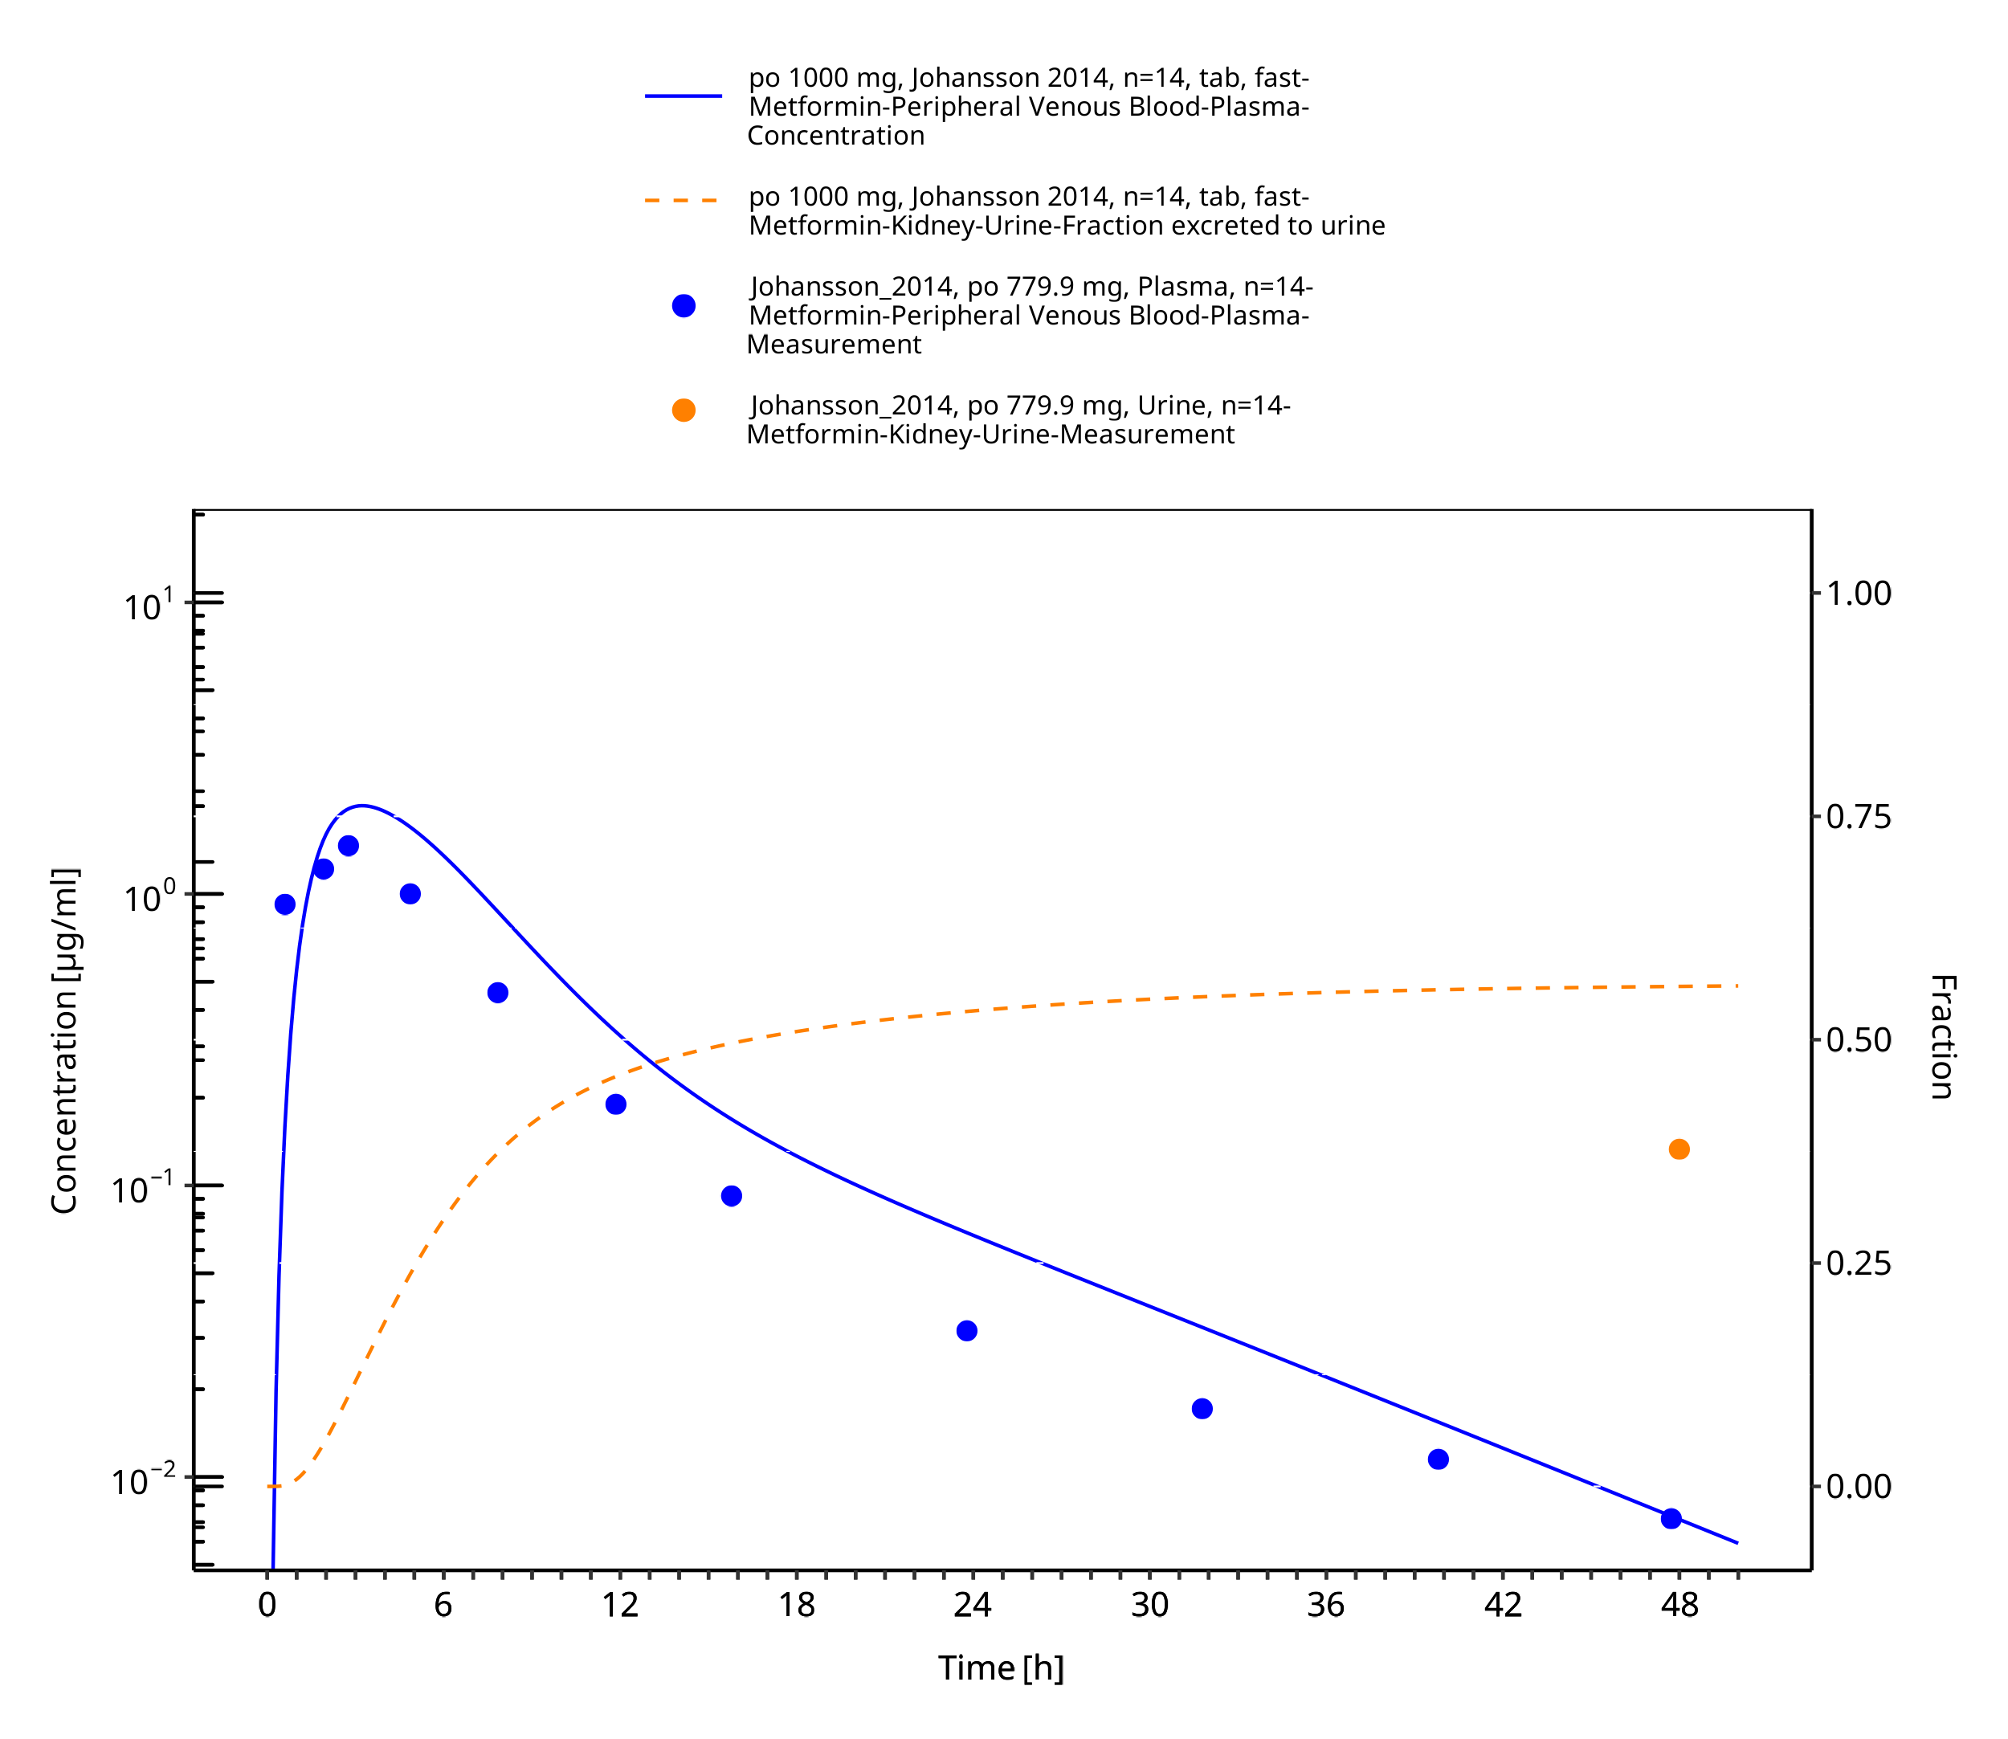
Figure 3-38: Metformin - po (tab) 1000 mg_Johansson 2014

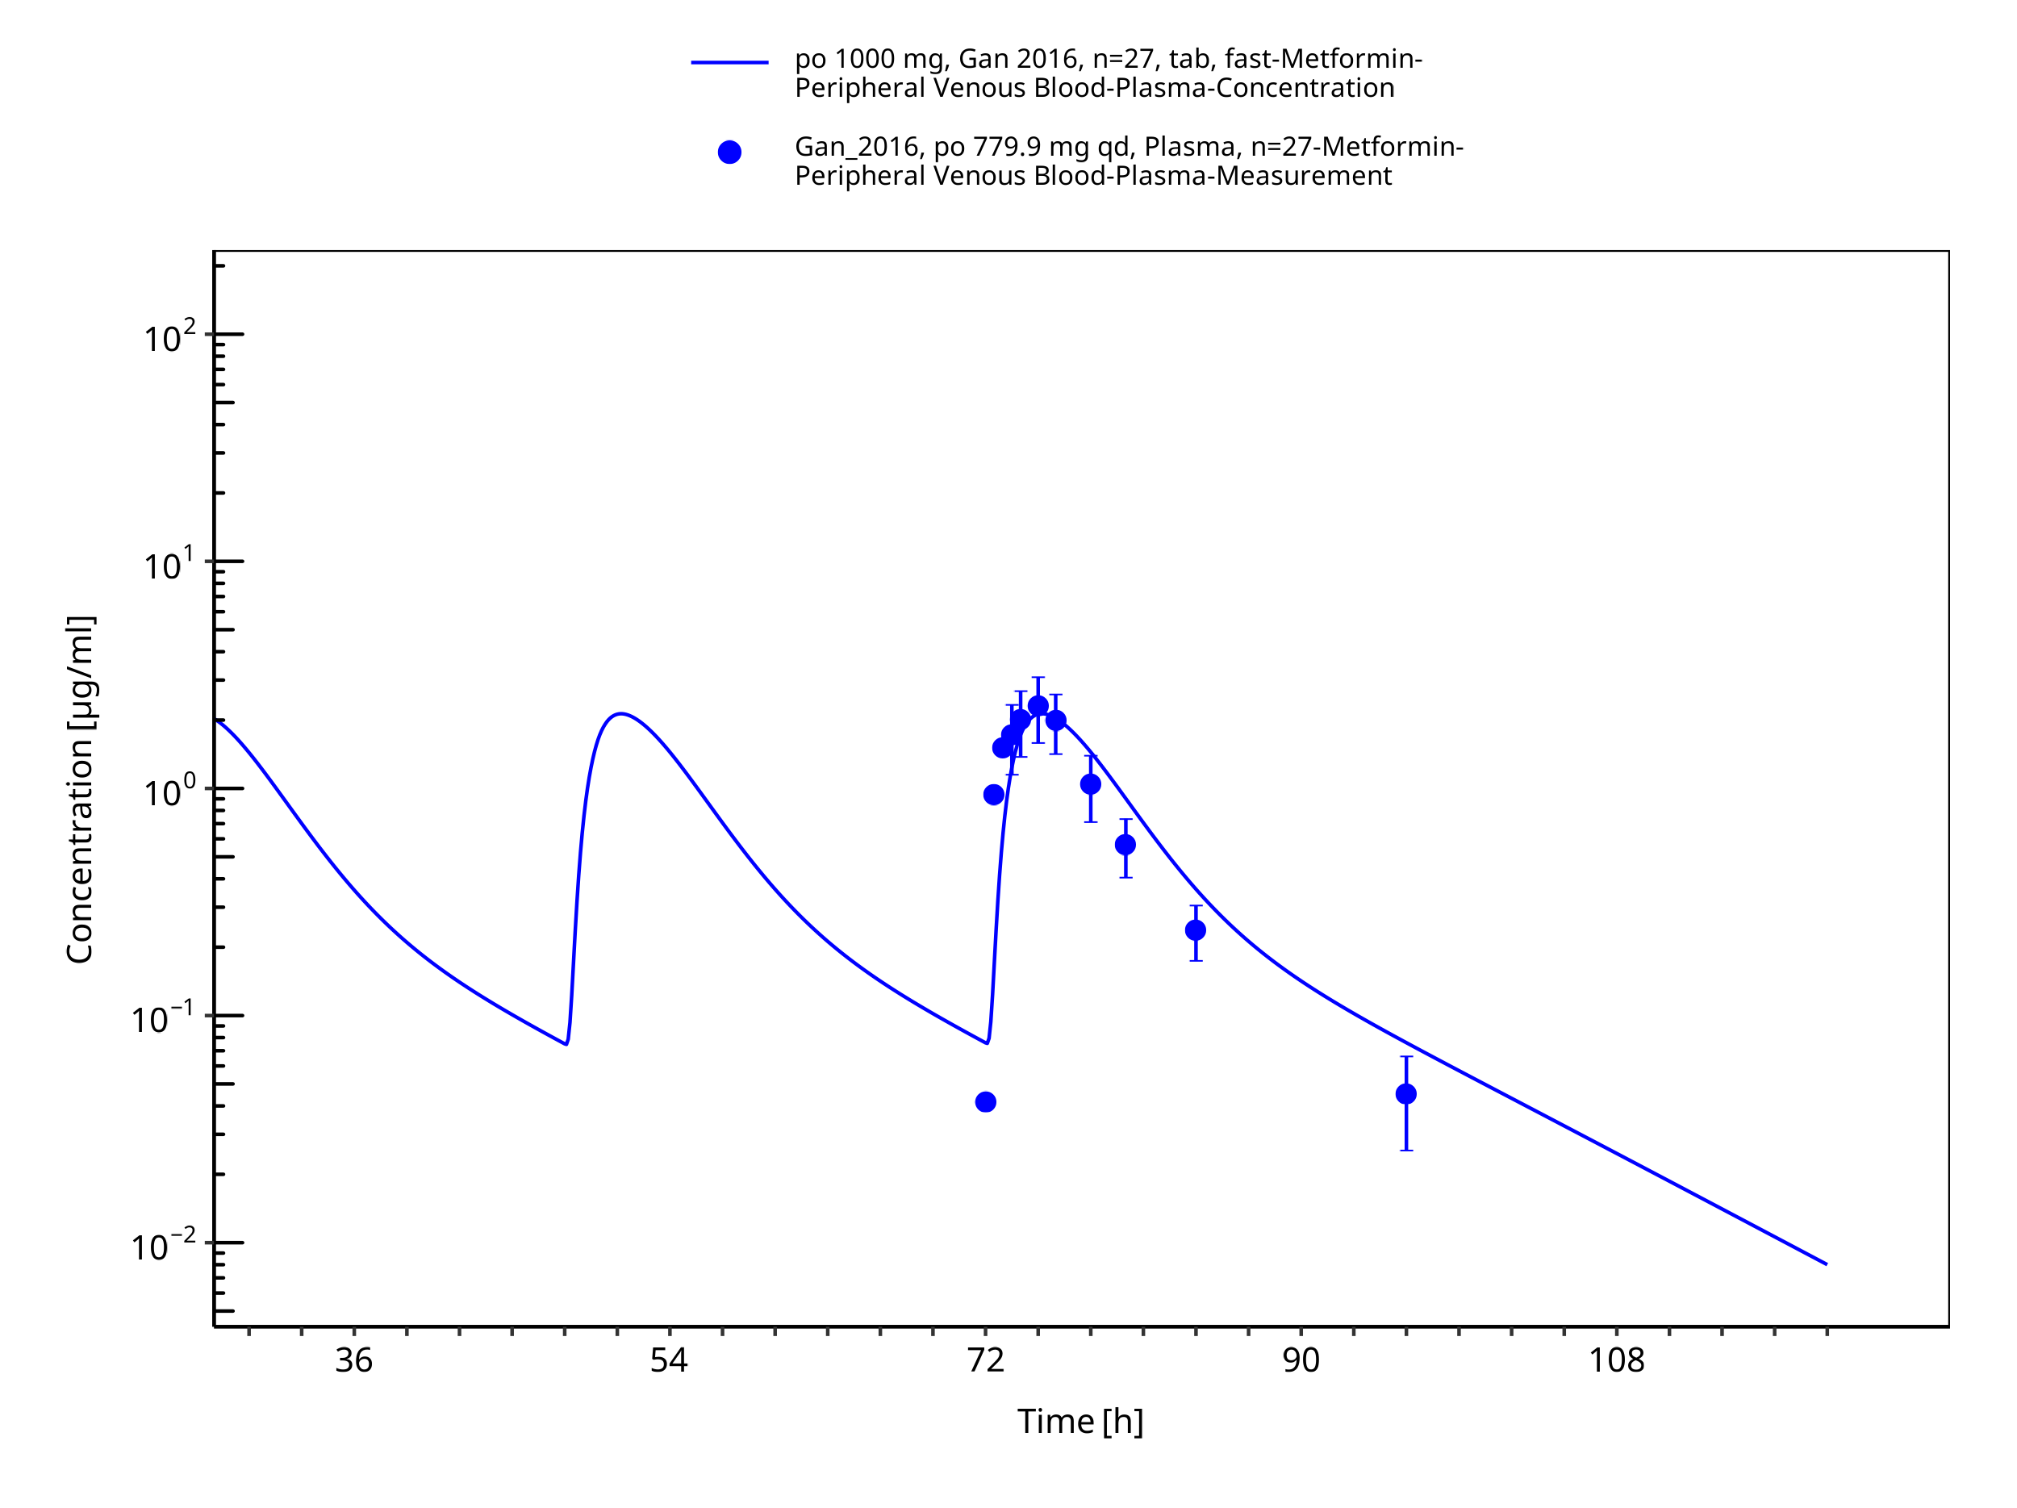
Figure 3-39: Metformin - po (tab) 1000 mg_Gan 2016

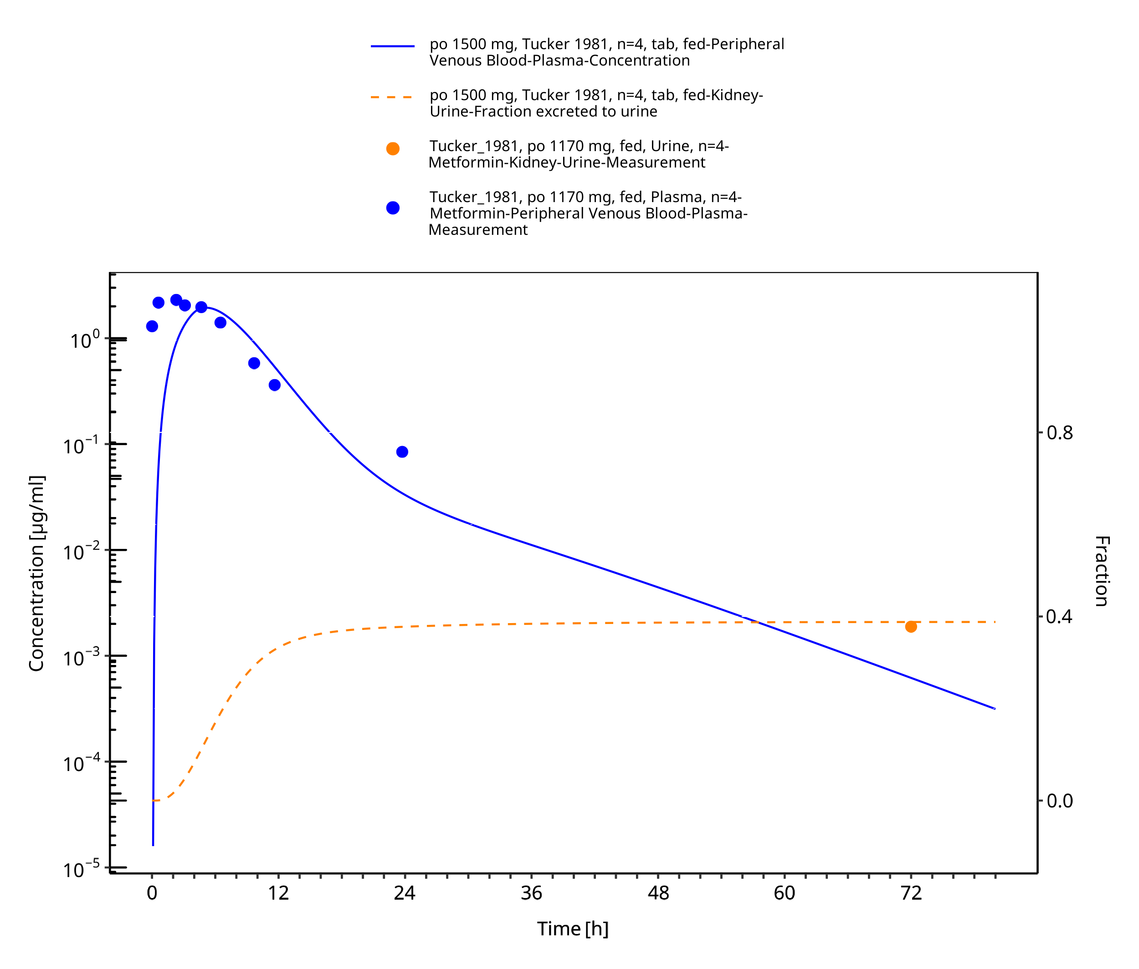
Figure 3-40: Metformin - po (tab) 1500 mg_Tucker 1981

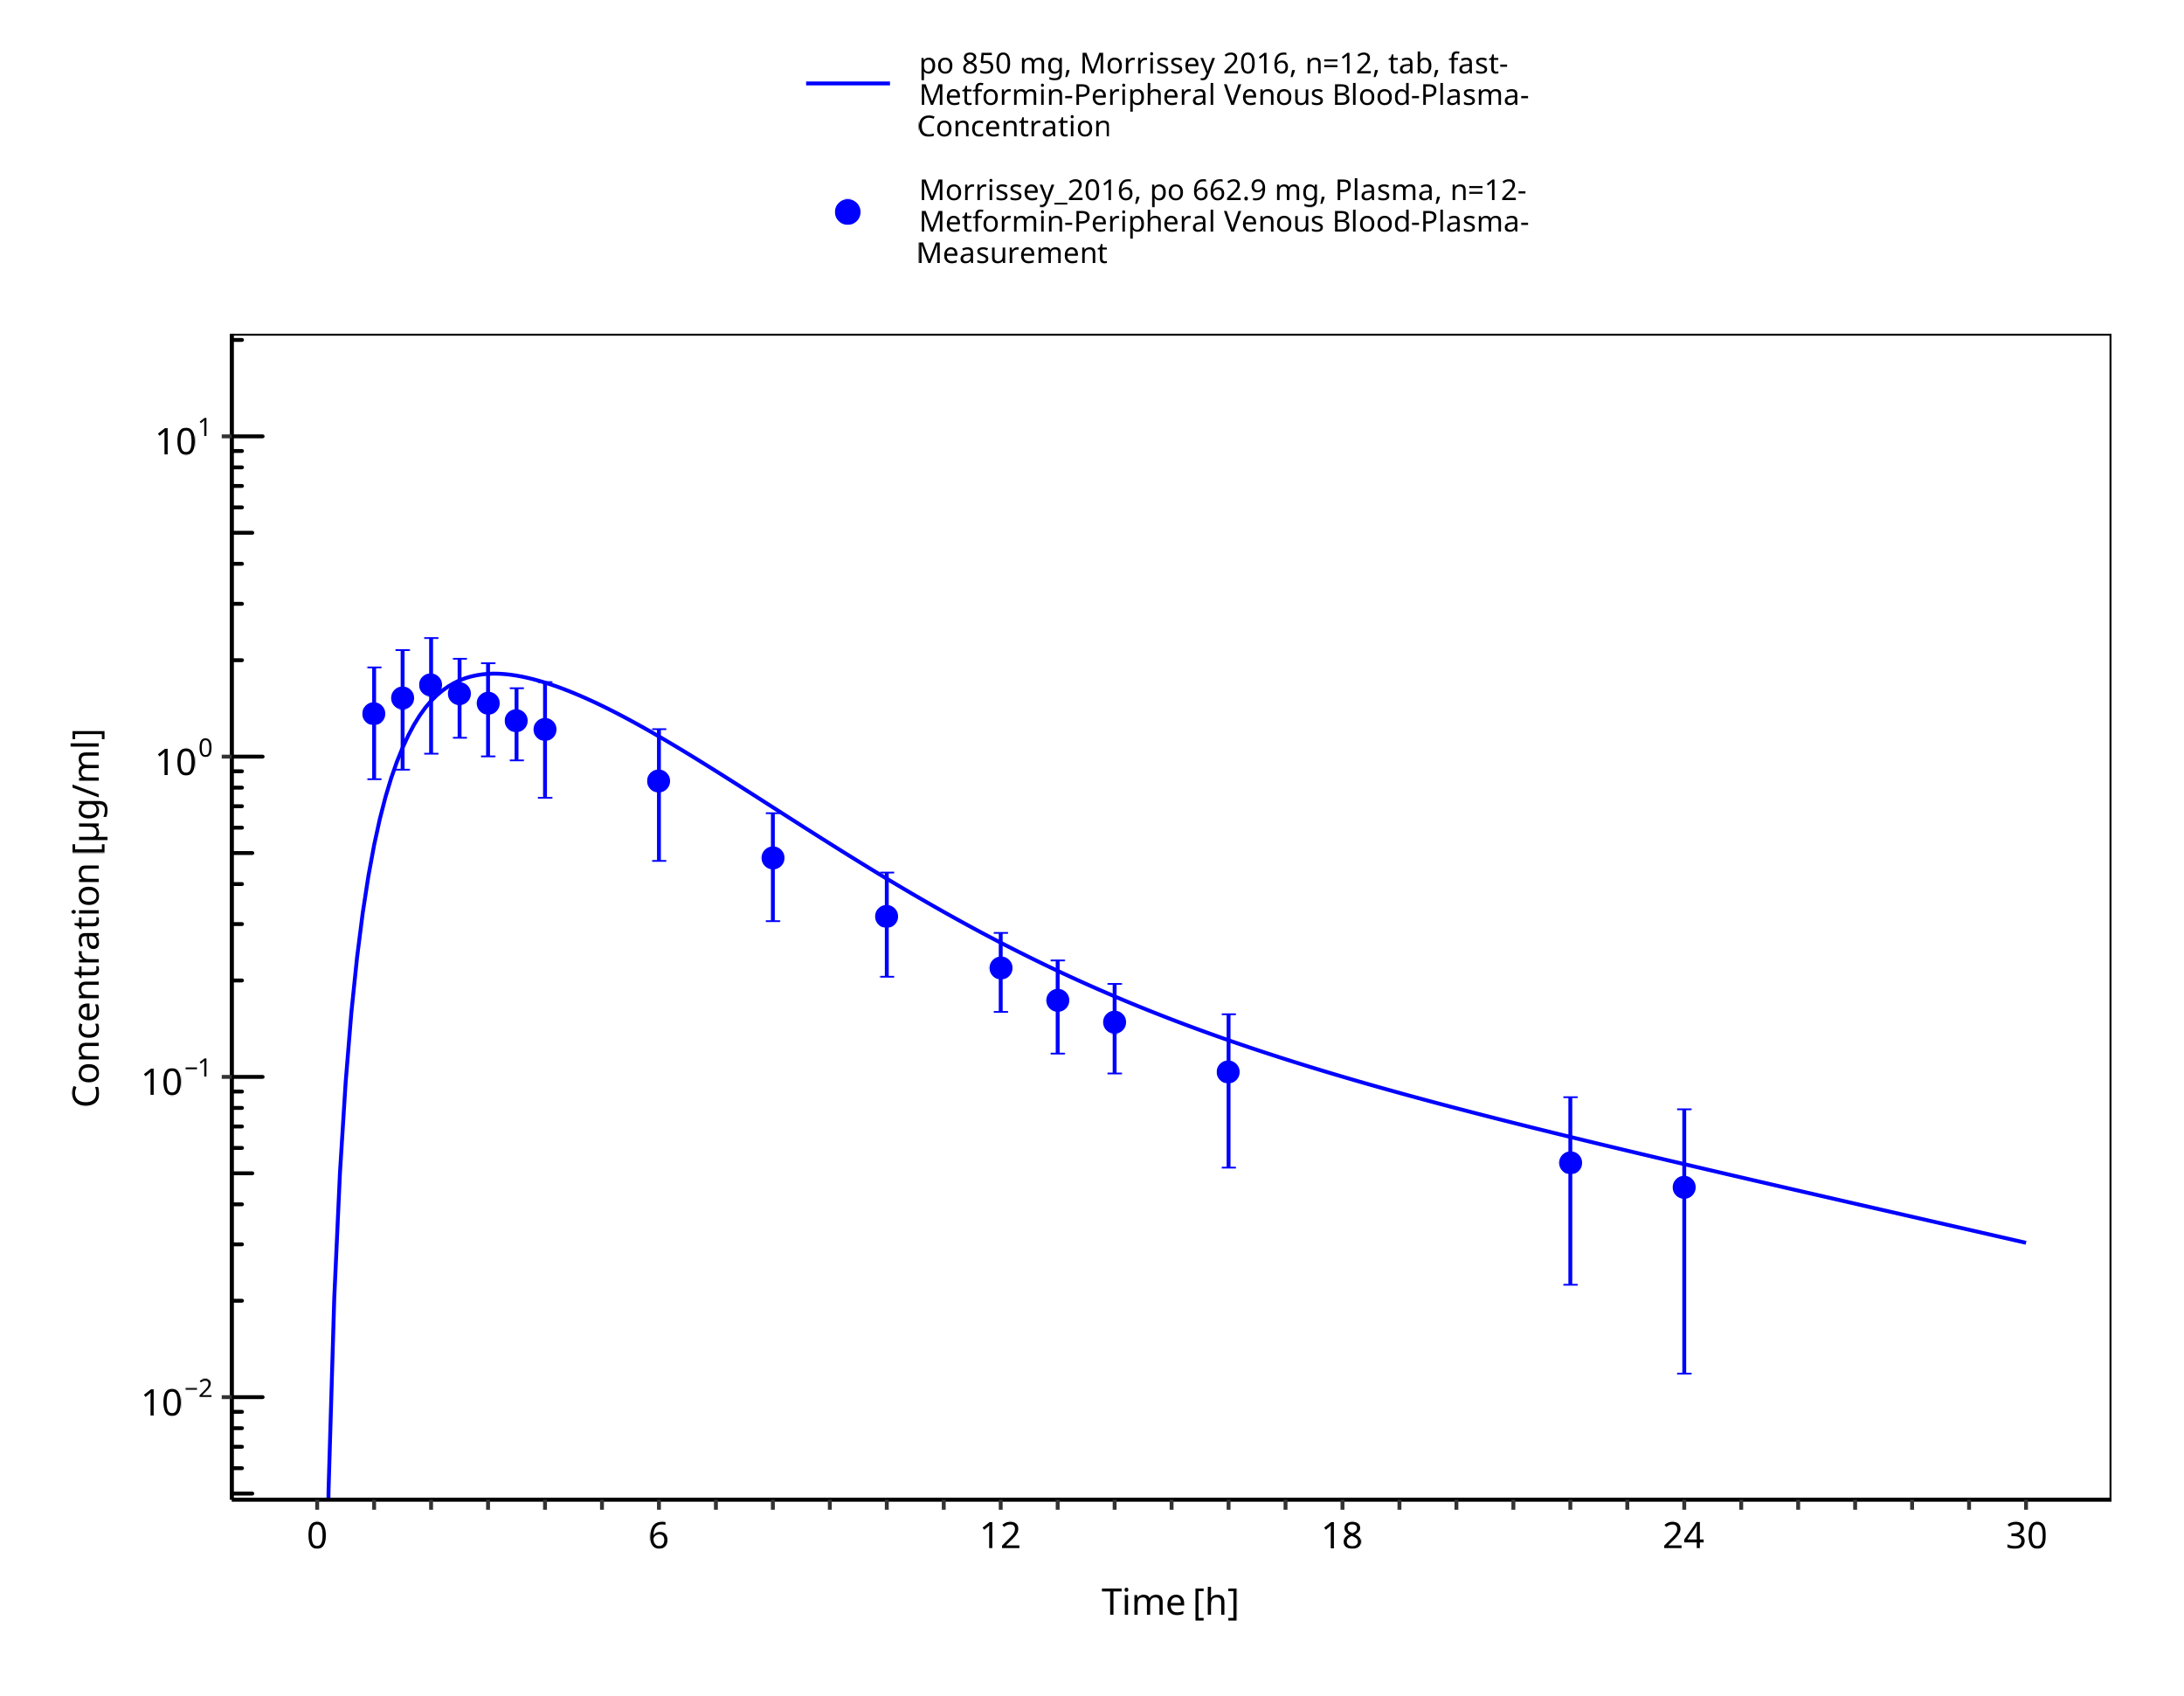
Figure 3-41: Metformin - po (tab) 850 mg_Morrissey 2016

Conclusion
The presented PBPK model adequately describes the intravenous and oral pharmacokinetics of metformin in adults.

References
Block 2008 Block LC, Schemling LO, Couto AG, et al (2008) Pharmaceutical equivalence of metformin tablets with various binders. Revista de Ciências Farmacêuticas Básica e Aplicada 29(1):29–35
Boehringer Ingelheim 2018 Boehringer Ingelheim Pharma GmbH & Co KG (2018) The effect of potent inhibitors of drug transporters (verapamil, rifampin, cimetidine, probenecid) on pharmacokinetics of a transporter probe drug cocktail consisting of digoxin, furosemide, metformin and rosuvastatin. BI Trial No. 0352-2100. EudraCT 2017-001549-29
Caillé 1993 Caillé G, Lacasse Y, Raymond M, et al (1993) Bioavailability of metformin in tablet form using a new high pressure liquid chromatography assay method. Biopharm Drug Dispos 14:257–263. https://doi.org/10.1002/bdd.2510140308
Chen 2009 Chen Y, Li S, Brown C, et al (2009) Effect of genetic variation in the organic cation transporter 2 on the renal elimination of metformin. Pharmacogenet Genomics 19:497–504. https://doi.org/10.1097/fpc.0b013e32832cc7e9
Cho 2011 Cho SK, Yoon JS, Lee MG, et al (2011) Rifampin enhances the glucose-lowering effect of metformin and increases OCT1 mRNA levels in healthy participants. Clin Pharmacol Ther 89:416–421. https://doi.org/10.1038/clpt.2010.266
Cho 2014 Cho SK, Kim CO, Park ES, Chung J-Y (2014) Verapamil decreases the glucose-lowering effect of metformin in healthy volunteers. Br J Clin Pharmacol 78:1426–1432. https://doi.org/10.1111/bcp.12476
Desai 2014 Desai D, Wong B, Huang Y, et al (2014) Surfactant-Mediated Dissolution of Metformin Hydrochloride Tablets: Wetting Effects Versus Ion Pairs Diffusivity. Journal of Pharmaceutical Sciences 103:920–926. https://doi.org/10.1002/jps.23852
Di Cicco 2000 Di Cicco RA, Allen A, Carr A, et al (2000) Rosiglitazone Does Not Alter the Pharmacokinetics of Metformin. The Journal of Clinical Pharmacology 40:1280–1285. https://doi.org/10.1177/009127000004001113
Ding 2014 Ding Y, Jia Y, Song Y, et al (2014) The effect of lansoprazole, an OCT inhibitor, on metformin pharmacokinetics in healthy subjects. Eur J Clin Pharmacol 70:141–146. https://doi.org/10.1007/s00228-013-1604-7
FDA 2017 US Food and Drug Administration (2017) Drug development and drug interactions: Table of substrates, inhibitors and inducers. https://www.fda.gov/drugs/drug-interactions/labeling/drug-development-and-drug-interactions-table-substrates-inhibitors-and-inducers
Gan 2016 Gan L, Jiang X, Mendonza A, et al (2016) Pharmacokinetic drug-drug interaction assessment of LCZ696 (an angiotensin receptor neprilysin inhibitor) with omeprazole, metformin or levonorgestrel-ethinyl estradiol in healthy subjects. Clin Pharmacol Drug Dev 5:27–39. https://doi.org/10.1002/cpdd.181
Gormsen 2016 Gormsen LC, Sundelin EI, Jensen JB, et al (2016) In Vivo Imaging of Human 11C-Metformin in Peripheral Organs: Dosimetry, Biodistribution, and Kinetic Analyses. J Nucl Med 57:1920–1926. https://doi.org/10.2967/jnumed.116.177774
Graham 2011 Graham GG, Punt J, Arora M, et al (2011) Clinical pharmacokinetics of metformin. Clin Pharmacokinet 50:81–98. https://doi.org/10.2165/11534750-000000000-00000
Gusler 2001 Gusler G, Gorsline J, Levy G, et al (2001) Pharmacokinetics of metformin gastric-retentive tablets in healthy volunteers. J Clin Pharmacol 41:655–661. https://doi.org/10.1177/00912700122010546
Hanke 2020 Hanke N, Türk D, Selzer D, et al (2020) A Comprehensive Whole-Body Physiologically Based Pharmacokinetic Drug-Drug-Gene Interaction Model of Metformin and Cimetidine in Healthy Adults and Renally Impaired Individuals. Clin Pharmacokinet. 59:1419-1431. doi: 10.1007/s40262-020-00896-w.
Hibma 2016 Hibma JE, Zur AA, Castro RA, et al (2016) The Effect of Famotidine, a MATE1-Selective Inhibitor, on the Pharmacokinetics and Pharmacodynamics of Metformin. Clin Pharmacokinet 55:711–721. https://doi.org/10.1007/s40262-015-0346-3
Jang 2016 Jang K, Chung H, Yoon J-S, et al (2016) Pharmacokinetics, Safety, and Tolerability of Metformin in Healthy Elderly Subjects. J Clin Pharmacol 56:1104–1110. https://doi.org/10.1002/jcph.699
Johansson 2014 Johansson S, Read J, Oliver S, et al (2014) Pharmacokinetic evaluations of the co-administrations of vandetanib and metformin, digoxin, midazolam, omeprazole or ranitidine. Clin Pharmacokinet 53:837–847. https://doi.org/10.1007/s40262-014-0161-2
Kim 2014 Kim A, Chung I, Yoon SH, et al (2014) Effects of proton pump inhibitors on metformin pharmacokinetics and pharmacodynamics. Drug Metab Dispos 42:1174–1179. https://doi.org/10.1124/dmd.113.055616
Kolesnikov 2015Kolesnikov N, Hastings E, Keays M, et al (2015) ArrayExpress update—simplifying data submissions. Nucleic Acids Research 43:D1113–D1116. https://doi.org/10.1093/nar/gku1057
Manitpisitkul 2014 Manitpisitkul P, Curtin CR, Shalayda K, et al (2014) Pharmacokinetic interactions between topiramate and pioglitazone and metformin. Epilepsy Res 108:1519–1532. https://doi.org/10.1016/j.eplepsyres.2014.08.013
Marathe 2000 Marathe PH, Wen Y, Norton J, Greene DS, Barbhaiya RH, Wilding IR. Effect of altered gastric emptying and gastrointestinal motility on metformin absorption. Br J Clin Pharmacol. 0:325-32. doi: 10.1046/j.1365-2125.2000.00264.x.
Masuda 2006 Masuda S, Terada T, Yonezawa A, et al (2006) Identification and functional characterization of a new human kidney-specific H+/organic cation antiporter, kidney-specific multidrug and toxin extrusion 2. J Am Soc Nephrol 17:2127–2135. https://doi.org/10.1681/asn.2006030205
Meyer 2012 Meyer M, Schneckener S, Ludewig B, et al (2012) Using expression data for quantification of active processes in physiologically based pharmacokinetic modeling. Drug Metab Dispos 40:892–901. https://doi.org/10.1124/dmd.111.043174
Morrissey 2016 Morrissey KM, Stocker SL, Chen EC, et al (2016) The Effect of Nizatidine, a MATE2K Selective Inhibitor, on the Pharmacokinetics and Pharmacodynamics of Metformin in Healthy Volunteers. Clin Pharmacokinet 55:495–506. https://doi.org/10.1007/s40262-015-0332-9
NCHS 1997 National Center for Health Statistics (NCHS) (1997) Third National Health and Nutrition Examination Survey (NHANES III). Tech. rep., Hyattsville, MD 20782
Najib 2002 Najib N, Idkaidek N, Beshtawi M, et al (2002) Bioequivalence evaluation of two brands of metformin 500 mg tablets (Dialon & Glucophage)–in healthy human volunteers. Biopharm Drug Dispos 23:301–306. https://doi.org/10.1002/bdd.326
NCBI 2019 National Center for Biotechnology Information (NCBI) (2019) Expressed Sequence Tags (EST) from UniGene
Nishimura 2005 Nishimura M, Naito S (2005) Tissue-specific mRNA Expression Profiles of Human ATP-binding Cassette and Solute Carrier Transporter Superfamilies. Drug Metabolism and Pharmacokinetics 20:452–477. https://doi.org/10.2133/dmpk.20.452
Nishimura 2006 Nishimura M, Naito S (2006) Tissue-specific mRNA expression profiles of human phase I metabolizing enzymes except for cytochrome P450 and phase II metabolizing enzymes. Drug Metab Pharmacokinet 21:357–374. https://doi.org/10.2133/dmpk.21.357
Oh 2016 Oh J, Chung H, Park S-I, et al (2016) Inhibition of the multidrug and toxin extrusion (MATE) transporter by pyrimethamine increases the plasma concentration of metformin but does not increase antihyperglycaemic activity in humans. Diabetes Obes Metab 18:104–108. https://doi.org/10.1111/dom.12577
Otsuka 2005 Otsuka M, Matsumoto T, Morimoto R, et al (2005) A human transporter protein that mediates the final excretion step for toxic organic cations. Proc Natl Acad Sci U S A 102:17923–17928. https://doi.org/10.1073/pnas.0506483102
Pentikäinen 1979 Pentikäinen PJ, Neuvonen PJ, Penttilä A (1979a) Pharmacokinetics of metformin after intravenous and oral administration to man. Eur J Clin Pharmacol 16:195–202. https://doi.org/10.1007/BF00562061
PK-Sim Ontogeny Database Version 7.3 PK-Sim Ontogeny Database Version 7.3 (https://github.com/Open-Systems-Pharmacology/OSPSuite.Documentation/blob/38cf71b384cfc25cfa0ce4d2f3addfd32757e13b/PK-Sim%20Ontogeny%20Database%20Version%207.3.pdf)
Robert 2003 Robert F, Fendri S, Hary L, et al (2003) Kinetics of plasma and erythrocyte metformin after acute administration in healthy subjects. Diabetes Metab 29:279–283. https://doi.org/10.1016/s1262-3636(07)70037-x
Sambol 1996 Sambol NC, Brookes LG, Chiang J, et al (1996) Food intake and dosage level, but not tablet vs solution dosage form, affect the absorption of metformin HC1 in man. British Journal of Clinical Pharmacology 42:510–512. https://doi.org/10.1111/j.1365-2125.1996.tb00017.x
Sambol 1995 Sambol NC, Chiang J, Lin ET, et al (1995) Kidney function and age are both predictors of pharmacokinetics of metformin. J Clin Pharmacol 35:1094–1102. https://doi.org/10.1002/j.1552-4604.1995.tb04033.x
Sirtori 1978 Sirtori CR, Franceschini G, Galli-Kienle M, et al (1978a) Disposition of metformin (N,N-dimethylbiguanide) in man. Clinical Pharmacology & Therapeutics 24:683–693. https://doi.org/10.1002/cpt1978246683
Somogyi 1987 Somogyi A, Stockley C, Keal J, et al (1987) Reduction of metformin renal tubular secretion by cimetidine in man. British Journal of Clinical Pharmacology 23:545–551. https://doi.org/10.1111/j.1365-2125.1987.tb03090.x
Stopfer 2016 Stopfer P, Giessmann T, Hohl K, et al (2016) Pharmacokinetic Evaluation of a Drug Transporter Cocktail Consisting of Digoxin, Furosemide, Metformin, and Rosuvastatin. Clin Pharmacol Ther 100:259–267. https://doi.org/10.1002/cpt.406
Stopfer 2018 Stopfer P, Giessmann T, Hohl K, et al (2018) Effects of Metformin and Furosemide on Rosuvastatin Pharmacokinetics in Healthy Volunteers: Implications for Their Use as Probe Drugs in a Transporter Cocktail. Eur J Drug Metab Pharmacokinet 43:69–80. https://doi.org/10.1007/s13318-017-0427-9
Tucker 1981 Tucker GT, Casey C, Phillips PJ, et al (1981a) Metformin kinetics in healthy subjects and in patients with diabetes mellitus. Br J Clin Pharmacol 12:235–246. https://doi.org/10.1111/j.1365-2125.1981.tb01206.x
Valentin 2002 Valentin J (2002) Basic anatomical and physiological data for use in radiological protection: reference values: ICRP Publication 89. Annals of the ICRP 32:1–277
Vidon 1988 Vidon N, Chaussade S, Noel M, Franchisseur C, Huchet B, Bernier JJ (1988) Metformin in the digestive tract. Diabetes Research and Clinical Practice 4:223–229
Wang 2008 Wang Z-J, Yin OQP, Tomlinson B, Chow MSS (2008) OCT2 polymorphisms and in-vivo renal functional consequence: studies with metformin and cimetidine. Pharmacogenet Genomics 18:637–645. https://doi.org/10.1097/FPC.0b013e328302cd41
Willmann 2007 Willmann S, Hohn K, Edginton A, et al (2007) Development of a physiology-based whole-body population model for assessing the influence of individual variability on the pharmacokinetics of drugs. Journal of pharmacokinetics and pharmacodynamics 34:401–31. https://doi.org/10.1007/s10928-007-9053-5
Wishart 2006 Wishart DS, Knox C, Guo AC, et al (2006) DrugBank: a comprehensive resource for in silico drug discovery and exploration. Nucleic Acids Res 34:D668-672. https://doi.org/10.1093/nar/gkj067
Yin 2016 Yin J, Duan H, Wang J (2016) Impact of Substrate-Dependent Inhibition on Renal Organic Cation Transporters hOCT2 and hMATE1/2-K-Mediated Drug Transport and Intracellular Accumulation. J Pharmacol Exp Ther 359:401–410. https://doi.org/10.1124/jpet.116.236158
Zhou 2007 Zhou M, Xia L, Wang J (2007) Metformin Transport by a Newly Cloned Proton-Stimulated Organic Cation Transporter (Plasma Membrane Monoamine Transporter) Expressed in Human Intestine. Drug Metab Dispos 35:1956–1962 https://doi: 10.1124/dmd.107.015495.
Zhou 2009 Zhou SF, Zhou ZW, Yang LP, Cai JP (2009) Substrates, inducers, inhibitors and structure-activity relationships of human cytochrome P450 2C9 and implications in drug development. Current Medicinal Chemistry 16:3480–3675. https://doi.org/10.2174/092986709789057635

