Table of Contents

# 1. Time profiles and residual plots

## 1.1. Time profiles and residual plots for Sim_1

Figure 1: Time profiles of Sim_1 for MiniModel2. Time profiles are plotted in a linear scale.

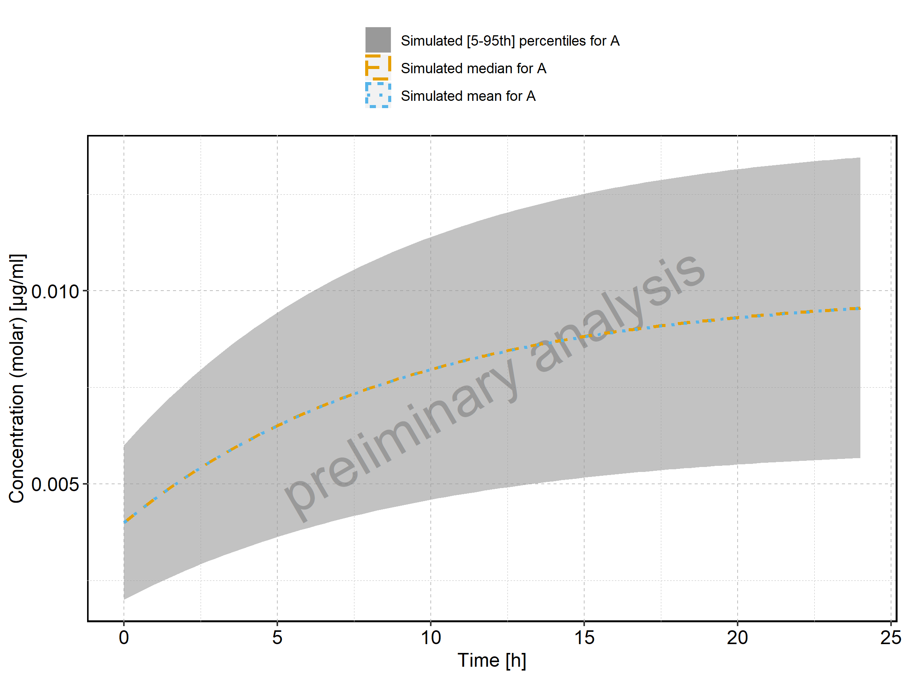

Figure 2: Time profiles of Sim_1 for MiniModel2. Time profiles are plotted in a logarithmic scale.

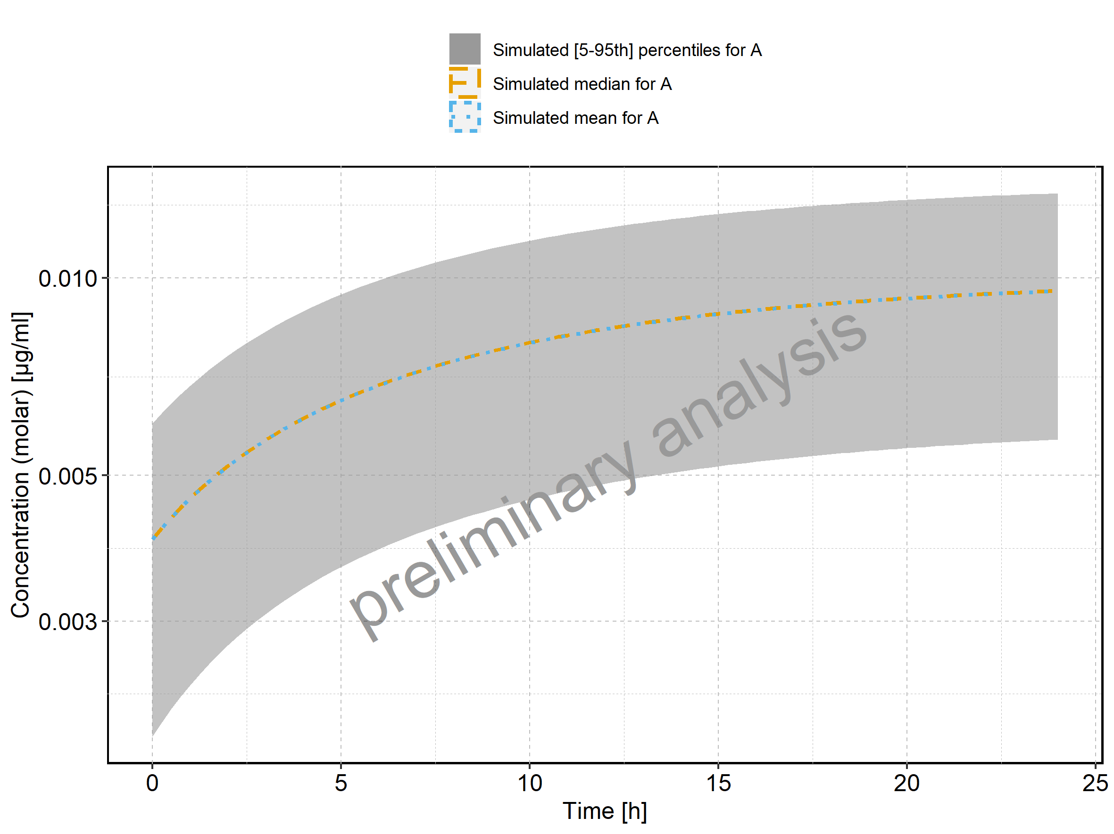

## 1.2. Time profiles and residual plots for Sim-2

Figure 3: Time profiles of Sim-2 for MiniModel2. Time profiles are plotted in a linear scale.

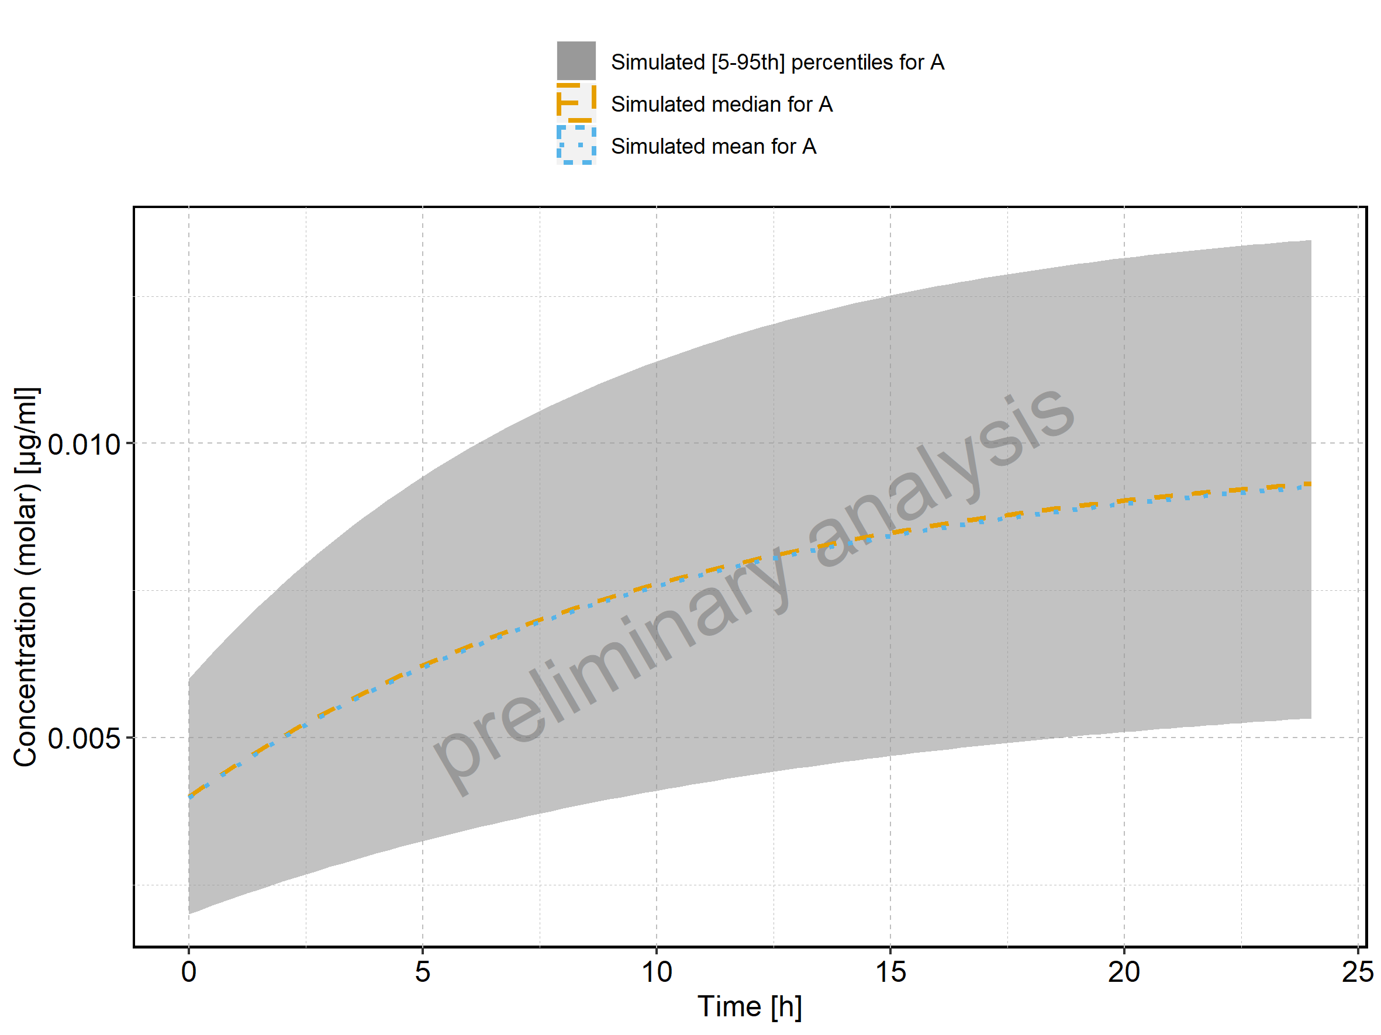

Figure 4: Time profiles of Sim-2 for MiniModel2. Time profiles are plotted in a logarithmic scale.

