CYP1A2 DDI Qualification

Abstract

| Version | 1.0-OSP12.0 |
| --- | --- |
| Qualification Plan Release | https://github.com/Open-Systems-Pharmacology/Qualification-DDI-CYP1A2/releases/tag/v1.0 |
| OSP Version | 12.0 |
| Qualification Framework Version | 3.3 |

This qualification report is filed at:

https://github.com/Open-Systems-Pharmacology/OSP-Qualification-Reports

Table of Contents

# 1 Introduction

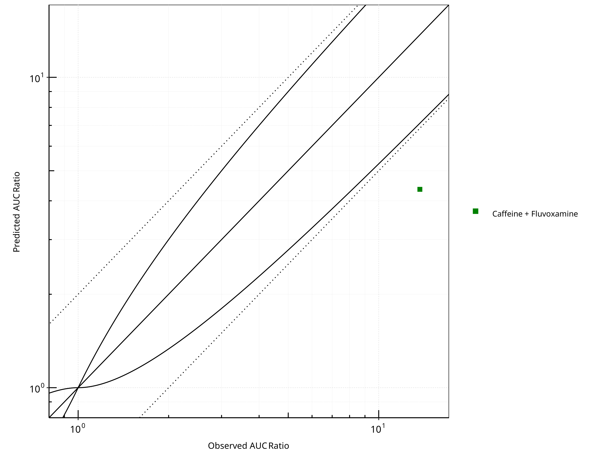

**Figure 1-1: CYP1A2 DDI. Predicted vs. Observed AUC Ratio. (δ = 1 in Guest *et al.* formula)**

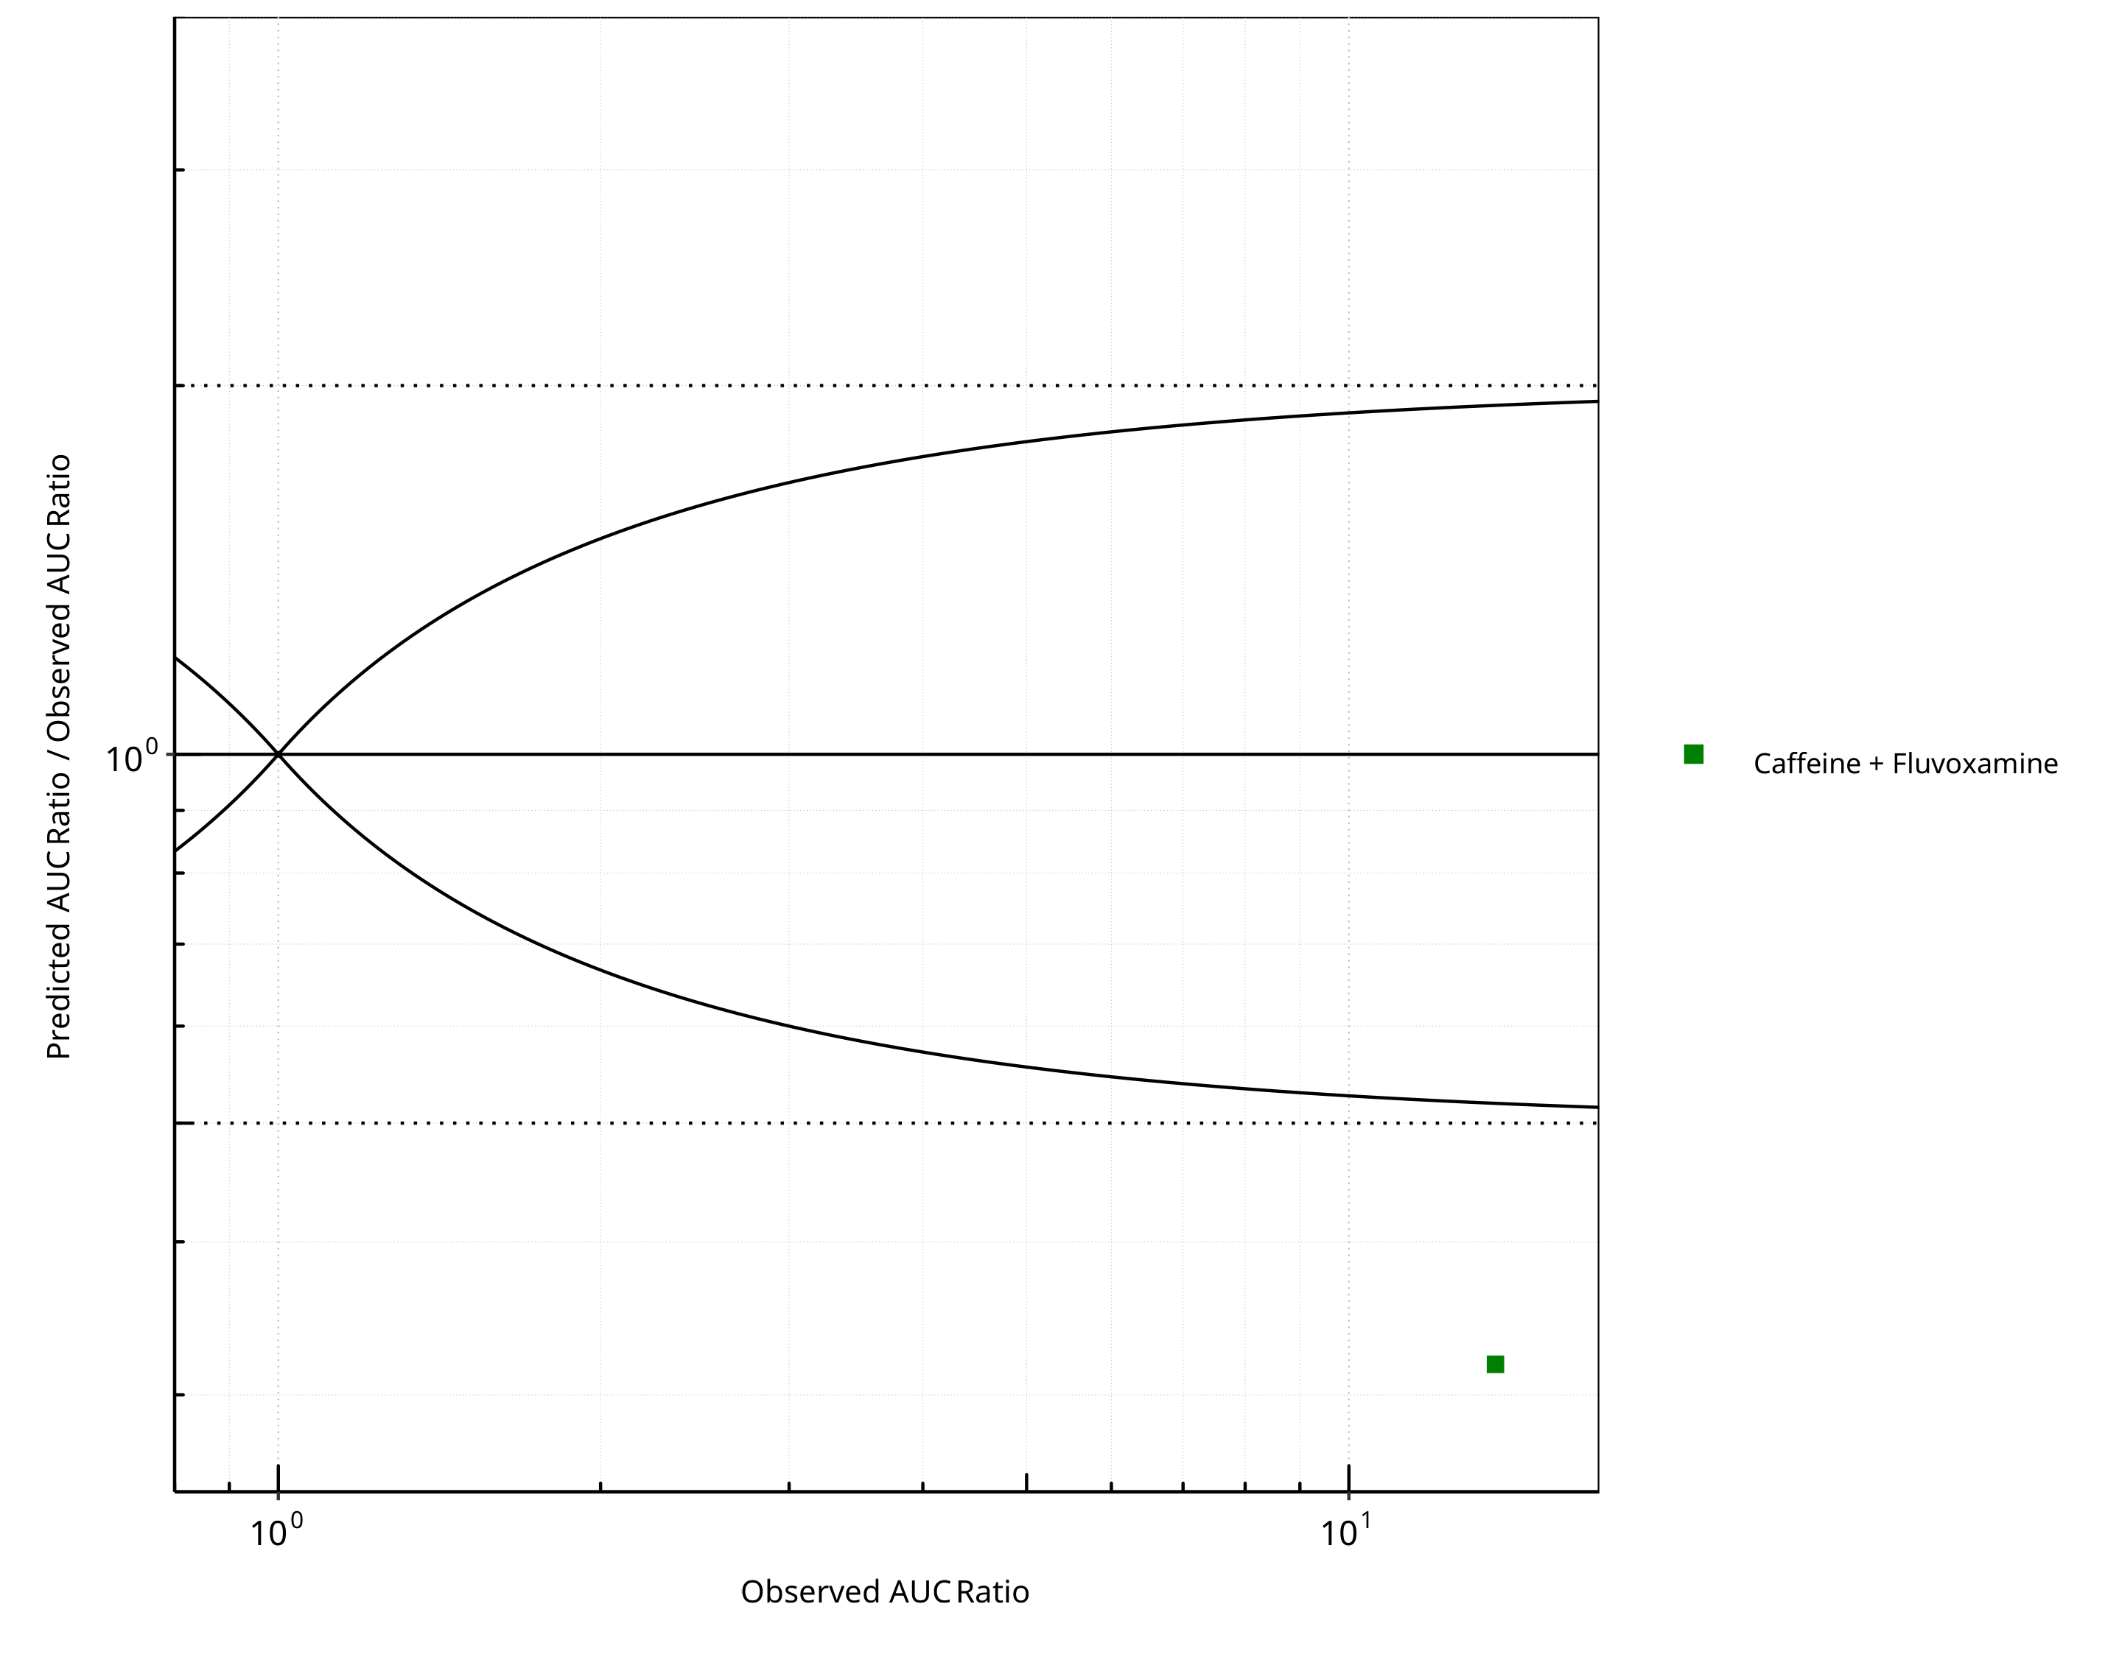

**Figure 1-2: CYP1A2 DDI. Predicted/Observed vs. Observed AUC Ratio. (δ = 1 in Guest *et al.* formula)**

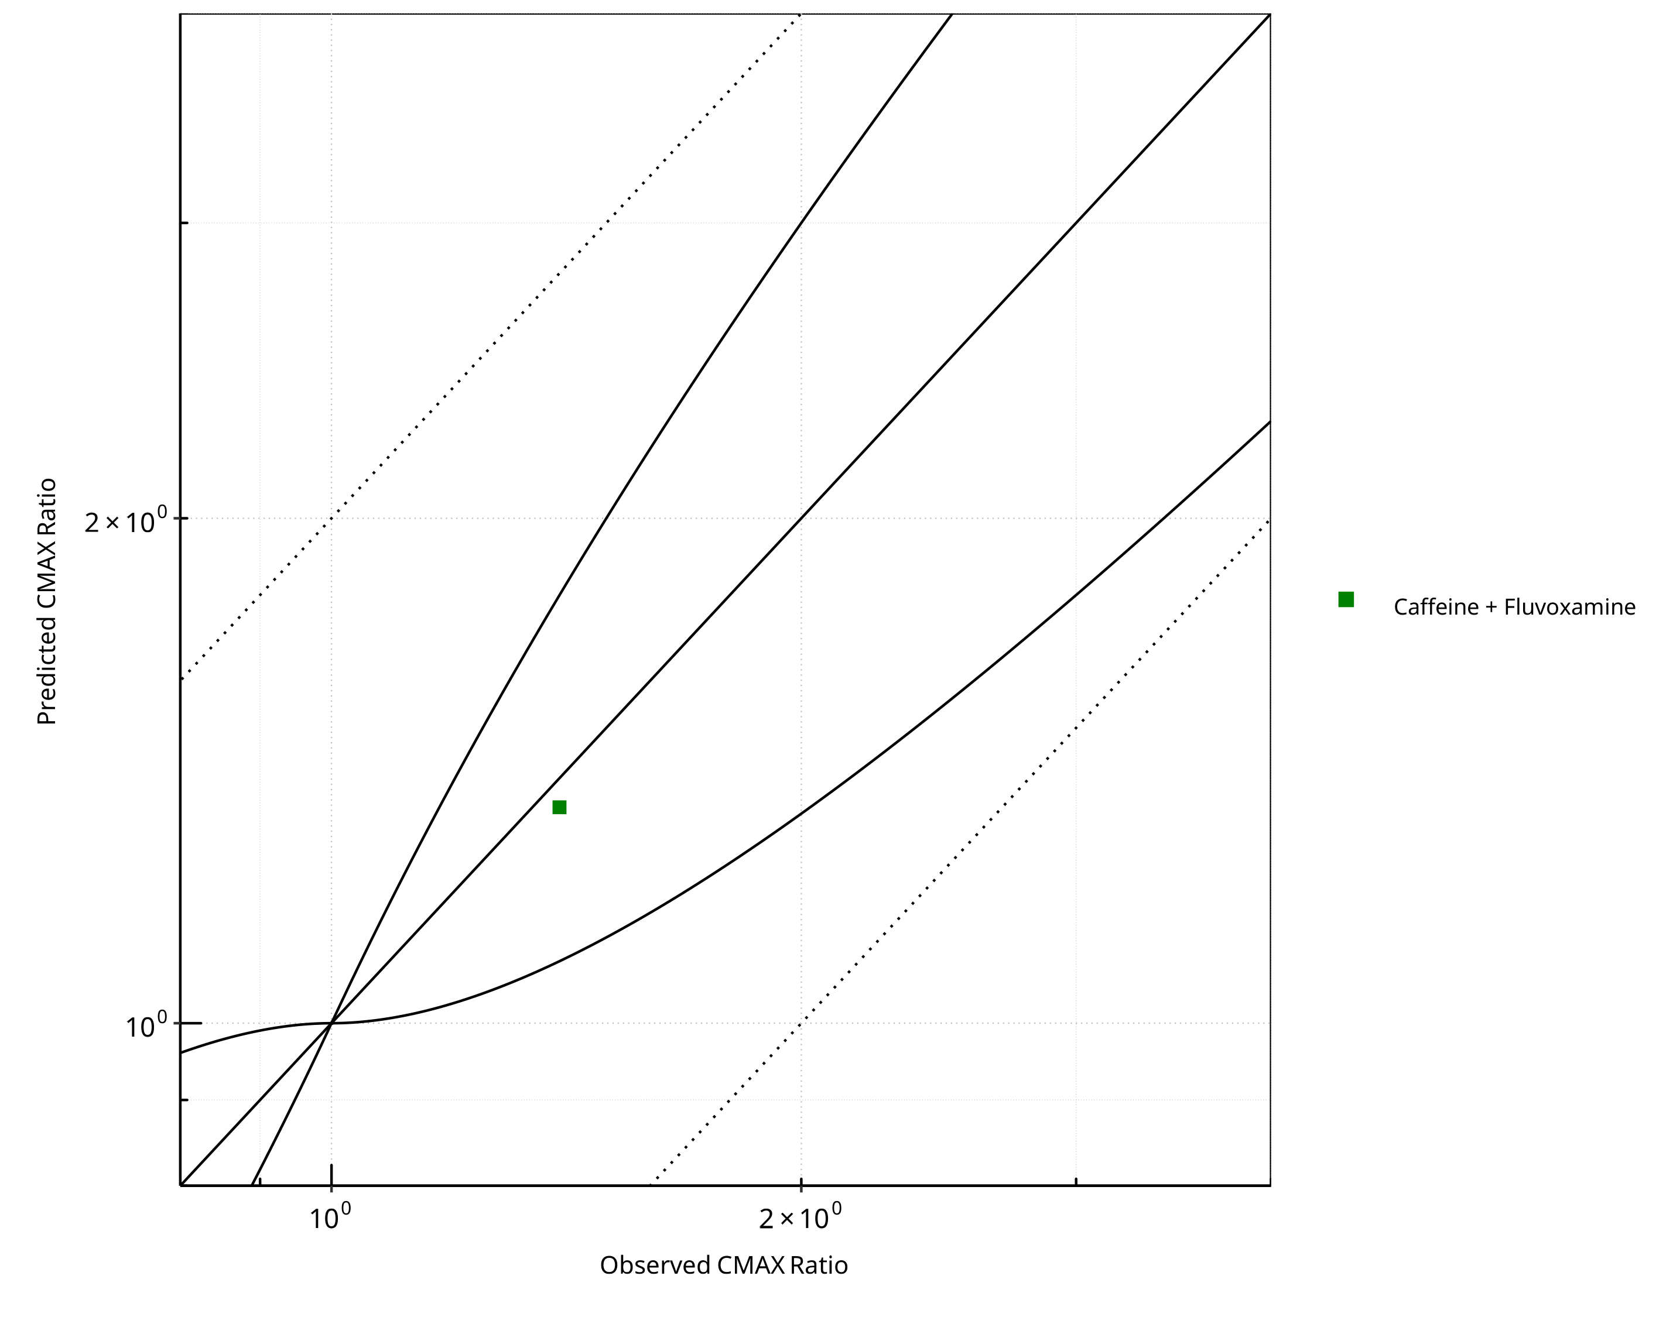

**Figure 1-3: CYP1A2 DDI. Predicted vs. Observed CMAX Ratio. (δ = 1 in Guest *et al.* formula)**

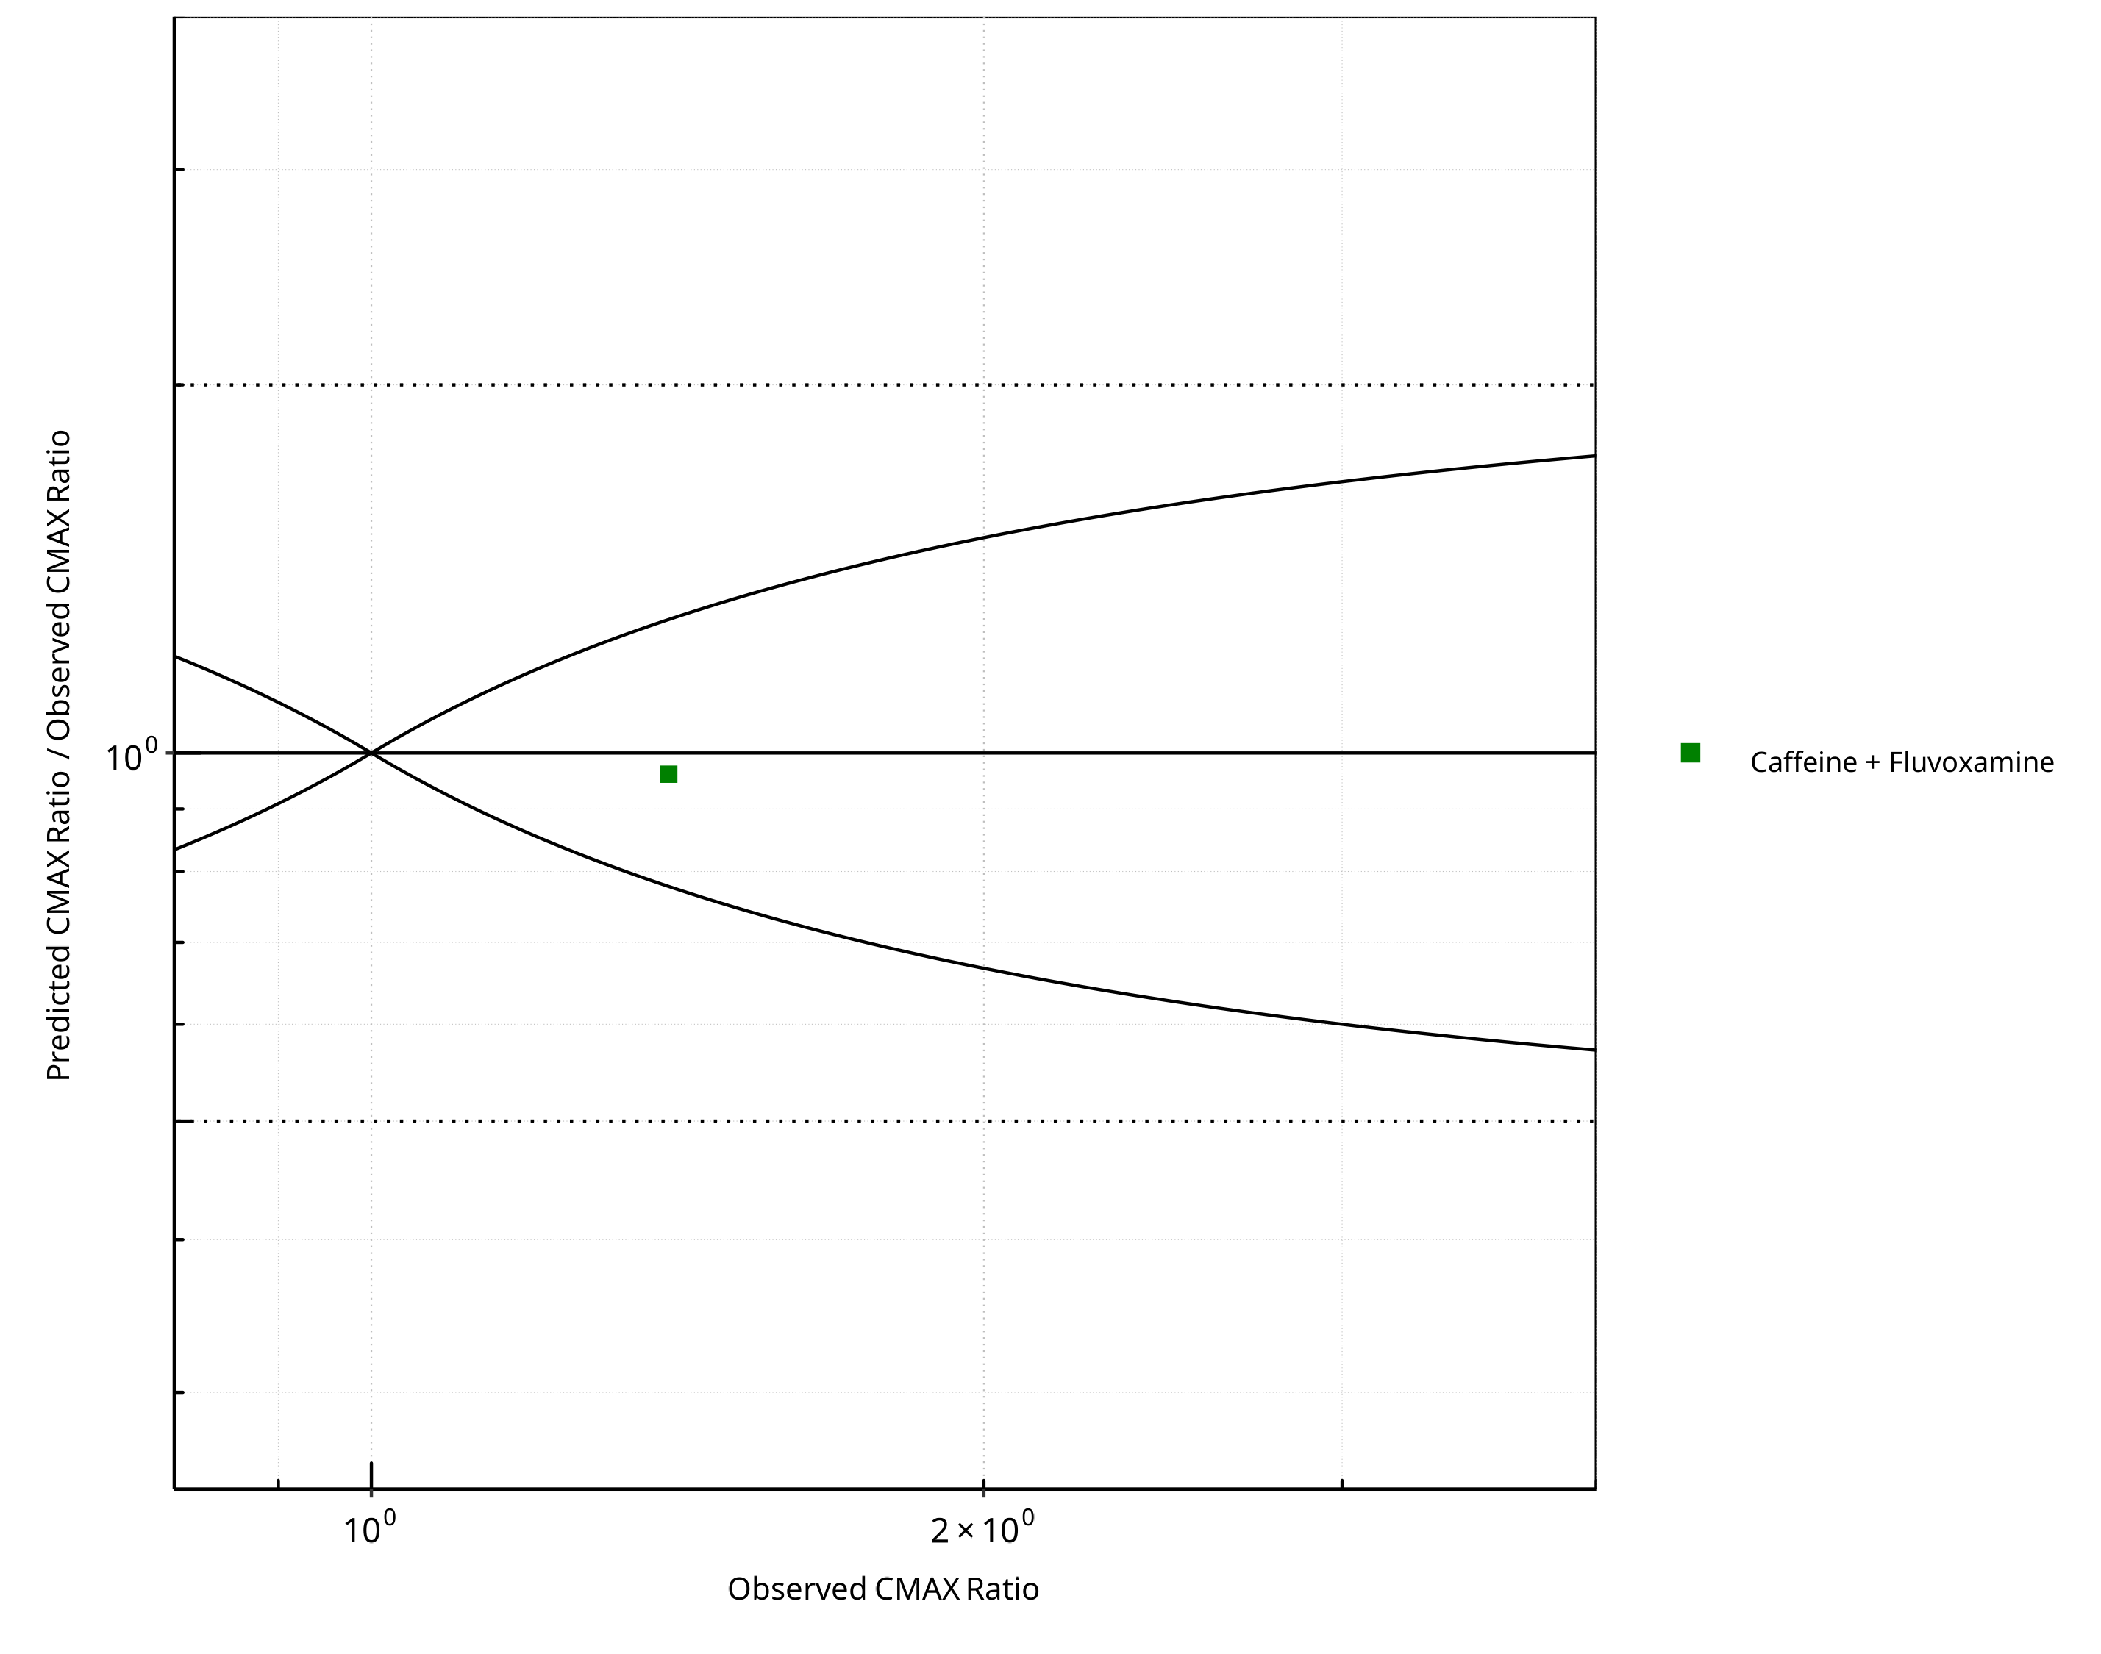

**Figure 1-4: CYP1A2 DDI. Predicted/Observed vs. Observed CMAX Ratio. (δ = 1 in Guest *et al.* formula)**

**Table 1-1: GMFE for CYP1A2 DDI Ratio**

| PK parameter | GMFE |
| --- | --- |
| AUC | 3.15 |
| CMAX | 1.04 |

**Table 1-2: Summary table for CYP1A2 DDI - AUC Ratio. (δ = 1 in Guest *et al.* formula)**

| AUC | Number | Ratio [%] |
| --- | --- | --- |
| Points total | 1 | - |
| Points within Guest *et al.* | 0 | 0 |
| Points within 2 fold | 0 | 0 |

**Table 1-3: Summary table for CYP1A2 DDI - CMAX Ratio. (δ = 1 in Guest *et al.* formula)**

| CMAX | Number | Ratio [%] |
| --- | --- | --- |
| Points total | 1 | - |
| Points within Guest *et al.* | 1 | 100 |
| Points within 2 fold | 1 | 100 |

**Table 1-4: Summary table for CYP1A2 DDI**

| DataID | Perpetrator | Victim | Predicted AUC Ratio | Observed AUC Ratio | Pred/Obs AUC Ratio | Predicted CMAX Ratio | Observed CMAX Ratio | Pred/Obs CMAX Ratio | Reference |
| --- | --- | --- | --- | --- | --- | --- | --- | --- | --- |
| 14006 | Fluvoxamine, 100 mg, PO, | Caffeine, PO | 4.35 | 13.71 | 0.32 | 1.34 | 1.40 | 0.96 | Culm-Merdek 2005 |

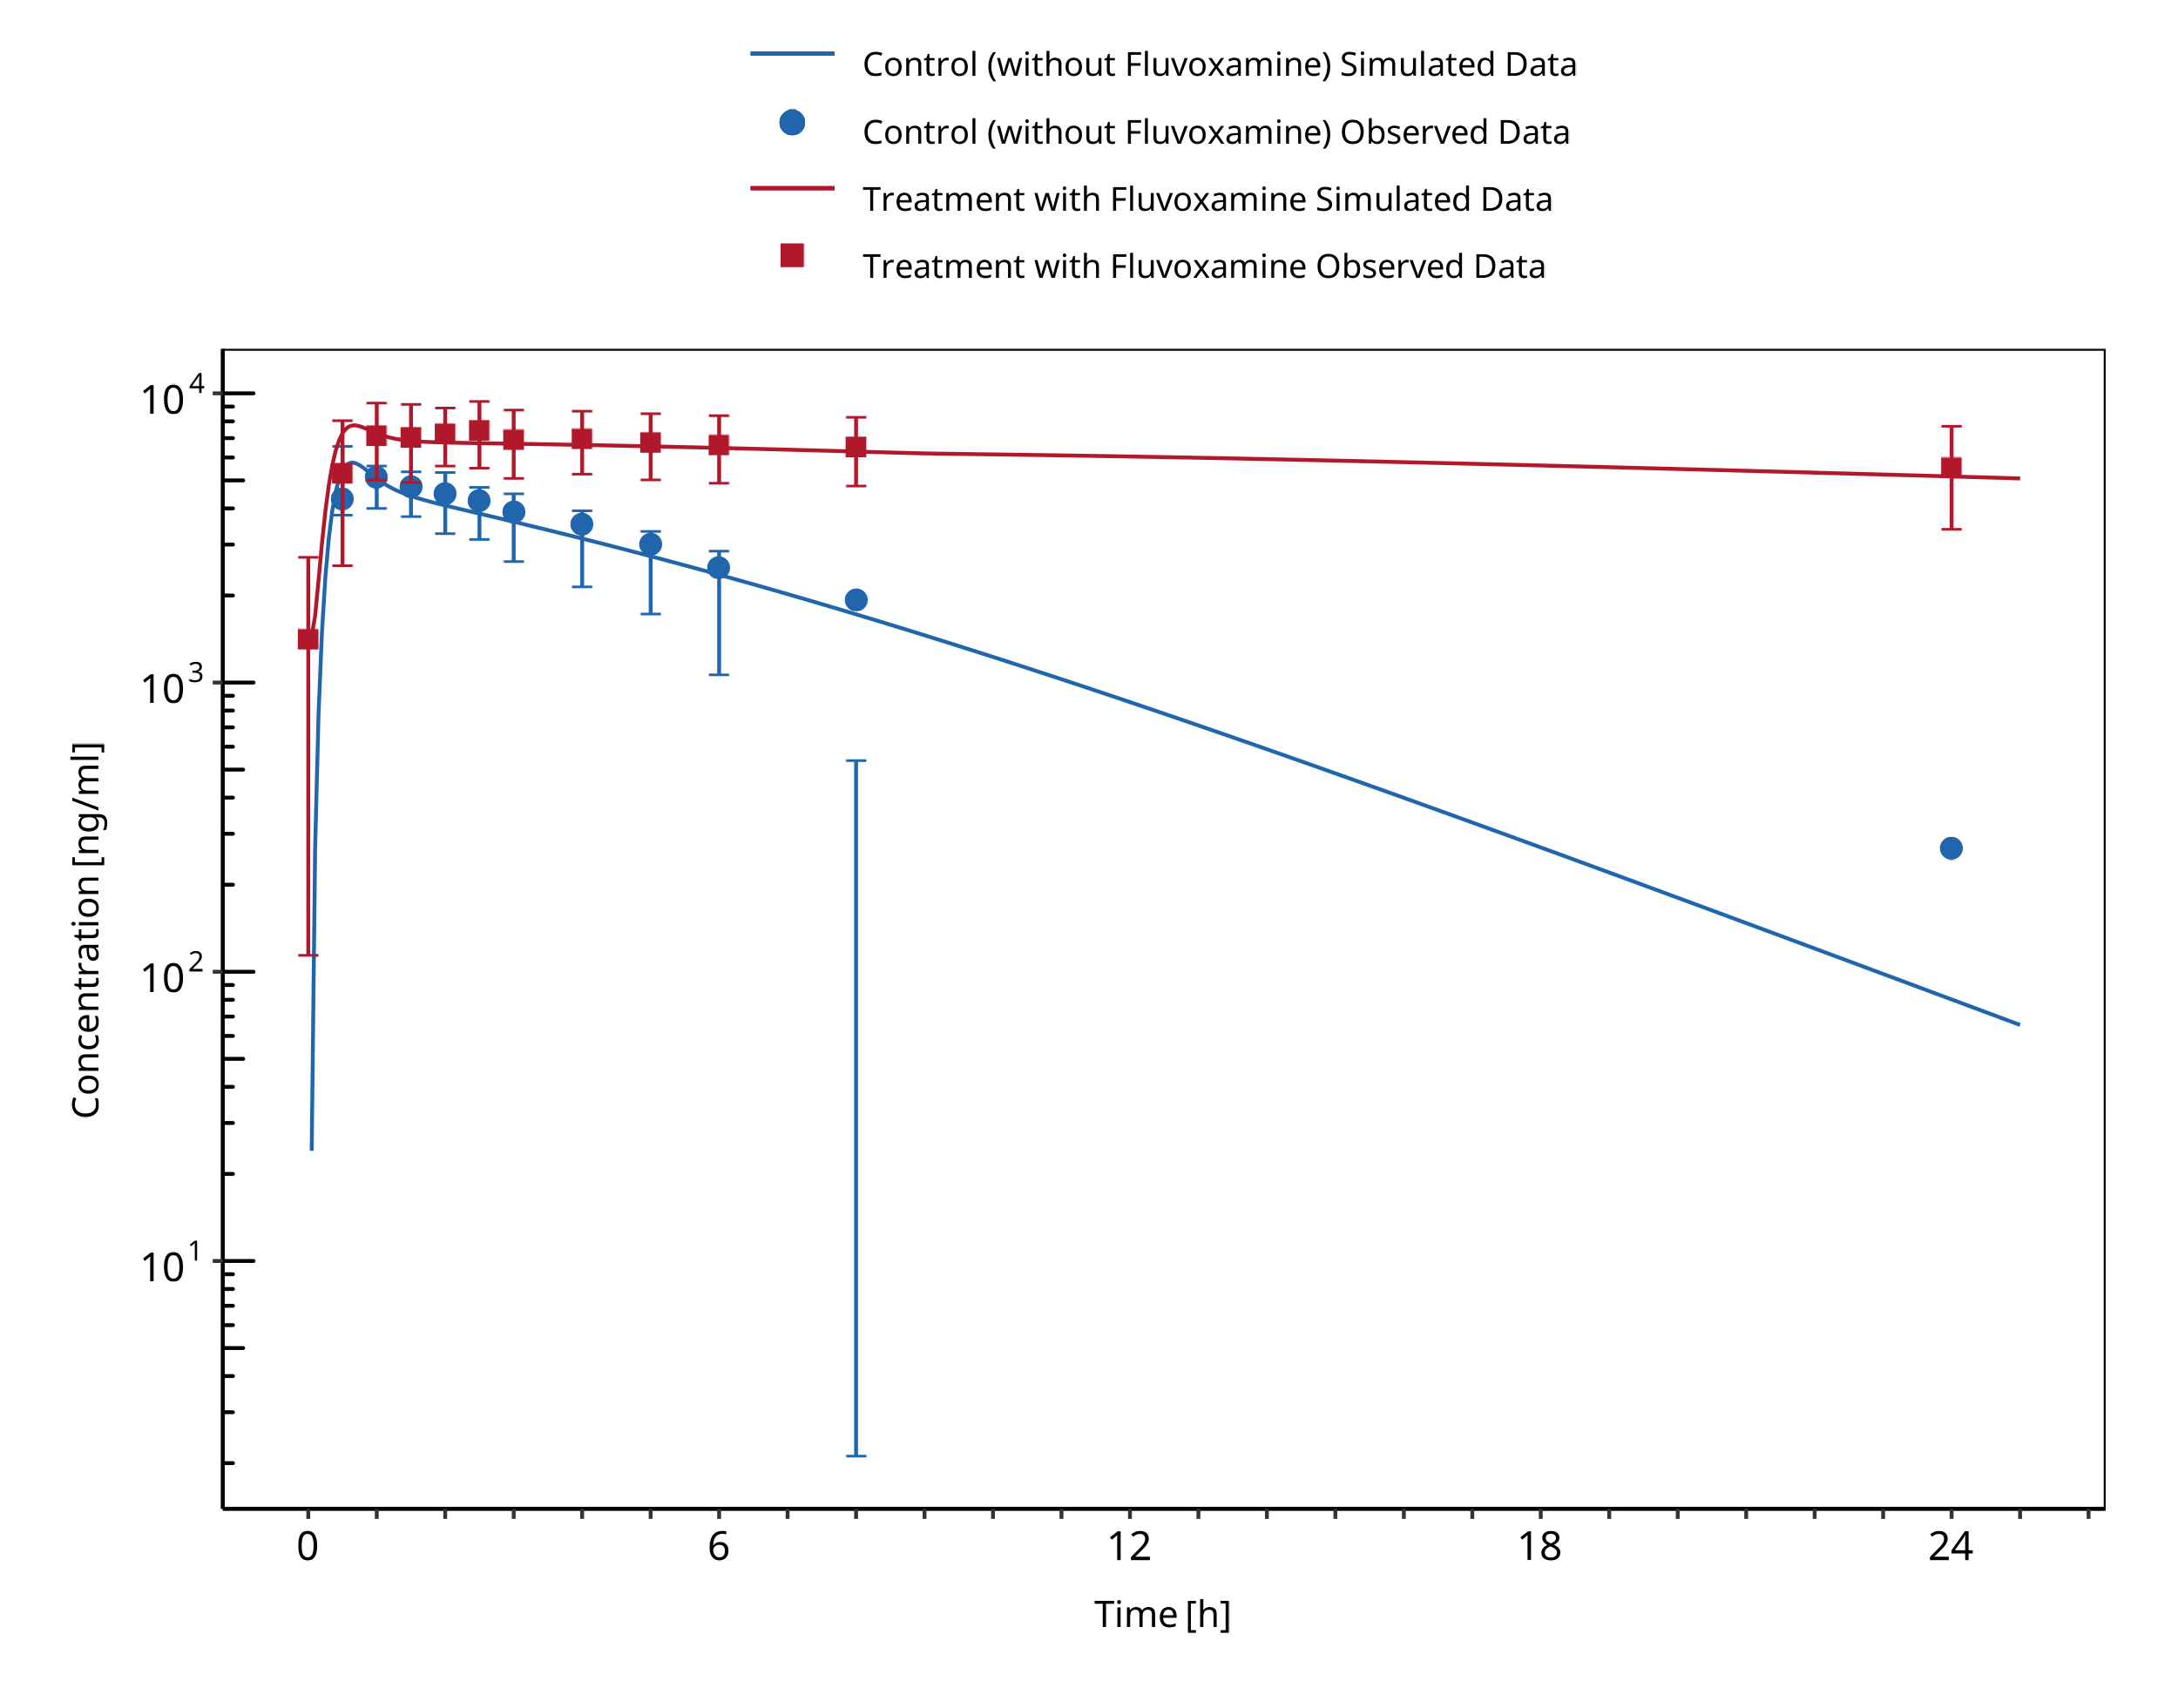

**Figure 1-5: Culm-Merdeck 2005 (Caffeine 250 mg po)**