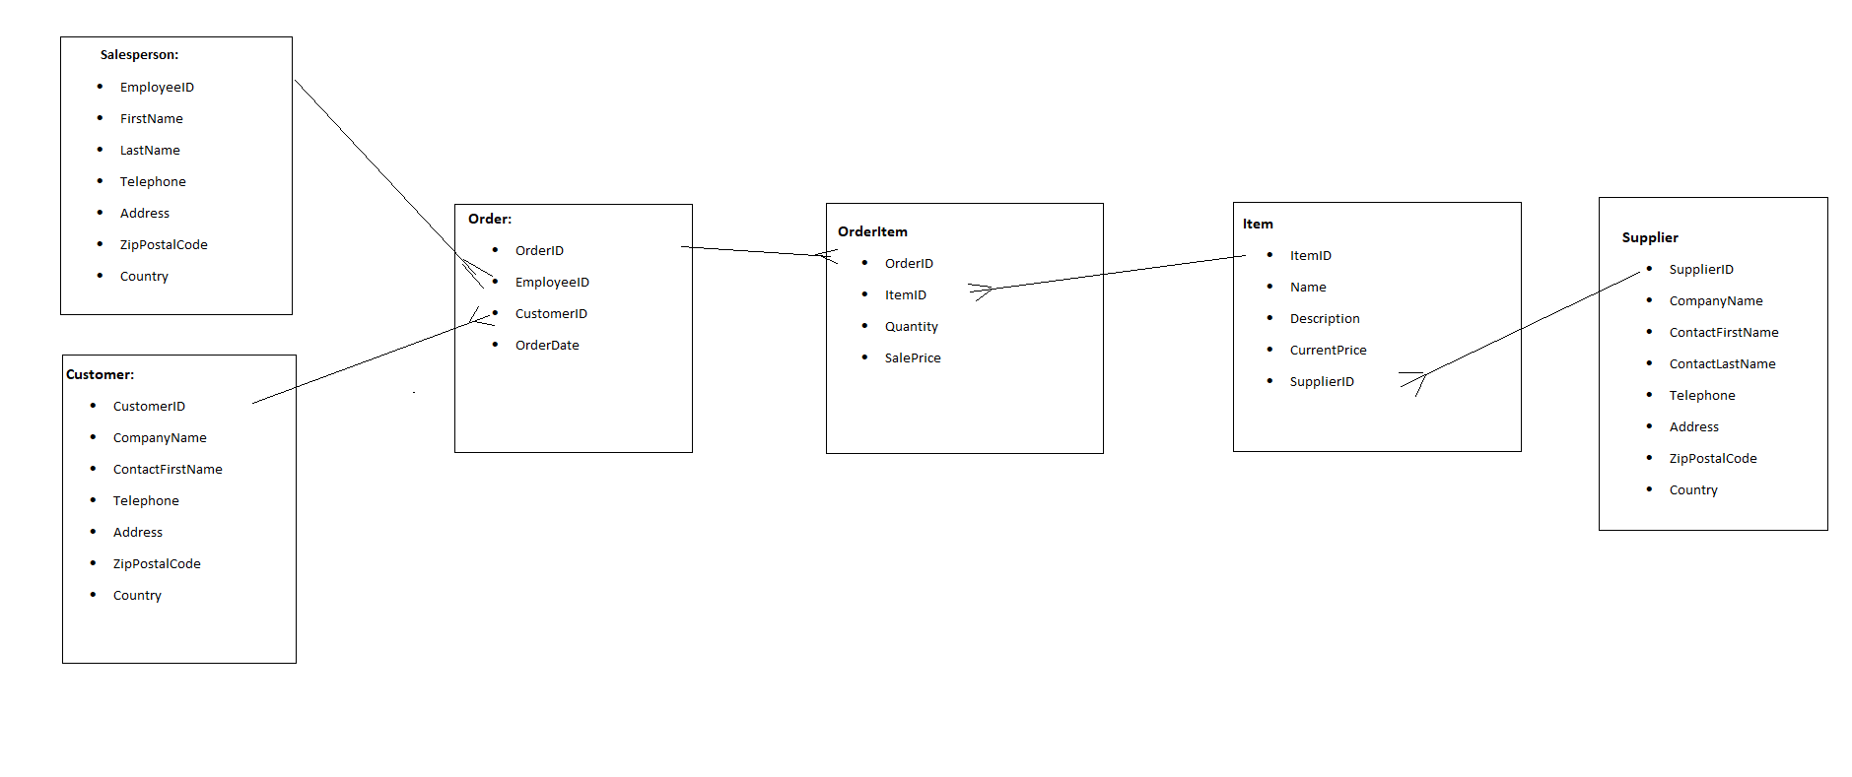

**Общие запросы:**

SELECT Firstname, LastName, Address, ZipPostalCode, Country

WHERE Country = ‘France’

SELECT c.CompanyName, o.OrderDate, oi.Quantity*oi.SalesPrice AS ‘Price’, i.Name as ‘Item’

FROM Customer c

JOIN

Order o

ON

c.CustomerID=o.CustomerID

JOIN OrderItem oi

ON o.OrderID=oi.OrderID

JOIN

Item i

ON oi.ItemID=i.ItemID

WHERE c.CompanyName=’Contoso’