Table of Contents

Preface
Data on intercellular interactions in tissues come from two main sources: receptor studies and clinical observations.
Receptor data describe the behavior of an individual cell and follow, in essence, a relay logic: under the influence of specific factors the cell switches from one mode to another. Tissue behavior, however, is not the sum of the responses of millions of individual cells. Clinical data provide a different level of description: concentrations of substances, the conditions under which cells survive or die, and the overall dynamics of interacting cell populations. A third source is experimental work on cell cultures and organoids, but its results are not always reproduced in the clinic.
The interaction between a group of cells and the organism is usually considered solely in terms of the immune response. This work assumes that, while a clone remains small, an effective immune response is either not triggered or is insufficient to determine its fate; in our model, that fate is decided at the scale of 500–5,000 cells. Moreover, tissue architecture creates numerous niches in which immune recognition is impeded. At this early stage the fate of a clone is therefore determined primarily by the properties of the tissue itself rather than by immunity.
The process described here is difficult to observe directly at present. A clone of 500–5,000 cells lies several orders of magnitude below the scale at which a tumor focus becomes reliably detectable by current clinical imaging. Small clonal foci are sometimes found incidentally on histological examination, but a tissue section captures only a single moment, while a biopsy destroys the very object whose development one would need to follow over time. Between the stage at which the small size of a clone limits the likelihood of an effective immune response and the point at which a tumor becomes clinically visible lies a gap of three to four orders of magnitude in cell number, which current clinical imaging cannot reliably bridge (experimental systems are not bound by this limit).
One of the tissue properties that determine the fate of a clone at this stage is the cell's energy supply, which follows two routes: oxidative, and oxygen-independent via glycolytic breakdown of glucose. Comparing their contributions in body fluids leads to a conclusion that is rarely taken into account in analyses of cellular interactions. Plasma glucose concentration is about 5 mM. Glycolysis yields 2 ATP per glucose molecule, i.e. about 10 mM ATP per liter. Plasma at a pO₂ of about 100 mmHg contains only about 0.13 mM dissolved oxygen. Through oxidative phosphorylation this corresponds to roughly 0.6–0.7 mM ATP (about 5 ATP per O₂ molecule, P/O ≈ 2.5). Thus, in the same volume of plasma, glycolysis of the available glucose yields about 15 times more ATP than oxidation of the dissolved oxygen. In interstitial fluid, where pO₂ is lower (about 30–40 mmHg), the difference rises to 30–50-fold.
This estimate excludes hemoglobin-bound oxygen and refers only to the supply directly available to the cell from the surrounding fluid. For epithelium it is this supply from the surrounding fluid that matters, but a comparison of stores does not determine the ratio of continuous fluxes: haemoglobin in the underlying capillaries continuously replenishes oxygen, and the estimate shows only that the instantly available oxygen store is small compared with the glucose store. Epithelium has no blood vessels of its own and receives glucose and oxygen by diffusion from the underlying tissue across the basement membrane. For a cell within such a sheet, oxygen may be a limited resource, whereas glucose is available in considerably greater quantity. The cost of the glycolytic route is lactate accumulation and local acidification, which themselves become factors of cell selection.
A second route of oxygen delivery is directly from the gas phase where tissue is in contact with air. Such contact occurs in the single-layered pseudostratified epithelium of the Eustachian tube and airways, in the corneal epithelium, and in mucosae whose protective layer is compromised. In these tissues oxygen may reach cells from two sides: from the underlying tissue and from the surface. The oxygen partial pressure at the cell surface is not equal to atmospheric (about 160 mmHg); it depends on ventilation of the cavity, the mucus and fluid layer, and oxygen consumption by the tissue itself. Depending on these conditions, surface diffusion may relieve oxygen limitation while increasing oxidative load, making cellular resistance to oxygen toxicity more important.
There is also evidence of oxygen toxicity to immature tissues, although reliable quantitative estimates cannot yet be given. The situation is similar for glycogen. Cells at early stages after embryo formation are known to contain less glycogen than mature cells, but the numerical values remain uncertain. We hypothesize that reversion of a cell to a less differentiated state shifts it along precisely these two axes: it reduces glycogen stores and alters oxygen resistance.
This work analyzes clonal development at different levels of cellular glycogen and different degrees of cellular oxygen resistance. The model is parameterized not with absolute values but with ratios of these parameters between two cell populations. These two parameters define a grid: glycogen content × cell survival under oxygen exposure. The central question is at which ratio of these parameters a clone becomes established in the monolayer and at which it is eliminated, and how this balance shifts under injury. We expect that the same clone may be eliminated in an intact monolayer yet become established under chronic injury without any additional genetic alterations: it is not the clone that changes, but the selective environment.
The simulation model represents a monolayer. Cells are either eliminated or shed (desquamated) into the lumen and do not accumulate vertically. The founding clone has a low rate of reversion to a less differentiated state. For the model it is immaterial whether reversion results from mutation or from a return to a previous, less differentiated state.
The work is not deterministic and does not aim to derive mathematical formulas describing tissue behavior. It is based on simulation of stochastic processes: division, reversion, death and desquamation occur with defined probabilities. The same parameter set produces different clonal trajectories on repeated runs. The outcome is therefore not a single result but a distribution of outcomes across a large number of runs: the proportion of runs in which the clone becomes established and the proportion in which it is eliminated.
The cell sheet can stretch through cell flattening and partially cover defects, thereby creating sites where division is possible throughout the layer. Monolayer behavior is studied in three regimes: at rest, after limited injury, and under chronic injury.
We are aware of the cost of this approach. Indirect evidence can increase or decrease the plausibility of a hypothesis, but on its own it cannot establish that the hypothesis is true. Every transfer of a mechanism from one tissue to another is identified explicitly as such, and sources requiring verification are clearly marked. This work is not the final word on the subject. It is an attempt to give a testable form to what would otherwise remain intuition, and to present it to those who will have the tools to confirm, refute, or refine it.
This work does not contradict receptor-based models. It occupies its own niche and complements them.

Section 0. Definitions, Model Boundaries, and Reading Conventions
This section brings together statements that were previously scattered across separate texts. It establishes three things: what exactly is being modeled, within what boundaries the claims hold, and how to read the numbering and references. All subsequent chapters rely on the definitions given here and do not repeat them.

0.1. The pre-immune window
Everything described in this work concerns a single, bounded interval of tissue history, referred to below as the pre-immune window. The name is conventional: it does not mean that the immune system is absent, but that during this interval it is not the determining factor in the fate of the clone.
The window opens when a single reverted cell appears in an intact epithelial monolayer. It closes in one of two ways: either the clone disappears without passing the retention filters (the filters that determine whether a clone persists in the tissue), or it leaves the window by breaching the basement membrane or by reaching a mass at which it becomes, in principle, capable of producing a systemically significant signal.
Within the window, the immune system is not treated as an independent, determining filter of clonal fate. This does not mean that local immune recognition or individual immune interactions are absent: NK cells, tissue-resident immune cells, and cGAS–STING signaling can, in principle, respond even to a small number of altered cells. The position adopted here is narrower: at the scale considered, these interactions do not produce a sustained, effective response that becomes a determining filter of clonal fate alongside, or instead of, the resource, oxygen, and structural filters described here. In this work it is taken as a starting condition.
This defines the main limit of the model’s scope. Everything said below about the fate of a clone concerns competition, resources, geometry, and mechanics, not immune recognition. Beyond the window, other mechanisms become decisive (antigen recognition, immune masking, immune distraction), and this model neither describes them nor claims to.

0.2. The reverted cell: a phenotypic definition
Reversion here refers to a phenotypic state of the cell, not to its origin. The model assumes that during normal renewal of the epithelial monolayer, a small fraction of daughter cells shifts into an earlier, less differentiated state. This is assumed to be a low-rate background stochastic process that requires no external damaging trigger.
Within the model, this phenotype can arise in two ways:
- with genomic damage, as a result of a spontaneous replication error or mutagenic exposure, with a fixed mutation that disables some of the differentiation checkpoints;
- without genomic damage, as a purely epigenetic failure of the differentiation program during asymmetric division, leaving no trace in the DNA sequence.
The model does not distinguish between these two routes. Both produce a cell with the same set of model properties: a reduced energy buffer (revStore), vulnerability to oxygen at the moment of birth (oxyRev), and the ability to divide when free space is available. Both are captured by a single frequency parameter (pRevert), and the simulation engine does not distinguish between them by design.
This assumption follows from the boundary set in 0.1. All filters acting within the window (the energy buffer, the oxygen filter at birth, competition for free space, adhesive anchoring, and the upper and lower density thresholds) operate on the cell’s phenotype and position, not on its genotype. This does not mean that mutational and epigenetic reversion are biologically identical: genotype can affect metabolism, division rate, stress tolerance, adhesion, and sensitivity to apoptosis. The model’s claim is narrower: once a cell has been assigned its model phenotype, its subsequent fate within the window does not depend on how that phenotype arose. If genotype shifts the model properties themselves, such a shift can be represented in the model only as a change in phenotype parameters.
The distinction between the two routes becomes meaningful at exactly two points, both of which lie at or beyond the boundary of the model:
- At the exit from the window. The clone’s antigenic profile may depend on its origin. Mutational reversion can generate neoantigens, whereas non-mutational reversion can alter the expression of differentiation-associated or embryonic antigens without changing the DNA sequence; central tolerance to some of these antigens may be incomplete. The immunological consequences of this distinction lie outside the model and are treated as a limitation of the calculation rather than as an input.
- At the entry into the window. Mutagenic exposure (smoking, occupational carcinogens) and chronic loss of the DNA damage checkpoint increase the frequency of specifically the mutational subfraction. In other words, they act on pRevert, not on the retention filters.
This separation between how often the event occurs and the conditions under which it is selected serves as the main tool for interpreting population data. In general form:
frequency of established clones ≈ rate of reverted-cell generation × probability of clonal retention in tissue.

0.3. Barriers and their status
The model identifies four mechanistically distinct barriers that prevent a reverted clone from becoming established. They should not be considered statistically independent: in real tissue, resource supply, oxygen, cell density, and the state of the basement membrane are interrelated, and the interaction between barriers is a separate subject of analysis. The barriers have different status in this work, and this difference should not be blurred:
Barrier | Physical mechanism | Status in this work
Resource competition for space and glucose | finite free space, supply threshold | tested in simulation (Chapter 1)
Oxidative vulnerability of the reverted lineage | one-time filter at the moment of cell birth | tested in simulation (Chapter 2)
Basement membrane integrity | O₂-dependent structural maintenance | supported theoretically (Section 1.7)
Suppression by differentiated neighbors | contact inhibition, density thresholds | supported theoretically
The key result of Part I is that the two barriers tested in simulation are neither interchangeable nor redundant, and that they differ in kind rather than in degree. Within the main range of the resource parameter, the resource barrier does not prevent establishment even in undamaged tissue; its only trace appears below that range and is removed entirely by wounding. The oxygen barrier, by contrast, at reduced glycogen (revStore ≈ 0.33) holds establishment to a fraction of a percent in undamaged tissue and retains a dose-dependent effect even after wounding; at full glycogen the same filter does not contain the clone (Section 2.6), and containment arises from the joint action of both barriers. The comparison therefore concerns not the strength of two barriers but the difference in how they act: the resource barrier alone does not contain the clone and is removed by wounding; the oxygen barrier contains only in combination with reduced glycogen and retains a dose-dependent effect after wounding; the region of robust containment arises from their joint action.

0.4. Reading conventions
Status of statements. The text distinguishes four types of statements: model definitions (what a term means), model assumptions (what is accepted within this work without proof), model results (what has been shown in simulation or derived from the model), and external biological evidence (what has been established independently of the model). Where the status of a statement may not be obvious, it is stated explicitly.
Numbering. Sections are numbered within each chapter, prefixed by the chapter number (Section 3.4 is the fourth section of Chapter 3).
References. The work carries a single numbered reference list, placed after the Afterword and the statement of code availability. A citation such as [4] therefore denotes the same work wherever it appears. Earlier versions of this text kept separate lists per chapter, with numbering restarting in each; any cross-reference inherited from those versions should be read against the unified list.
Status of sources. Entries in the reference list were checked against the published record (September–October 2026): journal, year, volume and pages were confirmed, and a DOI or PMID is given wherever one exists, except for entries marked “verification incomplete” (currently 12 and 15), whose checking must be completed before print. Where an earlier draft cited a preprint, the peer-reviewed version is cited instead and the substitution is noted in the entry. Sources that are historical or are not journal articles — Cohnheim’s lectures, a textbook chapter, a StatPearls entry — are cited in the form their nature allows.
Cross-system extrapolations. Every extrapolation of a mechanism from one model system to another is explicitly identified as such rather than presented as an established correspondence.

Part I. The Model, the Simulation Benches, and Their Behavior

Introduction. One engine, two benches
Both benches in this part run on the same epithelial simulation engine, “Jenny1”: a hexagonal lattice of about 6,000 nodes, in which each cell owns a territory of one to four nodes; tension (the mean territory size of a cell and its neighbors) governs the awakening of reserve cells and division; glucose diffuses across the sheet and is consumed in proportion to each cell’s metabolic state; and division is asymmetric (the mother returns to reserve, and the daughter also enters reserve with a probability of about 1/11). The reverted lineage differs from the normal one in two parameters:
- revStore — the ceiling of the reverted cell’s glycogen store, as a fraction of the store of a differentiated cell (the resource axis);
- oxyRev — the probability that a newborn reverted cell survives a one-time oxygen filter at the moment of its birth (the oxygen axis). In the sibling-fate variants B and C (Section 2.6) the same parameter sets the survival of a cell at division, s = (1 + oxyRev)/2, so that oxyRev 0.30, 0.40, 0.50, 0.55, 0.60 and 1.0 correspond to s = 0.65, 0.70, 0.75, 0.775, 0.80 and 1.0.
Only the features that distinguish the two benches are described here; the full engine specification accompanies the code.
Note on the parameter oxyRev. The parameter is a generic counter of division-linked cytotoxicity: s is the probability that a cell survives a division (0.5 ≤ s ≤ 1; s = 1 means no filter). Treating the factor as a constant per-division survival fraction is an analogy with the fractional-kill hypothesis of cytotoxic pharmacology (Skipper et al.), which concerns the action of a given dose and states that it kills a constant fraction of cells independent of their number; it does not by itself give a constant probability per division, which is an assumption of the present model; the constancy with clone size is a first approximation (size-dependent kill in sigmoid growth is described by Norton and Simon). The eliminating factor (ElF) itself is not specified: oxygen is the working assumption of this paper, and the same counter can represent any agent that acts at division, a cytostatic drug among them. The expected cell number is multiplied by 2s per division, so growth is possible only for s > 0.5. The engine parameter is called oxyRev and is converted to s as s = (1 + oxyRev)/2 (oxyRev 0.30, 0.50, 0.60 and 1.0 give s = 0.65, 0.75, 0.80 and 1.0); the tables, figures and code of this paper keep the engine name oxyRev, and s is given in the text where the scale matters. How the fates of the two sister cells are coupled is an assumption of the model, so three variants were computed (Section 2.6). In A (maternal; the engine of Chapters 1–2) the mother always survives and only the daughter is exposed, passing with p = oxyRev = 2s − 1; this can be read as a regime of local critical damage in which at most one of the two cells is hit, but that reading is proposed, not proved by the code. In B the two cells are exposed independently and each survives with probability s. In C the fates are fully coupled: one draw per division, and both cells survive with probability s or both die. In all three variants the expected number of survivors per pair is the same, 2s, and only the variance differs: both cells are lost with probability 0 in A, (1 − s)² in B and 1 − s in C. In a monolayer under stretch the position of the dead cell does not matter, only the number of survivors; the positional meaning of which sister dies belongs to a three-dimensional tissue and is not tested here. Because s can be assigned separately to reverted and normal cells, the same counter can also be used to estimate selective toxicity against the reverted clone: an agent would be selective if it lowers s of reverted cells below 0.5 while s of normal cells stays above it. This use lies outside the range explored in the present series: s < 0.5 was not examined. When two independent factors act on one division (oxygen and a drug), their survival probabilities multiply, s = s(O₂) · s(drug); this is an arithmetic statement, not a result (see the open question at the end of Section 2.6).
The engine exists in two implementations. They share the model, the random-number generator and the order of its calls, but differ in one respect: the JavaScript bench gives each cell a territory of one to four lattice nodes, whereas the Python engine holds one cell per node. Runs are therefore cross-checked at the level of outcomes rather than trajectories — the two agree on whether a clone becomes established and on its final size, and disagree on timing:
- epithelium_bench.html (and epithelium_bench_no_o2filter.html, the earlier build without the oxygen filter) — an interactive visual bench in JavaScript with real-time rendering, used for illustration and manual exploration, not for collecting statistics;
- epithelium__numba.py (merged with the batch runner in run_batch_oxygrid.py and run_batch_oxygrid_wound.py) — a headless Python/Numba engine for running hundreds of independent simulations in parallel; all quantitative statistics in this part were obtained with it.
The order of presentation follows the logic of the test. First (Chapter 1), the oxygen filter is switched off (oxyRev = 1.0), and we ask whether resource regulation alone can hold back a reverted clone. Then (Chapter 2), with the same glycogen (revStore = 0.33), the oxygen filter is switched on. The two benches differ in the value of a single parameter, oxyRev, so comparing them is a controlled experiment on one system rather than a comparison of two different models.
Common protocol for both benches. Horizon 20,000 h; a clone is counted as established when the largest connected reverted cluster exceeds 500 cells, checked every 24 h; 100 independent seeds per parameter combination, with the same seed set (0–99) in every series. Three environmental scenarios: none — no wounding; bounded — a series of wounds that stops at the first threshold crossing; chronic — wounding without stopping until the end of the horizon. Wound protocol: first wound at 1,000 h, defect size 200 cells, interval drawn per run from {12, 24, 48} h.
Desquamation and two-dimensional geometry. In a real monolayer, desquamation — the shedding of surplus and aged cells into the lumen — is what keeps the epithelium a single layer: cells that cannot be accommodated in the plane leave it upward instead of accumulating vertically. The bench does not model this process explicitly, because its outcome is already built into the geometry: the lattice is strictly two-dimensional, each node belongs to at most one cell, and a cell cannot occupy a node that is already owned, so the sheet cannot thicken and every conflict over space is resolved within the plane. Vertical accumulation is therefore impossible by construction, and all clone sizes reported in this part are areas within a single layer. Desquamation is treated here as a property of the geometry rather than as an additional mechanism, and it is deliberately not added to the engine.
Two consequences follow. First, invasion of the extracellular matrix cannot occur on the bench: the endpoint is the lateral establishment of a clone within the layer, not its exit from it. The barriers that stand between a lateral clone and invasion — the preserved single-layer geometry and the proteins of the basement membrane (Section 1.7) — act at the next step and are discussed, not simulated. Second, a cell leaves the sheet in the engine in one way only: it is removed, and the nodes it owned become free. The engine does not distinguish death from extrusion into the lumen, because for the geometry of the sheet the two are the same event — a node becomes available; the distinction between them is biological, not mathematical. Differentiated cells are removed at the end of their lifespan, whereas cells of the reverted lineage are exempt from that age-dependent route and are removed only through loss of niche, starvation or the oxygen filter at birth. With respect to cell turnover, the bench therefore represents the least favorable case for the tissue, and the containment provided by the oxygen filter (Chapter 2) is obtained without any help from turnover.
Table I.1. Summary of the two benches.
Bench | oxyRev | revStore | Scenarios | Runs | Question
Without the oxygen filter (Ch. 1) | 1.0 (off) | 0.33; control grid 0.20–0.30 | none / bounded / chronic | 300 + 900 | Is resource regulation alone sufficient?
With the oxygen filter (Ch. 2) | 0.30–0.50 | 0.33 | none; bounded / chronic | 500 + 800 | What does a second, resource-independent barrier change?
Joint grid (Sec. 2.6; S0–S5) | 0.30–1.0 | 0.20–1.0 | none; bounded / chronic (S3) | 6,610 | Does the oxygen filter suffice alone? How do the two barriers combine?

Chapter 1. The Bench Without the Oxygen Filter: Resource Regulation Alone Is Not Enough

1.1. Aim
To isolate the resource (glycogen) axis from the oxygen axis and test whether a reduced energy store of the reverted lineage — together with competition for glucose and the finite amount of free space available for division — is enough for the tissue to prevent a reverted clone from becoming established. This is logically the first and simplest of the barriers, and for that reason it is tested first and separately from the oxygen barrier.
The label “without the oxygen filter” is more precise than “anoxic”: glucose and all other engine rules operate as usual; only the oxygen culling of newborn reverted cells is switched off.

1.2. Implementation
The bench is not a separate file but a parameter value, oxyRev = 1.0, explicitly documented in the engine as “no filter, old behaviour”: every newborn reverted cell is guaranteed to survive, and the only lineage-specific constraint left is the reduced glycogen buffer.
class EngineParams:
...
revStore=.33, # fixed default (was .2 in the old engine)
oxyRev=1.0, # O2 filter: 1.0 = no filter, old behaviour
Run configuration:
row = run_one(
run_id=0,
params=dict(lifeD=6.0, revStore=0.33, oxyRev=1.0),
seed=SEED, target_hours=20000, scenario=SCENARIO, # 'none' / 'bounded' / 'chronic'
stop_threshold=500,
)

1.3. Results at revStore = 0.33
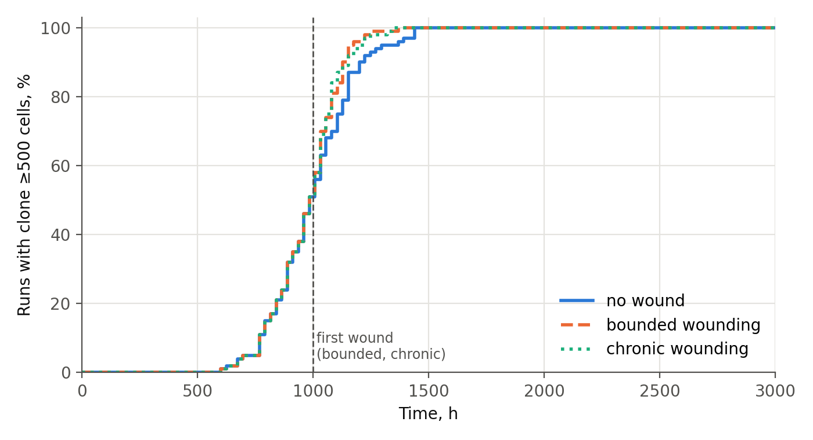
Figure 1.1. Cumulative share of runs in which the clone has become established (≥500 cells), by time and scenario; revStore = 0.33, oxyRev = 1.0 (filter off). The dashed line marks the first wound in the bounded and chronic scenarios.
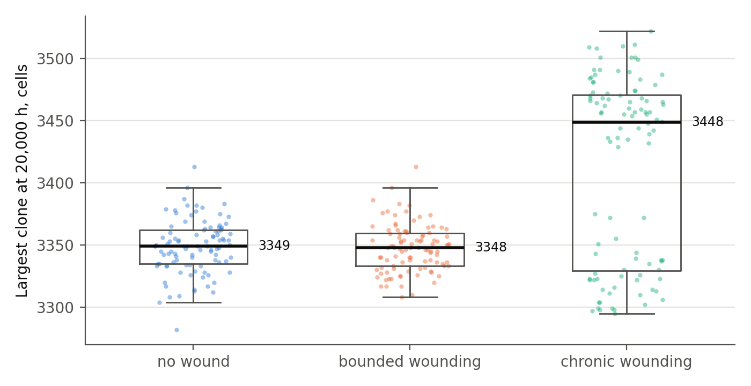
Figure 1.2. Size of the largest reverted clone at the end of the run (20,000 h), by scenario; each point is one run, boxes show the quartiles; revStore = 0.33, oxyRev = 1.0.
Table 1.1. The bench without the oxygen filter at revStore = 0.33 (100 runs per scenario).
Scenario | Established (≥500), % | Median time, h (p10–p90) | Median final clone, cells | Final density (median)
none (no wound) | 100 | 984 (768–1,202) | 3,349 | 0.558
bounded | 100 | 984 (768–1,130) | 3,348 | 0.558
chronic | 100 | 984 (768–1,152) | 3,449 | 0.574
The clone becomes established in 100% of runs in all three scenarios, including the complete absence of wounding, and it does so quickly: the median is 984 h, within the first 5% of the observation horizon, and every run crosses the threshold by 1,440 h. By the end of the run the clone occupies roughly 3,300–3,450 cells, more than half of all cells in the sheet.
The near-identity of the three scenarios must not be read as “wounding changes nothing.” The first wound is inflicted at 1,000 h, and in 51% of runs the clone crosses the threshold before that moment, so for half of the runs the scenarios are indistinguishable by construction. In the remaining runs wounding slightly accelerates establishment (the 90th percentile of establishment time falls from 1,202 h without wounding to 1,130–1,152 h with it; Fig. 1.1), but it cannot raise a probability that is already 100%. The correct reading is therefore: without the oxygen filter, the clone does not need a wound in order to become established. The scenarios differ only after establishment: under chronic wounding the final clone is slightly larger (3,449 vs. 3,349 cells) because the wound keeps freeing space.

1.4. The boundary of the resource parameter and a test below it

1.4.1. The choice of the lower revStore value
In both benches the glycogen ceiling of the reverted lineage is not set below about one third of the full store of a differentiated cell (revStore = 0.33). This is a chosen model value, not an established biological limit.
The choice is motivated, though not proven, by the following consideration. Cells with such a small autonomous glycogen reserve are, in the great majority of cases, terminally differentiated, non-dividing cells that are metabolically supported by their neighbors rather than competing for resources on their own. The best-studied example is the neuron: neurons store very little glycogen and, according to the astrocyte–neuron lactate shuttle hypothesis, depend to a substantial degree on lactate supplied by astrocytes, particularly under increased load [1, 2]. The quantitative importance of this shuttle remains debated [3], but the qualitative point — that neurons are not energetically self-sufficient in the way a proliferating cell must be — does not depend on its resolution.
This example points in the opposite direction from the model, and that should be said plainly: a neuron does not divide or compete for territory, whereas the reverted cell of the model actively divides and competes for glucose and space. The general principle is nevertheless shared: an autonomous glycogen reserve below a certain threshold is found mainly in cells that have left the active cycle. The analogy therefore does not justify a threshold, and the value 0.33 should not be read as a biological boundary: a small glycogen reserve does not mean an inability to divide when current substrate supply is sufficient, and the neuron gives no numerical basis for 0.33 specifically relative to a differentiated epithelial cell. The region revStore < 0.33 was tested separately (Section 1.4.2 and series S5), and its results are part of the main finding: the containment zone continues below 0.33.

1.4.2. A revStore grid from 0.20 to 0.30
An additional grid, revStore ∈ {0.20, 0.25, 0.30}, was run with oxyRev = 1.0 in all three scenarios, with 100 seeds per combination (900 runs, horizon 20,000 h).
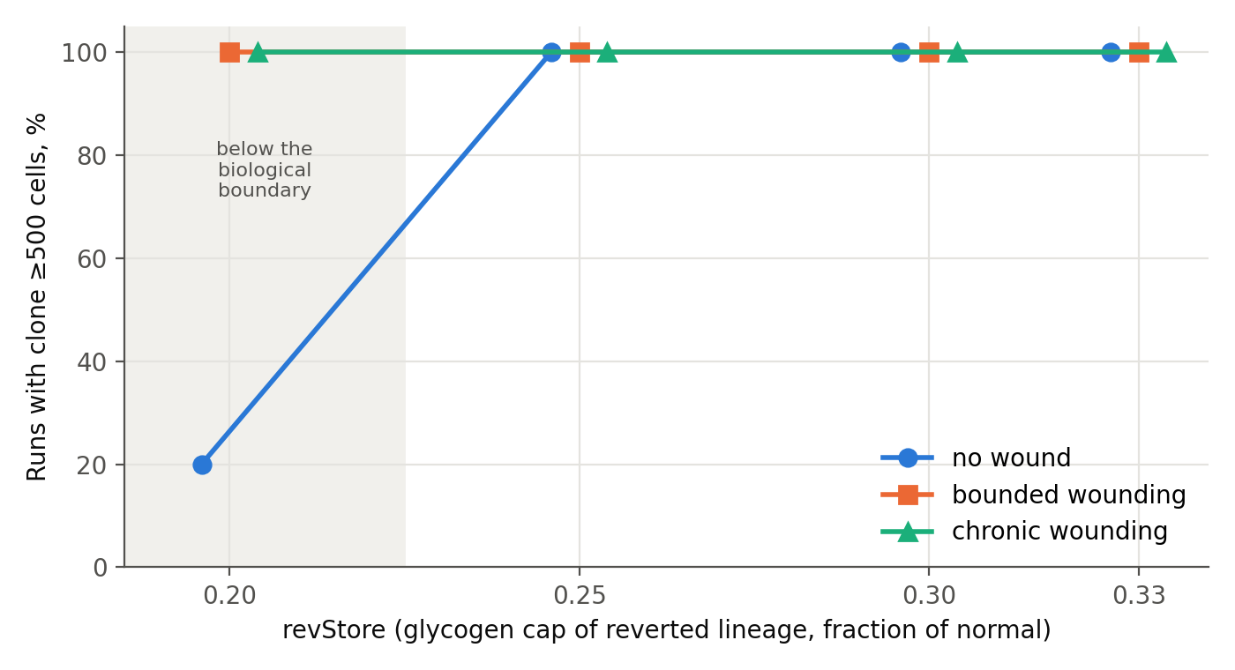
Figure 1.3. Share of runs with an established clone (≥500 cells) as a function of revStore, by scenario (oxyRev = 1.0). Markers of overlapping series are offset horizontally for legibility; the shaded band marks the region below the reference value revStore = 0.33 (Section 1.4.1).
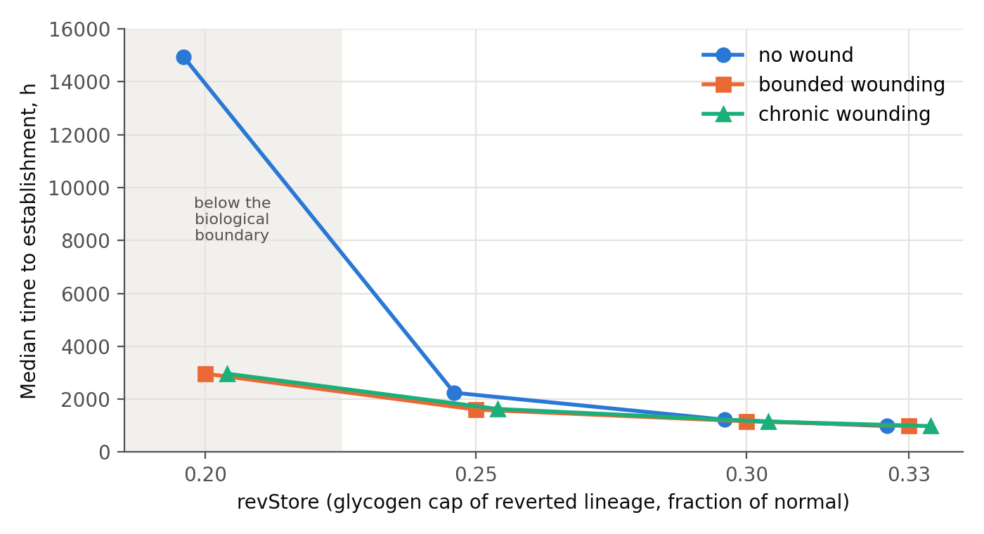
Figure 1.4. Median time to establishment as a function of revStore, by scenario (among runs in which the clone became established; oxyRev = 1.0).
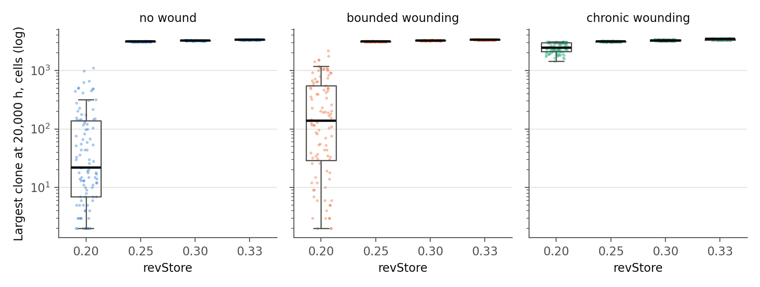
Figure 1.5. Size of the largest reverted clone at 20,000 h as a function of revStore, by scenario (log scale; zero-size clones plotted at 1; oxyRev = 1.0).
Table 1.2. The bench without the oxygen filter across the revStore grid (100 runs per row).
revStore | Scenario | Established (≥500), % | Median time, h | Median final clone, cells | Final density
0.20 | none | 20 | 14,940 | 22 | 0.547
0.20 | bounded | 100 | 2,964 | 138 | 0.542
0.20 | chronic | 100 | 2,964 | 2,460 | 0.509
0.25 | none | 100 | 2,244 | 3,125 | 0.520
0.25 | bounded | 100 | 1,608 | 3,122 | 0.520
0.25 | chronic | 100 | 1,632 | 3,129 | 0.521
0.30 | none | 100 | 1,224 | 3,244 | 0.540
0.30 | bounded | 100 | 1,164 | 3,248 | 0.541
0.30 | chronic | 100 | 1,152 | 3,259 | 0.543
0.33 (Sect. 1.3) | all three | 100 | 984 | 3,349–3,449 | 0.558–0.574
At revStore = 0.25 and 0.30 the behavior is the same as at 0.33: 100% establishment in every scenario and a final clone of 3,100–3,260 cells. Reducing glycogen only postpones establishment (984 → 1,224 → 2,244 h without wounding); it does not prevent it.
At revStore = 0.20 without wounding the picture changes: establishment falls to 20%, the median time among the runs that do establish is 14,940 h, close to the end of the horizon, and the median final clone is 22 cells. This is the only point in the grid where anything resembling a barrier appears.
That barrier is removed by wounding. In the bounded scenario (a series of wounds until the first threshold crossing; a median of about 100 wounds), establishment returns to 100% (median 2,964 h), with a final clone of 138 cells — wounding stops, and the clone has nothing further to grow into. In the chronic scenario establishment is also 100%, and the final clone reaches 2,460 cells, because the wound keeps freeing territory.
The effect at 0.20 appears as a jump rather than as a smooth gradient (0.25 and 0.30 are indistinguishable from 0.33 in establishment probability), and it disappears under wounding. It looks more like a threshold of buffer depletion — the starting store of a reverted daughter becomes so small that a substantial fraction of such cells fail to complete their first few division cycles before the buffer runs out — than like graded resource competition. The value 0.20 lies below the range in which a dividing, competing cell is a coherent model at all (Section 1.4.1), and the fact that the effect appears only there supports the chosen lower bound of 0.33 rather than undermining it.

1.5. Conclusion of Chapter 1: resource regulation alone is not enough
The bench without the oxygen filter gives an unambiguous answer. Resource regulation — the reduced glycogen buffer of the reverted lineage together with competition for glucose and for free space — does not by itself hold back a reverted clone:
- Across the whole range tested, including the region below the reference value set out in Section 1.4.1 (revStore 0.20–0.33), the clone becomes established in 100% of runs under every scenario, with the single exception of revStore = 0.20 without wounding; lowering glycogen postpones establishment but does not prevent it.
- Establishment does not require a wound: at revStore = 0.33, half of all clones cross the threshold before the first wound is inflicted.
- That single exception — the only sign of resistance anywhere in the grid, 20% establishment at revStore = 0.20 without wounding — appears below the reference value revStore = 0.33 (Section 1.4.1) and is fully removed by wounding.
The resource axis is thus necessary as the background against which competition takes place at all, but it is insufficient as a barrier. Holding the clone back requires at least one additional mechanism that does not depend on resources. Chapter 2 tests such a mechanism.

1.6. Methodological note: the historical estimate of 14%
An earlier run on a previous version of the engine (see Appendix A, Section A.5) gave 14% establishment without wounding. That figure is not comparable with the results of this chapter: the earlier version handled the reverted lineage according to different logic, which predated the introduction of the oxygen filter as a mechanism, and it used a different value of the glycogen parameter. The difference between 14% and 100% cannot be attributed to the reduction of the resource alone; it combines the change of engine with at least one other change in its internal dynamics. The historical file is kept as an archival reference point and is not used for quantitative conclusions.

1.7. Why the second barrier may be oxygen-dependent
If resource regulation is insufficient, a more general question arises: what minimal set of independent barriers is needed for a complex multicellular structure to persist for a long time without allowing a single deviant clone to expand? And why is complex multicellularity so much more common among aerobic organisms than among anaerobic ones?
The answer does not reduce to the amount of available energy (ATP per cell): some of the necessary barriers are chemically unattainable without oxygen. The collagen prolyl and lysyl hydroxylases — enzymes without which collagen does not fold into a stable triple helix — obligately use molecular O₂ as a co-substrate, together with Fe²⁺ and 2-oxoglutarate [4]. This applies above all to type IV collagen, the main structural protein of the basement membrane. In mice lacking collagen prolyl 4-hydroxylase I, the assembly of basement-membrane type IV collagen fails while fibril-forming collagens are still produced, and the embryos die [5]; loss of lysyl hydroxylase 3 likewise disrupts type IV collagen secretion and basement-membrane formation, with early lethality [6]. This is a chemical rather than an energetic constraint: without O₂ the reaction does not proceed at all, rather than proceeding more slowly. This supports an oxygen dependence of the basement-membrane barrier, but not death of newly formed cells at division: the latter remains an assumption of the model (Section 0.3). Separately, the oxygen dependence of dNTP synthesis (ribonucleotide reductase) is worth noting: in hypoxia replication slows, with partial compensation through RRM2B [62]. This is an independent constraint under oxygen shortage that a future model should take into account; it does not justify the sign of the present oxygen filter, in which a greater oxygen contribution strengthens culling.
This yields a list of independent barriers, of which the bench in this chapter tests only the first:
Table 1.3. Independent barriers against clonal establishment and their status in Part I.
Barrier | Physical mechanism | Where tested
Resource competition for space and glucose | finite free space, supply threshold | Chapter 1 — insufficient on its own
Oxidative vulnerability of the reverted lineage | one-time filter at the moment of cell birth | Chapter 2; Section 2.6 (joint grid with glycogen)
Basement membrane integrity | O₂-dependent structural reaction, impossible without O₂ in principle | not tested in simulation
Suppression by differentiated neighbors | contact inhibition, paracrine signals | not tested in simulation
A caveat on anaerobic multicellularity. Fully anaerobic multicellularity is not forbidden in principle, but no known example demonstrates its independent origin. Henneguya salminicola, a myxozoan parasite that lacks a mitochondrial genome [7], belongs to the Cnidaria, a lineage whose body plan (including the basement membrane) had already been built by aerobic ancestors; the loss of aerobic respiration occurred on top of a finished architecture, in a parasitic niche where the energetic load is carried by the host. The loriciferans reported from permanently anoxic deep-sea sediments, which carry hydrogenosome-like organelles instead of mitochondria [8], are likewise nested within the aerobic Ecdysozoa. In both cases independence from oxygen is a secondary regression built on an existing body plan, not an independent construction of complexity without oxygen.

Chapter 2. The Bench With the Oxygen Filter: A Second Barrier and Its Behavior Under Injury

2.1. Aim
To test what changes when a second barrier, independent of resources, is added — a one-time survival filter applied to each reverted cell at the moment of its birth — at the same reduced glycogen as in Chapter 1 (revStore = 0.33). The motivation is the direct result of Chapter 1 (resource regulation alone is not enough) and the independently established link between oxygen and basement-membrane integrity (Section 1.7).

2.2. Implementation
The filter is implemented as a single random draw at the creation of each new reverted cell — both at a fresh reversion event and at the division of an already established reverted clone — rather than as a background hazard acting in calendar time. A daughter that fails the filter does not join the reverted lineage and is shed. The key fragment:
if clin[cid] == 1:
# parent already belongs to the reverted lineage:
# the new daughter rolls the O2 filter independently
if _rnd(counters) < oxyRev:
clin[kid] = 1
cst[kid] = DIFF
clife[kid] = 1e9
ctol[kid] = tol_steps
else:
clin[kid] = 0
cst[kid] = SHED
cshed[kid] = shedT
counters[C_REVOXYDEATH] += 1
cst[cid] = DIFF
elif _rnd(counters) < pRevert:
# fresh reversion event: this daughter
# also rolls the O2 filter
counters[C_REVTOT] += 1
if _rnd(counters) < oxyRev:
clin[kid] = 1
cst[kid] = DIFF
clife[kid] = 1e9
ctol[kid] = tol_steps
cgly[kid] = sMax0 * revStore
else:
clin[kid] = 0
cst[kid] = SHED
cshed[kid] = shedT
counters[C_REVOXYDEATH] += 1
Series without wounding (run_batch_oxygrid.py):
TARGET_HOURS = 20000
STOP_THRESHOLD = 500
OXY_GRID = [0.3, 0.35, 0.4, 0.45, 0.5]
N_SEEDS = 100
SCENARIO = 'none'
for oxy in OXY_GRID:
for seed in range(N_SEEDS):
run_one(params=dict(lifeD=6.0, revStore=0.33, oxyRev=oxy),
seed=seed, target_hours=TARGET_HOURS, scenario=SCENARIO,
stop_threshold=STOP_THRESHOLD)
Series under wounding (run_batch_oxygrid_wound.py): oxyRev ∈ {0.35, 0.40, 0.45, 0.50} × scenario ∈ {bounded, chronic}, 100 seeds per combination (800 runs), with the same wound protocol as in Chapter 1.

2.3. Results without wounding
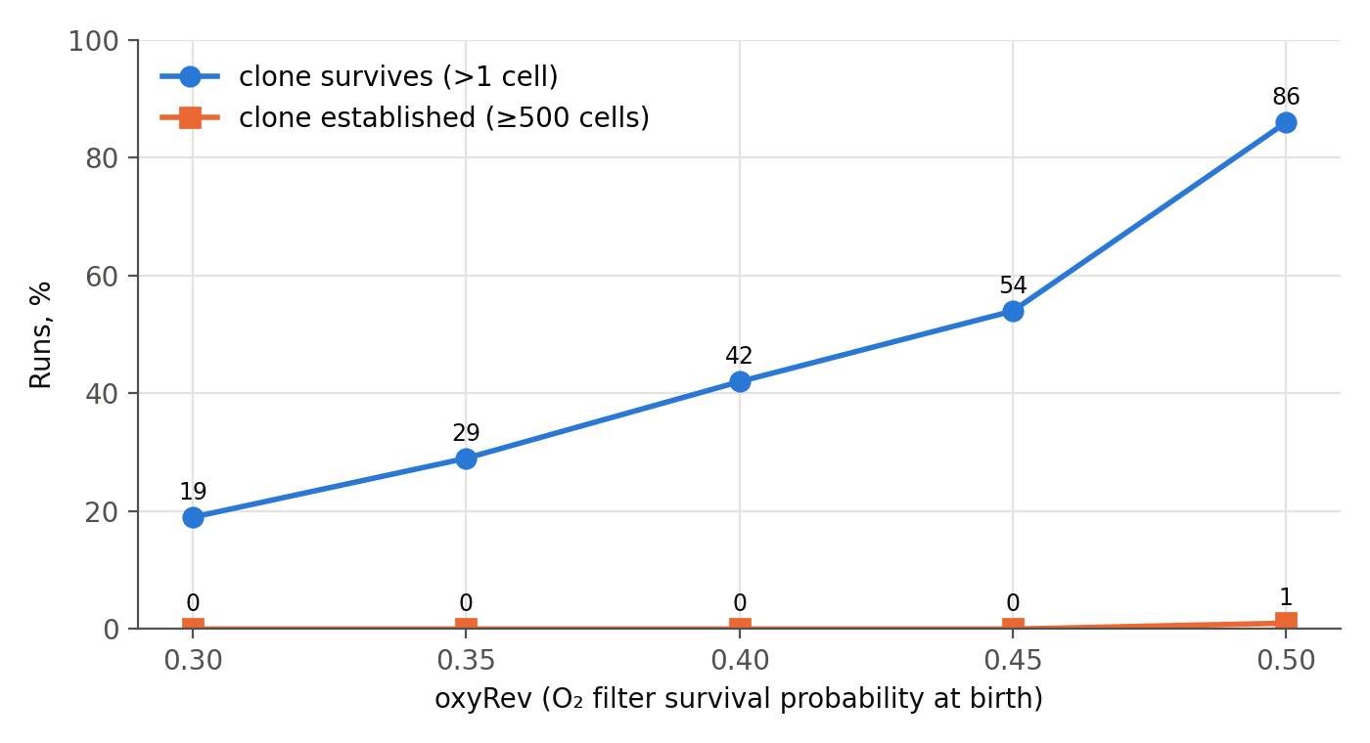
Figure 2.1. Share of runs with a surviving clone (>1 cell) and with an established clone (≥500 cells) at the end of the run, by oxygen-filter value, without wounding (revStore = 0.33).
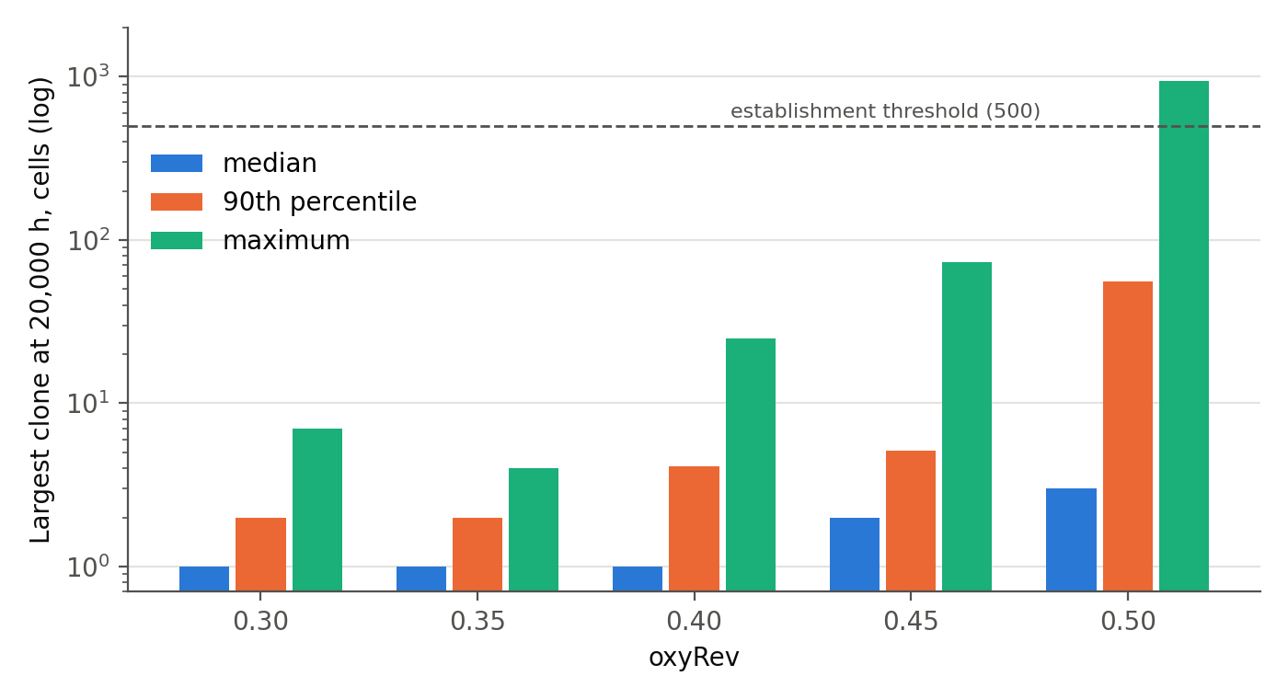
Figure 2.2. Largest reverted clone at 20,000 h by oxygen-filter value, without wounding: median, 90th percentile and maximum over 100 runs (log scale; the dashed line marks the establishment threshold).
Table 2.1. The bench with the oxygen filter, no wounding (revStore = 0.33; 100 runs per row).
oxyRev | Clone survives (>1 cell), % | Median clone | p90 | Maximum | Established (≥500), of 100
0.30 | 19 | 1 | 2.0 | 7 | 0
0.35 | 29 | 1 | 2.0 | 4 | 0
0.40 | 42 | 1 | 4.1 | 25 | 0
0.45 | 54 | 2 | 5.1 | 73 | 0
0.50 | 86 | 3 | 55.4 | 947 | 1
The number of reversion events is practically independent of oxyRev (a median of 443–451 per run): reversion happens as often as in Chapter 1, but almost every clone that arises stays within a few cells. Establishment remains at 0–1% across the entire grid. The transition toward frequent outliers begins near oxyRev ≈ 0.5, where the share of surviving clones nearly doubles (54% → 86%) and the maximum clone grows by an order of magnitude (73 → 947 cells).

2.4. Results under wounding
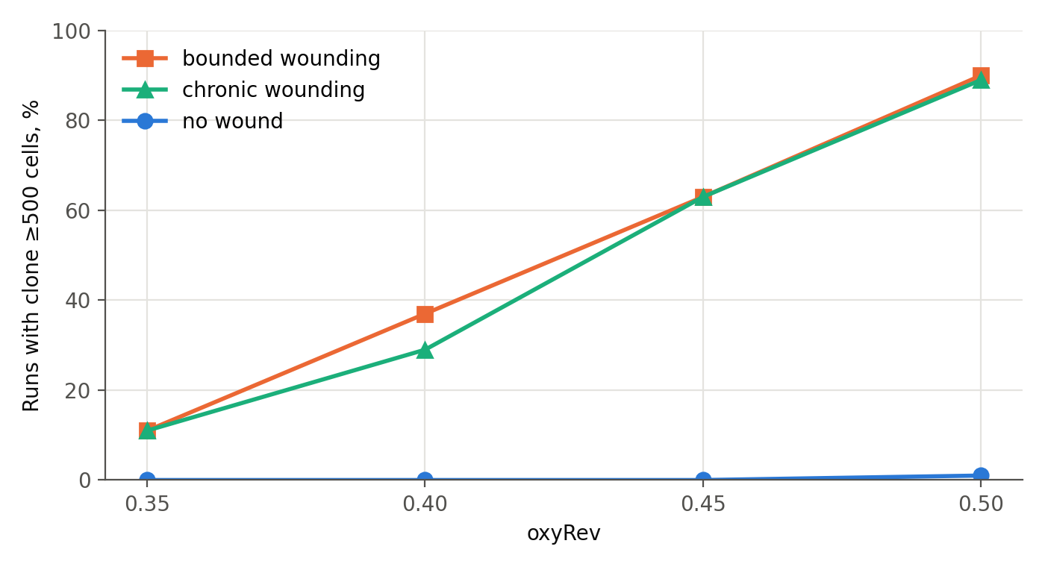
Figure 2.3. Share of runs with an established clone (≥500 cells) by oxygen-filter value under bounded and chronic wounding, compared with the no-wound series (revStore = 0.33).
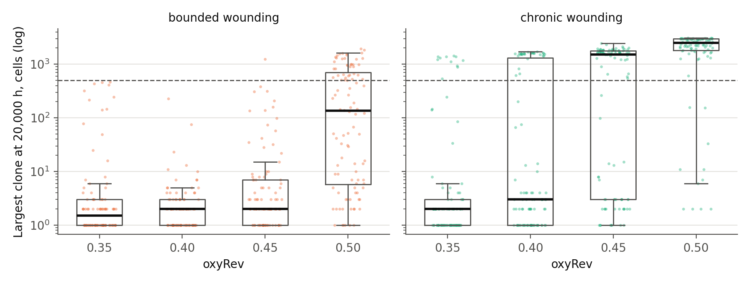
Figure 2.4. Largest reverted clone at 20,000 h under bounded wounding (stops after establishment) and chronic wounding (continues to the end of the horizon), by oxygen-filter value (log scale; the dashed line marks the establishment threshold).
Table 2.2. The bench with the oxygen filter under wounding (revStore = 0.33; 100 runs per cell).
Scenario | oxyRev 0.35 | 0.40 | 0.45 | 0.50
bounded, established, % | 11 | 37 | 63 | 90
chronic, established, % | 11 | 29 | 63 | 89
chronic, median clone share of living cells at the end | <0.1% | <0.1% | 49% | 83%
Under wounding the oxygen filter is not erased, unlike the only trace of resource resistance found in Chapter 1 (revStore = 0.20: 20% → 100% under wounding). Establishment increases gradually, from 11% to about 90%, depending on oxyRev: even when wounding removes the constraint on free space, the oxygen filter retains a dose-dependent resistance. At the same time, wounding clearly weakens this barrier: without wounding, establishment at the same filter values is 0–1%.
The closeness of bounded and chronic in establishment probability (11/37/63/90 vs. 11/29/63/89) is a property of the design rather than a separate result: before the first threshold crossing the two scenarios are mechanically identical and can differ only afterwards. The residual difference (for example, 37 vs. 29 at oxyRev 0.40) arises because the wound interval is drawn independently for the bounded and chronic series (for the same seed it coincides in only about 38% of pairs), not because wounding continues after establishment.
The scenarios differ in what happens after establishment. At oxyRev = 0.50 the median final clone under chronic wounding (2,507 cells, 83% of the living cells in the sheet) is almost 18 times larger than under bounded wounding (135.5 cells). The probability of establishment is set by the oxygen filter at the moment of cell birth; the final size is set by subsequent growth, which depends on how much space the clone receives after it has become established.

2.5. The two benches compared
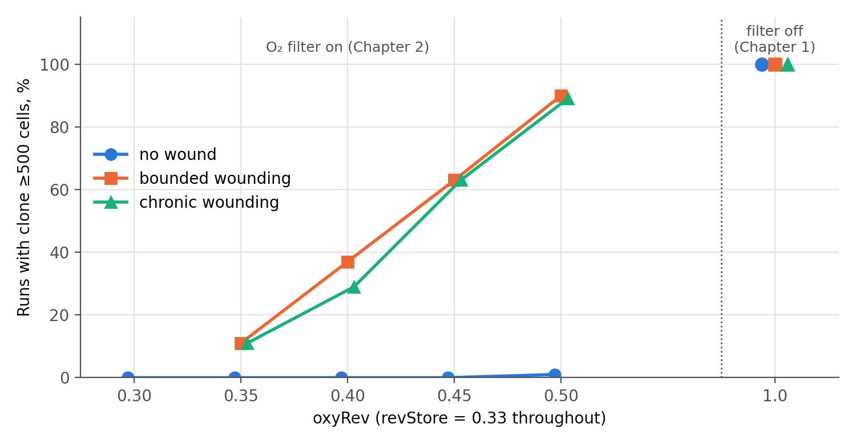
Figure 2.5. Share of runs with an established clone across both benches at revStore = 0.33: the oxygen-filter grid (Chapter 2) and the filter switched off, oxyRev = 1.0 (Chapter 1), by scenario. The wounding series were not run at oxyRev = 0.30.
Table 2.3. Establishment with and without the oxygen filter at the same glycogen.
Condition (revStore = 0.33) | Established, no wound | Established, under wounding | Median time, no wound
Without the oxygen filter (oxyRev = 1.0) | 100% | 100% | 984 h
With the oxygen filter (oxyRev 0.30–0.45) | 0% | 11–63% (oxyRev 0.35–0.45) | —
With the oxygen filter (oxyRev = 0.50) | 1% | ~90% | 16,752 h (single case)

2.6. The completed design: the full revStore × oxyRev grid (series S0–S5)
Chapters 1 and 2 sampled three corners of the resource × oxygen design. A further 6,610 runs (series S0–S5, Appendix A) complete it: the same engine, lattice, horizon and threshold; pRevert and seeds 0–99 as before in S0–S3, 100 runs per cell (series S4 varies pRevert and uses 50 seeds). The runner was first checked against the published data: series S0 repeats two published cells (revStore = 0.33, oxyRev = 0.40 and 1.0; five seeds each) and reproduces all ten runs in all ten outcome columns without a single deviation. Together with the earlier series the no-wound grid now has 50 cells of 100 runs (Figure 2.6).
The fourth corner. At full glycogen (revStore = 1.0) the oxygen filter does not contain the clone: establishment is 100% at every value of oxyRev from 0.30 to 1.0. The filter only delays it, from a median of 336 h without the filter to 1,416 h at oxyRev = 0.30 (about four-fold). The picture is the same at revStore = 0.75 (100% everywhere; 408 h without the filter, 2,280 h at 0.30). At revStore = 0.50 containment first appears at the strongest filter (20% at oxyRev = 0.30, with a median establishment time of 11,460 h) and is lost by oxyRev = 0.35. At revStore = 0.33 the transition is sharp: 0% at oxyRev 0.30–0.45, 1% at 0.50, 75% at 0.55 and 100% at 0.60. Reduced glycogen with the filter off gives containment only at revStore = 0.20 (20% establishment).
The low-glycogen rows. Series S5 (1,500 runs, 100 per cell) fills the rows revStore = 0.30, 0.25 and 0.20 at oxyRev 0.30, 0.40, 0.50, 0.55 and 0.60; the columns 0.35 and 0.45 were not run in these rows. Of the fifteen cells, fourteen gave no established clone in 100 runs. The one exception is revStore = 0.30 at the weakest filter, oxyRev = 0.60: 28% establishment, with a median time of about 13,300 h among the 28 runs that established. Containment therefore extends below revStore = 0.33, and the oxyRev at which it is lost shifts toward weaker filters as glycogen falls: between 0.50 and 0.55 at revStore = 0.33 (1% and 75%), between 0.55 and 0.60 at 0.30 (0% and 28%), and somewhere between 0.60 and the filter switched off at 0.25 and 0.20, where it was not located more finely. The product rule is approximate here: at products of 0.175–0.18 establishment is 100% (revStore 0.50, oxyRev 0.35), 75% (0.33, 0.55) and 28% (0.30, 0.60), so at equal product the cell with less glycogen is the more contained.
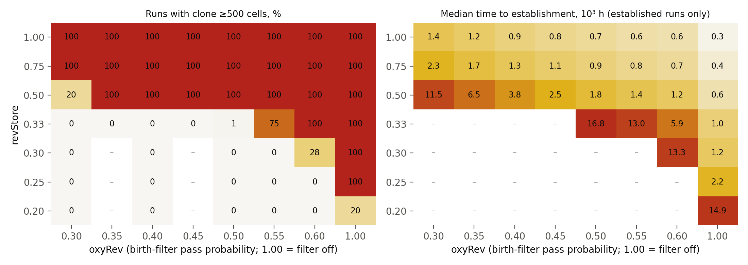
Figure 2.6. Joint grid of reduced glycogen (revStore) and the oxygen birth filter (oxyRev), no wounding, 100 runs per cell. Left: share of runs with a clone of at least 500 cells. Right: median time to establishment among established runs, so cells with few established runs (revStore = 0.33 at oxyRev 0.50 and 0.55, revStore = 0.30 at oxyRev 0.60, revStore = 0.50 and 0.20 at their single contained cells) rest on 1–20 runs (see the left panel). Dashes: in the left panel, cell not run (revStore 0.20–0.30 at oxyRev 0.35 and 0.45); in the right panel, no established runs or cell not run.
The two barriers combine approximately as a product. Among the 27 cells in which at least 90 runs established, the median time to establishment follows ln t = 5.38 − 1.64 ln(revStore) − 1.64 ln(oxyRev) (R² = 0.89 on cell medians; the same fit on the 2,700 individual runs gives exponents of 1.60 each, R² = 0.80). The two exponents are practically equal, so the delay is governed by the product revStore × oxyRev, and containment is lost where that product reaches about 0.15–0.20 (Figure 2.7). The relation is empirical and approximate. It describes the time to establishment only in runs that did establish, which excludes the contained cells, and it is not exact at the low end: at the same product of 0.20, revStore = 0.20 without the filter delays establishment to 14,940 h, whereas revStore = 0.50 with oxyRev = 0.40 gives 3,768 h.
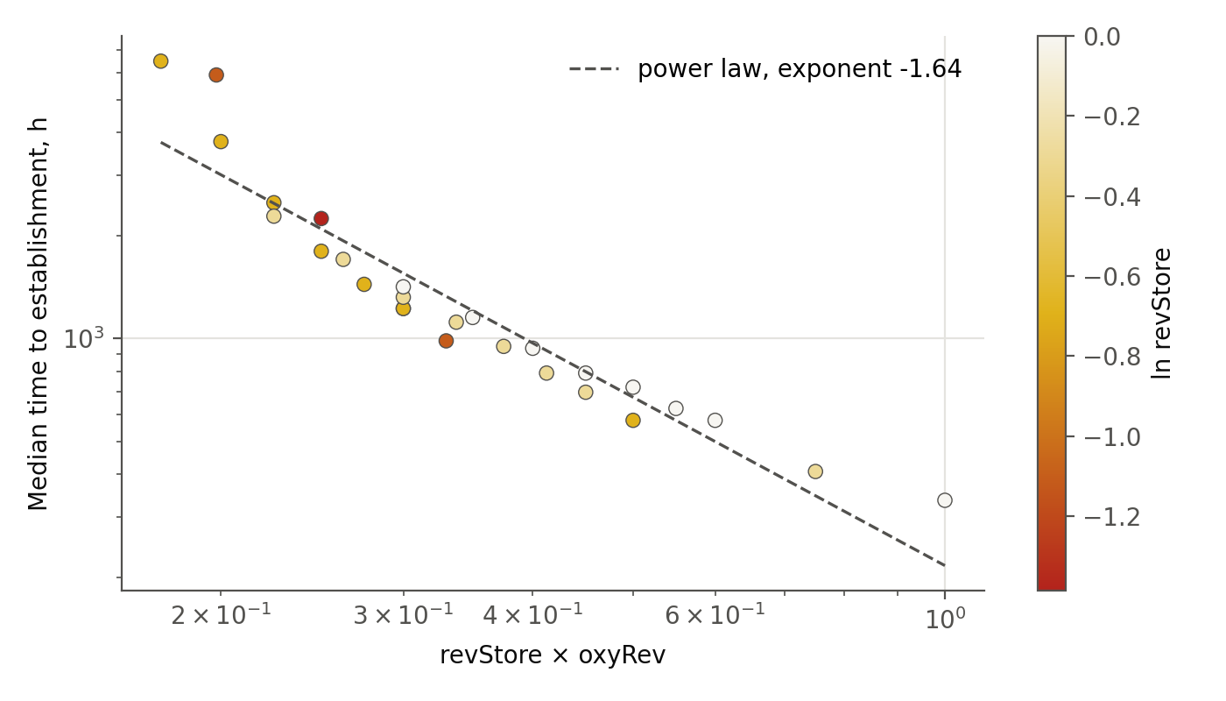
Figure 2.7. Median time to establishment against revStore × oxyRev, cells with at least 90 established runs (log–log). The dashed line is the power-law fit described in the text.
Wounding at an active filter. Series S3 repeats the wounding experiment at oxyRev = 0.50 across revStore = 0.20–1.0, with bounded and chronic runs of the same seed sharing the same wound interval (Table 2.4, Figure 2.8). The paired design works as intended: bounded and chronic runs have identical establishment probability and time and differ only in the final size of the clone. Wounding weakens the combined barrier at revStore = 0.33 (establishment 1% → 90%), but it does not rescue a clone that has too little glycogen under an active filter: at revStore = 0.20 establishment is 0%, whereas with the filter off the same glycogen gave 20% → 100% under wounding (Chapter 1). At revStore = 0.25 only the shortest wound interval, 12 h, produced establishment (45% of 44 runs); at revStore = 0.33 intervals of 12 h and 24 h gave 100% and 48 h gave 63% (27–44 runs per interval). At revStore ≥ 0.50 establishment is already 100% and wounding changes only its timing slightly (revStore = 0.50: 1,560 h under wounding against 1,800 h without it at the same filter value).
Table 2.4. Wounding at oxyRev = 0.50 (series S3; 100 runs per revStore and scenario).
revStore | No wound, established, % | Under wounding, established, % | Median time under wounding, h | Median final clone, bounded / chronic, cells
0.20 | 0 | 0 | — | 1.5 / 1.5
0.25 | 0 | 20 | 10,848 | 2 / 4
0.33 | 1 | 90 | 5,280 | 205 / 2,267.5
0.50 | 100 | 100 | 1,560 | 3,662.5 / 3,522.5
1.0 | 100 | 100 | 720 | 3,952 / 3,576
The no-wound entry at revStore = 0.33 is the oxyRev = 0.50 cell of the grid; the no-wound entries at revStore 0.20 and 0.25 are the oxyRev = 0.50 cells of series S5. Establishment is identical in the two wound scenarios by construction.
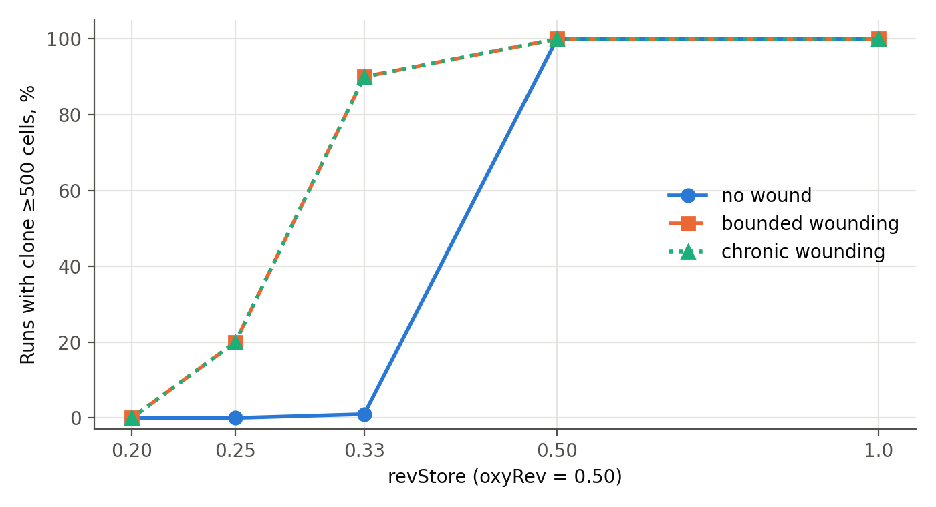
Figure 2.8. Establishment at oxyRev = 0.50 without wounding and under bounded or chronic wounding. The two wound curves coincide because the runs share seeds and wound intervals.
Robustness to the reversion rate. Series S4 repeats the central part of the no-wound grid (revStore 0.33, 0.50 and 1.0; oxyRev 0.30–1.0) with the reversion rate halved and doubled, 1/2000 and 1/500 per division against the base 1/1000, with 50 runs per cell (1,500 runs; Figure 2.9). The containment pattern is unchanged. At revStore = 1.0 establishment is 100% in every cell at all three rates. At revStore = 0.33 it stays at 0–4% for oxyRev 0.30–0.50 and is 98–100% from oxyRev 0.60. Only at the margin of containment (revStore = 0.50, oxyRev = 0.30) does it vary with the rate, 4%, 20% and 24% for the halved, base and doubled rate. What the rate does change is the time and the number of surviving clones. At revStore = 0.33 and oxyRev = 0.60 the median time to establishment is 7,776 h, 5,904 h and 4,356 h at the halved, base and doubled rate. At revStore = 0.33 and oxyRev = 0.50 the share of runs ending with a clone of at least 12 cells, the persistence regime of Section 2.6, is 14%, 23% and 34%. A rarer reversion therefore changes how many clones are attempted and how fast one succeeds, not where the boundary between containment and establishment lies.
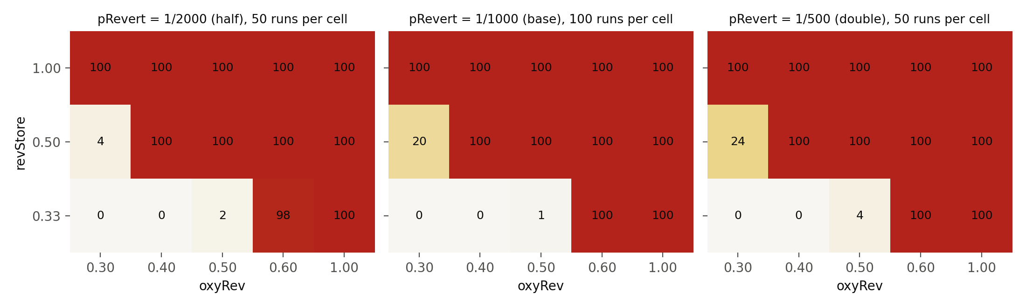
Figure 2.9. Share of runs with an established clone (≥500 cells), no wounding, at three reversion rates. The central panel is the base series (100 runs per cell); the outer panels are series S4 (50 runs per cell).
Sensitivity to the sibling-fate rule. In the engine used throughout, the mother of a dividing reverted-lineage pair always survives and the daughter passes the filter with probability p = oxyRev (the maternal variant, A). Two alternative readings were computed on the no-wound grid. In variant B the factor acts on both cells of the pair independently and each survives with probability s = (1 + oxyRev)/2, so the mother can also die. In variant C the fates are fully coupled: one draw per division, and both cells survive with probability s or both die. In all three variants the expected number of survivors per pair is 2s; they differ only in how often both cells are lost at once (never in A, (1 − s)² in B, 1 − s in C). Each alternative was run on 5,500 runs, the same cells and seeds as the series above with oxyRev < 1 (cells with oxyRev = 1.0 are identical in all variants and were not repeated). Establishment is ordered A ≥ B ≥ C in all 67 cells: 3,040 runs established in A, 2,733 in B and 2,387 in C. No run established in C that did not establish in A or in B; in 346 pairs B established where C did not, in 308 pairs A established where B did not, and in 1 pair B established where A did not. Fisher’s exact test (P < 0.05) separates A from B in 7 cells, B from C in 7 and A from C in 12 of 67, all at the boundary of containment. At the base reversion rate the value of s at which establishment reaches 50% rises at each step: at revStore = 0.50 from 0.660 in A to 0.688 in B and 0.713 in C (oxyRev 0.319, 0.375 and 0.425), and at revStore = 0.33 from 0.767 in A to 0.795 in B and about 0.815 in C (oxyRev 0.533, 0.590 and about 0.63). For C at revStore = 0.33 the 50% point lay above the range of the grid (no establishment up to oxyRev 0.60), and an extension of 800 runs (oxyRev 0.65, 0.70, 0.75 and 0.80, that is s = 0.825–0.90; variants B and C; 100 seeds per cell; same engine, horizon and threshold) located it: C establishes in 84% of runs at oxyRev 0.65 and in 100% from 0.70, while B establishes in 100% in all four cells; the median time to establishment at oxyRev 0.65 is 9,840 h in C and 4,824 h in B. The whole range from “at most one cell lost” to “fates fully coupled” therefore moves the containment boundary by about 0.05 in s. At the halved and doubled reversion rates the grid is coarser (steps of 0.1); at revStore = 0.50 the 50% point lies at oxyRev 0.348 and 0.334 in A and at 0.450 and 0.450 in C. Where all three variants reach 100% (28 cells), establishment is slower the more the fates are coupled: the median ratios of times are 1.06 (B/A), 1.28 (C/A) and 1.21 (C/B), larger near the boundary (revStore = 0.50, oxyRev = 0.40: 3,768 h in A, 7,320 h in B and 16,920 h in C). The qualitative picture is the same in all three variants (Figure 2.10). This was tested without wounding only; the wound series (S3 and Chapter 2) were not recomputed in B and C and remain in the maternal variant. The implementation of the three rules was checked against their formulas on 2.28 million division pairs (Appendix A.8).
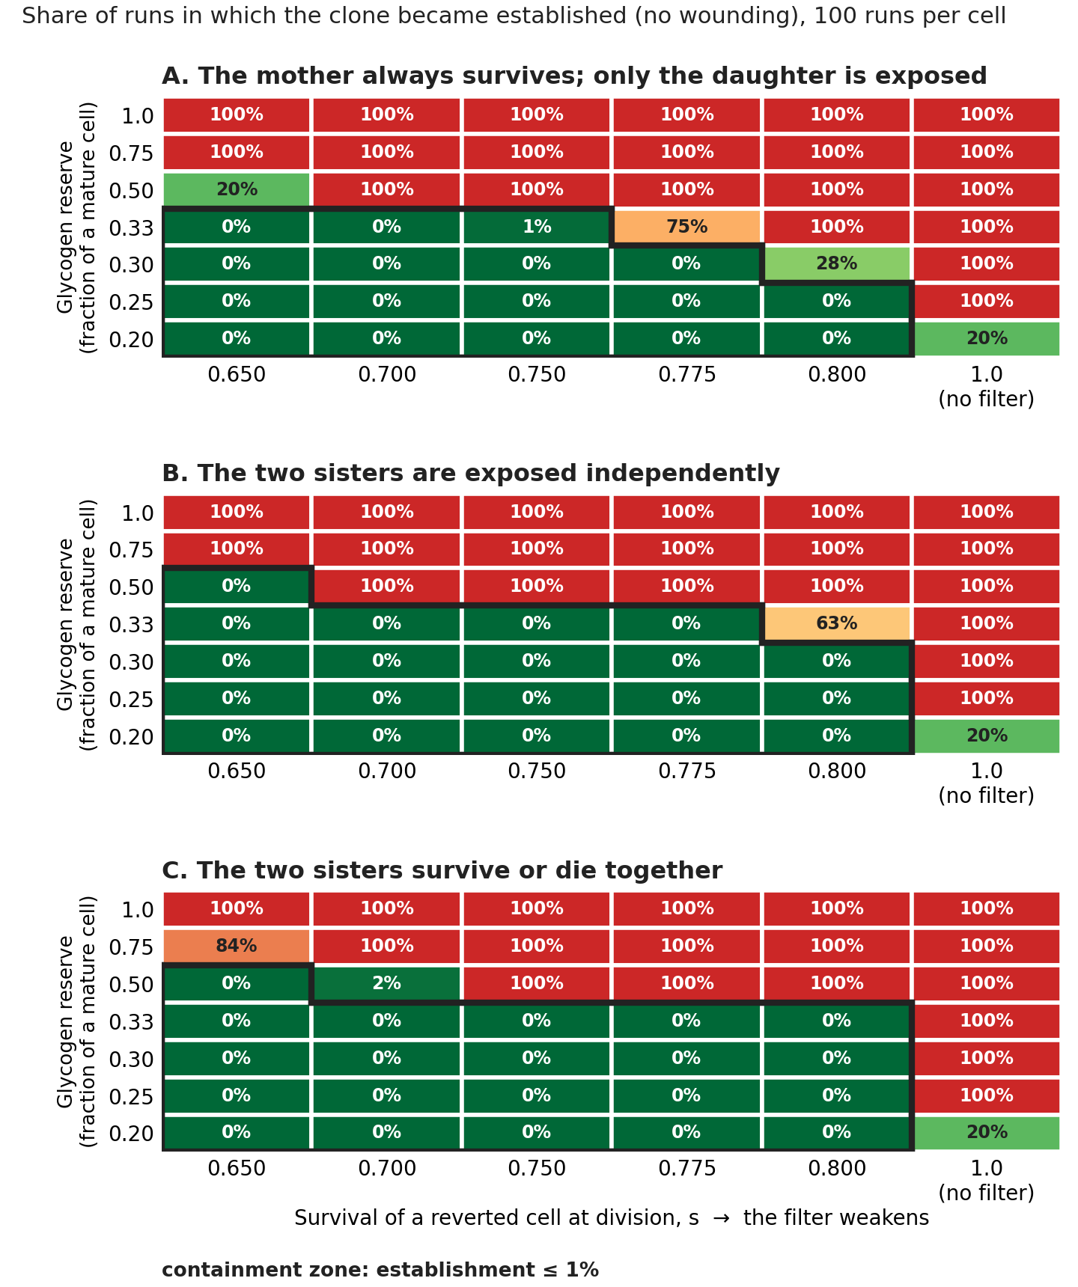
Figure 2.10. Share of runs with an established clone (≥500 cells), no wounding, 100 runs per cell, in three variants of how the two sister cells share the exposure: A, the mother always survives and only the daughter is exposed (the engine of Chapters 1–2); B, the two sisters are exposed independently; C, the two sisters survive or die together. The scale s = (1 + oxyRev)/2 is the same in all panels (0.5 ≤ s ≤ 1; 1 = no filter); rows are revStore. Green: contained; red: established; black outline: containment zone (≤1%). The cells with revStore = 0.33 above s = 0.80 are given in the text (800-run extension).
Two limits of this section should be kept in view. First, the grid explores one filter form (a one-time birth filter) and one glycogen cap, glucose supply is held at a single value, and the product relation is a description of this grid and not a law. Second, the establishment threshold of 500 cells was fixed in advance; the 24-hour trajectories recorded for every run make it possible to test 250 and 1,000 cells without re-running, and that check was done (Appendix A.6): the ordering of the results is preserved, while the percentages in the transition zone change. Lattice size and glucose supply are likewise left open: the code, run data and runners are freely available (MIT licence for code, CC BY 4.0 for data), so these extensions can be carried out by others as well as by the authors, should there be interest.
Open question: a second eliminating factor. The counter s is not tied to oxygen and describes the survival of a cell at division under any eliminating factor (ElF), a cytostatic drug among them. If oxygen and a drug act on one division independently and constantly, their survival probabilities multiply, s = s(O₂) · s(drug), and the boundary of Figure 2.10 shifts: with a drug s of 0.9, the s of the oxygen filter at which establishment reaches 50% moves at revStore = 0.50 from 0.66–0.71 to about 0.73–0.79. This is an arithmetic inference from the maps, not a result of the runs. It ignores the action of the drug on the surrounding normal cells and the cyclic nature of treatment courses, and it assumes that the two axes of the map are independent, which is not certain. In ovarian clear cell carcinoma high PAS positivity (glycogen) is associated with platinum resistance and worse survival in univariate analysis, and suppression of glycogen synthesis raises sensitivity to cisplatin in cell lines and xenografts [63]; after adjustment the enzyme GYS1, not the staining itself, remained an independent factor. In cervical cancer the link between glycogen and chemoresistance has been shown in cell lines, in mice and in 6 patient samples, without survival data [64]. These are associations and laboratory findings, not proven causation; if the glycogen reserve changes s under a drug, the two axes of the map are coupled. Whether PAS positivity of tumour cells changes in surgical or biopsy material after chemotherapy, and how it relates to prognosis under further treatment, remains an open clinical question.

2.7. Conclusion of Chapter 2
Taken together, Chapters 1 and 2 and the completed grid of Section 2.6 give a more precise statement than either bench alone. Neither barrier suffices on its own across its range. Resource regulation without the filter fails (100% establishment at every revStore from 0.25 to 1.0), and the oxygen filter at full or moderately reduced glycogen fails as well (100% establishment at revStore ≥ 0.75 for every oxyRev down to 0.30, delayed four- to six-fold). Containment appears only where the two act together, roughly where revStore × oxyRev falls to 0.15–0.20, and the delay to establishment scales approximately with that product raised to the power −1.6. Wounding shifts but does not remove this boundary: it weakens the combined barrier at revStore = 0.33 (1% → 90% at oxyRev = 0.50) but does not rescue a clone with too little glycogen under an active filter (revStore = 0.20: 0%), unlike with the filter off (20% → 100%). The statement that the oxygen filter is the only working barrier therefore holds only at reduced glycogen (revStore ≈ 0.33), where the filter is the factor that decides the outcome.
Limitations. The grid is empirical: the product relation is approximate and describes only runs that established. One filter form and one glycogen cap were used. Wounding was explored only at oxyRev = 0.50 (and, in Chapter 2, at 0.35–0.50 for revStore = 0.33), and below revStore = 0.33 the oxygen filter was combined with glycogen only at oxyRev 0.30, 0.40, 0.50, 0.55 and 0.60, without wounding (series S5). The reversion rate was varied only two-fold up and down (Section 2.6, series S4). The establishment threshold was varied by recomputation from the recorded trajectories (Appendix A.6); the lattice size remains to be checked. The sibling-fate variants B and C were recomputed only for the no-wound grid (Section 2.6); the wound series remain in the maternal variant A. Chemotherapy as a second eliminating factor was not modelled (open question at the end of Section 2.6).

Part II. The Model Against Tissue Data, and the Boundaries of the Pre-Immune Window

Chapter 3. Mathematics Mirroring a Biological Process
A five-site epithelial series, two controlled comparisons, and what the bench of Part I predicted about each.

3.1. What this chapter claims, and what it does not
Part I ends with an ordering rather than a measurement. At reduced glycogen the oxygen filter holds establishment to a fraction of a percent; at full glycogen the same filter only delays it; wounding weakens the combined barrier without removing it; and the two barriers combine approximately as a product. The parameters carrying these results are dimensionless, the lattice is calibrated to no particular tissue, and the horizon is not calendar time. The only comparison with tissue that such a bench can support is a comparison of signs and orderings — the restriction stated as Rule 7 in Section 4.3 and anticipated here.
This chapter performs that comparison against a series of five epithelial sites. The series was assembled independently of the bench and around a different question: whether luminal oxygen tension orders the frequency of intraepithelial lesions. It does not. What makes the series useful here is the reason why it does not.
Three claims are made, in descending order of strength.
- The series contains two comparisons that isolate, one each, the two terms of the decomposition adopted in Section 0.2. Clinical frequency data normally confound those terms; the bench separates them by construction. This is the chapter’s principal result.
- One site carries a directly measured lesion that corresponds to the bench’s modal contained outcome — persistence without expansion. The correspondence holds in ordering and in the direction of its dependence on the reversion rate, not in value.
- The architecture-dependence that the bench produces mechanically, through free space, appears in the series as a roughly hundred-fold difference in lesion frequency between sites with a shared luminal environment, in which equality of oxygen and viral exposure has not been measured.
Three things are not claimed. That bench percentages and clinical frequencies are commensurable — they are not, and Section 3.7 sets out why in detail. That any bench parameter was fitted to any figure in this chapter — none was, and Section 3.6 states the one place where a threshold was deliberately aligned with a histological definition, which is a different operation. And that the series confirms the model: a series of five sites, two of them represented by a single pair each, can raise or lower the plausibility of an ordering, not establish it.
The status of everything in this chapter, under the convention of Section 0.4, is external biological evidence set beside model results, with the join between the two marked wherever it occurs.

3.2. The series
Table 3.1. Five epithelial sites: luminal environment, architecture, and the measured frequency of intraepithelial lesions. All figures in this table are clinical; no bench quantity appears in it.
Site | Lumen | Epithelium | Lesion frequency
Fallopian tube | very low O₂; closed, unventilated | ciliated columnar monolayer, no basal layer | p53 signature in 50 % of controls and 71 % of BRCA carriers [9]; STIC 3.5 %, occult invasive carcinoma 1.5 % at risk-reducing surgery [10]
Endocervical canal | low O₂; mucus plug | columnar monolayer | glandular precancer at 0.02× the squamous rate [11]; AIS 2.8 % of detected precancers against 31 % with CIN3 alone [12]
Transformation zone (nulliparous) | intermediate; unventilated, diffusion only | immature squamous metaplasia, stratifying | CIN common; HSIL cytology ~0.5–1 %, LSIL 2–3 %
Vaginal wall | as above | mature stratified squamous | VaIN about 100× rarer than CIN [13]; incidence 0.1–0.3 per 100 000 [14]
Eustachian tube | highest; middle ear ~40–50 mmHg, ventilated on swallowing | ciliated pseudostratified, with basal cells | effectively nil; middle-ear carcinoma a few cases per million per year
Two features of the series should be stated before any interpretation of it.
Ventilation, not anatomical openness, sets luminal oxygen. The vagina is open yet unventilated, and oxygen reaches it by diffusion alone; the Eustachian tube exchanges gas convectively every time it opens. The ordering of the series by oxygen therefore does not follow the ordering by anatomical accessibility, and a reader who substitutes one for the other will misread the table.
The resident flora doubles as a bioassay for that oxygen — obligate anaerobes where the tension is near zero, facultative organisms and aerobes where it is low but finite. This is an independent check on the first column, which otherwise rests on direct measurements of varying quality.
Two figures in Table 3.1 carry no citation and must be sourced before the table is used in print: middle-ear carcinoma incidence, given as a few cases per million per year, and middle-ear gas tension at 40–50 mmHg. They are retained because the Eustachian row is load-bearing in Section 3.4 and because both figures are, in order of magnitude, uncontroversial; they are flagged here in accordance with Section 0.4 rather than silently carried.
A third qualification concerns the hundred-fold ratio in the vaginal row, which is the single most consequential number in this chapter. In the cohort analysis cited [13] that ratio is attributed to earlier work rather than measured, so it should be read as an established order of magnitude with a secondary provenance, not as a primary measurement. The argument of Section 3.4 requires only the order of magnitude.

3.3. Luminal oxygen alone does not order the series
The extremes are suggestive. The most hypoxic lumen, the fallopian tube, carries a clonal lesion (p53 signatures) in 50% of the 40 controls of one series [9]. The best-oxygenated and the only ventilated one, the Eustachian tube: no comparable studies of small clones exist for it, and the absence of findings cannot be taken as an established absence of clones. On those two points alone, oxygen could be protective, and in the direction the bench predicts: in the engine a weak filter — the limit oxyRev → 1, which corresponds to a lumen in which newborn reverted cells are not oxidatively culled — lets clones survive, and a harsh filter does not.
The middle of the series destroys that reading. The vaginal wall and the cervical transformation zone sit in one lumen, at one oxygen tension, exposed to the same human papillomavirus — and the frequency of intraepithelial neoplasia differs by about two orders of magnitude. Whatever orders this table, it is not oxygen, because across that pair oxygen does not vary at all.
This is not an embarrassment for the model but the reason the series was worth importing. The bench produces exactly this dissociation internally. At revStore = 0.33 and oxyRev = 0.50 without wounding, 86 % of runs end with a surviving reverted clone and 1 % with an established one (Table 2.1). Survival and expansion are set by different mechanisms in the engine — the filter at birth governs the first, available space governs the second — and the series shows the same two mechanisms coming apart in tissue. A single-site study cannot see this; it needs a pair in which one of the two is held still.

3.4. Two comparisons, two factors
The frequency of a lesion is the product of two things that are usually confounded: how often a candidate clone arises, and how likely one is to survive and expand where it arises. That is the decomposition of Section 0.2, repeated here in the form the data impose:
frequency of established clones ≈ rate of generation of reverted cells × probability of their retention in the tissue
The series contains two pairs that partly separate the terms, because in each one of them seems to differ less than the other; neither pair isolates a factor strictly.
Table 3.2. Two controlled comparisons within the series.
Pair | Held fixed | Varied | Isolates
vaginal wall against cervical transformation zone | luminal oxygen, virus, organ | architecture — mature stratified squamous against immature metaplastic junction | the architectural term: about 100× in lesion frequency
fallopian tube against Eustachian tube | architecture — ciliated tubular lining of similar calibre | exposure — ovulatory oxidative burst, follicular-fluid reactive species, heme iron from retrograde menstruation, against none of these | the exposure term
Neither pair is clean on its own, and both defects run in the same direction, which is worth stating plainly.
The Eustachian tube is pseudostratified in parts and therefore holds a protected basal reserve that the fallopian tube lacks, so its near-zero rate has two candidate causes rather than one. The pair consequently bounds the exposure term rather than measuring it. Against this, there is an internal gradient within the middle ear that argues for the exposure term rather than away from it: the rare carcinomas that do occur there arise disproportionately on a background of chronic suppurative otitis media — that is, where a repeated-injury exposure has been supplied to the one lining in the series that otherwise has none. A site that acquires an exposure acquires a lesion rate, at approximately similar architecture.
The vaginal pair is the stronger of the two, and it is the pair that cannot be removed from this chapter without destroying its logic. It is also the pair that sits outside the monolayer: both of its members are stratified or stratifying. It belongs here not as a case of the model — the bench represents a monolayer and nothing else — but as the contrast class that makes the architectural term visible at all. Two stratified sites differing a hundred-fold at an approximately similar luminal environment are consistent with architecture carrying a term of its own; what the bench then supplies is a mechanism for that term in the one architecture it can represent.

3.5. Three tissue variables, three bench quantities
The three variables of the series have three different jobs, and each corresponds to a distinct quantity in the engine. Setting them side by side is the operation from which this chapter takes its title, so the correspondence should be stated exactly, with its slack shown.
Table 3.3. The mapping. This table relates roles and directions, not values; no cell asserts that a bench number estimates a tissue number.
Tissue variable | Term of Section 0.2 | Gate | Bench quantity | What the bench shows | What the series shows
luminal oxygen | retention | once, at the birth of a cell | oxyRev — probability of passing the filter at birth; low oxyRev is a harsh filter, hence a well-oxygenated lumen | containment at reduced glycogen (0–1 % establishment, oxyRev 0.30–0.45); only delay at full glycogen (Section 2.6) | hypoxic lumen with high clonal persistence; ventilated lumen with none; but the pair at constant oxygen differs 100-fold
architecture | retention | continuous | free space: lattice occupancy, and the wound protocol that creates vacancies | wounding raises establishment from 1 % to about 90 % at oxyRev = 0.50 without changing the filter (Table 2.4) | about 100× between stratified and metaplastic junction at constant oxygen and virus
exposure | generation | continuous | pRevert — reversion rate per division, varied two-fold up and down in series S4 | the containment boundary does not move; the number of surviving clones and the time to establishment do (Section 2.6) | ovulatory and menstrual exposure against none, at comparable architecture
Three observations about this mapping, two of them cautionary.
First, the sign convention must be read carefully, because the bench and the tissue label the same thing from opposite ends. In the engine oxyRev is a survival probability, so a high value means a weak filter; in tissue a high luminal oxygen tension means a strong oxidative cull at the moment of a cell’s birth. The hypoxic fallopian tube therefore corresponds to the bench’s permissive corner, oxyRev → 1, and the ventilated Eustachian tube to its harsh corner. Read in that direction, the two extremes of the series agree with the bench; read in the other, they appear to contradict it. This is a translation, not a result, and it is recorded here so that the translation is not performed silently anywhere in this chapter.
Second, the architectural row is where the correspondence is loosest. In the engine, architecture enters only as the availability of lattice nodes, and vacancies are created only by wounding. In tissue, the architectural difference between a stratified epithelium and a metaplastic junction is not primarily a difference in free space: it involves a protected basal reserve, a differentiation gradient across layers, and — as Section 3.8 sets out — a self-generated internal oxygen minimum, none of which the engine contains. The bench and the series agree that architecture carries a term, and agree on its sign; they do not agree on its mechanism, and the bench should not be read as explaining the hundred-fold ratio.
Third, the exposure row is the only one where the bench and the series are testing genuinely the same statement. The bench varies the rate of generation while holding retention fixed and finds that the containment boundary is unmoved while the counts and timings shift (series S4). The series varies exposure at approximately constant architecture and finds a difference in lesion frequency. Both say: exposure acts on the first term, not on the filters. This is the one row on which the mapping is tight, and it is also, independently, the row with the least clinical weight, resting as it does on a single pair with a known confound.

3.6. Persistence without expansion
The lesion that makes the fallopian tube an outlier in Table 3.1 is not a dysplasia at all, and this is the most consequential fact in the chapter.
The p53 signature is defined as at least twelve consecutive secretory nuclei with aberrant p53, in epithelium that is morphologically normal and not proliferating [10]. It is persistence without expansion: a clone that has survived and stopped. It is found in 50 % of controls and 71 % of BRCA carriers, and detection roughly doubles with serial sectioning, so the figure is a function of how hard one looks [9].
The bench’s contained regime has the same shape. At revStore = 0.33 and oxyRev = 0.50 without wounding, establishment is 1 % while 86 % of runs end with a surviving clone, median size 3 cells (Table 2.1); and the share of runs ending with a clone of at least twelve cells is 23 % at the base reversion rate, 14 % at half that rate and 34 % at double it (Section 2.6, series S4). The modal outcome of a contained clone on the bench is therefore not elimination and not establishment but persistence at small size — which is what the histology reports.
What corresponds, and at what strength:
- The ordering. Persistence greatly exceeds expansion at the same site, in both. On the bench, 23 % against 1 %; in the tube, 50 % against 3.5 % for STIC and 1.5 % for occult invasive carcinoma [9, 10]. These ratios refer to different cohorts and measures (50 % — controls in a series of 40 women; 3.5 % and 1.5 % — 400 high-risk women), so they cannot be compared as a ratio of stages; neither figure was fitted to the other, and the agreement is in the qualitative ordering only.
- The dependence on the rate of generation. On the bench, raising the reversion rate raises the share of persisting clones (14 → 23 → 34 %) while leaving the containment boundary where it was. In tissue, the prediction is that exposure should raise the sub-morphological background without proportionately raising the rate of progression — which is testable, and is the first row of the study proposed in Section 3.9.
- The direction with respect to oxygen. The site with the weakest oxidative cull carries the largest sub-morphological background. On the bench this is the permissive corner of the filter.
What does not correspond, and must not be presented as if it did:
- The magnitudes. 23 % and 50 % are not two estimates of one quantity. They differ by more than a factor of two, and the comparison is not even of like units: the bench percentage is per run of a simulated sheet of about 6,000 nodes over 20,000 dimensionless hours, the histological percentage is per woman examined, over a reproductive lifetime, in a tube whose epithelium is orders of magnitude larger.
- The threshold. The coincidence of the number twelve is definitional, not empirical. The twelve-cell cut on the bench was adopted because the histological criterion is twelve consecutive nuclei, so that the two would count comparable objects; no bench parameter was adjusted to reproduce any clinical figure, and the agreement in ordering reported above would be worthless if one had been. Readers should treat the twelve-cell share as a quantity defined for this comparison, not as a property of the model discovered independently of it.
Why this one correspondence carries more weight than the rest of the chapter: the Preface argues that the process modelled here will never be observed directly, because a clone of 500–5,000 cells sits three to four orders of magnitude below clinical detectability and a biopsy destroys the object it samples. That argument stands. But it concerns the established clone. A clone of twelve morphologically normal cells is not below the reach of any method at all — it is routinely counted in archival tissue by immunohistochemistry on serial sections. The pre-immune window turns out to have one observable after all, and it is the window’s modal outcome rather than its exit. Of everything in this chapter, this is the finding that most changes what can be asked of the model.

3.7. Where the mapping stops: what the series cannot compare
The first row of Table 3.1 and the rest of it were not measured the same way, and the difference is not one of precision.
The 50 % figure comes from p53 immunohistochemistry on extensively sectioned tissue, counting at least twelve consecutive nuclei in situ. The cervical and vaginal figures come from morphology and from exfoliative cytology. A smear cannot detect a twelve-cell clone of normal morphology; it is not a weaker test of the same thing but a test of something else. Set side by side without that caveat, the series invites a one-line dismissal, and it would deserve it.
Three consequences are adopted as rules of presentation for this work.
Clinical frequencies and bench outcomes never appear in one table. Table 3.1 carries clinical figures only; Tables 2.1 to 2.4 carry bench outcomes only; Table 3.3 relates roles and directions and contains no commensurated numbers. Where the two are compared in prose, as in Section 3.6, the units of each are stated.
The caveat precedes the table it qualifies rather than following it. In this chapter the ordering is: the series (3.2), its internal qualifications (3.2, 3.3), the comparisons (3.4), the mapping (3.5), the one quantitative correspondence (3.6), and only then this section — which is late. A reader who stops before it will have been warned twice already, in 3.1 and in 3.2, that the frequencies are heterogeneous in provenance.
Three of the five sites have no entry for the sub-morphological lesion at all. Nobody has applied the marker protocol to the vaginal wall, to the transformation zone, or to the Eustachian tube. The corresponding cells of Table 3.1 are therefore not low — they are empty, and the distinction matters for Section 3.9.
A fourth qualification is specific to the transformation-zone row. Its lesion frequency tracks the extent and exposure of the junction rather than the chemistry around it. In nulliparous women the zone lies on the ectocervix and is large; with age and parity it retracts into the canal. CIN incidence peaks in the third decade, when the junction is most exposed, and the luminal environment, on the data available, does not change substantially across that transition (it has not been measured directly). The zone is a transient architectural state, and the lesion frequency follows the state. This supports the architectural reading of the vaginal pair while weakening the use of that row as a fixed point: the comparison in Table 3.2 is between a mature stratified epithelium and a stage, not a stable tissue.

3.8. Architecture manufactures its own hypoxia
Architecture can also produce the oxygen condition rather than merely coexisting with it, which is why a well-oxygenated lumen does not settle the matter.
In a stratified epithelium the overlying layers consume and block luminal oxygen, and the resulting internal minimum has been measured directly in skin: the oxygen profile falls to a distinct minimum at about 100 µm, at the dermo-epidermal junction, which is where the basal cells sit [15]. A monolayer has no such minimum. It faces the lumen on one side and the stroma on the other, and every cell in it is the same distance from its supply.
That predicts where each architecture should be found, and the prediction largely holds: a monolayer where the lumen is already hypoxic — fallopian tube, endocervical canal, colon — and stratified or pseudostratified lining where the lumen is oxygenated or ventilated — oesophagus, vagina, ectocervix, skin, airways, bladder. The alveolus is the systematic exception, and it is a forced one: its function is gas transfer, and a shield would abolish it. It is also a principal site of carcinoma, where exposure dominates everything else.
This section is where the series says something the bench cannot represent, and the limitation is structural rather than a matter of tuning. In the engine, oxygen is a property of a cell lineage — a single probability attached to the reverted line at the moment of birth — and not a field defined over the sheet and the matrix. A tissue that generates its own oxygen minimum by stacking cells is therefore outside the engine’s expressive range, not merely untested in it. Section 4.2 lists “oxygen as a field rather than a lineage parameter” as the first of the model’s missing axes on internal grounds; the measured minimum in skin is independent external support for putting it first, and the vaginal pair of Table 3.2 is the clinical reason it matters. The same consideration constrains how the hundred-fold ratio may be explained: part of that ratio may be oxygen after all, generated by the architecture rather than supplied by the lumen, in which case the clean separation of terms in Table 3.2 is cleaner in the table than in the tissue.

3.9. The study the series implies, and its bench-side counterpart
One protocol — p53 immunohistochemistry, extensive sectioning, a threshold of twelve consecutive nuclei — applied to the other three sites on archival material.
Table 3.4. Predicted sub-morphological background, if the reading of Sections 3.4 and 3.5 is right.
Site | Predicted sub-morphological background | Reason
fallopian tube | high — measured at 50 % [9] | hypoxic lumen, large exposure
endocervical canal | present but lower | lumen hypoxic, exposure small
vagina and transformation zone | low | exposure viral rather than oxidative
Eustachian tube | near zero | ventilated lumen, no exposure
The design is informative whichever way it comes out. A near-zero result in the endocervical canal would mean that the exposure term accounts for the fallopian tube’s 50 % and that the architectural claim remains untested. A substantial one — ten to thirty per cent — would make background clonality a property of the monolayer rather than of the tube, which is the stronger version of the model’s claim and the one the bench actually produces.
The bench side of the same study requires no new runs. The runner records the size of the largest clone every 24 h for all 6,610 runs of series S0–S5 (Appendix A), so the share of runs ending with a clone of at least twelve cells can be extracted for every cell of the revStore × oxyRev grid, not only for the three cells reported in Section 2.6. That yields a predicted ordering of sub-morphological background across the grid, to be set against the histological ordering of Table 3.4 — an ordering against an ordering, which is the only form of comparison Rule 7 permits. This extraction is the single most useful piece of analysis left undone in this work.

3.10. Other sites: where the components are redistributed
Earlier versions of this chapter carried a seven-site table, extending the same reasoning to the thyroid follicular epithelium, the peritoneal mesothelium, the pancreatic duct and the distal lung. That material is compressed here, for a reason internal to the model: most of it concerns events at or beyond the boundary of the pre-immune window as Section 0.1 defines it — implantation on a foreign surface, invasion along nerve sheaths, progression in an organ whose area makes the relevant comparisons statistically inaccessible. A chapter that sets the bench against tissue data should not be carrying its weight in phenomena the bench cannot reach. What survives is retained because it bears on the window itself.
Adhesion acts with opposite signs locally and ectopically. In native tissue, E-cadherin-mediated contacts and integrin anchoring to the cell’s own basement membrane hold a clone in the monolayer state; local invasion requires that this apparatus be lost — the cadherin switch, weakened integrin anchoring, activation of matrix metalloproteinases. On a foreign serosal surface the requirement inverts: a shed cell must acquire the ability to attach, and the best-studied instance is the binding of CA125/MUC16 to mesothelin, which directly mediates heterotypic adhesion and is blocked by anti-CA125 antibodies [40–42]. CD44–hyaluronan and integrin–fibronectin interactions belong to the same class. The practical conclusion — locally, gain is required for persistence and loss for invasion; ectopically, gain of a new adhesion profile is the condition of growth at all — is a pair of mirror-image requirements rather than one process read in two directions, and the two should be kept apart when a particular site is analysed. Within this work the point is a boundary condition: the exit gate is absent from the engine (Section 4.2), so adhesion is the mechanism of a transition the bench cannot represent. Section 4.1.1 places it as the third term of the decomposition and states what would be required to quantify it.
Where geometric shelter is impossible, protection can only be biochemical. The distal lung is the exception that the general scheme of Section 3.8 forces: gas exchange requires oxygen on both sides of the epithelial barrier, so spatial shelter cannot exist there in principle, and the persistence of a reverted cell can rest only on cell-autonomous redox capacity — the oxidative branch of the pentose phosphate pathway generating NADPH for the regeneration of reduced glutathione [32–35]. G6PD is overexpressed in many tumours and is required for resistance to oxidative stress and during metastasis [33, 34]. Independently of malignancy, the same biochemistry explains why extremely preterm newborns, with a physiologically immature antioxidant system, tolerate direct contact with oxygen at the edge of failure: retinopathy of prematurity and bronchopulmonary dysplasia are its direct clinical expression [35–38]. Carried over to a reverted clone in the alveolus, this implies not tolerance but a race between depletion of redox defence and the next division, in which a local excess of glucose may partly compensate for low initial capacity — with the caveat that part of the increased pathway flux in a dividing cell runs through the non-oxidative branch, which yields no NADPH and serves only nucleotide synthesis [39]. This is a cross-system extrapolation from neonatal and tumour biology to a hypothetical reverted clone, and is marked as such under Section 0.4.
Quiescence can substitute for geometry. Where crypts are absent, the protective role of position is partly taken over by kinetics: a small, predominantly quiescent facultative progenitor population — club cells and bronchioalveolar stem cells of the bronchioloalveolar junction, and type II pneumocytes — which are considered likely cells of origin of lung adenocarcinoma precisely because they combine proliferative competence with a low background division rate [27–31]. Geometric isolation proper is best documented in the endocervical crypts, where adenocarcinoma in situ is characteristically multifocal and produces skip lesions, spreading along hidden crypt architecture rather than as a single front [18–21]; the gastric-type, HPV-independent glandular pathway accounts for about a fifth of endocervical adenocarcinomas and has atypical lobular endocervical glandular hyperplasia as its precursor [16, 17]. In the fallopian tube the corresponding kinetic component is the quiescence of secretory cells together with the cyclic wound of ovulation [22–26].
Two site-specific effects that the general scheme does not predict. In the pancreatic duct, the positional component manifests not as protection but as a route: perineural invasion is found in the majority of resection series, far exceeding vascular and lymphatic invasion and independently of them [43–45]. The same framework therefore does not determine which low-resistance route will dominate; the anatomical substrate does. And in the distal lung, scale is a factor in its own right. The alveolar epithelium covers 70–100 m², with some 300–500 million alveoli [46, 47], against units to a few tens of cm² for the tubes and the canal — four to five orders of magnitude, not a factor of several. At that scale any sufficiently rare local deviation of geometry is guaranteed to occur many times, and a documented example exists: turbulence at bronchial branching points creates persistent hot spots of particle deposition on the carinal ridges, whose distribution correlates with the observed localisation of bronchogenic carcinoma [48, 49]. The difference from the tubes is not that geometric inhomogeneities exist in one and not the other — crypts and bends exist in both — but that a surveyable number of them can be tested for statistical association with neoplasia, and hundreds of millions cannot. For organs of this scale a purely geometric contribution to initiation cannot be excluded and must be treated as a separate source of variability, not reducible to the energy or redox components.

3.11. Conclusion of Chapter 3
The bench of Part I yields an ordering: survival of a reverted clone and its expansion are set by different mechanisms, acting at different gates, and containment requires both to be unfavourable at once. A five-site epithelial series assembled around an unrelated question yields an ordering of its own, and the two agree on three points — that luminal oxygen is associated with survival, that architecture is associated with expansion, and that exposure is associated with the number of attempts rather than the fate of any one of them; the series does not isolate causal factors. The agreement is in signs and in orderings, which is the level at which this model is entitled to speak.
One correspondence is sharper than the rest. The bench’s contained regime is not elimination but persistence at small size, and tissue carries a directly counted lesion of exactly that description — at least twelve consecutive nuclei, morphologically normal, not proliferating, in half of all tubes examined. That gives the pre-immune window its first observable, and it lies at the window’s modal outcome rather than at its exit, where the Preface’s argument about undetectability applies with full force. The threshold alignment that makes the two countable in the same terms is definitional and is marked as such; the agreement of orderings around it is not.
Two limits should be carried forward. The series cannot be read as a measurement of the model, because its rows were not measured the same way, and the one row that carries a sub-morphological figure is the one row measured by a method the others were not subjected to. And the architectural term, which the series isolates most convincingly, is the term the bench represents least well: a stratified epithelium generates its own internal oxygen minimum, and oxygen in the engine is a property of a lineage rather than a field over the tissue. The clinical comparison therefore does not merely leave that missing axis open — it is the strongest argument in this work for closing it first.

Chapter 4. Interpreting the Results: From Measurements to Rules
Chapters 1 and 2 and the completed grid of Section 2.6 answer a question about barriers and give particular numbers: without the oxygen filter a clone becomes established in 100% of runs at every glycogen value from 0.25 to 1.0, the one exception lying below the boundary of Section 1.4.1 and being removed by wounding; with the filter at reduced glycogen (revStore = 0.33), in 0–1% of runs without wounding and, under wounding, in a graded fashion from 11% to about 90%; with the filter at full glycogen, in 100% of runs, only later. These numbers belong to the bench and to its parameterization. The present chapter moves the result to a different level of description: from the numbers themselves to the rules those numbers set for further work, and to a list of what the model does not yet contain.
The chapter has two parts. The first is a map of the conditions under which a reverted clone arises and becomes established, with a note on where each condition pushes the model. The second is the set of rules that follow from that map. Nothing here is stated as a numerical recommendation: the chapter asserts signs and orderings rather than magnitudes, and the grounds for that restriction are set out in Rule 7 (Section 4.3).

4.1. The decomposition everything rests on
The starting form is given in Section 0.2:
frequency of established clones ≈ rate of generation of reverted cells × probability of their retention in the tissue
The value of this decomposition lies not in the formula itself but in the fact that almost every substantive factor enters both terms, and usually with opposite signs. The net sign of a factor is therefore not a property of the factor: it is set by which of the two terms is limiting in a given tissue. This is what makes statements of the form “factor X protects against neoplasia” or “factor X raises risk” meaningless when made without reference to a site.
Chapters 1 and 2 measure only the second term. The rate of generation is held fixed in Chapters 1 and 2 (pRevert = 1/1000 per division); it was varied only in series S4 (Section 2.6), where the containment boundary did not shift while counts and timing did. Everything said below about the first term follows from the structure of the model and from external biological evidence, not from the runs.

4.1.1. A third term: exit from the layer and acceptance at the site of arrival
The decomposition above describes one tissue — the one in which the clone arose. For a clone that leaves its epithelium and grows elsewhere, two further factors are required, and they are terms in their own right rather than refinements of the first two:
frequency of ectopic growth ≈ attempts at the source × probability of exit from the layer × acceptance at the site of arrival
Leaving the layer is a probabilistic event, not a function of the clone’s instantaneous size. The quantity to which it should be taken as proportional is the cumulative number of births within the clone — the sum of divisions of the reverted lineage over the clone’s whole history, which is neither its size nor its age taken separately. What follows is then an expected number of exit attempts over the clone’s lifetime, not a rate: cumulative births is a count, and converting it into a frequency would require a time base, which the bench does not have, its horizon being dimensionless (Rule 7). In a clone that grows by continuous division, cumulative births increase with final size (the ratio itself depends on the parameters and is not used here; Section 4.6.1), so size enters as a multiplier of the expected number of attempts and not as a gate. There is no threshold to be crossed.
The route of exit should be named, because two different ones are usually conflated and they carry very different probabilities. Breaching the basement membrane is one; extrusion into the lumen is the other, and in a monolayer it is not a pathological event but the normal mechanism by which the sheet stays a single layer (Preface; Introduction to Part I). For a clone in the fallopian tube the second route requires nothing to be overcome at all: shedding happens continuously, the basement membrane is never involved, and the shed cell arrives in the peritoneal cavity by the anatomy of the organ. The second term of the decomposition is therefore not uniformly small, and its magnitude is a property of the site rather than of the clone. This also sharpens what the term is about: for ectopic growth the question is not invasion but implantation, and the two should not be carried under one name.
The population consequence is a possibility, not a result. The number of reversion events per run is almost independent of the oxygen filter — a median of 443 to 451 — while establishment across the same grid is 0 to 1 % (Section 2.3), so attempts at reversion are nearly constant where successes differ by two orders of magnitude. This alone does not show where exit attempts come from: the quantity that matters is the cumulative number of births in each clone, as set out above, and a single clone that grows can produce more births than many short-lived ones. Whether clones that never become established supply most of the attempts therefore requires separate sums of births for the two groups of clones, which have not been computed here. If they did, a source that is never visible could be the source that supplies most of the attempts.
The receptivity of the site of arrival is the third term, and it belongs to a different tissue altogether. Nothing in this work measures it. Section 3.10 sets out the one mechanism for it that is reasonably well documented — the acquisition of an adhesion profile permitting attachment to a foreign surface — and notes that this is the inverse of what local invasion requires.
Competing explanations. A lesion found outside an organ without a demonstrable primary admits at least three readings, and the present one is not privileged among them. The source may have been present at detectable size and missed, through too few blocks or sections. It may have been present and regressed. Or it may have been a clone that disseminated early from a lesion that did become established, rather than one that never did. The reading proposed here is distinct from the first of these, and the distinction is empirical rather than verbal: a source missed through sampling should be recovered as sectioning is extended, and the recovery should saturate, whereas a source that sits below the twelve-nucleus criterion is not counted however completely the tissue is examined. The one relevant datum points both ways and settles nothing yet — detection of the p53 signature roughly doubles when sectioning is extended [9], which shows that sampling loss is real and large without showing where it stops. Regression and early dissemination are not addressed by this work at all, and nothing here excludes them.
Status, and one open choice. Under the convention of Section 0.4 this is a proposed extension of the decomposition, not a model result. The second term is absent from the engine, which gives a cell the outcomes “died” and “remained in the sheet” but not “left” (Section 4.2), and the third lies outside the boundary set in Section 0.1. The proportionality as stated holds for the exit of single cells. If exit also occurs as the coordinated detachment of a group, size re-enters as a condition and not only as a multiplier, since a group of k cells requires a clone of at least k and the probability of a concerted detachment need not rise linearly with size. The claim that no threshold exists is therefore made for single-cell exit; the group case is left open rather than folded into the same expression.
The central biological unknown. Surviving in the epithelium of origin and growing on a foreign surface are different competences, and the second does not follow from the first. Section 3.10 sets out what ectopic attachment requires — an adhesion profile that has to be acquired, the inverse of what local invasion requires — and there is no reason internal to this model to expect a transient clone to have acquired it. This, rather than any of the quantitative gaps, is the point on which the proposal stands or falls, and it is a question about cells, not about geometry or energetics. It cannot be settled on any bench of the kind used here.
Direction for subsequent work, and what is deliberately left out of this paper. No estimate is offered here for the second or third term, and none should be read into the expression; attaching arbitrary coefficients to it would add the appearance of quantification without the substance. Four steps are needed, in this order, and only the first is within reach of the material this work uses. (i) Separate a sub-threshold source from a sampling loss, by extending sectioning until marker detection saturates — a question the archival protocol of Section 3.9 answers as a by-product, at no additional cost. (ii) Establish whether cells of a transient clone carry the adhesion competence described above; until this is known the second and third terms cannot be meaningfully bounded. (iii) Define an independent attempt and fix a time base before any number is attached to the second term. (iv) Position the proposal against the existing literature on early dissemination and on implantation growth. The last step is required before any claim of novelty can be made, and it is expressly not attempted here: it is a review in its own right, and the boundary of this paper is the decomposition itself, not the magnitudes of its terms or its place in that literature.

4.2. Five conditions and the model’s missing axes
Table 4.1. Permissive conditions, their sign in each term, and their status in this work. An arrow gives the direction in which the condition shifts that term; a dash means the condition does not appreciably affect it. “Gate” is the point at which the condition acts: once at the birth of a cell, continuously, or at the exit from the layer.
Condition | Generation / retention | Gate | Status in this work
Hypoxia | ↓ / ↑ | birth; exit | partly tested (Ch. 2)
Absence of desquamation | — / ↑ | continuous | model assumption
Loss of epithelial–matrix protein complementarity | — / ↑ | exit | not in the model
Stretch of the epithelial sheet | ↑ / ↑ | continuous | partly
Glucose supply | — / ↑ above a low threshold | continuous | tested (Ch. 1)
Hypoxia. The only one of the five conditions that enters both terms with opposite signs. Low oxygen weakens the filter applied at the birth of a reverted cell and, at the same time, undermines — through the obligately oxygen-dependent hydroxylation of type IV collagen (Section 1.7) — the membrane that would later have contained the clone; in the opposite direction it lowers oxidative damage, that is, the rate of generation itself. In the engine all of this is reduced to a single lineage parameter, the probability of passing the filter at the moment of birth. Hence the first direction of development: oxygen should become a field of the environment, shared by cell and matrix, rather than a property of a cell lineage. While it remains a lineage property, the model can describe only one of its three actions.
Absence of desquamation in the reverted lineage. In the engine a cell leaves the sheet in one way only: it is removed, and the nodes it owned become free. The engine does not distinguish the death of a cell from its extrusion into the lumen, because for the geometry of the sheet the two are the same event — a node becomes available; the distinction between them is biological, not mathematical. Differentiated cells are removed at the end of their lifespan, whereas cells of the reverted lineage are exempt from that age-dependent route and leave only through lack of space, starvation, or the filter at birth. This is an assumption, not a result, and it shifts retention upward. The bench accordingly represents the least favorable case for the tissue, and the containment it shows is achieved with no contribution from normal cell turnover at all. Direction of development: departure from the sheet should become a property of a cell’s state rather than of its lineage, with a shared parameter taking different values for a differentiated and for a reverted cell. The present result would then be the limiting case of zero age-dependent departure for the reverted lineage, and between that case and normal turnover there would be an axis to move along.
Loss of complementarity between epithelial and matrix proteins. The stability of the basement membrane rests on the compatibility of the proteins of the sheet and of the extracellular matrix; while it holds, the single-layer structure holds with it. This condition acts at the exit gate, which the model does not contain at all: a cell has the outcome “died” and the outcome “remained in the sheet”, but not the outcome “left”. All results of Chapters 1 and 2 therefore concern the lateral establishment of a clone within the layer, and this should be stated outright rather than implied. Direction of development: a third outcome and, with it, a separate probability of exit that depends on the state of the membrane.
Stretch of the epithelial sheet. The only condition that raises both terms at once: tension wakes reserve cells and thereby increases the number of divisions, each carrying its own probability of reversion, while simultaneously freeing space for a clone that has already arisen. Hence its special status — it is not a defect that can be removed but the very machinery by which the tissue repairs itself. The engine implements only the lower density limit; the upper one, extrusion under crowding, is absent. Direction of development: a second threshold, after which density becomes a variable with two edges rather than one.
An open question adjoining this condition. In the engine the reversion rate is a constant, so the only coupling stretch has is to the number of divisions and to free space; the checkpoint that would suppress reversion is not represented at all, and the model therefore cannot pose the question the condition invites. Outside the model there is reason to think the coupling exists. The apical kinase ATR responds to mechanical stress at the nuclear envelope independently of DNA lesions [60], so the machinery that registers injury is mechanically responsive before any question of damage arises; and p53, downstream of it, is not only a brake but a component of the regenerative programme — it is required for the emergence of revival stem cells in the irradiated intestine, it cooperates with Yap in inducing them, and its effect divides by duration rather than by kind, transient activity promoting regeneration while sustained activity suppresses it and collapses the culture [59]. That division suggests the question to ask is not which agent injures the epithelium but how long the signal persists. A biphasic course has been reported in irradiated liver, where p53 signalling falls after the first days and rises again at six and twenty weeks alongside fibrosis [61]; regeneration was not measured there, so the observation is consistent with a chronic-wound trigger without establishing one. The bench already holds the instrument for the corresponding model question, in the pair of wound scenarios that differ in duration at matched intensity and give the same probability of establishment with an almost eighteen-fold difference in final clone size (Section 2.4). What it does not hold is the coupling itself: making the reversion rate a function of local tension, and distinguishing cells that still respond to the signal from cells that no longer do, are separate steps, and the second requires two competing populations rather than one. No answer is proposed here, and p53 is named as a node of that programme rather than as a sensor, the sensing being upstream of it. The question is recorded because the condition is already in the model while the mechanism that would govern it is not — and because series S4, which varied the reversion rate globally and left the containment boundary unmoved, cannot answer it: a globally raised rate is not the same as a rate correlated with the local state, since only the second makes reversion and vacancy occur in the same place.
Sufficient glucose supply. The result of Chapter 1 is stronger here than it appears: the clone becomes established under ordinary supply, and cutting the lineage’s own buffer to a third of normal does not prevent it. An excess of resource is therefore not among the conditions for establishment — the resource threshold is low, and that is precisely why the resource axis does not work as a barrier. It follows that the meaningful variable is not the level of supply but its constancy: what matters is the amplitude of fluctuation, not the mean. In the engine supply is constant, so this axis does not exist there; introducing it is a separate step.
Taken together, these five points form not a list of risk factors but a map of the model’s missing axes: oxygen as a field rather than a lineage parameter, departure from the sheet as a property of state, a third outcome at the exit from the layer, an upper density limit, and a variable amplitude of resource supply.

4.3. The rules
Rule 1. Before judging a factor, resolve it into the two terms. A statement that a factor protects or raises risk has no meaning until it is said whether the factor acts on generation or on retention. Consequence for study design: measuring clone frequency alone does not separate the two contributions; an independent estimate of the rate of generation, normalized per division, is required.
Rule 2. The sign is a property of the limiting term, not of the factor. Factors that enter both terms usually enter with opposite signs, so the net sign is set by whatever is limiting in the tissue at hand, and that is determined by anatomy. Consequence: the sign of a factor cannot be carried from one tissue to another until it has been established that the same term is limiting in both.
Rule 3. Report a barrier’s strength only together with a perturbation. Two barriers that are indistinguishable at rest may diverge completely under damage: with the filter off the resource barrier disappears, whereas the oxygen barrier retains a dose-dependent effect and the combined barrier is weakened but not removed (Section 2.6). Consequence: a result obtained in undisturbed tissue is uninformative by itself, and the perturbation protocol is part of the definition of the barrier.
Rule 4. Name the gate. Factors act at different points: once at the birth of a cell, continuously through resource and space, and only at the exit through the state of the membrane. A factor that is neutral at one gate turns out to be decisive at another: the bounded and chronic wounding scenarios give the same probability of establishment and an almost eighteen-fold difference in final clone size. Consequence: the endpoint must be named; the establishment of a clone and its subsequent growth are different processes with different determinants.
Rule 5. Levers lie where the mechanism is asymmetric. A barrier built from the machinery of normal function — tension, cell turnover — cannot be strengthened without paying for it in repair. The upper density limit and the integrity of the basement membrane are asymmetric: removing them only harms, maintaining them costs nothing. Consequence: points of intervention should be sought among asymmetric mechanisms, and symmetric ones should be described as constraints rather than as targets.
Rule 6. Stability is an intersection of windows, not a sum of barriers. For every factor both edges are destructive: at low oxygen the reverted cell survives, at high oxygen generation rises. Several moderate deviations may therefore be worse than one severe deviation — the intersection of windows narrows faster than any single barrier weakens. Section 2.6 shows the same on the barrier side: the two barriers combine approximately as a product, and neither alone contains the clone over most of its range, whereas moderate settings of both together do. Consequence: combinations of weak deviations should be studied, not only strong isolated ones, and every factor should be tested at both edges.
Rule 7. The model fixes signs and orderings, not magnitudes. The bench’s parameters are dimensionless, the lattice is not calibrated to any particular tissue, and the horizon is not calendar time. This is not a defect calling for apology but a declared level of description: directions and comparisons between conditions are transferable, whereas absolute values belong to the parameterization. Consequence: predictions are stated as directions and relative comparisons, and any number taken from the bench is treated as an artifact of parameterization until calibration has been carried out.

4.4. What kind of model this is
The bench does not predict values; it determines the direction of a process. This is not a weakened version of a quantitative model but a class of its own, with an established tradition behind it, and the class should be named outright.
Levins set out the choice facing anyone who builds models: generality, realism and precision cannot all three be had at once, and one must be sacrificed [50]. A model that gives up precision for the sake of generality and realism is following a declared strategy, not suffering from an unfinished one. The qualitative analysis of partially specified systems, which he also developed, shows that the sign of a system’s response to a perturbation can be derived from the structure of its connections without numerical parameter values [51, 52]. The present chapter does exactly that: Rules 1–6 are statements about signs and about what the sign depends on.
The same boundary was later described quantitatively in systems biology. In models with many parameters, predictions separate into stiff ones, robust to wide changes in the parameters, and sloppy ones, wholly dependent on them; the usefulness of a model is determined by whether it has stiff predictions, and not by how precisely its coefficients have been fitted [53]. This offers a ready way of dividing the results of the present work as well.
Stiff. At reduced glycogen (revStore ≈ 0.33) the gap between 100% establishment without the oxygen filter and 0–1% with it spans two orders of magnitude; re-tuning of the reversion rate (series S4) did not reverse it; the establishment threshold was varied only by recomputation (Appendix A.6), the lattice size was not varied, and the rule for the fate of the two sister cells moves the boundary by about 0.05 in s but does not remove the gap (Section 2.6). It does not extend to full glycogen, where the same filter does not contain the clone (100% establishment at every oxyRev down to 0.30), so the gap belongs to the reduced-glycogen regime. Equally robust is the difference in how the barriers behave under damage: with the filter off the resource barrier disappears entirely, whereas the oxygen barrier retains a dose-dependent gradient. The ordering is robust too: establishment accelerates monotonically with glycogen across the whole range tested.
Sloppy. The critical value of the oxygen filter near 0.5, the median time to establishment of 984 h, the final clone size of about 3,300 cells — these are coordinates within the chosen parameterization, not properties of a tissue; the same holds for the location of the containment boundary, at a revStore × oxyRev product of about 0.15–0.20. They are necessary for reproducibility and unfit for transfer.
Hence a principle of presentation: stiff results are put forward as results, sloppy ones are given as coordinates within the bench and marked as such. In this form Rule 7 stops being a declaration and becomes a way of writing.
The claim that the model shows direction has a price. It rests on the direction not reversing when parameters change, and that requires a separate check: a reversion rate twice as high and twice as low, a different establishment threshold, a different lattice size. The reversion rate has been varied (series S4, Section 2.6): the ordering is preserved. The threshold was checked without new runs from the 24 h trajectories of series S0–S5 (thresholds of 250, 500 and 1,000 cells; 43 no-wound cells at pRevert = 1/1000, 4,110 runs; Appendix A.6). The ordering of cells is preserved (Spearman ρ 0.995 for 250 against 500 and 1.000 for 1,000 against 500); the containment and full-establishment regions do not shift, apart from one cell at the boundary (revStore 0.30, oxyRev 0.55: 0% at 500 and 2% at 250). Percentages change in the transition zone: for example at revStore 0.30 and oxyRev 0.60 establishment is 51, 28 and 14% at thresholds of 250, 500 and 1,000. For the bounded-wounding scenario the 1,000 threshold cannot be assessed from these data, because wounding stops when 500 is crossed; the 2,500 previously published runs have no trajectories. The lattice size was not varied, so the claim about direction is established for the reversion rate and the establishment threshold and remains asserted for the lattice size.
And a final limitation, which the strengthened claim makes more important than before. The model gives direction only for the mechanisms it implements. It cannot be asked about the exit of a clone from the layer or about the upper density limit at all: those mechanisms are not in the engine, and any judgement about them belongs to the discussion, not to the model.

4.5. The status of the statements in this chapter
Rules 3 and 4 rest directly on the results of Chapters 1 and 2. Rules 1 and 2 follow from the decomposition adopted in Section 0.2 and from the structure of the model, not from the runs. Rules 5 and 6 are structural consequences and have been tested neither on the bench nor against external data. Rule 7 is a methodological position rather than a result; its grounds and limits are set out in Section 4.4, and the division of results into stiff and sloppy given there is itself a claim about the structure of the model, requiring a check for robustness to parameters. Of the five conditions in Section 4.2, the first (partly, at the birth gate only) and the fifth have been tested on the bench; the second is adopted as an assumption; the fourth is half implemented; the third is absent from the model. The three-term extension of Section 4.1.1 is a proposed decomposition: of its three terms only the first is measured here, the second is absent from the engine, and the third concerns another tissue entirely. Its one result drawn from the runs is the conversion between cumulative births and clone size.
All formulations here apply to the pre-immune window and to a monolayer epithelium. Carrying them beyond those limits requires not an extension of the rules but their re-derivation. The sole exception is Section 4.1.1, which states explicitly that it reaches past both limits, and which is marked throughout as a proposal rather than a finding.

4.6. General conclusion
The five conditions of Section 4.2 were assembled independently of one another — each from its own place in the model — and nevertheless describe a single state of the tissue. According to the model, the conditions under which a reverted clone becomes established resemble those of the embryonic niche. This is an agreement of conditions, not evidence of an embryonic state of the cells; several components of the embryonic niche (developmental programmes, gene expression, basement-membrane remodelling, tissue growth) are absent from the engine.
The correspondence holds for each condition in turn. Early development proceeds in physiological hypoxia, and the oxygen tension of the stem-cell niche is an order of magnitude below arterial [54, 55]. Embryonic epithelium has no programme of terminal differentiation followed by the departure of the cell — that is, no age-dependent route of the kind from which the reverted lineage is exempt in the engine. The basement membrane in development is not a fixed barrier: it is remodelled, and the epithelial–mesenchymal transition is a normal developmental programme rather than a failure. The upper density limit is lifted by definition in a growing primordium, since the tissue is increasing rather than maintaining its numbers. Finally, the metabolic profile of the reverted lineage in the model — a small store of its own with dependence on current supply — is closer to the glycolytic cell of a primordium than to a differentiated neighbour with a full buffer.
This should be formulated as a statement about the niche, not about the cell. The engine contains no gene expression and knows only space, glucose, oxygen at the moment of birth, and tension; it may therefore say that conditions approach embryonic ones, but not that a cell switches on an embryonic programme.
The embryonic state itself divides into two distinguishable parts, and the distinction carries content. The conditions of a stem-cell niche — hypoxia, spatial shelter, quiescence of a small progenitor population — are preserved in adult tissue: the crypts of the cervical canal, the tubal fimbriae and the transformation zone are arranged in exactly this way. What adult tissue lacks is not the niches but the removal of certain restraints: age-dependent departure of the cell, the upper density limit, and a stable basement membrane. The embryo has the niche without those restraints; the adult organism has the niche together with them. Hence a more precise formulation of the conclusion: a clone becomes established where the conditions of a stem-cell niche are joined by the removal of adult restraints — and this is why the list of sites in Chapter 3 turns out to be a series of reserve niches.
The resemblance of tumor tissue to embryonic tissue has been asserted repeatedly, from Cohnheim’s embryonal-rest hypothesis [56] and Potter’s concept of partially blocked ontogeny [57] through to the description of tumour states as normally unoccupied attractors of the developmental network [58]. The novelty of the present conclusion lies not in the resemblance itself but in where it comes from: the embryonic niche is reached by a model containing neither developmental programmes nor gene expression, one that operates solely with space, resource, oxygen and tension. This is a convergence, not an observation of similarity.
The objection of circularity should be addressed separately. Reversion is defined in Section 0.2 as a shift towards a less differentiated state, and the conclusion may therefore appear to be contained in the premise. The grounds for holding otherwise are these: the reverted cell in the model is given exactly three properties — a reduced energy buffer, vulnerability to oxygen at the moment of birth, and the ability to divide when free space is available. None of them is an embryonic feature; oxygen enters the model through an independently justified mechanism; and two of the five conditions — age-dependent departure and the density limit — belong to the sheet rather than to the cell and form no part of the definition of reversion at all.
A second open question: the direction of travel, and what carries it. The conclusion above is stated as a resemblance of conditions, and it leaves open what moves a tissue along the axis on which the resemblance is measured. One candidate reading is that two processes are continuously present rather than one process with an occasional failure. In the forward direction, architecture is built — layers stack, vessels form, basement membranes assemble — and the conditions follow the structure: oxygen rises, and metabolism moves away from the glycolytic state with which development begins in physiological hypoxia [54, 55]. In the reverse direction, architecture degrades and the earlier conditions reappear, so that the phenotype selected at the first step becomes viable again. On this reading the aerobic-glycolytic phenotype of a clone is not a trait acquired because it is useful, nor merely what survives culling, but the metabolic condition of minimal architecture; and architecture, not oxygen, is the carrier of the whole sequence. Two observations in this work point the same way: a stratified epithelium manufactures its own internal oxygen minimum by stacking layers (Section 3.8), and the basement membrane is itself an oxygen-dependent structure, type IV collagen requiring molecular O₂ obligately for its hydroxylation (Section 1.7). Architecture both produces the condition and depends on it.
The two directions would not be symmetrical, and the asymmetry can be stated without appeal to anything outside this work. Both are stochastic in their trajectories; they differ in whether the outcome is canalised, and the reason is structural rather than biological — a structure can be assembled in few orders and lost in many, so construction removes degrees of freedom while degradation adds them. That is also why the present engine can address only one of the two: its lattice is fixed, architecture there is neither built nor destroyed, and what the bench measures is the filter standing between the two directions rather than either direction itself. The question is therefore recorded, not answered, and three limits belong to it. It would have to be named in a way that places the inversion in the sequence of conditions carried by architecture and not in the selective mechanism, which is unchanged; the candidate term used in discussion has been retrograde selection, and it would require that definition at first use. It would have to inherit the restriction of this section — a statement about the niche, not about the cell, since the engine contains no developmental programme and may not assert that one is re-entered — which is what distinguishes it from the embryonal-rest and blocked-ontogeny hypotheses [56, 57], claims about the programme of a cell rather than about the structure around it. And it is licensed, if at all, for a single step and not for a graded descent: the engine has no axis of differentiation, only a glycogen store and a birth filter, so nothing here supports a clone retracing developmental stages in order. What such a question would predict is at least sharp enough to fail: the reverse flux should scale with the rate at which architecture turns over rather than with the amount of damage accumulated, which is also what the question raised in Section 4.2 predicts from an unrelated starting point. A setting with a variable distance to the source and an architecture that can change is required before either can be tested, and Section 4.6.1 sets out why the present geometry cannot supply it.

4.6.1. The clone builds its own conditions: what of this is in the model
What has been said above describes the conditions under which a clone arises. A separate question is what sustains its growth and persistence once it has arisen. The obvious answer is that the clone subsequently builds those conditions for itself. Part of such a loop is found directly in the existing data, part is not, and the difference between them matters.
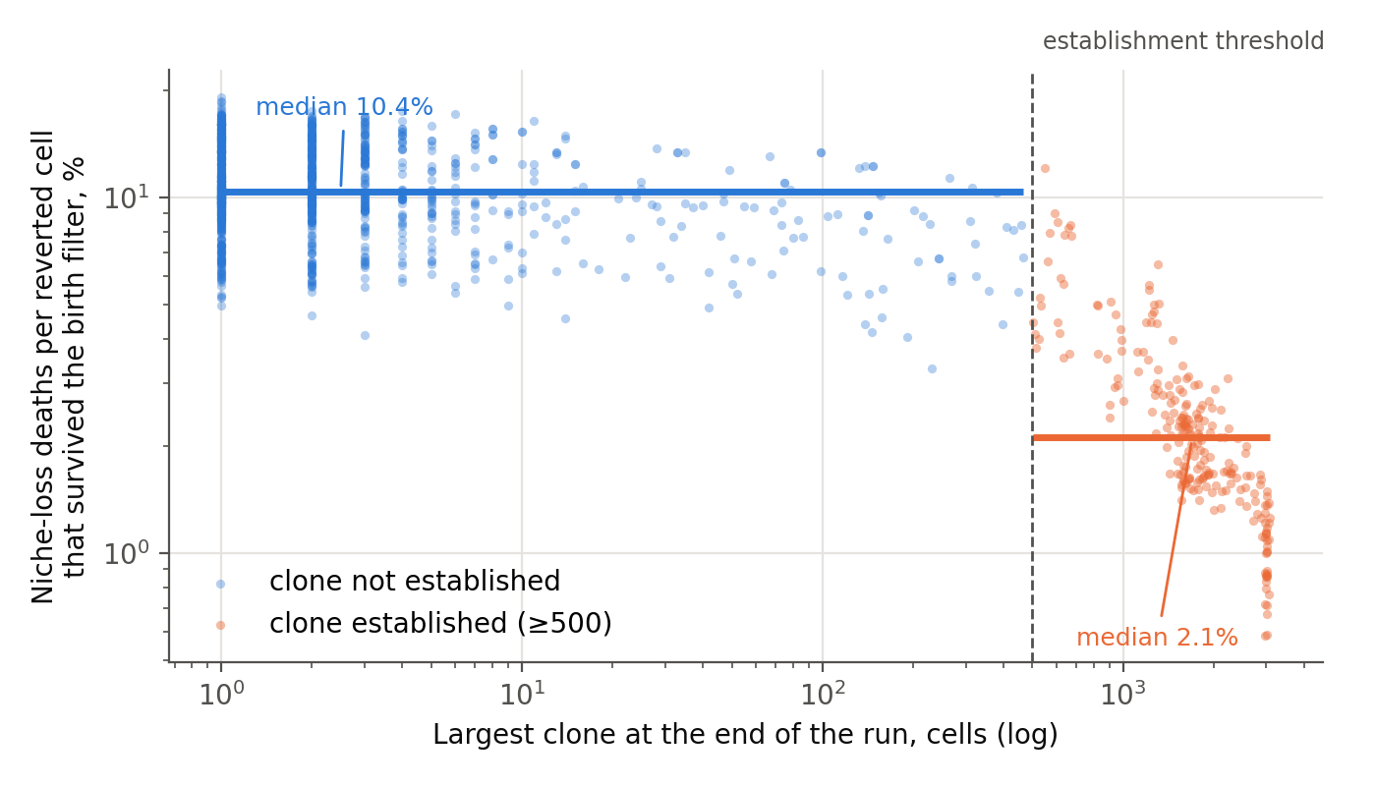
Figure 4.1. Deaths of reverted cells from loss of niche, expressed per birth that survived the oxygen filter, as a function of final clone size. Both axes are logarithmic; the wounded and unwounded series at oxyRev from 0.30 to 0.50 are pooled, 1,300 runs. Horizontal lines give the group medians.
What is measured. Among reverted cells that survive the oxygen filter at birth, the fraction that then die from loss of niche is 10.4% in runs where no clone became established and 2.1% where one did — a five-fold difference. The quantity falls monotonically with clone size (Spearman rank correlation −0.55). The mechanism can be read directly in the engine’s code: death from loss of niche occurs only in a cell that has neither free territory of its own nor neighbours of the same lineage, and the area occupied by a clone removes both conditions. In other words, the clone does remove one of the barriers for its own cells — the one tied to space.
What does not happen. The clone does not reduce its oxygen tax. An established clone grows by continuous division of the reverted lineage. Every such division rolls the birth filter anew, and nothing in the model allows the clone to pay it less, however large it grows. The initial supposition — that a quiescent interior shelters the clone from the filter — is not supported by the model: an established clone is in constant turnover, not at rest. The number of divisions per cell of the clone depends on the parameters and was not calibrated here; the argument does not rest on it.
The loop is therefore selective. The clone builds itself a way out of the barrier tied to space and does not build one out of the oxygen barrier. This agrees with the conclusion of Chapter 2 and explains why the oxygen filter remains the only barrier that keeps acting after a clone has become established, whereas resource and space constraints cease to act once it has. Before establishment neither barrier suffices alone (Section 2.6).
The boundary of the question itself is also found here, and it does not run where it seemed to. In real tissue a growing clone consumes oxygen and remodels the matrix, that is, it has feedbacks aimed at precisely the two barriers it cannot escape within the model. Testing whether a clone builds itself an environment resembling the embryonic one is, however, impossible in the present setting altogether, and the reason is anatomical rather than computational.
In a monolayer every cell sits on the basement membrane, and supply arrives from the stroma beneath it. The distance to the source is the same for every cell of the sheet and does not change with clone size: spreading laterally, the clone does not move away from its supply. A self-generated hypoxic core requires that some cells lie further from the source than others, and with equal distances that is achieved by accumulation in the vertical plane or by exit into the stroma; equal distance, however, does not guarantee equal concentration, which also depends on consumption and on diffusion resistance. The present engine therefore cannot reproduce this feedback: oxygen in it is not a spatial field with consumption, so the thesis of a self-created embryonic environment is not tested here, and a general prohibition for monolayers does not follow from the geometry alone.
The same consideration explains why the loop measured above proved to be a spatial one: territory is the only feedback that two-dimensional geometry permits. The five-fold reduction in deaths from loss of niche shows that a mechanism of this kind operates, but it does not confirm the general thesis, since it concerns the only axis available.
The question can be closed by a setting with a variable distance to the source. What is required of it is self-generated gradients of oxygen and glucose, and a critical mass above which the filter in the core ceases to cull; the present engine does not represent such a threshold. A full three-dimensional lattice is not the only route to this: the axis “distance to vessel” is already contained in the paracapillary and intercapillary geometries, and the loop may legitimately be closed there without building a volume of tissue in full.
Such a setting should be designed with Rule 7 in mind. It introduces new free parameters — diffusion length, consumption rate, spacing between sources — and it is they that will determine the answer. Only the sign can be trusted in it: whether a self-generated hypoxic core appears at all, and whether it reverses the sign of the oxygen barrier. The radius at which this happens belongs to the parameterization, not to the tissue. A bench built around the question of sign will give a transferable result; one built around the question of radius will not.
A limitation of this observation. The runs in which a clone grew are the same runs in which it survived, and cause and consequence cannot be separated from end-of-run data: the five-fold difference describes both what allowed the clone to become established and what followed from establishment. They can be separated within a single run, by comparing the rate of death from loss of niche before and after the threshold is crossed. This requires recording the counters over the course of a run, not only clone size; the present runner records the latter, and adding the former is a one-line change.

Afterword: Why the Model Stops Here
The restricted design of the present model is deliberate. Its purpose is not to reproduce the full architecture of a growing neoplasm, but to isolate the conditions under which a reverted lineage can first persist and become established within an epithelial sheet.
For this reason the parameter grid was built around the comparisons that question requires, rather than as a complete factorial exploration of the possible combinations. The combination of full glycogen storage (revStore = 1.0) with an active oxygen filter (oxyRev < 1), initially left out, was later simulated (Section 2.6; Appendix A.3): the filter alone does not contain the clone at full glycogen. The conclusions of Chapters 1 and 2 are accordingly stated for reduced glycogen, and the completed grid sets their limits: containment requires both a reduced glycogen store and an active oxygen filter, and what the grid does not test is any other form of filter or glycogen limit.
The value revStore = 0.33 should likewise not be read as a measured physiological quantity. It is a model value chosen to represent a substantially reduced but still operational energy buffer in the reverted lineage; the lower bound of the range is likewise a model choice, not a biological inference (Section 1.4.1). The additional revStore series tests whether the behavior observed at this reference value is peculiar to a single parameter choice (Section 1.4.2); it does not attempt to locate a universal glycogen threshold.
Finally, the two-dimensional geometry is itself part of the experimental design rather than a simplification accepted for convenience. By making vertical accumulation impossible, the monolayer bench separates retention and lateral establishment from the degrees of freedom that appear once a clone can grow out of the plane (Introduction to Part I; Section 4.6.1). The present model is therefore not a reduced three-dimensional tumor model. It establishes the reference system required for the next stage of the work, in which vertical growth, tissue deformation, basement-membrane interaction, extracellular-matrix constraints, spatial gradients and invasion can be introduced explicitly.
The endpoint of this study is consequently also the starting point for the models that follow it: a clone that has succeeded in becoming established within the epithelial plane. What happens when that clone is allowed to leave the plane is a separate problem, and it requires a three-dimensional architecture.
One further boundary is drawn inside the text rather than here. Section 4.1.1 proposes that a clone which never becomes established may still supply cells to an ectopic site, and extends the decomposition by two terms to accommodate it. That proposal is deliberately left unquantified and unpositioned with respect to the literature on early dissemination: the four steps it would take are set out there, and none of them belongs in this paper. It is included because the decomposition is what this work is about, and because a term that is known to be missing should be named rather than left to be inferred.

Code and Data Availability
The simulation engine, the batch runners, the interactive JavaScript bench and the complete run data behind Chapters 1, 2 and 4 — 9,110 runs, one row per run — are archived at Zenodo under DOI 10.5281/zenodo.23065346, together with the script that regenerates every figure in this paper from the deposited data. The archive is released under the MIT licence for the code and CC BY 4.0 for the data and figures: 10.5281/zenodo.23065346 The runs of the sibling-fate variants B and C (5,500 each), of the 800-run extension at revStore = 0.33 and of the 3,000-run check of the sibling-fate rule (Appendix A.8), with their runners, are to be deposited with the next version of the archive.

References
1. Pellerin L., Magistretti P.J. Glutamate uptake into astrocytes stimulates aerobic glycolysis: a mechanism coupling neuronal activity to glucose utilization. Proc Natl Acad Sci USA. 1994;91(22):10625–10629. doi:10.1073/pnas.91.22.10625
2. Magistretti P.J., Allaman I. A cellular perspective on brain energy metabolism and functional imaging. Neuron. 2015;86(4):883–901. doi:10.1016/j.neuron.2015.03.035
3. Dienel G.A. Lack of appropriate stoichiometry: strong evidence against an energetically important astrocyte–neuron lactate shuttle in brain. J Neurosci Res. 2017;95(11):2103–2125. doi:10.1002/jnr.24015
4. Myllyharju J. Prolyl 4-hydroxylases, the key enzymes of collagen biosynthesis. Matrix Biol. 2003;22(1):15–24. doi:10.1016/s0945-053x(03)00006-4
5. Holster T., Pakkanen O., Soininen R. et al. Loss of assembly of the main basement membrane collagen, type IV, but not fibril-forming collagens and embryonic death in collagen prolyl 4-hydroxylase I null mice. J Biol Chem. 2007;282(4):2512–2519. doi:10.1074/jbc.M606608200
6. Rautavuoma K., Takaluoma K., Sormunen R. et al. Premature aggregation of type IV collagen and early lethality in lysyl hydroxylase 3 null mice. Proc Natl Acad Sci USA. 2004;101(39):14120–14125. doi:10.1073/pnas.0404966101
7. Yahalomi D., Atkinson S.D., Neuhof M. et al. A cnidarian parasite of salmon (Myxozoa: Henneguya) lacks a mitochondrial genome. Proc Natl Acad Sci USA. 2020;117(10):5358–5363. doi:10.1073/pnas.1909907117
8. Danovaro R., Dell’Anno A., Pusceddu A. et al. The first metazoa living in permanently anoxic conditions. BMC Biol. 2010;8:30. doi:10.1186/1741-7007-8-30
9. Mehra K.K., Chang M.C., Folkins A.K., Raho C.J., Lima J.F., Yuan L., Mehrad M., Tworoger S.S., Crum C.P., Saleemuddin A. The impact of tissue block sampling on the detection of p53 signatures in fallopian tubes from women with BRCA 1 or 2 mutations (BRCA+) and controls. Mod Pathol. 2011;24(1):152–156. doi:10.1038/modpathol.2010.171 — p53 signatures in 71 % of BRCA carriers and 50 % of controls, P = 0.12; detection roughly doubled by serial sectioning. Published online 24 September 2010; the source note from which this entry was imported cited the online year, and the print year is given here.
10. Visvanathan K. et al. Fallopian tube lesions in women at high risk for ovarian cancer: a multicenter study. Cancer Prev Res (Phila). 2018;11(11):697–706. doi:10.1158/1940-6207.CAPR-18-0009 — source of the definition of the p53 signature as at least twelve consecutive secretory nuclei, and of the figures: invasive serous carcinoma 1.5 %, STIC 3.5 %, STIL 1.3 % among 400 high-risk women.
11. Glandular abnormalities, adenocarcinoma in situ, and glandular intraepithelial neoplasia. NCBI Bookshelf, NBK568389. — glandular abnormalities at 0.5–0.8 per 1000 smears, and 0.02 times the rate of squamous reports. Not a journal article; cited in the form its nature allows.
12. Cervical adenocarcinoma in situ in the United States: results from population-based laboratory surveillance, 2008–2014. PMC5632134. — AIS in 2.8 % of 18 394 detected cervical precancers, against 31 % with CIN3 alone. Verification incomplete: the repository returned a browser challenge when this entry was re-checked, so journal, volume, pagination and DOI remain to be confirmed before print.
13. Suchońska B., Ługowski F., Papież M., Ludwin A. Vaginal intraepithelial neoplasia (VaIN) — a retrospective cohort analysis of epidemiology, risk factors, and management in an academic clinical center. J Clin Med. 2025;14(15):5386. doi:10.3390/jcm14155386 — 90.9 % of patients with VaIN 2+ were HPV-positive in this cohort. The ratio of about one hundred against CIN, used in Table 3.1, is attributed in this paper to earlier work rather than measured in the cohort; see the qualification in Section 3.2.
14. Vaginal intraepithelial neoplasia — overview. ScienceDirect topic page. — incidence 0.1–0.3 per 100 000. A reference compilation rather than a primary source, retained for an order of magnitude only.
15. Stücker M., Struk A., Altmeyer P., Herde M., Baumgärtl H., Lübbers D.W. The cutaneous uptake of atmospheric oxygen contributes significantly to the oxygen supply of human dermis and epidermis. J Physiol. 2002;538(3):985–994. doi:10.1113/jphysiol.2001.013067 — surface pO₂ 163 ± 9 Torr; the outer 0.25–0.40 mm supplied almost exclusively from the atmosphere; a distinct minimum at about 100 µm, at the dermo-epidermal junction. Verification incomplete: the full-text repository could not be reached when this entry was re-checked, so volume, pagination and DOI remain to be confirmed before print.
16. The evolving spectrum of endocervical adenocarcinoma in situ (AIS). Virchows Arch. 2020. doi:10.1007/s00428-020-02770-3
17. Gastric-type adenocarcinoma of the cervix. Pathology Outlines. — the HPV-independent glandular pathway, about 20 % of endocervical adenocarcinomas, with atypical lobular endocervical glandular hyperplasia as its precursor. A reference website; cited in the form its nature allows.
18. Polterauer S., Reinthaller A., Horvat R., Joura E., Grimm C. et al. Cervical adenocarcinoma in situ: update and management. Curr Obstet Gynecol Rep. 2013;2(2):86–93. doi:10.1007/s13669-013-0039-6 — previously cited here as “Bogers J. et al.”; that attribution could not be confirmed for this article.
19. Adolph L., Mann A., Liu X.Q., Roberts L. et al. Follow-up of women with cervical adenocarcinoma in situ treated by conization: a single centre clinical experience. Gynecol Oncol. 2024;187:74–79. doi:10.1016/j.ygyno.2024.05.004 — previously cited here as “Munmany M. et al., Gynecol Oncol Rep.”; neither the first author nor the journal matched the published record.
20. Ciavattini A., Giannella L., Delli Carpini G., Tsiroglou D., Sopracordevole F., Chiossi G., Di Giuseppe J.; Italian Society of Colposcopy and Cervico-Vaginal Pathology (SICPCV). Adenocarcinoma in situ of the uterine cervix: clinical practice guidelines. Eur J Obstet Gynecol Reprod Biol. 2019;240:273–277. doi:10.1016/j.ejogrb.2019.07.014
21. Milic N., Varnicic Lojanica M., Ivanovic S., Ivanovic M., Ivanovic K., Jovic N. Cervical adenocarcinoma in situ in a young nulliparous patient with persistent ASC-US and multiple-type HPV infections without HPV 16 and 18 types — case report. Diagnostics (Basel). 2026;16(4):617. doi:10.3390/diagnostics16040617
22. Labidi-Galy S.I. et al. High grade serous ovarian carcinomas originate in the fallopian tube. Nat Commun. 2017;8(1):1093. doi:10.1038/s41467-017-00962-1
23. Cheng Z. et al. The genomic trajectory of ovarian high-grade serous carcinoma can be observed in STIC lesions. J Pathol. 2024;264(1):42–54. doi:10.1002/path.6322 — this is the peer-reviewed version; the preprint of the same work is titled “…is determined in STIC lesions”, a stronger claim that the published title does not make.
24. Luvero D., Angioli R., Notaro E. et al. Serous tubal intraepithelial carcinoma (STIC): a review of the literature on the incidence at the time of prophylactic surgery. Diagnostics (Basel). 2024;14(22):2577. doi:10.3390/diagnostics14222577
25. Kader T. et al. Multimodal spatial profiling reveals immune suppression and microenvironment remodeling in fallopian tube precursors to high-grade serous ovarian carcinoma. Cancer Discov. 2025;15(6):1180–1202. doi:10.1158/2159-8290.CD-24-1366 — this is the peer-reviewed version; previously cited here as a 2024 bioRxiv preprint.
26. Kraiczy J., Yu B. Human fallopian tube epithelial organoids with TP53 mutation recapitulate features of serous tubal intraepithelial carcinoma (STIC). Gynecol Oncol. 2025;203:198–208. doi:10.1016/j.ygyno.2025.10.038
27. Sainz de Aja J., Dost A.F.M., Kim C.F. Alveolar progenitor cells and the origin of lung cancer. J Intern Med. 2021;289(5):629–635. doi:10.1111/joim.13201
28. Jones-Freeman B., Starkey M.R. Bronchioalveolar stem cells in lung repair, regeneration and disease. J Pathol. 2020;252(3):219–226. doi:10.1002/path.5527
29. Yin H., Jing B., Xu D. et al. Identification of active bronchioalveolar stem cells as the cell of origin in lung adenocarcinoma. Cancer Res. 2022;82(6):1025–1037. doi:10.1158/0008-5472.CAN-21-2445
30. Lin C., Song H., Huang C. et al. Alveolar type II cells possess the capability of initiating lung tumor development. PLoS ONE. 2012;7(12):e53817. doi:10.1371/journal.pone.0053817
31. Yin H., Jiang Z., Feng X., Ji Z., Jin W. et al. Identification of Sca-1+Abcg1+ bronchioalveolar epithelial cells as the origin of lung adenocarcinoma in a Gprc5a-knockout mouse model through the interaction between lung progenitor AT2 and Lgr5 cells. Oncogene. 2020;39(18):3754–3773. doi:10.1038/s41388-020-1251-2
32. Lan T., Arastu S., Lam J. et al. Glucose-6-phosphate dehydrogenase maintains redox homeostasis and biosynthesis in LKB1-deficient KRAS-driven lung cancer. Nat Commun. 2024;15:5857. doi:10.1038/s41467-024-50157-8
33. Aurora A.B., Khivansara V., Leach A. et al. Loss of glucose 6-phosphate dehydrogenase function increases oxidative stress and glutaminolysis in metastasizing melanoma cells. Proc Natl Acad Sci USA. 2022;119(6):e2120617119. doi:10.1073/pnas.2120617119
34. Benito A., Polat I.H., Noé V., Ciudad C.J., Marin S., Cascante M. Glucose-6-phosphate dehydrogenase and transketolase modulate breast cancer cell metabolic reprogramming and correlate with poor patient outcome. Oncotarget. 2017;8(63):106693–106706. doi:10.18632/oncotarget.21601
35. Kimble A., Robbins M.E., Perez M. Pathogenesis of bronchopulmonary dysplasia: role of oxidative stress from ‘omics’ studies. Antioxidants (Basel). 2022;11(12):2380. doi:10.3390/antiox11122380
36. Fu R.-H., Chiu T.-H., Chiang M.-C., Lien R. et al. Lower erythrocyte glutathione peroxidase activity in bronchopulmonary dysplasia in the first week of neonatal life. Neonatology. 2008;93(4):269–275. doi:10.1159/000112209
37. Couroucli X.I. Oxidative stress in the retina: implications for retinopathy of prematurity. Curr Opin Toxicol. 2018;7:102–109. doi:10.1016/j.cotox.2017.11.008 — previously cited here as “Semin Fetal Neonatal Med. 2017”; both the journal and the year were wrong.
38. Retinopathy of prematurity. StatPearls. Treasure Island (FL): StatPearls Publishing; 2025.
39. Patra K.C., Hay N. The pentose phosphate pathway and cancer. Trends Biochem Sci. 2014;39(8):347–354. doi:10.1016/j.tibs.2014.06.005
40. Rump A., Morikawa Y., Tanaka M. et al. Binding of ovarian cancer antigen CA125/MUC16 to mesothelin mediates cell adhesion. J Biol Chem. 2004;279(10):9190–9198. doi:10.1074/jbc.M312372200
41. Kaneko O. et al. A binding domain on mesothelin for CA125/MUC16. J Biol Chem. 2009;284(6):3739–3749. doi:10.1074/jbc.M806776200
42. Scholler N., Garvik B., Hayden-Ledbetter M., Kline T., Urban N. Development of a CA125-mesothelin cell adhesion assay as a screening tool for biologics discovery. Cancer Lett. 2007;247(1):130–136. doi:10.1016/j.canlet.2006.03.029
43. Felsenstein M. et al. Perineural invasion in pancreatic ductal adenocarcinoma (PDAC): a saboteur of curative intended therapies? J Clin Med. 2022;11(9):2367. doi:10.3390/jcm11092367. Correction: J Clin Med. 2023;12(21):6947. doi:10.3390/jcm12216947 (Tables 1–2 and related text corrected; the authors state that the conclusions are unaffected).
44. Kondo N., Murakami Y., Uemura K., Hashimoto Y., Nakagawa N., Sasaki H., Sueda T. An increased number of perineural invasions is independently associated with poor survival of patients with resectable pancreatic ductal adenocarcinoma. Pancreas. 2015;44(8):1345–1351. doi:10.1097/MPA.0000000000000413 — previously cited here as “Ann Surg Oncol. 2015”; the journal was wrong.
45. Borsekofsky S., Tsuriel S., Hagege R.R., Hershkovitz D. Perineural invasion detection in pancreatic ductal adenocarcinoma using artificial intelligence. Sci Rep. 2023;13:13628. doi:10.1038/s41598-023-40833-y
46. Crapo J.D., Mercer R.R. Normal anatomy and defense mechanisms of the lung. In: Baum G.L., Crapo J.D., Celli B.R., Karlinsky J.B., eds. Textbook of Pulmonary Diseases. 6th ed. Philadelphia: Lippincott-Raven; 1998:23–46.
47. Ochs M., Nyengaard J.R., Jung A. et al. The number of alveoli in the human lung. Am J Respir Crit Care Med. 2004;169(1):120–124. doi:10.1164/rccm.200308-1107OC
48. Schlesinger R.B., Lippmann M. Selective particle deposition and bronchogenic carcinoma. Environ Res. 1978;15(3):424–431. PMID 679903
49. Balásházy I., Hofmann W., Heistracher T. Local particle deposition patterns may play a key role in the development of lung cancer. J Appl Physiol. 2003;94(5):1719–1725. doi:10.1152/japplphysiol.00527.2002 — replaces an earlier entry cited as “J Aerosol Med. 1991”, which could not be located in the published record.
50. Levins R. The strategy of model building in population biology. Am Sci. 1966;54(4):421–431.
51. Levins R. Discussion paper: the qualitative analysis of partially specified systems. Ann N Y Acad Sci. 1974;231(1):123–138. doi:10.1111/j.1749-6632.1974.tb20562.x
52. Justus J. Loop analysis and qualitative modeling: limitations and merits. Biol Philos. 2006;21(5):647–666. doi:10.1007/s10539-006-9050-x
53. Gutenkunst R.N., Waterfall J.J., Casey F.P., Brown K.S., Myers C.R., Sethna J.P. Universally sloppy parameter sensitivities in systems biology models. PLoS Comput Biol. 2007;3(10):e189. doi:10.1371/journal.pcbi.0030189
54. Mohyeldin A., Garzón-Muvdi T., Quiñones-Hinojosa A. Oxygen in stem cell biology: a critical component of the stem cell niche. Cell Stem Cell. 2010;7(2):150–161. doi:10.1016/j.stem.2010.07.007
55. Covello K.L., Kehler J., Yu H. et al. HIF-2α regulates Oct-4: effects of hypoxia on stem cell function, embryonic development, and tumor growth. Genes Dev. 2006;20(5):557–570. doi:10.1101/gad.1399906
56. Cohnheim J. Vorlesungen über allgemeine Pathologie. Berlin: Hirschwald; 1877 (the embryonal-rest hypothesis). For a modern account of the theory and its history, see Capp J.-P. Cancer stem cells: from historical roots to a new perspective. J Oncol. 2019;2019:5189232. doi:10.1155/2019/5189232
57. Potter V.R. Phenotypic diversity in experimental hepatomas: the concept of partially blocked ontogeny. The 10th Walter Hubert Lecture. Br J Cancer. 1978;38(1):1–23. doi:10.1038/bjc.1978.159
58. Huang S., Ernberg I., Kauffman S. Cancer attractors: a systems view of tumors from a gene network dynamics and developmental perspective. Semin Cell Dev Biol. 2009;20(7):869–876. doi:10.1016/j.semcdb.2009.07.003
59. Morral C., Ayyaz A., Kuo H.-C. et al. (Kirsch D.G., corresponding). p53 promotes revival stem cells in the regenerating intestine after severe radiation injury. Nat Commun. 2024;15:3018. doi:10.1038/s41467-024-47124-8 — p53 is required for the emergence of revival stem cells and fetal-like crypt base columnar cells after irradiation; the rise is transient, peaking about two days after injury and limited by Mdm2 feedback by day three; sustained activation reduces regeneration and collapses organoid culture; Yap cooperates in inducing the revival state; transactivation-domain mutants fail to induce apoptosis yet remain sensitised to gastrointestinal syndrome, indicating that the protective effect runs through reprogramming rather than arrest or apoptosis.
60. Kumar A., Mazzanti M., Mistrik M., Kosar M., Beznoussenko G.V., Mironov A.A., Garrè M., Parazzoli D., Shivashankar G.V., Scita G., Bartek J., Foiani M. ATR mediates a checkpoint at the nuclear envelope in response to mechanical stress. Cell. 2014;158(3):633–646. doi:10.1016/j.cell.2014.05.046. PMID 25083873 — an apical DNA-damage-response kinase responding to mechanical stress at the nuclear envelope, independently of DNA lesions.
61. Melin N., Yarahmadov T., Sanchez-Taltavull D., Birrer F.E., Brodie T.M., Petit B., Felser A., Nuoffer J.M., Montani M., Vozenin M.C., Herrmann E., Candinas D., Aebersold D.M., Stroka D. A new mouse model of radiation-induced liver disease reveals mitochondrial dysfunction as an underlying fibrotic stimulus. JHEP Rep. 2022;4:100508. doi:10.1016/j.jhepr.2022.100508 — p53 signalling after a single focal 50 Gy dose is biphasic: strong at day 1, reduced by day 6, rising again at weeks 6 and 20, with p21 elevated throughout and p16 accumulating in the fibrotic focus by week 20. Cited here for the time course only; hepatocyte proliferation and regeneration were not measured in that work, which therefore does not establish the sign of the effect.
62. Foskolou I.P. et al. Ribonucleotide reductase requires subunit switching in hypoxia to maintain DNA replication. Mol Cell. 2017;66(2):206–220.e9. doi:10.1016/j.molcel.2017.03.005
63. Liang H.-Y., Luo R.-Z., Deng R., Chen S.-L. et al. Glycogen stores mediated by the p53-GYS1 feedback circuit engenders platinum resistance in ovarian clear cell carcinoma. Cell Death Differ. 2025;32(9):1707–1721.
64. Chen X., Yang N., Wang Y., Yang S., Peng Y. PCK1-mediated glycogenolysis facilitates ROS clearance and chemotherapy resistance in cervical cancer stem cells. Sci Rep. 2024;14:13670.

Appendix A. Extensions the Published Code Supports
This appendix belongs to Part I. The 2,500 runs of Chapters 1, 2 and 4 were extended by the 6,610 runs of series S0–S5, whose results are reported in Section 2.6; the appendix documents their design and the extensions the published engine and runners further support, so that a reader can repeat or carry them on without reconstructing anything. The code, the complete run data (9,110 runs, with 24-hour trajectories for series S0–S5) and the runner for these series are published with the paper. The 11,800 runs of the sibling-fate variants B and C and of the extension at revStore = 0.33 (Appendix A.7), and the 3,000 runs of the rule check (Appendix A.8), are to be added with the next version of the archive.
Every series below uses the same engine, lattice (76 × 79), horizon (20,000 h), establishment threshold (500 cells), pRevert (1/1000) and seed set (0–99; 0–49 in S4) as Chapters 1–2, so its output is directly comparable with the published runs. The runner supplied for them differs from the two used in Chapters 1–2 in two respects only: the size of the largest clone is recorded every 24 h for the whole run, so that the establishment threshold can be varied afterwards without re-running (for the bounded scenario only the 500-cell threshold is protocol-exact, because crossing it stops the wounding); and in wound series the bounded and chronic runs of the same seed share the same wound interval, giving a paired design.
Table A.1. Simulation series the published code supports, with the settings each would use (6,610 runs in all, including the 10-run reproducibility check).
Series | revStore | oxyRev | Scenario | Runs | Purpose
S0 | 0.33 | 0.40; 1.0 | none | 10 | Exact reproduction of 5 seeds from the existing series (engine check)
S1 | 1.0; 0.33 | 0.30–0.60, 1.0; 0.55–0.60 | none | 1,000 | The missing corner: the oxygen filter with full glycogen; upper end of the oxygen grid
S2 | 0.50; 0.75 | 0.30–0.60, 1.0 | none | 1,600 | The rest of the revStore × oxyRev phase diagram
S3 | 0.20–1.0 | 0.50 | bounded, chronic (paired) | 1,000 | Sensitivity to glycogen under wounding
S4 | 0.33, 0.50, 1.0 | 0.30–1.0 (5 values) | none (pRevert 1/2000 and 1/500) | 1,500 | Robustness to the reversion rate; 50 seeds per cell
S5 | 0.20, 0.25, 0.30 | 0.30, 0.40, 0.50, 0.55, 0.60 | none | 1,500 | The low-glycogen corner of the grid; two computers (S5A / S5B)
A.1. Per-seed data. The published run tables give one row per run, so the distributions behind every aggregate reported in Chapters 1–2 can be recovered without re-running anything. The runner supplied for the series below adds a second file holding the 24-hour trajectory of clone size for each run.
A.2. Wounding. Sensitivity to glycogen under wounding at oxyRev = 0.50 — series S3, reported in Section 2.6. The revStore grid runs from 0.20 to 1.0, so it also covers the oxygen filter at full glycogen under wounding at this filter value. Bounded and chronic runs of the same seed share the same wound interval, so that the two scenarios can differ only after establishment (Section 2.4). In all series the wound is inflicted at the centre of the sheet, as in Chapters 1–2.
A.3. Joint revStore × oxyRev grid without wounding. A test of whether the two barriers combine multiplicatively or interact (series S1 and S2, combined with the existing revStore = 0.33 series). The grid includes revStore = 1.0 with oxyRev < 1 — the corner of the design missing from the first version of Part I. The result (Section 2.6) is that the filter is not sufficient on its own at full glycogen, and that the two barriers combine approximately as a product. Series S5 adds the rows revStore = 0.20–0.30 at five filter values.
A.4. Reproducibility checks. Series S0 reproduces five seeds of the existing series exactly and is the first thing to run: any deviation means the engine is not the one that produced the published data. Run by the authors, it reproduced all ten runs in all ten outcome columns without deviation (Section 2.6). The JavaScript and Python implementations can also be compared, at the level of outcomes rather than step-by-step trajectories, for the reason given in the Introduction to Part I.
A.5. The historical run on the previous engine. The archival run referred to in Section 1.6 (14% establishment without wounding), with its engine version and parameter values stated explicitly. It is kept as a reference point only and is not compared quantitatively with the current engine.
A.6. Sensitivity to the establishment threshold. The establishment threshold (500 cells) is conventional, and in a two-dimensional model it does not correspond to a clinical boundary. To check whether the result depends on it, establishment was recomputed from the 24 h trajectories of series S0–S5 at thresholds of 250, 500 and 1,000 cells (the condition is “greater than the threshold”, as in the engine; at 500 the establishment flag is reproduced for all 6,610 runs). The recomputation needs no new runs; the script is code/threshold_sensitivity.py and the results are in data/derived/threshold_sensitivity.csv. Limitations: the 2,500 previously published runs have no trajectories; for the bounded-wounding scenario the 1,000 threshold is not assessed, because wounding stops when 500 is crossed; the trajectory is recorded once per 24 h, so brief peaks between samples are not seen.
A.7. Sensitivity to the sibling-fate rule. The engine contains a switch between the maternal variant used throughout (A: the mother survives, the daughter passes the filter with p = oxyRev; sibMode = 0), a variant with independent fates (B: each cell of a reverted-lineage pair survives with s = (1 + oxyRev)/2; sibMode = 1) and a variant with coupled fates (C: one draw per division, both cells survive with s = (1 + oxyRev)/2 or both die; sibMode = 3). A further mode (sibMode = 2, conditional) was written and dropped. For the same seed and parameters the maternal mode reproduces the engine of Chapters 1–2 step by step (1,500 steps compared: counters, cell ownership, lineage and state arrays are identical), and adding mode 3 left modes 0 and 1 unchanged (same state after 1,500 steps). The 5,500 runs of Section 2.6 (every no-wound cell with oxyRev < 1, the same seeds) were repeated with sibMode = 1 and with sibMode = 3 and compared run by run with the maternal data (scripts run_B_recompute.py and run_C_recompute.py; columns of the first work plus sibMode, Ps and mom_death). A further 800 runs (revStore = 0.33, oxyRev 0.65, 0.70, 0.75 and 0.80, variants B and C, seeds 0–99; script run_ext_033.py) extend the grid above its earlier range. Every run goes the full 20,000 h, so run time does not depend on the outcome. The runners and the run tables are to be added to the archive with the next version. The wound series were not repeated in B and C.
A.8. Check of the sibling-fate rule. The three variants differ only in how the two cells of a dividing reverted-lineage pair share the exposure, so the engine was checked directly against the formulas (s = (1 + oxyRev)/2, p = oxyRev). At every division of a reverted-lineage cell (a “pair”) the engine counts whether both cells were lost, exactly one, or none (three added counters; the random stream is unchanged). The expected shares are, for variant A, 0, 1 − p and p; for B, (1 − s)², 2s(1 − s) and s²; for C, 1 − s, 0 and s. The check was run for the three variants at oxyRev 0.30, 0.40, 0.50, 0.60 and 0.80 (s = 0.65–0.90), 200 seeds per cell and 2,000 steps per run, at a reversion rate of 0.5 per division chosen only to obtain many pairs quickly (the rule does not depend on it): 3,000 runs and 2,284,817 pairs, at least 101,000 in every cell. The founding reversion of a cell (the first time a daughter of a normal cell becomes reverted) is not a pair and was not counted; in all three variants it passes the filter with probability p = oxyRev, so the variants differ only in the divisions of cells that are already reverted. The observed shares agree with the formulas (the 15 cells are in data/derived/pair_check_summary.csv). The structural zeros are exact: in A both cells were never lost, in C exactly one cell was never lost. The largest deviation among the 35 non-degenerate comparisons is 3.1 standard errors (variant B, s = 0.75, both cells lost: 6.06% against 6.25%); the other four B cells are within 1.5 standard errors, and the sum of squared deviations is 42.3 against an expectation of about 35 ± 8. With 35 comparisons a deviation of this size has a probability of about 7% under the formulas alone, so we regard it as consistent with chance, but it was not repeated. The check tests the implementation of the rule, not the biology: which of the three rules is closer to a tissue is an assumption, which is why all three were run. A branching-process argument predicts the same ordering of the variants (for a single founder without limits of space or resources the probability that the lineage dies out is 0 in A, ((1 − s)/s)² in B and (1 − s)/s in C), but the corresponding limiting case of the engine was not tested.

