Architecture of Organism & Malignancy
The Pre-Immune Window of Monolayer Neoplasia — Preface, Section 0, Parts I–II (Chapters 1–4)
Dmitrochenko Y., M.D.
Demi S. L., Data Scientist
Working edition, September 2026

Preface
This work is about a process that will never be observed directly. A clone of 500–5,000 cells—the stage at which, in our model, the fate of a reverted cell is decided—lies several orders of magnitude below the scale at which a tumor focus becomes reliably detectable by current clinical imaging. Clones at this scale are not merely theoretical: small clonal foci are sometimes found incidentally on histological examination. But a tissue section captures only a single moment, while a biopsy destroys the very object whose development one would need to follow over time. Between the stage at which the small size of a clone limits the likelihood of an effective immune response and the point at which a tumor becomes clinically visible lies a gap of three to four orders of magnitude in cell number, beyond the reach of any direct method.
Theoretical oncology can be roughly divided into two dominant approaches. The first describes the tumor at the cellular level, through receptor signaling cascades and through its interaction with the immune system as a process of recognition and evasion. The second treats tumor growth as a physical process—diffusion, mechanics, and competition for resources—usually without regard to cellular and immune specificity and typically at the stage of an already established tumor mass.
This work does not claim to offer a universal model of oncogenesis. Its subject is the gap between these two approaches and between stages: the point at which reverted cells have already organized into a clone but have not yet become an effective target of the immune system. We model neither an established tumor nor a single transformed cell, but an intermediate, mesoscopic stage at which a small clone already functions as a tissue system. At this scale, receptor-level mechanisms and the physics of shared resources act simultaneously, and neither approach on its own can describe what happens.
The molecular components of this process are well studied: IGF1R and the PI3K/AKT/mTOR axis, p53, the molecular systems of immune recognition, regulation, and evasion (PD-1/PD-L1, NKG2D, CD200R, STING), and the metabolic machinery of the cell. We take these as given. At the tissue level, however, their interactions give rise to properties that do not exist at the level of a single cell.
- Nonlinearity. A clone can simultaneously receive a wake-up signal from senescent neighbors via TNFR1 and an opposing concealment signal through CD200 expression or STING silencing. Its fate is determined by the balance between these signals, not by their sum.
- Sequence and geometry. Reawakening before immune masking is restored and reawakening after it are different processes. Whether a cell receives a signal depends on its position relative to its neighbors and to the boundary of the perfused region. In one part of this work, tissue geometry alone proves sufficient to explain resistance to invasion.
- Probability. In our model, reversion occurs at a frequency on the order of one event per thousand divisions, the survival of a newly reverted cell is a single stochastic trial, and the establishment of a clone is the outcome of a chain of such rare events. The appropriate language here is therefore that of distributions, and we model the process as stochastic, just as statistical mechanics describes an ensemble rather than a single particle.
How can one test a model whose object cannot be seen? Physics is familiar with this situation: many of its quantities cannot be observed directly and are tested by comparing predicted distributions of outcomes with measurable statistical traces. We look for such traces in populations in which one of the model’s parameters has been shifted by nature or disease: individuals with G6PD deficiency or glycogen storage diseases, those born preterm, groups along the socioeconomic gradient, and smokers. For this reason, the model comes first: it allows us to state what must be true if the hypothesis is correct. Only then is a single question put to data from gynecology, pulmonology, neonatology, cancer epidemiology, and red blood cell biochemistry: is what was measured for an entirely different purpose consistent with the model’s prediction?
We chose the epithelial monolayer as the object of modeling because it is the simplest tissue architecture on which the approach can be developed before being extended to more complex structures. This approach can yield two results. The first is an understanding of how cells interact during oncogenesis before the immune response becomes effective, when the fate of a clone is determined by resources, tissue geometry, and chance. The second is a foundation for subsequent, more complex models: the patterns of non-immune interaction established here become the base layer onto which receptor-level and immune mechanisms can later be added.
We are aware of the cost of this approach. Indirect evidence can increase or decrease the plausibility of a hypothesis, but on its own it cannot establish that the hypothesis is true. Every transfer of a mechanism from one tissue to another is identified explicitly as such, and sources requiring verification are clearly marked. This work is neither the final word nor a challenge to existing lines of research. It is an attempt to give a testable form to what would otherwise remain intuition, and to present it to those who will have the tools to confirm, refute, or refine it.

Section 0. Definitions, Model Boundaries, and Reading Conventions
This section brings together statements that were previously scattered across separate texts. It establishes three things: what exactly is being modeled, within what boundaries the claims hold, and how to read the numbering and references. All subsequent chapters rely on the definitions given here and do not repeat them.

0.1. The pre-immune window
Everything described in this work concerns a single, bounded interval of tissue history, referred to below as the pre-immune window. The name is conventional: it does not mean that the immune system is absent, but that during this interval it is not the determining factor in the fate of the clone.
The window opens when a single reverted cell appears in an intact epithelial monolayer. It closes in one of two ways: either the clone disappears without passing the retention filters (the filters that determine whether a clone persists in the tissue), or it leaves the window by breaching the basement membrane or by reaching a mass at which it becomes, in principle, capable of producing a systemically significant signal. A quantitative estimate of the window’s upper boundary is given in Chapter 5: for the actual anatomy of target organs, the margin below the mass threshold ranges from thirtyfold to five-hundredfold, while the basement membrane barrier acts independently of mass.
Within the window, the immune system is not treated as an independent, determining filter of clonal fate. This does not mean that local immune recognition or individual immune interactions are absent: NK cells, tissue-resident immune cells, and cGAS–STING signaling can, in principle, respond even to a small number of altered cells. The position adopted here is narrower: at the scale considered, these interactions do not produce a sustained, effective response that becomes a determining filter of clonal fate alongside, or instead of, the resource, oxygen, and structural filters described here. The justification for this position is given in Chapter 5; the other chapters take it as a starting condition.
This defines the main limit of the model’s scope. Everything said below about the fate of a clone concerns competition, resources, geometry, and mechanics, not immune recognition. Beyond the window, other mechanisms become decisive (antigen recognition, immune masking, immune distraction), and this model neither describes them nor claims to.

0.2. The reverted cell: a phenotypic definition
Reversion here refers to a phenotypic state of the cell, not to its origin. The model assumes that during normal renewal of the epithelial monolayer, a small fraction of daughter cells shifts into an earlier, less differentiated state. This is assumed to be a low-rate background stochastic process that requires no external damaging trigger.
Within the model, this phenotype can arise in two ways:
- with genomic damage, as a result of a spontaneous replication error or mutagenic exposure, with a fixed mutation that disables some of the differentiation checkpoints;
- without genomic damage, as a purely epigenetic failure of the differentiation program during asymmetric division, leaving no trace in the DNA sequence.
The model does not distinguish between these two routes. Both produce a cell with the same set of model properties: a reduced energy buffer (revStore), vulnerability to oxygen at the moment of birth (oxyRev), and the ability to divide when free space is available. Both are captured by a single frequency parameter (pRevert), and the simulation engine does not distinguish between them by design.
This assumption follows from the boundary set in 0.1. All filters acting within the window (the energy buffer, the oxygen filter at birth, competition for free space, adhesive anchoring, and the upper and lower density thresholds) operate on the cell’s phenotype and position, not on its genotype. This does not mean that mutational and epigenetic reversion are biologically identical: genotype can affect metabolism, division rate, stress tolerance, adhesion, and sensitivity to apoptosis. The model’s claim is narrower: once a cell has been assigned its model phenotype, its subsequent fate within the window does not depend on how that phenotype arose. If genotype shifts the model properties themselves, such a shift can be represented in the model only as a change in phenotype parameters.
The distinction between the two routes becomes meaningful at exactly two points, both of which lie at or beyond the boundary of the model:
- At the exit from the window. The clone’s antigenic profile may depend on its origin. Mutational reversion can generate neoantigens, whereas non-mutational reversion can alter the expression of differentiation-associated or embryonic antigens without changing the DNA sequence; central tolerance to some of these antigens may be incomplete. The immunological consequences of this distinction lie outside the model and are treated in Chapter 5 as a limitation of the calculation rather than as an input.
- At the entry into the window. Mutagenic exposure (smoking, occupational carcinogens) and chronic loss of the DNA damage checkpoint (Chapter 6) increase the frequency of specifically the mutational subfraction. In other words, they act on pRevert, not on the retention filters.
This separation between how often the event occurs and the conditions under which it is selected serves as the main tool for interpreting population data in Chapters 7 and 8. In general form:
frequency of established clones ≈ rate of reverted-cell generation × probability of clonal retention in tissue.

0.3. Barriers and their status
The model identifies four mechanistically distinct barriers that prevent a reverted clone from becoming established. They should not be considered statistically independent: in real tissue, resource supply, oxygen, cell density, and the state of the basement membrane are interrelated, and the interaction between barriers is a separate subject of analysis. The barriers have different status in this work, and this difference should not be blurred:
Barrier | Physical mechanism | Status in this work
Resource competition for space and glucose | finite free space, supply threshold | tested in simulation (Chapter 1)
Oxidative vulnerability of the reverted lineage | one-time filter at the moment of cell birth | tested in simulation (Chapter 2)
Basement membrane integrity | O₂-dependent structural maintenance | supported theoretically (Chapters 1, 5)
Suppression by differentiated neighbors | contact inhibition, density thresholds | supported theoretically (Chapter 6)
The key result of Part I is that the two barriers tested in simulation are neither interchangeable nor redundant, and that they differ in kind rather than in degree. Within the biologically consistent range of the resource parameter, the resource barrier does not prevent establishment even in undamaged tissue; its only trace appears below that range and is removed entirely by wounding. The oxygen barrier, by contrast, holds establishment to a fraction of a percent in undamaged tissue and retains a dose-dependent effect even after wounding. The comparison therefore concerns not the strength of two barriers but the presence of one and the absence of the other, together with their different robustness to damage.

0.4. Reading conventions
Status of statements. The text distinguishes four types of statements: model definitions (what a term means), model assumptions (what is accepted within this work without proof), model results (what has been shown in simulation or derived from the model), and external biological evidence (what has been established independently of the model). Where the status of a statement may not be obvious, it is stated explicitly.
Numbering. Sections are numbered within each chapter, prefixed by the chapter number (Section 6.4 is the fourth section of Chapter 6). Chapter 6 retains its original three-level paragraph numbering (e.g., 6.4.3) because internal cross-references depend on it.
References. Reference lists are given separately for each chapter and keep their original citation numbering within that chapter; there is no unified bibliography. A reference such as [4] in Chapter 7 and [4] in Chapter 8 refers to different works.
Status of sources. Every entry in the reference lists was checked against the published record in September 2026: journal, year, volume and pages were confirmed, and a DOI or PMID is given wherever one exists. Where an earlier draft cited a preprint, the peer-reviewed version is cited instead and the substitution is noted in the entry. Sources that are historical or are not journal articles — Cohnheim’s lectures, a textbook chapter, a StatPearls entry — are cited in the form their nature allows.
Cross-system extrapolations. Every extrapolation of a mechanism from one model system to another is explicitly identified as such rather than presented as an established correspondence.

Part I. The Model, the Simulation Benches, and Their Behavior

Introduction. One engine, two benches
Both benches in this part run on the same epithelial simulation engine, “Jenny1”: a hexagonal lattice of about 6,000 nodes, in which each cell owns a territory of one to four nodes; tension (the mean territory size of a cell and its neighbors) governs the awakening of reserve cells and division; glucose diffuses across the sheet and is consumed in proportion to each cell’s metabolic state; and division is asymmetric (the mother returns to reserve, and the daughter also enters reserve with a probability of about 1/11). The reverted lineage differs from the normal one in two parameters:
- revStore — the ceiling of the reverted cell’s glycogen store, as a fraction of the store of a differentiated cell (the resource axis);
- oxyRev — the probability that a newborn reverted cell survives a one-time oxygen filter at the moment of its birth (the oxygen axis).
Only the features that distinguish the two benches are described here; the full engine specification accompanies the code.
The engine exists in two implementations, synchronized in logic and in the order of random-number-generator calls, so that the results of one can be cross-checked against the other:
- epithelium_bench.html / epithelium_bench_g033_o02.html — an interactive visual bench in JavaScript with real-time rendering, used for illustration and manual exploration, not for collecting statistics;
- epithelium__numba.py (merged with the batch runner in run_batch_oxygrid.py and run_batch_oxygrid_wound.py) — a headless Python/Numba engine for running hundreds of independent simulations in parallel; all quantitative statistics in this part were obtained with it.
The order of presentation follows the logic of the test. First (Chapter 1), the oxygen filter is switched off (oxyRev = 1.0), and we ask whether resource regulation alone can hold back a reverted clone. Then (Chapter 2), with the same glycogen (revStore = 0.33), the oxygen filter is switched on. The two benches differ in the value of a single parameter, oxyRev, so comparing them is a controlled experiment on one system rather than a comparison of two different models.
Common protocol for both benches. Horizon 20,000 h; a clone is counted as established when the largest connected reverted cluster exceeds 500 cells, checked every 24 h; 100 independent seeds per parameter combination, with the same seed set (0–99) in every series. Three environmental scenarios: none — no wounding; bounded — a series of wounds that stops at the first threshold crossing; chronic — wounding without stopping until the end of the horizon. Wound protocol: first wound at 1,000 h, defect size 200 cells, interval drawn per run from {12, 24, 48} h.
Desquamation and two-dimensional geometry. In a real monolayer, desquamation — the shedding of surplus and aged cells into the lumen — is what keeps the epithelium a single layer: cells that cannot be accommodated in the plane leave it upward instead of accumulating vertically. The bench does not model this process explicitly, because its outcome is already built into the geometry: the lattice is strictly two-dimensional, each node belongs to at most one cell, and a cell cannot occupy a node that is already owned, so the sheet cannot thicken and every conflict over space is resolved within the plane. Vertical accumulation is therefore impossible by construction, and all clone sizes reported in this part are areas within a single layer. Desquamation is treated here as a property of the geometry rather than as an additional mechanism, and it is deliberately not added to the engine.
Two consequences follow. First, invasion of the extracellular matrix cannot occur on the bench: the endpoint is the lateral establishment of a clone within the layer, not its exit from it. The barriers that stand between a lateral clone and invasion — the preserved single-layer geometry and the proteins of the basement membrane (Section 1.7) — act at the next step and are discussed, not simulated. Second, a cell leaves the sheet in the engine in one way only: it is removed, and the nodes it owned become free. The engine does not distinguish death from extrusion into the lumen, because for the geometry of the sheet the two are the same event — a node becomes available; the distinction between them is biological, not mathematical. Differentiated cells are removed at the end of their lifespan, whereas cells of the reverted lineage are exempt from that age-dependent route and are removed only through loss of niche, starvation or the oxygen filter at birth. With respect to cell turnover, the bench therefore represents the least favorable case for the tissue, and the containment provided by the oxygen filter (Chapter 2) is obtained without any help from turnover.
Table I.1. Summary of the two benches.
Bench | oxyRev | revStore | Scenarios | Runs | Question
Without the oxygen filter (Ch. 1) | 1.0 (off) | 0.33; control grid 0.20–0.30 | none / bounded / chronic | 300 + 900 | Is resource regulation alone sufficient?
With the oxygen filter (Ch. 2) | 0.30–0.50 | 0.33 | none; bounded / chronic | 500 + 800 | What does a second, resource-independent barrier change?

Chapter 1. The Bench Without the Oxygen Filter: Resource Regulation Alone Is Not Enough

1.1. Aim
To isolate the resource (glycogen) axis from the oxygen axis and test whether a reduced energy store of the reverted lineage — together with competition for glucose and the finite amount of free space available for division — is enough for the tissue to prevent a reverted clone from becoming established. This is logically the first and simplest of the barriers, and for that reason it is tested first and separately from the oxygen barrier.
The label “without the oxygen filter” is more precise than “anoxic”: glucose and all other engine rules operate as usual; only the oxygen culling of newborn reverted cells is switched off.

1.2. Implementation
The bench is not a separate file but a parameter value, oxyRev = 1.0, explicitly documented in the engine as “no filter, old behaviour”: every newborn reverted cell is guaranteed to survive, and the only lineage-specific constraint left is the reduced glycogen buffer.
class EngineParams:
...
revStore=.33, # fixed default (was .2 in the old engine)
oxyRev=1.0, # O2 filter: 1.0 = no filter, old behaviour
Run configuration:
row = run_one(
run_id=0,
params=dict(lifeD=6.0, revStore=0.33, oxyRev=1.0),
seed=SEED, target_hours=20000, scenario=SCENARIO, # 'none' / 'bounded' / 'chronic'
stop_threshold=500,
)

1.3. Results at revStore = 0.33
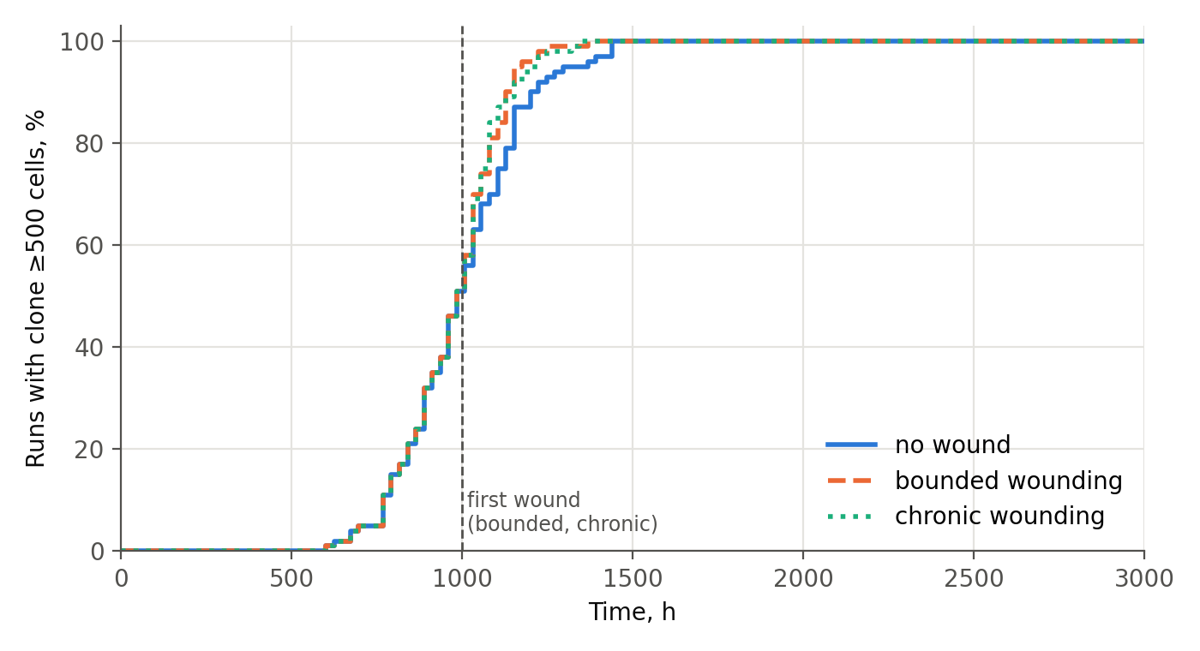
Figure 1.1. Cumulative share of runs in which the clone has become established (≥500 cells), by time and scenario; revStore = 0.33, oxyRev = 1.0 (filter off). The dashed line marks the first wound in the bounded and chronic scenarios.
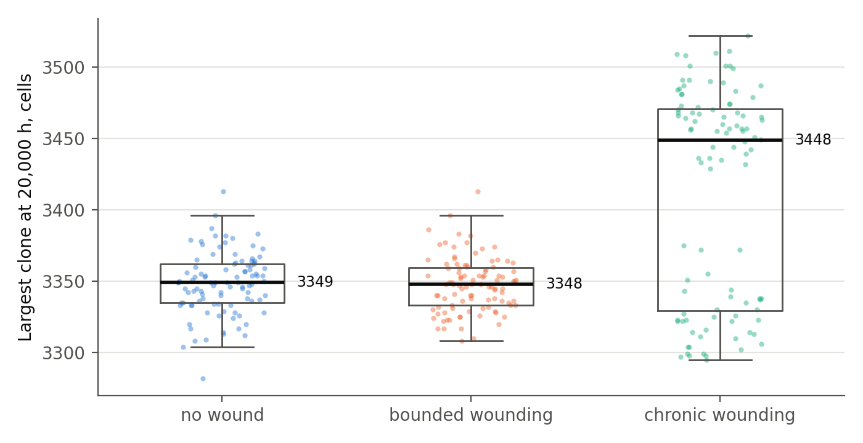
Figure 1.2. Size of the largest reverted clone at the end of the run (20,000 h), by scenario; each point is one run, boxes show the quartiles; revStore = 0.33, oxyRev = 1.0.
Table 1.1. The bench without the oxygen filter at revStore = 0.33 (100 runs per scenario).
Scenario | Established (≥500), % | Median time, h (p10–p90) | Median final clone, cells | Final density (median)
none (no wound) | 100 | 984 (768–1,202) | 3,349 | 0.558
bounded | 100 | 984 (768–1,130) | 3,348 | 0.558
chronic | 100 | 984 (768–1,152) | 3,449 | 0.574
The clone becomes established in 100% of runs in all three scenarios, including the complete absence of wounding, and it does so quickly: the median is 984 h, within the first 5% of the observation horizon, and every run crosses the threshold by 1,440 h. By the end of the run the clone occupies roughly 3,300–3,450 cells, more than half of all cells in the sheet.
The near-identity of the three scenarios must not be read as “wounding changes nothing.” The first wound is inflicted at 1,000 h, and in 51% of runs the clone crosses the threshold before that moment, so for half of the runs the scenarios are indistinguishable by construction. In the remaining runs wounding slightly accelerates establishment (the 90th percentile of establishment time falls from 1,202 h without wounding to 1,130–1,152 h with it; Fig. 1.1), but it cannot raise a probability that is already 100%. The correct reading is therefore: without the oxygen filter, the clone does not need a wound in order to become established. The scenarios differ only after establishment: under chronic wounding the final clone is slightly larger (3,449 vs. 3,349 cells) because the wound keeps freeing space.

1.4. The boundary of the resource parameter and a test below it

1.4.1. Why revStore is not taken below about one third
In both benches the glycogen ceiling of the reverted lineage is not set below about one third of the full store of a differentiated cell (revStore = 0.33). The constraint is biological.
Cells with such a small autonomous glycogen reserve are, in the great majority of cases, terminally differentiated, non-dividing cells that are metabolically supported by their neighbors rather than competing for resources on their own. The best-studied example is the neuron: neurons store very little glycogen and, according to the astrocyte–neuron lactate shuttle hypothesis, depend to a substantial degree on lactate supplied by astrocytes, particularly under increased load [1, 2]. The quantitative importance of this shuttle remains debated [3], but the qualitative point — that neurons are not energetically self-sufficient in the way a proliferating cell must be — does not depend on its resolution.
This example points in the opposite direction from the model, and that should be said plainly: a neuron does not divide or compete for territory, whereas the reverted cell of the model actively divides and competes for glucose and space. The general principle is nevertheless shared: an autonomous glycogen reserve below a certain threshold is found only in cells that have left the active cycle and no longer depend on their own energetic self-sufficiency. An actively dividing, competing reverted lineage with revStore well below one third would be a biologically inconsistent combination. The region revStore < 0.33 is therefore not treated as a biological regime in its own right, but it was tested separately (Section 1.4.2) — not to argue that it is realistic, but to make sure that the result of Section 1.3 is not an artifact of a single parameter value.

1.4.2. A revStore grid from 0.20 to 0.30
An additional grid, revStore ∈ {0.20, 0.25, 0.30}, was run with oxyRev = 1.0 in all three scenarios, with 100 seeds per combination (900 runs, horizon 20,000 h).
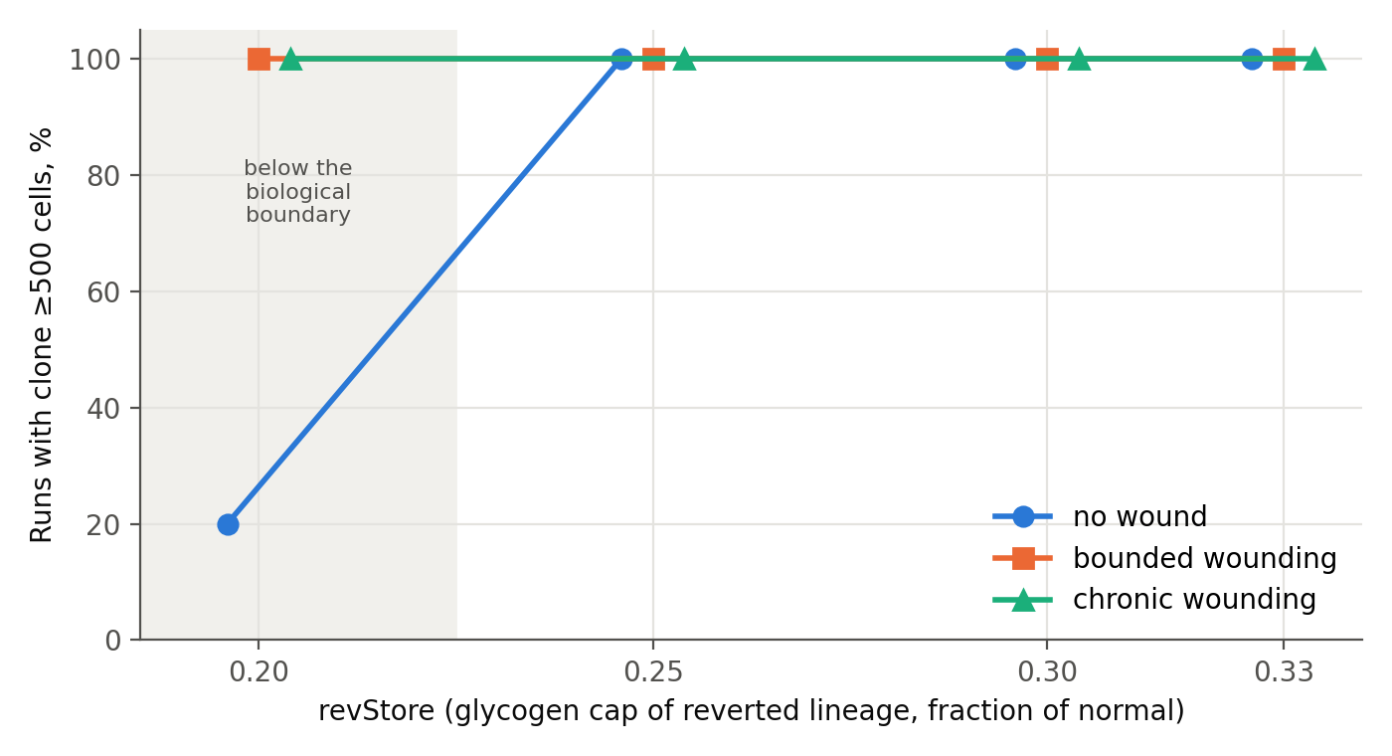
Figure 1.3. Share of runs with an established clone (≥500 cells) as a function of revStore, by scenario (oxyRev = 1.0). Markers of overlapping series are offset horizontally for legibility; the shaded band marks the region below the biological boundary (Section 1.4.1).
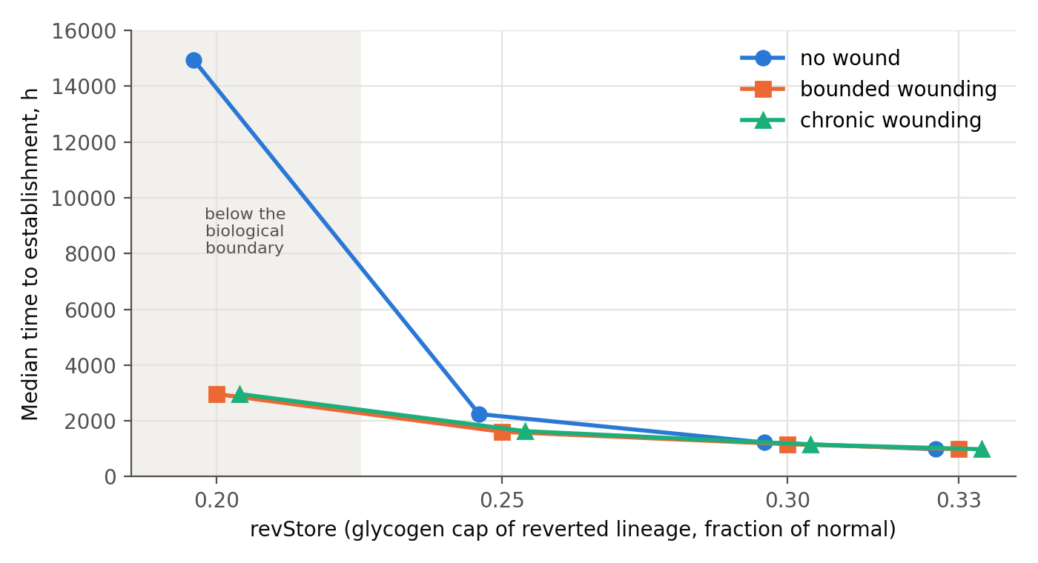
Figure 1.4. Median time to establishment as a function of revStore, by scenario (among runs in which the clone became established; oxyRev = 1.0).
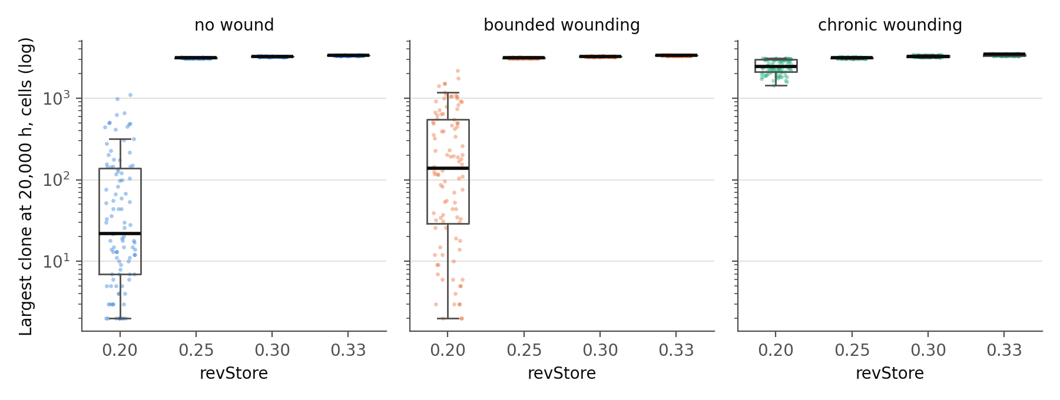
Figure 1.5. Size of the largest reverted clone at 20,000 h as a function of revStore, by scenario (log scale; zero-size clones plotted at 1; oxyRev = 1.0).
Table 1.2. The bench without the oxygen filter across the revStore grid (100 runs per row).
revStore | Scenario | Established (≥500), % | Median time, h | Median final clone, cells | Final density
0.20 | none | 20 | 14,940 | 22 | 0.547
0.20 | bounded | 100 | 2,964 | 138 | 0.542
0.20 | chronic | 100 | 2,964 | 2,460 | 0.509
0.25 | none | 100 | 2,244 | 3,125 | 0.520
0.25 | bounded | 100 | 1,608 | 3,122 | 0.520
0.25 | chronic | 100 | 1,632 | 3,129 | 0.521
0.30 | none | 100 | 1,224 | 3,244 | 0.540
0.30 | bounded | 100 | 1,164 | 3,248 | 0.541
0.30 | chronic | 100 | 1,152 | 3,259 | 0.543
0.33 (Sect. 1.3) | all three | 100 | 984 | 3,349–3,449 | 0.558–0.574
At revStore = 0.25 and 0.30 the behavior is the same as at 0.33: 100% establishment in every scenario and a final clone of 3,100–3,260 cells. Reducing glycogen only postpones establishment (984 → 1,224 → 2,244 h without wounding); it does not prevent it.
At revStore = 0.20 without wounding the picture changes: establishment falls to 20%, the median time among the runs that do establish is 14,940 h, close to the end of the horizon, and the median final clone is 22 cells. This is the only point in the grid where anything resembling a barrier appears.
That barrier is removed by wounding. In the bounded scenario (a series of wounds until the first threshold crossing; a median of about 100 wounds), establishment returns to 100% (median 2,964 h), with a final clone of 138 cells — wounding stops, and the clone has nothing further to grow into. In the chronic scenario establishment is also 100%, and the final clone reaches 2,460 cells, because the wound keeps freeing territory.
The effect at 0.20 appears as a jump rather than as a smooth gradient (0.25 and 0.30 are indistinguishable from 0.33 in establishment probability), and it disappears under wounding. It looks more like a threshold of buffer depletion — the starting store of a reverted daughter becomes so small that a substantial fraction of such cells fail to complete their first few division cycles before the buffer runs out — than like graded resource competition. The value 0.20 lies below the range in which a dividing, competing cell is a coherent model at all (Section 1.4.1), and the fact that the effect appears only there supports the chosen lower bound of 0.33 rather than undermining it.

1.5. Conclusion of Chapter 1: resource regulation alone is not enough
The bench without the oxygen filter gives an unambiguous answer. Resource regulation — the reduced glycogen buffer of the reverted lineage together with competition for glucose and for free space — does not by itself hold back a reverted clone:
- Across the whole biologically justified range (revStore 0.25–0.33), the clone becomes established in 100% of runs, with or without wounding; lowering glycogen postpones establishment but does not prevent it.
- Establishment does not require a wound: at revStore = 0.33, half of all clones cross the threshold before the first wound is inflicted.
- The only sign of resistance (20% establishment at revStore = 0.20 without wounding) appears outside the biologically consistent range and is fully removed by wounding.
The resource axis is thus necessary as the background against which competition takes place at all, but it is insufficient as a barrier. Holding the clone back requires at least one additional mechanism that does not depend on resources. Chapter 2 tests such a mechanism.

1.6. Methodological note: the historical estimate of 14%
An earlier run on a previous version of the engine (see Appendix A, Section A.5) gave 14% establishment without wounding. That figure is not comparable with the results of this chapter: the earlier version handled the reverted lineage according to different logic, which predated the introduction of the oxygen filter as a mechanism, and it used a different value of the glycogen parameter. The difference between 14% and 100% cannot be attributed to the reduction of the resource alone; it combines the change of engine with at least one other change in its internal dynamics. The historical file is kept as an archival reference point and is not used for quantitative conclusions.

1.7. Why the second barrier should be oxygen-dependent
If resource regulation is insufficient, a more general question arises: what minimal set of independent barriers is needed for a complex multicellular structure to persist for a long time without allowing a single deviant clone to expand? And why is complex multicellularity so much more common among aerobic organisms than among anaerobic ones?
The answer does not reduce to the amount of available energy (ATP per cell): some of the necessary barriers are chemically unattainable without oxygen. The collagen prolyl and lysyl hydroxylases — enzymes without which collagen does not fold into a stable triple helix — obligately use molecular O₂ as a co-substrate, together with Fe²⁺ and 2-oxoglutarate [4]. This applies above all to type IV collagen, the main structural protein of the basement membrane. In mice lacking collagen prolyl 4-hydroxylase I, the assembly of basement-membrane type IV collagen fails while fibril-forming collagens are still produced, and the embryos die [5]; loss of lysyl hydroxylase 3 likewise disrupts type IV collagen secretion and basement-membrane formation, with early lethality [6]. This is a chemical rather than an energetic constraint: without O₂ the reaction does not proceed at all, rather than proceeding more slowly.
This yields a list of independent barriers, of which the bench in this chapter tests only the first:
Table 1.3. Independent barriers against clonal establishment and their status in Part I.
Barrier | Physical mechanism | Where tested
Resource competition for space and glucose | finite free space, supply threshold | Chapter 1 — insufficient on its own
Oxidative vulnerability of the reverted lineage | one-time filter at the moment of cell birth | Chapter 2
Basement membrane integrity | O₂-dependent structural reaction, impossible without O₂ in principle | not tested in simulation
Suppression by differentiated neighbors | contact inhibition, paracrine signals | not tested in simulation
A caveat on anaerobic multicellularity. Fully anaerobic multicellularity is not forbidden in principle, but no known example demonstrates its independent origin. Henneguya salminicola, a myxozoan parasite that lacks a mitochondrial genome [7], belongs to the Cnidaria, a lineage whose body plan (including the basement membrane) had already been built by aerobic ancestors; the loss of aerobic respiration occurred on top of a finished architecture, in a parasitic niche where the energetic load is carried by the host. The loriciferans reported from permanently anoxic deep-sea sediments, which carry hydrogenosome-like organelles instead of mitochondria [8], are likewise nested within the aerobic Ecdysozoa. In both cases independence from oxygen is a secondary regression built on an existing body plan, not an independent construction of complexity without oxygen.

References for Chapter 1
- Pellerin L., Magistretti P.J. Glutamate uptake into astrocytes stimulates aerobic glycolysis: a mechanism coupling neuronal activity to glucose utilization. Proc Natl Acad Sci USA. 1994;91(22):10625–10629. doi:10.1073/pnas.91.22.10625
- Magistretti P.J., Allaman I. A cellular perspective on brain energy metabolism and functional imaging. Neuron. 2015;86(4):883–901. doi:10.1016/j.neuron.2015.03.035
- Dienel G.A. Lack of appropriate stoichiometry: strong evidence against an energetically important astrocyte–neuron lactate shuttle in brain. J Neurosci Res. 2017;95(11):2103–2125. doi:10.1002/jnr.24015
- Myllyharju J. Prolyl 4-hydroxylases, the key enzymes of collagen biosynthesis. Matrix Biol. 2003;22(1):15–24. doi:10.1016/s0945-053x(03)00006-4
- Holster T., Pakkanen O., Soininen R. et al. Loss of assembly of the main basement membrane collagen, type IV, but not fibril-forming collagens and embryonic death in collagen prolyl 4-hydroxylase I null mice. J Biol Chem. 2007;282(4):2512–2519. doi:10.1074/jbc.M606608200
- Rautavuoma K., Takaluoma K., Sormunen R. et al. Premature aggregation of type IV collagen and early lethality in lysyl hydroxylase 3 null mice. Proc Natl Acad Sci USA. 2004;101(39):14120–14125. doi:10.1073/pnas.0404966101
- Yahalomi D., Atkinson S.D., Neuhof M. et al. A cnidarian parasite of salmon (Myxozoa: Henneguya) lacks a mitochondrial genome. Proc Natl Acad Sci USA. 2020;117(10):5358–5363. doi:10.1073/pnas.1909907117
- Danovaro R., Dell’Anno A., Pusceddu A. et al. The first metazoa living in permanently anoxic conditions. BMC Biol. 2010;8:30. doi:10.1186/1741-7007-8-30

Chapter 2. The Bench With the Oxygen Filter: A Second Barrier and Its Behavior Under Injury

2.1. Aim
To test what changes when a second barrier, independent of resources, is added — a one-time survival filter applied to each reverted cell at the moment of its birth — at the same reduced glycogen as in Chapter 1 (revStore = 0.33). The motivation is the direct result of Chapter 1 (resource regulation alone is not enough) and the independently established link between oxygen and basement-membrane integrity (Section 1.7).

2.2. Implementation
The filter is implemented as a single random draw at the creation of each new reverted cell — both at a fresh reversion event and at the division of an already established reverted clone — rather than as a background hazard acting in calendar time. A daughter that fails the filter does not join the reverted lineage and is shed. The key fragment:
if clin[cid] == 1:
# parent already belongs to the reverted lineage:
# the new daughter rolls the O2 filter independently
if _rnd(counters) < oxyRev:
clin[kid] = 1
cst[kid] = DIFF
clife[kid] = 1e9
ctol[kid] = tol_steps
else:
clin[kid] = 0
cst[kid] = SHED
cshed[kid] = shedT
counters[C_REVOXYDEATH] += 1
cst[cid] = DIFF
elif _rnd(counters) < pRevert:
# fresh reversion event: this daughter
# also rolls the O2 filter
counters[C_REVTOT] += 1
if _rnd(counters) < oxyRev:
clin[kid] = 1
cst[kid] = DIFF
clife[kid] = 1e9
ctol[kid] = tol_steps
cgly[kid] = sMax0 * revStore
else:
clin[kid] = 0
cst[kid] = SHED
cshed[kid] = shedT
counters[C_REVOXYDEATH] += 1
Series without wounding (run_batch_oxygrid.py):
TARGET_HOURS = 20000
STOP_THRESHOLD = 500
OXY_GRID = [0.3, 0.35, 0.4, 0.45, 0.5]
N_SEEDS = 100
SCENARIO = 'none'
for oxy in OXY_GRID:
for seed in range(N_SEEDS):
run_one(params=dict(lifeD=6.0, revStore=0.33, oxyRev=oxy),
seed=seed, target_hours=TARGET_HOURS, scenario=SCENARIO,
stop_threshold=STOP_THRESHOLD)
Series under wounding (run_batch_oxygrid_wound.py): oxyRev ∈ {0.35, 0.40, 0.45, 0.50} × scenario ∈ {bounded, chronic}, 100 seeds per combination (800 runs), with the same wound protocol as in Chapter 1.

2.3. Results without wounding
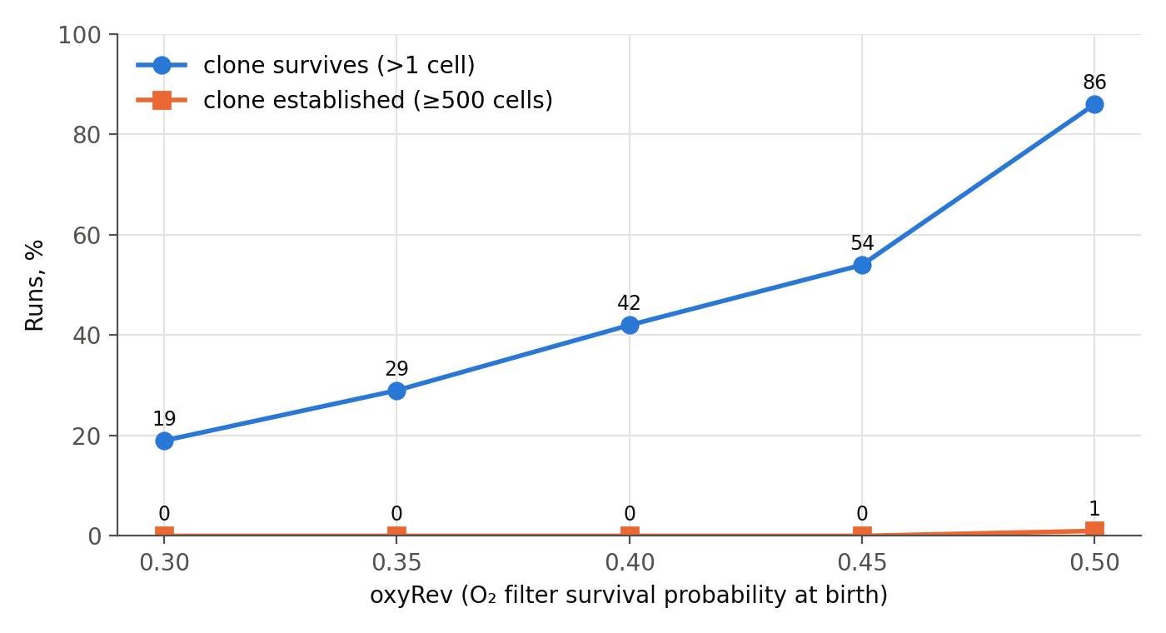
Figure 2.1. Share of runs with a surviving clone (>1 cell) and with an established clone (≥500 cells) at the end of the run, by oxygen-filter value, without wounding (revStore = 0.33).
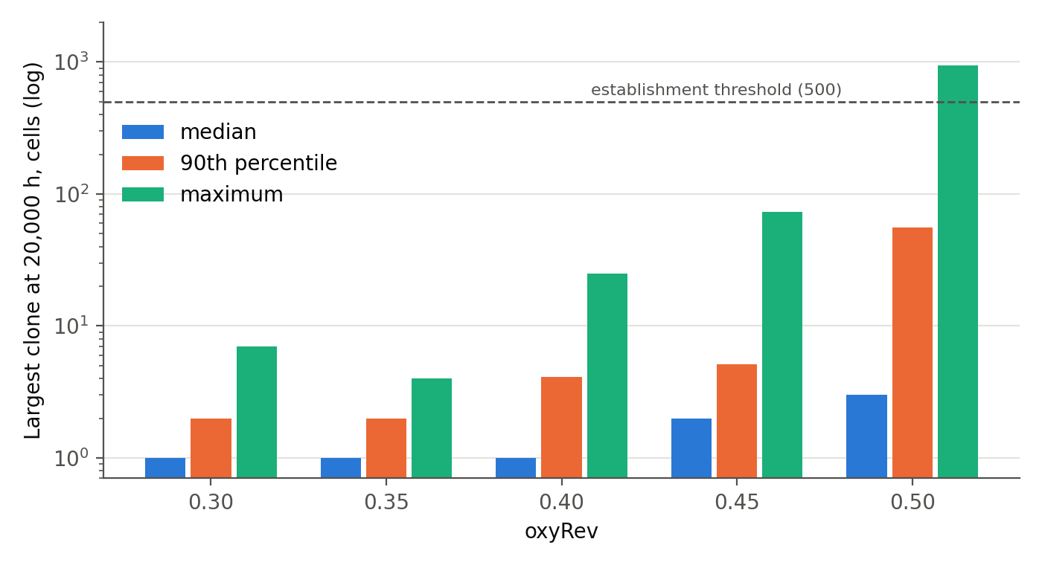
Figure 2.2. Largest reverted clone at 20,000 h by oxygen-filter value, without wounding: median, 90th percentile and maximum over 100 runs (log scale; the dashed line marks the establishment threshold).
Table 2.1. The bench with the oxygen filter, no wounding (revStore = 0.33; 100 runs per row).
oxyRev | Clone survives (>1 cell), % | Median clone | p90 | Maximum | Established (≥500), of 100
0.30 | 19 | 1 | 2.0 | 7 | 0
0.35 | 29 | 1 | 2.0 | 4 | 0
0.40 | 42 | 1 | 4.1 | 25 | 0
0.45 | 54 | 2 | 5.1 | 73 | 0
0.50 | 86 | 3 | 55.4 | 947 | 1
The number of reversion events is practically independent of oxyRev (a median of 443–451 per run): reversion happens as often as in Chapter 1, but almost every clone that arises stays within a few cells. Establishment remains at 0–1% across the entire grid. The transition toward frequent outliers begins near oxyRev ≈ 0.5, where the share of surviving clones nearly doubles (54% → 86%) and the maximum clone grows by an order of magnitude (73 → 947 cells).

2.4. Results under wounding
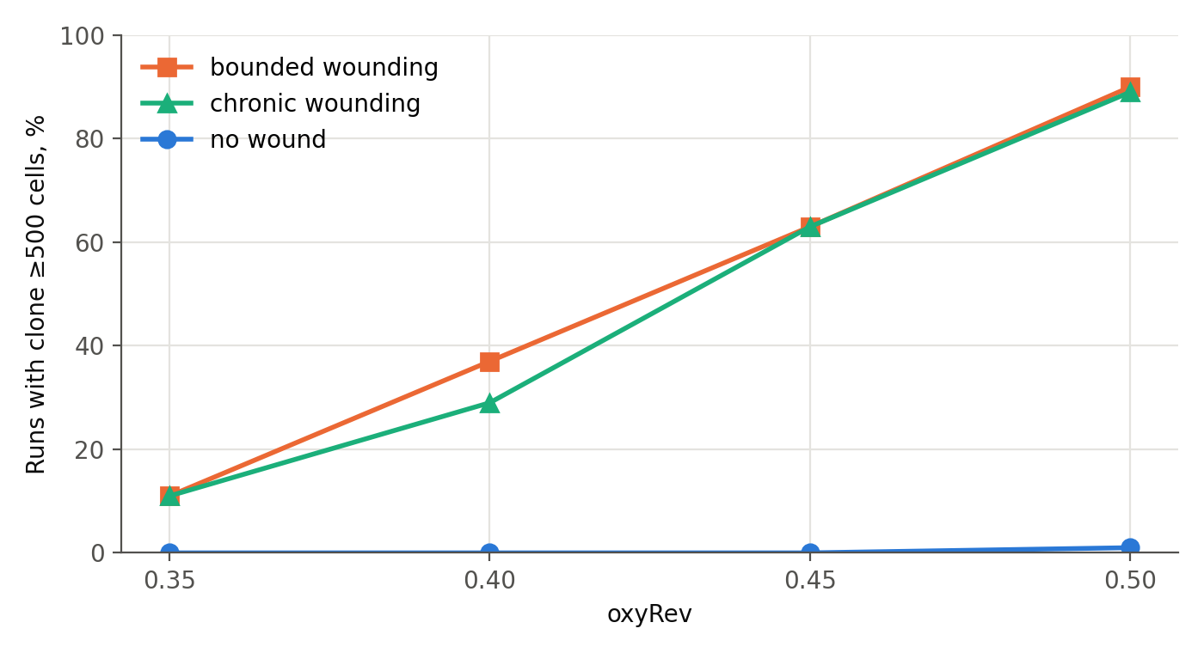
Figure 2.3. Share of runs with an established clone (≥500 cells) by oxygen-filter value under bounded and chronic wounding, compared with the no-wound series (revStore = 0.33).
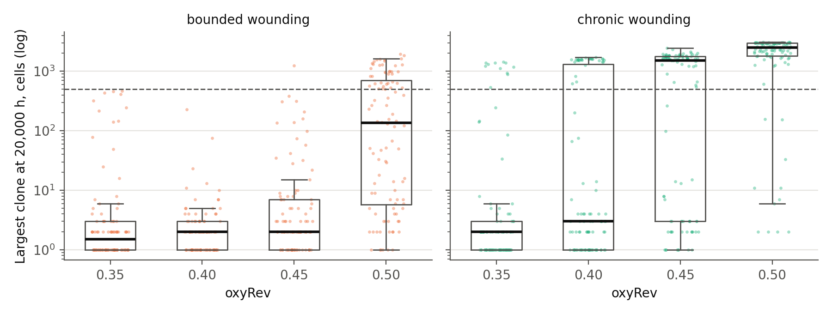
Figure 2.4. Largest reverted clone at 20,000 h under bounded wounding (stops after establishment) and chronic wounding (continues to the end of the horizon), by oxygen-filter value (log scale; the dashed line marks the establishment threshold).
Table 2.2. The bench with the oxygen filter under wounding (revStore = 0.33; 100 runs per cell).
Scenario | oxyRev 0.35 | 0.40 | 0.45 | 0.50
bounded, established, % | 11 | 37 | 63 | 90
chronic, established, % | 11 | 29 | 63 | 89
chronic, median clone share of living cells at the end | <0.1% | <0.1% | 49% | 83%
Under wounding the oxygen filter is not erased, unlike the only trace of resource resistance found in Chapter 1 (revStore = 0.20: 20% → 100% under wounding). Establishment increases gradually, from 11% to about 90%, depending on oxyRev: even when wounding removes the constraint on free space, the oxygen filter retains a dose-dependent resistance. At the same time, wounding clearly weakens this barrier: without wounding, establishment at the same filter values is 0–1%.
The closeness of bounded and chronic in establishment probability (11/37/63/90 vs. 11/29/63/89) is a property of the design rather than a separate result: before the first threshold crossing the two scenarios are mechanically identical and can differ only afterwards. The residual difference (for example, 37 vs. 29 at oxyRev 0.40) arises because the wound interval is drawn independently for the bounded and chronic series (for the same seed it coincides in only about 38% of pairs), not because wounding continues after establishment.
The scenarios differ in what happens after establishment. At oxyRev = 0.50 the median final clone under chronic wounding (2,507 cells, 83% of the living cells in the sheet) is almost 18 times larger than under bounded wounding (135.5 cells). The probability of establishment is set by the oxygen filter at the moment of cell birth; the final size is set by subsequent growth, which depends on how much space the clone receives after it has become established.

2.5. The two benches compared
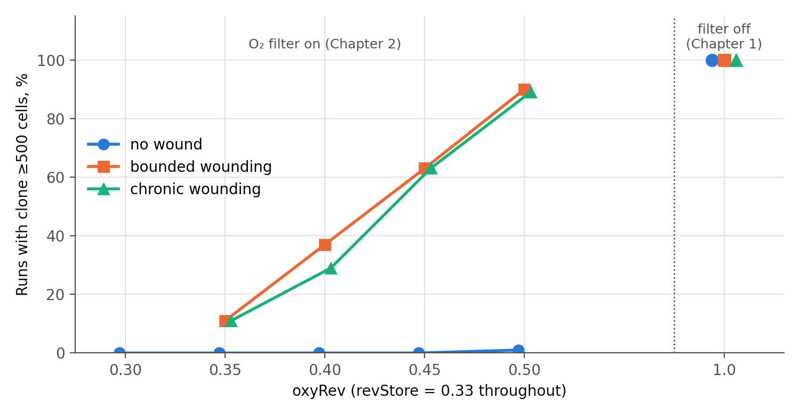
Figure 2.5. Share of runs with an established clone across both benches at revStore = 0.33: the oxygen-filter grid (Chapter 2) and the filter switched off, oxyRev = 1.0 (Chapter 1), by scenario. The wounding series were not run at oxyRev = 0.30.
Table 2.3. Establishment with and without the oxygen filter at the same glycogen.
Condition (revStore = 0.33) | Established, no wound | Established, under wounding | Median time, no wound
Without the oxygen filter (oxyRev = 1.0) | 100% | 100% | 984 h
With the oxygen filter (oxyRev 0.30–0.45) | 0% | 11–63% (oxyRev 0.35–0.45) | —
With the oxygen filter (oxyRev = 0.50) | 1% | ~90% | 16,752 h (single case)

2.6. Conclusion of Chapter 2
Resource regulation alone is not enough (Chapter 1), whereas the combination of reduced glycogen with the oxygen filter holds the clone back: 0–1% establishment without wounding across the whole grid oxyRev 0.30–0.50, compared with 100% without the filter at the same glycogen. Under wounding the oxygen filter partly retains its strength (establishment depends gradually on oxyRev), whereas the only trace of resource resistance in Chapter 1 was removed by wounding entirely. The practical implication for the model is that containment of the reverted clone is provided not by the resource axis but by adding an independent oxygen barrier to it.
Limitation. The experiment covers three corners of the resource × oxygen design: resource without the filter (Chapter 1) and resource with the filter (Chapter 2), each with and without wounding. The fourth corner — the oxygen filter with full, unreduced glycogen (revStore = 1.0, oxyRev < 1) — has not been run. The data therefore show that resource regulation alone is insufficient and that the oxygen filter, applied on top of it, produces containment; they do not show whether the oxygen filter is sufficient on its own, without reduced glycogen. The claim that the oxygen barrier is the only working mechanism will be justified only after that run.
Planned checks outside the scope of this chapter (see Appendix A):
- the oxygen filter at revStore = 1.0, the missing corner of the design (A.3);
- sensitivity to glycogen under wounding, with oxyRev fixed near the critical value found here (~0.45–0.50), including full glycogen (A.2);
- a repeat of the wounding series with a shared wound interval for bounded and chronic on the same seed, i.e. a paired design (A.2).

Part II. The Retention Filter and the Boundaries of the Pre-Immune Window

Chapter 3. A Three-Component Retention Filter for a Reverted Clone in a Monolayer Epithelium
Local persistence and the conditions for ectopic invasion.

3.1. Introduction
This note brings together the working model of a background reverted clone in a simple (monolayer) epithelium, previously discussed using several anatomical sites. The general premise of the model is that during normal renewal of a monolayer epithelium a small fraction of daughter cells stochastically “reverts” to an earlier, less differentiated state — background noise that requires no external damaging trigger. The fate of such a clone is determined not by the fact of reversion itself but by whether it survives local conditions long enough to become established. Below, this persistence is decomposed into three independent components of the filter, and the opposite-signed role of membrane adhesion proteins — as a barrier to local invasion and as a condition for ectopic growth — is considered separately.

3.2. Three components of the retention filter

3.2.1. The energy buffer: glycogen
The reverted lineage carries a substantially smaller glycogen store and, accordingly, less temporary resistance to energy deficit than its differentiated neighbors. This component is structurally uniform across all the sites considered: it is determined solely by the cell-autonomous metabolic status of the lineage and does not depend on the anatomy of a particular organ. In terms of the previously formulated “Primary Energy Filter” (Supply × Buffer × Demand × Time), glycogen plays precisely the role of the buffer — what allows a cell to survive a temporary gap between consumption and glucose delivery. Chapter 1 shows that, within the simulated monolayer, this component on its own is necessary but not sufficient to prevent establishment.

3.2.2. Oxygen resistance: two ways of implementing one principle
The oxygen component of the filter operates at every site but is implemented in two structurally different ways, depending on the geometry of the organ lumen.
Spatial shelter. At most of the sites examined (the cervical canal, part of the Eustachian tube, the fallopian fimbriae, the pancreatic duct), the apical lumen of the epithelium is not in direct contact with atmospheric air, and the basal/reserve cell layer even less so. In the fallopian tube the lumen is physiologically hypoxic (on the order of 5–8% O₂), which protects rather than culls a reverted clone. Here the filter acts almost “for free,” as a side effect of anatomy rather than as an actively paid-for defense.
Biochemical capacity. The distal lung (the bronchioloalveolar junction and the alveolus) is the exception: the function of gas exchange itself requires oxygen to be present on both sides of the epithelial barrier at once, so geometric shelter cannot exist here in principle. The persistence of a reverted cell at this site can rest only on cell-autonomous redox capacity — the oxidative branch of the pentose phosphate pathway (G6PD/6PGD), which generates NADPH for regenerating reduced glutathione (GSH) from its oxidized form [15–18]. G6PD is overexpressed in many tumors and is required for resistance to oxidative stress and during metastasis [16, 17]. Independently of malignancy, the same biochemistry explains why extremely preterm newborns — with a physiologically immature antioxidant system (reduced activity of glutathione peroxidase and related enzymes) — tolerate direct contact with oxygen at the edge of failure rather than comfortably: retinopathy of prematurity and bronchopulmonary dysplasia are the direct clinical expression of this immaturity [18–21]. Transferring this logic to a reverted clone in the alveolus implies not absolute tolerance but a race between depletion of redox defense and the cell’s next division, in which a local excess of glucose (the raw material for NADPH through the oxidative branch of the PPP) may partly compensate for an initially low capacity — with the caveat that part of the increased PPP flux in a dividing cell runs through the non-oxidative branch, which yields no NADPH and serves only nucleotide synthesis [22]. This is a cross-system extrapolation from neonatal and tumor biology to a hypothetical reverted clone.

3.2.3. The positional-kinetic component
The third component of the filter does not reduce to a single mechanism: it is assembled from different combinations of two independent sub-causes, depending on the site.
Geometric isolation — protection through physical distance: the reverted/reserve cell sits in an invagination (a crypt), separated from the threatening environment by a layer of stroma. The classic example is the endocervical crypts, where adenocarcinoma in situ is characteristically multifocal and produces “skip” lesions, spreading along the hidden crypt architecture rather than as a single front [1–4].
Quiescence and scarcity of the progenitor population — protection not through location but through kinetics: where geometric shelter is absent (the distal lung), the protective function is partly taken over by a small, predominantly quiescent facultative progenitor population — club cells and bronchioalveolar stem cells (BASCs) of the bronchioloalveolar junction, as well as type II pneumocytes. Both populations are considered likely cells of origin of lung adenocarcinoma precisely because they combine proliferative competence with a low background division rate [10–14].

3.3. Membrane adhesion proteins: a mirror-image function locally and ectopically
The same class of molecules — membrane adhesion proteins — plays structurally opposite roles, depending on which branch of the model is under consideration.

3.3.1. Locally: adhesion as a barrier that maintains persistence
In the native tissue, E-cadherin-mediated cell–cell contacts and integrin anchoring to the cell’s own basement membrane physically hold the clone in a monolayer state. Breaching the membrane and local invasion require a separate, additional event: downregulation of E-cadherin and a switch to N-cadherin (the cadherin switch, part of the EMT program), weakening of integrin anchoring, and activation of matrix metalloproteinases. Here, in other words, the adhesion apparatus has to be lost in order to invade.

3.3.2. Ectopically: adhesion as a condition for implantation
On a foreign surface (the peritoneal mesothelium and similar serosal surfaces), a shed cell must, on the contrary, acquire the ability to attach in the first place. The best-studied example is the interaction of CA125/MUC16 (expressed on serous ovarian/tubal carcinoma cells) with mesothelin, a GPI-anchored glycoprotein of mesothelial cells: binding of CA125 to mesothelin directly mediates heterotypic cell adhesion and can be blocked by anti-CA125 antibodies, confirming its functional rather than merely associated role in implantation [23–25]. CD44–hyaluronan and integrin–fibronectin interactions belong to the same class. Here the same molecular apparatus acts not as a brake but as an obligatory condition of entry: without it a shed cell will not physically attach, regardless of whether it has survived the energy and oxygen filters.
The practical conclusion: locally, “gain is required for persistence, loss is required for invasion”; ectopically, “gain of a new adhesion profile is required for growth to occur at all.” These are not one process running in one direction but a pair of mirror-image requirements that should be kept separate when analyzing a particular site.

3.4. Summary table by site
Table 3.1. The components of the retention filter across anatomical sites.
Site | Epithelial area (order of magnitude) | Oncogenesis (driver) | Glycogen / buffer | Oxygen protection | Positional-kinetic component
Cervical canal | units to tens of cm² | HPV E6/E7 → AIS in crypts [1–4] | Standard (5×) | Hypoxic lumen — shelter comes free | Geometric isolation (crypt/invagination)
Eustachian tube (tympanic part) | a few cm² | Isolated case reports; risk nearby (NPC at the orifice) | Standard | Direct atmospheric contact — the filter is at its harshest, no shelter | No crypts; reversion is culled before establishment
Fimbriae of the fallopian tube | tens of cm² | p53 signature → STIL → STIC → HGSOC [5–9] | Standard, but extrusion is the main route of loss | Hypoxic lumen (5–8% O₂) — protects the clone | Quiescence of secretory cells + the cyclic “wound” of ovulation
Thyroid follicular epithelium | tens of cm² | RET/PTC, BRAF (papillary); RAS, PAX8–PPARG (follicular) | Standard | Well-vascularized organ — not critical | TSH-controlled quiescence; invasion is itself the diagnostic criterion
Peritoneal mesothelium | ~1.7–2 m² | Primary mesothelioma (BAP1/NF2) is rare; secondary seeding by HGSOC is common | Standard (for native mesothelium) | Not limiting | Open receptive surface — requires an anchoring molecular set, not a buffer
Pancreatic duct | tens to a few hundred cm² (with branching) | KRAS → PanIN → loss of p16/SMAD4/p53 → PDAC | Standard | Not limiting (deep organ) | Perineural invasion is the dominant low-resistance route (up to ~90–94% of resections) [26–28]
Distal lung (BADJ/alveolus) | ~70–100 m² [29–31] | KRAS/EGFR de novo → AAH → AIS → adenocarcinoma | Standard, but oxidative PPP flux is increased in a Warburg-type clone | Two-sided O₂ contact — no shelter; protection is purely biochemical (G6PD/NADPH/GSH) | Quiescence of club cells/ATII/BASCs instead of geometry; at this area a geometric/aerodynamic contribution cannot be excluded [32, 33]

3.5. An illustration at the border of two regimes: the pancreatic duct
The pancreatic duct is a site where the positional-kinetic component manifests not as protection but as a specific route of progression: perineural invasion occurs with very high frequency (in different series of resection material, from 63% extrapancreatic invasion to 90–94% when counted by the number of foci per section), far exceeding vascular/lymphatic invasion in frequency and independently of it [26–28]. This shows that the same general framework of the model (energy buffer + oxygen status + local architecture) does not predict a single route of progression: the specific anatomical substrate (in this case, the abundance of nerve sheaths in the peripancreatic tissue) determines which low-resistance route will dominate.

3.6. Scale as a separate factor: epithelial area and the impossibility of excluding geometric anomalies
It deserves separate discussion that all three filter components considered above act over an epithelial area that, in the lung, differs from the other sites by four to five orders of magnitude, not by a factor of several. The alveolar epithelium of an adult covers on the order of 70–100 m² (about 300–500 million alveoli in the two lungs) [29–31]. The mucosa of the fallopian tube, the Eustachian tube, and the cervical canal — even allowing for folding (plicae) — amounts, in order of magnitude, to units to a few tens of cm². The difference is not “the lung is bigger” but “the lung is four to five orders of magnitude bigger.”
At this scale, what would be a rare exception on a small area becomes statistically inevitable: the presence of local geometric anomalies that are related neither to the energy buffer nor to the cell’s redox status, but to the purely mechanical/aerodynamic structure of the organ. A documented example is turbulence of airflow at the branching points of the bronchial tree, which creates persistent “hot spots” of inhaled-particle deposition on the carinal ridges; the distribution of these points correlates with the clinically observed localization of bronchogenic carcinomas [32, 33].
The fundamental difference from the tubes and the canal lies not in the existence of geometric inhomogeneities as such — they exist there too (crypts, bends) — but in the fact that their finite, surveyable number (tens) makes it possible, in principle, to test whether neoplasia is statistically tied to a particular anomaly. In the lung, with its ~300–500 million alveoli and countless branching points, any sufficiently rare (say, one in a million) local deviation of geometry is guaranteed to occur many times simply by the law of large numbers, and separating its contribution from that of the redox/energy filter becomes statistically hard precisely because of the size of the sample. This does not refute the three filter components described, but it obliges us to acknowledge that for the lung, unlike sites whose area is several orders of magnitude smaller, a purely geometric/mechanical contribution to the initiation of neoplasia cannot be excluded and must be treated as a separate, potentially significant fourth source of variability, specific to organs of this scale.

3.7. Open questions
- The ratio of oxidative to non-oxidative PPP flux in a reverted/preneoplastic lung cell has not been established directly; whether glucose-driven redox protection is real, or whether all the additional flux serves nucleotide synthesis for division, depends on it.
- It is not known whether an inducible NRF2/ARE response (active adaptation over time) is engaged in a reverted clone, or whether its persistence is entirely passive and determined only by glucose availability.
- Data are lacking on the population prevalence of atypical adenomatous hyperplasia (AAH) specifically in never-smokers without a history of COPD or tuberculosis; such data would distinguish, for the lung, between the hypothesis of “rare initiation” and that of “frequent initiation, efficient culling.”
- The kinetics of redox-capacity depletion in a reverted cell (linear, by analogy with the antioxidant reserve of a preterm infant, or with an adaptation point) have not been studied.

3.8. Conclusion
The model of the retention filter for a reverted clone breaks down into three structurally distinct, though jointly acting, components: a universal energy buffer (glycogen); oxygen resistance (implemented either as spatial shelter or as cell-autonomous biochemistry, depending on whether a one-directional oxygen gradient exists at a given site); and a positional-kinetic component (geometric isolation or quiescence of a small progenitor population). Separate from the question of the clone’s survival is the question of its ability to attach to a foreign surface: here the same class of adhesion molecules that locally restrains invasion through loss of function ectopically enables growth through acquisition of a new expression profile. For the lung, scale must additionally be taken into account: the epithelial area is four to five orders of magnitude larger than at the other sites examined, which makes it statistically impossible to exclude a contribution of purely geometric/aerodynamic anomalies (bifurcation points, zones of reduced mucociliary clearance) as a separate source of variability, not reducible to either the energy or the redox component of the filter. None of the local cases examined (the lung as an organ with two-sided oxygen contact and an enormous area, the pancreatic duct with its predominance of the perineural route, the peritoneum as a receptive surface without buffer protection) contradicts the general architecture of the model of monolayer neoplasia; they clarify which component of the filter carries the main load in a given anatomy.

References for Chapter 3
Entries verified against the published record in September 2026. Where a detail could not be confirmed, this is marked in the entry itself, following the convention of Section 0.4.
- Polterauer S., Reinthaller A., Horvat R., Joura E., Grimm C. et al. Cervical adenocarcinoma in situ: update and management. Curr Obstet Gynecol Rep. 2013;2(2):86–93. doi:10.1007/s13669-013-0039-6 — previously cited here as “Bogers J. et al.”; that attribution could not be confirmed for this article.
- Adolph L., Mann A., Liu X.Q., Roberts L. et al. Follow-up of women with cervical adenocarcinoma in situ treated by conization: a single centre clinical experience. Gynecol Oncol. 2024;187:74–79. doi:10.1016/j.ygyno.2024.05.004 — previously cited here as “Munmany M. et al., Gynecol Oncol Rep.”; neither the first author nor the journal matched the published record.
- Ciavattini A., Giannella L., Delli Carpini G., Tsiroglou D., Sopracordevole F., Chiossi G., Di Giuseppe J.; Italian Society of Colposcopy and Cervico-Vaginal Pathology (SICPCV). Adenocarcinoma in situ of the uterine cervix: clinical practice guidelines. Eur J Obstet Gynecol Reprod Biol. 2019;240:273–277. doi:10.1016/j.ejogrb.2019.07.014
- Milic N., Varnicic Lojanica M., Ivanovic S., Ivanovic M., Ivanovic K., Jovic N. Cervical adenocarcinoma in situ in a young nulliparous patient with persistent ASC-US and multiple-type HPV infections without HPV 16 and 18 types — case report. Diagnostics (Basel). 2026;16(4):617. doi:10.3390/diagnostics16040617
- Labidi-Galy S.I. et al. High grade serous ovarian carcinomas originate in the fallopian tube. Nat Commun. 2017;8(1):1093. doi:10.1038/s41467-017-00962-1
- Cheng Z. et al. The genomic trajectory of ovarian high-grade serous carcinoma can be observed in STIC lesions. J Pathol. 2024. doi:10.1002/path.6322 — this is the peer-reviewed version; the preprint of the same work is titled “…is determined in STIC lesions”, a stronger claim that the published title does not make.
- Luvero D., Angioli R., Notaro E. et al. Serous tubal intraepithelial carcinoma (STIC): a review of the literature on the incidence at the time of prophylactic surgery. Diagnostics (Basel). 2024;14(22):2577. doi:10.3390/diagnostics14222577
- Kader T. et al. Multimodal spatial profiling reveals immune suppression and microenvironment remodeling in fallopian tube precursors to high-grade serous ovarian carcinoma. Cancer Discov. 2025;15(6):1180 — this is the peer-reviewed version; previously cited here as a 2024 bioRxiv preprint.
- Kraiczy J., Yu B. Human fallopian tube epithelial organoids with TP53 mutation recapitulate features of serous tubal intraepithelial carcinoma (STIC). Gynecol Oncol. 2025;203:198–208. doi:10.1016/j.ygyno.2025.10.038
- Sainz de Aja J., Dost A.F.M., Kim C.F. Alveolar progenitor cells and the origin of lung cancer. J Intern Med. 2021;289(5):629–635. doi:10.1111/joim.13201
- Jones-Freeman B., Starkey M.R. Bronchioalveolar stem cells in lung repair, regeneration and disease. J Pathol. 2020;252(3):219–229. doi:10.1002/path.5527
- Yin H., Jing B., Xu D. et al. Identification of active bronchioalveolar stem cells as the cell of origin in lung adenocarcinoma. Cancer Res. 2022;82(6):1025–1037. doi:10.1158/0008-5472.CAN-21-2445
- Xu X. et al. Alveolar type II cells possess the capability of initiating lung tumor development. PLoS ONE. 2012;7(12):e53817. doi:10.1371/journal.pone.0053817
- Yin H., Jiang Z., Feng X., Ji Z., Jin W. et al. Identification of Sca-1+Abcg1+ bronchioalveolar epithelial cells as the origin of lung adenocarcinoma in a Gprc5a-knockout mouse model through the interaction between lung progenitor AT2 and Lgr5 cells. Oncogene. 2020;39(18):3754–3773. doi:10.1038/s41388-020-1251-2
- Lan T., Arastu S., Lam J. et al. Glucose-6-phosphate dehydrogenase maintains redox homeostasis and biosynthesis in LKB1-deficient KRAS-driven lung cancer. Nat Commun. 2024;15:5857. doi:10.1038/s41467-024-50157-8
- Loss of glucose 6-phosphate dehydrogenase function increases oxidative stress and glutaminolysis in metastasizing melanoma cells. Proc Natl Acad Sci USA. 2022;119(9):e2120617119. doi:10.1073/pnas.2120617119
- Benito A., Polat I.H., Noé V., Ciudad C.J., Marin S., Cascante M. Glucose-6-phosphate dehydrogenase and transketolase modulate breast cancer cell metabolic reprogramming and correlate with poor patient outcome. Oncotarget. 2017;8(63):106693–106706. doi:10.18632/oncotarget.21601
- Kimble A., Robbins M.E., Perez M. Pathogenesis of bronchopulmonary dysplasia: role of oxidative stress from ‘omics’ studies. Antioxidants (Basel). 2022;11(12):2380. doi:10.3390/antiox11122380
- Fu R.-H., Chiu T.-H., Chiang M.-C., Lien R. et al. Lower erythrocyte glutathione peroxidase activity in bronchopulmonary dysplasia in the first week of neonatal life. Neonatology. 2008;93(4):269–275. doi:10.1159/000112209
- Couroucli X.I. Oxidative stress in the retina: implications for retinopathy of prematurity. Curr Opin Toxicol. 2018;7:102–109. doi:10.1016/j.cotox.2017.11.008 — previously cited here as “Semin Fetal Neonatal Med. 2017”; both the journal and the year were wrong.
- Retinopathy of prematurity. StatPearls. Treasure Island (FL): StatPearls Publishing; 2025.
- Patra K.C., Hay N. The pentose phosphate pathway and cancer. Trends Biochem Sci. 2014;39(8):347–354. doi:10.1016/j.tibs.2014.06.005
- Rump A., Morikawa Y., Tanaka M. et al. Binding of ovarian cancer antigen CA125/MUC16 to mesothelin mediates cell adhesion. J Biol Chem. 2004;279(10):9190–9198. doi:10.1074/jbc.M312372200
- Kaneko O. et al. A binding domain on mesothelin for CA125/MUC16. J Biol Chem. 2009;284(6):3739–3749. doi:10.1074/jbc.M806776200
- Scholler N., Garvik B., Hayden-Ledbetter M., Kline T., Urban N. Development of a CA125-mesothelin cell adhesion assay as a screening tool for biologics discovery. Cancer Lett. 2007;247(1):130–136. doi:10.1016/j.canlet.2006.03.029
- Felsenstein M. et al. Perineural invasion in pancreatic ductal adenocarcinoma (PDAC): a saboteur of curative intended therapies? J Clin Med. 2022;11(9):2367. doi:10.3390/jcm11092367 (see also the published correction, J Clin Med. 2023)
- Kondo N., Murakami Y., Uemura K., Hashimoto Y., Nakagawa N., Sasaki H., Sueda T. An increased number of perineural invasions is independently associated with poor survival of patients with resectable pancreatic ductal adenocarcinoma. Pancreas. 2015;44(8):1345–1351. doi:10.1097/MPA.0000000000000413 — previously cited here as “Ann Surg Oncol. 2015”; the journal was wrong.
- Borsekofsky S., Tsuriel S., Hagege R.R., Hershkovitz D. Perineural invasion detection in pancreatic ductal adenocarcinoma using artificial intelligence. Sci Rep. 2023;13:13628. doi:10.1038/s41598-023-40833-y
- Crapo J.D., Mercer R.R. Normal anatomy and defense mechanisms of the lung. In: Baum G.L., Crapo J.D., Celli B.R., Karlinsky J.B., eds. Textbook of Pulmonary Diseases. 6th ed. Philadelphia: Lippincott-Raven; 1998:23–46. — alveolar and capillary surface area estimates (~70 m² alveolar, ~125 m² capillary).
- Ochs M., Nyengaard J.R., Jung A. et al. The number of alveoli in the human lung. Am J Respir Crit Care Med. 2004;169(1):120–124. doi:10.1164/rccm.200308-1107OC
- Knust J., Ochs M., Gundersen H.J.G., Nyengaard J.R. Stereological estimates of alveolar number and size and capillary length and surface area in mice lungs. Anat Rec (Hoboken). 2009;292(1):113–122. doi:10.1002/ar.20747
- Schlesinger R.B., Lippmann M. Selective particle deposition and bronchogenic carcinoma. Environ Res. 1978;15(3):424–431. PMID 679903
- Balásházy I., Hofmann W., Heistracher T. Local particle deposition patterns may play a key role in the development of lung cancer. J Appl Physiol. 2003;94(5):1719–1725. doi:10.1152/japplphysiol.00527.2002 — replaces an earlier entry cited as “J Aerosol Med. 1991”, which could not be located in the published record.

Chapter 4. Interpreting the Results: From Measurements to Rules
Chapters 1 and 2 answer a question about barriers and give particular numbers: without the oxygen filter a clone becomes established in 100% of runs across the whole biologically justified range of glycogen; with the filter, in 0–1% of runs without wounding, and, under wounding, in a graded fashion from 11% to about 90%. These numbers belong to the bench and to its parameterization. The present chapter moves the result to a different level of description: from the numbers themselves to the rules those numbers set for further work, and to a list of what the model does not yet contain.
The chapter has two parts. The first is a map of the conditions under which a reverted clone arises and becomes established, with a note on where each condition pushes the model. The second is the set of rules that follow from that map. Nothing here is stated as a numerical recommendation: the chapter asserts signs and orderings rather than magnitudes, and the grounds for that restriction are set out in Rule 7 (Section 4.3).

4.1. The decomposition everything rests on
The starting form is given in Section 0.2:
frequency of established clones ≈ rate of generation of reverted cells × probability of their retention in the tissue
The value of this decomposition lies not in the formula itself but in the fact that almost every substantive factor enters both terms, and usually with opposite signs. The net sign of a factor is therefore not a property of the factor: it is set by which of the two terms is limiting in a given tissue. This is what makes statements of the form “factor X protects against neoplasia” or “factor X raises risk” meaningless when made without reference to a site.
Chapters 1 and 2 measure only the second term. The rate of generation is held fixed throughout (pRevert = 1/1000 per division) and is never varied. Everything said below about the first term follows from the structure of the model and from external biological evidence, not from the runs.

4.2. Five conditions and the model’s missing axes
Table 4.1. Permissive conditions, their sign in each term, and their status in this work. An arrow gives the direction in which the condition shifts that term; a dash means the condition does not appreciably affect it. “Gate” is the point at which the condition acts: once at the birth of a cell, continuously, or at the exit from the layer.
Condition | Generation / retention | Gate | Status in this work
Hypoxia | ↓ / ↑ | birth; exit | partly tested (Ch. 2)
Absence of desquamation | — / ↑ | continuous | model assumption
Loss of epithelial–matrix protein complementarity | — / ↑ | exit | not in the model
Stretch of the epithelial sheet | ↑ / ↑ | continuous | partly
Glucose supply | — / ↑ above a low threshold | continuous | tested (Ch. 1)
Hypoxia. The only one of the five conditions that enters both terms with opposite signs. Low oxygen weakens the filter applied at the birth of a reverted cell and, at the same time, undermines — through the obligately oxygen-dependent hydroxylation of type IV collagen (Section 1.7) — the membrane that would later have contained the clone; in the opposite direction it lowers oxidative damage, that is, the rate of generation itself. In the engine all of this is reduced to a single lineage parameter, the probability of passing the filter at the moment of birth. Hence the first direction of development: oxygen should become a field of the environment, shared by cell and matrix, rather than a property of a cell lineage. While it remains a lineage property, the model can describe only one of its three actions.
Absence of desquamation in the reverted lineage. In the engine a cell leaves the sheet in one way only: it is removed, and the nodes it owned become free. The engine does not distinguish the death of a cell from its extrusion into the lumen, because for the geometry of the sheet the two are the same event — a node becomes available; the distinction between them is biological, not mathematical. Differentiated cells are removed at the end of their lifespan, whereas cells of the reverted lineage are exempt from that age-dependent route and leave only through lack of space, starvation, or the filter at birth. This is an assumption, not a result, and it shifts retention upward. The bench accordingly represents the least favorable case for the tissue, and the containment it shows is achieved with no contribution from normal cell turnover at all. Direction of development: departure from the sheet should become a property of a cell’s state rather than of its lineage, with a shared parameter taking different values for a differentiated and for a reverted cell. The present result would then be the limiting case of zero age-dependent departure for the reverted lineage, and between that case and normal turnover there would be an axis to move along.
Loss of complementarity between epithelial and matrix proteins. The stability of the basement membrane rests on the compatibility of the proteins of the sheet and of the extracellular matrix; while it holds, the single-layer structure holds with it. This condition acts at the exit gate, which the model does not contain at all: a cell has the outcome “died” and the outcome “remained in the sheet”, but not the outcome “left”. All results of Chapters 1 and 2 therefore concern the lateral establishment of a clone within the layer, and this should be stated outright rather than implied. Direction of development: a third outcome and, with it, a separate probability of exit that depends on the state of the membrane.
Stretch of the epithelial sheet. The only condition that raises both terms at once: tension wakes reserve cells and thereby increases the number of divisions, each carrying its own probability of reversion, while simultaneously freeing space for a clone that has already arisen. Hence its special status — it is not a defect that can be removed but the very machinery by which the tissue repairs itself. The engine implements only the lower density limit; the upper one, extrusion under crowding, is absent. Direction of development: a second threshold, after which density becomes a variable with two edges rather than one. This is also where the work joins Chapter 6, in which the upper limit is removed chronically.
Sufficient glucose supply. The result of Chapter 1 is stronger here than it appears: the clone becomes established under ordinary supply, and cutting the lineage’s own buffer to a third of normal does not prevent it. An excess of resource is therefore not among the conditions for establishment — the resource threshold is low, and that is precisely why the resource axis does not work as a barrier. It follows that the meaningful variable is not the level of supply but its constancy: what matters is the amplitude of fluctuation, not the mean. In the engine supply is constant, so this axis does not exist there; introducing it is a separate step, and it is the step that connects Part I with the population material of Chapters 7 and 8.
Taken together, these five points form not a list of risk factors but a map of the model’s missing axes: oxygen as a field rather than a lineage parameter, departure from the sheet as a property of state, a third outcome at the exit from the layer, an upper density limit, and a variable amplitude of resource supply.

4.3. The rules
Rule 1. Before judging a factor, resolve it into the two terms. A statement that a factor protects or raises risk has no meaning until it is said whether the factor acts on generation or on retention. Consequence for study design: measuring clone frequency alone does not separate the two contributions; an independent estimate of the rate of generation, normalized per division, is required.
Rule 2. The sign is a property of the limiting term, not of the factor. Factors that enter both terms usually enter with opposite signs, so the net sign is set by whatever is limiting in the tissue at hand, and that is determined by anatomy. Consequence: the sign of a factor cannot be carried from one tissue to another until it has been established that the same term is limiting in both.
Rule 3. Report a barrier’s strength only together with a perturbation. Two barriers that are indistinguishable at rest may diverge completely under damage: the resource barrier disappears, the oxygen barrier retains a dose-dependent effect. Consequence: a result obtained in undisturbed tissue is uninformative by itself, and the perturbation protocol is part of the definition of the barrier.
Rule 4. Name the gate. Factors act at different points: once at the birth of a cell, continuously through resource and space, and only at the exit through the state of the membrane. A factor that is neutral at one gate turns out to be decisive at another: the bounded and chronic wounding scenarios give the same probability of establishment and an almost eighteen-fold difference in final clone size. Consequence: the endpoint must be named; the establishment of a clone and its subsequent growth are different processes with different determinants.
Rule 5. Levers lie where the mechanism is asymmetric. A barrier built from the machinery of normal function — tension, cell turnover — cannot be strengthened without paying for it in repair. The upper density limit and the integrity of the basement membrane are asymmetric: removing them only harms, maintaining them costs nothing. Consequence: points of intervention should be sought among asymmetric mechanisms, and symmetric ones should be described as constraints rather than as targets.
Rule 6. Stability is an intersection of windows, not a sum of barriers. For every factor both edges are destructive: at low oxygen the reverted cell survives, at high oxygen generation rises. Several moderate deviations may therefore be worse than one severe deviation — the intersection of windows narrows faster than any single barrier weakens. Consequence: combinations of weak deviations should be studied, not only strong isolated ones, and every factor should be tested at both edges.
Rule 7. The model fixes signs and orderings, not magnitudes. The bench’s parameters are dimensionless, the lattice is not calibrated to any particular tissue, and the horizon is not calendar time. This is not a defect calling for apology but a declared level of description: directions and comparisons between conditions are transferable, whereas absolute values belong to the parameterization. Consequence: predictions are stated as directions and relative comparisons, and any number taken from the bench is treated as an artifact of parameterization until calibration has been carried out.

4.4. What kind of model this is
The bench does not predict values; it determines the direction of a process. This is not a weakened version of a quantitative model but a class of its own, with an established tradition behind it, and the class should be named outright.
Levins set out the choice facing anyone who builds models: generality, realism and precision cannot all three be had at once, and one must be sacrificed [1]. A model that gives up precision for the sake of generality and realism is following a declared strategy, not suffering from an unfinished one. The qualitative analysis of partially specified systems, which he also developed, shows that the sign of a system’s response to a perturbation can be derived from the structure of its connections without numerical parameter values [2, 3]. The present chapter does exactly that: Rules 1–6 are statements about signs and about what the sign depends on.
The same boundary was later described quantitatively in systems biology. In models with many parameters, predictions separate into stiff ones, robust to wide changes in the parameters, and sloppy ones, wholly dependent on them; the usefulness of a model is determined by whether it has stiff predictions, and not by how precisely its coefficients have been fitted [4]. This offers a ready way of dividing the results of the present work as well.
Stiff. The gap between 100% establishment without the oxygen filter and 0–1% with it spans two orders of magnitude; no plausible re-tuning of parameters will reverse it. Equally robust is the difference in how the two barriers behave under damage: the resource barrier disappears entirely, the oxygen barrier retains a dose-dependent gradient. The ordering is robust too: establishment accelerates monotonically with glycogen across the whole range tested.
Sloppy. The critical value of the oxygen filter near 0.5, the median time to establishment of 984 h, the final clone size of about 3,300 cells — these are coordinates within the chosen parameterization, not properties of a tissue. They are necessary for reproducibility and unfit for transfer.
Hence a principle of presentation: stiff results are put forward as results, sloppy ones are given as coordinates within the bench and marked as such. In this form Rule 7 stops being a declaration and becomes a way of writing.
The claim that the model shows direction has a price. It rests on the direction not reversing when parameters change, and that requires a separate check: a reversion rate twice as high and twice as low, a different establishment threshold, a different lattice size. The threshold can be checked without new runs, since the runner records the trajectory of clone size. What has to be shown is not agreement of numbers but preservation of the ordering; the numbers themselves may shift as much as they like. Until that check is done, the claim about direction remains asserted rather than established.
And a final limitation, which the strengthened claim makes more important than before. The model gives direction only for the mechanisms it implements. It cannot be asked about the exit of a clone from the layer or about the upper density limit at all: those mechanisms are not in the engine, and any judgement about them belongs to the discussion, not to the model.

4.5. The status of the statements in this chapter
Rules 3 and 4 rest directly on the results of Chapters 1 and 2. Rules 1 and 2 follow from the decomposition adopted in Section 0.2 and from the structure of the model, not from the runs. Rules 5 and 6 are structural consequences and have been tested neither on the bench nor against external data. Rule 7 is a methodological position rather than a result; its grounds and limits are set out in Section 4.4, and the division of results into stiff and sloppy given there is itself a claim about the structure of the model, requiring a check for robustness to parameters. Of the five conditions in Section 4.2, the first (partly, at the birth gate only) and the fifth have been tested on the bench; the second is adopted as an assumption; the fourth is half implemented; the third is absent from the model.
All formulations here apply to the pre-immune window and to a monolayer epithelium. Carrying them beyond those limits requires not an extension of the rules but their re-derivation.

4.6. General conclusion
The five conditions of Section 4.2 were assembled independently of one another — each from its own place in the model — and nevertheless describe a single state of the tissue. A reverted clone arises and becomes established where the local conditions of adult tissue approach embryonic ones.
The correspondence holds for each condition in turn. Early development proceeds in physiological hypoxia, and the oxygen tension of the stem-cell niche is an order of magnitude below arterial [5, 6]. Embryonic epithelium has no programme of terminal differentiation followed by the departure of the cell — that is, no age-dependent route of the kind from which the reverted lineage is exempt in the engine. The basement membrane in development is not a fixed barrier: it is remodelled, and the epithelial–mesenchymal transition is a normal developmental programme rather than a failure. The upper density limit is lifted by definition in a growing primordium, since the tissue is increasing rather than maintaining its numbers. Finally, the metabolic profile of the reverted lineage in the model — a small store of its own with dependence on current supply — is closer to the glycolytic cell of a primordium than to a differentiated neighbour with a full buffer.
This should be formulated as a statement about the niche, not about the cell. The engine contains no gene expression and knows only space, glucose, oxygen at the moment of birth, and tension; it may therefore say that conditions approach embryonic ones, but not that a cell switches on an embryonic programme.
The embryonic state itself divides into two distinguishable parts, and the distinction carries content. The conditions of a stem-cell niche — hypoxia, spatial shelter, quiescence of a small progenitor population — are preserved in adult tissue: the crypts of the cervical canal, the tubal fimbriae and the transformation zone are arranged in exactly this way. What adult tissue lacks is not the niches but the removal of certain restraints: age-dependent departure of the cell, the upper density limit, and a stable basement membrane. The embryo has the niche without those restraints; the adult organism has the niche together with them. Hence a more precise formulation of the conclusion: a clone becomes established where the conditions of a stem-cell niche are joined by the removal of adult restraints — and this is why the list of sites in Chapter 3 turns out to be a list of reserve niches.
The resemblance of tumor tissue to embryonic tissue has been asserted repeatedly, from Cohnheim’s embryonal-rest hypothesis [7] and Potter’s concept of partially blocked ontogeny [8] through to the description of tumour states as normally unoccupied attractors of the developmental network [9]. The novelty of the present conclusion lies not in the resemblance itself but in where it comes from: the embryonic niche is reached by a model containing neither developmental programmes nor gene expression, one that operates solely with space, resource, oxygen and tension. This is a convergence, not an observation of similarity.
The objection of circularity should be addressed separately. Reversion is defined in Section 0.2 as a shift towards a less differentiated state, and the conclusion may therefore appear to be contained in the premise. The grounds for holding otherwise are these: the reverted cell in the model is given exactly three properties — a reduced energy buffer, vulnerability to oxygen at the moment of birth, and the ability to divide when free space is available. None of them is an embryonic feature; oxygen enters the model through an independently justified mechanism; and two of the five conditions — age-dependent departure and the density limit — belong to the sheet rather than to the cell and form no part of the definition of reversion at all.

4.6.1. The clone builds its own conditions: what of this is in the model
What has been said above describes the conditions under which a clone arises. A separate question is what sustains its growth and persistence once it has arisen. The obvious answer is that the clone subsequently builds those conditions for itself. Part of such a loop is found directly in the existing data, part is not, and the difference between them matters.
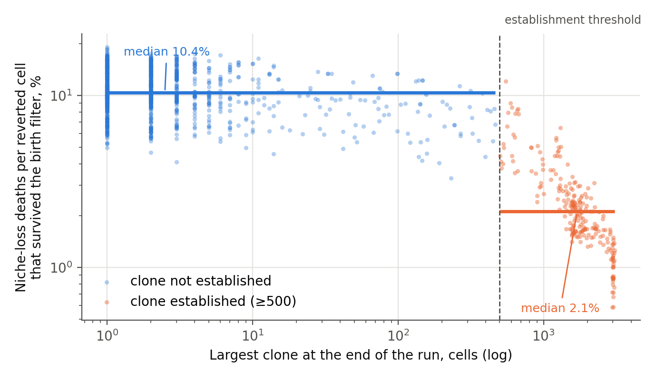
Figure 4.1. Deaths of reverted cells from loss of niche, expressed per birth that survived the oxygen filter, as a function of final clone size. Both axes are logarithmic; the wounded and unwounded series at oxyRev from 0.30 to 0.50 are pooled, 1,300 runs. Horizontal lines give the group medians.
What is measured. Among reverted cells that survive the oxygen filter at birth, the fraction that then die from loss of niche is 10.4% in runs where no clone became established and 2.1% where one did — a five-fold difference. The quantity falls monotonically with clone size (Spearman rank correlation −0.55). The mechanism can be read directly in the engine’s code: death from loss of niche occurs only in a cell that has neither free territory of its own nor neighbours of the same lineage, and the area occupied by a clone removes both conditions. In other words, the clone does remove one of the barriers for its own cells — the one tied to space.
What does not happen. The clone does not reduce its oxygen tax. Roughly 550 divisions of the reverted lineage occur per cell of the final clone, and this number does not depend on clone size (Spearman 0.08, p = 0.21). Every such division rolls the birth filter anew, and an established clone pays it in full however large it grows. The initial supposition — that a quiescent interior shelters the clone from the filter — is not supported by the data: an established clone is in constant turnover, not at rest.
The loop is therefore selective. The clone builds itself a way out of the barrier tied to space and does not build one out of the oxygen barrier. This agrees with the conclusion of Chapter 2 and explains why the oxygen filter remains the only working barrier even after a clone has become established, whereas resource and space constraints cease to act once it has.
The boundary of the question itself is also found here, and it does not run where it seemed to. In real tissue a growing clone consumes oxygen and remodels the matrix, that is, it has feedbacks aimed at precisely the two barriers it cannot escape within the model. Testing whether a clone builds itself an environment resembling the embryonic one is, however, impossible in the present setting altogether, and the reason is anatomical rather than computational.
In a monolayer every cell sits on the basement membrane, and supply arrives from the stroma beneath it. The distance to the source is the same for every cell of the sheet and does not change with clone size: spreading laterally, the clone does not move away from its supply. A self-generated hypoxic core requires that some cells lie further from the source than others, and that is achieved only by accumulation in the vertical plane or by exit into the stroma. In monolayer geometry the thesis of a self-created embryonic environment is therefore not merely untested — it is inexpressible, and no modification of the engine within the same geometry will change this.
The same consideration explains why the loop measured above proved to be a spatial one: territory is the only feedback that two-dimensional geometry permits. The five-fold reduction in deaths from loss of niche shows that a mechanism of this kind operates, but it does not confirm the general thesis, since it concerns the only axis available.
The question can be closed by a setting with a variable distance to the source. What is required of it is self-generated gradients of oxygen and glucose, and a critical mass above which the filter in the core ceases to cull; no such threshold can exist in a two-dimensional model. A full three-dimensional lattice is not the only route to this: the axis “distance to vessel” is already contained in the paracapillary and intercapillary geometries, and the loop may legitimately be closed there without building a volume of tissue in full.
Such a setting should be designed with Rule 7 in mind. It introduces new free parameters — diffusion length, consumption rate, spacing between sources — and it is they that will determine the answer. Only the sign can be trusted in it: whether a self-generated hypoxic core appears at all, and whether it reverses the sign of the oxygen barrier. The radius at which this happens belongs to the parameterization, not to the tissue. A bench built around the question of sign will give a transferable result; one built around the question of radius will not.
A limitation of this observation. The runs in which a clone grew are the same runs in which it survived, and cause and consequence cannot be separated from end-of-run data: the five-fold difference describes both what allowed the clone to become established and what followed from establishment. They can be separated within a single run, by comparing the rate of death from loss of niche before and after the threshold is crossed. This requires recording the counters over the course of a run, not only clone size; the present runner records the latter, and adding the former is a one-line change.

References for Chapter 4
- Levins R. The strategy of model building in population biology. Am Sci. 1966;54(4):421–431.
- Levins R. Discussion paper: the qualitative analysis of partially specified systems. Ann N Y Acad Sci. 1974;231(1):123–138. doi:10.1111/j.1749-6632.1974.tb20562.x
- Justus J. Loop analysis and qualitative modeling: limitations and merits. Biol Philos. 2006;21(5):647–666. doi:10.1007/s10539-006-9050-x
- Gutenkunst R.N., Waterfall J.J., Casey F.P., Brown K.S., Myers C.R., Sethna J.P. Universally sloppy parameter sensitivities in systems biology models. PLoS Comput Biol. 2007;3(10):e189. doi:10.1371/journal.pcbi.0030189
- Mohyeldin A., Garzón-Muvdi T., Quiñones-Hinojosa A. Oxygen in stem cell biology: a critical component of the stem cell niche. Cell Stem Cell. 2010;7(2):150–161. doi:10.1016/j.stem.2010.07.007
- Covello K.L., Kehler J., Yu H. et al. HIF-2α regulates Oct-4: effects of hypoxia on stem cell function, embryonic development, and tumor growth. Genes Dev. 2006;20(5):557–570. doi:10.1101/gad.1399906
- Cohnheim J. Vorlesungen über allgemeine Pathologie. Berlin: Hirschwald; 1877 (the embryonal-rest hypothesis). For a modern account of the theory and its history, see Capp J.-P. Cancer stem cells: from historical roots to a new perspective. J Oncol. 2019;2019:5189232. doi:10.1155/2019/5189232
- Potter V.R. Phenotypic diversity in experimental hepatomas: the concept of partially blocked ontogeny. The 10th Walter Hubert Lecture. Br J Cancer. 1978;38(1):1–23. doi:10.1038/bjc.1978.159
- Huang S., Ernberg I., Kauffman S. Cancer attractors: a systems view of tumors from a gene network dynamics and developmental perspective. Semin Cell Dev Biol. 2009;20(7):869–876. doi:10.1016/j.semcdb.2009.07.003

Afterword: Why the Model Stops Here
The restricted design of the present model is deliberate. Its purpose is not to reproduce the full architecture of a growing neoplasm, but to isolate the conditions under which a reverted lineage can first persist and become established within an epithelial sheet.
For this reason the parameter grid was built around the comparisons that question requires, rather than as a complete factorial exploration of the possible combinations. In particular, the combination of full glycogen storage (revStore = 1.0) with an active oxygen filter (oxyRev < 1) was not simulated (Section 2.6; Appendix A.3). That combination would answer a different question — whether the oxygen filter is sufficient for containment in the absence of a reduced glycogen buffer. The conclusions drawn here do not require an answer to it: they are limited to the demonstrated insufficiency of resource regulation under the conditions tested, and to the change produced when an independent oxygen-dependent filter is added to the same system.
The value revStore = 0.33 should likewise not be read as a measured physiological quantity. It is a model value chosen to represent a substantially reduced but still operational energy buffer in the reverted lineage; what is argued on biological grounds is the lower bound of the range, not the value itself (Section 1.4.1). The additional revStore series tests whether the behavior observed at this reference value is peculiar to a single parameter choice (Section 1.4.2); it does not attempt to locate a universal glycogen threshold.
Finally, the two-dimensional geometry is itself part of the experimental design rather than a simplification accepted for convenience. By making vertical accumulation impossible, the monolayer bench separates retention and lateral establishment from the degrees of freedom that appear once a clone can grow out of the plane (Introduction to Part I; Section 4.6.1). The present model is therefore not a reduced three-dimensional tumor model. It establishes the reference system required for the next stage of the work, in which vertical growth, tissue deformation, basement-membrane interaction, extracellular-matrix constraints, spatial gradients and invasion can be introduced explicitly.
The endpoint of this study is consequently also the starting point for the models that follow it: a clone that has succeeded in becoming established within the epithelial plane. What happens when that clone is allowed to leave the plane is a separate problem, and it requires a three-dimensional architecture.

Appendix A. Extensions the Published Code Supports
This appendix belongs to Part I. The 2,500 runs behind Chapters 1, 2 and 4 are complete, and the conclusions of those chapters rest on them alone. What follows is not a plan of further work by the authors but a description of the extensions the published engine and runners already support, set out so that a reader who wishes to carry them out can do so without reconstructing anything. The code, the complete run data and the runner for these series are published with the paper.
Every series below uses the same engine, lattice (76 × 79), horizon (20,000 h), establishment threshold (500 cells), pRevert (1/1000) and seed set (0–99) as Chapters 1–2, so its output is directly comparable with the published runs. The runner supplied for them differs from the two used in Chapters 1–2 in two respects only: the size of the largest clone is recorded every 24 h for the whole run, so that the establishment threshold can be varied afterwards without re-running (for the bounded scenario only the 500-cell threshold is protocol-exact, because crossing it stops the wounding); and in wound series the bounded and chronic runs of the same seed share the same wound interval, giving a paired design.
Table A.1. Simulation series the published code supports, with the settings each would use (3,600 runs, plus a 10-run reproducibility check).
Series | revStore | oxyRev | Scenario | Runs | Purpose
S0 | 0.33 | 0.40; 1.0 | none | 10 | Exact reproduction of 5 seeds from the existing series (engine check)
S1 | 1.0; 0.33 | 0.30–0.60, 1.0; 0.55–0.60 | none | 1,000 | The missing corner: the oxygen filter with full glycogen; upper end of the oxygen grid
S2 | 0.50; 0.75 | 0.30–0.60, 1.0 | none | 1,600 | The rest of the revStore × oxyRev phase diagram
S3 | 0.20–1.0 | 0.50 | bounded, chronic (paired) | 1,000 | Sensitivity to glycogen under wounding
A.1. Per-seed data. The published run tables give one row per run, so the distributions behind every aggregate reported in Chapters 1–2 can be recovered without re-running anything. The runner supplied for the series below adds a second file holding the 24-hour trajectory of clone size for each run.
A.2. Wounding. Sensitivity to glycogen under wounding at oxyRev = 0.50 — the experiment named as outstanding in Section 2.6 (series S3). The revStore grid runs from 0.20 to 1.0, so it also covers the oxygen filter at full glycogen under wounding at this filter value. Bounded and chronic runs of the same seed share the same wound interval, so that the two scenarios can differ only after establishment (Section 2.4). In all series the wound is inflicted at the centre of the sheet, as in Chapters 1–2.
A.3. Joint revStore × oxyRev grid without wounding. A test of whether the two barriers combine multiplicatively or interact (series S1 and S2, combined with the existing revStore = 0.33 series). The grid includes revStore = 1.0 with oxyRev < 1 — the corner of the design missing from Part I (Section 2.6), which determines whether the oxygen filter is sufficient on its own.
A.4. Reproducibility checks. Series S0 reproduces five seeds of the existing series exactly and is the first thing to run: any deviation means the engine is not the one that produced the published data. The JavaScript and Python implementations can also be compared directly, since they share the order of random-number-generator calls (see the Introduction to Part I).
A.5. The historical run on the previous engine. The archival run referred to in Section 1.6 (14% establishment without wounding), with its engine version and parameter values stated explicitly. It is kept as a reference point only and is not compared quantitatively with the current engine.

