The Pre-Immune Window of a Monolayer Epithelium
Key points for clinicians: glycogen, oxygen, the tube, injury, transient clones
Yuri Dmitrochenko, MD · Sarah-Lana Demi · code and data openly available: DOI 10.5281/zenodo.23065346
What this work is about. We model a single layer of epithelium after a cell has reverted to a less mature state. The proposed early stage may remain below routine detection thresholds. Immune interactions are not included: the window is “pre-immune” in the sense that the model asks what tissue energetics alone can do, not that it shows when immune recognition begins. Its main result is that combined energetic constraints can limit clonal growth while allowing small clones to persist. The model generates quantitative outcomes under defined assumptions; these are not calibrated clinical predictions. Establishment denotes the operational endpoint used in the simulations, not a histological diagnosis of neoplasia.
1. Glycogen and the oxygen filter: two barriers and a narrow window
The model assumes that mature cells have larger glycogen reserves and greater reliance on oxidative metabolism than reverted cells. Complete oxidation of glucose yields substantially more ATP per glucose molecule than anaerobic glycolysis; oxygen itself is not an energy substrate. Two parameters represent reduced glycogen reserves and reduced survival of newly produced reverted cells at division. The second parameter (oxyRev) is a generic counter of division-linked cytotoxic exposure: it sets the fraction of offspring that survive a division. Our working assumption is that the factor is oxygen (the “oxygen filter”), but the model does not depend on the nature of the factor. We ran the model 9,110 times on a layer of about 6,000 cells. The filter is an assumed mechanism to be tested, not a measured tissue response.
• Glycogen alone does not reliably contain the clone. Without the oxygen filter, establishment occurs in 100% of runs at tested reserves of 0.25 of normal or higher, and in 20% at 0.20. Smaller reserves can delay establishment or reduce its frequency within the simulated observation period.
• Oxygen alone does not reliably contain the clone either. With full glycogen reserves, even a strong filter delays establishment about fourfold, but establishment occurs in all runs in the reported comparison.
• Strong containment appears when both barriers act together. With reserves at about one-third of normal and a strong filter, establishment occurs in 0–1% of runs. The window is narrow: within the tested parameter range, a slightly weaker filter raises this to 75%, and then 100%. At reserves below one-third (0.30–0.20) the zone is wider: in 14 of the 15 tested cells no run out of 100 became established; the exception is a reserve of 0.30 at the weakest tested filter (0.60), 28%. These percentages describe finite simulation runs; 0% does not establish that the event is impossible.
The parameter oxyRev. The factor acts at each division as a constant surviving fraction: the probability s that a cell survives a division (0.5 ≤ s ≤ 1) is the same for both cells. This is an analogy with the fractional-kill hypothesis of cytotoxic pharmacology [1], which concerns the action of a given dose: an agent kills a constant fraction of cells independent of their number. A constant probability per division is an assumption of the model. Constancy across clone sizes is a first approximation; size-dependent kill in sigmoid tumour growth is described by the Norton–Simon hypothesis [2, 3]. The expected cell number is multiplied by 2s per division, so growth is possible only for s > 0.5. For computational convenience the engine assigns the whole effect to the daughter: the mother always survives, the daughter with probability p = 2s − 1; in tables and figures oxyRev = p. This is asymmetric survival (the mother is kept, the daughter passes the filter). It can be interpreted as local critical damage to at most one of the two cells, but that is an interpretation, not a result of the code; a systemic factor acting on both cells at once is not modelled. The share of cells dying per division is 1 − s = (1 − p)/2 and cannot exceed 50% in the engine (at p = 0). Because s can be set separately for reverted and normal cells, the same counter can be used to estimate selective toxicity against the reverted clone: an agent is selective if it lowers s of reverted cells below 0.5 while s of normal cells stays above it. This use lies outside the range explored in the present series: at s < 0.5 one obtains p = 2s − 1 < 0, so it needs a different implementation of the filter.
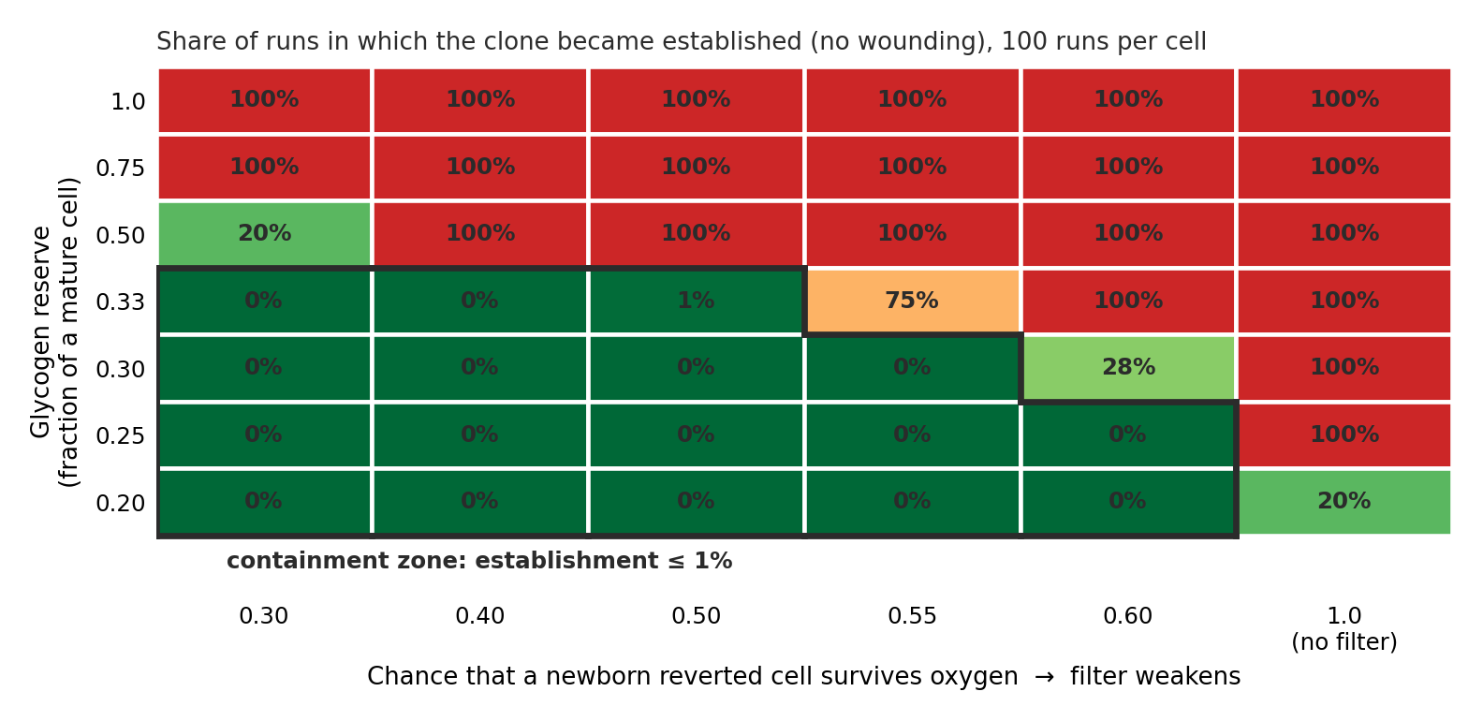
Fig. 1. Summary of model results (no wounding). Green — clone contained; red — clone established.
Containment is not elimination. In the reported containment regime, 23% of runs end with a living clone of at least twelve cells, whereas only 1% reach establishment. These outcomes distinguish persistence from establishment; they are not mutually exclusive categories. A clone can remain present without reaching the model’s establishment endpoint during observation.
2. Clinical parallels in the fallopian tube and Eustachian tube
Nothing was fitted to clinical figures. We use the two tubes as contrasting anatomical examples to motivate testing: the fallopian tube lumen is proposed to be relatively hypoxic, whereas the Eustachian tube is ventilated with air from the middle ear. A weaker filter represents lower division-linked cell mortality in the model (assumed here to be oxygen-related); a stronger filter represents higher mortality. Neither setting has been calibrated to measured luminal or epithelial oxygen levels.
• Fallopian tube. A published series reports p53 signatures — at least 12 consecutive secretory nuclei with aberrant p53 staining in morphologically normal, non-proliferating epithelium — in about 50% of control women (a series of 40) and 71% of BRCA carriers (24 women; the difference is not statistically significant, P = 0.12), with STIC reported at about 3.5% among 400 high-risk women (a different series). The coexistence of relatively frequent small signatures and less frequent intraepithelial lesions is qualitatively consistent with the model’s distinction between persistence and establishment. However, patient prevalence and simulation outcome frequencies have different denominators and observation conditions; their numerical ratios do not validate the mechanism. The reported clinical figures still require confirmation against the primary sources.
• Eustachian tube. Its connection to an air-containing cavity provides a contrasting anatomical setting. The rarity of middle-ear malignancy is an indirect observation, not a direct measure of clonal suppression in Eustachian tube epithelium. Differences in tissue architecture, cell populations and exposures could also contribute. A protective role for oxygen remains a hypothesis.
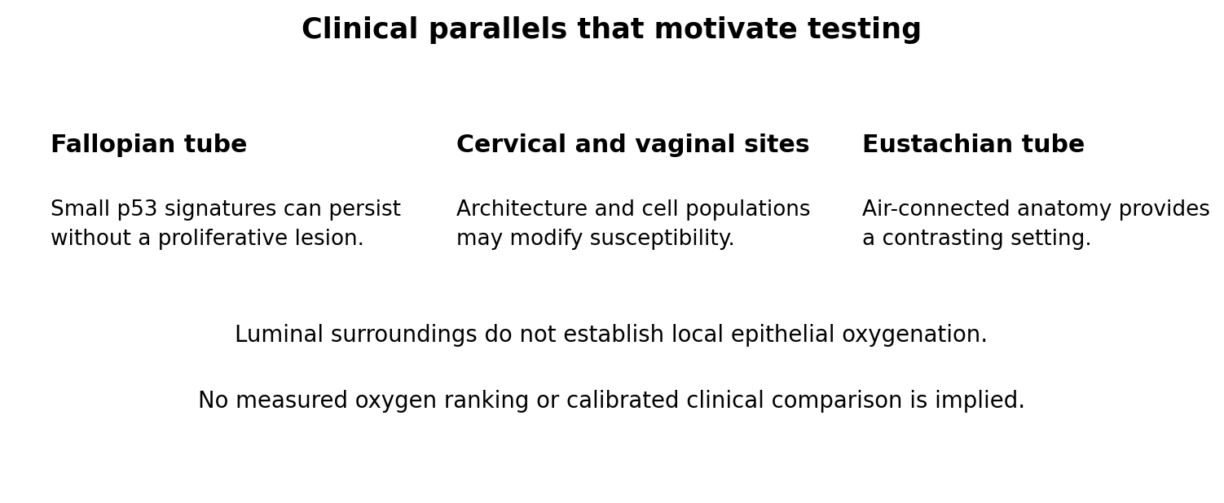
Fig. 2. Anatomical comparisons that motivate testing; oxygen levels are not measured or ranked.
Caveats. Oxygen alone cannot account for differences between epithelial sites. The vaginal wall and cervical transformation zone share a luminal environment but differ in architecture and susceptibility to lesions; shared surroundings do not imply identical local oxygenation or viral effects. Detection methods also differ: p53 signatures are identified by immunohistochemistry, whereas other lesions are assessed by morphology or cytology. Fig. 2 presents anatomical comparisons without assigning measured oxygen levels. A protected basal reserve is another possible explanation for the Eustachian tube comparison. These parallels motivate research rather than demonstrate causation.
3. Injury and stretching of the epithelial sheet: a possible explanation for the role of p53
In the model, wounding completely removes the space barrier (the clone gains free territory) and weakens, but does not remove, the oxygen barrier. Two wounding regimes, limited and chronic, give the same probability of establishment at equal intensity, yet the final clone differs in size almost 18-fold: what matters is how long the injury lasts, not only whether it happens.
A hypothesis, not a result. Stretching and repair could couple two processes: activation of reserve cells, potentially increasing opportunities for reversion, and creation of space for an existing clone. This provides a possible route by which a persistent p53-aberrant clone could expand after injury. The literature suggests that p53 participates in both growth restriction and repair, and that ATR can respond to mechanical stress without DNA damage. These observations motivate investigation of mechanical signalling; they do not establish that stretching generates p53-aberrant clones. The model contains neither p53 nor a link between stretching and reversion rate. The proposed mechanism therefore remains outside its tested results, and the supporting references are still being verified.
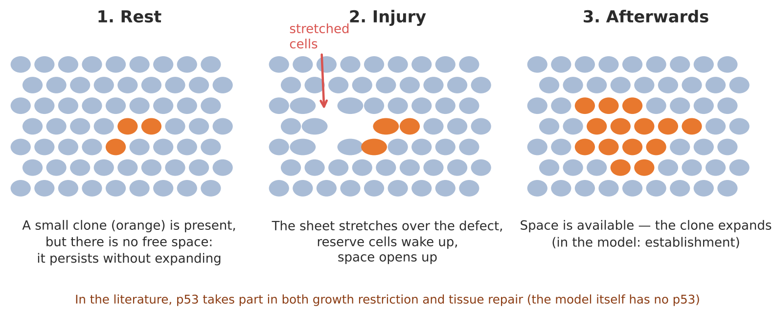
Fig. 3. Scheme of the proposed sequence (orange — reverted cells).
Open question: in your experience, where and under what conditions are p53 signatures and STIC found most often, and how would you explain that distribution? Does it change, in your view, with injury, stretching or other exposures of the tissue?
4. Transient clones: a possible source of ectopic cells without establishment
In the containment regime, small clones can persist through turnover and shed cells from the epithelial surface without crossing the basement membrane. The number of reversions per run changes little with the filter (about 450), while establishment ranges from 0 to 100%. This raises the possibility that clones which never become established contribute to the pool of shed cells. Reversion counts alone, however, do not quantify the number, viability or fate of shed cells, nor demonstrate that this source dominates. Fallopian tube anatomy provides a route into the peritoneal cavity, but successful implantation requires additional properties.
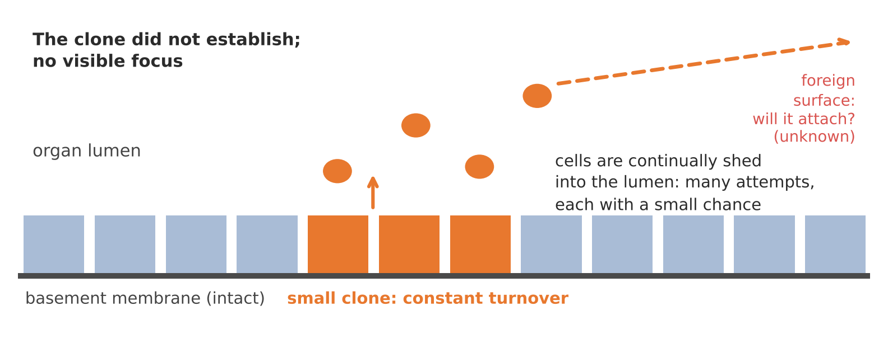
Fig. 4. A transient clone: many attempts to escape, each with a low probability.
What is proposed, and what it rests on. A source of ectopic cells may exist without a visible focus. The question here is implantation: can a shed cell survive, attach to a foreign surface and sustain growth? These abilities do not follow from the model. Testing the hypothesis requires evidence of viable shed cells, implantation competence and a lineage relationship to a subsequent lesion. Other explanations remain possible: a precursor may have been missed, regressed or disseminated early. More extensive sectioning can increase precursor detection, so absence of a detectable focus does not by itself establish an origin from transient clones.
Open question: how often do you see serous cancer with no detectable intraepithelial precursor, and how are such cases usually interpreted?
What this work does not claim. This is a simulation of a proposed early clonal process, not a clinical risk calculator. Its probabilities apply only to the tested assumptions, parameter ranges and observation periods. The establishment threshold (500 cells) is conventional; recomputed at 250 and 1,000 cells, the ordering of results is preserved, while percentages in the transition zone change. Clinical parallels suggest questions for validation; they do not establish the oxygen filter, the timing of immune recognition or the origin of ectopic malignancy. The central distinction is between clonal persistence, establishment and cell shedding. Primary-source verification of the clinical figures and mechanistic references remains necessary before publication.
References: [1] Skipper HE, Schabel FM Jr, Wilcox WS. Experimental evaluation of potential anticancer agents. XIII. On the criteria and kinetics associated with “curability” of experimental leukemia. Cancer Chemother Rep 1964;35:1–111. PMID 14117037. [2] Norton L, Simon R. Growth curve of an experimental solid tumor following radiotherapy. J Natl Cancer Inst 1977;58(6):1735–1741. doi:10.1093/jnci/58.6.1735. [3] Norton L, Simon R. The Norton–Simon hypothesis revisited. Cancer Treat Rep 1986;70(1):163–169. PMID 3510732.

