Act-1 Computer Programming 2

Pius Ambrose Cicero Aguilar
BSIT-203

Liquor.java File

public class Liquor {
CODE

private String drinkName;
private double price;
public static void main(String[] args) {

}

public void setdrinkName(String drink) {
drinkName = drink;
}

public void setPrice(double drinkPrice) {
price = drinkPrice;
}

public String getdrinkName() {
return drinkName;
}

public double getPrice() {
return price;
}
}

LiquorShop.java File

CODE

import java.util.Scanner;
public class LiquorShop {
public static void main(String[] args) {
String drinkName;
int price;

Scanner scan = new Scanner(System.in);
Liquor firstDrink = new Liquor();
Liquor secondDrink = new Liquor();

System.out.print("Enter Liquor Name: ");
drinkName = scan.nextLine();
System.out.print("Enter Price: ");
price = scan.nextInt();

firstDrink.setdrinkName(drinkName);
firstDrink.setPrice(price);

scan.nextLine();

System.out.print("Enter Liquor Name: ");
drinkName = scan.nextLine();
System.out.print("Enter Price: ");
price = scan.nextInt();

secondDrink.setdrinkName(drinkName);
secondDrink.setPrice(price);

System.out.println("\nFirst Liquor:");
System.out.println("Name: " + firstDrink.getdrinkName());
System.out.println("Price: P" + firstDrink.getPrice());

System.out.println("\nSecond Liquor:");
System.out.println("Name: " + secondDrink.getdrinkName());
System.out.println("Price: P" + secondDrink.getPrice());
}
}

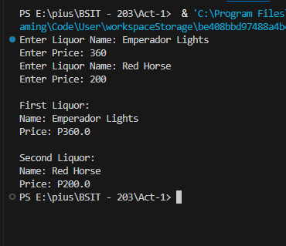
Output

