PT Computer Programming 2

Pius Ambrose Cicero Aguilar
BSIT-203

Version 1

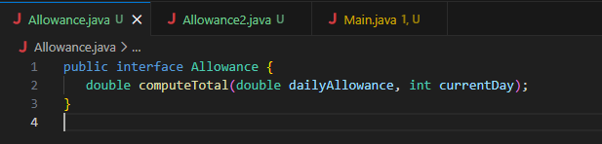

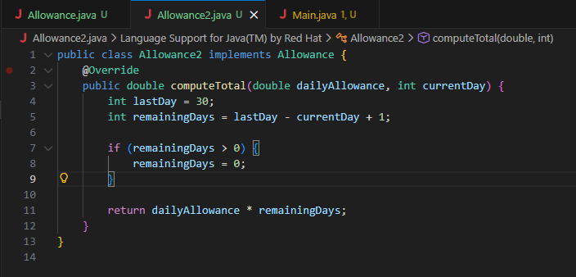

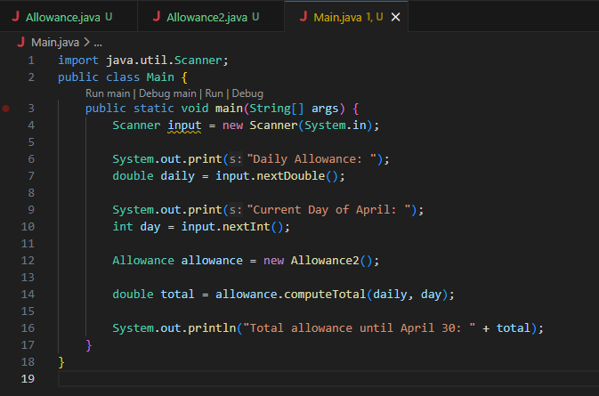

Output

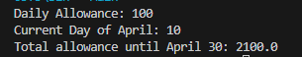
Version 2

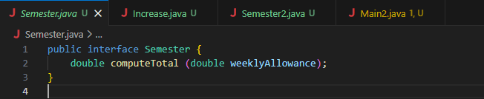
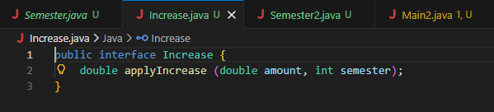

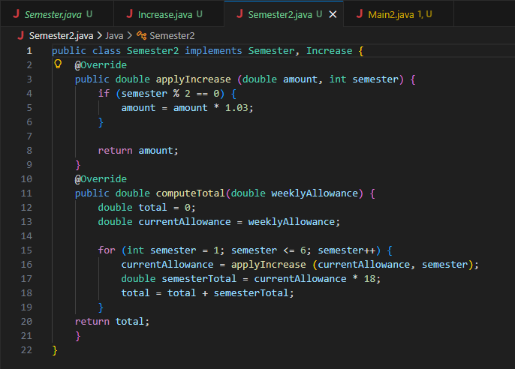
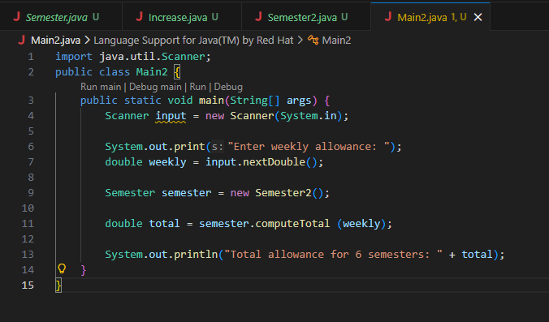

Output

 GitHub Link
https://github.com/YuriYurio0o/PT_prelim.git

