Performance Task

Pius Ambrose Cicero Aguilar
BSIT-203

import java.util.Scanner;
Code
import java.util.regex.Matcher;
import java.util.regex.Pattern;

public class Performance_task {
public static void main(String[] args) {
Scanner scanner = new Scanner(System.in);

System.out.print("Enter the first word: ");
String word1 = scanner.nextLine();

System.out.print("Enter the second word: ");
String word2 = scanner.nextLine();

String sub = word1.substring(word1.length() - 2);

Pattern pattern = Pattern.compile("[a-zA-Z]{1,2}" + sub);
Matcher matcher = pattern.matcher(word2);

if (matcher.matches()) {
System.out.println(word2 + " rhymes with " + word1);
} else {
System.out.println("I'm not sure! Sorry!");
}

scanner.close();
}
}

Output

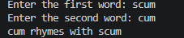
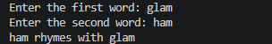
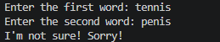
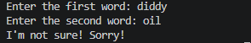

Link : https://github.com/YuriYurio0o/performance_task.git

