This shows the number of compilations done per hour, towards the end we were doing 1500 compilations an hour
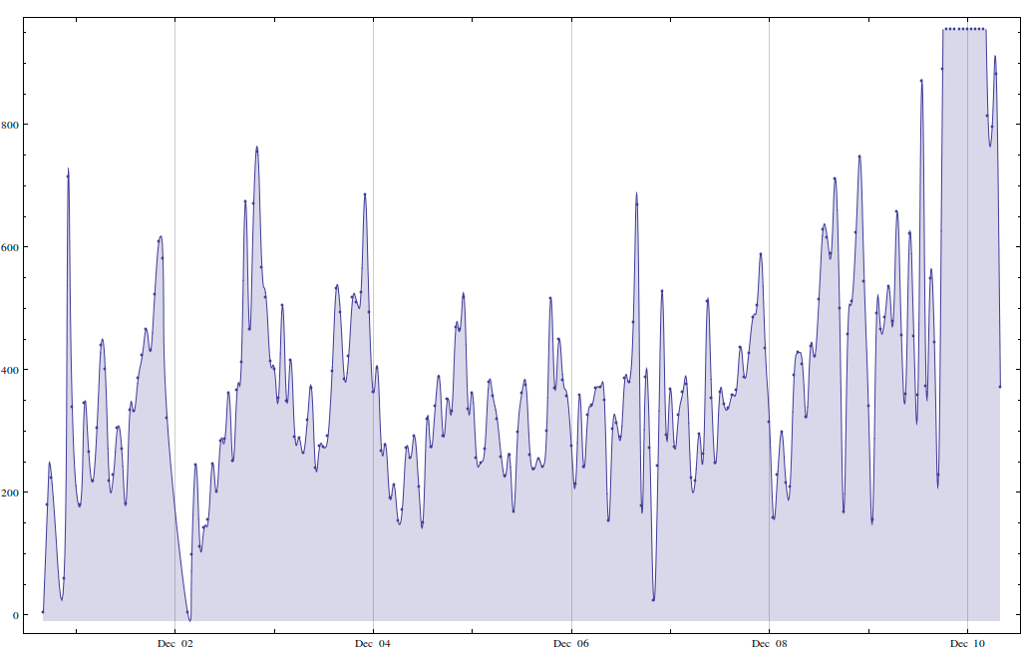
This shows the number of total number of submissions a function of time. The slope changes at the end.
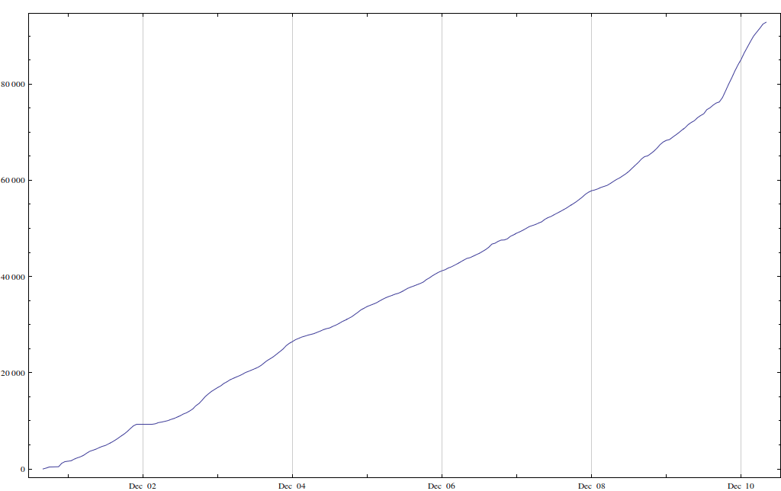
All in all, we processed 92000 submissions.

