Lab Submission System

We will be using a web based lab development and submission system through this course. The purpose of this web system is two fold: 1) it allows you to develop CUDA applications without the need to buy and/or setup a CUDA system, and 2) it allows us to grade your more efficiently, uniformly, and promptly. This document describes the online system, walking through the pages that you will see, and describing a sample submission.

# Web System

## System Flow

## Insertion Points

## Logging and Debugging

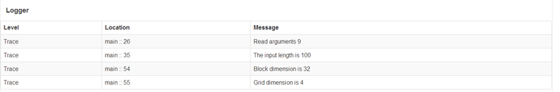

Logging View

## Timing Code

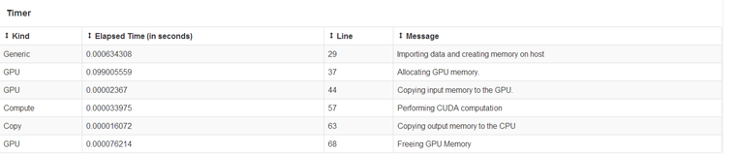

Timing View

## Previous Attempts

## Walk Through

# Behaviors

While developing the labs, you may encounter one or more of the following behaviors.

## No Error

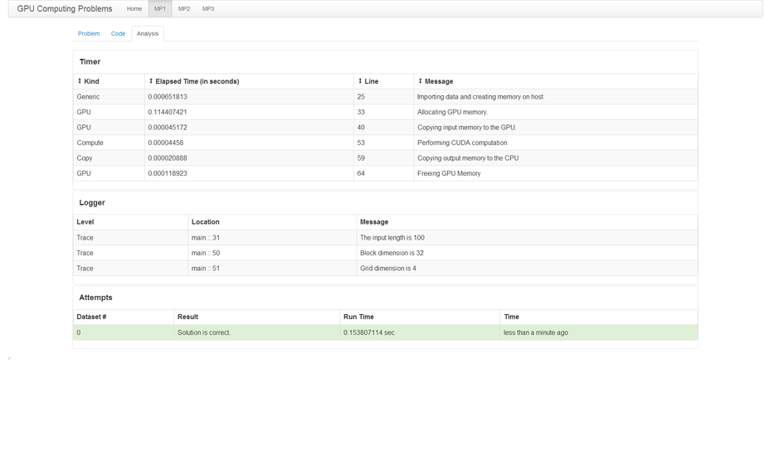

Solution is Correct

This means that no errors were found while running the program. Your program has been checked against the expected solution of the dataset you selected. Note that it might be the case that the program may run correctly on one dataset and not the other.

## Solution is Incorrect

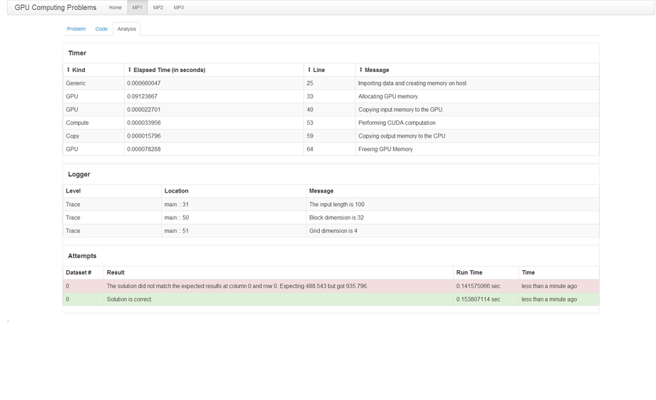

Solution is Incorrect

## Compilation Failed

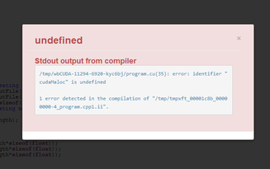

Compilation Failed

The error message

## Program Terminated due to Timeout

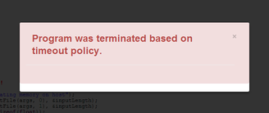

Program Terminated

The most likely cause of this error is that you have inadvertently placed an infinite loop either in your CPU or GPU code. Part of the reason for this behavior is that the system ensures fairness (i.e. you should not hog down the machine). To ensure fairness, the system is configured to terminate long running processes. When you see this error, you have hit that timeout limit.

## Memory Allocation Error

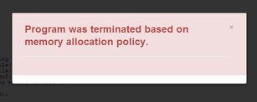

Memory Allocation

## Sandboxing Error

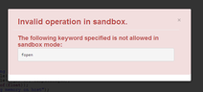

Sandbox Error

# Suggestions

# Grading

Grading is performed based on criteria that are specific for each lab. Aside from the program submitted compiling and running, we also look at how fast the program is in relation to the other submissions.

# System Requirements

A recent web browser is the only requirement for using and submitting labs in this course.