Equipment Store

Backend technology stack:

* NODE JS
* PostgreSQL
* Express
* Sequelize

1. Create database of 8 tables.
2. User authorization by jwt token.
3. REST API of internet store.

Database diagram:

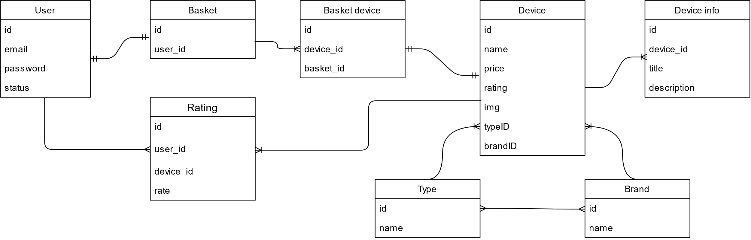

Endpoints

Users:

* POST – [http://.../api/user/registration](http://.../api/user/registration%20)  - fetch users
* POST – <http://.../api/user/login> - add user
* DELETE – <http://.../api/user/auth> - delete user

Devices:

* GET – <http://.../api/device> - fetch devices
* GET – <http://.../api/devic>e/:id - fetch device
* POST – [http://.../api/device](http://.../api/device%20)  - add device

Types:

* POST – <http://.../api/type> - create type
* GET – <http://.../api/type> - get types

Brands:

* POST – <http://.../api/brand> - create brand
* GET – [http://.../api/brand](http://.../api/brand%20)  - get brands

Front-end technology stack:

* React
* Redux
* React-bootstrap