**МІНІСТЕРСТВО ОСВІТИ І НАУКИ УКРАЇНИ**

**НАЦІОНАЛЬНИЙ УНІВЕРСИТЕТ “ЛЬВІВСЬКА ПОЛІТЕХНІКА”**

**НН ІНСТИТУТ ПІДПРИЄМНИЦТВА ТА ПЕРСПЕКТИВНИХ ТЕХНОЛОГІЙ**

**ЗВІТ**

з дисципліни “Основи електроніки ”

на тему:

***“*** **Arduino*”***

Виконав:

Студент гр. КН-114

Дубницький Ю.І.

Прийняв асистент:

Борейко О.Ю.

Львів–2018

Ми пишемо код який буде показувати символи на дисплеї

/*

* This video shows you how to use MAX7219 module with 8x8 LED matrix to display text or any characters on the LED.

* watch YouTube video: https://youtu.be/AAiDwBKs9uE

*

*Written by Ahmad S. for Robojax.com

*on Feb 26, 2017 in Ajax, Ontario, Canada

* Permission granted to share this code given that this

* note is kept with the code.

* Disclaimer: this code is "AS IS" and for educational purpose only.

*/

//We always have to include the library

// Based on a project posted https://github.com/wayoda/LedControl

#include "LedControl.h"

/*

Now we need a LedControl to work with.

// Customized for RoboJax.com on Feb 26, 2017 in Ajax, Ontario, Canada.

***** These pin numbers will probably not work with your hardware *****

pin 12 is connected to the DataIn

pin 11 is connected to the CLK

pin 10 is connected to CS

We have only a single MAX72XX.

*/

LedControl lc=LedControl(12,11,10,1);

/* we always wait a bit between updates of the display */

unsigned long delaytime=700;

void setup() {

/*

The MAX72XX is in power-saving mode on startup,

we have to do a wakeup call

*/

lc.shutdown(0,false);

/* Set the brightness to a medium values */

lc.setIntensity(0,8);

/* and clear the display */

lc.clearDisplay(0);

}

/*

This method will display the characters for the

word "Arduino" one after the other on the matrix.

(you need at least 5x7 leds to see the whole chars)

*/

void writeArduinoOnMatrix() {

/* here is the data for the characters */

// K

byte D[8]={ B01111110,B01000010,B01000010,B01000010,B01000010,B11111111,B10000001,B10000001};

byte Y[8]={ B01100010,B10100010,B00100010,B00100010,B00111110,B00000010,B00100100,B00111000};

byte B[8]= { B01111110,B01000000,B01000000,B01111110,B01000010,B01000010,B01000010,B01111110};

byte R[8]={B01000010,B01000010,B01000010,B01111110,B01000010,B01000010,B01000010,B01000010};

byte N[8]={ B01000100,B01000100,B01000100,B01000100,B01111100,B01000100,B01000100,B01000100};

byte U[8]={ B10000001,B10000011,B10000101,B10001001,B10010001,B10100001,B11000001,B10000001};

byte T[8]={ B01000100,B01000100,B01000100,B01000100,B01000100,B01111110,B00000010,B00000010};

byte P[8]={B01000000,B01000000,B01000000,B01000000,B01111110,B01000010,B01000010,B01111110};

byte K[8]={ B01000110,B01001000,B01010000,B01100000,B01100000,B01010000,B01001000,B01000110};

byte J[8]={B00100100,B10011001,B10000011,B10000101,B10001001,B10010001,B10100001,B11000001};

byte Q[8]={ B10011001,B01000010,B00100100,B10000001,B00000000,B01111110,B10011001,B10011001};

byte W[8]={B10100101,B01011010,B10100101,B01011010,B01011010,B10100101,B01011010,B10100101};

/* Letter */

for (int i=0; i<8; i++){

lc.setRow(0,i,D[i]);

}

delay(delaytime);

for(int i=0; i<8; i++){

lc.setRow(0,i,0);// this is for blank

}

/////////////// END of Letter///////

/* Letter */

for (int i=0; i<8; i++){

lc.setRow(0,i,Y[i]);

}

delay(delaytime);

for(int i=0; i<8; i++){

lc.setRow(0,i,0);// this is for blank

}

/////////////// END of Letter///////

/* Letter */

for (int i=0; i<8; i++){

lc.setRow(0,i,B[i]);

}

delay(delaytime);

for(int i=0; i<8; i++){

lc.setRow(0,i,0);// this is for blank

}

for (int i=0; i<8; i++){

lc.setRow(0,i,R[i]);

}

delay(delaytime);

for(int i=0; i<8; i++){

lc.setRow(0,i,0);// this is for blank

}

/////////////// END of Letter///////

/* Letter */

for (int i=0; i<8; i++){

lc.setRow(0,i,U[i]);

}

delay(delaytime);

for(int i=0; i<8; i++){

lc.setRow(0,i,0);// this is for blank

}

/////////////// END of Letter J///////

/* Letter */

for (int i=0; i<8; i++){

lc.setRow(0,i,T[i])

}

delay(delaytime);

for(int i=0; i<8; i++){

lc.setRow(0,i,0);// this is for blank

}

/////////////// END of Letter//////

/* Letter A *

/////////////// END of Letter//////

/* Letter X */

for (int i=0; i<8; i++){

lc.setRow(0,i,P[i])

}

delay(delaytime);

for(int i=0; i<8; i++){

lc.setRow(0,i,0);// this is for blank

}

/////////////// END of Letter//////

/* love */

for (int i=0; i<8; i++){

lc.setRow(0,i,K[i])

}

delay(delaytime);

for(int i=0; i<8; i++){

lc.setRow(0,i,0);// this is for blank

}

for (int i=0; i<8; i++){

lc.setRow(0,i,U[i])

}

delay(delaytime);

for(int i=0; i<8; i++){

lc.setRow(0,i,0);// this is for blank

}

for (int i=0; i<8; i++){

lc.setRow(0,i,J[i]);

}

delay(delaytime);

for(int i=0; i<8; i++){

lc.setRow(0,i,0);// this is for blank

}

for (int i=0; i<8; i++){

lc.setRow(0,i,Q[i])

}

delay(delaytime);

for(int i=0; i<8; i++){

lc.setRow(0,i,0);// this is for blank

}

for (int i=0; i<8; i++){

lc.setRow(0,i,W[i]);

}

delay(delaytime);

for(int i=0; i<8; i++){

lc.setRow(0,i,0);// this is for blank

}

/////////////// END of Letter///////

}// writeArduinoOnMatrix() end

void loop() {

writeArduinoOnMatrix();

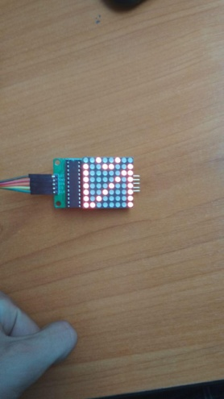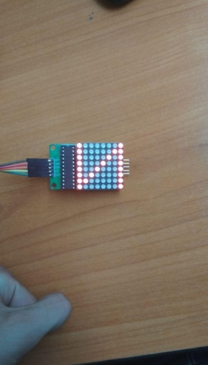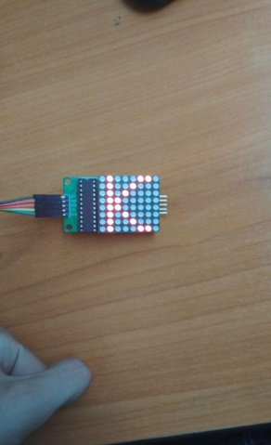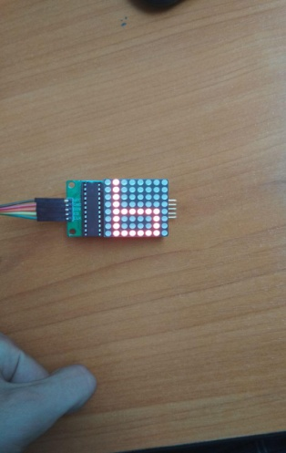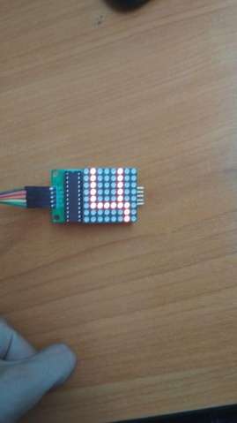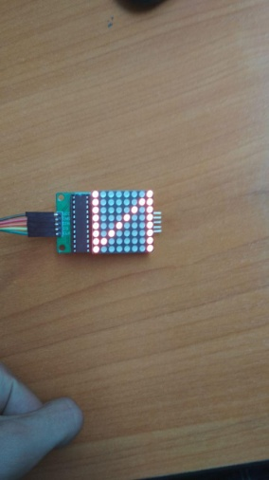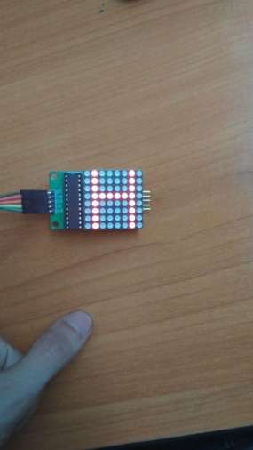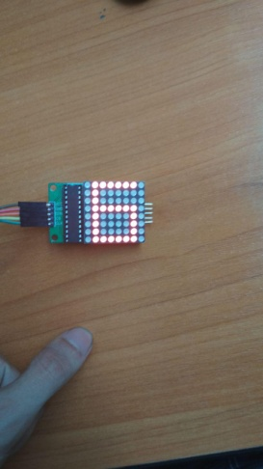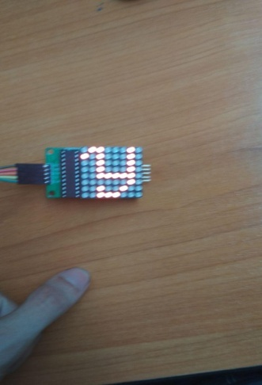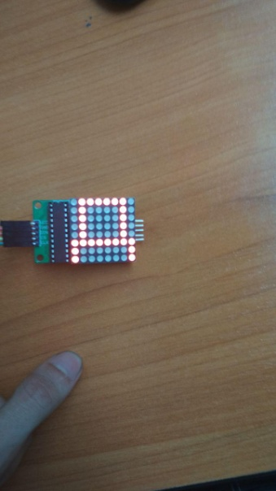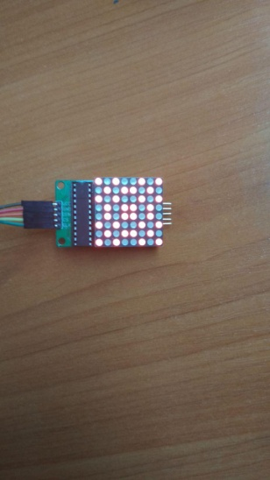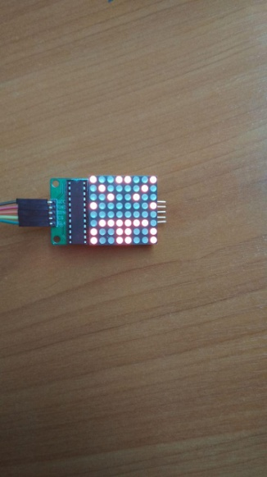

**Висновок:** ми навчились писати код для ардуїно.