businessmodelanalyst.com



EMPATHY MAP
PRINT and DESIGN you own EMPATHY MAP

Empathy Map
Designed for:
Designed by:
Date:
Version:

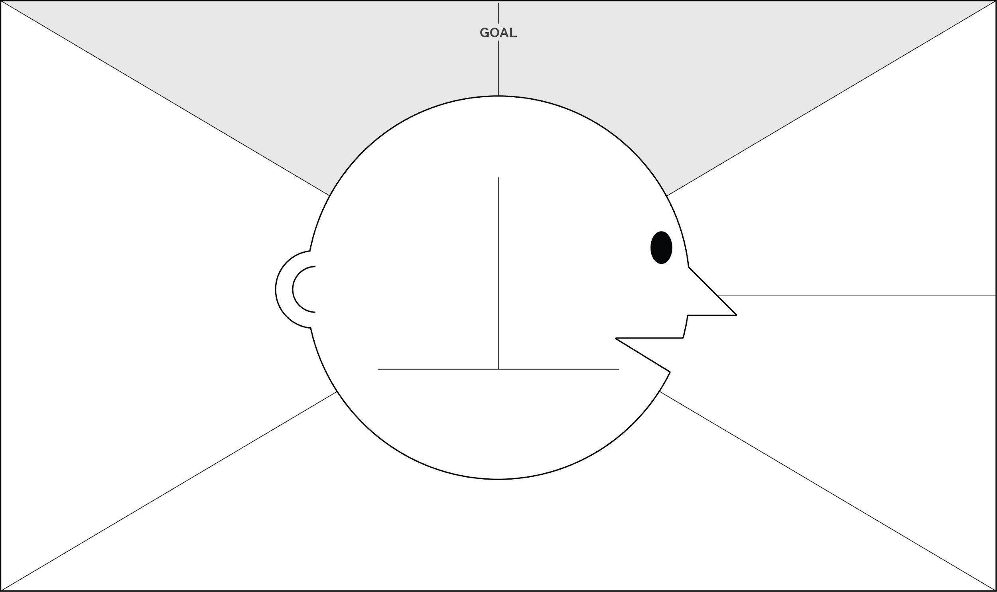
- WHO are we empathizing with?
- What do they need to DO?

7 What do they THINK and FEEL?

He see...

Responsabilidades do Cliente...

Customer profile...

PAINS
GAINS

- What do they SEE?

Gain 1

He see...

- What do they HEAR?

Pain 1

- What do they SAY?

He say...

He hear...

He hear...

Gain 2

Pain 2

- What do they DO?

He do...

He do...

He say...

Empathy Map
Designed for:
Designed by:
Date:
Version:

  - WHO are we empathizing with?
Who is the person we want to understand? What is the situation they are in?
What is their role the situation?
  - What do they need to DO?
What do they need to do diﬀerently?
What job(s) do they want or need to get done? What decision(s) do they need to make?
How will we know they were successful?

- What do they THINK and FEEL?

- What do they HEAR?
What are they hearing others say? What are they hearing from friends? What are they hearing from colleagues? What are they hearing second-hand?
PAINS
What are their fears, frustations and anxieties?
GAINS
What are their wants, needs, hopes and dreams?

- What do they SEE?
What do they see in the marketplace?
What do they see in their immediate environment? What do they see others saying and coming?
What are they watching and reading?

- What do they SAY?

What other thoughts and feelings might motivate their behavior?
What have we heard them say? What can we imagine them saying?

- What do they DO?
What do they do today?
What behavior have we observed? What can we imagine them doing?



GOOD LUCK
with your empathy map!

Follow me:
 businessmodelanalyst.com

 facebook.com/businessmodelanalyst linkedin.com/in/dpereirabr

