- This and the other documents look best in web layout.

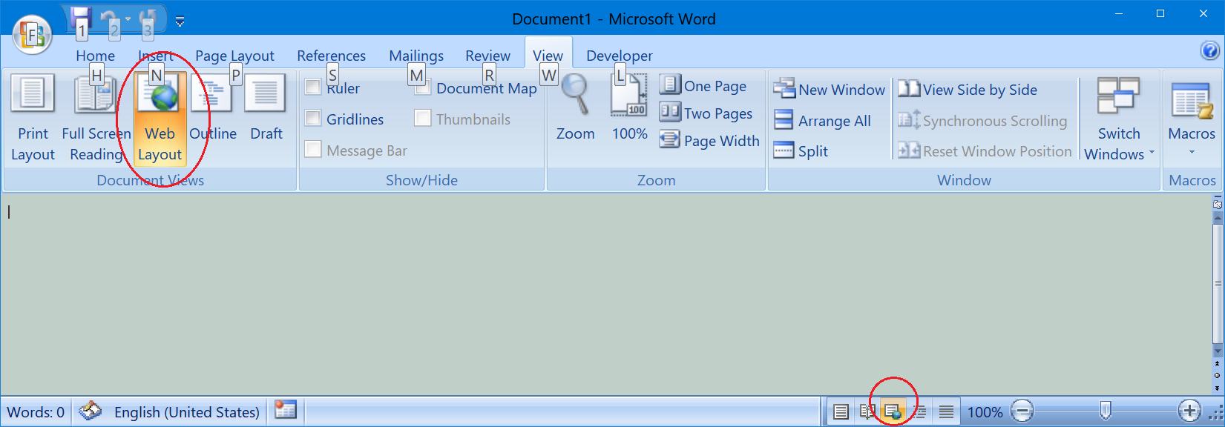

- 2019-05-20.

Implemented console output

- 2019-05-14.

First deliverable.

I recommend you to read all doc files, especially "7_Logger_User_Manual.doc".

