High Performance and High Time Resolution Logger -- User Manual

- On both Windows and Linux, the logger uses system calls that return high resolution date-time that is not guaranteed to be monotonic.

To eliminate date-time leaps, configure Windows to not sync date-time to NTP periodically, by unchecking the checkbox:

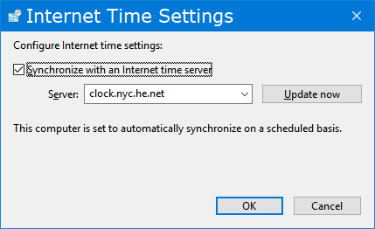

You might want to run an NTP client to keep system date-time synced. If properly configured, it should result in very small date-time leaps, likely under 1 us. There is an NTP client service that comes with Windows, which could actually automatically disable the above setting.

The same thing likely applies to Linux as well.

