High Performance and High Time Resolution Logger -- Programmer Manual

- All sources of interest that comprise the logger and related codebase are located under "SourceCode\QuantDiagnostics\Src\Quant".

I haven't made a library out of those sources. You simply need to include them into your project. This way, the compiler will optimize the code better.

The "...\Quant\pch.h" file includes all required third party files. There are some important comments in it, including Comment201802047. You can either include it or merge its content into your own precompiled header file. "...\Demo\pch.h" includes it.

You might want to include some/all my other header files into your precompiled header file as well.

The "Demo" subdirectory next to "Quant" contains demo code, parts of which you will need to copy to your code, with some modifications. Please review it together with all comments.

- I have provided 2 Visual Studio projects: one for Windows and another for Linux.

If you want to compile and run the Linux project, please see the auto-generated "SourceCode\QuantDiagnostics\LinuxDemo\readme\readme.html" for how to. If something is not clear you can Google for more info as well. Generally, you will need to configure your Linux host in Visual Studio options, under the "Cross Platform" ==> "Connection Manager" tab.

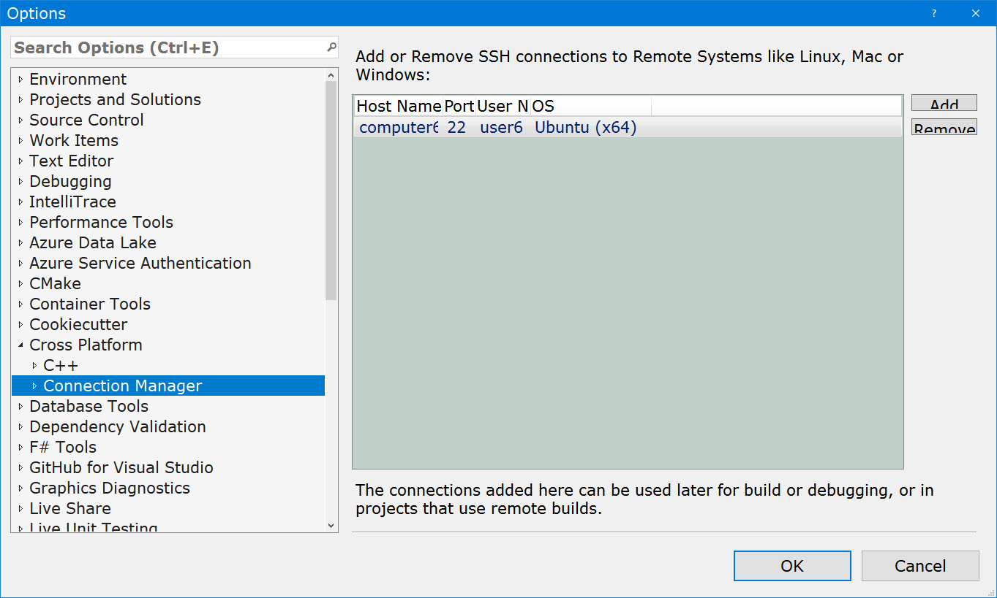

Then in the LinuxDemo project properties select that machine.

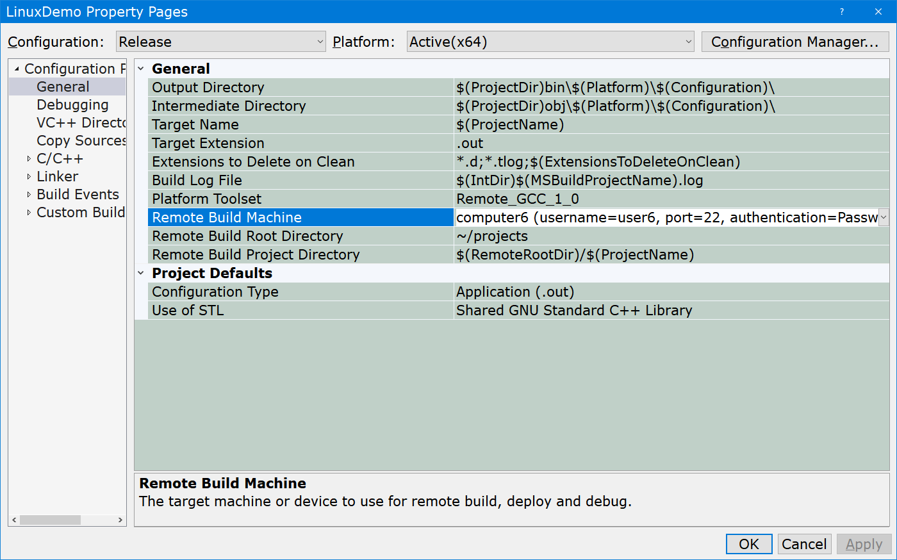

If afterwards it doesn't work you will likely need to install/enable some things on the Linux machine.

- The {TLogger} class.

It contains a buffer to which data is appended fast. Then a separate thread flushes the buffer to a file.

A typical log record is comprised of a few "fragments": a date-time-stamp, " | ", client code provided text, platform dependent new line chars.

The logger itself is pretty low level in that it isn't capable of formatting the whole log record. There are helper functions that do it.

You will typically be logging either a constant char-array (remember to explicitly provide its length as {sizeof(...) - 1}) or provide a format string and a few parameters for {snprintf} to write directly to the log file buffer. In both cases the logging is a single helper function call.

Sometimes you will need to log something more complex that consists of multiple fragments/substrings. You can implement it just as efficiently, with zero copy/allocate. The demo code contains a relevant example.

Note that for maximum efficiency, outcome severity, such as "INFO" or "ERROR", isn't handled as a separate fragment. It's to be provided in text. If you want to implement an equivalent of a configurable log level, such as log all warnings or worse, you can simply add a configurable parameter such as {IsLoggingVerbose} and if it's {true} log more. Additionally, you can log even more in debug build.

- Please review Comment201905134.

- Please review Comment201905092.

- Please review Comment201905117.

