Міністерство освіти і науки України

Запорізький національний технічний університет

кафедра програмних засобів

ЗВІТ

З лабораторної роботи №6

З дисципліни «Якість програмного забезпечення та тестування» з теми:

**«ТЕСТУВАННЯ WEB-САЙТІВ»**

Виконав:

студент групи КНТ-115 Ю.О. Лукашенко

Прийняла:

доцент, к.т.н Н.О.Миронова

2018

1. Мета роботи

Вивчити можливості тестування web-сайтів із застосуванням програми Xenu Link Sleuth.

1. Завдання до роботи

1.3.1 Ознайомитися з теоретичними відомостями щодо тестування web-сайтів за допомогою програми Xenu Link Sleuth.

1.3.2 Вибрати web-сайт для тестування. Отримати звіт за допомогою програми Xenu Link Sleuth. Побудувати мапу сторінок сайту.

1.3.3 Побудувати граф web-сайту.

1. Хід роботи

Результати тестування Xenu Link Sleuth зображена на рисунку 1.1

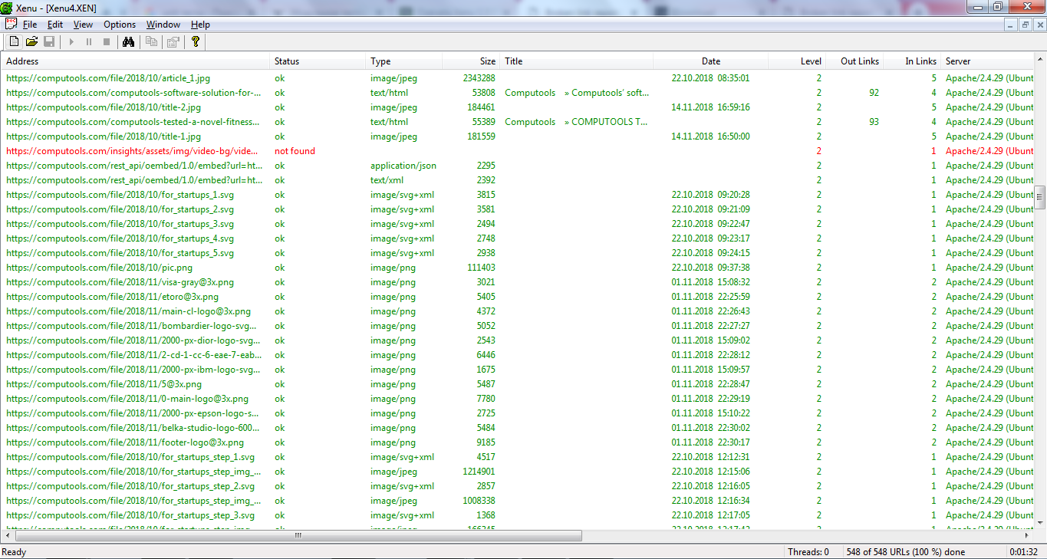

Рисунок 1.1 – Результати тестування Xenu Link Sleuth

Далі, на рисунку 1.2 наведено статистику моніторингу сайту <https://computools.com>.

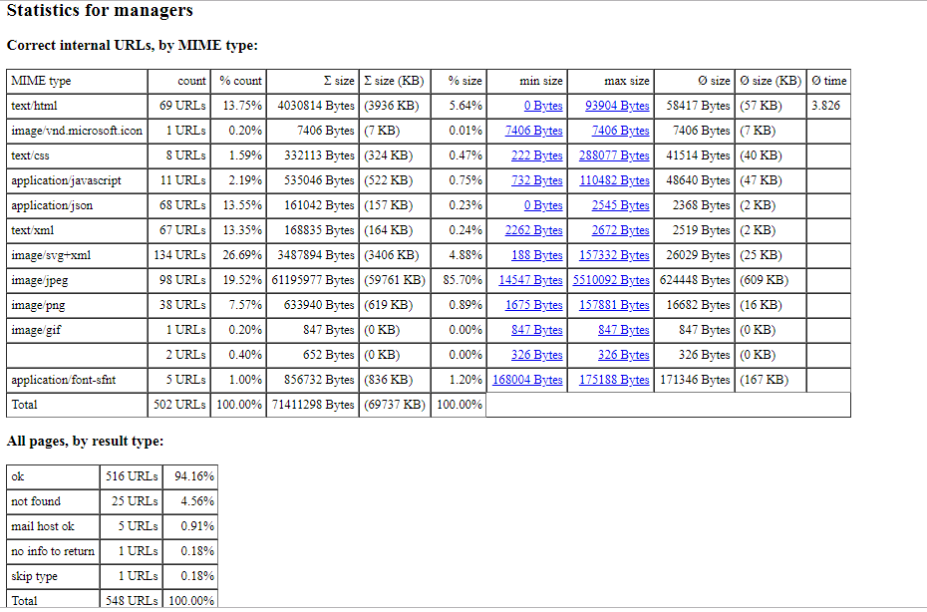

Рисунок 1.2 – Статистика моніторингу сайту https://computools.com

Сформована мапа сторінок сайту https://computools.com .

• [Computools](https://computools.com/)

* [Computools » Insights](https://computools.com/insights/)
  + [Computools » Strategic Business Planning](https://computools.com/strategic-business-planning/)
  + [Computools » Computools’ software solution for an entrepreneur](https://computools.com/computools-software-solution-for-an-entrepreneur/)
  + [Computools » COMPUTOOLS TESTED A NOVEL FITNESS TRACKER](https://computools.com/computools-tested-a-novel-fitness-tracker/)
* [Computools » Dedicated teams for startups](https://computools.com/dedicated-teams-for-startups/)
  + [Computools » Strategic Business Planning](https://computools.com/strategic-business-planning/)
  + [Computools » Computools’ software solution for an entrepreneur](https://computools.com/computools-software-solution-for-an-entrepreneur/)
  + [Computools » COMPUTOOLS TESTED A NOVEL FITNESS TRACKER](https://computools.com/computools-tested-a-novel-fitness-tracker/)
* [Computools » Dedicated Team of IT engineers](https://computools.com/dedicated-team-of-it-engineers/)
  + [Computools » Strategic Business Planning](https://computools.com/strategic-business-planning/)
  + [Computools » Computools’ software solution for an entrepreneur](https://computools.com/computools-software-solution-for-an-entrepreneur/)
  + [Computools » COMPUTOOLS TESTED A NOVEL FITNESS TRACKER](https://computools.com/computools-tested-a-novel-fitness-tracker/)
* [Computools » Big Data](https://computools.com/technologies/big-data/)
* [Computools » Artificial Intelligence](https://computools.com/technologies/artificial-intelligence/)
* [Computools » Cloud Computing](https://computools.com/technologies/cloud-computing/)
* [Computools » Internet of Things](https://computools.com/technologies/internet-of-things/)
* [Computools » VR & AR](https://computools.com/technologies/virtual-augmented-reality/)
* [Computools » Blockchain](https://computools.com/technologies/blockchain/)
* [Computools » About Us](https://computools.com/about-us/)
  + [Computools » Strategic Business Planning](https://computools.com/strategic-business-planning/)
  + [Computools » Computools’ software solution for an entrepreneur](https://computools.com/computools-software-solution-for-an-entrepreneur/)
  + [Computools » COMPUTOOLS TESTED A NOVEL FITNESS TRACKER](https://computools.com/computools-tested-a-novel-fitness-tracker/)
* [Computools » Careers](https://computools.com/careers/)
  + [Computools » Head of Office](https://computools.com/career/head-of-office/)
  + [Computools » Help Desk Manager](https://computools.com/career/help-desk-manager/)
  + [Computools » Senior Software Engineer, JAVA](https://computools.com/career/senior-software-engineer-java/)
  + [Computools » Business Development Manager](https://computools.com/career/business-development-manager-4/)
  + [Computools » Technical Project Manager](https://computools.com/career/technical-project-manager-3/)
  + [Computools » Senior Software Engineer, Python](https://computools.com/career/senior-software-engineer-python-2/)
  + [Computools » Business Development Manager](https://computools.com/career/business-development-manager-5/)
  + [Computools » Team Lead / Senior Software Engineer](https://computools.com/career/team-lead-senior-software-engineer/)
  + [Computools » Talent Sourcer](https://computools.com/career/talent-sourcer-2/)
  + [Computools » Senior Software Engineer, JAVA](https://computools.com/career/senior-software-engineer-java-2/)
  + [Computools » Senior Software Engineer, PHP](https://computools.com/career/senior-software-engineer-php/)
  + [Computools » Illustrator / Graphic Designer](https://computools.com/career/illustrator-graphic-designer/)
  + [Computools » SEO Analyst](https://computools.com/career/seo-analyst/)
  + [Computools » Data Scientist](https://computools.com/career/data-scientist-2/)
  + [Computools » Senior Software Engineer, Python](https://computools.com/career/senior-software-engineer-python/)
  + [Computools » Senior Business Analyst](https://computools.com/career/senior-business-analyst-3/)
  + [Computools » Senior Business Analyst](https://computools.com/career/senior-business-analyst-2/)
  + [Computools » Technical Project Manager](https://computools.com/career/technical-project-manager-2/)
  + [Computools » Business Development Manager](https://computools.com/career/business-development-manager-3/)
  + [Computools » Technical Project Manager](https://computools.com/career/technical-project-manager-4/)
  + [Computools » Senior Software Engineer, Python](https://computools.com/career/senior-software-engineer-python-3/)
  + [Computools » Senior Software Engineer, Scala](https://computools.com/career/senior-software-engineer-scala/)
  + [Computools » Business Development Manager](https://computools.com/career/business-development-manager-6/)
  + [Computools » Technical Project Manager](https://computools.com/career/technical-project-manager/)
  + [Computools » Senior Communications Manager](https://computools.com/career/senior-communications-manager/)
  + [Computools » Business Development Manager](https://computools.com/career/business-development-manager/)
  + [Computools » Talent Sourcer](https://computools.com/career/talent-sourcer/)
  + [Computools » Data Scientist](https://computools.com/career/data-scientist/)
  + [Computools » Senior Business Analyst](https://computools.com/career/senior-business-analyst/)
  + [Computools » Business Development Manager](https://computools.com/career/business-development-manager-2/)
  + [Computools » Senior Software Engineer, JS](https://computools.com/career/senior-software-engineer-js/)
* [Computools » Customer Area](https://computools.com/customer-area/)
* [Computools » Contact Us](https://computools.com/contact-us/)
* [Computools » Machine emotional intelligence](https://computools.com/emotionally-intelligent-applications-why-do-we-need-to-teach-a-machine-to-feel/)
* [Computools » IoT: User-centric Privacy Security](https://computools.com/user-centric-privacy-security-for-the-internet-of-things/)
* [Computools » Business applications of cloud computing](https://computools.com/cloud-computing-a-reliable-business-tool/)
* [Computools » Business transformation through blockchain](https://computools.com/blockchain-solutions-a-key-to-successful-business-transformations/)
* [Computools » Digital Workforce Productivity](https://computools.com/transformation/digital-workforce-productivity/)
* [Computools » In-House Digital Team](https://computools.com/transformation/in-house-digital-team/)
* [Computools » External Expertise Pool](https://computools.com/transformation/external-expertise-pool/)
* [Computools » Digital Traction Metrics](https://computools.com/transformation/digital-traction-metrics/)
* [Computools » Competitive Advantage](https://computools.com/transformation/competitive-advantage/)
* [Computools » Hack Your Company](https://computools.com/transformation/hack-your-company/)
* [Computools » Internal Digital Platform](https://computools.com/transformation/internal-digital-platform/)
* [Computools » Customer Engagement](https://computools.com/transformation/customer-engagement/)
* [Computools » Digital Operating Model](https://computools.com/transformation/digital-operating-model/)
* [Computools » CREELiT](https://computools.com/cases/creelit/)
  + [Privacy Policy](https://computools.com/wp/privacy-policy/)
* [Computools » Cci Assistant](https://computools.com/cases/cci-assistant/)
  + [Privacy Policy](https://computools.com/wp/privacy-policy/)
* [Computools » MeterSnap](https://computools.com/cases/metersnap/)
  + [Privacy Policy](https://computools.com/wp/privacy-policy/)
* [Computools » eToro](https://computools.com/cases/etoro/)
  + [Privacy Policy](https://computools.com/wp/privacy-policy/)
* [Computools » Epson](https://computools.com/cases/epson/)
  + [Privacy Policy](https://computools.com/wp/privacy-policy/)
* [Privacy Policy](https://computools.com/wp/privacy-policy)
  + [Computools » Computools Online Privacy Policy](https://computools.com/privacy-policy/)

Далі на рис. 1.3 зображений граф сайту computools.com

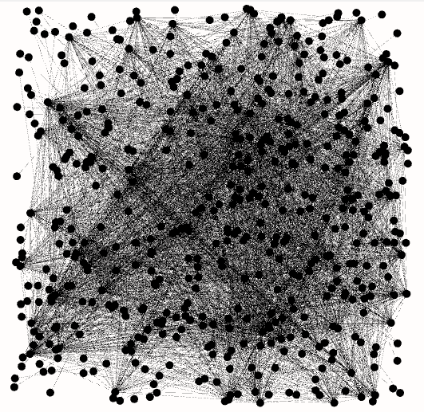

Рисунок 1.3 – Граф сайту https://computools.com

1. Висновки

В ході виконання лабораторної роботи, було вивчено можливості тестування web-сайтів за допомогою програми Xenu Link Sleuth.