*Task Manager*

Armas, Angel Chloe C.   
Department of Electronics and Computer Engineering

Computer Engineering

*Manila City, Philippines*  
[angel_armas@dlsu.edu.ph](mailto:angel_armas@dlsu.edu.ph)

Litam, Rafael Luis C.   
Department of Electronics and Computer Engineering

Computer Engineering

*Manila City, Philippines*  
[rafael_litam@dlsu.edu.ph](mailto:rafael_litam@dlsu.edu.ph)

Tumitit, Ma. Dominique B.   
Department of Electronics and Computer Engineering

Computer Engineering

*Manila City, Philippines*  
[ma_dominique_tumitit@dlsu.edu.ph](mailto:ma_dominique_tumitit@dlsu.edu.ph)

COURSE: LBYCPA2

SECTION EQ8

# INTRODUCTION

Students in the current digital era constantly struggle to balance their obligations to their personal lives with their academic responsibilities. Maintaining an orderly and effective digital workspace has become increasingly challenging due to the expansion of digital resources and personal data. Today's students extend their educational journey into the digital realm, where files and assignments call for an organized approach beyond traditional classrooms and textbooks.

To address these pressing issues, a dedicated team has embarked on a mission to simplify and enhance students' lives. Researchers have developed a task management system that goes beyond being just a software program; it is a skillfully crafted tool designed to help students organize their files based on various criteria. Equipped with features such as priority levels, due dates, categories, and detailed descriptions, this system caters to the diverse needs of modern learners.

The implementation of this approach will significantly boost students' productivity. It streamlines the management of their digital lives and contributes to their academic success by ensuring easy organization and retrieval of both personal and academic documents. This project is more than a mere collection of data structures and lines of code; it is a transformative tool that empowers students to efficiently complete their academic tasks.

Each student is expected to organize their folders to provide a quick and effective means of accessing their information. Managing numerous files can be challenging, particularly when dealing with multiple subjects, each with its own distinct requirements. Complicating matters further is the fact that students often store private data on their computers. By allowing students to categorize their academic and personal documents according to priority levels, deadlines, categories, descriptions, and other relevant factors, this task management system becomes a comprehensive and user-friendly solution to address these challenges. The primary objective of this method is to enhance overall productivity while ensuring that students can easily locate the information they need, precisely when they need it.

# OBJECTIVES

Developing user-centric work management software that maximizes student file organization is the aim. To manage jobs effectively, the platform will make use of data structures like ArrayList, HashMap, Stack, and Queue. Stack will take care of finished tasks; HashMap will provide speedy task retrieval; Queue will handle pending tasks; and ArrayList will keep an orderly list of tasks.

Secure login, prioritizing tools, strong categorization systems, detailed task descriptions, note-taking capabilities, and a task hierarchy structure that requires finishing required tasks before moving on to others are some of the main features. The completed tasks will be tracked by the system for monitoring and reference. The team feature will make it easy for members of the group to share tasks with one another, adding a personal touch to task management and encouraging productive teamwork.

The objective is to provide students with an intuitive, all-inclusive, and flexible task management system that meets their changing needs and guarantees a systematic and effective approach to their academic pursuits. Through the integration of these capabilities and a variety of data structures, the platform seeks to provide students with a comprehensive and flexible solution.

# METHODOLOGY

The task management system's data flow is made to effectively manage and organize students' personal and academic files. To handle various elements of job management, the system makes use of data structures including ArrayList, HashMap, Stack, and Queue. The system verifies the password and username once a user logs in. It opens the associated user file and initializes data structures such as a priority queue, task queue, stack for completed tasks, and hash map for quick task retrieval if the credentials are valid. After that, users may take actions like adding, amending, completing, or deleting tasks.

The Queue takes care of pending tasks, while the ArrayList keeps an organized list of tasks. While the HashMap guarantees speedy task retrieval, the Stack is utilized to organize completed jobs. Effective organization is facilitated by the use of prioritizing tools, robust classification schemes, and thorough job descriptions. The task hierarchy structure also incentivizes users to complete necessary activities before advancing to others.

**Pseudocode**

1. Input login username, password
2. If username is connected to the correct password
3. Open file “username”
4. Change scene
5. Initialize queue, stack, HashMap, priority queue
6. Input action(add task, edit task, finish task, remove task)
7. If add task
8. Input task name, due date, priority, person assigned
9. Add to task queue
10. Else if edit task
11. Edit task name, due date, priority, person assigned
12. Else if finish task
13. Input task queue number
14. Move row from queue to finished stack
15. Else if remove task

i. Input task queue number

ii. Remove from queue

1. End if
2. Else output “invalid account!”
3. End if

**FlowChart:**

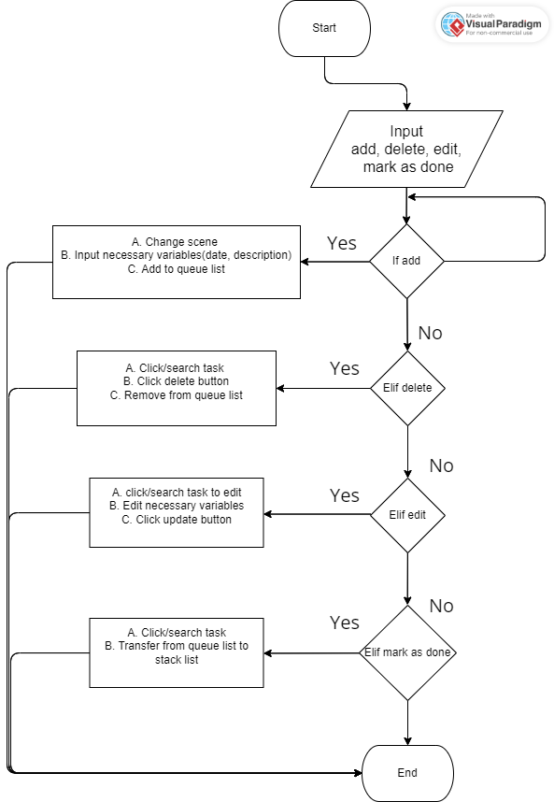

# RESULTS AND DISCUSSION

## C:\Users\ianboy\Downloads\1.3.png

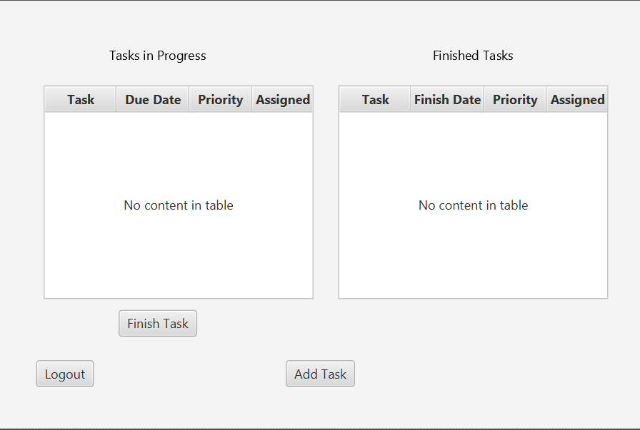

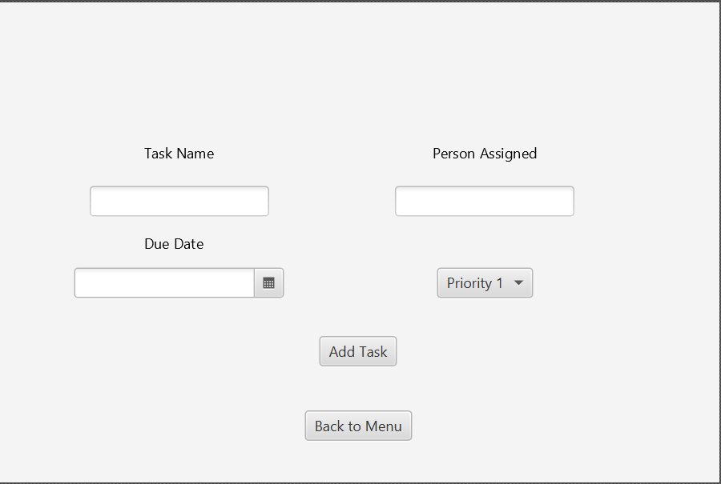

# CONCLUSION

The Task Manager project is poised to provide students with a practical solution to the persistent challenges they face in file and task management. Recognizing the overwhelming nature of academic and personal responsibilities, the project aims to empower students through the development of a user-friendly Task Manager. By incorporating features such as priority levels, due dates, categories, detailed task descriptions, hierarchical task management, and tools for monitoring task completion and team communication, the project aspires to enhance student productivity and streamline their daily lives. This initiative is not only focused on addressing the unique needs of students but also seeks to offer a valuable solution to the broader community.

Effective collaboration among team members is pivotal in every phase of this project, from front-end programming to back-end data architecture and from user interface design to comprehensive testing. The team places great importance on implementing a robust evaluation approach to gauge user satisfaction, system performance, and task management efficiency. The success of this project hinges on its ability to simplify students' lives and enhance their task management skills. With a commitment to proactively address potential challenges, adherence to a well-defined schedule with specific checkpoints, and efficient resource allocation to meet the project's objectives, the team is determined to ensure the project's success.

In conclusion, the Task Manager project is a promising endeavor designed to alleviate the intricate challenges faced by students juggling multiple classes and managing their personal files. With a comprehensive feature set and a strong team dedicated to its realization, the project has the potential to make a substantial impact on the academic and personal lives of students while contributing to the broader community. The team's commitment to effective teamwork, rigorous assessment, and proactive issue resolution positions this initiative for a successful outcome, ultimately fulfilling its mission of enhancing student productivity and task management effectiveness.

# CONTRIBUTORS

|  |  |  |
| --- | --- | --- |
| Members | Task Assigned | Accomplished |
| Armas, Angel |  |  |
| Litam, Rafael |  |  |
| Tumitit, Ma. Dominique |  |  |

# REFERENCES

[1] CS50. (2017). Arrays. CS50’s Introduction to Computer Science. https://cs50.harvard.edu/x/2023/shorts/arrays/

[2] CS50. (2017). Arrays. CS50’s Introduction to Computer Science. https://cs50.harvard.edu/x/2023/shorts/arrays/

[3]CS50. (2017). Doubly-Linked Lists. CS50’s Introduction to Computer Science. https://cs50.harvard.edu/x/2023/shorts/doubly_linked_lists/

[4] CS50. (2017). Hash Tables. CS50’s Introduction to Computer Science. https://cs50.harvard.edu/x/2023/shorts/hash_tables/

[5] CS50. (2017). Stacks. CS50’s Introduction to Computer Science. <https://cs50.harvard.edu/x/2023/shorts/stacks/>

[6] Okuboyejo, S. , Aremo, S. and Sowunmi, O. .Implementing an Academic Task Manager: Findings from a Pilot Study. https://pdfs.semanticscholar.org/8a08/7a0c6ffbd3b2c249f652dd930be8ff58568f.pdf

[7] Tan, J., Betts, J., Lance, T., Whittaker, A. and Yocum, D. .Developing a Task Management System - A Classroom Software Engineering Experience. https://www.scitepress.org/papers/2018/68344/68344.pdf