Appendix: Descriptive Statistics and Sample Distributions
Instagram Posts by German Political Actors
This appendix reports descriptive statistics for the post-level analytical sample (N = 5,906). Rows without a valid post ID were excluded from the descriptive analyses. Variables used only as technical identifiers, URLs, raw text, index columns, intercept terms, or intermediate model outputs were not included.
Appendix Table A1. Descriptive statistics for continuous variables
Variable | N | Missing | Mean | SD | Median | Min | Max
Likes | 5,906 | 0 | 1,480.61 | 4,562.71 | 349.00 | -1.00 | 156,063.00
Comments | 5,906 | 0 | 51.28 | 171.99 | 11.00 | 0.00 | 5,493.00
Text sentiment score | 5,906 | 0 | 0.77 | 0.17 | 0.80 | 0.00 | 0.99
Party/organization mentions in text | 5,906 | 0 | 0.35 | 0.89 | 0.00 | 0.00 | 17.00
Politician mentions in text | 5,906 | 0 | 0.49 | 1.16 | 0.00 | 0.00 | 14.00
Faces detected | 5,906 | 0 | 0.02 | 0.03 | 0.02 | 0.00 | 1.00
Average face size | 5,906 | 0 | 0.03 | 0.06 | 0.01 | 0.00 | 1.00
Account followers | 5,906 | 0 | 52,545.94 | 104,928.87 | 16,915.00 | 1,022.00 | 542,436.00
Account following | 5,906 | 0 | 940.76 | 844.18 | 706.00 | 2.00 | 2,940.00
Account media count | 5,906 | 0 | 1,465.97 | 1,062.46 | 1,223.00 | 53.00 | 3,978.00
Log account followers | 5,906 | 0 | 9.91 | 1.23 | 9.74 | 6.93 | 13.20
Log account following | 5,906 | 0 | 6.25 | 1.38 | 6.56 | 0.69 | 7.99
Log account media count | 5,906 | 0 | 7.03 | 0.76 | 7.11 | 3.97 | 8.29
Note. Engagement and account-level variables are highly right-skewed; log-transformed account measures are therefore reported alongside the original count variables.
Appendix Table A2. Distribution of core categorical variables
Variable | Category | n | %
Post format | Image | 4,973 | 84.2
Post format | Video | 933 | 15.8
Text sentiment | Positive | 2,606 | 44.1
Text sentiment | Neutral | 2,168 | 36.7
Text sentiment | Negative | 1,093 | 18.5
Text sentiment | Not classified | 39 | 0.7
Text frame | Professional / political | 5,268 | 89.2
Text frame | Private / personalized | 600 | 10.2
Text frame | Not classified | 38 | 0.6
Image frame | Professional / political | 4,486 | 76.0
Image frame | Private / personalized | 1,022 | 17.3
Image frame | Not classified | 398 | 6.7
Text personalization | Professional | 5,268 | 89.2
Text personalization | Private | 600 | 10.2
Text personalization | Not classified | 38 | 0.6
Image personalization | Professional | 4,486 | 76.0
Image personalization | Private | 1,022 | 17.3
Image personalization | Not classified | 398 | 6.7
Account owner presence in image | Account owner not detected | 3,380 | 57.2
Account owner presence in image | Account owner present | 2,526 | 42.8
Dominant visual emotion | No faces detected | 2,035 | 34.5
Dominant visual emotion | Happy | 1,341 | 22.7
Dominant visual emotion | Neutral | 888 | 15.0
Dominant visual emotion | Sad | 515 | 8.7
Dominant visual emotion | Fear | 471 | 8.0
Dominant visual emotion | Angry | 309 | 5.2
Dominant visual emotion | Not classified | 263 | 4.5
Dominant visual emotion | Surprise | 61 | 1.0
Dominant visual emotion | Disgust | 23 | 0.4
Note. Categories labelled “Not classified” originate from values coded as 0 in the source file. Percentages are calculated on the post-level analytical sample.
Appendix Table A3. Distribution of text topics
Category | n | %
Party politics | 1,944 | 32.9
Environmental politics | 802 | 13.6
Health | 686 | 11.6
Discrimination | 443 | 7.5
Russia-Ukraine war | 389 | 6.6
Military | 281 | 4.8
Agriculture & Nature | 226 | 3.8
Sports | 214 | 3.6
Selfcare/Freetime | 206 | 3.5
LGBTQ+ | 193 | 3.3
Holiday | 180 | 3.0
Education system | 136 | 2.3
Natural disaters | 76 | 1.3
Labor policies | 55 | 0.9
Missing | 38 | 0.6
Housing policies | 37 | 0.6
Note. Text topics are based on the text-topic labels in the processed dataset.
Appendix Table A4. Distribution of image topics
Category | n | %
Poster with persons | 1,329 | 22.5
Text poster | 749 | 12.7
Selfies | 550 | 9.3
Community engagement | 457 | 7.7
Group photos | 368 | 6.2
Interviews | 363 | 6.1
Meetings | 268 | 4.5
Campaign | 265 | 4.5
Speech | 258 | 4.4
Social media posts | 216 | 3.7
Other topics | 201 | 3.4
Not classified | 197 | 3.3
Natural landscapes | 113 | 1.9
Outdoor Scenes and Activities | 100 | 1.7
Animals | 90 | 1.5
Solo shots | 82 | 1.4
Infographics | 70 | 1.2
Newspaper | 59 | 1.0
Celebratory or special occasions | 45 | 0.8
Military and International Relations | 44 | 0.7
Food | 42 | 0.7
Public Service in Action | 40 | 0.7
Note. Image topics are based on the image-topic labels in the processed dataset.

Appendix Table A5. Descriptive statistics for comment-category counts
Variable | N | Posts with ≥1 comment in category | % posts with ≥1 | Mean count | SD | Median | Max
Political party/organization comments | 5,906 | 3,387 | 57.3 | 1.67 | 2.18 | 1.00 | 14
Comments about event | 5,906 | 2,822 | 47.8 | 1.82 | 2.87 | 0.00 | 15
Comments about policy | 5,906 | 2,037 | 34.5 | 0.78 | 1.45 | 0.00 | 15
Person/politician comments | 5,906 | 2,101 | 35.6 | 0.74 | 1.32 | 0.00 | 11
Comments outside selected categories | 5,906 | 3,492 | 59.1 | 3.24 | 3.93 | 2.00 | 15
Note. The comment-category variables are post-level counts, not mutually exclusive binary labels. A single post may contain comments belonging to multiple categories.
Appendix Table A6. Distribution of accounts in the analytical sample, top 20
Category | n | %
juliakloeckner | 601 | 10.2
malte.kaufmann | 403 | 6.8
hoechstnicole | 252 | 4.3
jankorte77 | 239 | 4.0
paulziemiak | 232 | 3.9
katja.kipping | 213 | 3.6
nouripour | 203 | 3.4
matthiashelferichafd | 192 | 3.3
christianlindner | 177 | 3.0
petr.bystron | 165 | 2.8
chrupallatino | 162 | 2.7
johannesvogel | 153 | 2.6
_svenlehmann_ | 144 | 2.4
sevim_dagdelen_ | 137 | 2.3
larsklingbeil | 135 | 2.3
joanacotar | 128 | 2.2
janine_wissler | 124 | 2.1
andreas.scheuer | 118 | 2.0
bundestagsperli | 118 | 2.0
abaerbock | 118 | 2.0
Other | 1,892 | 32.0
Note. Only the 20 most frequent accounts are displayed; all remaining accounts are grouped as “Other.”

Appendix Figures
Appendix Figure A1. Distribution of likes, log-transformed
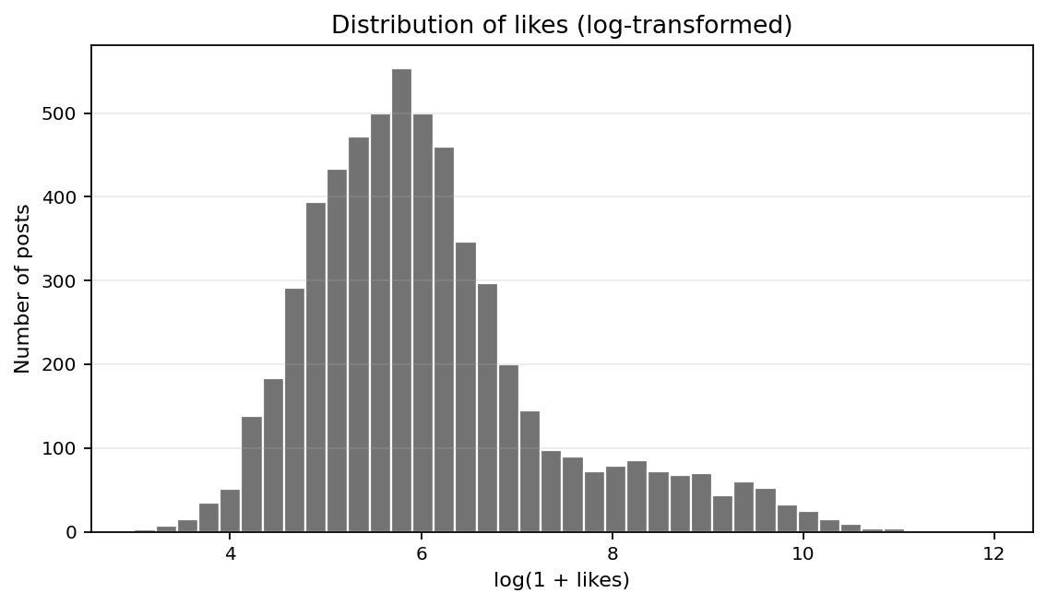
Note. The x-axis uses log(1 + likes) to reduce the influence of extremely high-engagement posts.

Appendix Figure A2. Distribution of comments, log-transformed
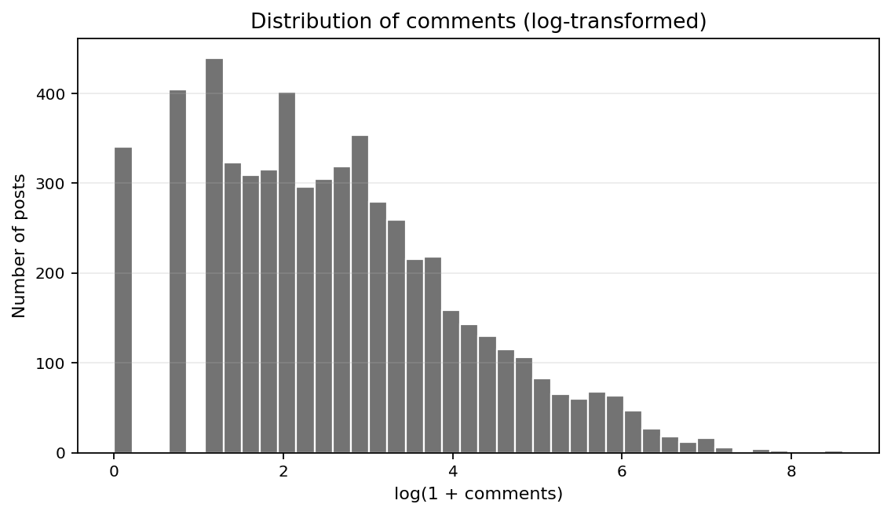
Note. The x-axis uses log(1 + comments) to reduce the influence of extremely high-comment posts.

Appendix Figure A3. Distribution of text sentiment
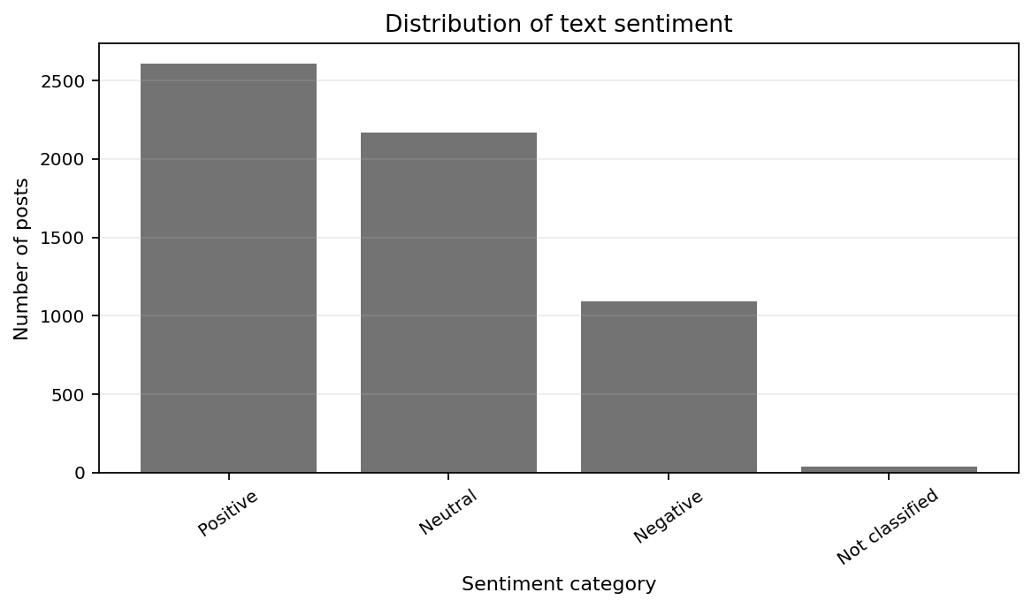
Note. The figure reports the number of posts in each text-sentiment category.

Appendix Figure A4. Distribution of text topics
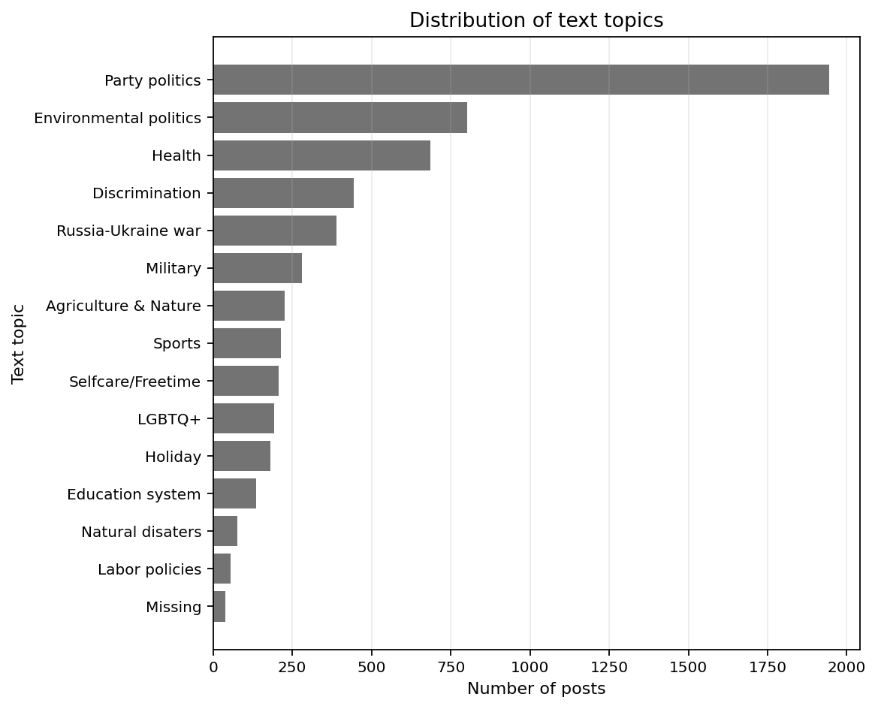
Note. The figure reports the 15 most frequent text-topic categories.

Appendix Figure A5. Distribution of image topics
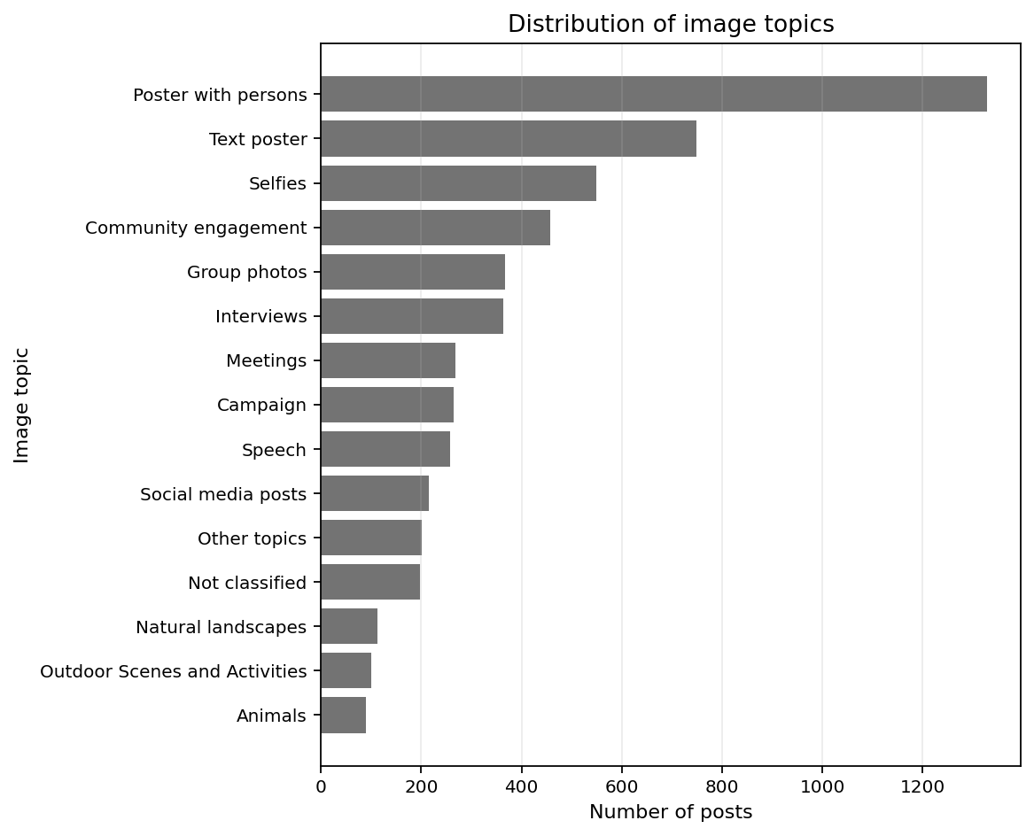
Note. The figure reports the 15 most frequent image-topic categories.

Appendix Figure A6. Distribution of dominant visual emotion
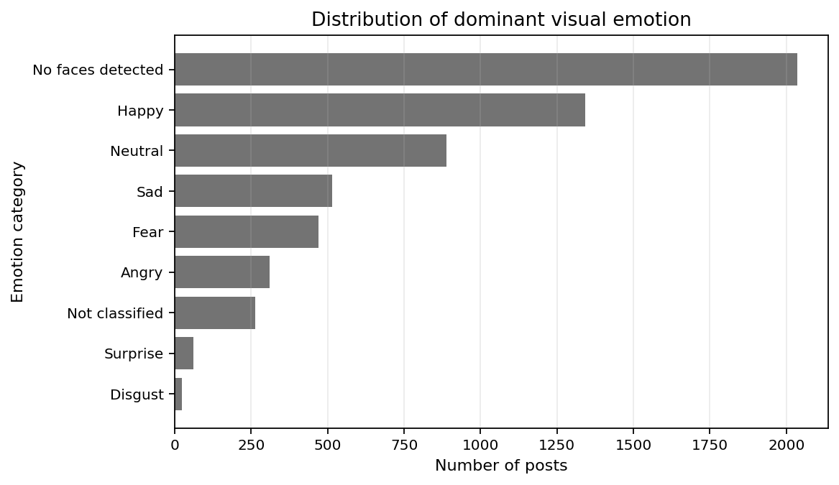
Note. The figure reports the most frequent dominant emotion categories after collapsing list-like labels to the first detected dominant emotion; “No faces detected” is retained as a separate category.

