資工三甲 N11170022 張育茹

CH08 簡答題 2

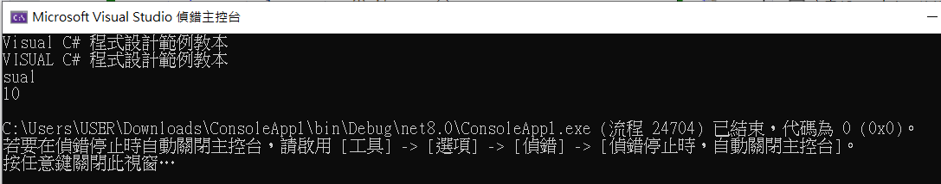

string str = "Visual C# 程式設計範例教本";

string str1 = str.ToUpper();

string str2 = str.Substring(2,4);

string str3 = str.IndexOf("程式").ToString();

Console.WriteLine(str);

Console.WriteLine(str1);

Console.WriteLine(str2);

Console.WriteLine(str3);

CH08 簡答題 6

排序：將一些資料依照特定原則排列成遞增或遞減的順序

搜尋：在資料中找出是否存在與鍵值相同的資料，如果資料存在，就進行後續的資料處理

沒有排序的資料、已經排序的資料

CH08 實作題 2

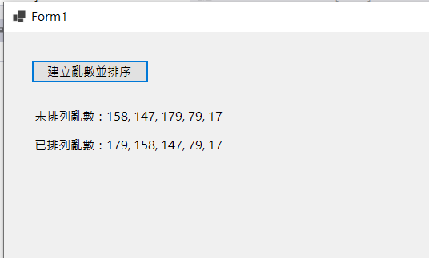

namespace CH08_2

{

public partial class Form1 : Form

{

public Form1()

{

InitializeComponent();

}

private void button1_Click(object sender, EventArgs e)

{

Random random = new Random();

int[] arrValue = new int[5];

string str1 = "未排列亂數：";

for (int i = 0; i < arrValue.Length; i++)

{

arrValue[i] = random.Next(1, 201);

str1 = str1 + arrValue[i] + ", ";

}

int last = str1.Length - 2;

str1 = str1.Remove(last, 2);

label1.Text = str1.ToString();

bubbleSort(arrValue);

}

public void bubbleSort(int[] arrValue)

{

int i, j, len, temp;

len = arrValue.GetUpperBound(0);

string str2 = "已排列亂數：";

for (i = len; i >= 0; i--)

{

for (j = 0; j <= (len - 1); j++)

if (arrValue[j + 1] < arrValue[j])

{

temp = arrValue[j + 1];

arrValue[j + 1] = arrValue[j];

arrValue[j] = temp;

}

str2 = str2 + arrValue[i] + ", ";

}

//int last = str2.Length - 2;

str2 = str2.Remove((str2.Length-2), 2);

label2.Text = str2.ToString();

}

}

}

CH08 實作題 4

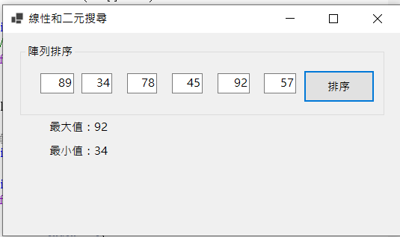

namespace Ch8_5_2

{

public partial class Form1 : Form

{

public Form1()

{

InitializeComponent();

}

private void button3_Click(object sender, EventArgs e)

{

int[] data = new int[6];

data[0] = Convert.ToInt32(txtData0.Text);

data[1] = Convert.ToInt32(txtData1.Text);

data[2] = Convert.ToInt32(txtData2.Text);

data[3] = Convert.ToInt32(txtData3.Text);

data[4] = Convert.ToInt32(txtData4.Text);

data[5] = Convert.ToInt32(txtData5.Text);

ArrMax(data);

ArrMin(data);

}

public void ArrMax(int[] data)

{

int i, index = 0;

// 找出最大值的索引

for (i = 0; i < data.GetLength(0); i++)

if (data[i] > data[index])

index = i;

label1.Text = "最大值：" + data[index].ToString();

}

public void ArrMin(int[] data)

{

int i, index = 0;

for (i = 0; i < data.GetLength(0); i++)

if (data[i] < data[index])

index = i;

label2.Text = "最小值：" + data[index].ToString();

}

}

}

CH09 簡答題 1

傳統的應用程式開發是將資料和操作分開來思考，著重於如何找出解決問題的程序或函數，即演算法。

物件導向的應用程式開發是將資料和操作一起思考，其主要工作是找出參與物件和物件之間的關係，並且透過這些物件的通力合作來解決問題。

CH09 簡答題 6

private修飾子：成員變數或方法只能在類別本身呼叫或存取，如果沒有使用修飾子，預設是private。

public修飾子：成員變數或方法是此類別建立物件對外的使用介面，可以讓C#程式碼呼叫物件的成員方法或存取成員變數。

protected修飾子：成員變數或方法可以在類別本身和其子類別存取或呼叫。

「工具方法」（Utility Methods）：-封裝一些常用功能或重複邏輯的靜態方法，方便在整個專案中重複使用，提升程式碼的可讀性、可維護性與重用性。

CH09 實作題 2

public class Box

{

public int Width;

public int Height;

public int Length;

public double GetVolume()

{

return (Width * Height * Length);

}

public void SetVolume(int width, int height, int length)

{

Width = width;

Height = height;

Length = length;

}

public double GetArea()

{

return ((Width * Height)+ (Width * Length) + (Height * Length))*2;

}

public void SetArea(int width, int height, int length)

{

Width = width;

Height = height;

Length = length;

}

}

|  |
| --- |
| **Box** |
| + Width: int  + Height: int  + Length: int |
| + GetArea():double  + SetArea(width: int, height: int, length: int): void |

CH09 實作題 4

using System.Numerics;

public class Cards

{

public int Name { get; set; }

public int Occupation { get; set; }

public int Age { get; set; }

public string? Phone { get; set; }

public int Email { get; set; }

public void GetCards(string name, string occupation, string age, string phonelist, string email)

{

name = Name.ToString();

occupation = Occupation.ToString();

age = Age.ToString();

phonelist = phonelist.ToString();

Phone = phonelist;

email = Email.ToString();

}

}

public class PhoneList

{

public int HomePhone { get; set; }

public int BusinessPhone { get; set; }

public int CellPhone { get; set; }

public void phonelist(string homephone, string businessphone, string cellphone)

{

homephone = HomePhone.ToString();

businessphone = BusinessPhone.ToString();

cellphone = CellPhone.ToString();

}

}