資工三甲 N11170022 張育茹

第10章 實作題 3

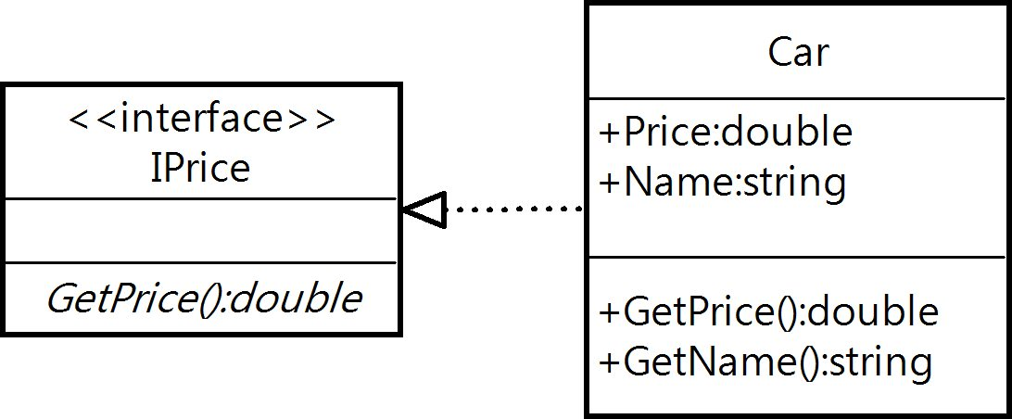

第11章 實作題 第1

public class HW4

{

static public int Cube(int value)

{

int square = value * value;

return square;

}

static public double Cube(double value)

{

double square = value * value;

return square;

}

static public int MinElement(int a, int b, int c)

{

int min = Math.Min(a, Math.Min(b, c));

return min;

}

static public int MinElement(int a, int b, int c, int d)

{

int min = Math.Min(a, Math.Min(b, Math.Min(c, d)));

return min;

}

}

第12章 實作題 第3

在陣列儲存不符合型別的元素時產生的例外

方法呼叫時，傳遞null參數時產生的例外

算錯誤時產生的例外

第13 章 實作題 第3

namespace HW5_CH13_實作題3

{

public partial class Form1 : Form

{

public Form1()

{

InitializeComponent();

BackColor = Color.Red;

}

private void libel1_MouseUp(object sender, MouseEventArgs e)

{

switch (e.Button)

{

case MouseButtons.Left:

BackColor = Color.Yellow;

break;

case MouseButtons.Right:

BackColor = Color.Green;

break;

}

}

}

}

第15章 簡答題 第4

using System.Diagnostics.Tracing;

using System.IO;

string path = "listFile.txt";

FileInfo fileInfo = new FileInfo(path);

StreamWriter sw = new StreamWriter(path);

sw.WriteLine("本書很適合初學者");

sw.Flush();

sw.Close();

StreamWriter sw1 = fileInfo.CreateText();

sw1.WriteLine("");

sw1.Flush();

sw1.Close();

StreamWriter sw2 = fileInfo.CreateText();

sw2.WriteLine("");

sw2.WriteLine("陳會安");

sw2.WriteLine("小龍女");

sw2.WriteLine("王美麗");

sw2.Flush();

sw2.Close();

StreamReader sr = new StreamReader(path);

char[] ch = new char[10];

int count = sr.Read(ch, 0, ch.Length);

string line = new string(ch, 0, count);

sr.Close();

StreamWriter sw3 = fileInfo.AppendText();

sw3.WriteLine(line);

sw3.Flush();

sw3.Close();

StreamReader sr1 = new StreamReader(path);

string? line1 = null;

int count1 = 3;

for(int i = 0; i < count1; i++)

{

line1 = sr1.ReadLine();

}

sr1.Close();

StreamWriter sw4 = fileInfo.AppendText();

sw4.WriteLine(line1);

sw4.Flush();

sw4.Close();

第15章 簡答題 第5

using System.IO;

namespace Ch15_4

{

public partial class Form1 : Form

{

public Form1()

{

InitializeComponent();

}

string path = "NotePad.txt";

private void Form1_Load(object sender, EventArgs e)

{

FileInfo fileInfo = new FileInfo(path);

StreamReader sr = new StreamReader(path);

txtOutput.Text = sr.ReadToEnd();

sr.Close();

txtOutput.SelectionStart = 0;

txtOutput.SelectionLength = 0;

}

private void Form1_FormClosing(object sender, FormClosingEventArgs e)

{

FileInfo fileInfo = new FileInfo(path);

StreamWriter sw = new StreamWriter(path);

sw.WriteLine(txtOutput.Text);

sw.Flush();

sw.Close();

}

}

}