Machine Learning HW3

## **Question 1 – Neural Networks**

I made my calculations on paper, so that I am putting the scanned versions.

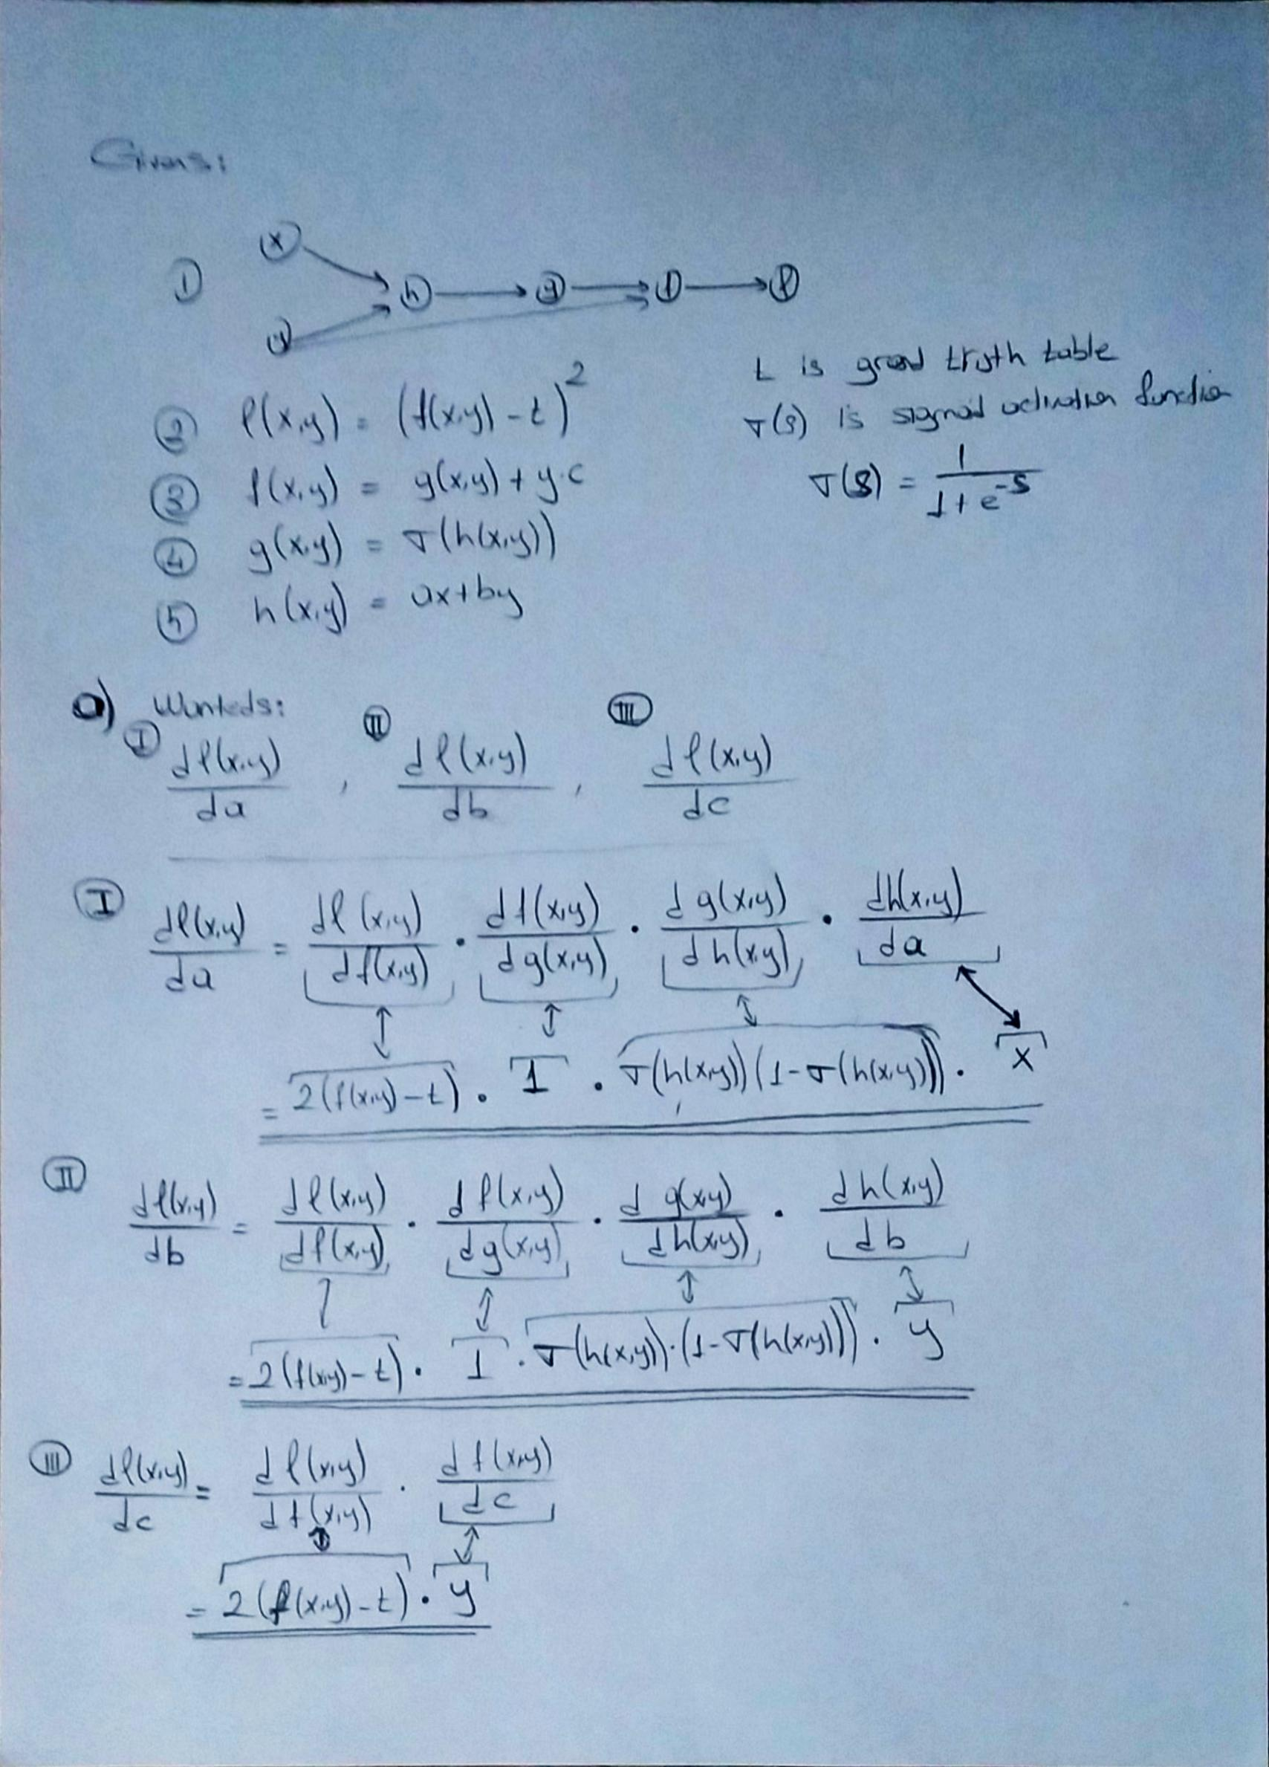

For the b part:

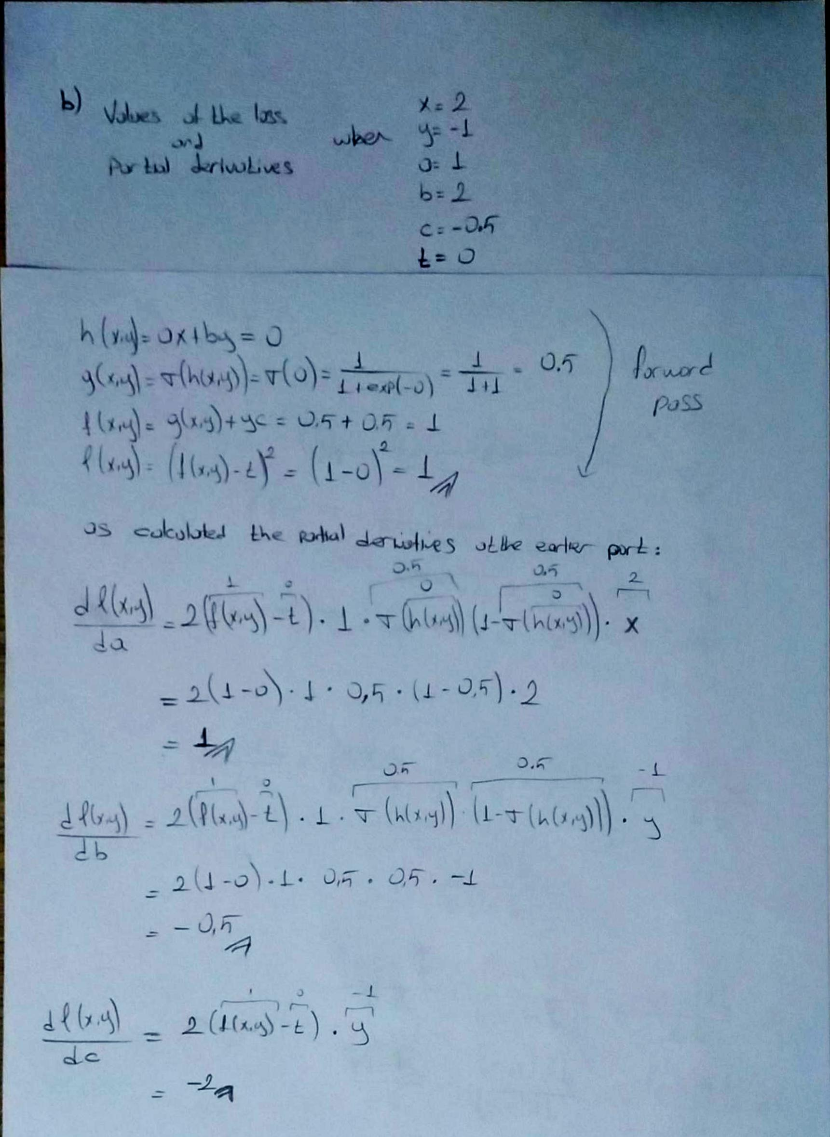

## **Question 2 - Spectral Clustering**

I attach the code I wrote as python notebook with the name **HW3.ipynb**.

For the b part I generated the following graphs:

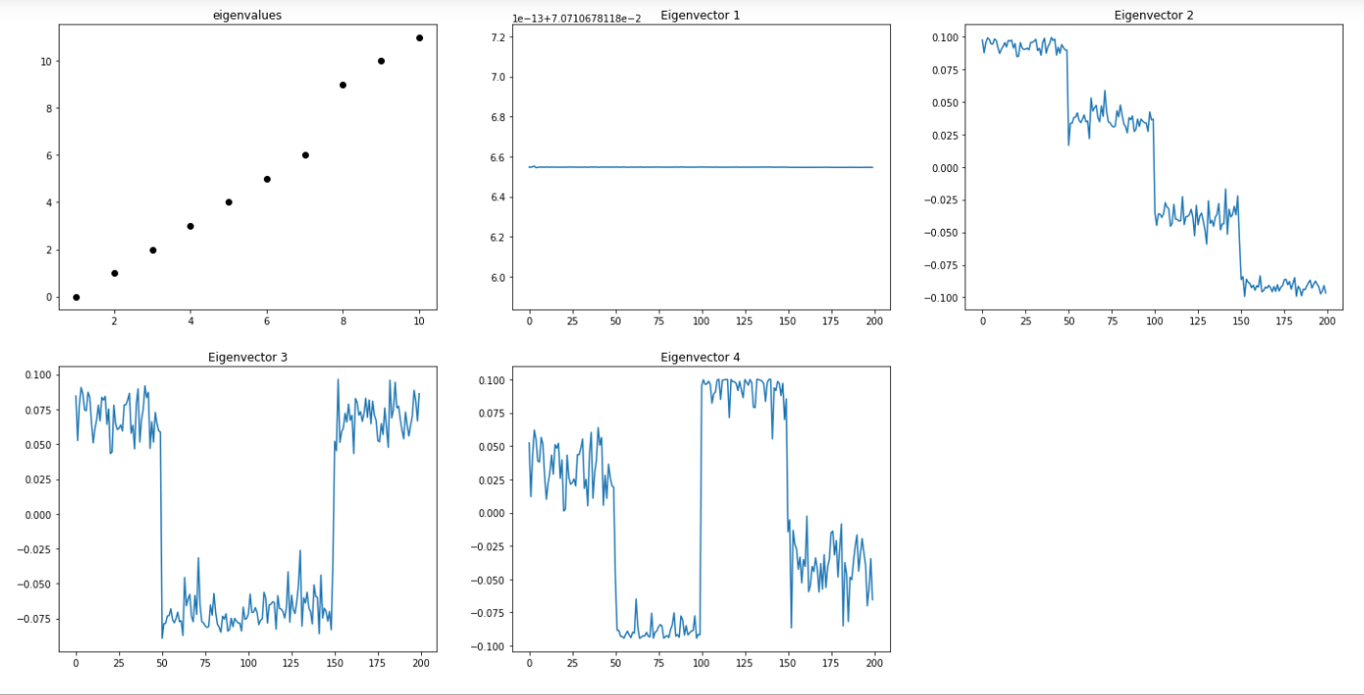

The code of the graphs is also in the python notebook.