STUDENT NAMES:

1-) Yusuf DEMİR 2018555014

2-) Anıl YILMAZ 2018555069

3-) Kağan ÖZDAMAR 2019555456

HOW TO PLAY MERGED:

In Merged! The aim in is to reach higher scores by combining the blocks on the playground.

WHİCH LİBRARYS,ADDONS,FUNCTİONS THAT WE USED:

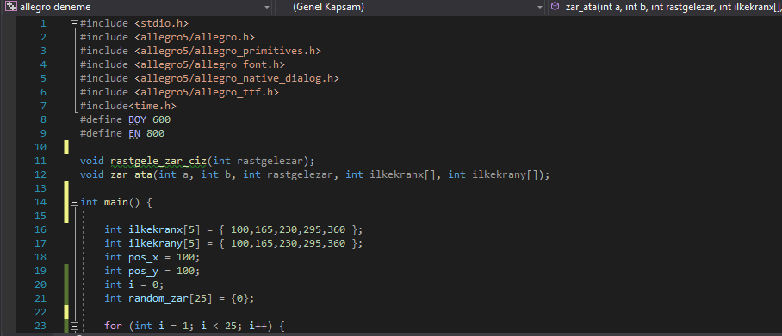

* We used <allegro5/allegro.h> to can use allegro5.
* We used <allegro5/allegro_primitives.h> to can use functions related primitives.
* We used <allegro5/allegro_font.h> to can use functions related fonts.
* We used <allegro5/allegro_ttf.h> to can use other font.
* We use <time.h> to create random number.
* We writed function(void rastgele_zar_ciz(int rastgele))to create random dice.These function take an integer parameter and draw rectangle related to the parameter.
* We writed function(void rastgele_zar_ciz(int rastgelezar))to create random dice.These function take an integer parameter and draw rectangle related to the parameter.
* We writed function(void zar_ata(int a,int b,int rastgelezar,ilkekranx[],int ilkekrany[]))to create random dice.These function take 3 integer parameters and 2 integer arrays.Function find the position by use int a,int b and 2 arrays .In addition draw rectangle related to the rastgelezar.

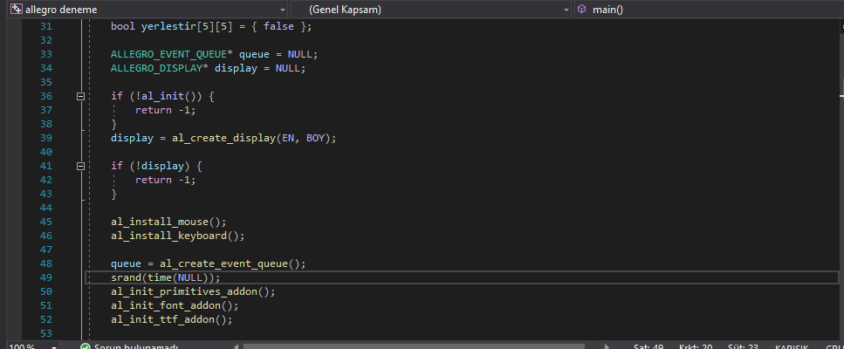

* We created ALLEGRO_EVENT_QUEUE and al_create _event_queue(); to generate events and hold these events.
* We used ALLEGRO_DISPLAY and al_create_display(); to create an display.
* We initialized allegro with if(!al_init()){return -1;}
* We used al_install_mouse(); and al_install_keyboard(); to initialize mouse and keyboard.
* We used al_init_primitives_addon(); , al_init_font_addon(); , al_init_ttf_addon(); to initialize them.
* We used srand(time(NULL)); to generate diferent numbers each time when generating random numbers.
* We used al_grab_mouse(display); to confine to mouse cursor to the display.
* We used al_set_mouse_xy(); to place the Mouse at the given coordinates on the display.

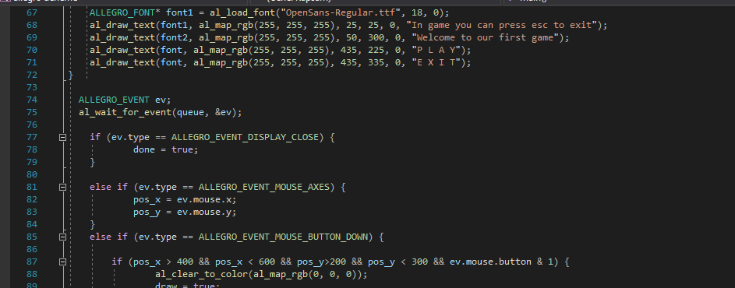

* ALLEGRO_FONT : A handle identifying any kind of font. Usually you will create it with [al_load_font](https://liballeg.org/a5docs/trunk/font.html#al_load_font) which supports loading all kinds of TrueType fonts supported by the FreeType library .
* We used function al_draw_text(); to write text on the display.
* We used functions al_draw_rectangle and al_draw_filled_rectangle, we can draw an outlined rectangle with al_draw_rectangle.This function takes some parameters (x1,x2,y1,y2-upper left and lower right points of the rectangle, al_map_rgb(); - color of the rectangle, thickness-thickness of the lines) then we can draw a filled rectangle with al_draw_filled rectangle.This function take some parameters(x1,x2,y1,y2-upper left and lower right points of the rectangle, al_map_rgb(); - color of the rectangle).
* ALLEGRO_EVENT is a union of all built in event structures. Functions al_wait_for_event(); wait until the event queue specified is non-empty.
* ALLEGRO_EVENT_DİSPLAY_CLOSE means that the close button of the window has been pressed.
* ALLEGRO_EVENT_MOUSE_AXES means that one or more mouse axis value changed but we use this only x and y axis.
* ALLEGRO_EVENT_MOUSE_BUTTON_DOWN means that a mouse button was pressed. We use only left mouse button(ev.mouse .button &1) with some coordinates.
* ALLEGRO_EVENT_KEY_DOWN means that a keyboard key was pressed.We use this only to key(ESCAPE) to can been leave the game at any time.

WHAT WE COULD DO AND WHAT WE COULDN’T DO:

We had create a menu ,you can start the when you press play and you can exit the game with exit button .

In game you can exit the game with escape key,we can generate random dice and draw it,when placing the dice to 5x5 square area we can’t use drag and drop so,we use left mouse button pressing . .Actually,there are some problem, drew random dice and we place but dice that we have placed are different from random dice that we have drawn .

We could not combine same value of dices so we couldn’t increase the score. Summary, there is no game stream.

DİVİSİON OF LABOR:

Yusuf DEMİR drafted the game and added menu and wrote the game codes and report.

Anıl YILMAZ and Kağan ÖZDAMAR found supplementary reference(video) and research fort he codes of similar games.