CS_28

# multi layer perceptron (Tanh function):

## Lap Example: (LR = 0.001, Epochs = 5000, layers = 5)

### Runs:

Run 1 : File name (“tanh2_weights_1.txt”)

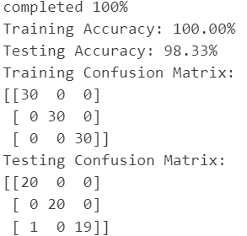

Run 2 : File name (“tanh2_weights_2.txt")

Run 3 : File name (“tanh2_weights_3.txt")

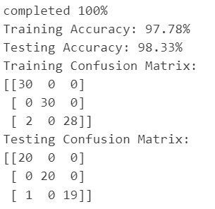

## Another Examples: (LR = 0.02, Epochs = 500, layers = 5,5)

### Runs:

Run 1

Run 2

