Arize AX
Proof of Concept (PoC)
A Proof of Concept is a 14-day trial conducted to prove the Arize AX Enterprise platform is compatible with your GenAI tech stack and achieve technical validation via mutually agreed success criteria. Below are the steps required from both teams to successfully complete a PoC together.

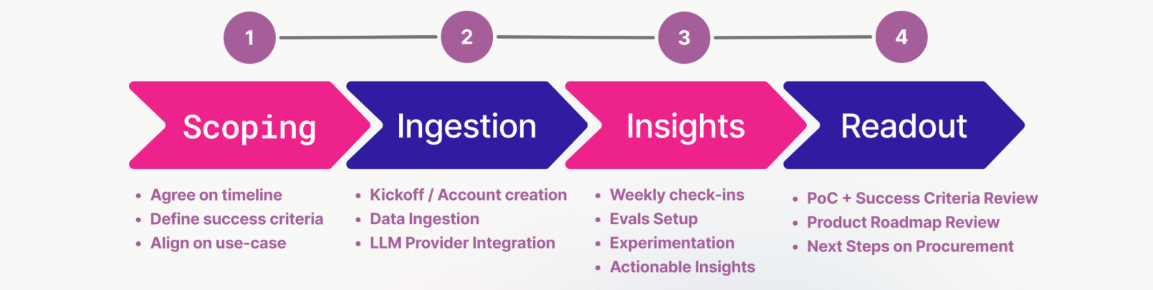

1. Executive Summary
Customer | [Company Name]
Start Date / Duration | Start: _____ / End: _____ - [X] Weeks
Framework(s) | [LangChain / LangGraph / LlamaIndex / Custom / etc.]
Current State | [DataDog / Splunk / Homegrown / None]
Environment | [SaaS / VPC / On-Prem]
Decision Date

Customer Team
Name | Role / Team | % Time Committed | Responsibilities

Arize Team
Name | Title | Email | Role

2. PoC Scoping

2a. Communication Setup
Item | Details
Slack / Communication Channel
Check-in Cadence
Primary Escalation Contact (Customer)
Primary Escalation Contact (Arize)

2b. Use Case
Complete the fields below to lock in the PoC scope. Only one use case should be selected.

Predominant Coding Agent | [e.g., Claude Code, Cursor, etc.]
Application Name / Description | [e.g., Customer Support Bot, Surveillance Agent]
Production vs. Staging | ☐ Production ☐ Staging ☐ Sample App (no prod access)
Expected Trace Volume / Day | [e.g., ~50K spans/day — estimate OK to start]
LLM Provider(s) | [OpenAI / Anthropic / AWS Bedrock / GCP Vertex / Azure OAI]
Orchestration Framework | [LangChain / LlamaIndex / LangGraph / Custom / None]
Vector DB (if RAG) | [Pinecone / Weaviate / pgvector / Internal / N/A]
ℹ Limit to one use case. Additional applications can be added in a follow-on expansion scope.

2c. Implementation Requirements
X | Requirement | Notes / Status
 | Deployment model confirmed for POC (SaaS, VPC, Private Connect)
 | Security review initiated (if required)
 | Procurement / legal review timeline known
 | API keys / LLM provider credentials available
 | Slack / communication channel created

ℹ Any unchecked item at kickoff is a blocker. Escalate immediately.

2d. VPC Deployment Scoping
X | Item | Response
 | Are you running in a cloud provider, hybrid cloud, or own data center? (GCP, AWS, Azure, etc)
 | Will Arize be able to leverage a managed kubernetes cluster? (AKS, EKS, GKE, etc)
 | Is the cluster and nodes dedicated to running the Arize platform?
 | Will Arize be able to leverage a dedicated node pool and storage?
 | What is your SMTP service? (Own smtp service, Sendgrid, AWS SNS, etc)
 | Will Arize have access to kubectl to operate and upgrade the cluster?
 | Can we pull images from 'ch.hub.arize.com', or what docker registry is available? (GCR, ECR, ACR, etc)
 | Is there access to a Blob Store? (GCS, S3, Azure Blob)
 | Are the specific custom encryption keys on the Blob Store (AWS KMS, GCP CMEK, etc)

3. Business Value & Use-Case Alignment

Business Outcome | Notes / Context
Increase revenue: Improve agent quality to drive revenue / conversion
Reduce costs: Reduce LLM costs, debugging time, governance & compliance
Mitigate Risk: Accelerate iteration, reduce time-to-production

How success is measured today:
___________________________________________

4. Success Criteria (3–5 criteria)
Select 3-5 criteria from the menu below.
X | Criteria | Customer Target / Notes | Docs
LLM / Agent Observability
 | Framework-agnostic tracing via OpenInference/OTel: all agent steps, tool calls, and retrievals captured regardless of orchestration layer | e.g., 100% of spans visible within 24 hrs of kickoff; all frameworks instrumented | Tracing
 | Session-level agent evaluation: measure end-to-end task completion, not just individual span quality | e.g., Agent task completion rate > X% measured at session level | Evaluation
 | Online LLM-as-a-judge evals running continuously on live traffic (hallucination, relevance, Q&A correctness, toxicity) | e.g., Hallucination rate < X% measured automatically on all prod traces | Evaluation
 | AI copilot: autonomous root-cause analysis and auto-generated evals surfaced directly from production traces | e.g., Mean time to root cause reduced from ___ days to < 4 hrs | Evaluation
 | Prompt IDE with version control, side-by-side comparison, and production trace replay: iterate without leaving the platform | e.g., ___ prompt variants tested per sprint (target: 2-3x current) | Iteration
 | Export curated datasets from live production traces and run reproducible experiments end-to-end in AX | e.g., Dataset curated from prod traces and experiment run within Week 2 | Iteration
 | Production-ready, customizable dashboards on cost, latency, token usage, custom evals and more | e.g., Cost per query visible; monthly LLM spend attributed by use case | Dashboards
 | Production-grade alerting on quality degradation with integrations to Slack, PagerDuty, webhooks: not just email | e.g., PagerDuty alert fires within 5 min of hallucination rate threshold breach | Monitoring
 | Headless debugging ability of GenAI traces leveraging a CLI and Skills | e.g., Spans pulled into coding agent in less than a minute for further analysis | Iteration
Traditional ML Observability — AX Exclusive vs. All LLM-Only Competitors
 | Unified LLM + traditional ML observability in a single platform: monitor classification, regression, and ranking models alongside LLM agents | e.g., ML surveillance models (F1, MAE, NDCG) and LLM agents visible in one pane | ML Monitoring
 | Feature-level drift monitoring with automated alerts when production distribution deviates from training baseline | e.g., Drift alert configured for top 10 features; PSI threshold = ___ | Drift Monitoring
 | Data quality monitoring for features, predictions, and actuals with segment-level drill-down (performance tracing) | e.g., Data quality monitor live on all input features within Week 1 | Data Quality Monitoring
 | Custom metrics and custom monitoring rules — define any business KPI and alert on it | e.g., Custom metric defined and alerting within Week 2 | Monitoring
Platform, Security & Enterprise Readiness
 | Scalability: Ability to handle large data volumes and ingestion on tracing, datasets, and playground execution | e.g., 50K datasets, 10M+ traces, executing 1K rows in playground | Security
 | Flexible deployment: Arize SaaS (GCP), VPC/Private Connect, or fully self-hosted — with CMEK encryption support | e.g., VPC deployment confirmed; CMEK validated in DR paper exercise | Security
 | SOC 2 + HIPAA certified platform with audit logs, SSO/SAML, and API-driven management — production-ready today | e.g., SSO configured; audit log access validated; compliance review passed | Security

5. Timeline & Milestones
Date | Owner | Milestone | Docs
 | Arize + Customer | PoC Scoping | -
 | Both | Kickoff | -
 | Customer Eng | Setup instrumentation | Tracing Setup
 | Customer | Evaluation Configuration | Evaluators
 | Both | Alyx, Review Progress | Alyx
 | Customer | Monitoring, Alerting Setup | Monitors
 | Both | Experimentation Walkthrough | Experiments
 | Both | PoC Readout
 | Customer Leadership | Go/ No-Go Decision
 | Both | Commercial Steps
 | Both | Go-live

6. Trial Log & Feedback
Use this section throughout the PoC to record meeting notes, blockers, and running feedback.

Date | Notes / Action Items

