Arize AX
Proof of Technology (PoT)
A Proof of Tech is a 7-day trial conducted to prove the Arize AX platform is compatible with your GenAI use-cases. Below are the steps required from both teams to successfully complete a PoT together.

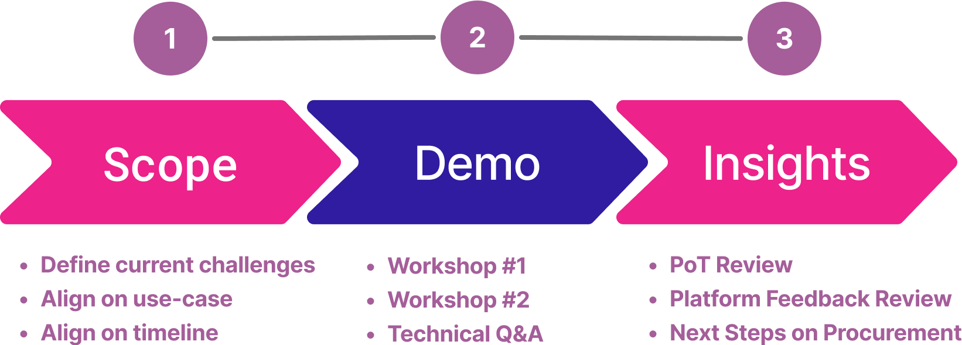

1. Summary
Customer | [Company Name]
Start Date / Duration | Start: _____ / End: _____ - [X] Weeks
Current State | [DataDog / Splunk / Homegrown / None]
Decision Date

2. PoT Scoping

2a. Communication Setup
Item | Details
Slack / Communication Channel
Workshop Cadence

2b. Use Case

Predominant Coding Agent | [e.g., Claude Code, Cursor, etc.]
Application Name / Description | [e.g., Customer Support Bot, Surveillance Agent]
Production vs. Staging | ☐ Production ☐ Staging ☐ Sample App (no prod access)
Type of Application | [LLM Calls / RAG / Agentic (Tool Calls) / Multi-Agent]
LLM Provider(s) | [OpenAI / Anthropic / AWS Bedrock / GCP Vertex / Azure OAI]
Orchestration Framework | [LangChain / LlamaIndex / LangGraph / Custom / None]
Vector DB (if RAG) | [Pinecone / Weaviate / pgvector / Internal / N/A]
What does the data look like? | Data schema / Data type / Example Input / Output
What kind of tool calls (if any)? | Weather API, Internal Knowledge Base, A2A
Important Eval Metrics | Hallucination, Tool Correctness, Agent Trajectory, Latency, Cost

3. Current Challenges with GenAI Apps

Checkbox (X) | Challenge
LLM / Agent Observability
 | Difficult/slow to experiment with different model providers / prompts
 | Hard to evaluate the quality of my GenAI application's responses
 | No visibility into what is happening behind the scenes of my agent
 | Lack of FinOps Dashboard / Cost Tracking
 | Hard to experiment and iterate on my agents in production
 | No visibility on my guardrails / Need guardrails + Red Teaming
 | Need human labeling / human in the loop for my GenAI applications
 | No centralized place to track my prompts / experiments
 | Lack of a workflow to iterate on my agent from CLI / Coding Agent
 | Lack of production-grade alerting / visualization on my apps

