**LAB 1**

**Objective :**

**Task 01:**

**Code:**

**(Receiver)**

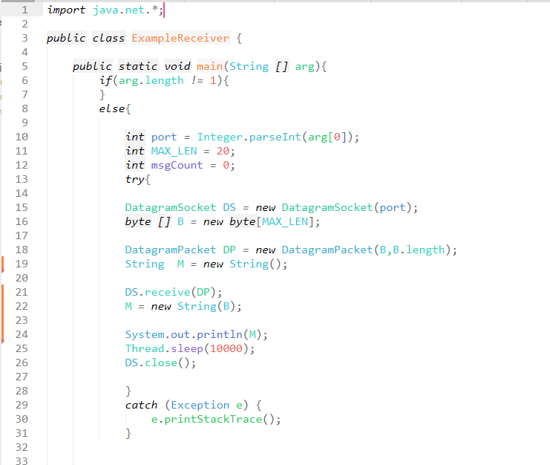

**(Sender)**

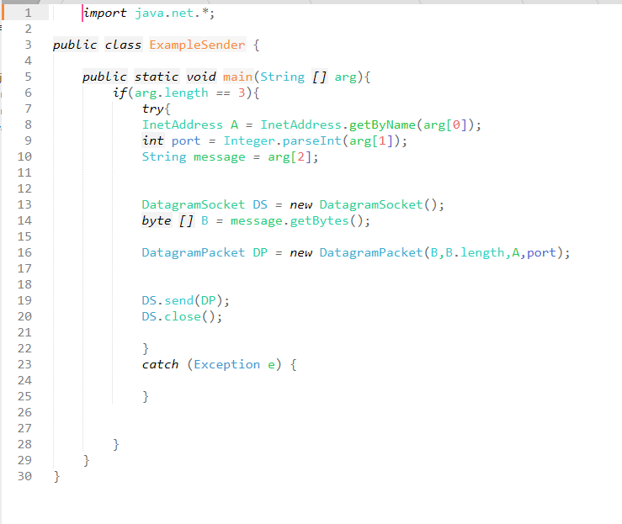

**Output:**

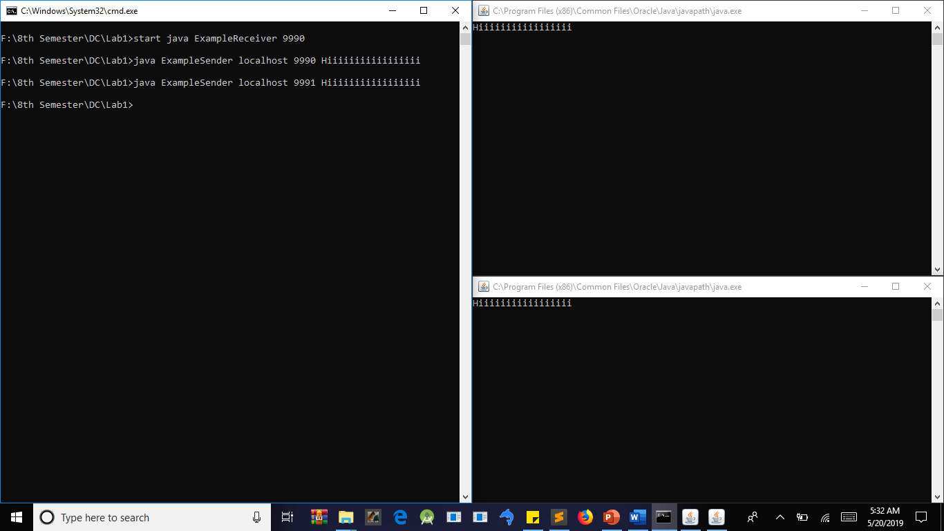

**Task 02:**

**Code :**

**(Receiver)**

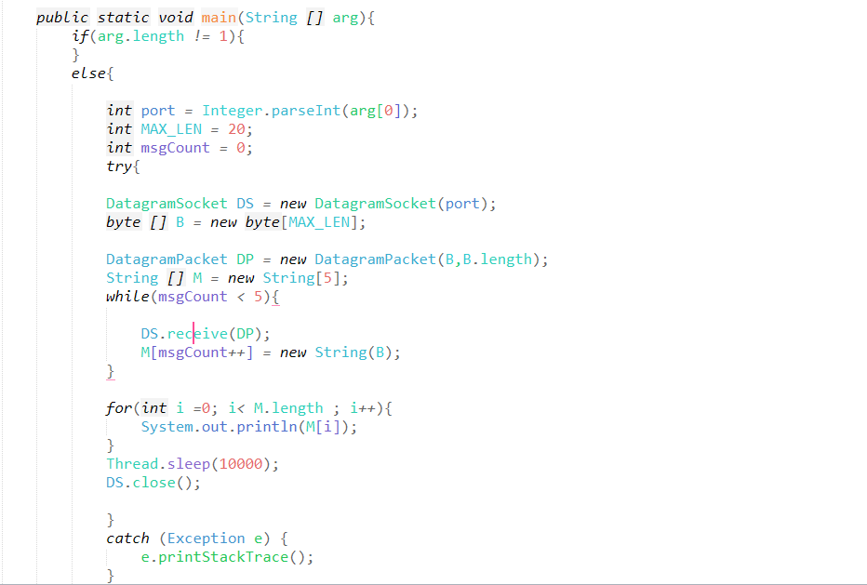

**(Sender)**

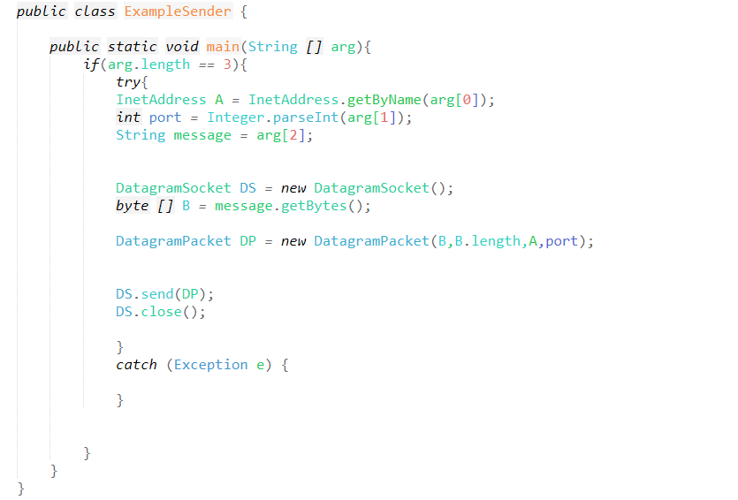

**Output:**

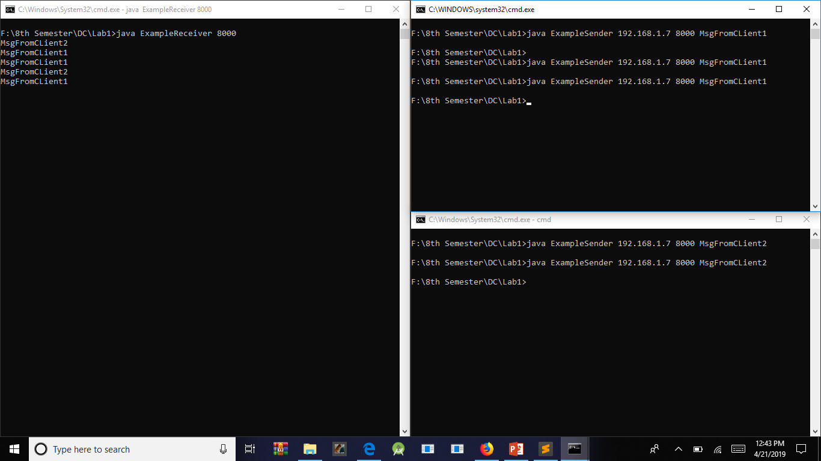

**Task # 03**

**Code:**

**(Sender)**

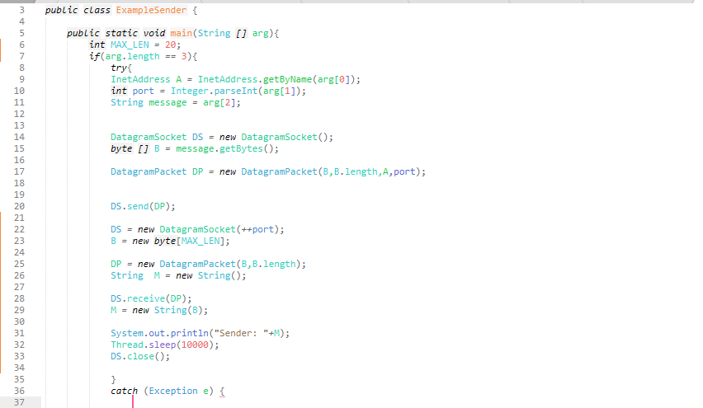

**(Receiver)**

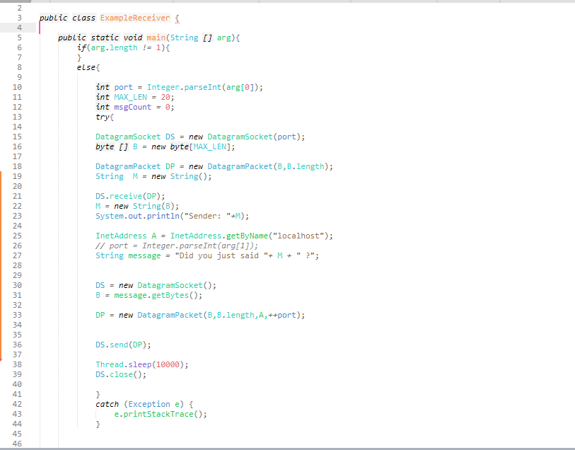

**Output:**

