Lab # 02

Objective :

Description:

*The acceptor which acts as a server waits to accept connection at a specific port number, so whenver a connection requester which acts as a client request the connection the server accepts that connection and sends a response message to it.*

Code:

(Requester)

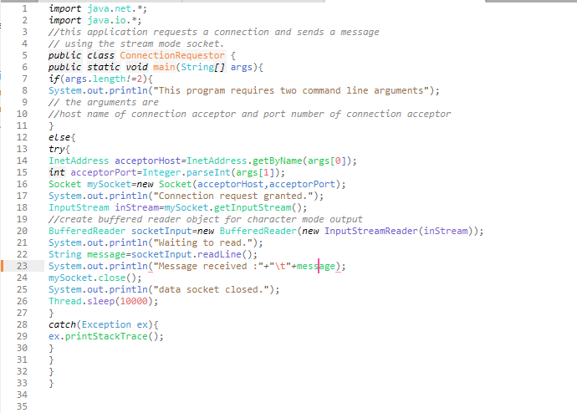

(Acceptor)

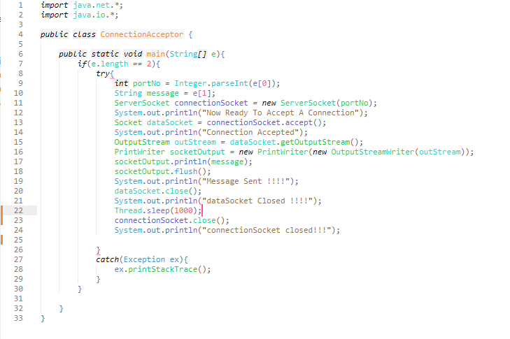

Output:

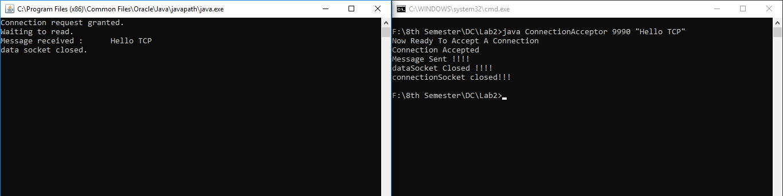

Task 2

Description:

The network error “java.net.ConnectException: Connection refused” clearly states that the client is trying to make TCP connection with the server and it fails at the end.

Output:

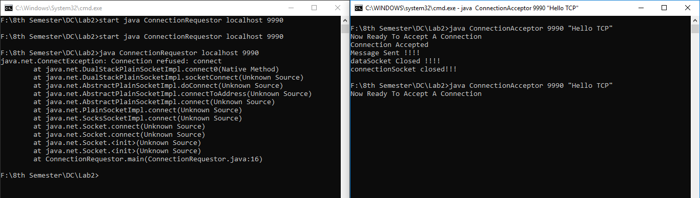

Task 3

Output:

(Before 5 seconds)

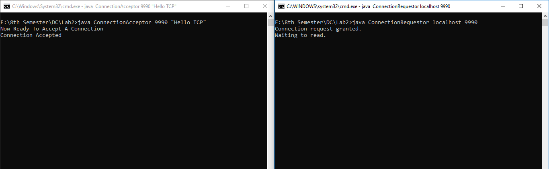

(After 5 seconds)

