**Yushmitha P**

**Quality Engineer**

**Part 4 = Other scenarios**

**1. Validate error message when user logins with invalid email address**

**Login to Application** [**https://www.bayt.com/en/login/**](https://www.bayt.com/en/login/)

**Enter invalid email address**

**Enter correct password**

**Click on login button**

**Check the validation error for invalid email**

**2. Validate error message when user logins with incorrect password**

**Login to Application** [**https://www.bayt.com/en/login/**](https://www.bayt.com/en/login/)

**Enter valid email address**

**Enter incorrect password**

**Click on login button**

**Check the validation error**

**3.Validate successful log out after user registers for first time**

**Hit the url** [**https://www.bayt.com/en/india/**](https://www.bayt.com/en/india/)

**Click on ‘Register’ button**

**Fill out the registration form**

**After success registration user logs into the application**

**Skip profile add information**

**Click on 3 dots**

**Navigate to ‘Logout’ section**

**Validate successful logout message**

**4. Validate user logs into application at Apply job section**

**Hit the url** [**https://www.bayt.com/**](https://www.bayt.com/)

**Select a job title under ‘Apply job’ section**

**Click on Apply button of first job post**

**As user already have account, sign in to the application**

**Enter valid email and password and log in**

**Verify user has successfully logged in to the bayt application**

**(Forgot Password scenario cannot be automated)**

**5.Validate Forgot Password scenario where user forgets the password during login to the application**

**Hit the url** [**https://www.bayt.com/**](https://www.bayt.com/)

**Click on login button**

**Click on ‘Forgot Password’ button**

**Enter email address to send link where user resets password**

**After resetting password login to application**

**Third party sign-in like gmail account,apple or facebook scenarios cant be automated because of security issues**

**6. Validate user registers with third part signin methods**

**Hit the url** [**https://www.bayt.com/**](https://www.bayt.com/)

**Click on ‘Register’ button**

**Now let user register with third party sign-ins methods**

**7. Validate user logs in with third part signin methods**

**Hit the url** [**https://www.bayt.com/**](https://www.bayt.com/)

**Click on ‘Log In’ button**

**Now let user register with third party sign-ins methods**

**8. Validate user confirms email address during first time registration**

**Hit the url** [**https://www.bayt.com/**](https://www.bayt.com/)

**Click on ‘Register’ button**

**Fill out the registration form**

**Click on ‘Create Account’**

**Go to email and confirm the mail address for verification**

**9.Validate user verifies mobile number after first time loggin after registration**

**Hit the url** [**https://www.bayt.com/**](https://www.bayt.com/)

**Click on ‘Register’ button**

**Fill out the registration form**

**Click on ‘Create Account’**

**User successfully logs into application**

**Click on verify link beside mobile number in profile section**

**Get verification code**

**Enter verification code**

**User successfully verifies mobile number**

**10. Validate user able to gets confirmation email again if they missed it during first time registration**

**Hit the url** [**https://www.bayt.com/**](https://www.bayt.com/)

**Click on ‘Register’ button**

**Fill out the registration form**

**Click on ‘Create Account’**

**User successfully logs into the application**

**Click on ‘Resend email’**

**Check email if gets confirmation email**

**Part 5:**

|  |  |  |  |  |  |
| --- | --- | --- | --- | --- | --- |
| **Test case Name** | **Test Type** | **Testcase**  **Description** | **Test Steps** | **Expected Result** | **Actual Result** |
| TC_NoEmailAddressInResistration | UI Test | Verify user views no email address in during client registration form | 1.Hit the url bayt.com  2.Click on ‘For employers’  3.Click on ‘Post a job’  4.Validate client views no email address field during company registration | 1.User should navigate to bayt.com home page  2.User should navigate to employers page  3.User should navigate company registration page  4.User should view no email address field | **Pass** |
| **TC_**ClientLanguageRegistration | UI Test and Functional Test | Verify company registration in English/French/arabic | 1.Hit the url bayt.com  2.Click on ‘For employers’  3.Click on ‘Post a job’  5.Selected language radio is ‘EN’  6.Fill the form  7.Click on ‘Register’ button | 1.User should navigate to bayt.com home page  2.User should navigate to employers pafe  3.User should navigate company registration page  4.Form is in English/French/arabic  5.User able to fill the form in English/Arabic/french  6.User views successful registration message. | **Pass** |
| **TC_NoPhoneAndEmailFieldsInJobPost** | **UI Test** | **Verify client do not view phone number and email address fields in post a job page in French/English/Arabic language** | 1.Enter the url <https://www.bayt.com/fr/employer-tests/qaTest/>  2.View the presence of fields  Phone Number And Email Address | 1.User should navigate to post a job page  2. User should not view Phone number and email address fields | **Pass** |
| **TC_ArabicPostAJobFields** | **UI Test** | **Verify client views all fields in Arabic language in Post a job section when he choose Arabic language during registration** | 1.Enter the url <https://www.bayt.com/ar/employer-tests/qaTest/>  2.View the presence of fields  In Arabic language | 1.User should navigate to post a job page  2. User should view all fields in Arabic language | **Fail** |
| **TC_FrenchPostAJobFields** | **UI Test** | **Verify client views all fields in French language in Post a job section when he choose French language during registration** | 1.Enter the url <https://www.bayt.com/fr/employer-tests/qaTest/>  2.View the presence of fields  In French language | 1.User should navigate to post a job page  2. User should view all fields in French language | **Fail** |
| **TC_EnglishPostAJobFields** | **UI Test** | **Verify client views all fields in English language in Post a job section when he choose English language during registration** | 1.Enter the url <https://www.bayt.com/en/employer-tests/qaTest/>  2.View the presence of fields  In English language | 1.User should navigate to post a job page  2. User should view all fields in English language | **Pass** |
| **TC_EnglishJobPostCreation** | **Functional Test** |  | 1.Enter the url <https://www.bayt.com/en/employer-tests/qaTest/>  2.View the presence of fields  In English language  3.Fill all the fields  4.Click on ‘Run’ button | 1.User should navigate to post a job page  2. User should view all fields in English language  3.User should be able to fill the fields in English  4.User should view job is successfully created in english | **Pass** |
| **TC_FrenchJobPostCreation** | **Functional Test** |  | 1.Enter the url <https://www.bayt.com/fr/employer-tests/qaTest/>  2.View the presence of fields  In French language  3.Fill all the fields  4.Click on ‘Run’ button | 1.User should navigate to post a job page  2. User should view all fields in French language  3.User should be able to fill the fields in French  4.User should view job is successfully created in French | **Pass** |
| **TC_ArabicJobPostCreation** | **Functional Test** |  | 1.Enter the url <https://www.bayt.com/ar/employer-tests/qaTest/>  2.View the presence of fields  In Arabic language  3.Fill all the fields  4.Click on ‘Run’ button | 1.User should navigate to post a job page  2. User should view all fields in Arabic language  3.User should be able to fill the fields in Arabic  4.User should view job is successfully created in Arabic | **Pass** |
| **TC_BackButton** | **Functional Test** |  | 1.Enter the url <https://www.bayt.com/ar/employer-tests/qaTest/>  2.View the presence of back button  3.Click on Back | 1.User should navigate to post a job page  2. User should view  Back button  3.User should navigate to home page of employer. | **Pass** |
| **TC_AllMandatoryFields** | **Functional Test** |  | 1.Enter the url <https://www.bayt.com/ar/employer-tests/qaTest/>  2.View the presence of all fields in Arabic  3.Fill the job post form with leaving some fields empty  4.Click on ‘Run’ | 1.User should navigate to post a job page  2. User should view fields in Arabic  3.User should be able to fill  4.User should view error messages that states mandatory to enter text in those fields | **Pass** |

**Bugs Identified**

1. **Language is not detected in Post a job form for French/arabic**

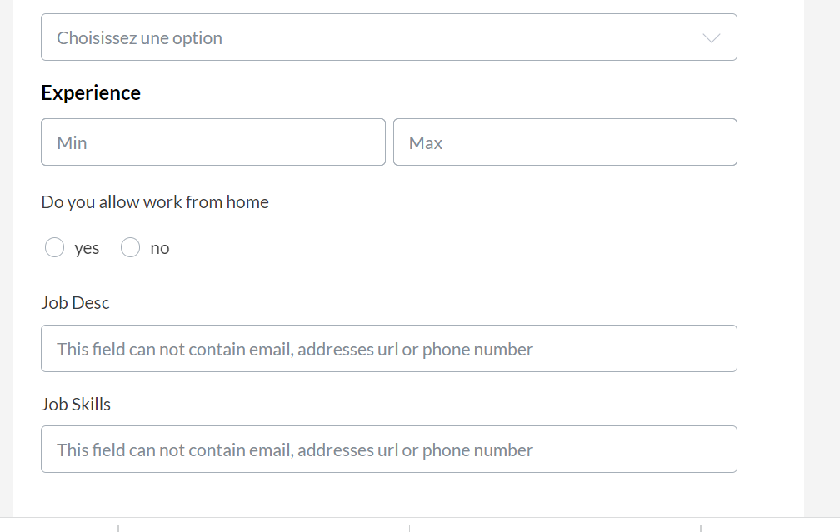

**2.Arabic Post a job form UI is not aligned to left but is aligned to right**

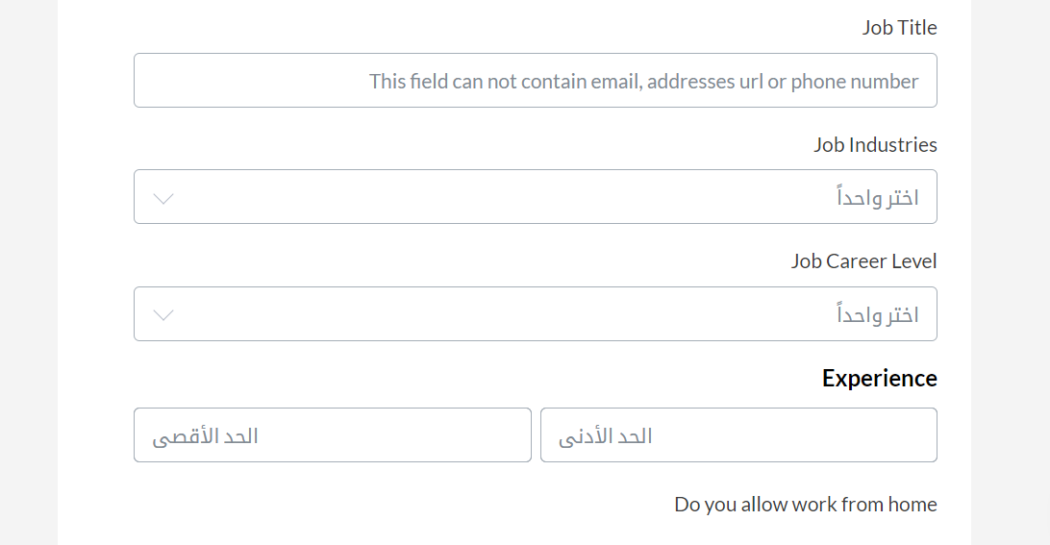

**3.User do not view successfully job posted message after job post creation**