Assignment 1: Pseudocode Development - Task:

* Write a detailed pseudocode for a simple program that takes a number as input, calculates the square if it's even or the cube if it's odd, and then outputs the result. Incorporate conditional and looping constructs.

Start

// Input

Prompt the user to enter a number

Read the number from the user and store it in a variable (num)

// Check if the number is even or odd

if num modulo 2 is equal to 0

// Number is even

square = num \* num

Read square

else

// Number is odd

cube = num \* num \* num

Read cube

End

Assignment 2: Flowchart Creation - Task

* Design a flowchart that outlines the logic for a user login process. It should include conditional paths for successful and unsuccessful login attempts and a loop that allows a user three attempts before locking the account.

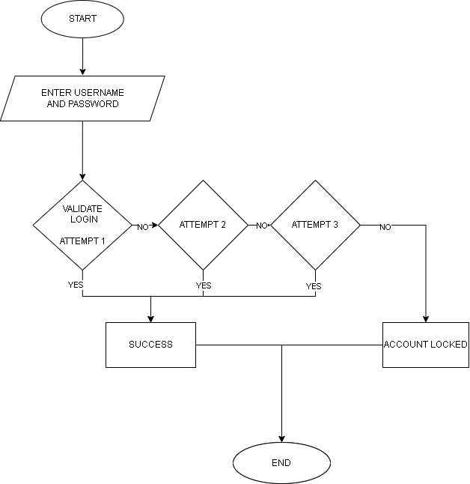

Assignment 3: Function Design and Modularization

* Create a document that describes the design of two modular functions: one that returns the factorial of a number, and another that calculates the nth Fibonacci number. Include pseudocode and a brief explanation of how modularity in programming helps with code reuse and organization.

FIBONACCI

function fibonacci (n)

if n=0

return 0

else if n=1

return 1

else :

return f(n-1)+f(n-2)

FACTORIAL

function factorial(n)

if n=0

return 1

else

return n\*f(n-1)