Yushuo Ruan

CSCI 5722 Computer Vision

HW5 – Write-up

1. The ComputeColorFeature simply returns the R, G, B layers as the three features, and it is called in ComputePositionColorFeatures function to produce the three color-features at the beginning. And then the position is added to the fourth and fifth layer of the feature matrix. Since the position of the pixel has not changed, we can use ndgrid function to produce X, Y coordinates and put each of them at the fourth and fifth layer of the feature matrix.

Gradient and edges method is also tested in the program. Gradient method is implemented using imgradientxy function. Gradients on x-direction and y direction are treated as two different features; each of the three color layers have its own pair of gradients, so gradient method generates six features just by itself. Edge method is implemented using edge function with Canny method; each color layer generates one feature, so three features are generated by edge. Both gradient and edge extract edges from the original images as a separate segmentation, but gradient is more blurred than the edge function. When these features work with color feature with out normalization, edges belong to different segmentation than the foreground object.

The normalization process is vectorized; $μ_{j}$ is first calculated for all the pixels in the features vector using mean function, and then $σ_{j}$ is calculated similarly using std function, and then feature norm is calculated directed using $μ_{j}$ and $σ_{j}$. An alternative way to normalize feature vector is to normalize everything to 0~1. According to the result, I believe that position is more important than color, since the object in image is usually a ‘cluster’ staying nearby. So I make the position features closer by dividing them to smaller numbers.

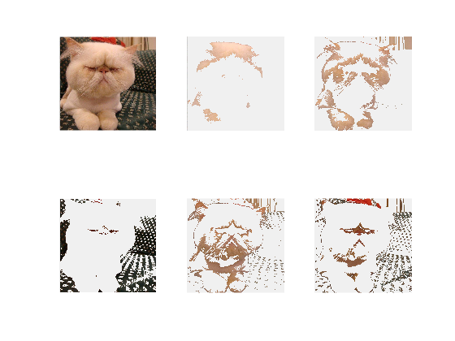

Image: car_grumpy.jpg  
k: 5

Custer method: kmeans_clustring

Feature method: Color

Normalization: true

Resize: 0.5  
==========================================================

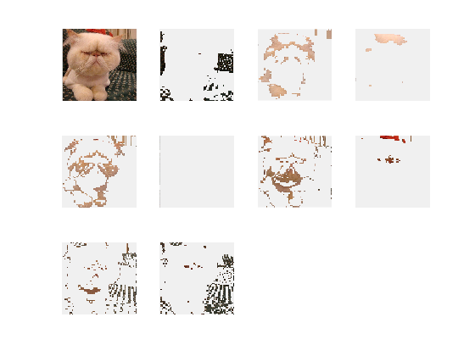  
Image: car_grumpy.jpg  
k: 5

Custer method: kmeans_clustring

Feature method: Color

Normalization: true  
Resize: 0.125

==========================================================

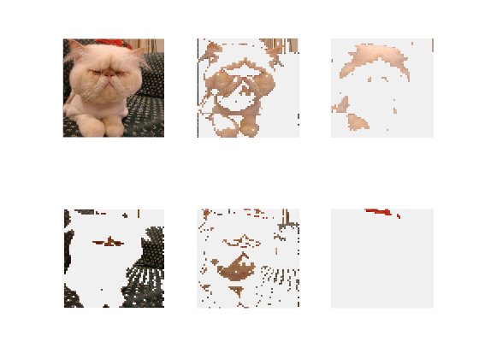

Image: car_grumpy.jpg  
k: 5

Custer method: HAC

Feature method: Color

Normalization: true

Resize: 0.125

==========================================================

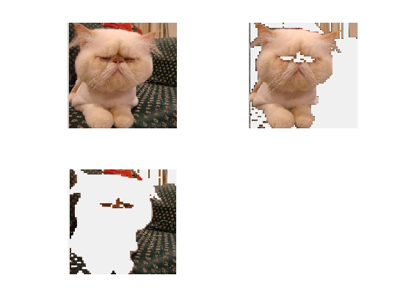

Image: car_grumpy.jpg  
k: 2

Custer method: HAC

Feature method: PositionColor

Normalization: true

Resize: 0.125

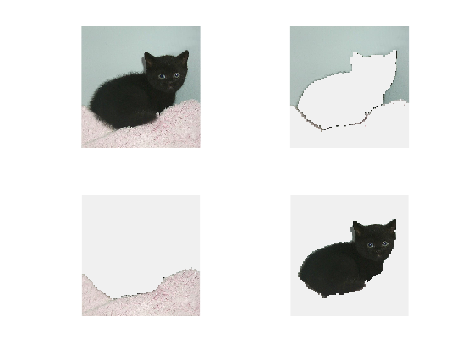

Image: black_kitten_star.jpg  
k: 3

Custer method: kmeans_clustring

Feature method: PositionColor

Normalization: true

Resize: 0.125

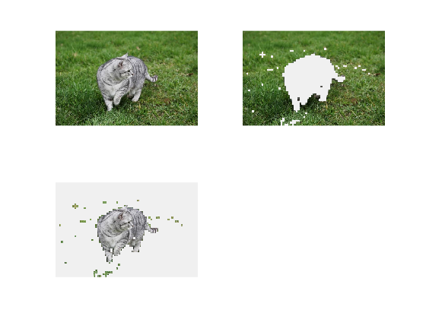

Image: grey-cat-grass.jpg  
k: 2

Custer method: HAC

Feature method: PositionColor

Normalization: true

Resize: 0.125

2. The segment