Jinan University
2023 ～ 2024 Academic Year, 2nd. Semester

Java Programming

Course Report

Course code : 60080008
Instructor: Yuxia Sun
Major: Computer Science & Technology
School: International School

Student name : ________蒋云翔_________
(p.s. your name on JNU academic system)

Student number : ________2022102330__________

Date of Submission (mm-dd-yyyy): __6/21/2024____

Table of Content
Ch1 Introduction to Computers, Programs, and Java 5
1. Bar-graph of Self-test 5
2. Correction & Learning 5
1) Correction 5
2) Correction 5
3) Correction 6
4) Correction 6
5) Correction 6
6) Correction 7
7) Correction 7
8) Correction 7
9) Correction 8
10) Correction 8
Ch2 Elementary Programming Ch2 Elementary Programming 8
1. Bar-graph of Self-test 8
2. Correction & Learning 9
1) Correction 9
2) Correction 9
3) Correction 9
4) Correction 10
5) Correction 10
6) Correction 10
7) Correction 10
8) Correction 11
9) Correction 11
10) Correction 11
11) Correction 11
12) Correction 12
Ch3 Selections 12
1. Bar-graph of Self-test 12
2. Correction & Learning 12
1) Correction 12
2) Correction 13
3) Correction 13
4) Correction 13
5) Correction 14
6) Correction 14
7) Correction 14
8) Correction 15
9) Correction 15
10) Correction 15
Ch4 Mathematical Functions, Characters, and Strings 16
1. Bar-graph of Self-test 16
2. Correction & Learning 16
1) Correction 16
2) Correction 16
3) Correction 16
4) Correction 17
5) Correction 17
6) Correction 17
7) Correction 17
8) Correction 17
9) Correction 18
10) Correction 18
11) Correction 18
12) Correction 18
13) Correction 19
Ch5 Loops 19
1. Bar-graph of Self-test 19
2. Correction & Learning 19
1) Correction 19
Ch6 Methods 20
1. Bar-graph of Self-test 20
2. Correction & Learning 20
1) Correction 20
2) Correction 20
3) Correction 21
4) Correction 21
5) Correction 22
6) Correction 22
7) Correction 23
8) Correction 23
Ch7 Single-Dimensional Arrays 23
1. Bar-graph of Self-test 23
2. Correction & Learning 23
1) Correction 23
2) Correction 24
3) Correction 24
4) Correction 24
5) Correction 25
6) Correction 25
7) Correction 25
8) Correction 26
9) Correction 26
10) Correction 26
11) Correction 27
12) Correction 27
Ch8 Multidimensional Arrays 27
1. Bar-graph of Self-test 27
2. Correction & Learning 27
1) Correction 27
Ch9 Objects and Classes 28
1. Bar-graph of Self-test 28
2. Correction & Learning 28
1) Correction 28
2) Correction 29
3) Correction 29
4) Correction 30
5) Correction 30
6) Correction 31
7) Correction 31
8) Correction 31
9) Correction 32
10) Correction 32
11) Correction 33
12) Correction 33
Ch10 Object-Oriented Thinking 34
1. Bar-graph of Self-test 34
2. Correction & Learning 34
1) Correction 34
2) Correction 34
3) Correction 34
4) Correction 35
5) Correction 35
6) Correction 35
Ch11 Inheritance and Polymorphism 36
1. Bar-graph of Self-test 36
2. Correction & Learning 36
1) Correction 36
2) Correction 37
3) Correction 37
4) Correction 38
5) Correction 38
6) Correction 38
7) Correction 39
8) Correction 39
9) Correction 40
Ch12 Exception Handling and Text I/O 40
1. Bar-graph of Self-test 40
2. Correction & Learning 41
1) Correction 41
2) Correction 41
3) Correction 42
4) Correction 42
5) Correction 43
6) Correction 44
Ch13 Abstract Classes and Interfaces 44
1. Bar-graph of Self-test 44
2. Correction & Learning 44
1) Correction 45
2) Correction 45
3) Correction 45
4) Correction 46
5) Correction 46
6) Correction 47
7) Correction 47
8) Correction 48
Ch14 JavaFX Basics (Optional) 48
1. Bar-graph of Self-test 48
2. Correction & Learning 48
1) Correction 48
2) Correction 49
3) Correction 49
4) Correction 49
5) Correction 50
6) Correction 51
Project I. *** () 51
1. The chosen program’s name and type 51
2. Running results of my modified program 52
3. Program functionalities modified by me 53
4. Test my program with Junit. (Optional) 54

Ch1 Introduction to Computers, Programs, and Java

1. Bar-graph of Self-test

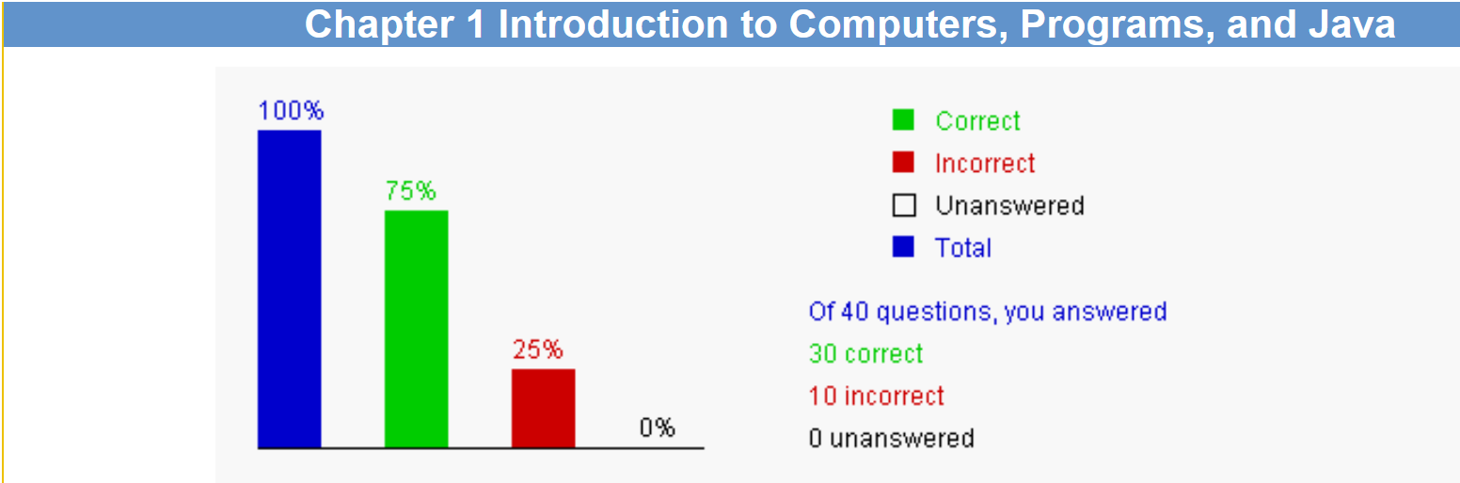

2. Correction & Learning

1) Correction
1.1 Hardware is the physical aspect of the computer that can be seen

Learning:
I read the introduction ppt and search on the internet, and I configure out that:A computer consists of two main parts: hardware and software. Hardware refers to the physical components of a computer, which include but are not limited to the central processing unit (CPU), random access memory (RAM), hard disk drives (HDD), solid-state drives (SSD), motherboard, power supply unit (PSU), graphics card, and peripheral devices such as monitors, keyboards, and mice. These components are tangible and can be seen and touched, making them the physical aspect of the computer. Software, on the other hand, is the programs and instructions that a computer runs. It includes operating systems (such as Windows, macOS, Linux), applications (like word processors, web browsers, games), and drivers. Although software is crucial for the operation of a computer, it is intangible and cannot be seen or touched directly by users. Therefore, when we talk about the physical aspect of a computer that can be seen, we are referring to its hardware.

2) Correction
1.3 The speed of the CPU may be measured in megahertz, gigahertz

Learning:
I search the internet and got the answer: Megahertz (MHz): This is a million cycles per second. It was the standard unit for measuring CPU speeds for a long time, especially during the earlier days of personal computing.
Gigahertz (GHz): As CPU speeds increased, the gigahertz became a more common unit. It represents one billion cycles per second and is used for modern, high-speed processors.

3) Correction
1.6 main memory is not permanent storage devices

Learning:
The website told us the correct answer and give me an illustration: Disks and CI are used to store data permanently. Data in memory is lost after the power is turned off

4) Correction
1.7 NIC is a device to connect a computer to a local area network (LAN).

Learning:
I search the internet and find all the metioned concepts in this problem.
A regular modem, often referred to as a "dial-up modem," is a device that enables a computer or other digital device to communicate with the internet service provider (ISP) over a standard telephone line. The term "modem" is short for "modulator-demodulator," which describes its two primary functions: modulating a digital signal onto an analog carrier signal for transmission, and demodulating an incoming analog signal back into a digital signal to be decoded by the computer.
DSL is a technology that uses existing telephone lines to deliver internet service. It converts a regular telephone line into a high-speed digital link by using a DSL modem at the customer's end and a DSL access multiplexer (DSLAM) at the service provider's end.
A cable modem is a device that uses the coaxial cable television infrastructure to provide high-speed internet access. It works by converting the cable signal into a digital signal that can be read by a computer or router.

5) Correction
1.8 Software and Programs are instructions to the computer

Learning:
I refer to the course ppt and search the internet and I learn: In essence, software and programs act as the bridge between a user's needs and the capabilities of the computer hardware. They allow users to interact with the computer in a meaningful and productive way.

6) Correction
1.14 Due to security reasons, Java applets cannot run from a Web browser in the new version of Java.

Learning:
I search the internet and got the explanation about this problem: Java applets were small programs that could be embedded in a webpage and executed by a Java-capable web browser. However, due to numerous security vulnerabilities associated with Java applets, and the rise of more secure and efficient web technologies, support for applets has been dropped in newer versions of Java and most modern web browsers have also discontinued support for them. As a result, it's no longer recommended or generally possible to run Java applets in a browser.

7) Correction
1.17 Java is architecture-neutral.

Learning:
At first I do not know the meaning of architecture-neutral clearly, so I search the internet and find the corresponding knowledge and find the explanation: "Architecture-neutral" means that the same software or code can run on different types of hardware without the need for significant modification. Java achieves this through the use of the Java Virtual Machine (JVM), which allows Java programs compiled into bytecode to be executed on any platform that has a compatible JVM. This is a key aspect of Java's "write once, run anywhere" (WORA) philosophy.

8) Correction
1.27 Java compiler translates Java source code into Java bytecode.

Learning:
I read the e-book and find the answer: bytecode is a set of instructions that can be read and executed by the Java Virtual Machine (JVM), which makes Java a platform-independent language. The JVM is responsible for the final step of converting bytecode into machine code specific to the host system's architecture.

9) Correction
1.28 Java virtual machine is a software that interprets Java bytecode.

Learning:
I read the e-book and find the corresponding explanation: The Java Virtual Machine (JVM) is an abstract computing machine that enables a computer to run Java programs as well as programs written in other languages that are also compiled to Java bytecode.

10) Correction
1.29 Suppose you define a Java class as follows, the source code should be stored in a file named Test.java
public class Test {
}
Learning:
I read the ppt and also search the internet and got the answer:
1. Class Declaration: In Java, the name of the public class must match the name of the file where it is saved.
2. File Extension: Java source files are typically saved with the .java extension, which indicates that the file contains Java source code.
3. Case Sensitivity: Java is case-sensitive, so the file name must exactly match the class name, including the correct use of uppercase and lowercase letters.

Ch2 Elementary Programming Ch2 Elementary Programming

1. Bar-graph of Self-test

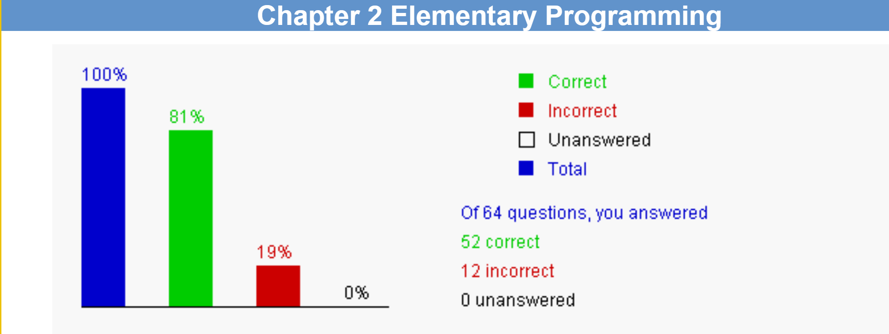

2. Correction & Learning

1) Correction
2.6 Every letter in a Java keyword is in lowercase? The answer is Yes.

Learning:
I read the course ppt and search the internet and get the answer: Java has a set of reserved keywords (like public, class, int, if, else, return, etc.) that have special meanings in the language. These keywords must always be written in lowercase.

2) Correction
2.8 Which of the following are correct names for variables according to Java naming conventions? The answer are: radius and findArea

Learning:
I read the course ppt and search the internet and then get the answer: A single-word variable is in lowercase. In a multiple-word variable, the words are concatenated with the first word in lowercase and the first letter of each subsequent word in uppercase.

3) Correction
2.13 To declare a constant MAX_LENGTH inside a method with value 99.98, you write: final double MAX_LENGTH = 99.98;

Learning:
I search the internet and get the answer: To declare a constant inside a method in Java, you would use the final keyword to indicate that the value of the variable will not change

4) Correction
2.14 Which of the following is a constant, according to Java naming conventions? The answers are: MAX_VALUE and COUNT

Learning:
The website tell me the explanation of this problem: All letters in a constant are in uppercase, In a multiple-word constant, the words are connected using underscores

5) Correction
2.16 According to Java naming convention, which of the following names can be variables? The answers are: findArea and totalLength.

Learning:
This problem is totally the same as 2.8, so I will not give an explanation here.

6) Correction
2.18 When assigning a literal to a variable of the byte type, if the literal is too large to be stored as a byte value, it receives a compile error.

Learning:
- I do not clearly understand the meaning of byte type, then I search the internet and know the reason for this problem: Byte Range: A byte in Java is an 8-bit signed integer, which means it can store values ranging from -128 to 127.
- Literal Values: If a literal value exceeds this range, it cannot be represented by a byte variable.

7) Correction
2.27 Math.pow(2, 3) returns 8.0.

Learning:
The methow Math.pow() will return a double value.

8) Correction
2.28 Math.pow(4, 1 / 2) returns 1.0.

Learning:
In method Math.pow(x,y), it will receive 2 int number. In this problem, 1/2 will be viewd as 0.0

9) Correction
2.32 Analyze the following code. The answer is: The program has a syntax error, because 09 is an incorrect literal value.
public class Test {
public static void main(String[] args) {
int month = 09;
System.out.println("month is " + month);
}
}

Learning:
I made a stupid mistake to obmit this easy key point, which is any numeric literal with the prefix 0 is an octal value.

10) Correction
2.35 Which of the following is incorrect? The answer is: float x = 1.0;

Learning:
When we define a float number, its value must continue with a lowercase ‘f’ such as float x = 1.0f;

11) Correction
2.50 What is i printed in the following code? The answer is: 5
public class Test {
public static void main(String[] args) {
int j = 0;
int i = j++ + j * 5;
System.out.println("What is i? " + i);
}
}

Learning:
Operands are evaluated from left to right in Java. The left-hand operand of a binary operator is evaluated before anypart of the right-hand operand is evaluated. This rule takes precedence over any other rules that gover expressions. Therefore, i++is evaluated first.,j is now 1. Since j++ is postincrement, the old value ofj is retured for i++. So i++ + i* 5 equals 0 + 1 * 5. So, theresult is 5.

12) Correction
2.54 Which of the following expressions will yield 0.5? The answers are: 1.0 / 2 and (double) 1 / 2 and 1 / 2.0

Learning:
Type casting’s rule.

Ch3 Selections

1. Bar-graph of Self-test
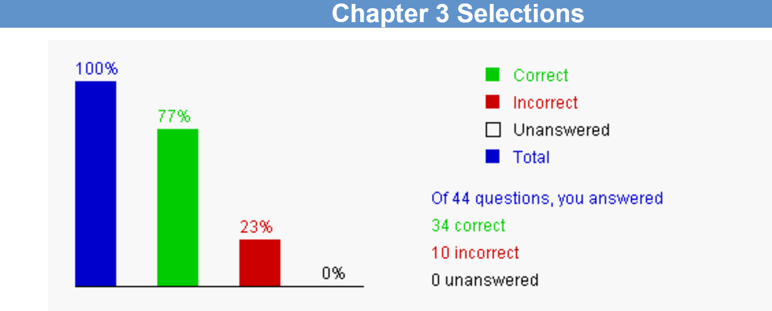

2. Correction & Learning

1) Correction
3.4 What is 1 - 0.1 - 0.1 - 0.1 - 0.1 - 0.1 == 0.5? The answer is: There is no guarantee that 1 - 0.1 - 0.1 - 0.1 - 0.1 - 0.1 == 0.5 is true.

Learning:
I read the e-book and ask my classmate cbz to figure out this question: The way computer stores the value is through using binary number, so it compute the data is an approximation computation, so the answer is clear right now.

2) Correction
3.7 What is the output of the following code?
int x = 0;
if (x < 4) {
x = x + 1;
}
System.out.println("x is " + x);
The answer is: x is 1

_{Learning:}
I made such a stupid miatake misreading the if conditional statement to for loop statement. Actually it is a very simple program and a problem.

3) Correction
3.8 Suppose income is 4001, what is the output of the following code?
if (income > 3000) {
System.out.println("Income is greater than 3000");
}
else if (income > 4000) {
System.out.println("Income is greater than 4000");
}
The answer is: Income is greater than 3000

Learning:
While I making this correction, I can not figure out why I will wrongly solve this problem. The answer is clear as the accurate value of income has been assigned already.

4) Correction
3.15 Which of the following is a possible output from invoking Math.random()? The answers are: 0.5 and 0.0

Learning:
I search e-book and make sure again on the internet and finally know that: Math.random() returns a real value between 0.0 and 1.0, excluding 1.0.

5) Correction
3.16 What is the output from System.out.println((int)Math.random() * 4)? The answer is: 0

Learning:
Recondidering the statement and analyse again, the answer is clear: Casting operation is performed before the * operator in (int)Math.random()*4.

6) Correction
3.18 Suppose you write the code to display "Cannot get a driver's license" if age is less than 16 and "Can get a driver's license" if age is greater than or equal to 16. Which of the following code is correct?
I:
if (age < 16)
System.out.println("Cannot get a driver's license");
if (age >= 16)
System.out.println("Can get a driver's license");
II:
if (age < 16)
System.out.println("Cannot get a driver's license");
else
System.out.println("Can get a driver's license");
III:
if (age < 16)
System.out.println("Cannot get a driver's license");
else if (age >= 16)
System.out.println("Can get a driver's license");
IV:
if (age < 16)
System.out.println("Cannot get a driver's license");
else if (age > 16)
System.out.println("Can get a driver's license");
else if (age == 16)
System.out.println("Can get a driver's license");

Learning:
Just analyse the program’s code step by step then the answer is clear.

7) Correction
3.29 Suppose x=10 and y=10. What is x after evaluating the expression (y > 10) && (x-- > 10)? The answer is: 10

Learning:
This code is concerned with a normal operator && in java, for the && operator, the right operand is not evaluated, if the left operand is evaluated as false.

8) Correction
3.34 Which of the following are so called short-circuit operators? The answers are: && and ||

Learning:
I searched the internet and got the explanation: && and l are short-circuit operator, meaning that if the left operand can determine the result of the operation, the right operand will be skipped.

9) Correction
3.36 Analyze the following program fragment:
int x;
double d = 1.5;
switch (d) {
case 1.0: x = 1;
case 1.5: x = 2;
case 2.0: x = 3;
}
The answer is: The switch control variable cannot be double.

Learning:
The switch value cannot be a floating-point number. So the correct answer is C.

10) Correction
3.40 The order of the precedence (from high to low) of the operators binary +, *, &&, ||, ^ is: The answer is: *, +, ^, &&, ||

Learning:
I search the internet and find the answer: 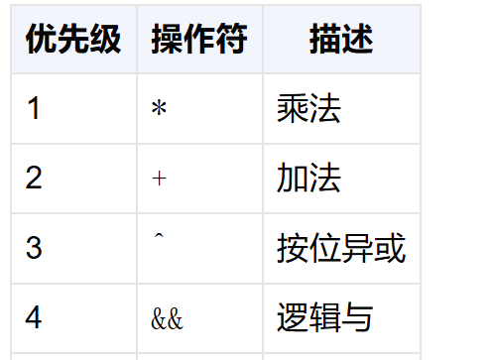

Ch4 Mathematical Functions, Characters, and Strings

1. Bar-graph of Self-test
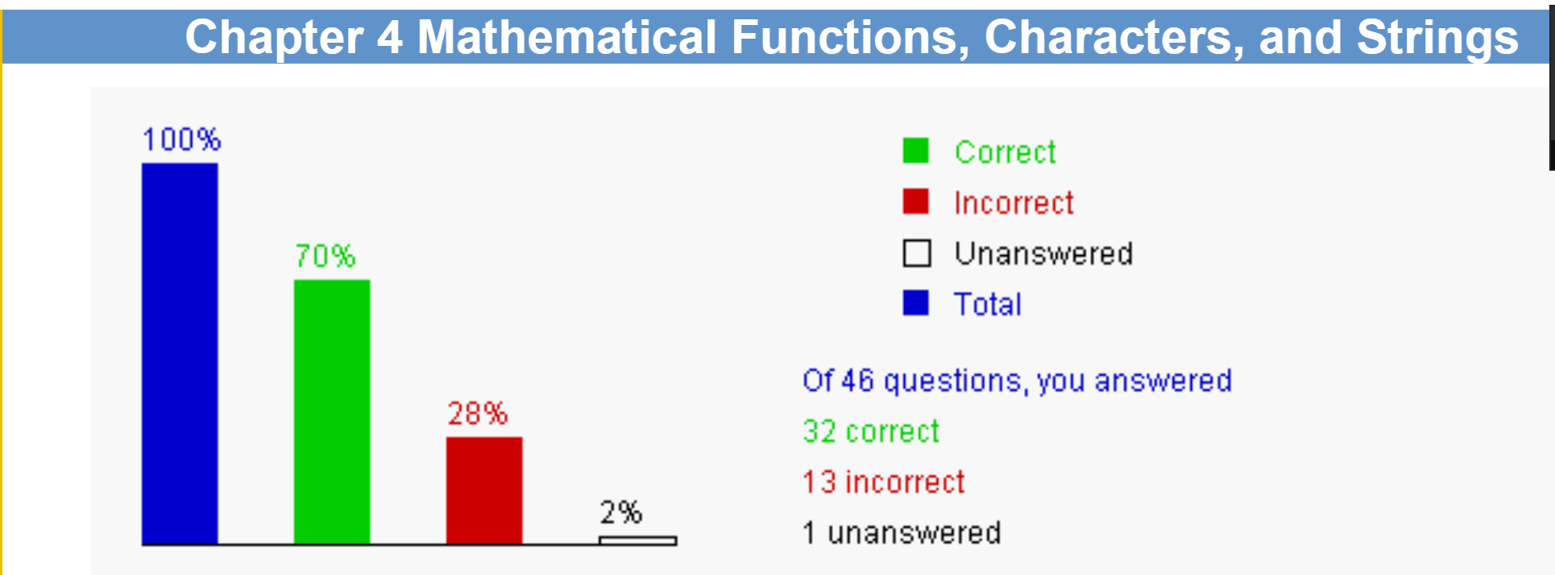

2. Correction & Learning

1) Correction
4.6 What is Math.round(3.6)? The answer is: 3

Learning:
I look up the corresponding information in course slides and got the explanation: round() function rerturns an int value.

2) Correction
4.7 What is Math.rint(3.6)? The answer is: 4.0

Learning:
I look up the corresponding information in course slides and got the explanation: rint() function rerturns an double value.

3) Correction
4.12 A Java character is stored in __________. The answer is: two bytes

Learning:
I search the internet and figure out that Java characters use Unicode encoding so the answer is clear that 2 bytes for space storation of Java character.

4) Correction
4.14 Which of the following statement prints smith\exam1\test.txt? The answer is: System.out.println("smith\\exam1\\test.txt");

Learning:
The concerned knowledge is escape character. To represent character \, we have to use \\,
just remember it!!

5) Correction
4.19 An int variable can hold __________. The answers are: 'x' and 120.

Learning:
A character can be implicitly cast into an int variable. The Unicode value of characteis assignment to the int variable. In this case, the code is 120 (see Appendix B).

6) Correction
4.20 Which of the following assignment statements is correct? The answers are: char c = 'd'; and char c = 100;

Learning:
An int value can be implicitly cast into a char variable. The Unicode of the character is
the int value. In this case, the character is d (see Appendix B).

7) Correction
4.24 Suppose Character x = new Character('a'), ________ returns true. The answers are: x.equals(new Character('a')) and x.equals('a').

Learning:
All choices can be found in our e-book given by Prof.Sun.

8) Correction
4.29 Which of the following is the correct statement to return JAVA? The answer is: "Java".toUpperCase()

Learning:
The function methods involved can be found in books or ppt, it is just a memory problem.

9) Correction
4.30 Suppose s1 and s2 are two strings. Which of the following statements or expressions is incorrect?
The answers are: String s3 = s1 - s2; and boolean b = s1.compareTo(s2); and char c = s1[0]; and char c = s1.charAt(s1.length());

Learning:
A is wrong because the - operator cannot be used for strings, B is wrong because the
compareTo method retums an intnot a boolean. C is wrong because the ll cannot be used
for accessing string elements. D is wrong because of index out of bounds.

10) Correction
4.32 "abc".compareTo("aba") returns ___________. The answer is: 2

Learning:
Learning from such an example, I am now totally know the usage of compareTo() function. The first two characters in the two strings are the same, The diferent belween the last two characters is 2.

11) Correction
4.33 "AbA".compareToIgnoreCase("abC") returns ___________. The answer is: 2

Learning:
This problem is very similar to 4.32, differing from the uppercase or lowercase of the characters.

12) Correction
4.34 ____________________ returns true. The answers are: "peter".equalsIgnoreCase("Peter") and "peter".equalsIgnoreCase("peter") and "peter".equals("peter")

Learning:
After figuring out the inner core of 4.32 and 4.33, this problem is easy to be handled with.

13) Correction
4.43 The statement System.out.printf("%3.1e", 1234.56) outputs ___________. The answer is: 1.2e+03

Learning:
%3.l e specifies a scientific notation with one digit after the decimal point.

Ch5 Loops

1. Bar-graph of Self-test
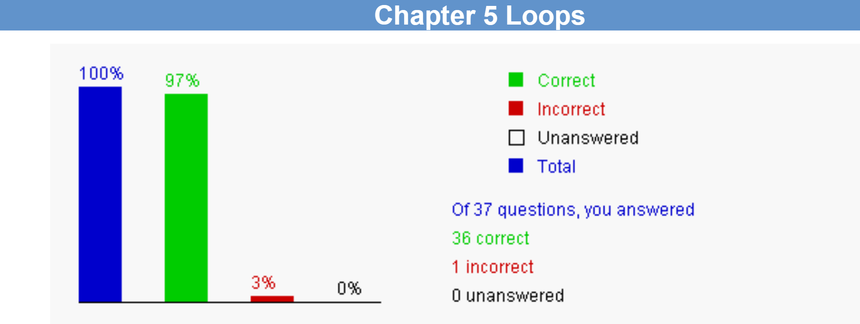

2. Correction & Learning

1) Correction
5.28 What is the output after the following loop terminates?
int number = 25;
int i;
boolean isPrime = true;
for (i = 2; i < number && isPrime; i++) {
if (number % i == 0) {
isPrime = false;
}
}
System.out.println("i is " + i + " isPrime is " + isPrime);
The answer is: i is 6 isPrime is false

Learning:
The code tests if number is prime by dividing the number with possible divisors 2.3, 4, and so on. nitially, isPrime isset to true. Once a divisor is found (i.e., number % i-- 0 is true), isPrime is set to false. The loop continuation condition nowbecomes false. The loop ends. If no divisor is found after the loop is finished, isPrime remains true. Since number is 25, number % i0 is tre when i is 5, in this case, isPrime is set to false and i++ increments i by 1 in the action-ater-each-iteration. So, the outpuis that i is 6 and isPrime is false.

Ch6 Methods

1. Bar-graph of Self-test
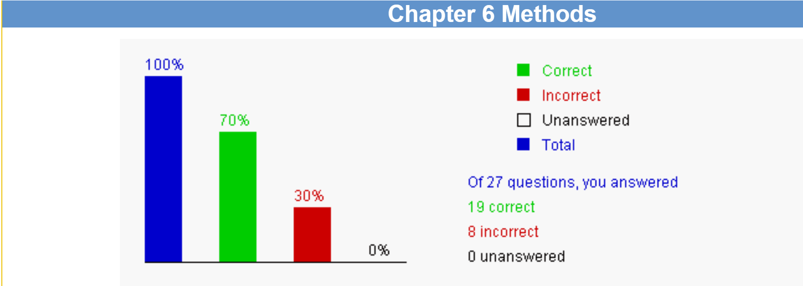

2. Correction & Learning

1) Correction
6.2 The signature of a method consists of ____________. The answer is: method name and parameter list

Learning:
I look up e-book and find the definition of it. A method signature consists of method name and parameter list.

2) Correction
6.10 You should fill in the blank in the following code with ______________. The answer is: char
public class Test {
public static void main(String[] args) {
System.out.print("The grade is " + getGrade(78.5));
System.out.print("\nThe grade is " + getGrade(59.5));
}
public static _________ getGrade(double score) {
if (score >= 90.0)
return 'A';
else if (score >= 80.0)
return 'B';
else if (score >= 70.0)
return 'C';
else if (score >= 60.0)
return 'D';
else
return 'F';
}
}
Learning:
Just figure out what type will be return.

3) Correction
6.13 Given the following method, what is the output of the call nPrint('a', 4)? The answer is: invalid call
static void nPrint(String message, int n) {
while (n > 0) {
System.out.print(message);
n--;
}
}

Learning:
Char type value can not be passed to string message!!!

4) Correction
6.14 Given the following method. The answer is: 2
static void nPrint(String message, int n) {
while (n > 0) {
System.out.print(message);
n--;
}
}
What is k after invoking nPrint("A message", k)?
int k = 2;
nPrint("A message", k);

Learning:
Read again the code, it is a very simple question actually.

5) Correction
6.17 Analyze the following code. The answer is: The program cannot compile because the compiler cannot determine which max method should be invoked.
public class Test {
public static void main(String[] args) {
System.out.println(max(1, 2));
}
public static double max(int num1, double num2) {
System.out.println("max(int, double) is invoked");
if (num1 > num2)
return num1;
else
return num2;
}
public static double max(double num1, int num2) {
System.out.println("max(double, int) is invoked");
if (num1 > num2)
return num1;
else
return num2;
}
}

Learning:
This code is concerned with a significant knowledge called ambiguous method invocation, it depends on the parameters passed to the method, which will tell the system to select the very fit one to implement the method.

6) Correction
6.18 Analyze the following code. The answer is: The program has a compile error because the two methods m have the same signature.
public class Test {
public static void main(String[] args) {
System.out.println(m(2));
}
public static int m(int num) {
return num;
}
public static void m(int num) {
System.out.println(num);
}
}

Learning:
The explanation of this problem let me know that: We can not override the method based on the type returned.

7) Correction
6.25 The client can use a method without knowing how it is implemented. The details of the implementation are encapsulated in the method and hidden from the client who invokes the method. This is known as __________. The answers are: information hiding and encapsulation

Learning:
I look up the e-book and find the corresponding definition of this problem.

8) Correction
6.27 __________ is a simple but incomplete version of a method. The answer is: A stub

Learning:
This definition can also be found in our e-book.

Ch7 Single-Dimensional Arrays

1. Bar-graph of Self-test
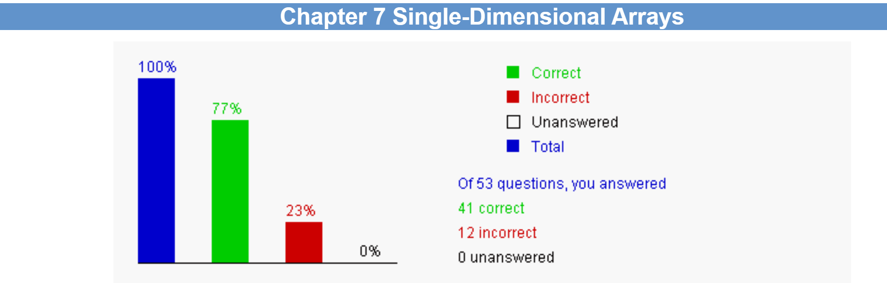

2. Correction & Learning

1) Correction
7.6 What is the correct term for numbers[99]? The answer is: indexed variable

Learning:
It is just a strict definition of indexed variable which can be found in our textbook.

2) Correction
7.8 Analyze the following code. The answer is: The program runs fine and displays x[0] is 0.
public class Test {
public static void main(String[] args) {
int[] x = new int[3];
System.out.println("x[0] is " + x[0]);
}
}

Learning:
In java programming, the program runs correctly and outputs x[0] is 0, because the first element of the array x[0] is automatically initialized to 0, the default value for int. This is a very significant character in java differing from other program language.

3) Correction
7.9 Which of the following statements are valid? The answers are: double d[] = new double[30]; and int[] i = {3, 4, 3, 2};

Learning:
Primitive data types cannot be created using the new keyword in Java. When declaring an array, you must specify the size of the array or initialize it with curly braces. When declaring an array, you can directly assign elements to it using curly braces.

4) Correction
7.10 How can you initialize an array of two characters to 'a' and 'b'? The answers are: char[] charArray = {'a', 'b'}; and char[] charArray = new char[]{'a', 'b'};

Learning:
I search the internet and asking gpt for help: We can directly initialize an array with curly braces {} when
declaring it, without explicitly declaring the size of the array. We can create an array using new char[]{}
and then initialize it with curly braces {}.

5) Correction
7.15 Analyze the following code:
public class Test {
public static void main(String[] args) {
double[] x = {2.5, 3, 4};
for (double value: x)
System.out.print(value + " ");
}
}

6) Correction
7.19 Which of the following is correct? The answers are: String[] list = new String[]{"red", "yellow", "green"}; and String[] list = {"red", "yellow", "green"};

Learning:
This problem is similar to 7.10 and 7.15.

7) Correction
7.32 Analyze the following code: The answer is: The program has a compile error because xMethod(new double[3]{1, 2, 3}) is incorrect.
public class Test1 {
public static void main(String[] args) {
xMethod(new double[]{3, 3});
xMethod(new double[5]);
xMethod(new double[3]{1, 2, 3});
}
public static void xMethod(double[] a) {
System.out.println(a.length);
}
}

Learning:
The problem itself’s explanation indicates that new double[3lf1, 2, 3} should be replaced by new doublel f1, 2, 3}) (anonymous array). But I searched the internet and can not figure out the inner reason. So there’s left question for this problem.

8) Correction
7.39 Which of the following statements are correct to invoke the printMax method in Listing 7.5 in the textbook? The answers are: printMax(1, 2, 2, 1, 4); and printMax(new double[]{1, 2, 3}); and printMax(1.0, 2.0, 2.0, 1.0, 4.0);

Learning:
This printMax() function must apply double type array.

9) Correction
7.40 For the binarySearch method in Section 7.10.2, what is low and high after the first iteration of the while loop when invoking binarySearch(new int[]{1, 4, 6, 8, 10, 15, 20}, 11)? The answer is: low is 4 and high is 6

Learning:
In this problem, we learned how to update the search range's starting and ending points based on the value of the middle element. After the first iteration, we understand that the low pointer moved to the fourth element of the array, while the high pointer remained unchanged. This helps us understand the efficiency and logical flow of the binary search algorithm.

10) Correction
7.41 If a key is not in the list, the binarySearch method returns _________. The answer is: -(insertion point + 1)

Learning:
I search the internet and find the related section in our e-book and learn: If you use the Arrays.binarySearch
method in Java and the target key is not in the list, the method will return a negative number. This negative
number is the negation of the insertion point plus one. By using this return value, you can determine where
the target key should be inserted to maintain the order of the list. Even if the target key does not exist, the
binarySearch method provides an efficient way to find the insertion point.

11) Correction
7.44 The __________ method sorts the array scores of the double[] type. The answer is: java.util.Arrays.sort(scores)

Learning:
This is just a strict usage of the sort function. The correct way to call this method is java.util.Arrays.sort(scores), where scores is an array of type double.

12) Correction
7.47 Assume int[] scores = {1, 20, 30, 40, 50}, what is the output of Syste,
System.out.println(java.util.Arrays.toString(scores))? The answer is: [1, 20, 30, 40, 50]

Learning:
The java.util.Arrays.toString method is used to convert an array into a string representation that is easy to read. For an array of integers, it generates a string that starts and ends with square brackets [ ], with the elements of the array separated by commas ,.

Ch8 Multidimensional Arrays

1. Bar-graph of Self-test
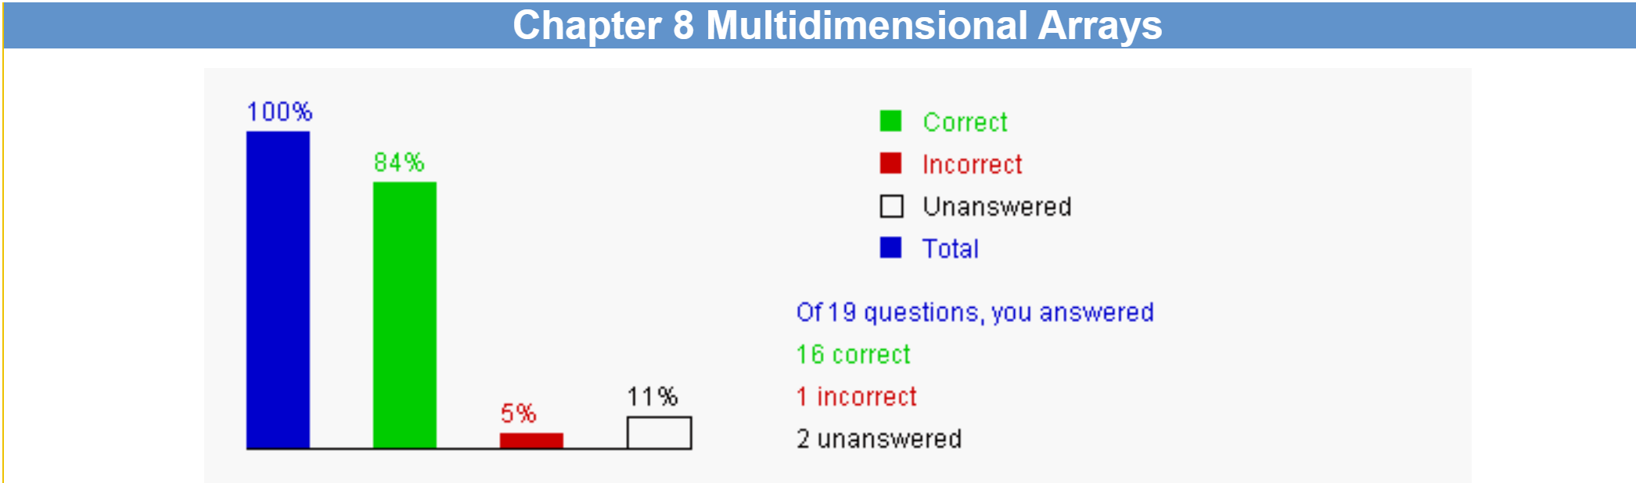

2. Correction & Learning

1) Correction
8.6 Analyze the following code:
public class Test {
public static void main(String[] args) {
boolean[][] x = new boolean[3][];
x[0] = new boolean[1]; x[1] = new boolean[2];
x[2] = new boolean[3];
System.out.println("x[2][2] is " + x[2][2]);
}
}
The answer is: The program runs and displays x[2][2] is false.

Learning:
In the provided code, x[2] is a boolean array, and although it is initialized, the elements within the array, such as x[2][2], are false until they are explicitly assigned a value. The corresponding knowledge is in section ragged array in out e-book.

Ch9 Objects and Classes

1. Bar-graph of Self-test
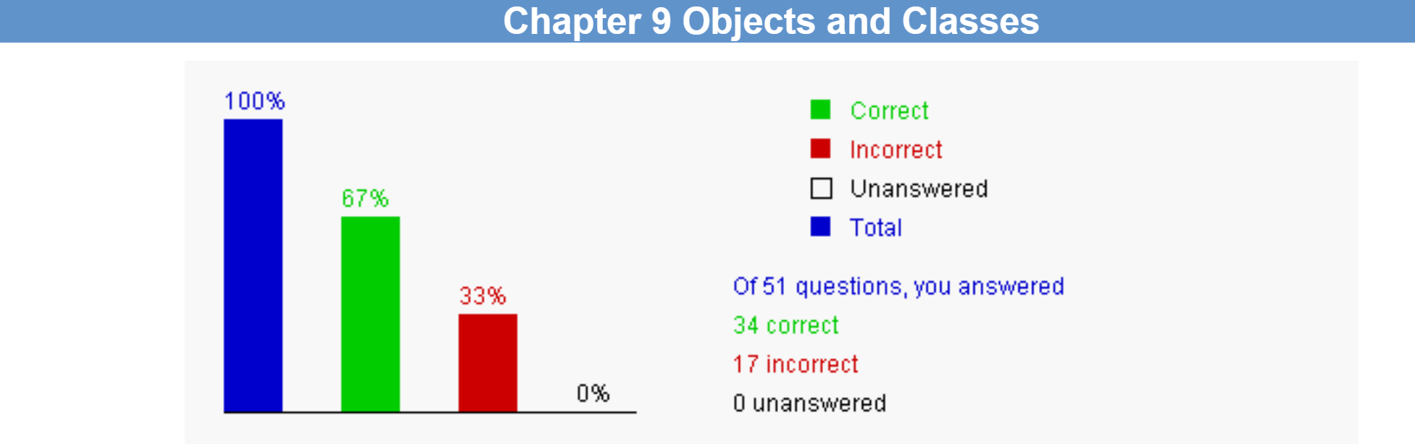

2. Correction & Learning

1) Correction
9.11 Analyze the following code.
public class Test {
int x;
public Test(String t) {
System.out.println("Test");
}
public static void main(String[] args) {
Test test = null;
System.out.println(test.x);
}
}
The answer is: The program has a runtime NullPointerException because test is null while executing test.x.

Learning:
The code then attempts to print test.x, but since test is null, this will cause a runtime NullPointerException. So we have to initialize the variables correctly.

2) Correction
9.15 Analyze the following code.
public class Test {
int x;
public Test(String t) {
System.out.println("Test");
}
public static void main(String[] args) {
Test test = new Test();
System.out.println(test.x);
}
}
The answer is: The program has a compile error because Test does not have a default constructor.

Learning:
The problem gave us a correct explanation to is: Note that a default no-arg constructor is provided only ifno constructors are explicitly defined in the class. In this case, aconstructor Test(String t) is already defined. So, there is no default no-arg constructor in the Test class.

3) Correction
9.20 To obtain the distance between the points (40, 50) and (5.5, 4.4), use _________. The answers are: new Point2D(40, 50).distance(5.5, 4.4) and new Point2D(40, 50).distance(new Point2D(5.5, 4.4)) new Point2D(5.5, 4.4).distance(40, 50) and new Point2D(5.5, 4.4).distance(new Point2D(40, 50))

Learning:
These methods’ usage must be remembered distinctively and be strictly used. The detailed usage and the
Matters needs attentions are in our e-book and course slides.

4) Correction
9.21 Variables that are shared by every instance of a class are __________. The answer is: class variables

Learning:
To figure out this concept clearly, I looked up our e-book and slides also and found the explanation:
- Class Variables: Also known as static variables, these are variables defined at the class level and are not associated with any particular instance. This means that class variables are shared by all instances of the class.
- Instance Variables: In contrast to class variables, instance variables are initialized each time a new instance of a class is created, and each instance has its own set of instance variables.

5) Correction
9.22 You should add the static keyword in the place of ? in Line ________ in the following code:
1 public class Test {
2 private int age;
3
4 public ? int square(int n) {
5 return n * n;
6 }
7
8 public ? int getAge() {
9 return age;
10 }
11 }
The answer is: in line 4

Learing:
I searched the internet and found the related knowledge:
- Static Methods: Static methods belong to the class itself, not to a specific instance of the class. They can be accessed directly via the class name without needing to create an instance of the class.
- Instance Methods: Instance methods require an instance of the class to be invoked and can access the class's non-static members, including instance variables and instance methods.
- Static Keyword: If a method needs to be declared as static, the static keyword should be used in the method declaration.

6) Correction
9.28 What code may be filled in the blank without causing syntax or runtime errors:
public class Test {
java.util.Date date;
public static void main(String[] args) {
Test test = new Test();
System.out.println(_________________);
}
}
The answer is: test.date

Learning:
b and d cause compile errors because date is an instance variable and cannot be accessed from static context. c is wrongbecause test.date is null, causing NullPointerException.

7) Correction
9.31 To prevent a class from being instantiated, _____________________. The answer is: use the private modifier on the constructor.

Learing:
I searched the internet and found the related knowledge:
- Private Constructor: Declaring a constructor as private prevents external access and instantiation of the class. This means that instances of the class cannot be created from outside the class.
- Class Instantiation: Normally, instances of a class can be created through a public constructor. If the constructor is not public, then it can only be called within the class itself.

8) Correction
9.33 Analyze the following code:
public class Test {
private int t;
public static void main(String[] args) {
int x;
System.out.println(t);
}
}
The answer is: t is non-static and it cannot be referenced in a static context in the main method.

Learning:
The reason has been explained correctly by the answer itself, we should just notice the reason that it failed.

9) Correction
9.36 Suppose you wish to provide an accessor method for a boolean property finished, what should the signature of this method? The answer is: public boolean isFinished()

Learning:
I searched the internet and found the related knowledge:
- Accessor Methods: Accessor methods are used to provide access to private properties within a class. They typically start with get or is.
- Boolean Properties: For boolean properties, it is common to use is as the prefix for the accessor method, which is a naming convention in Java.

10) Correction
9.40 What is the value of times displayed?
public class Test {
public static void main(String[] args) {
Count myCount = new Count();
int times = 0;
for (int i=0; i<100; i++)
increment(myCount, times);
System.out.println(
"myCount.count = " + myCount.count);
System.out.println("times = "+ times);
}
public static void increment(Count c, int times) {
c.count++;
times++;
}
}
class Count {
int count;
Count(int c) {
count = c;
}
Count() {
count = 1;
}
}
The answer is: 0

Learning:
Although the increment method is called 100 times, incrementing both myCount.count and times each time, the times variable in the main method does not change because times is passed as a local variable in the increment method and retains its initial value of 0.

11) Correction
9.48 You can declare two variables with the same name in __________. The answer is: different methods in a class

Learning:
The knowledge in this question overlaps a lot of aspects, so I searched the internet and found all of them:
- Scope: In Java, the scope of a variable determines the region from which it can be accessed. The scope of a local variable is limited to the block in which it is declared.
- Method Scope: Variables declared within a method (including formal parameters) are only visible within the scope of that method.
- Block Scope: Variables declared within a block (such as in loops or conditional statements) are only visible within that block.
- Variable Shadowing: A variable declared within a smaller scope can shadow (hide) a variable with the same name in an outer scope.
- Independence Between Methods: You can declare variables with the same name in different methods because their scopes are independent.
- Class Scope: Class-level variables (static variables) can be accessed from all methods in the class, but local variables declared within each method are independent.

12) Correction
9.49 Analyze the following code:
class Circle {
private double radius;
public Circle(double radius) {
radius = radius;
}
}
The answer is: The program will compile, but you cannot create an object of Circle with a specified radius. The object will always have radius 0.

Ch10 Object-Oriented Thinking

1. Bar-graph of Self-test
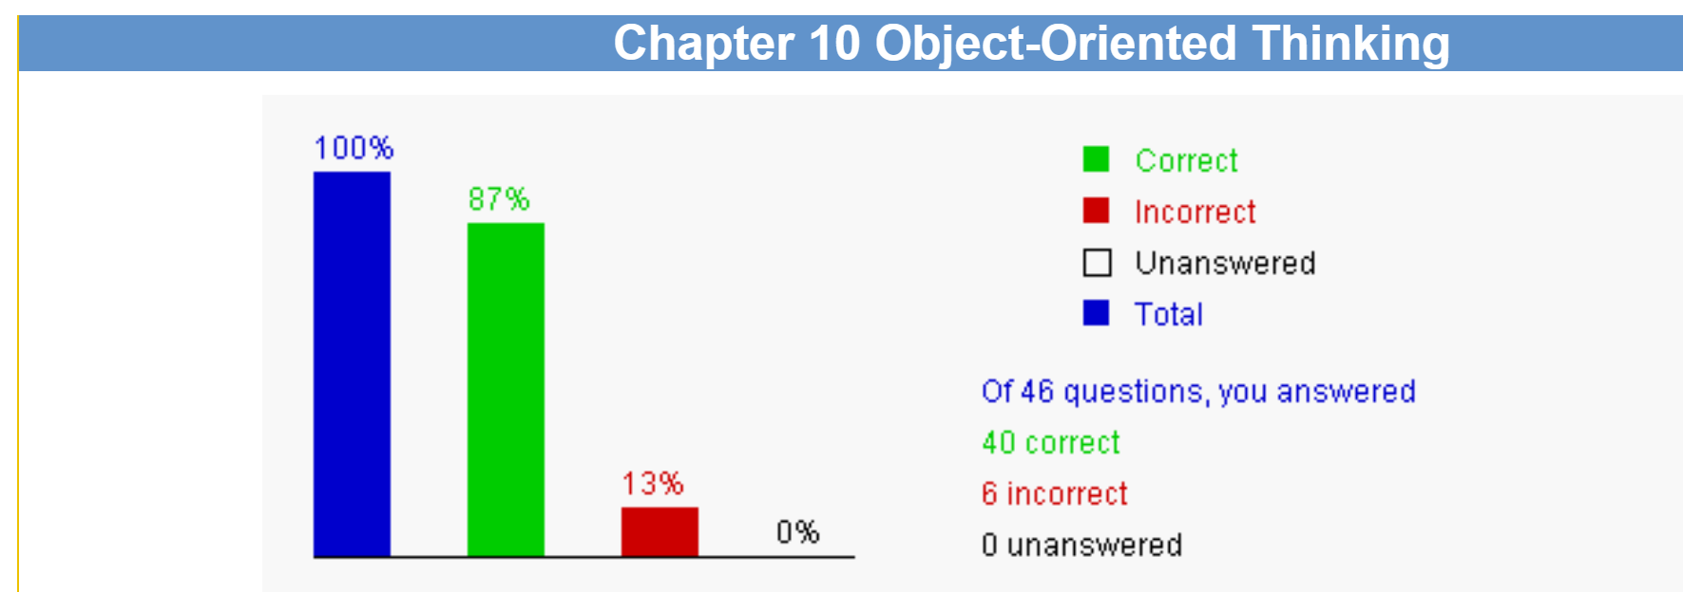

2. Correction & Learning

1) Correction
10.6 Which of the following statements are correct? The answers are: Integer.parseInt("100"); and Integer.parseInt("345", 8);

Learning:
The function Interger.ParseInt() can be passed by 2 parameters. The first one is string type, the second one
is a number indicates the scale of the number.

2) Correction
10.10 To create an instance of BigInteger for 454, use______. The answer is: new BigInteger("454");

Learning:

3) Correction
10.11 To create an instance of BigDecimal for 454.45, use _____. The answers are: new BigDecimal(454.45); and new BigDecimal("454.45");

Learning:
I went through our slides and found the correct method to use the function: The correct way to create an
instance of BigInteger for the value 454 is by using new.

4) Correction
10.16 Which of the following classes are immutable? The answers are: Integer and Double and BigInteger and BigDecimal and String

Learning:
Immutable Classes in Java:
- Integer: Although Integer is mutable, the Integer caching mechanism introduced in Java 8 makes Integer objects immutable for values between -128 and 127.
- Double: The Double class encapsulates a double primitive value, and it is immutable.
- BigInteger: The BigInteger class is used to represent large integers and is immutable.
- BigDecimal: The BigDecimal class represents immutable, arbitrary-precision decimal numbers.
- String: The String class is used to represent strings and is immutable.

5) Correction
10.17 Which of the following statements are correct? The answers are: new java.math.BigInteger("343"); and new java.math.BigDecimal("343.445"); and new java.math.BigDecimal(343.445);

Learning:
The related method is metioned in our slides and e-book. Just remember the usage and
the constraints of it.

6) Correction
10.26 What is the output of the following code?
String s = "University";
s.replace("i", "ABC");
System.out.println(s);
The answer is: University

Learning:
I learned from the explanation of this problem: No method in the String class can change the content of the string. String is an immutable class

Ch11 Inheritance and Polymorphism

1. Bar-graph of Self-test
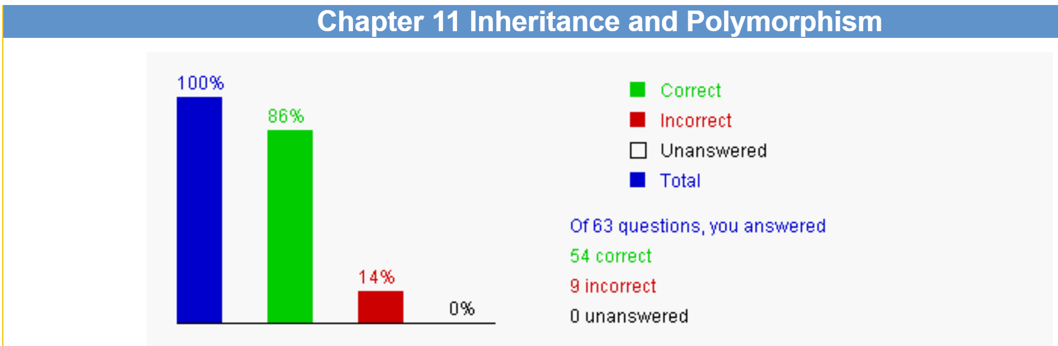

2. Correction & Learning

1) Correction
11.6 What is the output of running class C?
class A {
public A() {
System.out.println(
"The default constructor of A is invoked");
}
}
class B extends A {
public B() {
System.out.println(
"The default constructor of B is invoked");
}
}
public class C {
public static void main(String[] args) {
B b = new B();
}
}
The answer is: "The default constructor of A is invoked" followed by "The default constructor of B is invoked"

Learning:
Inspired by the explanation of this problem, I searched the internet and found a more detailed answer and explanation: In Java, the creation of an object follows a specific order, which includes the invocation of the superclass constructor followed by the subclass constructor.

2) Correction
11.7 Which of the following is incorrect? The answer is: A constructor may be static.

Learning:
I learned from the explanation of this problem: A constructor cannot be static, because you use a constructor to create a specific instance. A constructor may be privateIn this case, the use cannot create an instance using this constructor. For example, the constructor in the Math class is private. Aconstructor may invoke a static method iust ike any method can invoke a static method, A constructor can invoke an overloadedconstructor using the this kevword.

3) Correction
11.18 What is the output of the following code?
public class Test {
public static void main(String[] args) {
new Person().printPerson();
new Student().printPerson();
}
}
class Student extends Person {
private String getInfo() {
return "Student";
}
}
class Person {
private String getInfo() {
return "Person";
}
public void printPerson() {
System.out.println(getInfo());
}
}
The answer is: Person Person

Learning:
I learned from the explanation of this problem: Note that the getinfo method is private in Person. It is not known to the outside of the class. This is the method invoked from the printPerson() method.

4) Correction
11.22 Assume Cylinder is a subtype of Circle. Analyze the following code:
Circle c = new Circle (5);
Cylinder c = cy;

The answer is: The code has a compile error.

Learning:
The explanation told me the reason why I made a mistake: You cannot assign a variable of a supertype to a subtype without explicit casting

5) Correction
11.29 What is the output of the following code?
public class Test {
public static void main(String[] args) {
Object o1 = new Object();
Object o2 = new Object();
System.out.print((o1 == o2) + " " + (o1.equals(o2)));
}
}
The answer is: false false

Learning:
The knowledge matained in this problem is very similar to the content teached in our class. The corresponding content can be found in our slides.

6) Correction
11.30 What is the output of the following code?
public class Test {
public static void main(String[] args) {
String s1 = new String("Java");
String s2 = new String("Java");
System.out.print((s1 == s2) + " " + (s1.equals(s2)));
}
}
The answer is: false true

Learning:
This problem is the same as 11.29.x

7) Correction
11.34 Analyze the following code.
// Program 1:
public class Test {
public static void main(String[] args) {
Object a1 = new A();
Object a2 = new A();
System.out.println(a1.equals(a2));
}
}
class A {
int x;
public boolean equals(A a) {
return this.x == a.x;
}
}
// Program 2:
public class Test {
public static void main(String[] args) {
A a1 = new A();
A a2 = new A();
System.out.println(a1.equals(a2));
}
}
class A {
int x;
public boolean equals(A a) {
return this.x == a.x;
}
}
The answer is: Program 1 displays false and Program 2 displays true

Learning:
I learned from the explanation of the problem: In Program 1, the equals method in the Object class is invoked. In Program 2, the equals method in the class A isinvoked. T'here are now two overloaded methods available in the class A. i.e. public boolean equals(Object a) and public booleanequals(A a). Which ofthe two is used by al.equals(a2) is determined at compile time. al.equals(a2) in Program 1 matches the equalsmethod defimed in Object and al.equals(a2) in Program 2 matches the equals method defined in the class A.

8) Correction
11.51 Show the output of the following code:
String[] array = {"red", "green", "blue"};
ArrayList<String> list = new ArrayList<>(Arrays.asList(array));
list.add(0, "red");
System.out.println(list);
The answer is: ["red", "red", "green", "blue"]

Learning:
I surf the internet and found the related knowledge:
- Array to List Conversion: The Arrays.asList method can be used to convert an array to a list.
- ArrayList add Method: The ArrayList add(int index, E element) method allows you to insert an element at a specified position. In this example, the string "red" is inserted at index 0.
- List Output: System.out.println(list) will print the contents of the list, with the elements in the order they appear in the list.
- Index and Insertion Operation: In a list, index 0 is the first position. In this example, adding "red" at index 0 will move the original first element "red" to the second position, resulting in the list ["red", "red", "green", "blue"].

9) Correction
11.61 Which statements are most accurate regarding the following classes?
class A {
private int i;
protected int j;
}
class B extends A {
private int k;
protected int m;
}
The answer is: An object of B contains data fields i, j, k, m.

Learning:
I learned from the explanation of the problem: The data fields in a superclass are contained in a subclass. Whether the data fields in a superclass can be accessed in asubclass is a visibility issue. A private data field in a superclass cannot be directly accessed in a subclass, but the data field may havethe getter or setter methods, which can be used to get or set a data field value.

Ch12 Exception Handling and Text I/O

1. Bar-graph of Self-test
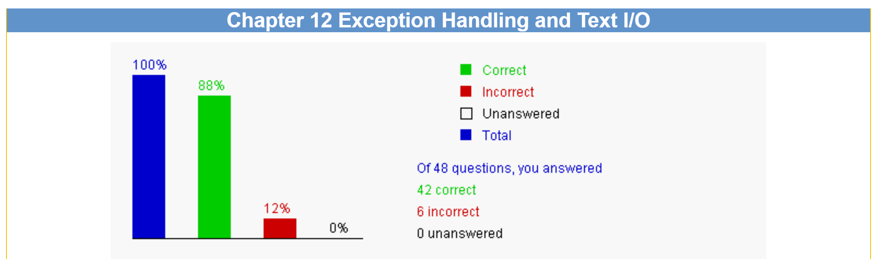

2. Correction & Learning

1) Correction
12.5 The following code causes Java to throw _________. The answer is: no exceptions

Learning:
I learned from the explanation of the problem: At present, Java does not throw integer overflow exceptions. The future version of Java may fix this problem to throw an over flow exception.

2) Correction
12.15 Analyze the following code:
public class Test {
public static void main(String[] args) throws MyException {
System.out.println("Welcome to Java");
}
}
class MyException extends Error {
}
The answer is: You should not declare a class that extends Error, because Error raises a fatal error that terminates the program.

Learning:
I learned from the explanation of the problem: When an exception of Error type occurs, your program would terminate. Therefore, you should not declare an exceptionthat extends Error. You declared an exception in the main method. If you did not throw anything, that is fine.

3) Correction
12.18 What is displayed on the console when running the following program?
public class Test {
public static void main(String[] args) {
try {
p();
System.out.println("After the method call");
}
catch (NumberFormatException ex) {
System.out.println("NumberFormatException");
}
catch (RuntimeException ex) {
System.out.println("RuntimeException");
}
}
static void p() {
String s = "5.6";
Integer.parseInt(s); // Cause a NumberFormatException
int i = 0;
int y = 2 / i;
System.out.println("Welcome to Java");
}
}
The answer is: The program displays NumberFormatException.

Learning:
The explanation of this problem told us: The main method invokes the method p. ln p, Integer,parselnt(s) causes a NumberFormatException. Thmethod p is now terminated, The NumberformatException exception is handled in the main method. So NumberFormatException isdisplayed.

4) Correction
12.27 What is displayed on the console when running the following program?
public class Test {
public static void main(String[] args) {
try {
System.out.println("Welcome to Java");
int i = 0;
int y = 2/i;
System.out.println("Welcome to Java");
}
finally {
System.out.println("End of the block");
}
System.out.println("End of the block");
}
}
The answer is: The program displays Welcome to Java and End of the block, and then terminates because of an unhandled exception.

Learning:
This code refer to a lot of knowledge, I surf the internet and found some definition of them:
- Exception Handling: The try-catch-finally block in Java is used for exception handling. The try block contains code that might throw an exception, the catch block is used to catch and handle the exception (if any), and the finally block is always executed.
- Division by Zero: In Java, dividing any number by 0 will throw an ArithmeticException.
- Execution of finally block**: Regardless of whether an exception occurs, the code in the finally block is always executed. However, if an exception occurs in the try block and is not caught in a catch block, the program will terminate after the finally block is executed.
- Uncaught Exception: If an exception is not caught by a catch block, the program will terminate due to the uncaught exception.
- Program Termination: When an uncaught exception occurs, the program will not execute any subsequent code, including code after the finally block.

5) Correction
12.28 Which of the following is not an advantage of Java exception handling? The answer is: Exception handling improves performance.

Learning:
I learned by asking gpt for help and found some related knowledge:
    - Separation of Exception Handling: Java separates the logic for handling exceptions from the normal flow of the program using try, catch, and finally blocks, which helps with code clarity and maintainability.
    - Caller's Caller Handling Exceptions: Java's exception mechanism allows exceptions to be thrown up the call stack to be potentially handled at a higher level.
    - Simplification of Programming: Exception handling allows developers to centralize error reporting and handling code within catch blocks, simplifying the complexity of error handling.
    - Performance Consideration: Exception handling does not improve program performance. In fact, overusing exception handling or using it in performance-sensitive code can negatively impact performance because creating and handling exceptions requires additional resources.
    - Exceptions for Exceptional Cases: Exception handling should be used for dealing with exceptional situations in a program's execution, not for regular control flow.

6) Correction
12.29 Analyze the following code:
public class Test {
public static void main(String[] args) {
try {
int zero = 0;
int y = 2/zero;
try {
String s = "5.6";
Integer.parseInt(s); // Cause a NumberFormatException
}
catch(Exception e) {
}
}
catch(RuntimeException e) {
System.out.println(e);
}
}
}
The answer is: A good programming practice is to avoid nesting try-catch blocks, because nesting makes programs difficult to read. You can rewrite the program using only one try-catch block.

Learning:
I learned from the explanation of the problem: The best answer is b. This question does not ask you what happens when you run the program. If you run the program, aRuntimeException would occur and it would be caught be the last catch clause.

Ch13 Abstract Classes and Interfaces

1. Bar-graph of Self-test
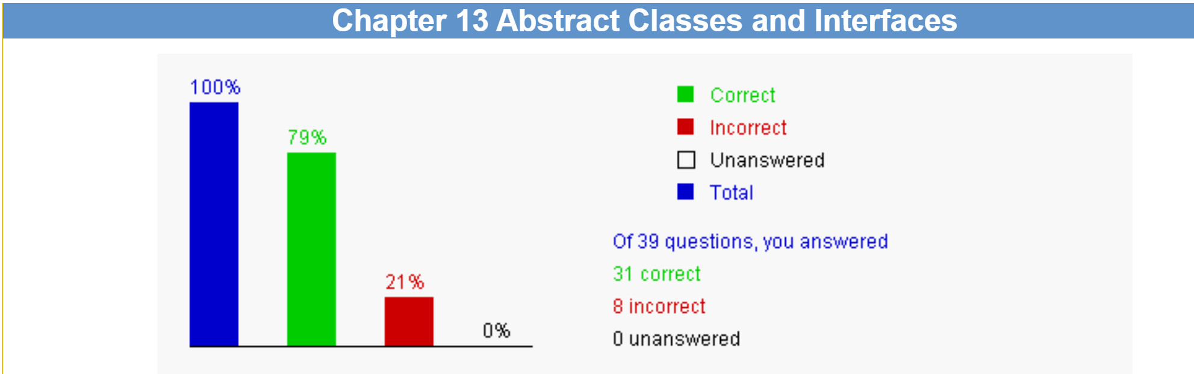

2. Correction & Learning

1) Correction
13.5 Suppose A is an abstract class, B is a concrete subclass of A, and both A and B have a no-arg constructor. Which of the following is correct? The answers are: A a = new B(); and B b = new B();

Learning:
I learned the related knowledge from the internet:
- Abstract Class: An abstract class cannot be instantiated, which means you cannot use the new keyword to create an object of an abstract class.
- Concrete Subclass: A concrete subclass is a non-abstract subclass of an abstract class, and it can be instantiated.

2) Correction
13.12 The java.util.Calendar and java.util.GregorianCalendar classes are introduced in Chapter 11. Analyze the following code. Which of the following statements is correct?
1. import java.util.*;
2. public class Test {
3. public static void main(String[] args) {
4. Calendar[] calendars = new Calendar[10];
5. calendars[0] = new Calendar();
6. calendars[1] = new GregorianCalendar();
7. }
8. }
The answer is: The program has a compile error on Line 5 because java.util.Calendar is an abstract class.

Learning:
The explanation of this problem is clear: (A) is incorrect since it is OK to use abstract class as data type for arrays. new Calendarl10] does not create Calendalobjects. It just creates an aray with 10 elements, each of which can reference to a Calendar obiect. (B) is correct since you cannotcreate an obiect from an abstract class.(0) is incorrect since it is fine to create a GregomianCalendar obiect and assien its reference to avariable of its superclass type.

3) Correction
13.14 Assume Calendar calendar = new GregorianCalendar(). __________ returns the week of the year. The answer is: calendar.get(Calendar.WEEK_OF_YEAR)

Learning:
I learned from the slides and e-book:
- Java Calendar Class: The Calendar class is an abstract class that provides a set of methods and fields for date and time manipulation, and it defines various field constants to represent different calendar fields.
- GregorianCalendar Class: The GregorianCalendar class is a concrete implementation of the Calendar class that handles dates and times according to the Gregorian calendar system.

4) Correction
13.23 Analyze the following code.
1. public class Test {
2. public static void main(String[] args) {
3. Fruit[] fruits = {new Fruit(2), new Fruit(3), new Fruit(1)};
4. java.util.Arrays.sort(fruits);
5. }
6. }
class Fruit {
private double weight;
public Fruit(double weight) {
this.weight = weight;
}
}
The answer is: The program has a runtime error on Line 4 because the Fruit class does not implement the java.lang.Comparable interface and the Fruit objects are not comparable.

Learning:
The explanation of this problem is clear enough:
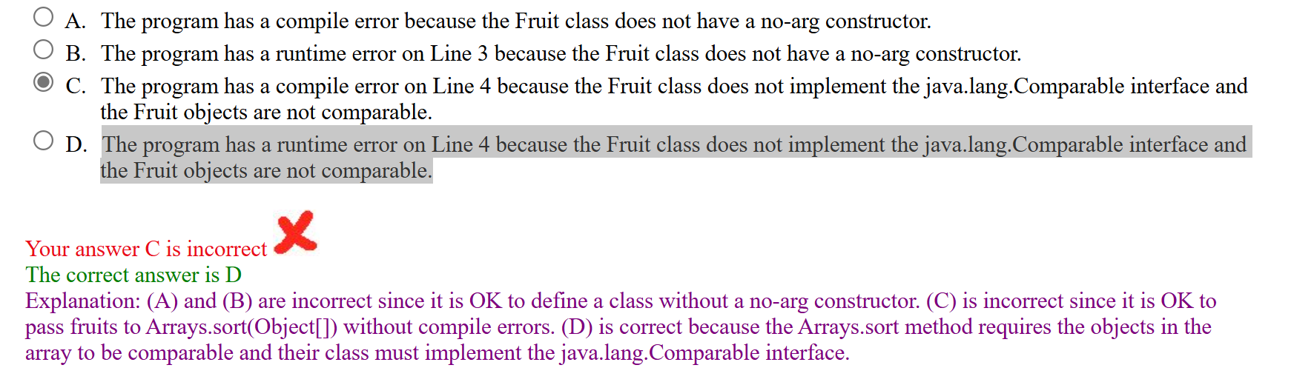

5) Correction
13.32 The Rational class in this chapter is defined as a subclass of java.lang.Number. Which of the following expressions is correct? The answers are: new Rational(5, 4).doubleValue(); and new Rational(5, 4).intValue();

Learning:
The explanation of this problem is clear enough.
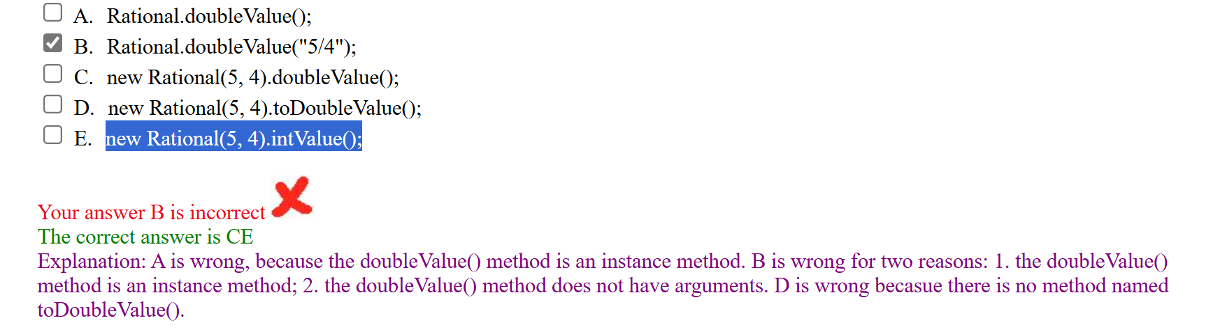

6) Correction
13.33 The Rational class in this chapter extends java.lang.Number and implements java.lang.Comparable. Analyze the following code.
1. public class Test {
2. public static void main(String[] args) {
3. Number[] numbers = {new Rational(1, 2), new Integer(4), new Double(5.6)};
4. java.util.Arrays.sort(numbers);
5. }
6. }

7) Correction
13.34 Which of the following statements are true?
The answers are: A class should describe a single entity and all the class operations should logically fit together to support a coherent purpose. And The constructors may be protected.

Learning:
The explanation of this problem is clear enough.
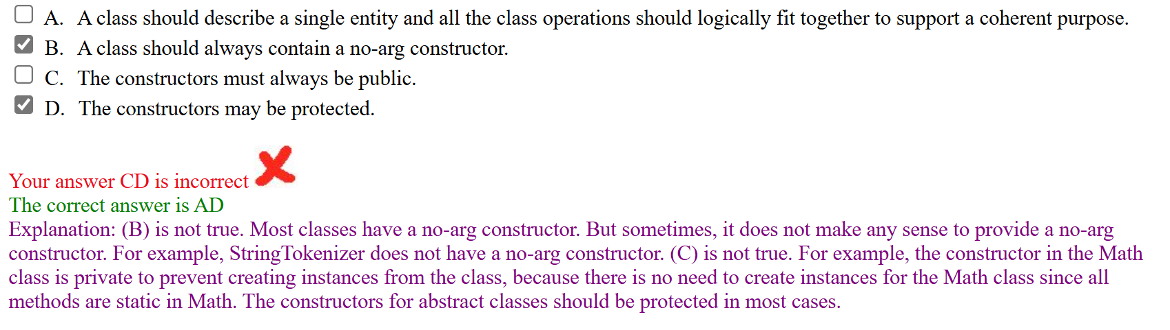

8) Correction
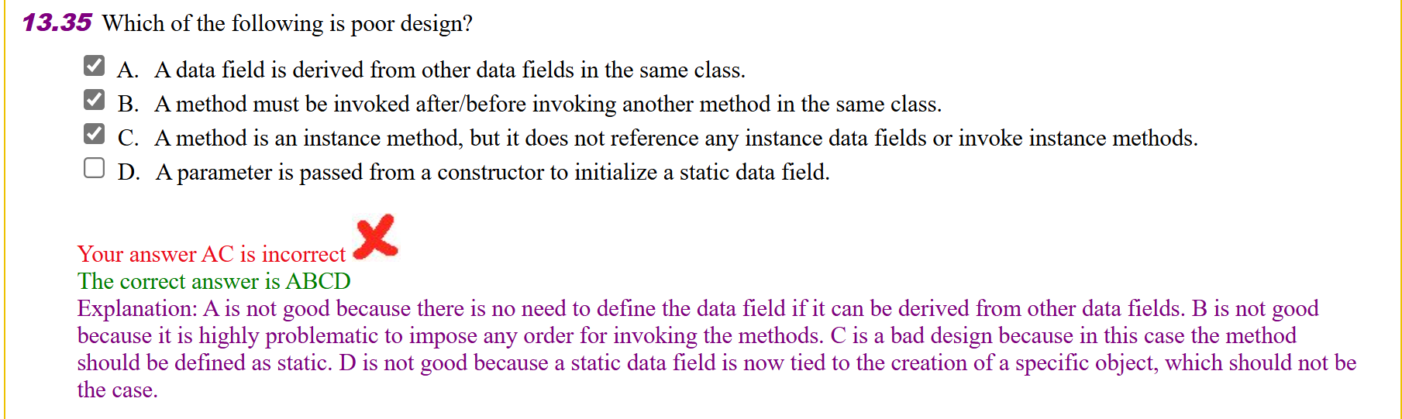

Ch14 JavaFX Basics (Optional)

1. Bar-graph of Self-test
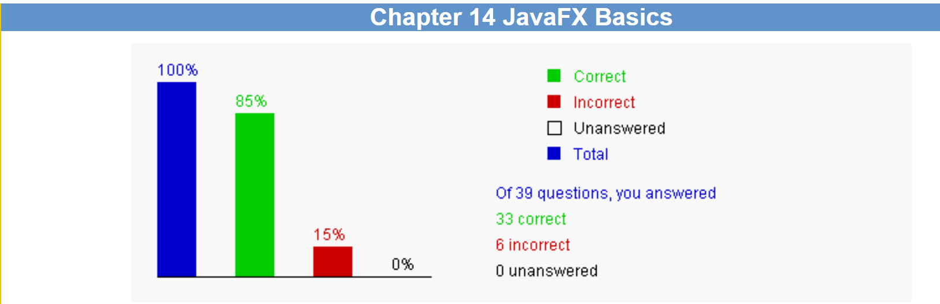

2. Correction & Learning

1) Correction
14.4 What is the output of the following JavaFX program?
import javafx.application.Application;
import javafx.stage.Stage;
public class Test extends Application {
public Test() {
System.out.println("Test constructor is invoked.");
}
@Override // Override the start method in the Application class
public void start(Stage primaryStage) {
System.out.println("start method is invoked.");
}
public static void main(String[] args) {
System.out.println("launch application.");
Application.launch(args);
}
}
The answer is: launch application. Test constructor is invoked. start method is invoked.

Learning:
I search the internet and found the answer: JavaFX Application Lifecycle: In JavaFX, the Application class serves as the entry point for all JavaFX applications. It contains the start method, which is called by the JavaFX runtime when the application is launched.

2) Correction
14.6 Which of the following statements are true? The answer is: A Node can be placed in a Pane.

Learning:
I search the internet and found the answer: JavaFX Nodes and Containers: In JavaFX, Node is the base class for all renderable graphical objects, and Pane is a container that can hold Node objects. Scene: Scene is a class in JavaFX that represents the content of a Stage. A Scene can contain a root Node, which is typically an instance of Pane or another Node type. Hierarchy: In the JavaFX UI hierarchy, Pane is a subclass of Node and therefore can contain other Node objects. Scene, as the content of the stage, can have a root that is any Node type.

3) Correction
14.16 Which of the following statements correctly rotates the button 45 degrees counterclockwise? The answers are: button.setRotate(360 - 45); and button.setRotate(-45);

Learning:
In JavaFX, the setRotate method's parameter indicates the angle of rotation for a node, with positive values representing clockwise rotation and negative values representing counterclockwise rotation.

4) Correction
14.25 To remove two nodes node1 and node2 from a pane, use ______. The answer is: pane.getChildren().removeAll(node1, node2);

Learning:
In JavaFX, to remove two nodes node1 and node2 from a Pane, you should use the
getChildren() method of the Pane to retrieve its list of child nodes, and then call the
removeAll method of that list to remove multiple nodes.

5) Correction
14.31 Analyze the following code:
import javafx.application.Application;
import javafx.scene.Scene;
import javafx.stage.Stage;
import javafx.scene.layout.HBox;
import javafx.scene.shape.Circle;
public class Test extends Application {
@Override // Override the start method in the Application class
public void start(Stage primaryStage) {
HBox pane = new HBox(5);
Circle circle = new Circle(50, 200, 200);
pane.getChildren().addAll(circle);
circle.setCenterX(100);
circle.setCenterY(100);
circle.setRadius(50);
pane.getChildren().addAll(circle);
// Create a scene and place it in the stage
Scene scene = new Scene(pane);
primaryStage.setTitle("Test"); // Set the stage title
primaryStage.setScene(scene); // Place the scene in the stage
primaryStage.show(); // Display the stage
}
/**
* The main method is only needed for the IDE with limited
* JavaFX support. Not needed for running from the command line.
*/
public static void main(String[] args) {
launch(args);
}
}
The answer is: The program has a compile error since the circle is added to a pane twice.

Learning:
In JavaFX, a node (Node) can only be added to a parent's children list once. If you try to add the same node to the same list multiple times, an IllegalStateException will be thrown because a node cannot belong to multiple parents at the same time.

6) Correction
14.39 Assume p is a Polygon, to add a point (4, 5) into p, use _______. The answers are: p.getPoints().add(4.0); p.getPoints().add(5.0); and p.getPoints().addAll(4.0, 5.0);

Learning:
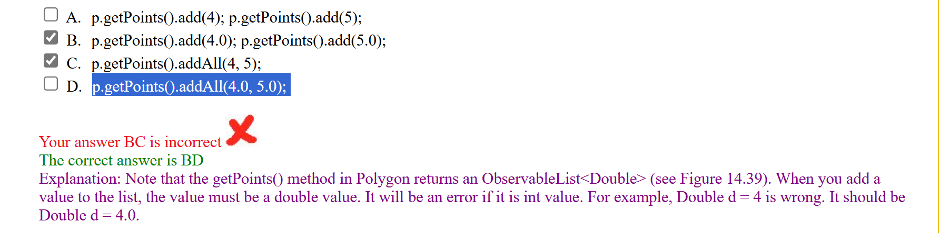

Project I. *** ()
https://www.interviewbit.com/blog/java-projects/
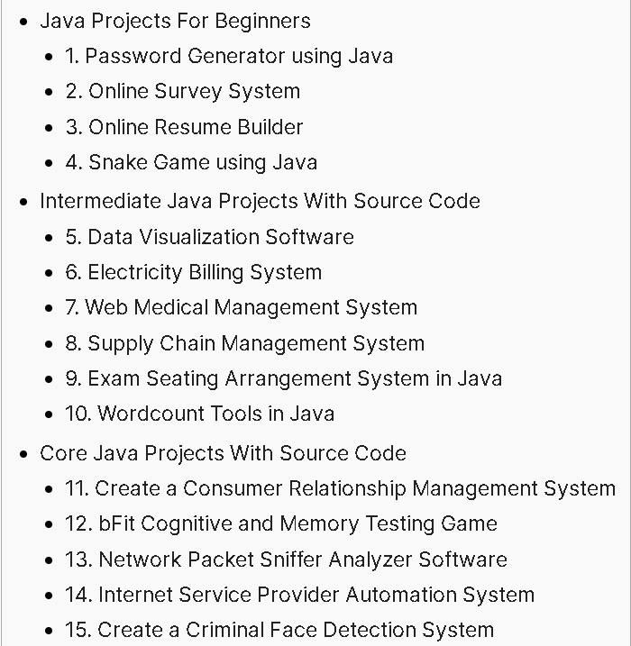
Choose one of the above 15 programs.
Modify the program’s GUI and some functionalities, and describe which parts are your modification. Show the running results of your modified program.
And try to test your program using Junit (Optional).

1. The chosen program’s name and type
4. Snake Game using Java

2. Running results of my modified program
(1) Screenshot of the running result

  Figure1： | 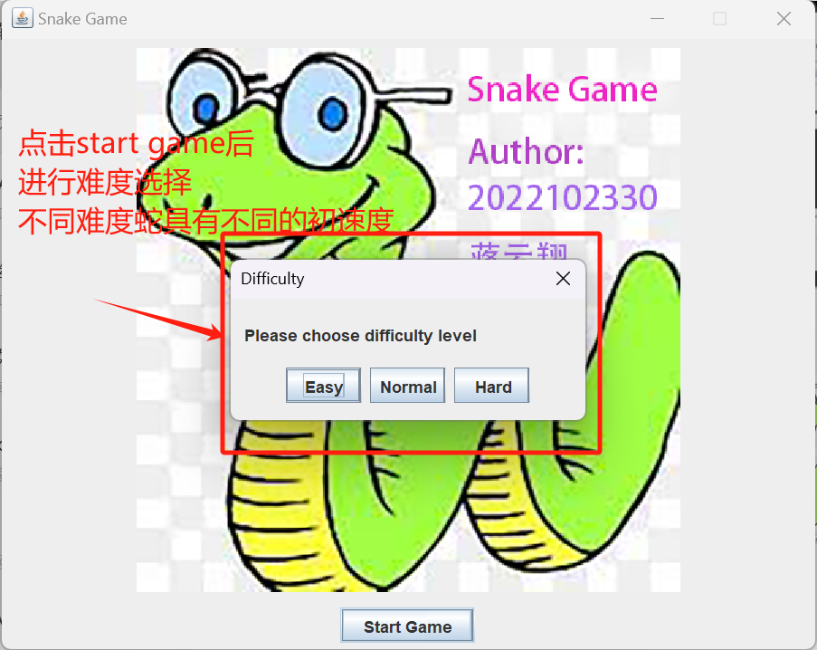  Figure2:
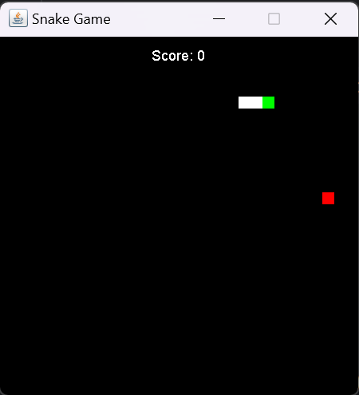  Figure3: | 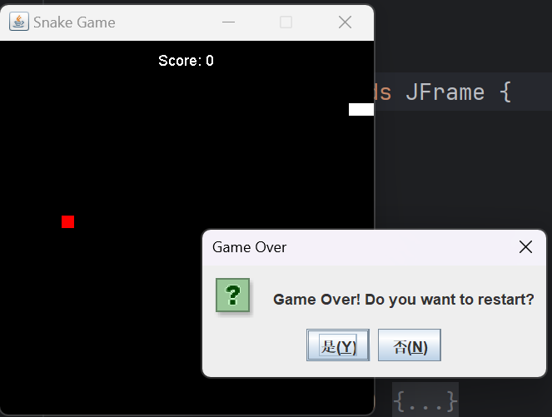  Figure4:

(2) The modified parts of the GUI
- Figure1:
  - I have designed a start game interface with a background image of the snake game, and I have placed a "Start Game" button for users to click on.
- Figure2:
  - After clicking on "Start Game," a selection box will appear, allowing users to choose the difficulty level of the snake game. Higher difficulty implies that the snake has a faster initial speed.
- Figure3:
  - For the game interface, I made the following changes: I replaced the snake and apple icons with the entire pixel blocks being colored in, which makes the UI design appear more full and simple, and it looks very comfortable to the users.
  - Additionally, I have added a score display to provide users with real-time feedback.
- Figure4:
  - After the game ends, a message box pops up to remind the user whether they want to restart the game.

3. Program functionalities modified by me
(1) Description of the modified functionalities
Function:
- Provided a feature for users to choose whether to start the game.
- Provided a feature for users to choose whether to restart the game.
- Designed the game scoring to motivate users to achieve higher scores.

(2) The total number of the SourceCode Lines created by me
About 200 SourceCode Lines

(3) List parts of the SourceCode Lines (less than one page) created by me
private void showDifficultyDialog() {
String[] options = {"Easy", "Normal", "Hard"}; // 难度选项
int choice = JOptionPane.showOptionDialog(this, "Please choose difficulty level", "Difficulty",
JOptionPane.DEFAULT_OPTION, JOptionPane.PLAIN_MESSAGE, null, options, options[0]);
int difficulty = 1; // 默认简单
switch (choice) {
case 0:
difficulty = 1;
break;
case 1:
difficulty = 2;
break;
case 2:
difficulty = 3;
break;
default:
break;
}
parent.startGame(difficulty); // 开始游戏，并传入选择的难度
}
@Override
protected void paintComponent(Graphics g) {
super.paintComponent(g);
// 绘制背景或其他自定义的绘图
}
@Override
public Dimension getPreferredSize() {
return new Dimension(600, 450); // 设置面板首选大小
}

4. Test my program with Junit. (Optional)
(1) Screenshots (less than 5 images) of testing classes in my program with Junit
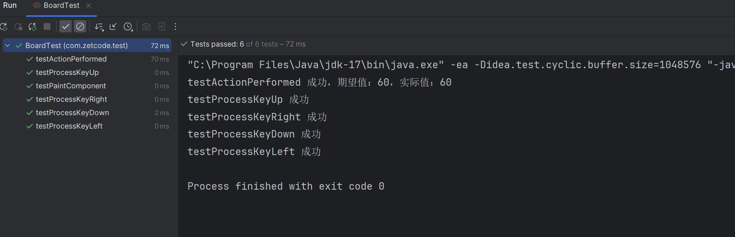
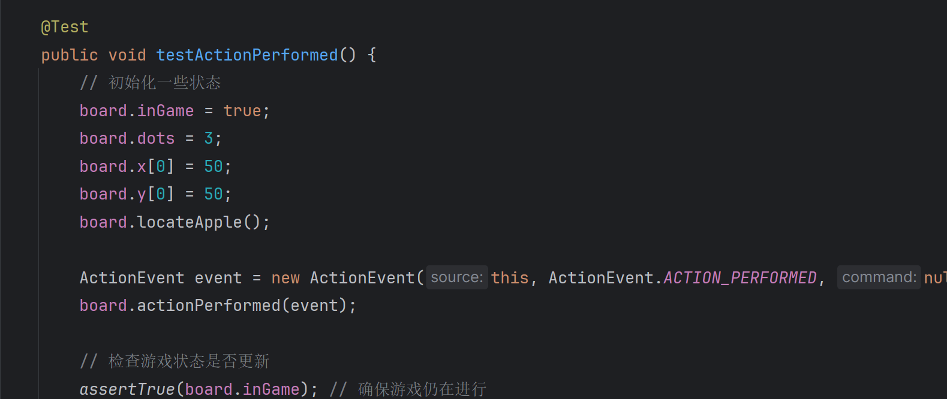
(2) list parts of source lines (less than one page) in your test class
@Test
public void testActionPerformed() {
// 初始化一些状态
board.inGame = true;
board.dots = 3;
board.x[0] = 50;
board.y[0] = 50;
board.locateApple();
ActionEvent event = new ActionEvent(this, ActionEvent.ACTION_PERFORMED, null);
board.actionPerformed(event);
// 检查游戏状态是否更新
assertTrue(board.inGame); // 确保游戏仍在进行
assertEquals(60, board.x[0]); // 检查蛇头是否移动（假设初始方向为右）
// 在测试成功时打印输出
System.out.println("testActionPerformed 成功，期望值：60，实际值：" + board.x[0]);
}

