Jinan University
2023 ～ 2024 Academic Year, 2nd. Semester

Java Programming

Course Report

Course code : 60080008
Instructor: Yuxia Sun
Major: Computer Science & Technology
School: International School

Student name : ________蒋云翔_________
(p.s. your name on JNU academic system)

Student number : ________2022102330__________

Date of Submission (mm-dd-yyyy): ________________

Table of Content
Ch1 Introduction to Computers, Programs, and Java 3
1. Bar-graph of Self-test 3
2. Correction & Learning 3
1) Correction 3
2) Correction: 3
Ch2 Elementary Programming 3
1. Bar-graph of Self-test 3
2. Correction & Learning 4
Project I. *** () 4
1. The chosen program’s name and type 5
2. Running results of my modified program 5
3. Program functionalities modified by me 5
4. Test my program with Junit. (Optional) 5

Ch1 Introduction to Computers, Programs, and Java

1. Bar-graph of Self-test
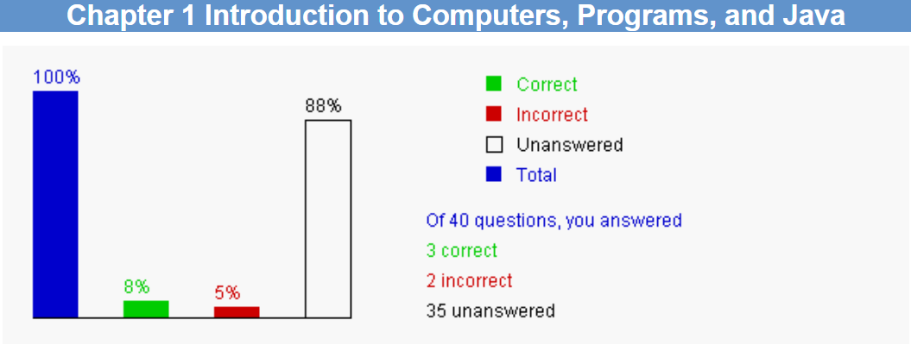

2. Correction & Learning
（If your answer of a question is wrong, please write the correct answer as follows. You also need briefly summarize how/what did you learn from this question, as the following example shows. ）

Correction
1.3 The speed of the CPU may be measured in megahertz, gigahertz
Learning:
I read Section1.2.1 of the textbook (/search on the web/ask the TA or teacher or classmate/……), and learnt: “In the 1990s, computers measured clock speed in megahertz (MHz), but CPU speed has been improving continuously; the clock speed of a computer is now usually stated in gigahertz (GHz)”

Correction:
1.6 …..
Learning:
…..

Ch2 Elementary Programming

1. Bar-graph of Self-test
……

2. Correction & Learning
……
……

Ch3 Selections

Ch4 Mathematical Functions, Characters, and Strings

Ch5 Loops

Ch6 Methods

Ch7 Single-Dimensional Arrays

Ch8 Multidimensional Arrays

Ch9 Objects and Classes

Ch10 Object-Oriented Thinking

Ch11 Inheritance and Polymorphism

Ch12 Exception Handling and Text I/O

Ch13 Abstract Classes and Interfaces

Ch14 JavaFX Basics

Project I. *** ()
https://www.interviewbit.com/blog/java-projects/
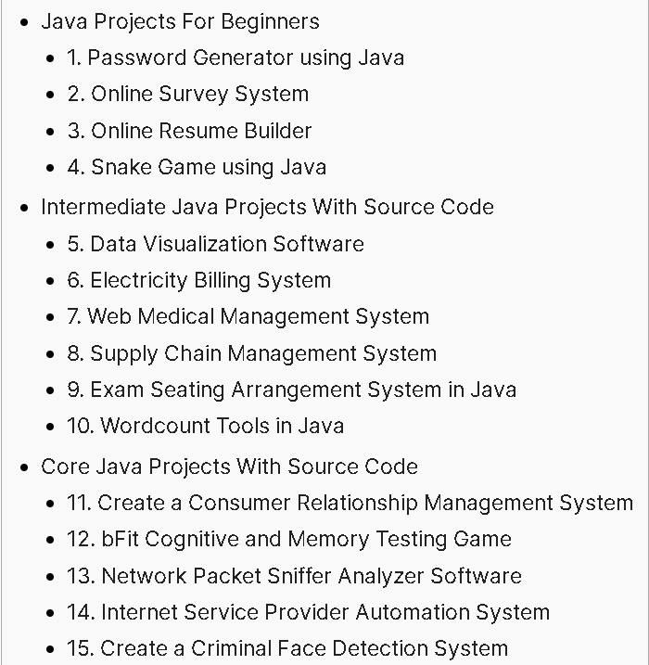
Choose one of the above 15 programs.
Modify the program’s GUI and some functionalities, and describe which parts are your modification. Show the running results of your modified program.
And try to test your program using Junit (Optional).

1. The chosen program’s name and type
6. Electricity Billling System (Intermediate Java Projects)

2. Running results of my modified program
(1) Screenshot of the running result
……
(2) The modified parts of the GUI
…..( description and/or sceenshot)

3. Program functionalities modified by me
(1) Description of the modified functionalities
……

(2) The total number of the SourceCode Lines created by me
… (e.g. 40 SourceCode Lines)…

(3) List parts of the SourceCode Lines (less than one page) created by me
…..

4. Test my program with Junit. (Optional)
(1) Screenshots (less than 5 images) of testing classes in my program with Junit
…..

(2) list parts of source lines (less than one page) in your test class
……

