卡通人物

**Course Report**

Course Title: Human Computer Interaction

Course No: 60080075

Student Name: **蒋云翔**

Student No: 2022102330

School: International School

Major: Computer Science and Technology

Instructor Jinyi Long

Academic Year:2024~2025,Semester : 1st [ ● ] 2nd[ ]

**Academic Affairs Office of Jinan University**

**Date** (dd/mm/yyyy) 4/1/2025

Adventure Innovator: Specs for the Next-Gen Travel Hub

Permission to make digital or hard copies of part or all of this work for personal or classroom use is granted without fee provided that copies are not made or distributed for profit or commercial advantage and that copies bear this notice and the full citation on the first page. Copyrights for third-party components of this work must be honored. For all other uses, contact the owner/author(s).

*CHI 2020 Extended Abstracts, April 25–30, 2020, Honolulu, HI, USA.*

© 2020 Copyright is held by the owner/author(s).

ACM ISBN 978-1-4503-6819-3/20/04.

DOI: https://doi.org/10.1145/3334480.XXXXXX

|  |
| --- |
| Yusi  Jinan University  International School Guangzhou, China |

# Abstract

As the tourism industry continues to flourish, there's an increasing need for smart and personalized travel planning tools. This project is dedicated to developing an intelligent travel assistant web page, with the primary goal of enhancing users’ travel planning experiences through technological innovation. Our system integrates advanced data analytics and user-centric interface design, offering features like scenic spot recommendations, itinerary customization, and more. It aims to address the issues of scattered information and limited functionality found in current tourism applications. By deeply analyzing user needs and applying innovative design principles, this project not only boosts the efficiency of travel planning but also elevates the overall travel experience for users. Moreover, this report delves into the project's contributions to individual professional development and its potential socioeconomic impact.

# Author Keywords

Human-computer interaction, intelligent travel assistant, advanced web design, functional integration

# Introduction

Nowadays, travel has become a popular leisure activity, leading to a growing demand for efficient travel planning and management tools. This project is dedicated to developing an intelligent travel assistant web page, with the primary goal of simplifying the travel planning process and enhancing the overall travel experience for users.

**Figure 1: Travel assistant**

This report outlines the design, implementation, and anticipated impact of a smart travel assistant web page. The motivation for this project arises from the prevalent issues in the current tourism application market, including scattered information, limited functionalities, and poor user experience. By integrating advanced smart technology and user-friendly interface design, our travel assistant aims to offer users a comprehensive travel information service. This includes, but is not limited to, attraction recommendations, itinerary planning, and weather forecasts.

# Requirements Analysis

Requirements Questions

* The list of requirements survey questions is as follows:
* What challenges do you typically face when planning a trip?
* What features would you like a travel assistant website to offer to address your travel issues?
* What information do you consider most crucial when selecting a travel destination?
* Which aspects of the user experience would you most like to see improved on travel websites?
* Do you engage with other travelers within the community? If so, what types of content do you prefer to share and discuss?
* What auxiliary functions do you find most helpful when using map navigation?
* Do you have any specific needs when shopping online or locating malls?
* What expectations do you have for the weather forecast feature?

# Summary of User Requirements



**Figure 1: Travel assistant icon**

Based on the answers to the above questions, I got the following summary list of requirements:

* **Common problems faced by users include complex itinerary planning, difficulty in finding localized travel information, and the lack of a communication platform with other travelers.**
* **Users desire features like one-click itinerary planning, real-time local activity updates, and seamless community communication on the website.**
* **When it comes to destination information, users are particularly interested in local cultural activities, food recommendations, and safety conditions.**
* **Users seek improvements in user experience, such as faster page loading speeds, more intuitive interface designs, and more accurate recommendation systems.**

**Many users are eager to share their travel experiences within the community and are interested in discussing travel tips and hidden attractions.**

* **For map navigation, users require features like pedestrian navigation mode, real-time traffic updates, and scenic spot previews.**
* **When shopping online or locating malls, users expect detailed product classifications, user reviews, and convenient price comparison tools.**
* **For weather forecasts, users look for clothing recommendations, UV index information, and suggestions for outdoor activities.**



# Human-computer interaction scenarios

Due to space limitations, we will use figures to illustrate the human-computer interaction scenarios in this context.

**Figure 3: Interaction Flow of a Self-Guided Travel Enthusiast with the "Journey Facilitator" System**

This figure highlights the key services accessed by a self-guided travel enthusiast using the "Journey Facilitator" system. It demonstrates how she utilizes the travel destination search, the map service for route planning and attraction recommendations, the weather service for forecasts and health tips, and the community platform where she can share her travel experiences and receive feedback.

* **Travel Destination Search:** She explores and selects travel destinations with personalized recommendations and detailed information.
* **Map Service for Route Planning and Attraction Recommendations:** This helps her plan routes efficiently and discover must-visit attractions, including real-time traffic updates and scenic spot previews.

# System Level Structure

Travel assistant is a holistic travel assistant platform designed to simplify the travel planning process for users by offering a suite of integrated services. Below is an overview of the primary services provided by the platform:

日程表

Here are the introductions for the specified modules:

1. **Search Module**

This module allows users to easily search for travel destinations, receive personalized shopping mall recommendations, and plan their shopping routes. By integrating various search features, it simplifies the process of finding the best places to visit and shop.

1. **Map Module**

The real-time map feature provides users with up-to-date navigation and route planning. This module includes real-time traffic updates, pedestrian navigation, and scenic spot previews, ensuring users have the most accurate and efficient travel routes.

1. **Information Module**

This module offers comprehensive weather forecasts and air quality information for various destinations. It helps users prepare for their trips by providing essential details on weather conditions, UV index, and air quality, ensuring a safe and enjoyable travel experience.

1. **Community Module**

The community module is a platform for users to share their travel experiences and leave reviews. It fosters a collaborative environment where travelers can discuss tips, recommend hidden attractions, and connect with other travel enthusiasts.

# Interface design

Part of the design interface of “Journey Facilitator" is shown in Figures 5 to 9:

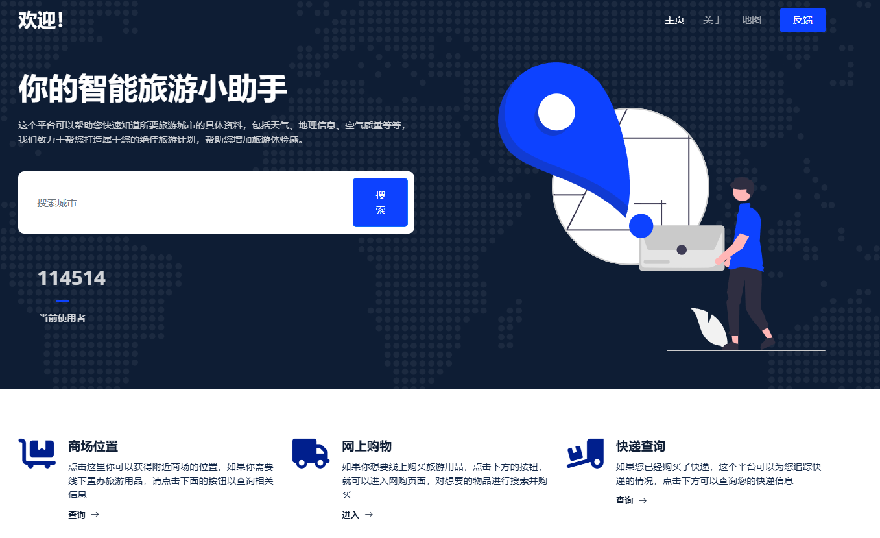

**Figure 5: Main frame**

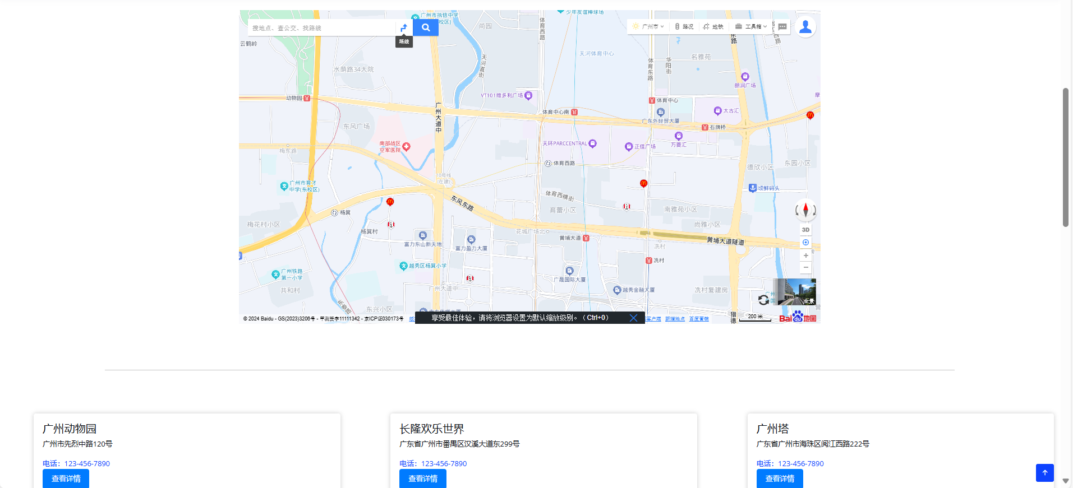

**Figure 6: Real-time map**

**Figure 7: Weather module**

**Figure 8: Feedback**

**Figure 9: Contact module**

# Intended Significance and Impact

The primary users of this project are self-guided travelers who seek in-depth cultural experiences and personalized travel services. This project is innovative in several ways:

* **Localized and personalized content recommendation system**: This system not only provides standardized travel information but also offers personalized recommendations based on the user’s past behavior and preferences.
* **Community communication platform integration**: It offers users a social space to share and gain travel experiences.
* **Dynamic weather adaptation function**: This feature adjusts recommended travel plans according to real-time weather changes.

The expected global, economic, environmental, and social impacts of the project are as follows:

* **Global impact**: By providing multi-language support and culturally sensitive content, the solution will enhance the travel experience for global users and foster understanding and respect between different cultures.
* **Economic impact**: Increased tourism will generate economic benefits for destination countries.
* **Social impact**: Community features will encourage users to share real travel experiences, promote social communication and mutual understanding, and help travelers avoid potential issues during their journeys.

# Outlook

Looking ahead, Travel Assistant aims to revolutionize the travel industry by integrating key services into one unified platform. User engagement is expected to increase, driven by personalized experiences, community content, and adaptable interfaces for diverse users.

With a simplified design and real-time updates, alongside AI enhancements, travel planning will become more efficient and informative. This project will enhance my expertise in user experience and front-end technology, enriching my professional skills throughout the product’s lifecycle.

# References

1. Weilin Liu, Yaqin Cao, and Robert W. Proctor. 2022. The roles of visual complexity and order in first impressions of webpages: An ERP study of webpage rapid evaluation. *International Journal of Human–Computer Interaction* 38, 14 (2022), 1345–1358. DOI: https://doi.org/10.1080/10447318.2022.2077447.
2. Aliaksei Miniukovich and Kathrin Figl. 2023. The effect of prototypicality on webpage aesthetics, usability, and trustworthiness. *International Journal of Human–Computer Studies* 179 (2023), 103103. DOI: https://doi.org/10.1016/j.ijhcs.2023.103103.
3. Chao Wang, Stephan Hasler, Manuel Muehlig, Frank Joublin, Antonello Ceravola, Joerg Deigmoeller, and Lydia Fischer. 2020. Designing interaction for multi-agent cooperative systems in an office environment. *International Conference on Human-Computer Interaction*. Lecture Notes in Computer Science, vol 12210. Springer, 14–26. DOI: https://doi.org/10.1007/978-3-030-50341-3_2.
4. Tomayess Issa and Pedro Isaias. 2022. Usability and human–computer interaction (HCI). In *Sustainable Design: HCI, Usability and Environmental Concerns*. Springer Nature, 23–40. DOI: https://doi.org/10.1007/978-3-030-96573-0.
5. Elena L. Glassman. 2023. Designing interfaces for human-computer communication: An on-going collection of considerations. *arXiv preprint arXiv:2309.02257*. (<https://arxiv.org/abs/2309.02257>).