|  |
| --- |
| * ***University:****JNU* |
| * ***Department:****Computer Science and Technology* |
| * ***Course:****Human-Computer Interaction* |
| * ***Project Title:****Interactive Computer Application Design—assumption/claim/problem space* |
| * ***Project Part:****Part 2* |
| * ***Author:****蒋云翔 2022102330（Yunxiang Jiang）（Accomplish the task by myself only）* |
| * ***Instructor:****龙锦益（Jinyi Long）* |
| * ***Date:****November 5, 2024* |

Catalogue

1. Assumptions 2

i. **Feasibility of Multimodal Interaction:** 2

ii. **Universal Demand for Personalization:** 2

iii. **Universality of Cross-Cultural Design:** 2

iv. **Accessibility of Education and Training:** 2

2. Claim 3

i. **Enhancing Productivity and Creativity:** 3

ii. **Increasing User Satisfaction and Loyalty:** 3

iii. **Promoting Social Inclusivity:** 3

3. Problem space 4

i. **Prediction of User Behavior and Preferences:** 4

ii. **Privacy and Data Security:** 4

iii. **Technological Sustainability:** 4

iv. **Multilingual and Localization Support:** 4

v. **Accessibility Design:** 4

# 1. Assumptions

1. **Feasibility of Multimodal Interaction:** The assumption that integrating various interaction modes, such as voice and haptic, can enhance user efficiency and experience aligns with HCI research on multimodal interfaces.
2. **Universal Demand for Personalization:** The assumption that users generally prefer to customize interfaces and functionalities according to personal habits and preferences resonates with HCI research on personalization and adaptive interfaces.
3. **Universality of Cross-Cultural Design:** The assumption that the application's cross-cultural design will make it more widely accepted.
4. **Accessibility of Education and Training:** The assumption that providing online tutorials and resources can lower the barrier for users to learn new tools is consistent with HCI research on educational technology and user training.



# 2. Claim

1. **Enhancing Productivity and Creativity:** The claim that the application can significantly improve user productivity and creativity by simplifying complex tasks and providing innovative tools is based on HCI research on the impact of tools and environments on creativity.
2. **Increasing User Satisfaction and Loyalty:** The claim that providing a pleasant and intuitive user experience can enhance user satisfaction and loyalty aligns with HCI research on user experience and brand loyalty.
3. **Promoting Social Inclusivity:** The claim that the application can promote social inclusivity by providing accessible and affordable design tools to a wider audience is related to HCI research on technology equality and social impact.

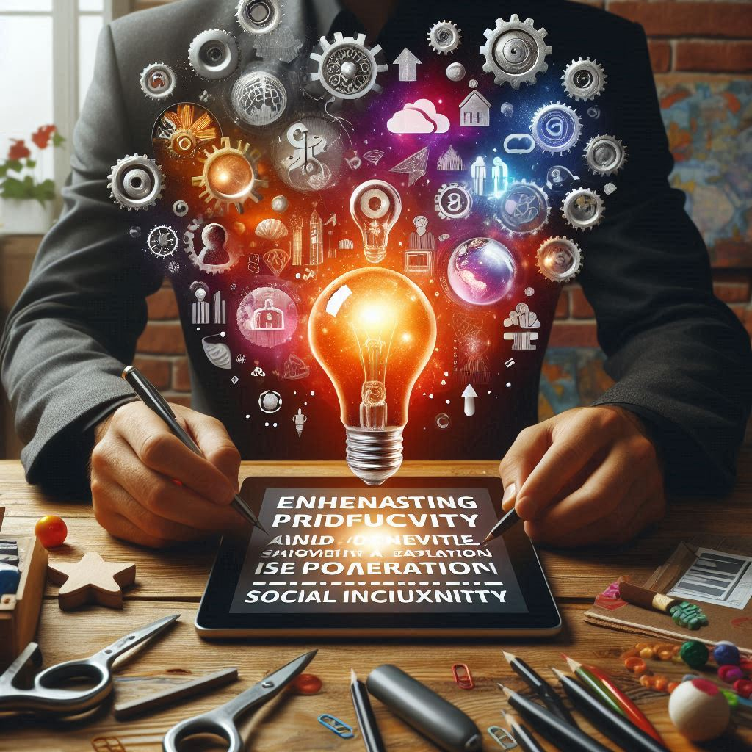

# 3. Problem space

1. **Prediction of User Behavior and Preferences:** The problem of accurately predicting and adapting to long-term changes in user behavior and preferences involves research on user behavior models and predictive algorithms in HCI.
2. **Privacy and Data Security:** The problem of protecting user privacy and data security while collecting and using user data to provide personalized services is related to research on privacy protection and ethical issues in HCI.
3. **Technological Sustainability:** The problem of ensuring the long-term maintainability and technological updates of the application to adapt to a rapidly changing technological environment involves research on technology lifecycle and sustainability in HCI.
4. **Multilingual and Localization Support:** The problem of providing effective localization support for users of different languages and cultural backgrounds is consistent with research on localization and internationalization in HCI.
5. **Accessibility Design:** The problem of ensuring the application is accessible to all users, including those with disabilities, involves research on accessible technology and inclusive design in HCI.

